PROFILE
I am a outgoing individual and a fast learner, who is eager to explore and learn new things, I am excited to join a Leading software company as an intern to grasp the industry practices while contributing my best to the organization

CONTACT
PHONE:
0719867768

Address:
No.8/4 Narangaspitiya ,Kirindiwela

EMAIL:
charukawish@gmail.com

SOCIAL
Github: charukawish97

LinkedIn:
www.linkedin.com/in/kasuncharuka

SKILLS
KASUN CHARUKA
Kirindiwela Central College-2007 - 2016 St. Sylvester’s college Kandy-2014 - 2016

Sri Lanka Institute of Information Technology
2019 - 2022
I’m currently 2nd year 2nd Semester BSc(Hon.)Information System Engineering Undergraduate in srilanka institute of information technology

EXTRA-CURRICULAR ACTIVITY

Member SLIIT ISE Community
2019

PROJECTS

Pharmacy System
2019
Using JAVA created Pharmacy system

Integrated Pharmacy Standalone System
2019
Using JAVA and SQL created application for Pharmacy system

Tools

Eclips, VS code, Vishual Studio,
R studio, Star UML, Packet Tracer,


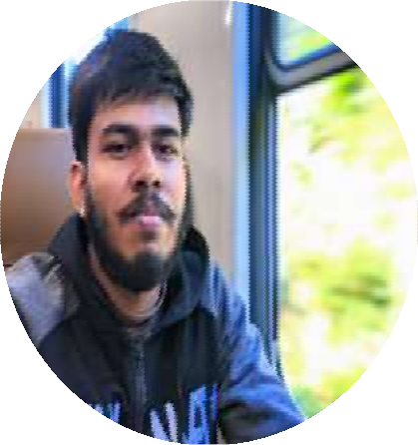
Java netwo CSS SQL UML
75%
80%
85%
75%
80%

