# PROJECT REPORT TEMLATE

# 1 INTRODUCTION

* Overview

The Event commit created with the purpose plan, develop and adminitor community, recreational, and cultural events within budgetary guidelines approved its call Event Management

* Purpose

Event Mangement is the process of the creating and maintaining an events.The process spans from the very beginning of planning all the way to post-event strategizing.At the start, an event manager makes planning decisions, such as the time, location, and theme their of events

# Problem Definition & Design Thinking

* Empathy Map

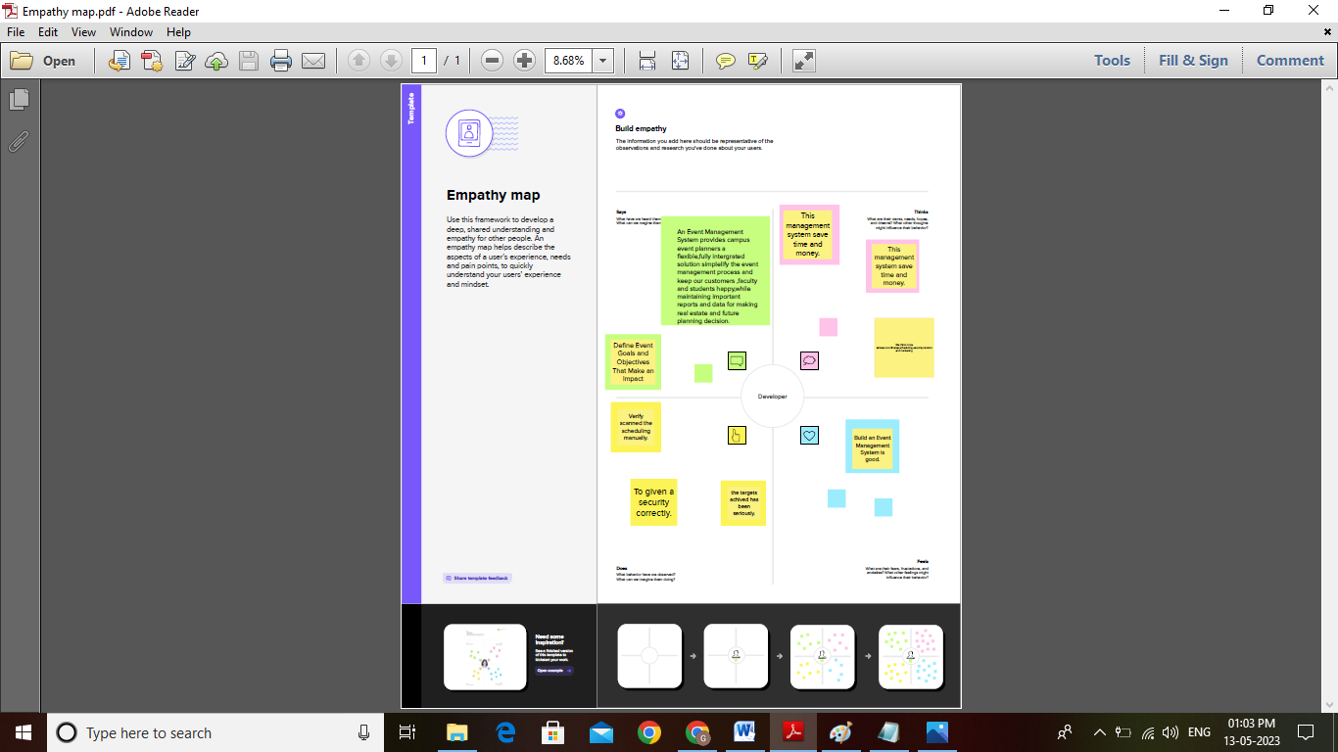

* Ideation & Brainstorming Map

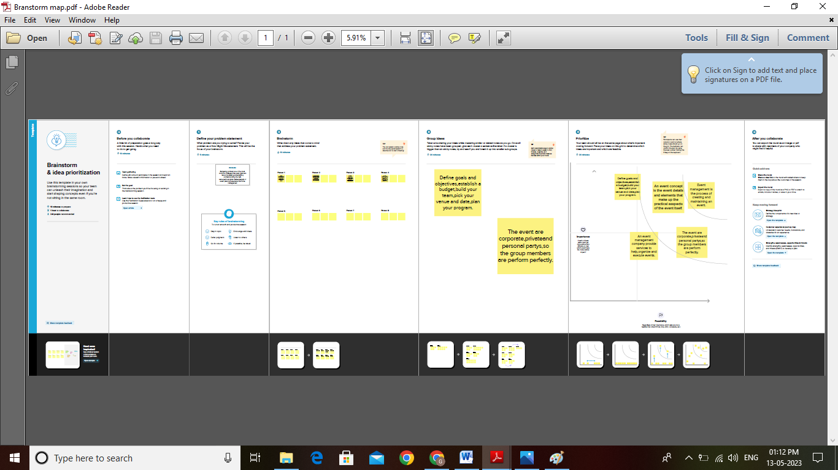

# RESULT

Data Model:

|  |  |
| --- | --- |
| Object name | Fields in the Object |
| Obj 1 | |  |  | | --- | --- | | Field label | Data type | | City | Text | |  |  | |
| Obj 2 | |  |  | | --- | --- | | Field label | Data type | | Start Date | Date/Time | |  |  | |

Do

# Trailhead Profile public URL

Team Lead – <https://trailblazer.me/id/gayan23>

Team Mamber 1 – <https://trailblazer.me/id/divys45>

Team Member 2 – <https://trailblazer.me/id/dramasamy6>

Team Mamber 3 – <https://trailblazer.me/id/ishwm9>

# ADVANTAGES & DISADVANTAGES

* Advantages:

1. Easier event management.

2. Saves time.

3. Cut costs.

4. Increase engagement.

5. Analyze and improve.

6. Automate your event.

7. Display a greater level of professionalism.

* Disadvantages:

1. Unconventional work hours.

2. Time away from family and friends.

3. Experience requirements.

4. Job instability.

5. Multiple events at the same time.

6. High level of responsibility.

# APPLICATION

1. Set ROI-Driven Event Goals and Objectives. The event's over, and you deem it a success.

2. Create a Solid Event Budget.

3. Design and Plan a Memorable Event.

4. Coordinate the Day of the Event.

5. Evaluate Your Event's Performance and Power Future Events.

# CONCLUTION

Event Management System is user friendly ans cost effective system, it is custumized with activities related to event management life-cyclie. It provides a new edge to management industry. SolutionDot always keep your objectives and goals on top priorty while developing any plan of work.

# FUTURE SCOPE

The are many career opportunities in event management. Its all depends on you what are your skill and interest areas. Company’s internel……