RESOLVENOW: Your Platform for Online Complaints

Project Details
Project Title: RESOLVENOW: Your Platform for Online Complaints
Team ID: LTVIP2026TMIDS37263
Team Leader: Konda Manasa
Team Members:
- Chinthakunta Gayathri
- Marramreddy Lakshmi Prasanna
- Kadire Gangothri
- Hemakshi B

1. Introduction
RESOLVENOW is a web-based complaint registration and management system designed to help users submit complaints online and track their resolution efficiently. Traditional complaint systems are slow, manual, and lack transparency. This platform digitizes the entire process, ensuring quick handling, real-time updates, and better communication between users and support agents.

2. Project Overview
Purpose
To provide a centralized, secure, and user-friendly platform where individuals can register complaints, monitor their status, interact with officials, and receive timely resolutions.
Key Features
✔ User registration and login
✔ Online complaint submission
✔ Upload supporting documents/images
✔ Real-time complaint tracking
✔ Agent assignment and communication
✔ Admin dashboard for management
✔ Notifications on status updates
✔ Secure data handling

3. System Architecture
Frontend
- HTML
- CSS
- JavaScript
- Bootstrap
Provides responsive user interface for users, agents, and admin.
Backend
- Python Flask (or Node.js if used)
Handles server logic, authentication, routing, and complaint processing.
Database
- SQLite / MongoDB
Stores user data, complaint details, status updates, and messages.

4. Setup Instructions
Prerequisites
- Python / Node.js installed
- Database configured
- Web browser
Steps to Run
- Clone the repository
git clone https://github.com/your-username/resolvenow.git
- Install dependencies
For Flask:
pip install -r requirements.txt
- Run the application
python app.py
- Open in browser
http://localhost:5000

5. Folder Structure
RESOLVENOW/
│
├── static/
│ ├── css/
│ ├── js/
│ └── images/
│
├── templates/
│ ├── login.html
│ ├── register.html
│ ├── dashboard.html
│ └── complaint_form.html
│
├── app.py
├── database.db
└── requirements.txt

6. User Interface Screenshots
User Login Page
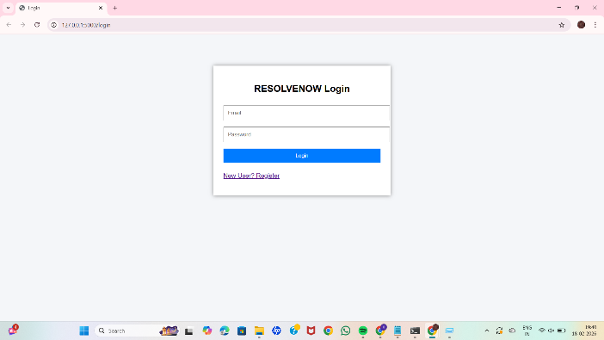

User Dashboard
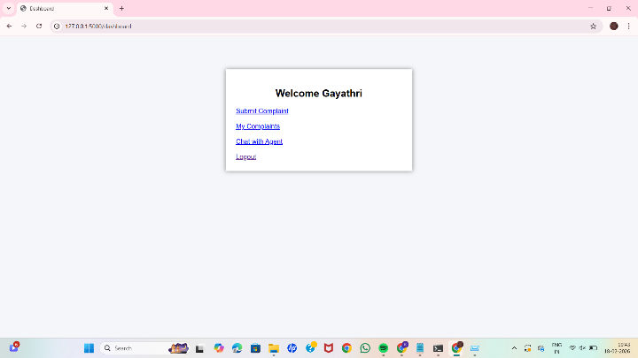

Complaint Submission Page
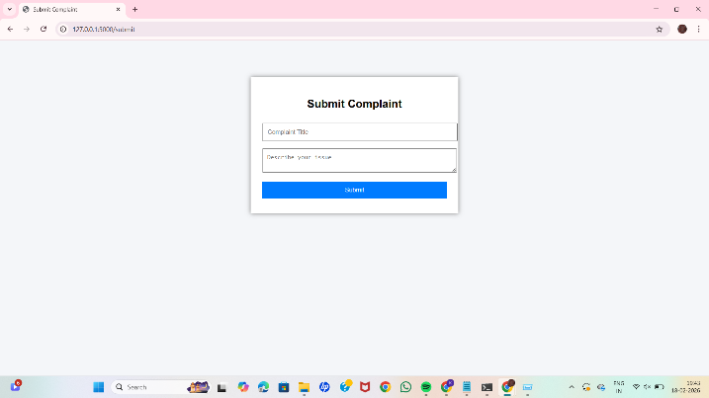

Admin Dashboard

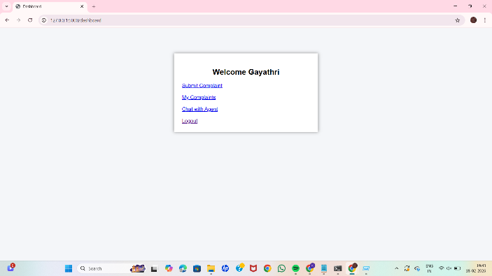

Complaint Tracking Page

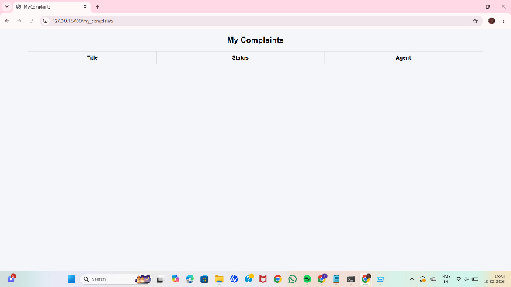

7. Testing
Tools Used
- Browser Testing
- Manual Functional Testing
Tested Scenarios
✔ User registration and login
✔ Complaint submission
✔ Status updates
✔ Admin assignment
✔ Communication between user and agent

8. Demo or Showcase
Screenshots: Included above
Demo Video: (Add YouTube or Drive link if available)

9. Known Issues
- Email/SMS notifications may not be implemented
- Limited real-time updates in basic version
- Mobile optimization can be improved

10. Future Enhancements
✔ Mobile application version
✔ AI-based complaint categorization
✔ Chatbot support
✔ Multi-language support
✔ Integration with government systems
✔ Advanced analytics dashboard

11. Conclusion
RESOLVENOW provides an efficient digital solution for complaint management. It enhances transparency, reduces manual workload, improves communication, and ensures faster resolution while maintaining data security and user satisfaction.

