Methods

Pre Processing Techniques:

Downloaded dataset and then imported as data frame using pandas and also imported some of the useful libraries like Numpy, pandas, matplot and seaborn. Using pandas, I understood the dataset by looking at its size, columns, data check (Head, tail), shape and columns.

Data Cleaning and feature engineering
Removed the null values and duplicates from the dataset and checked for invalid data and removed them as well. Added multiple useful features like customer variations, Order size and day type using existing features.

Aggregation and grouping Operations:
Performing Grouping Operations for some of the features like country, product and month and also aggregation functions like average, count and unique. Sorting operations was also implemented to look at the top list of country and customers and also performed statistical functions like mean, median, mode, range, percentile and standard deviation
Implemented charts using seaborn and matplot
Screenshots of charts shown below
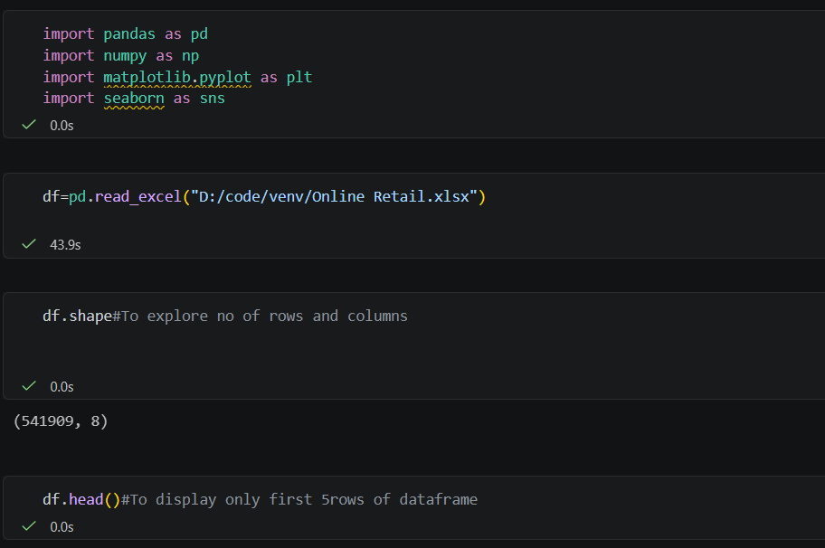

Fig 1: Loading dataset in pandas Data frame and the imported libraries and used the shape and head of loaded data frame

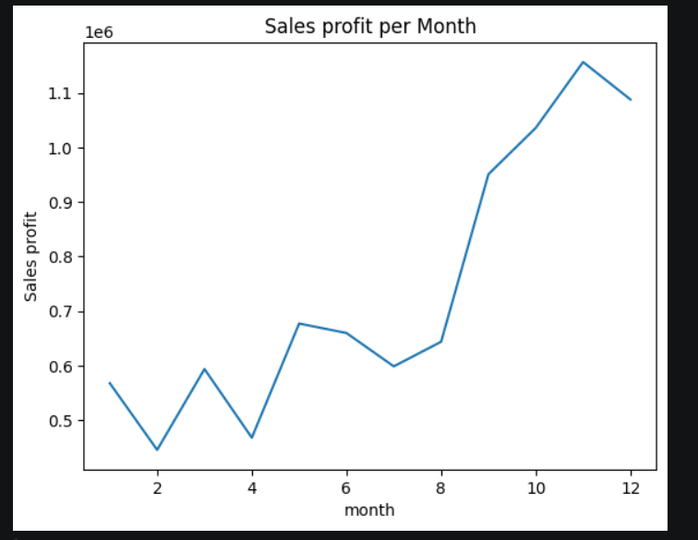
Fig 2: Line chart showing sales count of each month

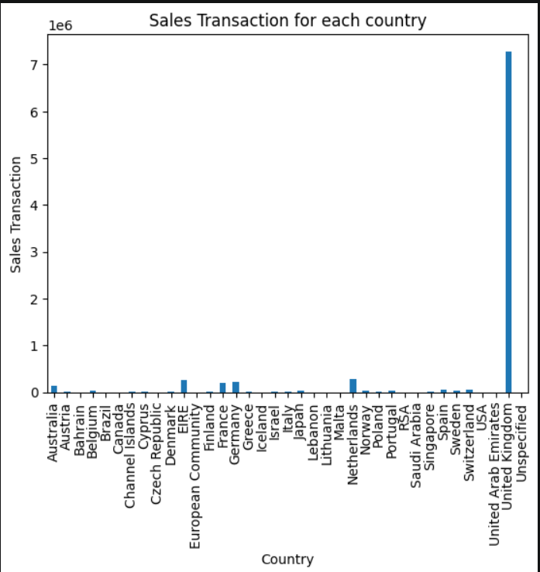

Fig 3: Bar chart showing sales transaction from each country
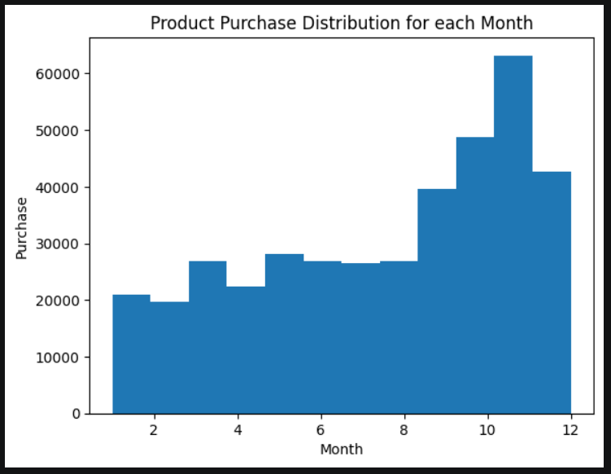
Fig 4: Histogram chart showing product purchase distribution for each month
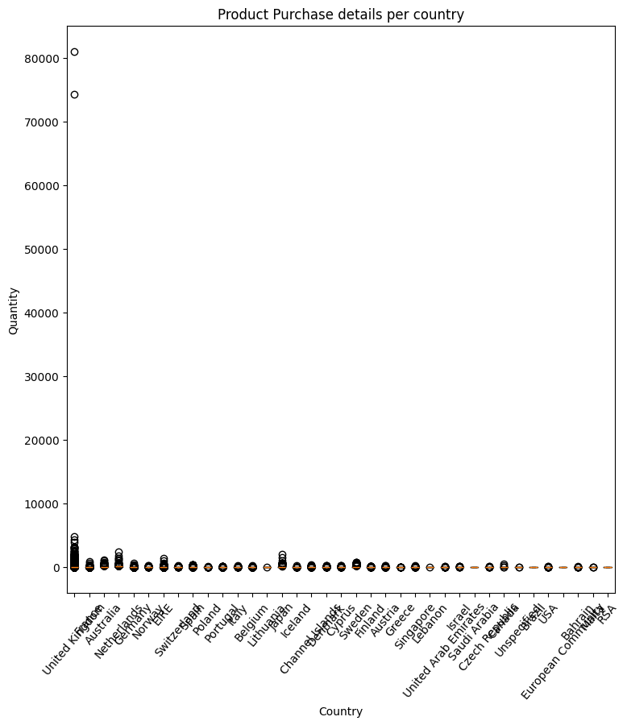
Fig 5: Box plot showing product purchased details for each country with an outlier only in 1 country
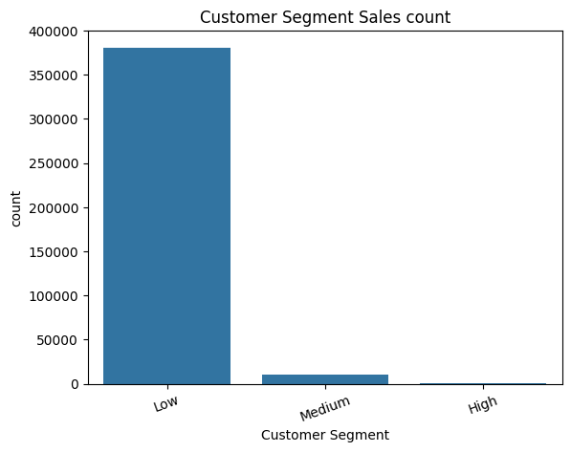
Fig 6: count plot chart showing the details of sales count segregated in terms of customer (Low, Medium, High) on the basis of product purchased aspect

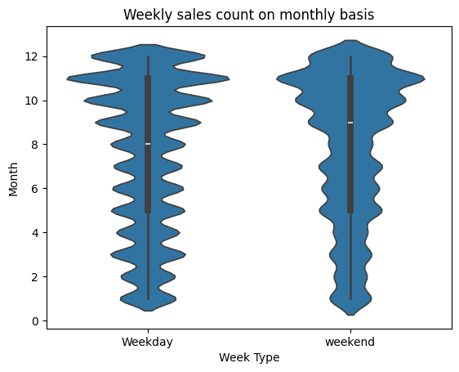
Fig 7 this violin chart showing about weekly sales count more either in week days or weekend on monthly basis
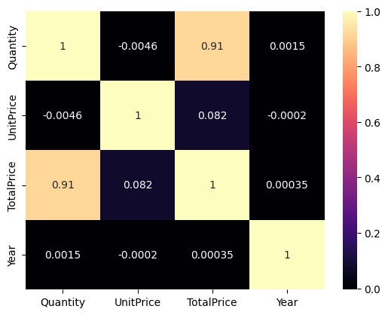
Fig 8: Heat map chart talks about correlation relationship among Quantity, unit Price, total price and year
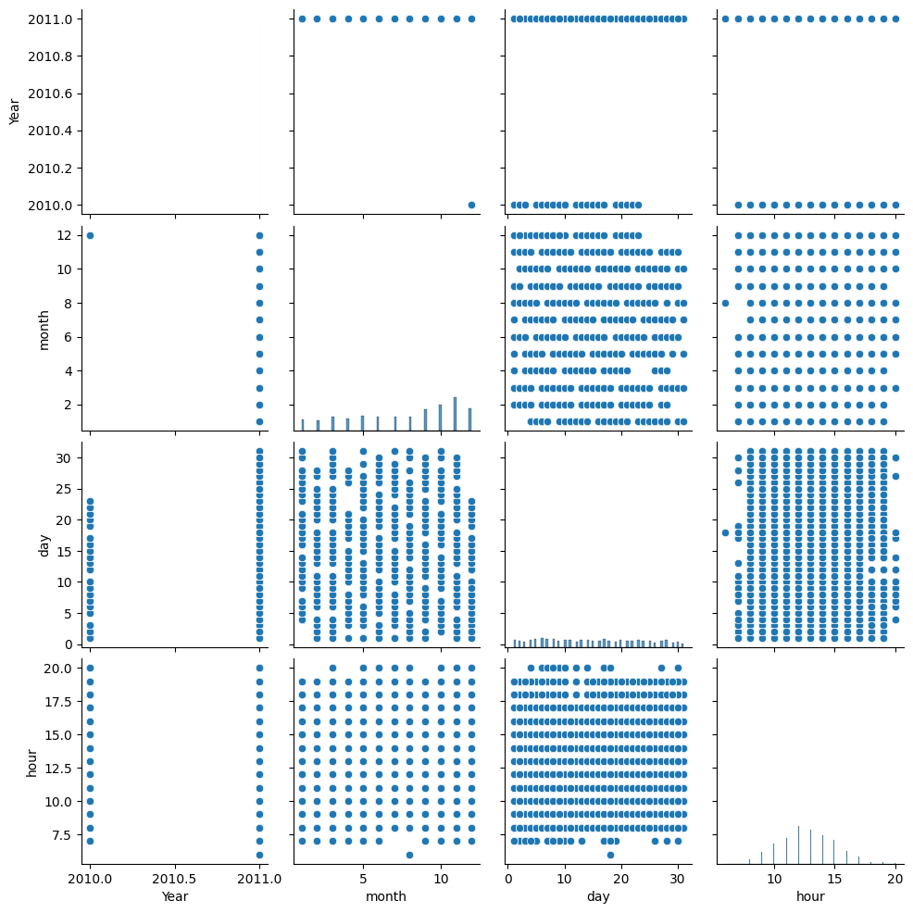
Fig 9: This pair plot talks about relationship about year, month, day and hour

