AWARENESS OF M-APPS FOR USERS IN DIGITAL ERA
Anil Kumar Jharotia
Librarian, Tecnia Institute of Advanced Studies,
Email: aniljharotia@yahoo.com

ABSTRACT
In this 21st century Library and information science professional’s essentially to use mobile technology in libraries and this new technology offering outreach technical options for librarians. Libraries have the well opportunity to extend new different types of library services to users. This study is a new platform for reaching students and faculty members. This paper focuses on mobile apps. The benefits of M-Apps use in higher education generally and particularly effective utilize in libraries and library services. The mobile apps have changed the way one connects and interacts with the world and mobile library services can meet people's needs for information in a fast-paced society.

Keywords: M-Apps, Mobile Technology, Library Service, M-Learning, Smartphone.

INTRODUCTION
In today’s competitive world, people are making use of mobile apps to stay in touch with their favorite brands. Whether it is their smartphone or tablet, mobile apps offer all the information to potential customers in an easy way. Regardless of what business you do, mobile apps are useful in getting new customers while retaining the old customers. Being available online round the clock will be a big boost for business and library service. It will be an added advantage, if the information is available in the form of mobile apps. With different mobile apps developed for platforms like – Android and iOS, you can create brand awareness among huge number of new and existing customers and users.
Today information and communications technology becoming portable and individual oriented. We are experiencing the first level of effective mobile learning as it was envisioned decades ago. As a result of the dedicated work of the mobile learning community in recent years we have witnessed an explosion in the growth of mobile learning across all sectors of education. M-learning or mobile learning is defined as learning across multiple contexts, through social and content interactions, using personal electronic devices. A form of distance education, m-learners use mobile device educational technology at their time convenience. M-learning technologies include handheld computers, Mp3 players, notebooks, mobile phones and tablets. M-learning focuses on the mobility of the learner, interacting with portable technologies. Using mobile tools for creating learning aids and materials becomes an important part of informal learning. M-learning is convenient in that it is accessible from virtually any where. Sharing almost instantaneous among everyone using the same content, which leads to the reception of instant feedback tips? M-learning also brings strong portability by replacing books and notes with small devices, filled with tailored learning contents.
Significantly, mobile devices are revolutionary because they transcend the boundaries of the structural stasis of classrooms and lecture halls and their associate modes of communication they do not have to be confined to one particular place in order to be effective. The evolution of handheld portable devices and wireless technology has resulted in radical changes in the social and economic lifestyles of modern people. Today, many technological devices are produced in portable form and people have become accustomed to them. These devices are reshaping user’s daily lives in different ways. Advanced mobile devices such as “smart” cellular telephones are very popular among people primarily because they are wireless and portable. These functionalities enable users to communicate while on the move. The popularity of these devices is therefore a consequent of their ability to function at multiple levels. Moreover, the intense commercial competitiveness in the mobile device industry is forcing manufacturers to be very innovative constantly striving to introduce new features that can give a competitive edge. But the development of digital technologies has so far been limited to social communication and few people have regarded mobile learning as a core pedagogical acidity in higher institutions of learning. Although this model has been used as a miner adjunct to learning activities such as lectures and assignments, it is still not the primary mode of delivery in higher education. Currently the, the instructional technology transmitted by them means of mobile technology is mainly social and to a lesser extent, economic.
OBJECTIVE

The objective of this paper is to shows the major library and information services provided by using mobile apps and technology to satisfy the information needs of variant users. Mobile learning is the ability to obtain or provide educational content on personal pocket devices such as PDAs, smart phones and mobile phones. Educational content refers to digital learning assets which included any form of content refer to digital learning assets which included any form of content or media made available on a personal device.
MOBILE DEVICES IN LIBRARY AND INFORMATION SERVICES
Today access information is has become vital. Now a day mobile phone is a part of human body without it life may not be survive. Mobile technology is playing very significant role in user’s information seeking behavior in such a way teaching, learning and research works as per users need.
Electronic textbooks: E-readers and tablets have new features that allow students to highlight and add annotations to the text, just as they would with paper texts. They give students the capability to link to additional information.
E-readers: Due to the popularity of Amazon’s Kindle and Barnes & Noble’s Nook. The latest generation takes content delivery to new levels, allowing for wireless browsing, purchasing, and delivery of content through these devices.
MP3 players: An iPod, iPhone or other MP3 player mobile devices can use in library for audio and/or video tours. With an iPod or MP3 player, users can explore the library at their convenience, concentrating on the parts of the collection most relevant to their needs.
Mobile Phones: The mobile phones are not only a phone portal to mobile outreach. Library and information professionals who used more traditional cell phones can consider text reference for their mobile outreach programs. With Google Voice and library-based options such as MyInfoQuest and Mosio’s Text a Library and information professionals can set up a text reference service that can help in handle ready reference questions or even more complicated questions quickly and easily.
Tablets: Tablets or Tablet PCs can be used in various activities for example searching databases, downloading articles, and perusing the catalog either through apps or tablet-formatted websites. The overall utility of tablets also makes them an ideal device for accessing a variety of documents, including e-books, e-journals and e-databases etc. Their ability to play audiovisual materials and their web connectivity could signal a new form of academic text that is both immersive and interactive. Tablets can also use on-the-spot reference services. The user can access the library’s resources conveniently through tablets while away from the reference desk. The design of the recent generation of tablets with Flash web technology can provide accessing some websites, especially video sites.
MOBILE APPS
App is the abbreviated form of the word “Application”. An application is a software program. It is designed to perform a specific function directly for the users. A mobile app is a computer program designed to run on smart phones, tablet computers and other mobile devices. The basic types of apps are
- Native app
- Hybrid app
- Web app
MAJOR M-APPS
Mobile applications are move away from the integrated software system. Each app provides limited and isolated functionality such as social networks, education, games, online commerce, calculator, map set. These M-Apps users can free download from ‘Google Play’ store in smartphone.

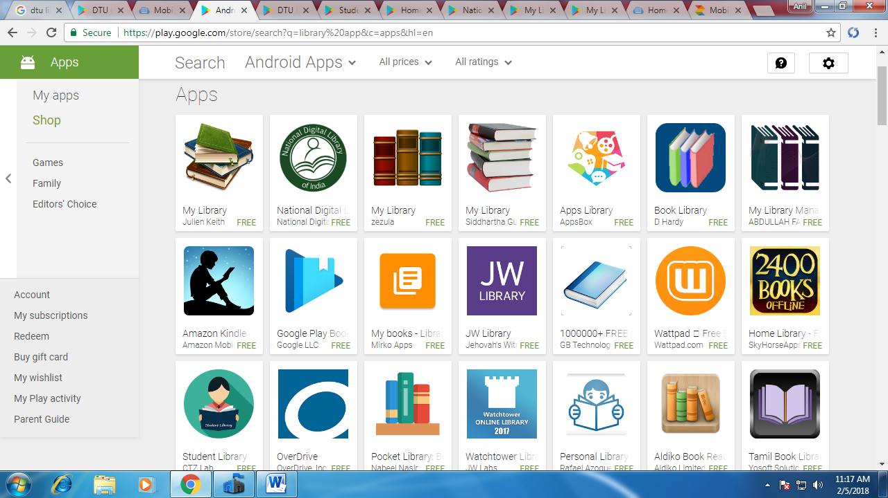
Fig.1 Major M-Apps available in ‘Google Play’
Home Library App
Home Library is a very convenient software application for reading books which contains over 2,400 classic works of English literature and covers almost all genres: fiction, philosophical treatises, opinion journalism, memoirs, children's books and others.
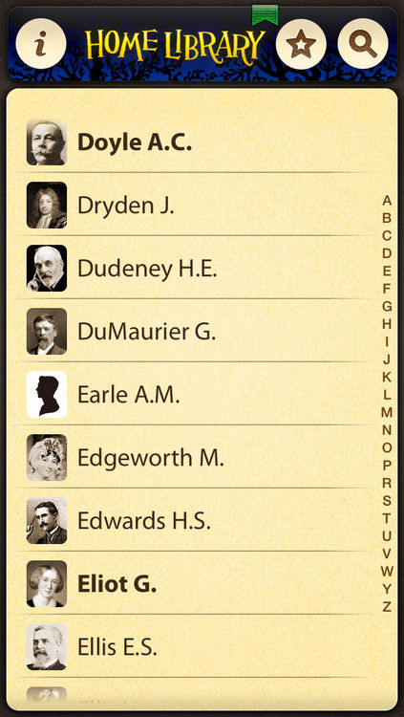
Fig.2: Home Library-Apps available in ‘Google Play’
Now you can search a book through many databases on the web just download our app and you will always have a massive e-book collection of the best English-language writers within reach! In the list of 370 authors you will be agreeably surprised to find not only the famous names like Charles Dickens, Arthur Conan Doyle, O. Henry, Jack London, Edgar Allan Poe, Robert Louis Stevenson, Mark Twain, but many, many others. User can free download this M-App from Google Play store for free eBooks.
Student Library App
This M-App is available on Google Play. Users can free download this app in smartphone. Users can check study resources online and download and share it through smartphone.
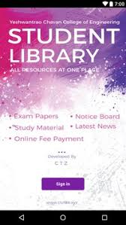
Fig.3: ‘Student Library’ Apps available in ‘Google Play’
National Digital Library M-App
Ministry of Human Resource Development under its National Mission on Education through Information and Communication Technology has initiated the National Digital Library of India (NDLI) pilot project to develop a framework of virtual repository of learning resources with a single-window search facility.
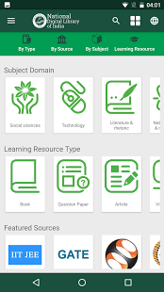
Fig.4: Mobile App: National Digital Library
Filtered and federated searching is employed to facilitate focused searching so that learners can find out the right resource with least effort and in minimum time. Users can free download NDL App for smartphone through Google App.
My Library App
My Library is a simple application that helps you to manage your library at books.google.com. My Library main features are:
• Adds/removes books from your books.google.com shelves
• Creates a shelf that shows personalized recommendations to you
• Enables to download pdf of books in public domain
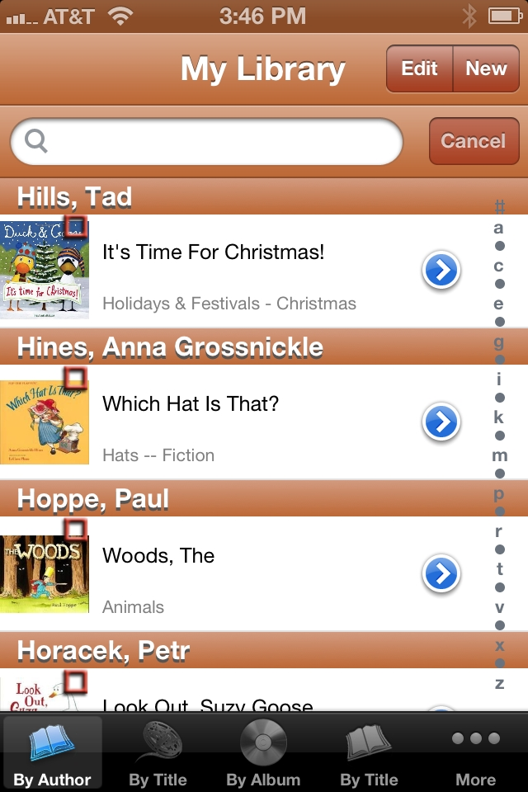
Fig.5: My Library App
• Support for tablet devices
• Utilizes the phone's camera to scan a barcode
Google Maps
Google Maps is a mapping mobile app developed by Google for the Android and iOS operating systems; it uses Google Maps for its information. It was first released for Android on September 23, 2008, and later for iOS on December 13, 2012 as an alternative to Apple Maps.
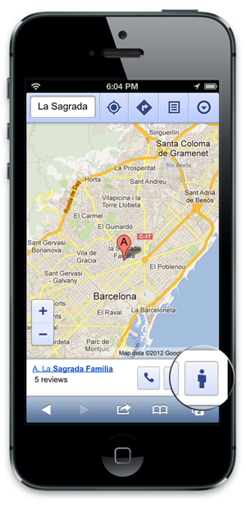
Fig.6: Google App on Mobile
Google Maps app help to users to find required location so many users used this app during search any place.
Duolingo
Duolingo is the fantastic language learning tool. It is totally and completely free app. This app offers six languages Spanish, Italian, English, Portuguese, German and French. Once we select the language want to learn it presented with a learning of tree sorts.
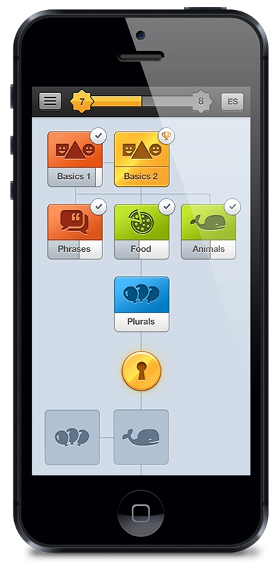
Fig.7: Duolingo App on Mobile
They provide lessons which you want learn and go through in the first form of tests. These tests are consists of questions.
Drop box
More so a tool of organizing your education than receiving it, Drop box allows you to access all your photos, documents, and videos on nearly any device.
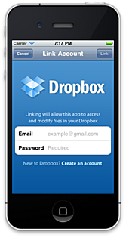
Fig.8: Dropbox App on Mobile

Your are given 2GB upon signing up with options for syncing and adding files to your favorite list for offline viewing on the go it’s very useful for sharing files.
Earth viewer App
Earth viewer is one of the coolest app it serves as a time machine to explore the geographical history of world. There is 3D images of earth that you can see swerve and zoom in and out form in order to look closely in the land formations and the natural structures of countries. We particularly linked looking through the interactive charges and data on temperature of countries. It shows world temperature map for the last 100 years and using the map we can see locations of modern cities tracked back over 500 million years.
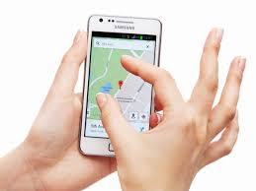
Fig.9 Earth Viewer App on Mobile
This app is a product of the Howard Hughes medical institute which is a nonprofit medical research organization. This app also has chronicles geological and biological events, fossils and impact events.
My open courses App
My open courses is an official partner of NPTEL, an initiative funded by NMEICT, ministry of HRD, Govt. of India at bringing education to every student with the use of technology. My open courses app is the similar to the Coursera app. It is presented with a list of categories in the left hand panel. The categories are many ranging from engineering and science to humanities and design. Once we select the category it will present a list of lectures and the professor who is taking them. My open courses offer over 11,000 hours curriculum based videos on Engineering, Management and other streams completely free of cost.
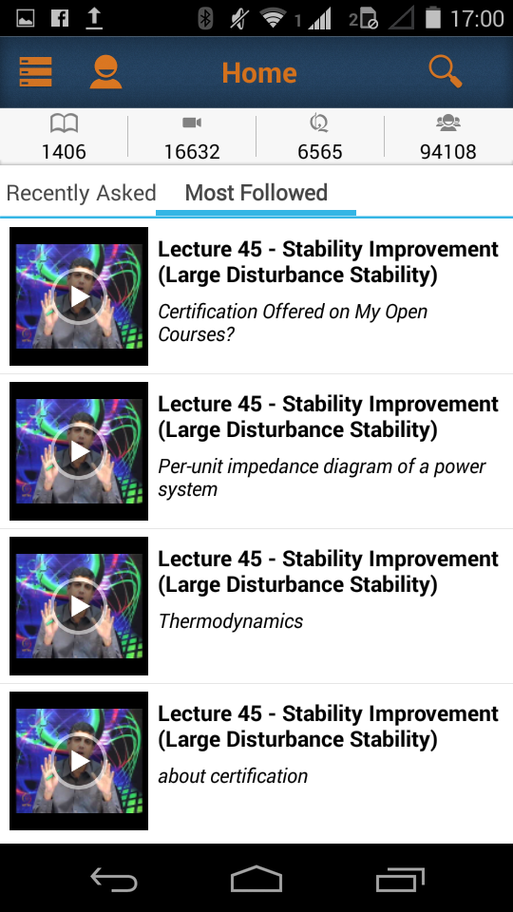
Fig. 10: My open courses App on Mobile
My open Courses videos are accompanied by subject notes assignments and reference material that will help students to have a complete overview of the subject. The student watching the videos ahs any doubt with regards to the subject, they can easily ask questions to hundreds of subject matter experts available on the platform. Viewing the videos does not require registration.
Benefits of Mobile Apps
Many businesses are building their own mobile apps and there are many reasons why they invest in mobile apps in a digital era to right strategies in place for online marketing.
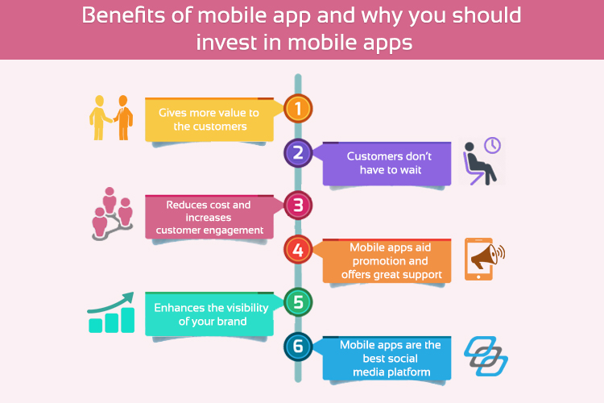
Fig. 11: Benefits of M-Apps
Owning a mobile app for your business is probably the most rewarding solution to give an edge over competitors. The world has shifted from desktops to smartphones, and is offering tremendous ROI.
Mobile apps are great way to reach out potential customers. You can enhance the experience of your customers by building the best mobile app. Some of the benefits of a mobile app are:
- Many companies that use their mobile apps to their advantage by offering rewards to the app subscribers. This will eventually motivate the customers to buy their products. If you already have one such program, you can integrate it into your mobile app.
- Mobile apps provide a faster and easier alternative to web browsing. The user needs to launch a web browser and enter the URL and wait for the site to load for accessing the business website. On the contrary, mobile apps are quick and take only a few seconds to launch.
- Mobile apps are very convenient for customers and users, as they are usually designed with usability in mind. The benefits of mobile apps are even greater when businesses decide to develop a custom mobile app with more flexibility and features.
FUTURE POTENTIALS OF M-APPS IN THE LIBRARIES
More and more changes are expected within four to five years in the field of mobile technology and its application to the libraries, the day is not far when we will use phone to read barcodes or RFIDs in the library and OPACs will develop GIS sensitivity and be able to communicate with users through their mobiles for holds, fines, late notices, alerts, etc.
CONCLUSION
Today, almost all the business processes has become virtual. Hence, there is an ever growing need of mobile app. If you want to provide better service to your customers, you should consider investing in the best mobile app development. With the rising popularity of mobile apps, it is worth for every business to invest in mobile app development. Mobile technology has become boon to the libraries. A library may reach the remote users effectively by adopting of mobile apps and mobile technology in its services. Mobile phones are inevitable tools for information communication. Human beings in a society use mobile phone to communicate thoughts, facts, conversations, in general, information. The dissemination of processed information is a common factor in a civilized society. Mobile technology is fast becoming the preferred method for connecting to the internet, especially for people on the go. Library professionals must keep pace with this trend and integrate themselves into the mobile realm if they wish to deliver enhanced user services.
REFERENCES
[1] Jharotia, Anil Kumar (2015). Mobile Applications and Technologies for Libraries: An Overview, International Conference on “Knowledge Organization in Academic Libraries” (I-KOAL 2015) held on 2-3 Jan. 2015 at Manipal University Jaipur, pp.155-170.
[2] Jharotia, Anil Kumar (2017). Mobile Apps for Users: An Innovating Technology, International Conference on “Global Business and Innovative Management: Challenges & Issue” held on 14-15 April. 2017 at TIAS, pp.171-181.
[3] Jharotia, Anil Kumar (2017). National Digital Library: An Initiative Digital India, Proceeding “Divyans and Digital India: Opportunity & Challenges”, pp.56-59.

[4] Kumari, C. and Harilakshmi, N. (2016). Education apps for mobile learning: a study, proceeding NCIET-16 pp.30-33.

Web References
Mobile apps information retrieved from:
- https://en.wikipedia.org/wiki/Google_Maps_(app)
- http://play.google.com/store/apps/details?id=gov.science360.radio.
- http://play.google.com/store/apps/details?id=example.matharithmetrics
- http://itunes.apple.com/in/app/history-maps-of-world/id303282377?mt=8
- http://secungbin.wordpress.com
- http://www.coursera.org
- http://www.hhmi.org
- http://play.google.com/store/apps/details?id=mobile.application.forfree.earth
- http://play.google.com/store/apps/details?id=com.medscape.android
- http://www.educationappstore.com/coursera.
- http://www.duling.com/
- http://en.wikipedia.org/wiki/duolingo
- http://nicolehennig.com/mobile-apps-news/
- https://play.google.com/store/apps/details?id=com.skyhorseapps.homelib_en_free
- http://rtmonline.in/proceedings/ncite-2016/ncite-2016-pview.pdf
- http://www.businessofapps.com/mobile-app-benefits/
- https://search.proquest.com/openview/4697d8be4c5d4552ae38b9d6ad019f96/1?pq-origsite=gscholar&cbl=1246355

