Trader Behavior & Market Sentiment
An Analysis of Hyperliquid Trading Performance Against the Bitcoin Fear & Greed Index
PrimeTrade.ai Data Science Assignment | Prepared by Candidate Submission

Executive Summary
This report examines whether Bitcoin market sentiment (Fear & Greed Index) is associated with measurable differences in trader performance on Hyperliquid, using ~211,000 trade records from 32 accounts spanning May 2023 to May 2025, merged with the daily sentiment classification.
The headline finding is a non-linear, 'W-shaped' relationship: traders perform best during Fear and Extreme Greed, and worst during Extreme Fear and (plain) Greed. Overall trading activity — trade count, volume, and number of active accounts — rises as sentiment falls, indicating traders are more active, not less, during fearful markets. The single largest loss events in the dataset cluster on Greed days, pointing to overconfidence-driven risk-taking as a key failure mode.

1. Dataset Overview
Two datasets were merged on calendar date:
- Bitcoin Fear & Greed Index: daily sentiment score (0–100) and classification (Extreme Fear, Fear, Neutral, Greed, Extreme Greed), Feb 2018 – May 2025.
- Hyperliquid Trader Data: 211,224 individual trade executions across 32 accounts and 246 coins, with execution price, size, side, direction, closed PnL, and fees.
Date coverage between the two datasets was effectively complete — only 1 of 480 trading days in the trader dataset lacked a matching sentiment record. Roughly half of all trade rows (50.6%) record a Closed PnL of exactly zero; these are position-opening trades (Open Long / Open Short), so performance metrics below focus on the ~104,000 realized (PnL ≠ 0) trades unless otherwise noted.

2. Performance by Market Sentiment
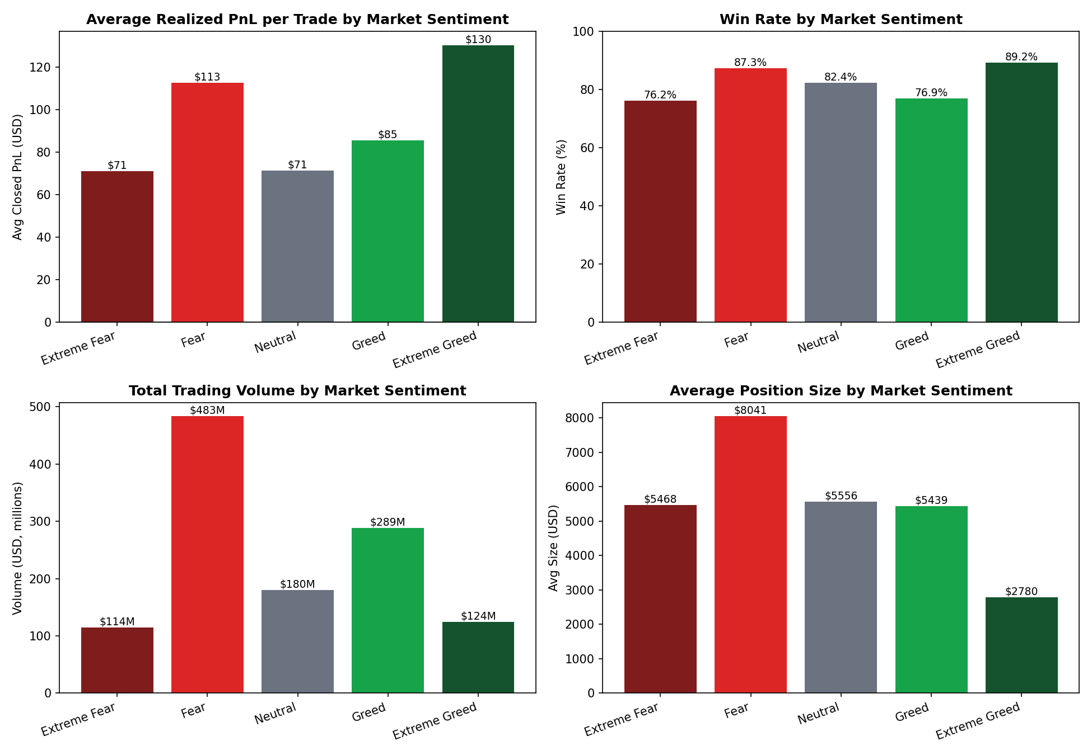
Figure 1: Average realized PnL, win rate, total volume and average position size across the five sentiment regimes.
Sentiment | Trades | Win Rate | Avg PnL/Trade | Total PnL | Volume | Avg Size | Profit Factor
Extreme Fear | 21,400 | 76.2% | $34.54 | $739K | $114M | $5,350 | 2.16
Fear | 61,837 | 87.3% | $54.29 | $3.36M | $483M | $7,816 | 6.66
Neutral | 37,686 | 82.4% | $34.31 | $1.29M | $180M | $4,783 | 4.32
Greed | 50,303 | 76.9% | $42.74 | $2.15M | $289M | $5,737 | 3.03
Extreme Greed | 39,992 | 89.2% | $67.89 | $2.72M | $125M | $3,112 | 11.03

Key observations:
- Best regimes: Extreme Greed (89.2% win rate, profit factor 11.0) and Fear (87.3% win rate, profit factor 6.7) produced the strongest and most consistent trader outcomes.
- Weakest regimes: Extreme Fear (76.2%) and plain Greed (76.9%) had the lowest win rates and profit factors — both roughly a third of the Extreme Greed figure.
- Fear days saw the largest average position size ($7,816) and by far the highest trading volume ($483M, ~35% of total volume) despite being only one of five categories — traders lean in hardest during fear, and it pays off on average.
- Extreme Greed trades are the smallest on average ($3,112) yet the most reliably profitable, suggesting disciplined, smaller-size trend-following rather than reckless leverage-chasing at euphoric tops.

3. Sentiment vs. Trading Activity Over Time
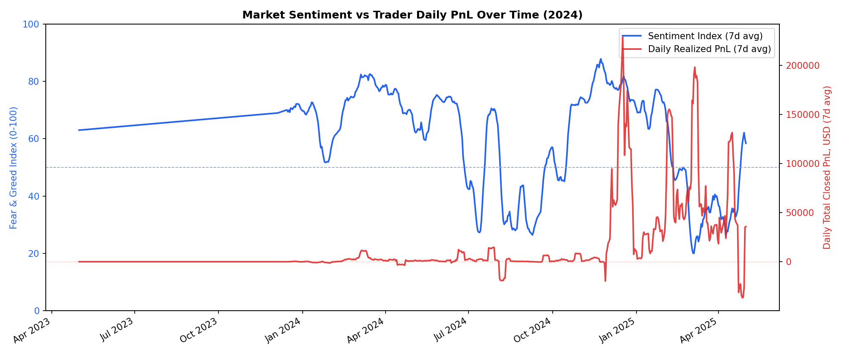
Figure 2: 7-day rolling Fear & Greed Index (blue, left axis) vs 7-day rolling daily realized PnL (red, right axis).
Daily-level correlations between the sentiment score and activity metrics are consistently negative:
Metric | Correlation with Sentiment Value
Daily trade count | -0.245
Daily volume | -0.264
Active accounts | -0.278
Daily total PnL | -0.083

Trading activity (volume, trade count, and number of active accounts) rises as sentiment falls toward Fear/Extreme Fear. This is consistent with fear-driven markets prompting more frequent repositioning, while daily aggregate PnL shows only a weak relationship with sentiment — the strong pattern only emerges once regimes are separated into the five discrete buckets (Section 2), because the relationship is non-linear (W-shaped) rather than a simple trend.

4. Risk Behavior: Profit Factor, Direction Bias & Tail Events
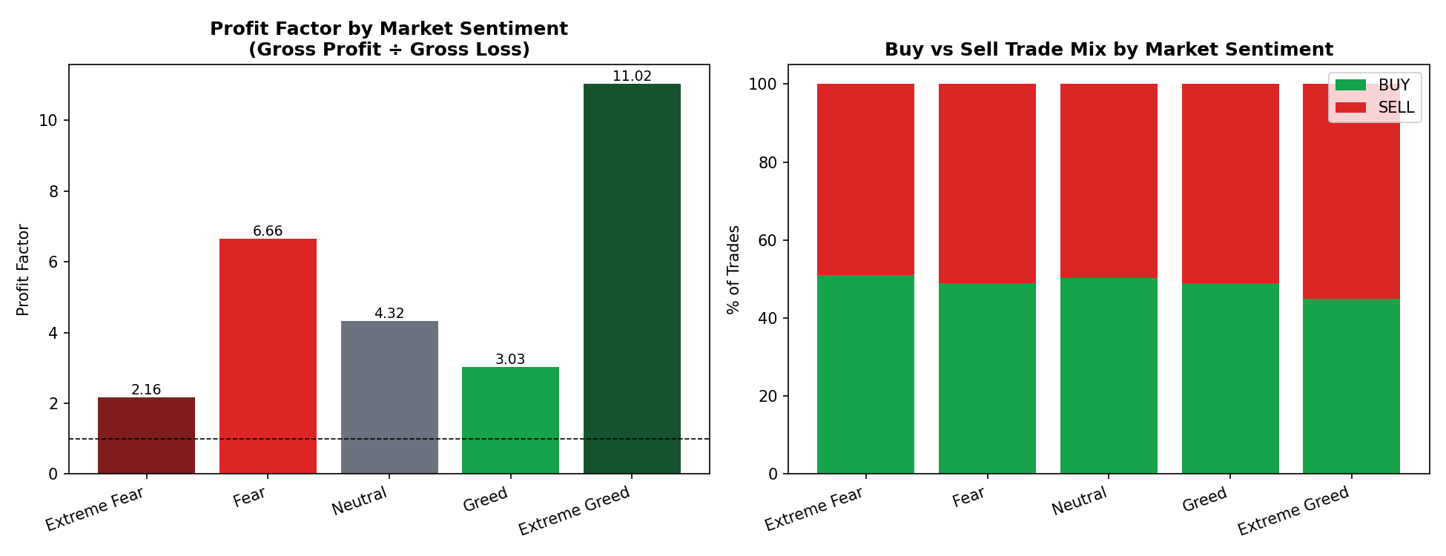
Figure 3: Profit factor (left) and Buy/Sell trade mix (right) by sentiment regime.
The profit factor chart sharpens the same W-shaped pattern seen in win rates: Extreme Greed (11.0) and Fear (6.7) are dramatically more favorable than Extreme Fear (2.2) or Greed (3.0), meaning that for every $1 lost in the weak regimes, only $2–3 was won back on average, versus $6–11 in the strong regimes.
Sell-side trades modestly increase as sentiment shifts from Extreme Fear (48.9% sell) to Extreme Greed (55.1% sell) — consistent with traders taking profit / fading strength into greedy markets and buying more into fear.
Tail-risk events are concentrated in Greed conditions:
- The single largest loss in the dataset (–$117,990 on ETH) occurred on a Greed day (Dec 6, 2024).
- A single account lost over $184,000 across four TRUMP trades — including the dataset's only forced liquidation — all on one Greed day (Apr 23, 2025), a textbook overconfidence/over-leverage blowup.
- By contrast, six of the ten largest single-trade gains occurred during Fear or Extreme Fear, reinforcing that contrarian entries during fear were disproportionately rewarded.

5. Trader & Market Composition
32 unique accounts traded 246 different coins. BTC alone accounted for $644M of the ~$1.19B total volume (54%), followed by HYPE ($142M), SOL ($125M) and ETH ($118M) — the market is heavily BTC-led with a long tail of altcoin speculation.
Profitability was broad but not universal: of the 32 accounts, between 21 and 27 were net-profitable in any given sentiment regime (roughly 65–85%), with Greed and Fear regimes having the highest count of profitable accounts (27 and 26) and Extreme Fear/Neutral the lowest (21 each) — again pointing to Extreme Fear and (to a lesser extent) plain Greed as the regimes where more traders struggle.

6. Strategic Recommendations
- Lean into Fear, size normally into Extreme Fear: Fear days combine high win rate, high profit factor, and the largest average position sizes — the data supports treating Fear as a favorable, not merely 'brave', entry regime. Extreme Fear, however, has the weakest profit factor of all regimes (2.16) — capitulation days warrant smaller size and wider stops, not maximum conviction.
- Treat 'Greed' (non-extreme) as the highest-risk regime for overconfidence: it hosts the largest single loss and the only liquidation in the dataset, alongside a below-average win rate. Position-size discipline and stricter stop-losses are most valuable specifically here — not at extreme euphoria, where traders in this dataset were actually more disciplined (smallest average size, highest win rate).
- Use Extreme Greed for trend-following with tight risk: the 89.2% win rate and 11.0 profit factor with the smallest average size suggest a 'ride the trend, take profit fast' approach is working well and should be preserved, not abandoned, as euphoria builds.
- Watch activity spikes as a contrarian signal: since trade count and active-account participation rise as sentiment falls, an unusual spike in trading activity may itself be a leading indicator of a fear regime, useful for tactical positioning ahead of the official index update.
- Add per-account leverage/position-limit monitoring: a small number of accounts drove the largest tail losses. A concentration or leverage-limit alert during Greed conditions specifically would likely have prevented the worst drawdown event in this dataset.

7. Methodology Notes & Limitations
- Closed PnL of exactly $0 was treated as a position-opening event (not a losing trade) and excluded from win-rate/profit-factor calculations; including these zero rows in an 'all trades' PnL sum is still valid and shown separately in Section 2.
- Only one explicit liquidation event is tagged in the 'Direction' field; actual forced-close events may be under-represented if the exchange records them under generic Close Long/Close Short entries.
- The dataset covers 32 accounts only — likely proprietary or invited trader wallets rather than the full Hyperliquid user base — so findings describe this cohort's behavior, not the broader market.
- Correlation figures in Section 3 are daily-level Pearson correlations on aggregated data; the discrete-regime breakdown in Section 2 is the more informative view given the non-linear relationship observed.

