**PROJECT -3**

PROBLEM-1:

Files for creating the points dataset and the seeds dataset are written in java

KMeans is done using Hadoop 1.1.0.

Map-Reduce Code is written in java

PROBLEM-2:

This is done using RHadoop

Plots are shown below:

1. Plot the output where country codes on the x-axis, and the count on the y-axis

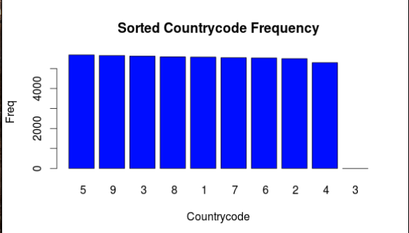

1. Sort the output descending based on the count, and re-plot the chart

