Enzyme provides the testing utility functions for React components such as **shallow**, **mount** and **render** whereas Jest is a test runner and an assertion library. Without Jest, there is no way to run Enzyme tests.

UNIT TESTING

Unit tests for UI, COMPONENTS, LOGIC 15-20 NO DUPLICATES

FOR REACT REACT-REDUX REDUX TYPESCRIPT AND SAGA

* React Testing Library is the most popular and very lightweight library to write test cases for React components.
* jest-dom is an associate library for the Testing Library that provides custom DOM element matchers for Jest.
* Both packages are pre-installed when you create an application using the create-react-app package.

Unit test using React Testing Library

1. Create a react application

npx create-react-app test-react-app

2. Create any application (App.js)

3. Write test cases for the App.js component. We have configured the application through the create-react-app so we don’t need manual installation for React Testing Library. You can install the jes-dom and react-testing-library for the manual configuration.

Here, we will use the **describe method for the grouping the test cases** and **test method to describe the case.**

We will test the following use case for the App.js component.

1. render the title of an application

Assert - The title should be in the document

1. render the Created By text

Assert - The Created By text should be in the document

1. render the Created By link

Assert - Created By link should have a title attribute, a href attribute with a value

1. render initial counter text

Assert - Counter text should have counter class with 0 value

1. render buttons

Assert –

The Increment button should be in the document with “Increment” text

The Decrement button should be in the document with “Decrement” text

Here, we will use the render and screen methods to load and query the element in the dom for testing.

4. Output

npm test

**How to test an input field using the React Testing Library.**

Here we will use the userEvent.type() method from the @testing-library/user-event npm package.

USE OF TESTING

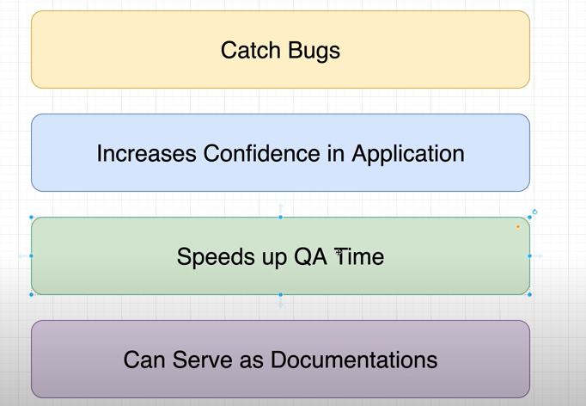

TYPES OF TESTING

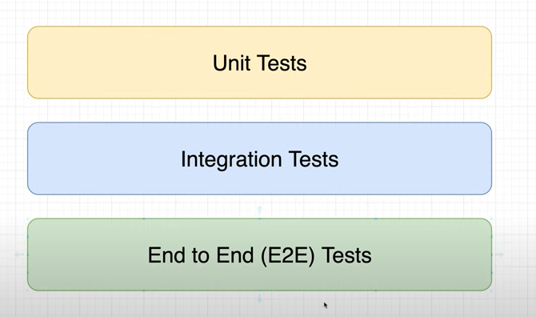

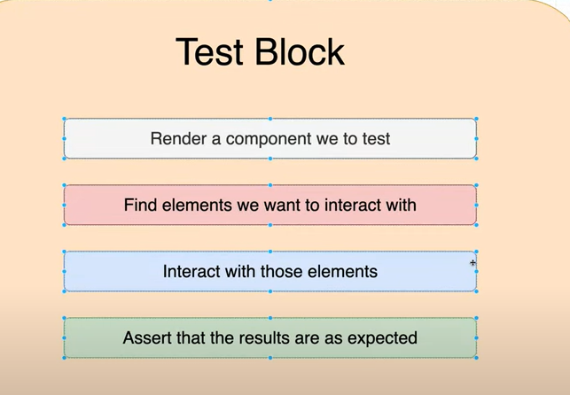

QUERY METHODS

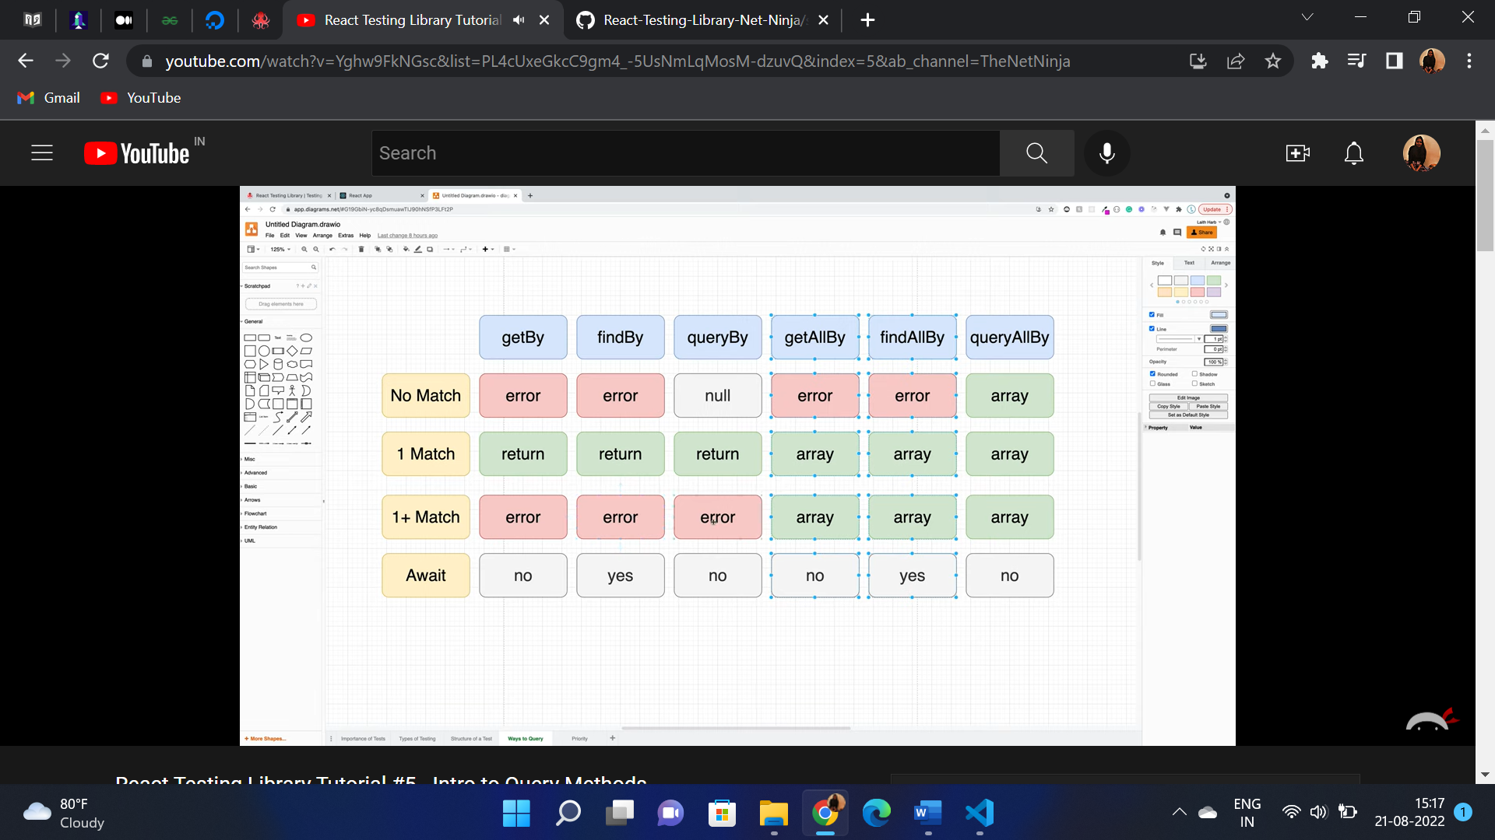

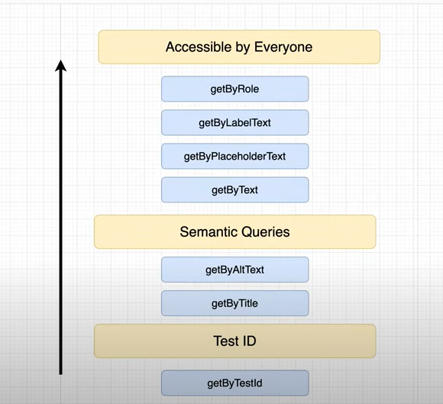

ASSERTIONS

FIRE EVENTS

INTEGRATION TESTS