|  |  |  |  |  |  |
| --- | --- | --- | --- | --- | --- |
| Programme | : | **B.Tech** | Semester | : | **WS 2020-2021** |
| Course | : | **Database Management Systems (Embedded Lab)** | Code | : | **CSE2004** |
| Faculty | : | **Dr. M. Braveen / Dr. M. Rajesh** | Slot | : | **L33 + L34** |
| Reg. no. | : | **20BCE1359** | Name | : | **Gayathri Sathish** |



1. DDL Commands
2. Create a table for a student, with register number, programme, name, email id, date of birth, city and cgpa as attributes.



1. Add mobile number attribute to student relation and describe the structure

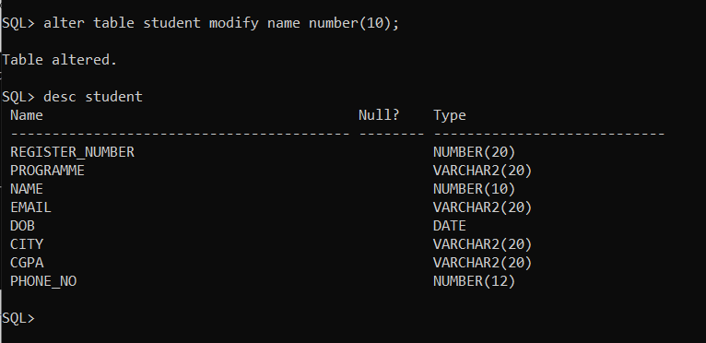

1. Change the data type of name in student relation and describe the structure

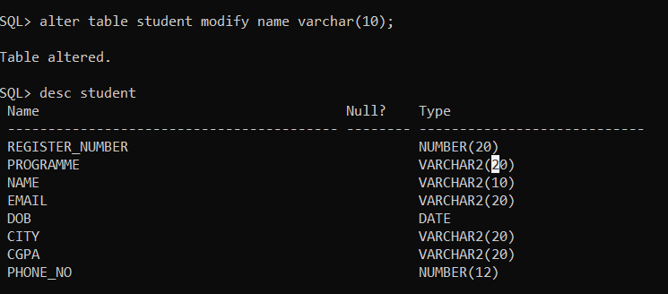

1. Change the size of any attribute and describe the structure

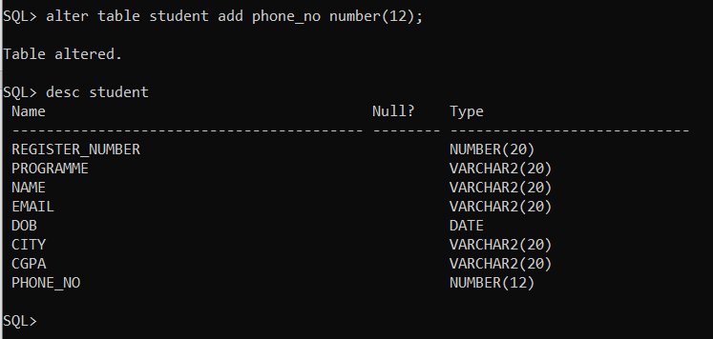

1. Rename the any of the attribute as in student relation and describe the structure

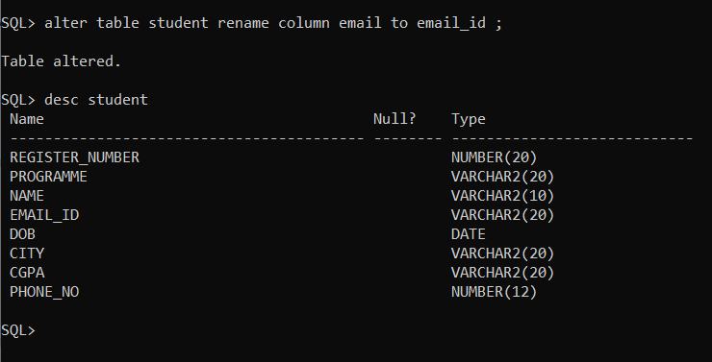

1. Insert 7 records to student relation.

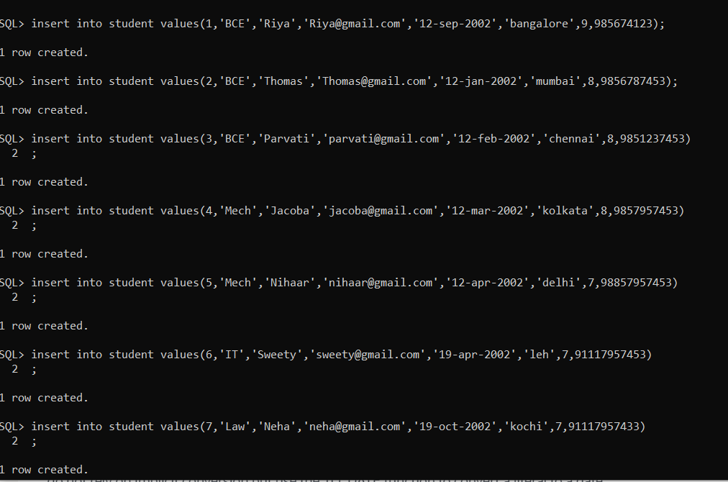

1. Copy the contents of student table and name the table as stud relation.

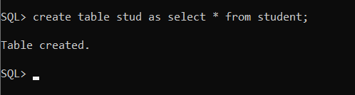

1. Delete the email id attribute from stud relation and describe the structure

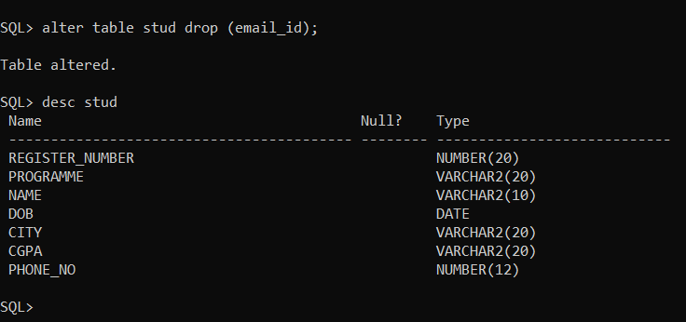

1. Display the contents of the stud relation

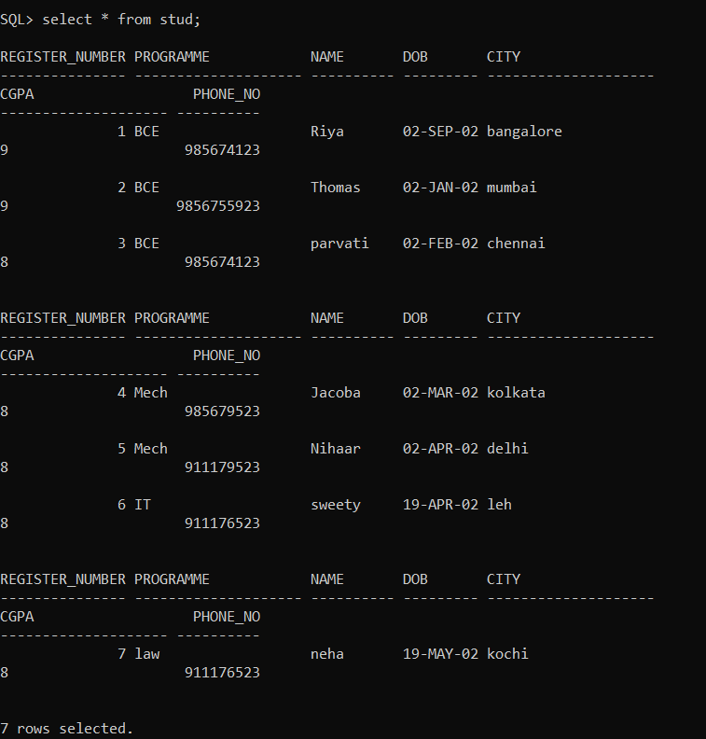

1. Rename the *stud* relation as *stu*

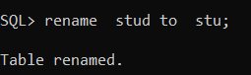

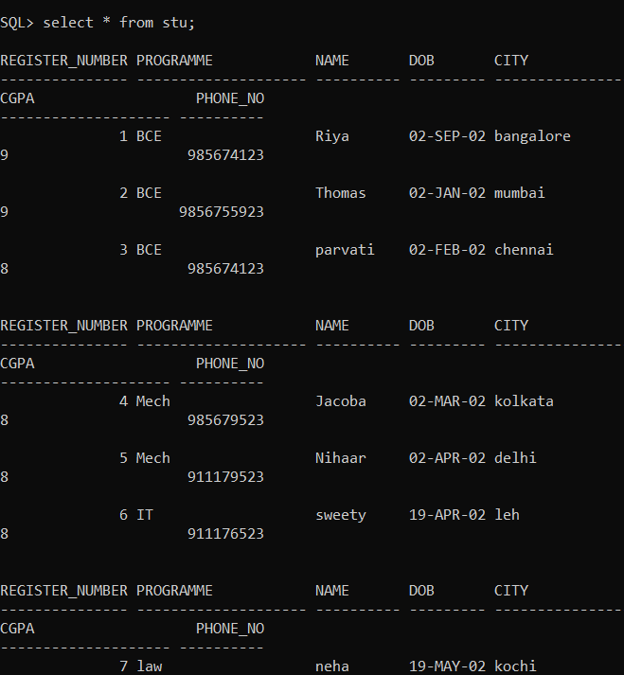

1. Delete the contents of stu relation, describe the structure and display the contents of the table

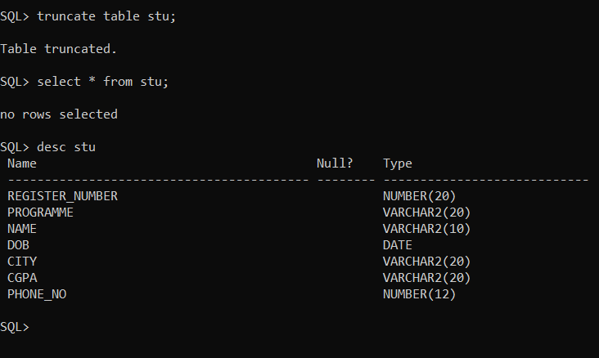

1. Delete the structure of stu relation, describe the structure and display the contents of the table

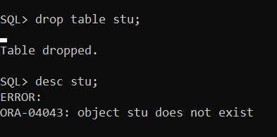

1. DML Commands:
2. List the records of student relation.

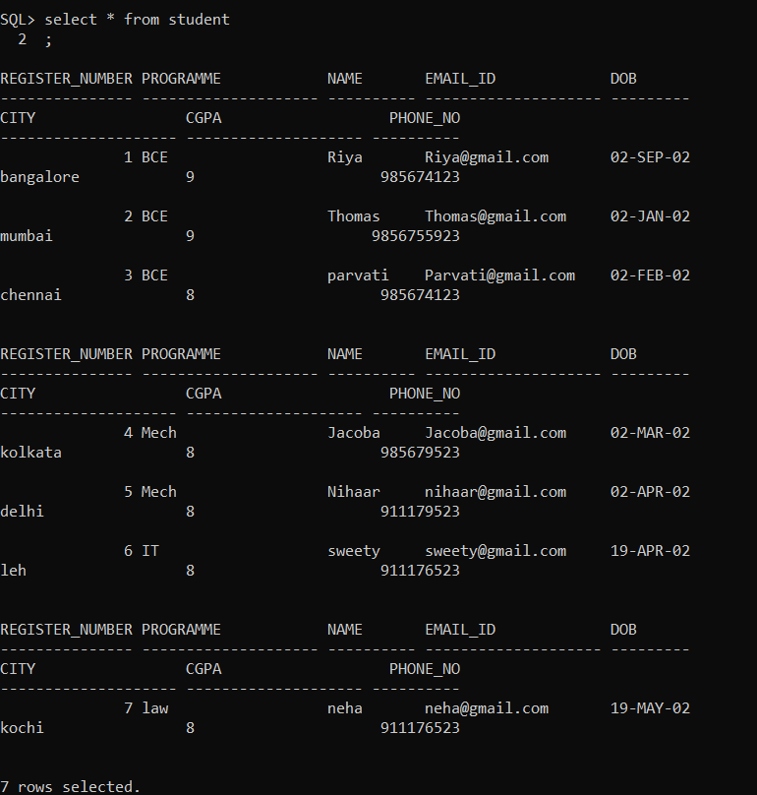

1. List all student details whose cgpa is > 8

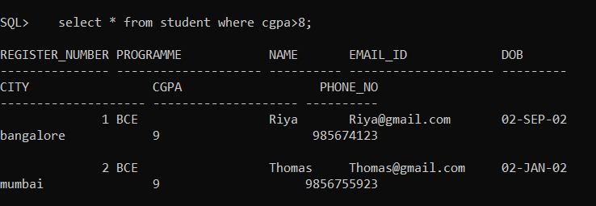

1. List the name of the student whose date of birth is ’01-march-2000’

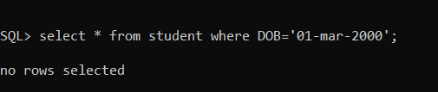

1. List the student’s details who are from Delhi and doing CSE.

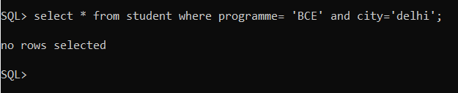

1. List the student’s details who are either from Delhi or from Chennai.

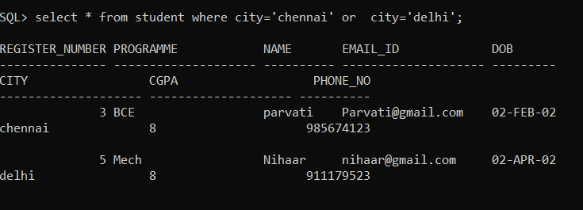

1. List the name and email id of the student who doesn’t lived in Mumbai.

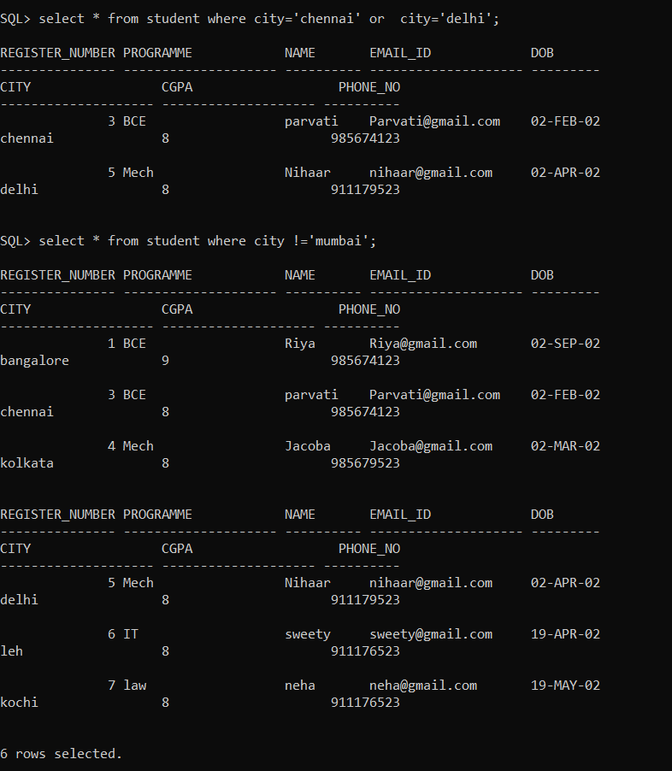

1. Sort the student details based on their dob in descending order

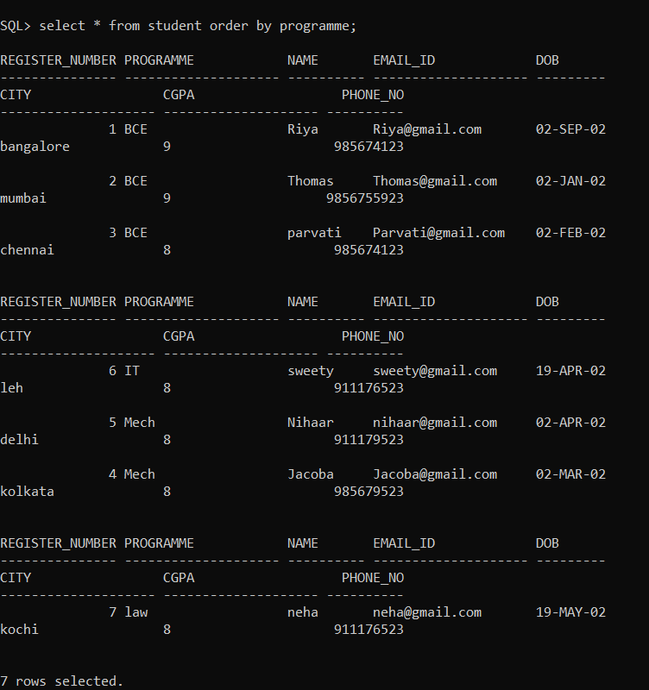

1. Sort the student details based on their name in ascending order and city in descending order.

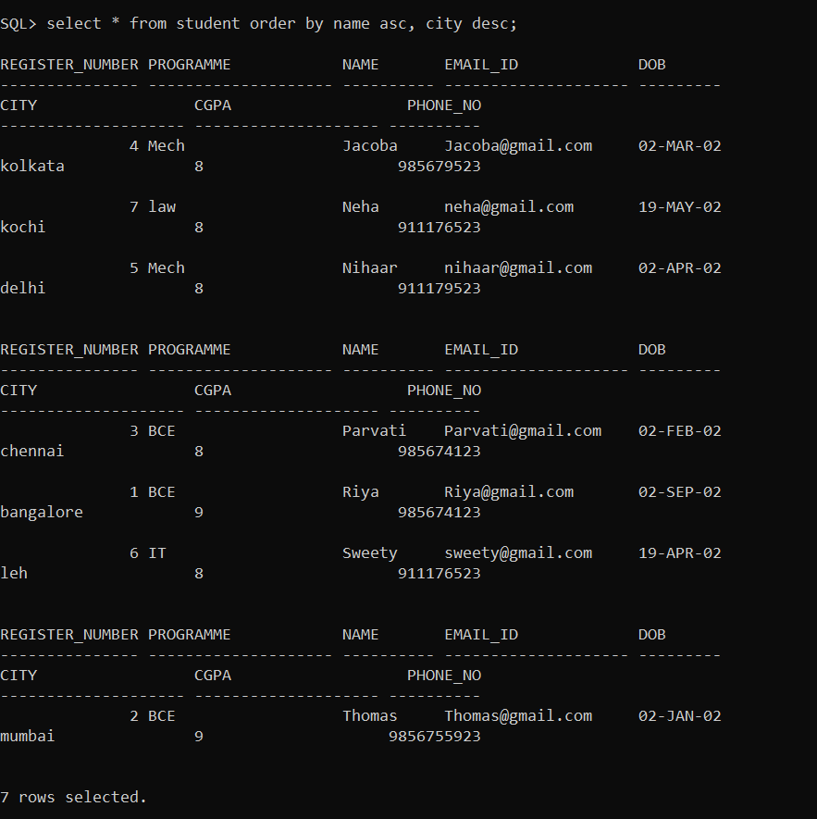

1. List the name of the students with those name starts with ‘r’ and ends with ‘i’

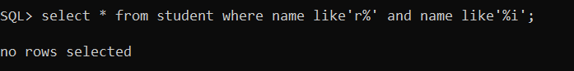

1. List the name of the students who has ‘s’ in their name

