

|  |  |  |  |  |  |
| --- | --- | --- | --- | --- | --- |
| Programme | : | **B. Tech** | Semester | : | **WS 2020-21** |
| Course | : | **Database Management Systems (Embedded Lab)** | Code | : | **CSE2004** |
| Faculty | : | **Dr. M. Braveen**  **Dr. M. Rajesh** | Slot | : | **L33 + L34** |
| Name | : | **Gayathri Sathish** | Regis no | : | **20BCE1359** |

**Date: 22-03-2021**

**SQL- Joins**

With the following created table with key constraints

student(regno, sname, cgpa)

course(ccode, cname, credits)

faculty(empid, fname, designation)

course_student(regno, ccode)

course_faculty(empid, ccode)

Write SQL queries for the following.

1. List the students details who have taken CSE2004

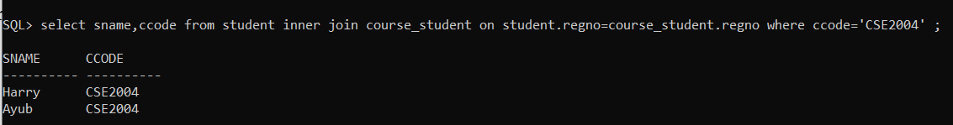

1. List the faculty names with designation “Professor” who teaches CSE2004



1. List the courses with more than 2 credits which was taught by the faculty “Anand”

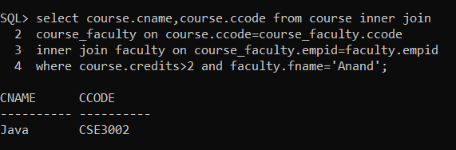

1. 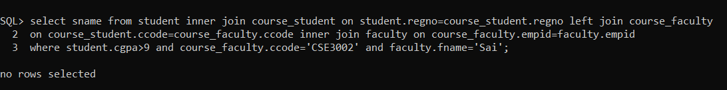List the students with >9 CGPA and has taken CSE3002 course taught by “Prof. Sai” [Cross Join and Left Outer Join]
2. List the register number, name, course code, course name and faculty empid, name involved in the course CSE1001

