

|  |  |  |  |  |  |
| --- | --- | --- | --- | --- | --- |
| Programme | : | **B. Tech** | Semester | : | **2** |
| Course | : | **Database Management Systems (Embedded Lab)** | Code | : | **CSE2004** |
| Faculty | : | **Dr. M. Braveen, Dr. M. Rajesh** | Slot | : |  |
| Name | : | **Gayathri Sathish** | Number | : | **20BCE1359** |

**Date: 05-04-2021, Monday**

**SQL – Date Functions, Aggregation and Joins**

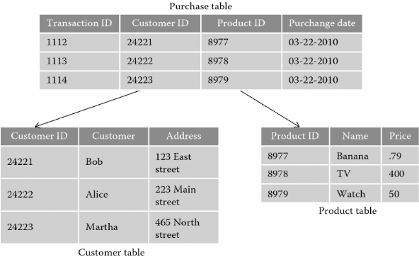

**Consider the above relational tables and write SQL queries for the following**

1. Create the above tables with primary and foreign keys

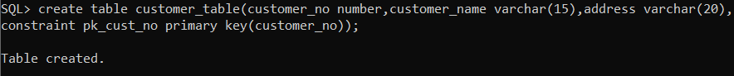





1. Add 5 more records to purchase table

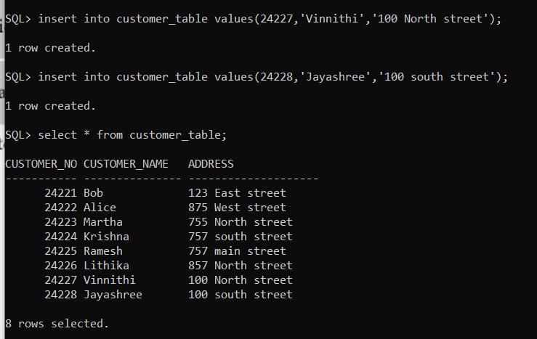

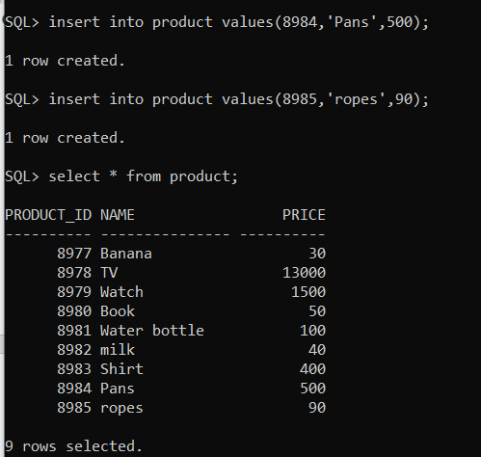

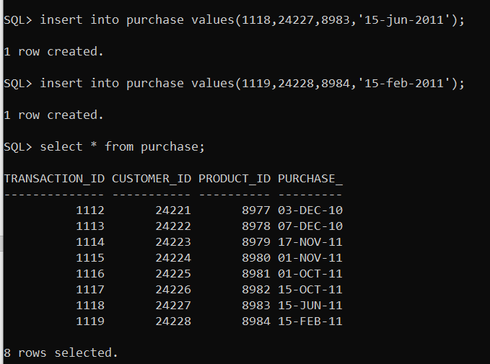

1. List the name of the customer who have purchased during the year 2010

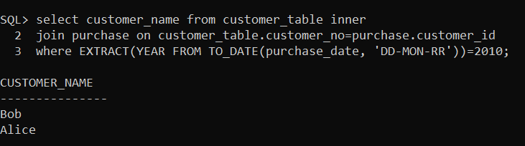

1. List the transaction id, purchase date, name of the product of the transaction, with maximum price

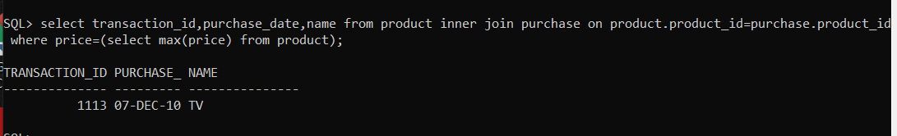

1. List the sum of prices of all the products bought by the customer id 24221

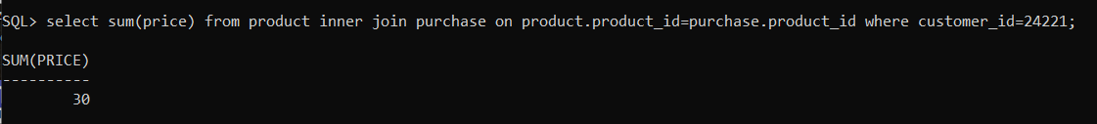

1. Count the number of products purchased by Bob

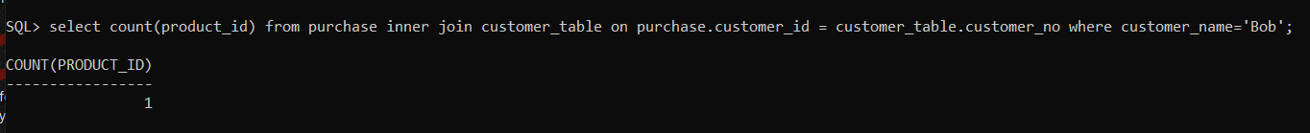

1. Count the number of customers who have purchased TV during august 2012.

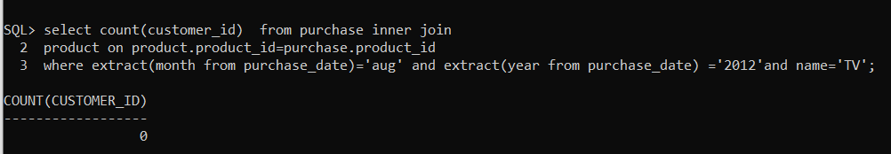

1. Find the name of the product which has the minimum price with the transaction ids and customer ids who have bought that.

