CO2-AT3-Debugging and Optimization Task

NAME : GAYATHRI N.P
REG .NO : 192421362

Q12. Debugging Linear Search (Premature Termination)
The following Linear Search code stops execution prematurely due to incorrect loop control. Identify the logical error causing early termination. Explain why valid elements may not be found. Debug the code to ensure complete traversal. Optimize the implementation for clarity and correctness. Analyze the time complexity and rewrite the corrected code
def linear_search(arr, key):
for i in range(len(arr)):
if arr[i] != key:
return -1 # ERROR
else:
return i

Error 1
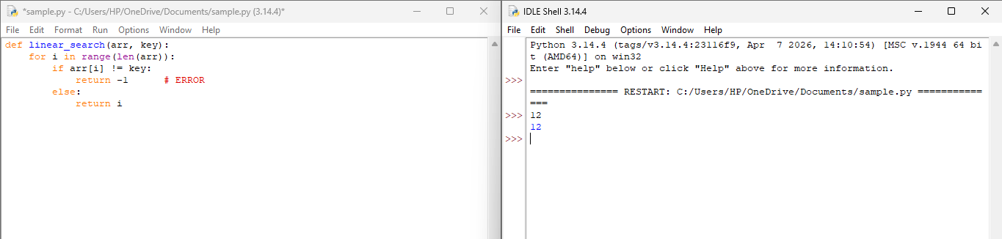
Program Error
- The error in this program is a logical error.
- The statement return -1 is placed inside the for loop.
- When the first element does not match the key, the function immediately returns -1.
- The program stops searching without checking the remaining elements.
- This causes the search to terminate early and produces an incorrect result.

Why Valid Elements May Not Be Found
- The program checks only the first element of the array.
- If the key is present in the second or any later position, it is never checked.
- The function returns -1 before completing the search.
- Therefore, the program may report that the element is not found even though it exists in the array.

Debugging
- Move return -1 outside the for loop.
- This allows the program to check all the elements in the array.
- If the key is found, the function returns its index.
- Otherwise, it returns -1 after completing the search.
Optimization
- The code is optimized by moving return -1 outside the loop.
- This ensures that every element is checked before returning -1.
- The corrected code is simple, easy to understand, and produces the correct result.
- It improves the clarity and correctness of the program.

Corrected Code
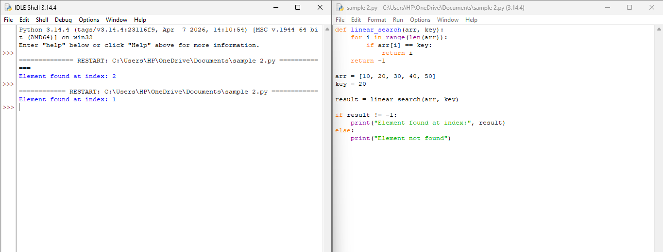

Time Complexity
- If the search element is found at the first position, then only one comparison is required. Hence, the Best Case Time Complexity is O(1).
- If the search element is found at the middle position of the array, then about n/2 comparisons are required. Hence, the Average Case Time Complexity is O(n).
- If the search element is found at the last position or is not present in the array, then all n elements are compared. Hence, the Worst Case Time Complexity is O(n).
- The algorithm uses only a few variables and does not require any extra memory. Hence, the Space Complexity is O(1).

Output Screen Explanation
- The program runs successfully without any syntax errors.
- It defines the linear_search() function and calls it with the given array and search key.
- The function checks each element one by one.
- When the key is found, it returns the index of that element.
- If the returned value is not -1, the program prints "Element found at index: index value".
- If the key is not present, the program prints "Element not found".

Algorithm: Linear Search
Step 1: Start.
Step 2: Initialize i = 0.
Step 3: Repeat while i < n and A[i] is not equal to key.
Step 4: Increment i by 1 (i = i + 1).
Step 5: If i < n, return i (the index where the key is found).
Step 6: Otherwise, return -1 (element not found).
Step 7: Stop.

