CO5-AT1
NAME : Gayathri N P
REG NO. 192421362

Q12. Graph Isomorphism Verification (Constraint-Based Decision Problem)
Given two graphs, determine whether they are structurally identical under vertex relabeling. Clearly define constraints related to vertex mapping and edge preservation. Analyze how these constraints restrict possible mappings. Develop a backtracking-based solution to test all feasible mappings. Apply constraint checking to eliminate invalid correspondences early. Justify how your solution ensures correctness and discuss its computational classification.
Answer:

1. Problem Definition
Given two graphs:
G1=(V1,E1)
and
G2=(V2,E2)
we need to determine whether they are isomorphic.
Two graphs are isomorphic if there exists a one-to-one mapping (bijection) between their vertices such that the adjacency relationship between vertices is preserved.
If such a mapping exists, the graphs are structurally identical even though their vertex labels may be different.
Example
If
V1={1,2,3}
and
V2={A,B,C}
and the mapping is:
1→A,2→B,3→C1\rightarrow A,\quad 2\rightarrow B,\quad 3\rightarrow C
then the mapping is valid only if every edge in G1G_1 corresponds to an edge in G2G_2.

2. Constraints
For a valid isomorphism, the following constraints must be satisfied.
Constraint 1: Same number of vertices
∣V1∣=∣V2∣
If the number of vertices is different, the graphs cannot be isomorphic.
Constraint 2: Same number of edges
∣E1∣=∣E2∣
If the number of edges differs, the graphs cannot be isomorphic.
Constraint 3: One-to-one vertex mapping
Each vertex of G1G_1 must map to exactly one vertex of G2G_2.
Also, two different vertices of G1G_1 cannot map to the same vertex of G2G_2.
f(u)=f(v)⇒u=vf(u)=f(v)
Constraint 4: Edge preservation
For every pair of vertices u,vu,v:
(u,v)∈E1 ⟺ (f(u),f(v))∈E2(u,v)
This means an edge must remain an edge after mapping.
Constraint 5: Degree preservation
Corresponding vertices must have the same degree.
degree(u)=degree(f(u))
This is an important constraint because it allows many invalid mappings to be rejected early.

3. How Constraints Restrict Possible Mappings
Initially, if both graphs have nn vertices, there can be:
n!n!
possible mappings.
For example, if n=4n=4:
4!=244!=24
possible mappings exist.
However, constraints reduce this search space.
For example:
- A vertex with degree 3 can only map to a vertex with degree 3.
- A vertex with degree 1 cannot map to a vertex with degree 2.
- If two already-mapped vertices have an edge between them in G1G_1, their corresponding vertices must also have an edge in G2G_2.
Therefore, invalid mappings are rejected before completing the entire mapping.
This is called constraint-based pruning.

4. Backtracking Approach
We construct the vertex mapping one vertex at a time.
For each vertex of G1G_1:
- Select an unmapped vertex from G2G_2.
- Check whether the mapping satisfies the constraints.
- If valid, continue with the next vertex.
- If invalid, reject that mapping immediately.
- Backtrack and try another candidate.
- If all vertices are successfully mapped, the graphs are isomorphic.

5. Algorithm
Pseudocode
GRAPH-ISOMORPHISM(G1, G2)

Input:
Two graphs G1 and G2 with n vertices

Output:
TRUE if G1 and G2 are isomorphic
FALSE otherwise

1. If |V1| != |V2|:
return FALSE

2. If |E1| != |E2|:
return FALSE

3. If degree sequences of G1 and G2 are different:
return FALSE

4. Initialize mapping[n] = -1
Initialize used[n] = FALSE

5. return BACKTRACK(0)

BACKTRACK(i):

1. If i == n:
return TRUE

2. For every vertex v in G2:

If used[v] == FALSE:

If degree(i) != degree(v):
continue

mapping[i] = v

If CHECK-CONSTRAINTS(i) == TRUE:

used[v] = TRUE

If BACKTRACK(i + 1) == TRUE:
return TRUE

used[v] = FALSE

mapping[i] = -1

3. return FALSE

6. Constraint Checking
The CHECK-CONSTRAINTS() function verifies whether the newly selected mapping is valid.
CHECK-CONSTRAINTS(i):

For every previously mapped vertex j:

If edge(i,j) exists in G1:

If edge(mapping[i], mapping[j]) does not
exist in G2:

return FALSE

If edge(i,j) does not exist in G1:

If edge(mapping[i], mapping[j]) exists in G2:

return FALSE

return TRUE
Thus, the algorithm does not wait until all vertices are mapped.
It checks the edges as soon as a new correspondence is created.
Output

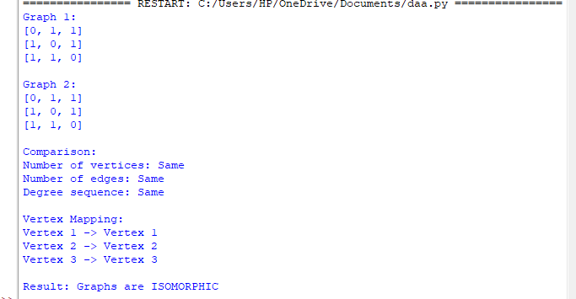

8. Correctness
The algorithm is correct because it considers every possible feasible vertex mapping through backtracking.
If the algorithm returns TRUE:
A complete one-to-one mapping has been found, and all edge relationships have been checked.
Therefore, the mapping preserves adjacency, so the two graphs are isomorphic.
If the algorithm returns FALSE:
Every possible mapping has either:
- violated the one-to-one constraint,
- violated the degree constraint, or
- violated the edge-preservation constraint.
Therefore, no valid isomorphism exists.
Hence, the algorithm correctly determines graph isomorphism.

9. Time Complexity
For two graphs containing nn vertices, there can be up to:
n!n!
possible vertex mappings.
For each mapping, edge constraints may require up to:
O(n2)O(n^2)
comparisons.
Therefore, the worst-case time complexity of the straightforward backtracking algorithm is approximately:
O(n!×n2)\boxed{O(n!\times n^2)}
or commonly expressed as:
O(n!)\boxed{O(n!)}
when focusing on the dominant factorial search.
Space Complexity
The algorithm stores:
- vertex mapping
- visited/used array
- recursion stack
Therefore:
O(n)\boxed{O(n)}
additional space, excluding graph storage.

10. Computational Classification
The Graph Isomorphism decision problem asks:
Given two graphs, are they isomorphic?
It belongs to the complexity class:
NP\boxed{NP}
because, if a vertex mapping is provided, we can verify in polynomial time whether the mapping preserves adjacency.
The problem is not known to be NP-complete, nor is it known to be in P in the general classical setting. A major breakthrough by Babai gave a quasi-polynomial-time algorithm for general graph isomorphism.
However, for a DAA backtracking implementation, the straightforward worst-case search remains factorial:
O(n!⋅n2)\boxed{O(n! \cdot n^2)}
11. Conclusion
The graph isomorphism problem can be solved using constraint-based backtracking by constructing a vertex mapping incrementally. Degree constraints, one-to-one mapping constraints, and edge-preservation constraints eliminate invalid mappings at an early stage. This significantly reduces unnecessary exploration compared with checking every complete permutation.
The algorithm is correct because it systematically explores all feasible mappings and accepts only a mapping that preserves the complete graph structure.
Final classification:
Graph Isomorphism∈NP\boxed{\text{Graph Isomorphism} \in NP}
and the basic backtracking solution has worst-case complexity:
O(n!⋅n2)\boxed{O(n! \cdot n^2)}
which makes it suitable for small graphs but inefficient for large graphs.

