SIMATS ENGINEERING
Assignment
COURSE NAME: OBJECT ORIENTED ANALYSIS AND DESIGN
COURSE CODE: CSA11

COURSE OUTCOME COVERED
CO1: Analyse the fundamentals of Object-Oriented Systems Development, including object basics, Object-Oriented Systems Development Life Cycle, Object-Oriented Methodologies, Model-Driven Development (MDD), and Agile practices.
CO2: Apply UML techniques including Use Case, Class, Interaction, State Transition, Activity, Package, Component, and Deployment Diagrams to model a software system.
CO3: Analyse objects, classes, attributes, methods, and relationships through Use Case Modelling, Object Analysis, Classification, and identification of object relationships.

Assignment Weightage: 100%

QUESTIONS: 1 Total Marks:100
Annexure A
Assignment

Code of Conduct:

I ____________________ (Name / Reg No) certify that this submission is my original work and that I have adhered to the guidelines specified for this assessment.
I understand that any violation of academic integrity rules will result in disciplinary action.

Signature of the student:

Course Code & Name | CSA11 – Object Oriented Analysis and Design
Assignment Title | Object-Oriented Analysis and UML-Based Design of an AI-Enabled Smart Healthcare Appointment and Patient Support System (AI-SHAPS)
Course Outcome(s) – CO | CO1: Analyse the fundamentals of Object-Oriented Systems Development, including object basics, Object-Oriented Systems Development Life Cycle, Object-Oriented Methodologies, Model-Driven Development (MDD), and Agile practices.  CO2: Apply UML techniques including Use Case, Class, Interaction, State Transition, Activity, Package, Component, and Deployment Diagrams to model a software system.  CO3: Analyse objects, classes, attributes, methods, and relationships through Use Case Modelling, Object Analysis, Classification, and identification of object relationships.
Bloom’s Taxonomy Level | BL3 – Apply, BL4 – Analyse, BL5 – Evaluate, BL6 – Create
SDG Mapping (SDG 1–17) | SDG 4 – Quality Education  SDG 9 – Industry, Innovation and Infrastructure  SDG 11 – Sustainable Cities and Communities

1. Problem Analysis and Requirement Summary

Write about the problem and list the system requirements.

Example:

Online patient registration

Doctor search by specialization

Appointment booking

AI-based doctor recommendation

Lab report upload

Prescription management

2. Actor Identification

Identify all users interacting with the system.
Actor | Role
Patient | Books appointments
Doctor | Treats patients
Receptionist | Manages appointments
Administrator | Controls system
Laboratory Staff | Uploads reports
Pharmacy Staff | Updates medicine status

3. Use Case Descriptions

Write a short description for each use case.

Example:

Use Case: Book Appointment

Actor: Patient

Preconditions: Patient logged in.

Steps:

Search doctor.

Select date.

Choose slot.

Confirm booking.

Postcondition: Appointment created.

4. Use Case Diagram

Draw a UML Use Case Diagram showing all actors and their interactions.

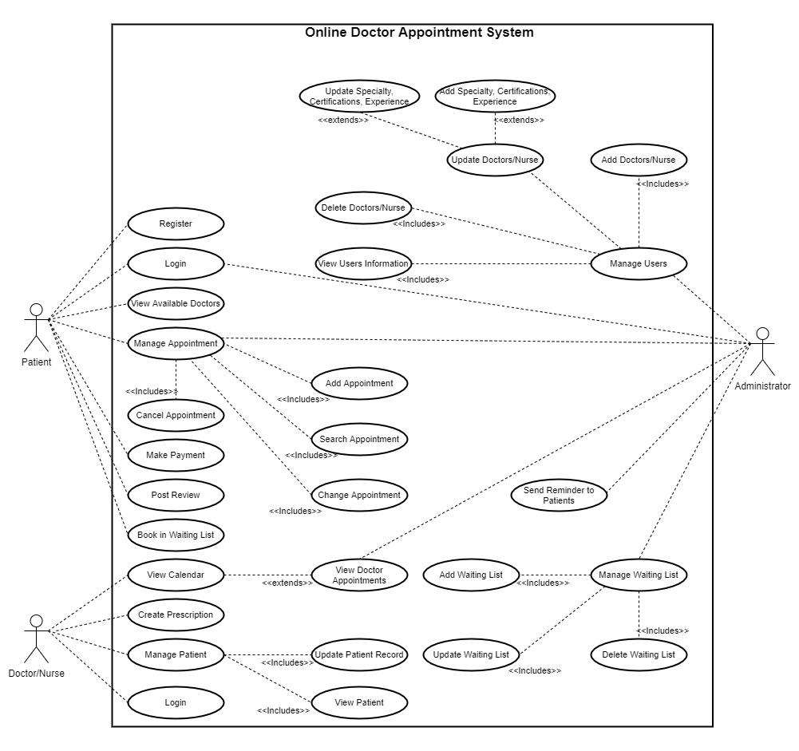

5. Object and Class Identification

Identify major classes.

Example:

Patient

Doctor

Appointment

Prescription

LaboratoryReport

Pharmacy

Administrator

Notification

6. Class Diagram

Draw the UML Class Diagram.

Include:

Attributes

Methods

Relationships

Inheritance

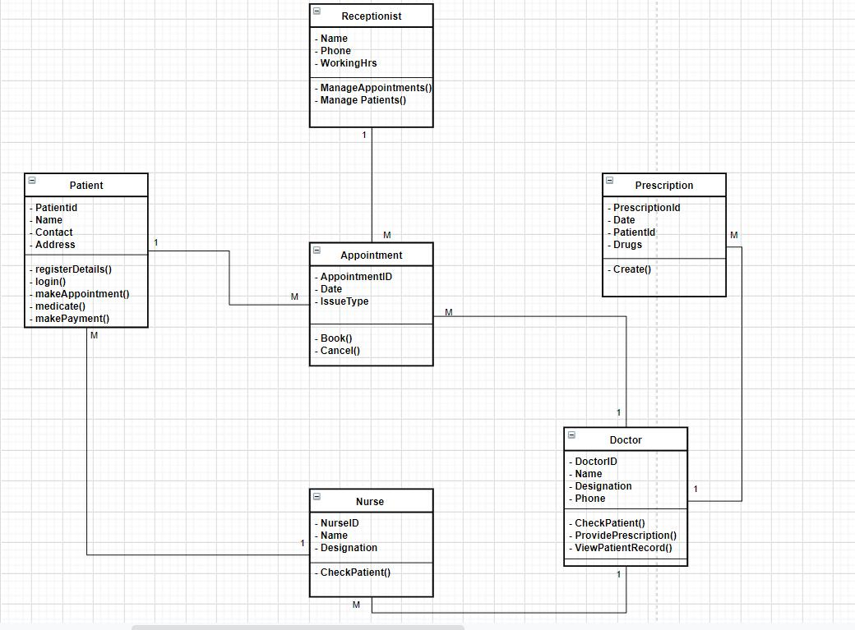

7. Sequence Diagram

Show how messages flow.

Example:

Patient books appointment.

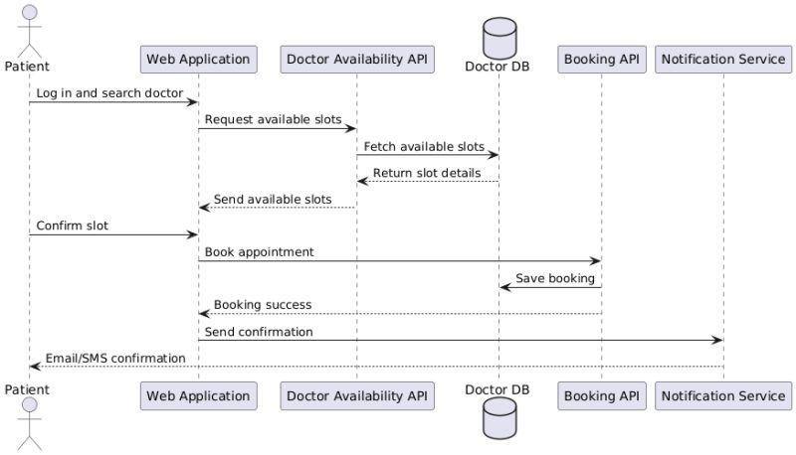

8. Activity Diagram

Show the workflow.

Example:

Login

Search Doctor

Select Slot

Book Appointment

Confirmation

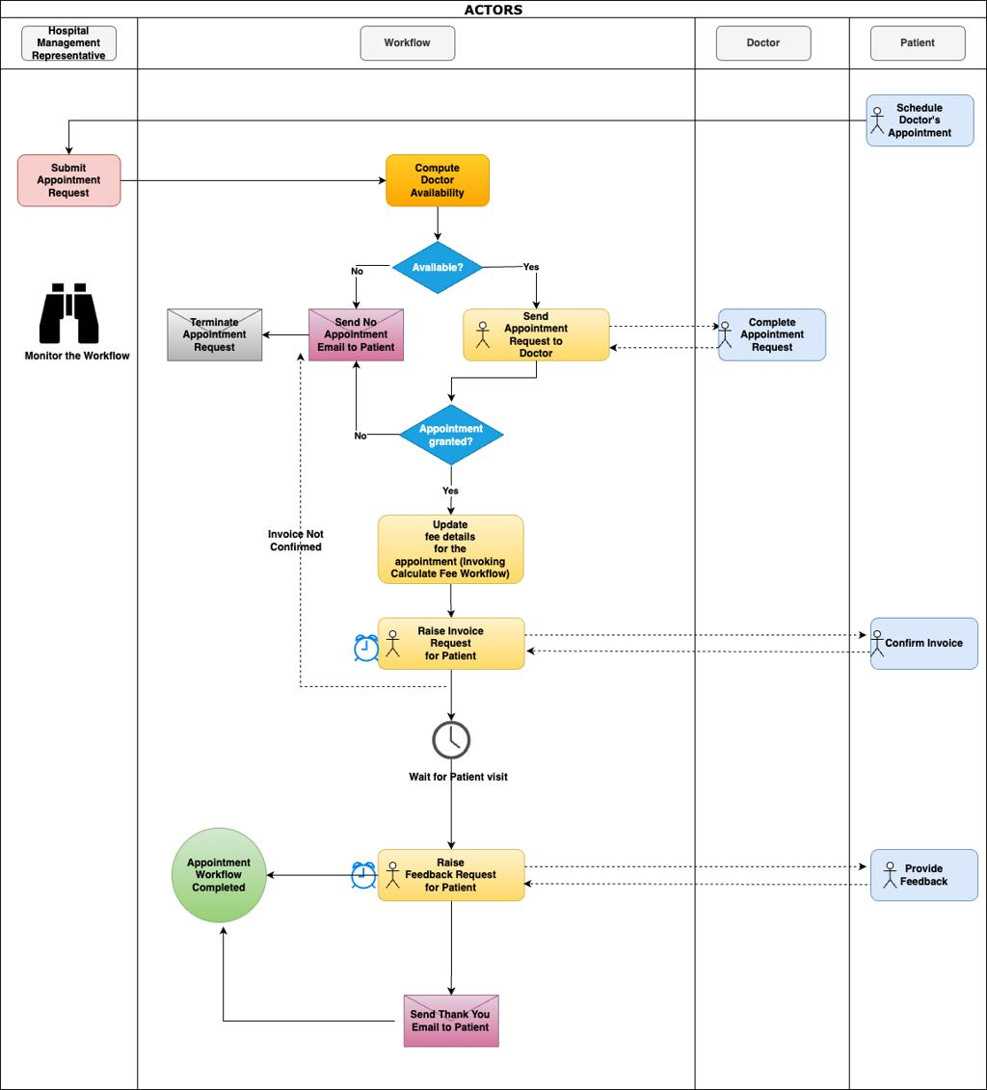

9. State Transition Diagram

Draw states of an Appointment.

Example:

Requested

Confirmed

Completed

Cancelled

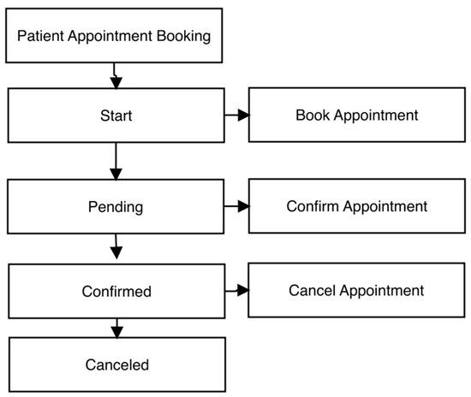

10. Package Diagram

Divide the system into modules.

Example:

Patient Module

Doctor Module

AI Recommendation Module

Laboratory Module

Pharmacy Module

Admin Module

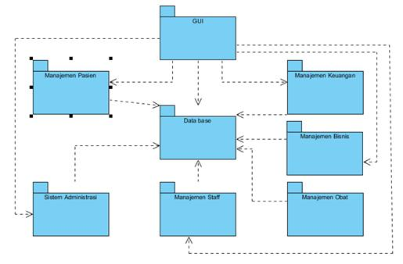

11. Component Diagram

Show software components.

Example:

Web Application

AI Engine

Database

Notification Service

Lab Service

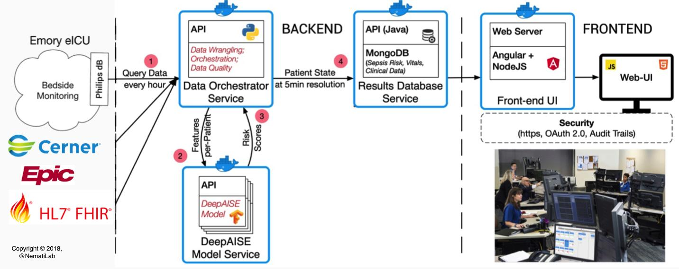

12. Deployment Diagram

Show where software runs.

Example:

Client Device

Web Server

AI Server

Database Server

Cloud Storage

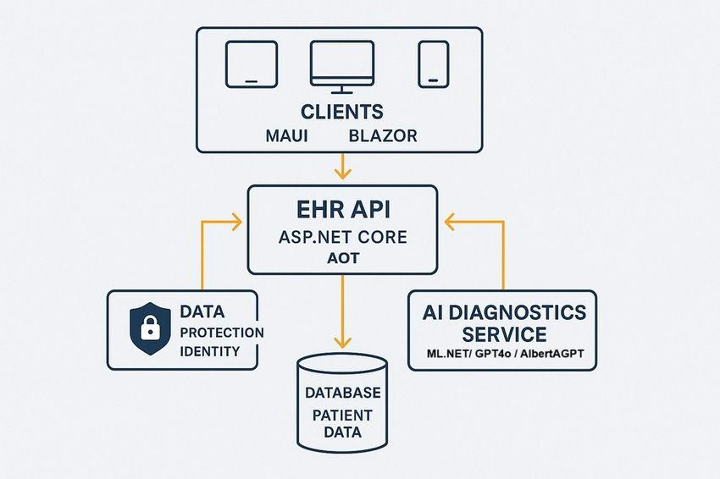

13. Object Responsibility Analysis

Assign responsibilities.
Object | Responsibility
Patient | Book appointments
Doctor | Manage schedule
Appointment | Store booking
Lab Report | Store results
Notification | Send reminders

14. Design Principles and Design Pattern Justification

Mention OOAD principles.

Use:

Encapsulation

Abstraction

Inheritance

Polymorphism

High Cohesion

Low Coupling

Design Patterns:

Singleton (Database connection)

Factory (Create users)

Observer (Appointment notifications)

15. Assumptions and Constraints

Example:

Assumptions:

Internet available.

Every patient has one account.

Constraints:

Appointment depends on doctor availability.

Secure login required.

16. Requirement-to-Use Case/Class Traceability

Create a traceability table.
Requirement | Use Case | Class
Book Appointment | Book Appointment | Appointment
View Reports | View Report | LaboratoryReport
Prescription | View Prescription | Prescription

17. Implementation / Prototype and Results

Create a simple prototype.

You can use:

Figma

Draw.io

HTML/CSS

PowerPoint

Include screenshots of:

Login

Dashboard

Appointment page

Doctor page

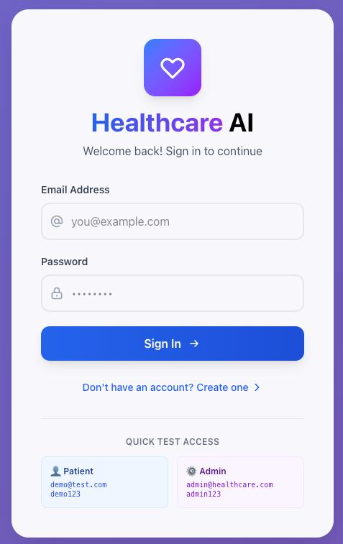

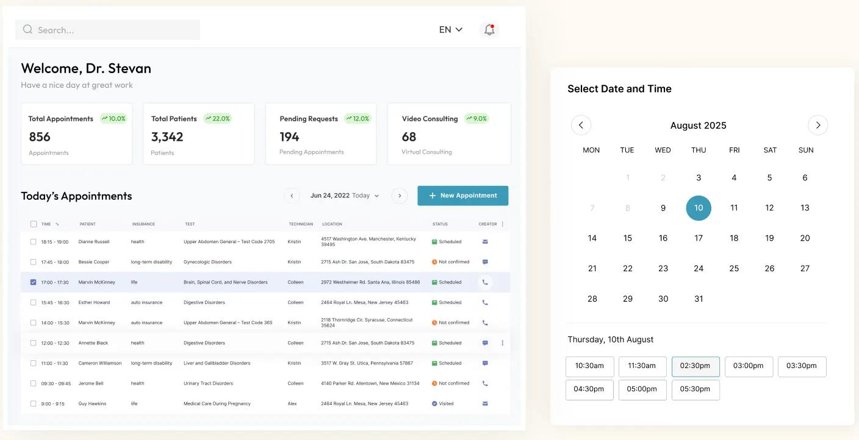

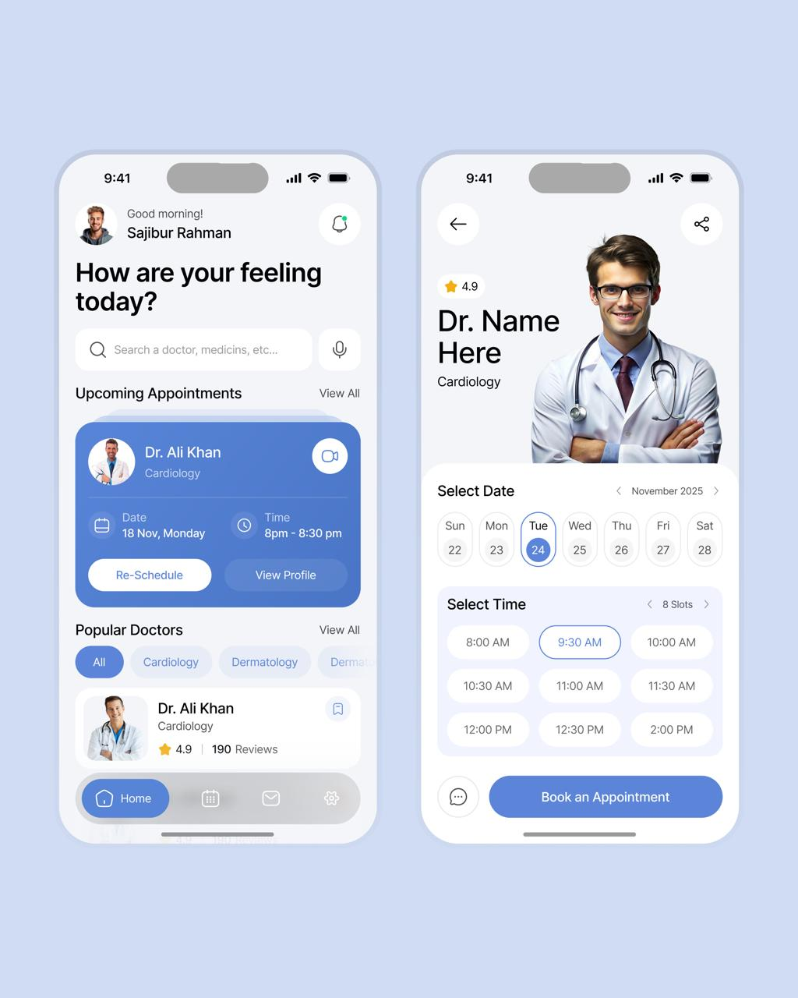

18. Reflection on Design Decisions and Learning Outcomes

Write about:

What you learned about OOAD.

Why UML diagrams help.

Challenges faced.

How AI improves healthcare.

19. GitHub Upload

Upload your work to GitHub.

Repository example: AI-SHAPS-OOAD-Assignment

Include:

Report

UML diagrams

Prototype

Screenshots

Tools you can use

The assignment recommends:

StarUML

Draw.io

Visual Paradigm

PlantUML

Lucidchart

Enterprise Architect

Assessment Rubrics
Criteria (CO Mapping) | Max Marks | Excellent | Good | Satisfactory | Needs Improvement
Problem Understanding, Object Identification & Requirements Analysis (CO1) | 10 | Clearly analyses the problem domain and accurately identifies all major actors, objects, system responsibilities, and requirements from the given scenario. | Identifies most actors, objects, and requirements with minor gaps or inaccuracies. | Identifies basic actors and objects but analysis is incomplete or contains some inconsistencies. | Poor understanding of the problem; major actors, objects, and requirements are missing or incorrectly identified.
Use Case Modelling & Actor Identification (CO2) | 10 | Correctly identifies all relevant actors and use cases; Use Case Diagram clearly represents system boundary, relationships, and interactions. | Most actors and use cases are correctly identified with minor modelling errors. | Basic actors and use cases are identified, but relationships or system boundary need improvement. | Actors and use cases are poorly identified; diagram is incomplete or inconsistent.
Class Identification, Attributes, Methods & Relationships (CO2/CO3) | 15 | Classes, attributes, methods, associations, aggregation/composition, inheritance, and dependencies are accurately identified and logically justified. | Class structure is mostly correct with minor errors in attributes, methods, or relationships. | Basic classes and relationships are identified but lack detail or contain several modelling issues. | Classes, attributes, methods, or relationships are missing, inappropriate, or poorly structured.
UML Behavioural & Interaction Modelling (CO2) | 15 | Sequence, Activity, and State Transition Diagrams accurately represent system behaviour and are fully consistent with the identified use cases and classes. | Behavioural diagrams are mostly correct with minor inconsistencies. | Basic behavioural diagrams are provided but some interactions, activities, or states are incomplete. | Behavioural diagrams are missing, unclear, or inconsistent with the proposed system.
UML Architectural Modelling & Design Evaluation (CO3) | 15 | Package, Component, and Deployment Diagrams clearly represent modular structure, system components, dependencies, and deployment environment with strong justification. | Architectural diagrams are mostly correct with minor omissions or modelling errors. | Basic architectural representation is provided but lacks clarity or sufficient justification. | Architectural diagrams are incomplete, inappropriate, or inconsistent with the system design.
Object Responsibilities, Design Principles, Axioms & Patterns (CO3) | 15 | Responsibilities are appropriately assigned; design axioms, cohesion, coupling, encapsulation, abstraction, and suitable design patterns are clearly justified and effectively applied. | Design principles and patterns are appropriately applied with minor limitations in justification. | Some design principles are identified, but application or justification is limited. | Design principles, axioms, responsibilities, or patterns are absent or incorrectly applied.
Consistency, Traceability & Overall Design Quality (CO3) | 10 | All UML models are mutually consistent, requirements are traceable to use cases/classes, and the overall design is complete, feasible, scalable, and maintainable. | Design is largely consistent and traceable with minor gaps. | Some consistency and traceability are demonstrated, but important links are missing. | Major inconsistencies exist between requirements, use cases, classes, and UML diagrams.
Reflection, SDG Relevance & Learning Outcomes | 10 | Provides insightful reflection on design decisions, challenges, OOAD concepts learned, and clearly establishes the relevance of the selected SDGs. | Provides good reflection with reasonable connection to design decisions and SDGs. | Reflection is present but generic with limited discussion of learning and SDG relevance. | Reflection is missing, superficial, or unrelated to the assignment and SDGs.
Total | 100

Deliverables
To receive full credit, each submission must include the following:
- Problem Analysis and Requirement Summary
- Actor Identification
- Use Case Descriptions
- Use Case Diagram
- Object and Class Identification
- Class Diagram
- Sequence/Interaction Diagram(s)
- Activity Diagram
- State Transition Diagram
- Package Diagram
- Component Diagram
- Deployment Diagram
- Object Responsibility Analysis
- Design Axioms/Principles and Design Pattern Justification
- Assumptions and Constraints
- Requirement-to-Use Case/Class Traceability
- Implementation/Prototype and Results
- Reflection on Design Decisions and Learning Outcomes
- GitHub Upload

