Ticket System

**Introduction:**

OS Ticket is an open-source ticketing system widely used for customer support and issue tracking. It helps organizations efficiently manage, organize, and streamline customer queries and support requests.

**Overview of OS Ticket:**

***Key Factors of Ticket System:***

* Ticket assignment
* Ticket prioritization
* Ticke categorization
* Automated workflows
* Customizable forms
* Reporting and Analytics.

**Working Process of OS Ticket System:**

*There are 5 types of Ticket categorisation,*

* Creating ticket
* Assigning ticket
* Categorizing and prioritizing tickets
* Tracking tickets
* Communicating with customers.

**How to use OS Ticket System:**

* Login using URL or by clicking inside the sandman
* Navigate dashboard to view the open and create ticket options
* The foundry details and the details of tickets will also be directly saved in Database Connection
* Each foundry ticket will contain unique ticket id.

**User:**

* Users can open the link create and submit the tickets
* They do not have access to administrative settings or system-wide configurations
* They can also edit and resubmit the tickets.

**Admin:**

* Admin can handle both user side and the admin side ticket
* They can assign view, edit, resolve and close the ticket sent by the end users
* They can also manage settings related to ticket departments, workflows, email notifications, etc.

**Ticket Management Workflow:**

* Use filters to sort tickets by status, priority, or department
* The ticket is assigned to the agent based on the predefined rules
* Once the ticket is resolved the agent marks the ticket as closed with comments on that ticket.

**Customization of OS Ticket:**

* For each foundry, their own foundry detail drop down will be displayed to create the ticket
* The data will be automatically gathered from the data base connection
* Customize ticket forms to collect relevant data
* Also, there will be **an Issue description** box to state the issue of the ticket
* Configure departments, teams, and agents for efficient ticket routing.

**Ticket Filtering:**

* Ticket filtering refers to the ability to sort, view, or prioritize tickets based on certain criteria (e.g., priority, status, department, or tags).

**Ticket Priorities:**

* High
* Medium
* Low

**Ticket Status:**

* Open
* Close
* Resolved

**Database Connection (DB) Schema:** 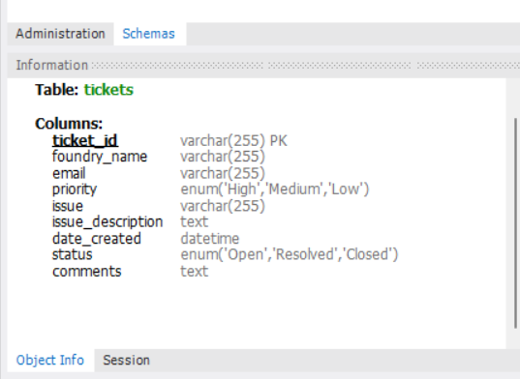

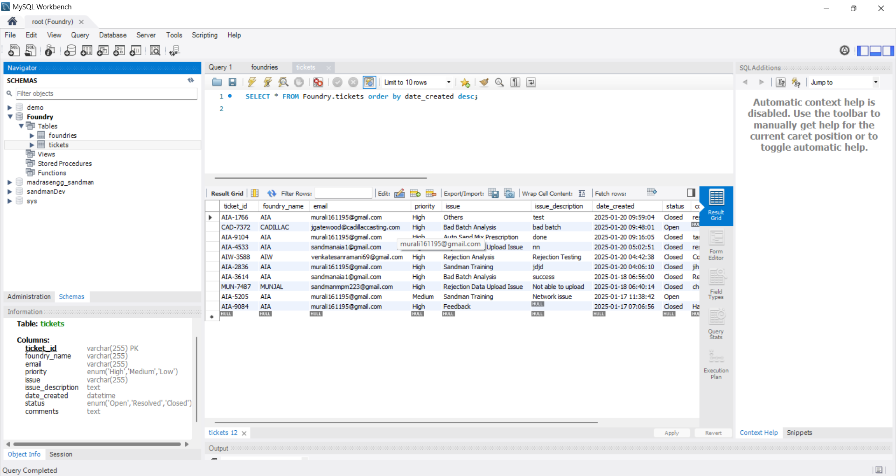

***Foundry SQL Queries:***

CREATE TABLE foundries (

foundry_id INT AUTO_INCREMENT PRIMARY KEY,

foundry_name VARCHAR(255) NOT NULL UNIQUE,

person_name VARCHAR(255),

email VARCHAR(255),

phone VARCHAR(15)

);

INSERT INTO foundries (foundry_name, person_name, email, phone) VALUES

('AIA', 'Muralidharan M', 'murali161195@gmail.com', '7299114796'),

('AIA', 'Steve Waugh', 'sandmanaia1@gmail.com', '9042927339'),

('AIA', 'Hitesh Dohare', 'lab.kerala@aiaengineering.com', '6359964009'),

('AIA', 'Jitendra Patel', 'jitendra.patel@aiaengineering.com', '9723430298'),

('AIA', 'Dhiru Solanki', 'dhiru.solanki@aiaengineering.com', '6359964022'),

('AIA', 'Dharmesh Tripathi', 'dharmesh.tripathi@aiaengineering.com', '8238023325'),

('AIA', 'Prashant Kulkarni', 'prashant.kulkarni@aiaengineering.com', '7203092751'),

('AIA', 'Moulding K1', 'moulding.k1@aiaengineering.com', '7211197937'),

('AIA', 'Hegde Sir', 'hegde@aiaengineering.com', '9099911987');

INSERT INTO foundries (foundry_name, person_name, email, phone) VALUES

('AIW', 'Sandman MPM1', 'sandmanmpm1@gmail.com', '9960486404'),

('AIW', 'Anmol Kawale', 'kawaleanmol9@gmail.com', '9304606973'),

('AIW', 'Venkatesan Ramani', 'venkatesanramani69@gmail.com', '9897631846'),

('AIW', 'R . D Ganesan', 'r.d.ganesan@ashokiron.com', '9304976231'),

('AIW', 'Prashant Patil', 'prashant50.pp@gmail.com', '9822278878'),

('AIW', 'Sandeep Agasar', 'sandeepagasar111@gmail.com', '9361342611'),

('AIW', 'Ravi Kumar', 'ravikumar.n@ashokiron.com', '9834894364'),

('AIW', 'Dharnendhar Shiragapur', 'dharanendra.shiragapur@ashokiron.com', '9663805983'),

('AIW', 'Vaibhav Bhogan', 'bhoganvaibhav3.142@gmail.com', '9222775065'),

('AIW', 'Mahesh Sambari', 'p3.lab@ashokiron.com', '9872162487');

INSERT INTO foundries (foundry_name, person_name, email, phone) VALUES

('MUNJAL', 'Murali Krishnan', 'sandmanmpm223@gmail.com', '9860486663'),

('MUNJAL', 'Gopinath R', 'gopinath.nkl07@gmail.com', '9655739398'),

('MUNJAL', 'Anil Mishra', 'laboratory@munjalkiriu.co.in', '92891277209'),

('MUNJAL', 'BL Kumawat', 'blkumawat@munjalkiriu.co.in', '9958130522'),

('MUNJAL', 'Abhishek Tiwari', 'castingstdroom@munjalkiriu.co.in', '7048956565'),

('MUNJAL', 'Saravanan K', 'ksaravanan@munjalkiriu.co.in', '9910048934'),

('MUNJAL', 'Rajendra Kumar', 'rajendra@munjalkiriu.co.in', '9971666474'),

('MUNJAL', 'Madeswaran G', 'madeshwaran@munjalkiriu.co.in', '9971090237'),

('MUNJAL', 'Ishikawa K', 'kishikawa@munjalkiriu.co.in', '9205155966'),

('MUNJAL', 'Somveer Singh', 'sstanwar@munjalkiriu.co.in', '9821011655');

INSERT INTO foundries (foundry_name, person_name, email, phone) VALUES

('CADILLAC', 'Sandman Cadillac', 'sandmancadillac@gmail.com', '+1 231-429-4845'),

('CADILLAC', 'John Gatewood', 'jgatewood@cadillaccasting.com', '+1 231-429-4845'),

('CADILLAC', 'Brooks Lucas', 'blucas@cadillaccasting.com', '+1 231-429-4845'),

('CADILLAC', 'Kyle Klein', 'kklein@cadillaccasting.com', '+1 231-429-4845'),

('CADILLAC', 'Mary Schafer', 'mschafer@cadillaccasting.com', '+1 231-429-4845'),

('CADILLAC', 'Jason Owens', 'jowens@cadillaccasting.com', '+1 231-429-4845'),

('CADILLAC', 'Eric Watrous', 'Ewatrous@cadillaccasting.com', '+1 231-429-4845'),

('CADILLAC', 'Sand Lab', 'slab@cadillaccasting.com', '+1 231-429-4845'),

('CADILLAC', 'Desmond Pow', 'dpow@cadillaccasting.com', '+1 231-429-4845');

INSERT INTO foundries (foundry_name, person_name, email, phone) VALUES

('MCIE', 'Sandman MPM', 'sandmanmpm17@gmail.com', '9767532052'),

('MCIE', 'Dhamankar Sachin', 'dhamankar.sachin@cie-india.com', '9657712172'),

('MCIE', 'Sharanappa Kyatanakeri', 'kyatanakeri.sharanappa@cie-india.com', '9552504692'),

('MCIE', 'Sachin Devalekar', 'devalekar.sachin@cie-india.com', '9673767883'),

('MCIE', 'Sanap Akash', 'sanapakash26@gmail.com', '7798939939'),

('MCIE', 'Shinde Mallikarjun', 'shinde.mallikarjun@cie-india.com', '9309870472'),

('MCIE', 'Narsing Dinde', 'dindesanskar2000@gmail.com', '9657712182'),

('MCIE', 'Sudhakar Rane', 'rane.sudhakar@cie-india.com', '9978157111'),

('MCIE', 'Arif Mulani', 'mulania555@gmail.com', '8080515552'),

('MCIE', 'Sathish Kumar', 'satishkumar95048472@gmail.com', '9657712258');

SELECT * FROM foundries;

SELECT DISTINCT foundry_name FROM foundries

CREATE TABLE tickets (

ticket_id VARCHAR(20) PRIMARY KEY,

foundry_name VARCHAR(255) NOT NULL,

email VARCHAR(255),

priority ENUM('High', 'Medium', 'Low') NOT NULL,

issue VARCHAR(255) NOT NULL,

issue_description TEXT,

status ENUM('Open', 'Closed', 'Resolved') DEFAULT 'Open',

comments TEXT,

date_created DATE DEFAULT CURRENT_DATE,

resolved_time DATE NULL,

FOREIGN KEY (foundry_name) REFERENCES foundries(foundry_name) ON DELETE CASCADE

);