**Abstract:** During recent years, in industrial sector we observed many changes from decades. When there was no technology humans used to work in the industries and produce a large amount of production. But in recent years, when technology was developed vastly and we were successful in building an agent i.e., a machine which works as humans and gives the accurate and perfect value or required output to a given task. As we know robots are designed in unique pattern to replaces a human. Robots are renowned for their precision, speed and strength. This article is based on robotic arms- pick and place robots. Robotics arms are invented to perform mimic actions of humans. In Industries pick and place operations are used by robotic arms. Artificial intelligence plays a crucial role in building and manipulating machines. In AI machine learning is used to build or apply an algorithm for a particular robot based on given task. This article discusses about AI and learning approaches of machine learning-how are they related to robotic arms. Each method that has been described in literature is assessed in terms of its good and bad points, Ill discuss here select upgrades to functions throughout the reader may scroll down from the top. The last part of this paper interprets the literature and makes clear what questions are still outstanding. Validation of the experimental method itself, the generalization from a specific model and the right choice concerning grasp pose are still all areas where additional research is needed'.

**Introduction:**

*Robots* have been used in the industry for many years now. Robots are designed in such a way that it replaces humans, robots are better than humans because of their strength, speed, power and accuracy. Robots can achieve any complex tasks by their speed and precision. Robots follow the set of instructions instructed by humans without doubting the instruction or breaking the instructions. For every task we need to give an individual set of instructions to avoid errors. As a result, the robot engineer must re-write the program for every single task, give the set of instructions according to the task or they must create separate tools to control the robots to perform a particular task. For building a robot we need to deal with some important branches like design of the robot, construction of machine, use to control robot, sensors and information processes. These activities help robots to behave has humans. They perform a task without any mistake and completes the job efficiently. Maximum number of robots are automatic in nature, so they perform the task without human interference. The idea of building robots by using artificial intelligence has been came true. Artificial intelligence and machine learning plays an important role in building the robots.

**Robotics Background:**

The background of robotics takes back to the ancient times where humans created them to perform the human tasks. The inventers and thinkers had a passion of creating a machine which can talk, dance, work and can even take decisions required for the given task. They have many generations passed to improve the world of robotics and every generation has contributed their best to create a useful robot. As we know science has made an important role in development of robots, by providing theoretical and practical knowledge and multiple disciplines like physics and mechanics. These were further divided into material science, kinetics, dynamics, energy and power systems, mathematics such as algorithms, control systems and artificial intelligence, computer science such as programming, software development, simulation and virtual modelling, electronics such as microelectronics, sensers, actuators and communication systems, biology such as biomimicry, neuroscience, cognitive science and human robot interaction. Which has led to great construction and design of robots which performs complex tasks.

Robotic arms are invented to perform mimic actions of human. These have the mechanical parts and are created with no human emotions, pick and place operations are used by robots by providing them online programming.

As we know robotics is a vast learning subject, it includes Artificial intelligence (AI) and machine learning algorithms to improve their performances. Machine learning and artificial intelligence (AI) and robotics are interlinked with each other.

**Robotic System:**

Robotics is a diverse field that encompasses mechanical, electrical, and computer science disciplines.

**Definition of a Robot:**

A robot is a programmable and versatile machine designed to carry out tasks through programmed movements. Robots typically handle tasks that are dull, dangerous, dirty, or costly to human workers. Nowadays, there exist numerous types of robots such as humanoid robots, legged robots, self-driving cars, military robots, bio-inspired or bionic system robots, collaborative robots, and medical robots.

**Ethical Laws for Robots:**

**First Law:**

A robot must not injure people or, by doing nothing, let someone to be harmed.

**Second Law:** Except for situations in which the first law is violated, a robot must obey human commands**.**

**Third Law:** A robot is required to follow commands given by human beings, except when such commands conflict with the first law.

**Fourth Law / Asimov’s Law:** A robot is permitted to perform tasks currently done by a human, but it must ensure the person retains suitable employment.

**Advantages of robotic systems:** Robotics are recognized for their safety, speed, precision, uniformity, reliability, excellence, productivity, efficiency, reduction of labour burden, creation of jobs or industries, application of robotic technology across diverse sectors, and versatility.

**Disadvantages of robotic system:** robots have specific disadvantages mainly they are economic stress on company, jobless or unemployment, lack of human intelligence, less dextrous, very costly, needs very skilled operators, high Maintenace and more power consumption etc.,

**Use of robotic systems:** Robots are used in Manufactuing, working alongside humans in manufacturing plants, assembly, inspection, packing, transport, earth and space exploration, nuclear installations, medicine and surgery, defence and weaponry, academics and research, companies, waiters, assistants, vacuum bots, search and resume missions, logistics chain, news readers, teaching, assistants, farming agriculture, armed forces and etc.,

**Robot links:** Links are the members or elements that forms the robots. Links can be connected in various configurations. They are considered as rigid or resistant bodies. Links are rigid and flexible (like belt, chain etc.,). Links are joined together kinematically and forms joints which behave like kinematic pairs. A midpoint which joins the links are called joint. Joint keeps physical constraints on the relative motion between the links. These joints help to put constraints on the movements and reduces the degree of freedom to less than 6.

**Robot joints:** A midpoint which joins the links are called joint. There are three types of joints which are divided based on degree of freedom. When degree of freedom = 1, then we use linear joint, rotary joint and helical joint. Cylindrical and universal joints are used when the degree of freedom is equal to two. When the degree of freedom =3, then we use spherical joint and planar joint. Linear joints are further divided into prismatic joint and sliding joint, both are collinear and orthogonal, the usage depends on the required configuration of links. Rotary joints are further divided into two types they are revolute joint and twisting joint; these are used for free movements in requires angle.

**Kinematic chains:** When links are connected in series with help of joints to form kinematic pair, then the arrangement of links and joints are known as kinematic chains. They are four types of kinematic chains they are singular link, binary link, ternary link and quaternary link. Kinematic chains are further divided into two types, they are open kinematic chain and closed kinematic chain. When every link is not connected to at least two or more links it is called as open kinematic chain. When every link is connected to at least two or more links then it is called as closed kinematic chain. Kinematic chains are based on linkage, mechanism and machine:

**Linkage:** When one link of kinematic chain is fixed in ground then it is called a linkage. Here when we give definite input motion to linkages, we receive definite motion of all other links.

**Mechanism:** Mechanism is the process which undergoes in linkages. It passes relative motion from one link to another. When we give definite motion as input through linkages, we receive definite motion of links.

**Machine:** This is the external part which gives output by undergoing linkage and mechanisms. When we give definite motion as input through linkages than we receive definite motion of all other remaining links, if it is a predicted output.

**Robotic Manipulator:**

Robotic manipulator it manipulates the robots to do certain tasks. It has a three-degree-of-freedom robotic arm and wrist assembly. Robotic arm is a translator for the robot. It has a separate workspace. Wrist assembly is having an orientation for the robot. It contains it separate work volume. They are three types of robotic manipulator. They are spatial manipulator (maximum dof = 6), planar manipulator (maximum dof =3) and redundant manipulator (maximum dof >6(dexterity)). There are six degrees of freedom in the dimensions of a rigid body.

**Degree of freedom (DOF):**

Degreee of freedom is also known as connectivity. The minimum number of independent variables which are fully required to define the configuration is known as degreee of freedom. This is also defined as the “independent movements” that an object will perform in an 3D space or number of independent relative motion a kinematic pair can have been known as its degreee of freedom.

**Robotic Manipulator = Robotic arm (position of 3Dof) + Robot’s wrist (orientation 3dof)**

**For solving degree of freedom:**

For spatial mechanism [ kulzback’s criterion],

(dof) = 6(L-1) - 5p1 - 4p2 - 3p3 - 2p4 – 1p5

For planar mechanism [Gxebler’s criterion],

(Dof) = 3(l-1) - 2p1 – 1p2

For solving redundant mechanism,

(dof) = 3 (Lt - L - Lr) - 2 (p1 - P) - 1. P2- Fr

**Robot Anatomy:**

It is a study of different parts and subsystems of robotic system. This is the study of constructing a robot manipulator.

Robot system basically works on,

**Robotic manipulator (dof = 6) + end effector (tool or gripper) (it may or may not have dof)**

**Applications of robot’s anatomy:**

* **Links and joints**
* **Robotic arm configuration**
* **Degree of freedom**
* **Robot's wrist**
* **End effectors**
* **Sensors or controllers**
* **Drivers or actuators**
* **Power supply etc.,**

**Robots Anatomy – Robot’s Wrist:**

* Wrist assembly is attached to the robots Arms's endpoint.
* There are six degrees of freedom in the dimensions of a rigid body.
* Wrist may have less dof but it affects dexterity.
* RPY wrist: Three dof wrist is called roll pitch wrist.
* The x, y, and z planes must all connect at a single place.

**Robot’s Anatomy – End Effector:**

End effector is based on two principles - tools and grippers. Tools directly perform work on workpiece. Gripper grabs or holds the workpiece.

**Types of tools:**

* Cutting tool.
* Drilling tool.
* Milling tool.
* Inspection tool.
* Spray gun.

**Types of Grippers:**

* Single and double gripper.
* Internal and external gripper.
* The gripper is both soft and hard (force and form closure).
* Active and passive gripper.
* Flexible and vacuum gripper.
* Magnetic gripper.
* Fneumatic gripper.

**Robot's Anatomy - Sensors, Drivers and Controllers:**

Robotic sensors are devices that generate an output signal to detect physical phenomena. A sensor is a device module machine, or sub system that detects events or changes in its environment and sends the information to other electronics. Sensors are further divided into two types- internal and external sensors.

**Applications of robotic sensors:**

* Senses the manipulator’s joint-link parameters.
* Helps in motion control.
* Senses velocity, force, torque, etc.
* Ensures system safety and security.
* Works on vision and inspection.

**Some sensors installed in robotics systems:**

* Vision system(camera).
* Range finders.
* Gas sensors.
* Haptic or tactile sensors.
* Limit switches or reed switches.
* Potentiometers and encoders.
* Temperature sensors.
* Force and torque sensors.
* Accelerometers.
* Collision detection sensors.

**Robot actuators (Drivers):**

An actuator is a component of a machine or system that facilitates physical movements by transforming energy—typically hydraulic, electrical, and air energy—into mechanical force. This part is what makes it possible for the robot to move. Actuators transform energy into motion or mechanical force when it is applied. They are different types of actuators they are pneumatic (air), hydraulic (fluid), electrical (electricity), piezoelectric actuator and ultrasonic actuators. Electrical actuators are further divided into Stepper motor, DC motors, AC motors, servo motors, harmonic drivers, cycloidal drivers.

**Robot controller and programming:**

A robotic controller is a device that regulates how robots move. This includes program and mechanical approaches to control a robot. The controller is the robotic system's brain.

**Robot programming methods:**

Teaching a robot to complete its work cycle is known as robot programming. There are three basic methods- teach by demonstration or teach by showing or lead through program. The other method is to teaching pendant or textual commands or programming languages. The third method is to simulation, further it is divided into two parts- offline(cold) and online(hot).

**Robot classification:**

* Geometry.
* Workspace or work envelope.
* Actuation or drive technology.
* Control method.
* Application.
* DOF.
* Kinematic structure.
* Motion control.

**Robot specification:**

While the drive technologies, work envelope geometries and motion control methods provide convenient ways to broadly classify robots, there are several additional characteristics that allows the users to further specific manipulators.

**Robot specifications:**

* No. Of axes ... quantity.
* Load carrying capacity... kg.
* Maximum speed, cycle time- mm/sec.
* Reach and stroke – mm.
* Tool orientation – deg.
* Repeatability – mm.
* Precession and Accuracy – mm.
* Operating environment
* Resolution (programming and control).

**Robot Notations:**

A clear and consistent system of notations becomes a challenge. Notational convention adopted in this are as follow:

**Scalar:** Scalars are lowercase alphabets (a to z) or by numbers 1,2,3...... etc.

**Vectors:** Vectors are lowercase alphabets with arrow above the alphabet. Uppercase alphabets have arrow above the alphabet. Vectors can also be represented by two numbered an alphabet with arrow on top. Vectors can scan represented by using two alphabets that means vectors starts at a and ends at b.

**Matrices:** Matrix is represented by uppercase alphabet with square brackets. Examples are [P], [T] or [D]. Subscript and superscript can also be added. Examples are [ $${}_{}^{1}T2$$] or [ $${}_{}^{1}D2$$] .

**Coordinate frames:** Coordinate frames are denoted by numbers enclosed by curly brackets. Examples are {1},{2}, {3}. Also represented by uppercase alphabets enclosed in curly brackets. Examples are {F}, {U}, {M}, {B} etc. Symbolized by a trio of alphabets encased in {}. examples are {xyz} or {uvw} where these are three principal axes.

**Matrix / Determinant Operators:**

Determinant: If matrix A=>[A], Then determinant of [A]=>|A| or det(A).

* Matrix transpose: [ $${}_{}^{A^{T}}$$]
* Matrix inverse: $$A^{ −1}$$

**Vectors operators are:**

* Dot product
* Cross product
* **Angles:** Angles are denoted by $$θ$$, $$α$$, $$γ$$, $$∅$$ etc. Numbered notations are $$θ1,θ2; α1,α2; ∅1,∅2$$ etc.
* cos $$θ1$$ => C $$θ1$$
* sin $$∅$$ => S $$∅$$
* Cos $$\left(θ+∅\right)$$ = >C $$θ∅$$
* Cos $$\left(θ+∅\right)$$ =>C $$\left(θ+∅\right)$$ => C $$θ∅$$
* Sin $$θ1$$* Cos $$θ2$$ => S $$θ1$$. C $$θ2$$ =>S1.S2
* Sin ( $$θ1+θ2$$) => S $$12$$
* Cos( $$θ1−θ2$$) => C $$12$$

**Transformations:** Transformations are represented by a matrix with a superscription left side and a subscript on the right side.

Example:

[ $${}_{}^{1}T_{2}^{}$$]

Were,

* 1 is leading superscript.
* T is Transformation matrix.
* 2 is Trailing subscript.

This means the transformation of the frame {2} with respect to frame {1}.

**Kinematics Descriptions:**

In the study of kinematics of robot manipulators, we must deal with the position and order orientation of several rigid bodies in three-dimensional Cartesian space.

* 3 DOF=> Position.
* 3 DOF=> Orientation.
* 6 DOF=> “Pose” of the robotic Manipulator.

**Pose = “Position” + “Orientation” => “Configuration”.**

We deal with locations of several bodies in space. These includes links of robots, tools, work pieces etc. A fixed reference coordinate system is used to specify the rigid body's configuration. Then, a cartesian coordinate frame is attached to the moving body, to describe its pose or configuration with respect to the fixed frame. This frame attached to the moving body is known as the moving frame or body frame or object frame or mobile frame.

**Cinematic descriptions:**

Establishing these coordinate frames of reference to define the position and orientation of rigid bodies in 3D cartesian space.

**Kinematic description:**

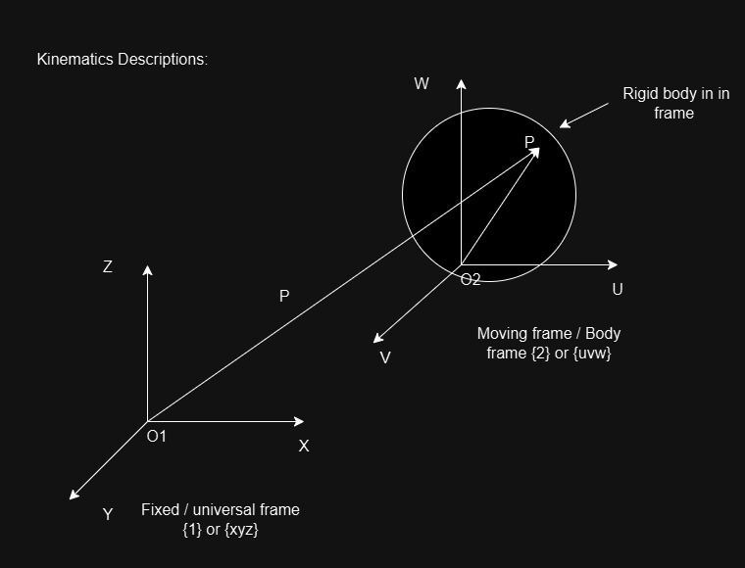

In 3D space, a coordinate frame is a set of three orthogonal right-handed axes [xyz] which are called the three principal axes. These principal axes intersect at a point called the origin of the coordinate frame. It is represented by O. this frame is denoted by {1} or {xyz} other frames in the 3D space are marked in a similar way. Three-unit vectors [XYZ] act along the three principal axes [XYZ] respectively. Position vector of a point P in a frame {1}.

**Mapping:**

Mapping refers to the process of changing the description of a point (or vector) in space from one coordinate system to the other.

Types of mapping:

* Translation.
* Rotation.
* Translation along with rotation(transformation).

**Translation:**

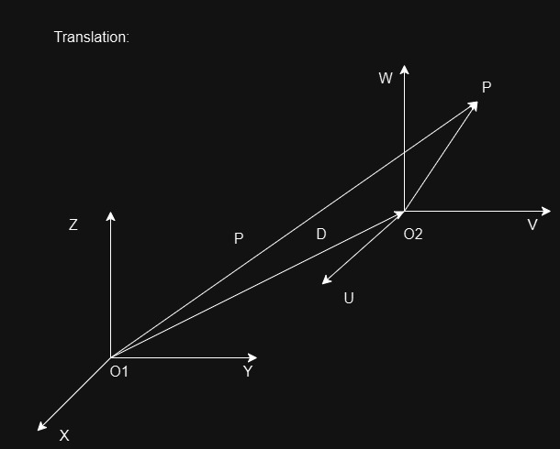

**Orientation Rotation:**

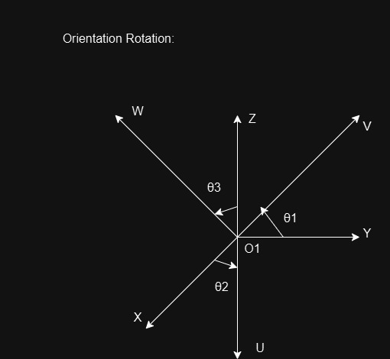

**Translation along with rotation (“Transformation”):**

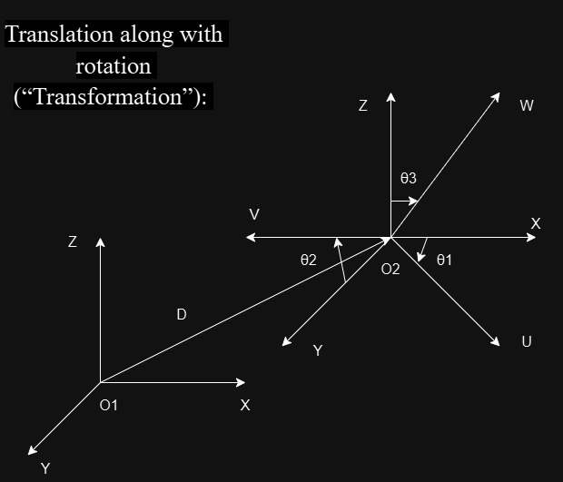

**Robot kinematics:**

**Introduction to position analysis:**

Serial manipulators are made of links and joints. They are also known as open loop manipulator. For a robot to perform a task the location of end effector relative to fired base must be established first. This is called the positional analysis problem. The two types of positional analysis problems are inverse positional analysis, sometimes referred to as inverse kinematics, and direct positional analysis, also known as forward kinematics.

Kinematics: It is the study of motion and geometry combined without considering the motion's causing process. For robot kinematics, we need to develop the kinematic models.

Kinematic model: It is a mathematical relationship between configuration of end effector and spatial configuration of joint and links. For example, simulation. For a given set of geometrical parameters of the robot, we can use its joint variable to compute the position and orientation of each link. We attack a coordinate frame to every link method. We refer to this type of study as forward kinematics.

**Direct / Forward kinematics:**

Given a robot's joint-link characteristics, the task is to determine the end effector's orientation and position in relation to a specified reference frame. For an n-DOF robot manipulator is called the forward kinematic model. This model gives the position and orientation of the end effector as a function of the joint – link variables and other joint – link constants.

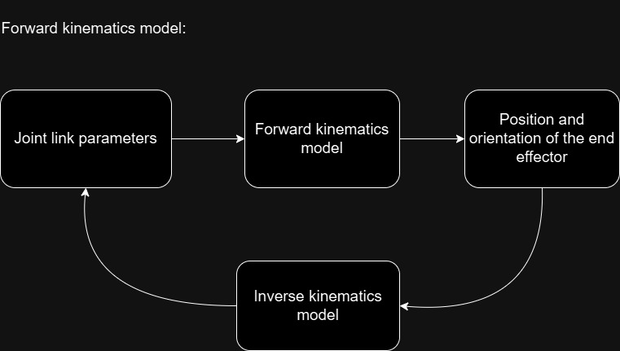

For a serial manipulator, direct kinematics is straightforward, whereas inverse kinematics becomes very difficult on the other hand, for a parallel manipulator, inverse kinematics is very straight forward, whereas direct kinematics becomes very difficult. They are two commonly used methods, denavit and hartenberg’s method and the method of successive screw displacements, are introduced. Both methods are systematic in nature and more suitable for the kinematic analysis of serial manipulators.

**Robot’s mechanical structure – links and joints:**

Any serial manipulator is made up of fixed kink or base, chains of rigid bodies called links and joints containing actuators.

**Link and joint description – notations, coordinate system and parameters.**

**A Generalised link:**

**Link parameters:** link length (a i) and link twist angle (α i) are together known as link parameters. Hence, ai is link length of ith link. α i and the ith link's link twist. To specify position and orientation of a link in space a coordinate frame is attached to each link is frame {i} to link {i}. A link describes the relative position and orientation of joint axes at its two ends. For the two axes (i+1) and i; there exists a mutual perpendicular which gives the shortest distance between the two axes. 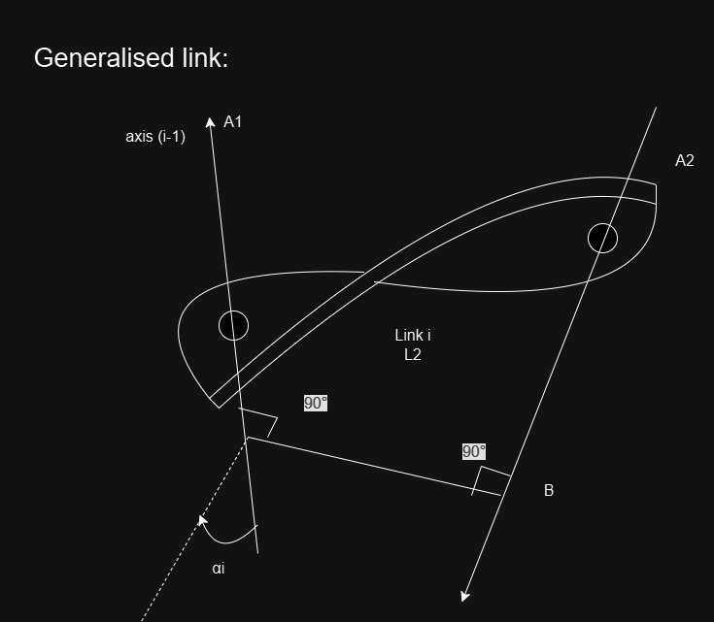

Link length (a i): There is a mutual perpendicular between the two axis (i-1) and i that provides the shortest distance between them. This shortest distance along the common normal to the two axes is defined as the link is denoted as ai.

**Link twist (α i):** The angle between the projection of axis (i-1) and axis i on a plane perpendicular to common normal AB known as the link twist angle and is denoted by α i for the ith link. In the right hard sense, this link twist angle α i is measured from axis (i-1) to axis i with respect to the common normal AB.

**A Generalised Joint:**

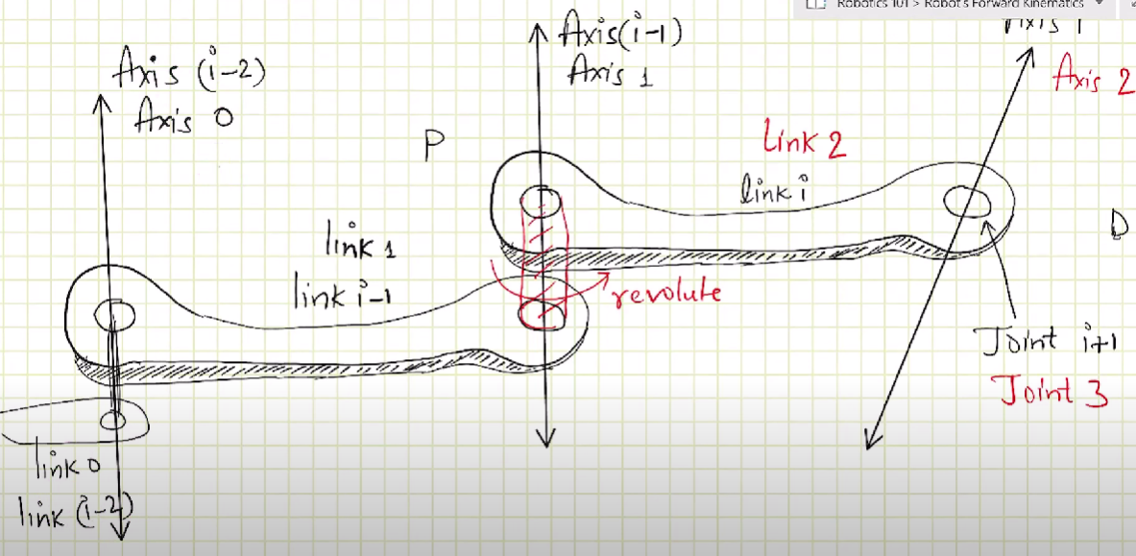For two links connected by a joint the relative position of these links is measured by the displacement at the joint which is either joint angle θ i for revolute joint or joint di for prismatic joint.

**Joint distance di:** perpendicular distance between the two adjacent common Normals ai-1 and ai measured along axis i-1 to make ai-1 intersect with ai.

**Joint angle θ i:** The angle between two adjacent common normal ai-i and ai measured in right-handed direction about the axis (i-1). It is the rotation about the joint axis (i-1) needed to make ai-1 parallel to ai. Therefore, di and θ i are referred to be joint parameters.

Generalised joint displacement variables:

let, generalised joint displacement variable for the ith joint = qi

Therefore, if joint I is prismatic, qi= d i; and if joint I is revolute, qi= θ i. Denavit – Hartenberg convention (DH notation):

It is a convention used for assigning frames to links and identifying the joint and link parameters. It involves a systematic procedure for assigning right-handed orthogonal coordinate frames, one to each link in an open kinematic chain. The four joint link, parameters which are identified using Denavit hertenberg notation are as follows:

ai -> link length.

α i -> link twist

di -> joint distance

Θ i -> joint angle

Di is also known as joint offset. After frame is assigned to each link successfully homogeneous transformation matrices relations the frames attached to successive links, describing the spatial relationship adjustment links are calculated from relationship between adjacent links are calculated from DH table. Finally, composite transformation matrix is calculated from in dividual transformations matrices. This CTM maps the end effector’s frame to the base frame.

**Inverse Kinematics:**

For inverse kinematics, the end effector’s location is known (that is the position and orientation of end effector is known) and the problem is to find out the joint variables needed to bring the effector to the desired position and orientation. The determination of all possible and feasible sets of joint variables, which would achieve the specific position and orientation of the manipulators end effector with respect to the base frame.

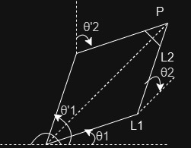**Joint variables:** Systematic representation of joint parameters according to the type of joint.

Position + orientation gives $${}_{}^{0}Y_{n}^{}$$ = $${}_{}^{0}Y_{2}^{}$$. [θ1 and θ2] gives solution of inverse kinematics. [θ’1 and θ’2] gives solution of inverse kinematics. solutions are not unique. J**oint variables:** Systematic representation of joint parameters according to the type of joint. where, q = θi for revolute joint.

q= di for prismatic joint.

**End effector location:**

Location = Position + Orientation

Manipulator’s workspace:

Volume of space in which the manipulator can locate its end effector is called the workspace. Workspace shape is functions of inverse kinematics. Workspace are divided into types they are reachable workspace (RWS) and dexterous workspace (DWS).

Reachable workspace is the region (volume) that can be reached by the origin of the end effector frame with at least one configuration. Manipulability is very poor. Practicality is generally reduced. Whereas dexterous workspace is the space, region or volume where the manipulator’s end effector frame can reach every point from all configurations. Manipulability is greater enhanced as one point can be reached in more than one orientation (configuration). Practicality is improved as end effector is enhanced. DWS is either smaller or same as the RWS. Manipulator workspace is dependent in the mechanical joint limits, configuration of manipulators and on the number of degreee of freedom of the manipulator.

**Solution of Inverse kinematics:**

Inverse kinematics handles equations which are non-linear, simultaneous, transcendental equations. Also, number of equations greater than unknowns i.e., coupled equations or dependent equations. Inverse solutions have unique solutions and no solutions.When desired point p lies outside the reachable workspace. When p is inside RWS, then also not all orientations are realizable, unless p lies with in dexterous workspace.

All position and orientation solution (Finite solution): for a manipulator to have all position and orientation solutions, the number of degrees of freedom DOF mut at least match the number of independent constraints. For general dexterous manipulators, DOF is greater than or equal to 6, it is necessary but not sufficient. For other manipulator with DOF is more or less than six, the solutions are complex and must be analysed on individual basis using a combination of different approaches.

When a manipulator has DOF less than 6, the number of equations is more than the number of unknowns. Thus, called over determined manipulators. These manipulators are not able to attain the desired position and orientation in 3D space. When manipulator is greater than 6, the number of equations is less compared to the number of unknowns. These are called under determined manipulators. These are very difficult to solve as number of unknowns are more, but these manipulators have enhanced dexterity and mobility. When a manipulator has DOF is equal to 6, the number of unknowns is equal to the number of equations. These are solvable but maths id difficult.

**Multiple solutions:** common to have multiple inverse kinematics solutions, robotics due to presence of parallel axes of two consecutive revolute joints. Another reason for multiple solutions is presence of trigonometric functions in equations.

Multiple solutions:

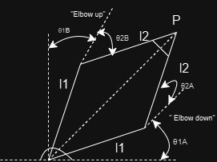

**Solvable manipulators: A** manipulator is said to be solvable if it is possible to find all the solutions to its inverse kinematics problem for a given position and orientation.

**Inverse kinematics solution methods:**

* Geometric technique.
* Decoupling technique.
* Inverse transformation.
* Screw algebra technique.
* Dua matrices technique.
* Dual quaternions technique.
* Iterative methods
* Software packages- Matlab, ROS 2, Robo DK.

**Numerical Solution:**

**Singular and degenerate configuration:**

For robot of any DOF, at singular configuration, the ed effector loses one or more degrees of freedom and the actual degrees of freedom of the robot becomes less than the dimensions in which it actually operates. At singularity, the kinematic equation becomes linearly dependent and some solutions (out of total solutions) becomes undefined.

**Singular configurations occurs when:**

* Two axes of prismatic joints become parallel.
* Two axes of revolute joints become identical.

At singular configuration, because the velocity needed to move the end-effector reaches infinity torque. To determine singular configurations, we use Jacobian matrix [manipulator or differential motion and statics].

**Artificial intelligence:**

*Artificial intelligence* is a popular branch of computer science which plays an important role in building and manipulating machines which matches the human intelligence. It provides the multiple approaches and different types of solutions for a particular problem by which machines can create their known solutions to a specific problem.AI helps machines to improve their capabilities capacity and it also create tools. Now-a-days humans are using AI tools more often because of their accurate solutions, as a result AI has become an important part of our day-to-day life.

**Artificial intelligence Model:**

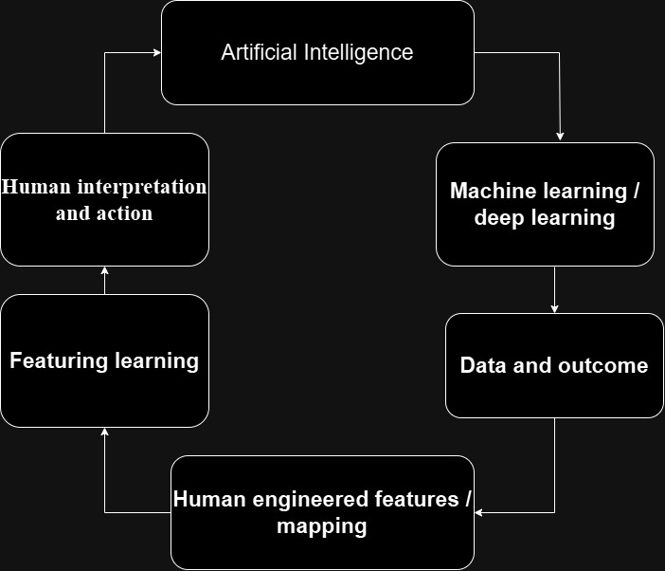

**Techniques used for robotic arms by artificial intelligence:**

* ***Precision and control:***

Precision refers to the target by which a robot arm can reach the position without any deviation. Control is important on a robot because small errors can have a huge consequence. Robotic arms contain many sensors which may get activated and can get deviated from the task so in this situation AI adjusts so that it remains on the target. Precision even means to stick to a particular algorithm which helps robotic arms to reach its destination in a minimal required time, it allows robotics arms to move smoothly and make less unnecessary hand movements, so the task is done accurately on time or before time. AI gives advanced mechanical control techniques to robot to perform a task finely, where when we compare human and robot the robot can do the task more easily and comfortably compared to human. For example, precision and control is more often used for accurate movements like surgery, in surgeries human hands may be hesitated or we observe most surgeons shaking their hands so to avoid this we may use robotic arms because it moves the robotic arm precisely in a controlled pattern.

* ***Vision systems:***
* It is an application of artificial intelligence (AI), Vision system refers to visual representation for robotic arm. It helps to interpret the visual information i.e., to locate, to pick up, to place a thing or to interact with the objects. Vision system mainly deals with cameras visual presentation, the cameras are placed in the robotic arm to capture an object. These can include 2D and 3D cameras depending on an application. It even manages the light in the visual presentation so that the robotic arm can capture clear images. It controls the visibility and reduce the shadows and sees that nothing interferes the image processing, with help of visual system we can even detect a particular object, it allows to identify the particular object clearly and then the robotic arms perform the task.it is responsible for face recognition such has shape, colour or size and then stores it in the memory to perform a task. Visual system of robotic arms is more often used in manufacturing, surgery, quality control, logistics and warehousing, research and development. 2D and 3D cameras, for instance, are employed for visualization. ***Grasp planning:***

Grasp planning is a blueprint for the given task which guides the robotic arms according to the task. The grasp planning includes different type of algorithms and different types of approaches by making the task in minimal time. It includes previous experiences and improves the success rate according to the task. It provides different types of sensors which are related to shape, size, object, weight and resistance. AI gives the algorithms according to their respective sensors so that they can act as soon as they are assigned a task.

* ***Imitation learning:***

AI provides algorithms that help robotic arms to manipulate the complex tasks that are done by humans. Robotic arms are designed in such a way that robotics arms can observe humans doing a specific task and imitate the same thing within no time, robotic arms can learn many actions such as working, picking objects, placing objects or repeating the work in less time. They are designed to observe and mimic the same actions. They perform actions like food handling, packing and helping humans in day-to-day life.

* ***Path optimization:***

AI algorithms, provides deep observing skills to robotic arms, so that they can mimic it exactly. These observing skills even include analysing a task and even improving the process, as we know robotic arms mimic human actions so by observing a task a robotic arm can even change the process and improve the working by doing less work or by doing less hand movement or adjust the hand movements accordingly to perform the task quickly, efficiently and with minimal energy consumption and by performing safe operations and less operations to avoid any damage. They even analyse the collisions which come under process of working for the task and they try to avoid the collisions. By avoiding the collisions, they save time and do the work properly before the task is done.

* ***Autonomy:***

AI helps robotic arms to perform a task without any mistakes and help from others. It gives algorithms which give strength to make own decisions and actions to complete the task. Robotic arms do task autonomously by avoiding the collisions or mistakes, which make the task done minimum time ad all the robotic arms work simultaneously without wasting the time. These are more often implemented in industries like manufacturing, logistics, healthcare, and even autonomous vehicles.

**Machine learning:**

***Machine learning*** is a subset of artificial intelligence; it helps us to verify data based on predictions and perform the task according to the required situations. It helps by feeding large amount of data to the machine at a time and helps the machine to identifies its own strategies. Machine learning is mainly based on three algorithms which provide the best approaches to feed the data or to improve the performances of the machines. Machine learning approaches helps us to analyse the large amount of data, it creates a best possible action carried out by the machine.

***Approaches:***

* Supervised learning algorithm
* Unsupervised learning algorithm
* Reinforcement learning algorithm
* Deep learning algorithm
* SUPERVISED LEARNING ALGORITHM

.  **ROBOTIC ARMS:**

***Robotic arms*** are the application of robots. Robotic arms are vastly used in large scale industries. They are different types of robotic arms which are used in different places. Construction of the robotic arms is difficult because of complex structures and complex mechanisms, as we know the establishment of artificial intelligence is the main key of constructing robots without any complexity. Now a days because of artificial intelligence the algorithm and techniques are being implemented easily. Robotic arms react Fastly and are very stylish by their structure. We use different arms for different jobs.

**Types of robotic arms are,**

* Articulated arm
* Six-axis
* Collaborative robot
* SCARA
* Cartesian
* Cylindrical
* Spherical or polar
* Parallel or delta
* Anthropomorphic
* ***Articulated arms:***

***Laser mechanism articulated arm:***

These arms are used in medical field or in industries where the laser must move easily or Fastly. These arms have five or more than five joints so that the arm can move flexibly and is fast enough to perform every operation at the given time.

* ***Six-axis robots:***

Six – axis robots come under articulated robots; they are mainly used for industrial purposes. They are well known for their flexibility and fast movement the arms in six- axis robots are based on x, y and z planes. They can perform pitch, yaw and roll movements, these makes the robots to perform similar actions compared to human, is more productive in nature. Six- axis robots have six arms; each arm has freedom to perform each assigned action.

***Movements of each axis of six-axis robots:***

* ***Axis one:*** this axis is located at the base of the robot. It helps the robots to move in two specific directions at a degree of 180, i.e., it helps the robot to move left or right at a specific angle.
* ***Axis two:*** this axis controls the lower part of the arm it provides forward and backward movements. These axis takes responsibility of lifting, placing, moving an object from a place along the x and y planes.
* ***Axis three:*** this is same as axis two but in this axis the arm is lowered to raise the upper arm, it increases the vertical reach of the arm. this arm uses all the planes (x, y and z).
* ***Axis four:*** This arm helps in rotating motion. The function of this arm is to rotate the arm at a degree of 360 and perform the action. The upper arm rotates in the circular motion.
* ***Axis five:*** the axis five also works on the movement of the upper arm as the axis four but this arm focuses on yaw and pitch movements. Pitch movements are used to move the tip of the arm in up or down direction. Whereas Yaw movements are used to move the arms in left or right directions.
* ***Axis six:*** this is a wrist of an industrial robot, which helps to perform the functions pitch, roll and yaw. Depending on the task, it uses all the a, y, and z planes and permits 360-degree wrist movement.
* ***The collaborative robot:***

These robots are called Cobots or collaborative robots. When we talk about industrial robots they are kept away from the humans because they don't know that humans are near them, and they can hurt humans. For this problems scientist came up with a modern solution which refers to cobots. In cobots, the robots work aside the humans.

As we know modern problems have modern solutions, here the problem is solved by installing the sensors in robots. These robots act according to their surroundings, it even has a safety mode if they sense any contact around them. For example, now there are slightly changes in the behaviour of industrial robots, they are slowed whenever a human comes in their contact.

* ***SCARA robots:***

Firstly, SCARA stands for Selective Compliance Assembly Robot Arms, the arms of the robots move freely and stiffly and are used to pick and place, sorting and assembly. here the robot's arms are fixed at the final axis and maintains the movements and stiffness of the robotic arms. they have 4 axes with 2 parallel hands situated at the right angle of the axis. The SCARA Robots are mostly known for their accuracy and precision outputs. They move Fastly and reduce the number of errors in the process of completing a task, they are widely used in industrial machines.

* ***Cartesian robots:***

Here cartesian robots are also known as linear robots, it works on the principle of moving in a rotatory motion on the orthogonal axes- X, Y and Z axes. it coordinates with each axis and controls the movement i.e., circular movements of an arm. Some of the major applications of cartesian robots are CNC machine (computer numerical control machines) and 3D printing, camera, laser etc.,

* ***Cylindrical robots:***

Cylindrical robots are known for their unique design and style. These robots are mechanically having a rotatory axis at the base for rotation. To control height hands, they have linear axes. They occupy minimal workplace. Applications of cylindrical robots are it tends and handles the machine and material, welding, palletization and dispensing.

* ***Spherical / Polar robots:***

Another name for polar robots is spherical robots. It has one linear joint and two rotatory joints, it has an arm whose hand has a twisting joint which allows to create a polar coordinate system, these are located at the base of robot. Applications of polar robots are tending machine tools, automation handling, assembly operations, automated die casting process tending and many more.

* ***Parallel / delta robots:***

These robots have a specific speed automation which helps to complete the task in time or before time. It is a unique design compared other robots. Delta refers to a triangle where triangle faces downwards. A Gripper is connected to the mechanical linkages. industries in which delta robots are used: pharmaceuticals, food beverages, retail Packinging, cosmetics, medical, additive manufacturing. Applications of delta robots are pick and place, assembly, disassembly, packing, sorting.

***Industries and applications for robotic arms:***

***Common industries include:***

* Aerospace
* Automotive
* Metals
* Food and beverages
* Pharmaceuticals
* Plastics
* Health sciences
* Electronics

***Applications of robotics arms are:***

* Packaging
* Palletizing
* Material handling
* Painting
* Welding
* Assembly
* Inspection
* Cutting
* Dispensing

**When to use robotic arms:**

* When there is a requirement of high precision.
* To perform a heavy or dangerous work.
* When there is receptive task with high volume work.
* When there is a use of remote or teleoperation.

**When not to use robotic arms:**

* When the given works comes under complex or adaptive tasks.
* When there is a highly customized production or a low volume work.
* When there are fewer budget constraints.
* When there are tasks which require more sensors than required.

**Cost Consideration on robotic arms:**

* Cost consideration include robotic arm prices, the tools attached to the robotic arms
* There are end effectors like grippers, welders, or drills etc., these require a constant installation or an update which helps to perform a task without any interruption.
* Robotic arms also need software and programs which decide the path of the execution or a process to finish the assigned work. They customize robotic arms according to the task.
* Robotic arms need routine Maintenace, repairs and spare parts of the specific parts of the robot’s arm.
* Industries need a staff who can handle technical needs of a robotic arm. The technician needs to train and operate the robotic arm according to the given task.
* Robots consume more electricity as compared to human so the power consumption by robots are more.