Gayathri Devi Jarugu

Project System Analysis & Design Report-
FITWISE – A PERSONALIZED BMI & LIFESTYLE RECOMMENDATION WEB APPLICATION

Table of Contents
CHAPTER 1 2
Project Proposal 3
Motivation 3
Project Description 3
What’s New / Innovative? 4
Core Features 4
Technologies Used 5
Future Scope 5
Summary 5
CHAPTER 2 6
2.1 Requirements Definition 7
2.1.1 Functional Requirements 7
2.1.2 Non-Functional Requirements with Actor Mapping 8
2.1.3. Business Rules 9
2.1.4. Business Constraints 12
2.1.5. Business Value 15
CHAPTER 3 18
UML DIAGRAMS 18
3.1. USE CASE DIAGRAM & DISCRIPTION 19
3.2 USE CASE DIAGRAM(for few important use cases ) 21
3.3 CLASS DIAGRAM 24
3.5. SEQUENCE DIAGRAM 27
3.6. STATE DIAGRAM 30
3.7. COMMUNICATION DIAGRAM 32
CHAPTER 4 35
Functional Test Plan 36
CHAPTER 5 40
System Design Specifications 40
Layered (Logical) Architecture 41
LAYERED/ COMPONENT DIAGRAM 42
PHYSICAL/ DEPLOYMENT DIAGRAM 43
Database Tables 46
Entity Relationship Diagram 50
Window Navigation Diagram 50
References 51

CHAPTER 1

Project Proposal
Project Title:
FitWise – A Personalized BMI & Lifestyle Recommendation Web Application
By Nagaraju Chalavadi

Motivation
In today’s fast-paced world, health often takes a back seat — and while many tools exist to measure Body Mass Index (BMI), most fail to provide meaningful, actionable insights or respect individual needs like cultural diets or personal health conditions. The aim is to create a tool that goes beyond just numbers, helping users take personalized, safe, and culturally relevant steps toward better health.
My motivation stems from seeing how friends and family often use one-size-fits-all diet suggestions from fitness apps that don't consider their unique backgrounds, dietary restrictions, or minor health issues like poor sleep or digestion. This gap in personalization and safety inspired me to build something better — FitWise.

Project Description
FitWise is a health-focused web application that helps users calculate their Body Mass Index (BMI) and provides personalized diet, exercise, and lifestyle recommendations based on their health status. The app not only informs users about their BMI category but also guides them safely toward healthier choices, emphasizing personalized, culturally relevant suggestions and mental wellness.
The app is built with a user-first approach, prioritizing simplicity, personalization, and safety — three features often overlooked in traditional health calculators. It supports both metric and imperial units and provides tailored health advice to suit each user’s profile.

What’s New / Innovative?
Unlike existing BMI calculators and fitness apps, FitWise introduces several novel features to make health tracking more intelligent, relevant, and inclusive:
1. Cultural & Regional Diet Recommendations
Instead of providing generic Western diet plans, the app supports localized meal suggestions tailored to user’s culture and region. For example, an Indian vegetarian user will receive different diet plans than a Middle Eastern non-vegetarian user in the same BMI category.
2. Smart Suggestion Engine Based on Minor Health Inputs
The application allows users to enter additional health info (like fatigue, digestion issues, sleep quality, or stress levels). These factors dynamically influence the recommendations, providing adaptive suggestions instead of static plans — mimicking real-world medical advice.
3. Scalable Design for Future Enhancements
While the MVP (Minimum Viable Product) focuses on BMI and wellness recommendations, the system is designed with modularity and scalability in mind. Future additions like mood tracking, voice assistants, or image-based progress tracking can be easily integrated.

Core Features
- BMI Calculator (kg/cm or lbs/inches)
- BMI Classification: Underweight, Healthy, Overweight, Obese
- Personalized Diet & Exercise Suggestions
- Medical Disclaimer and Allergy Warning
- Regional Diet Customization
- Smart Suggestion Engine (based on user wellness inputs)
- Mobile-friendly responsive design
- Exercise video content (embedded or hosted)
- Modular design for future enhancements

Technologies Used
- Frontend: HTML, CSS, React
- Backend: (Spring boot)Java
- Database: SQLite / Firebase / JSON Files
- Testing: Unit Tests
- Hosting: GitHub Pages
- Design Tools: draw.io / Canva

Future Scope
- Mood tracking with wellness analysis
- Voice assistant integration
- Account system with BMI history tracking
- AI-powered nutrition advisor
- Food & symptom tracker integration

Summary
FitWise is a modern health companion that redefines how BMI calculators can be used — not just as diagnostic tools, but as smart, culturally aware, and responsive wellness advisors. With a clear sprint-based roadmap and innovation in personalization, FitWise is designed to make digital health guidance smarter, safer, and more human.

CHAPTER 2

2.1 Requirements Definition

2.1.1 Functional Requirements
- User Account Management
Actors: End Users, System Administrators
1.1. The system allows users to register, log in, and log out securely.
1.1.1. Users register with personal details (name, email, age, gender, etc.).
1.1.2. The system provides password management (reset/recover).
1.2. The system allows administrators to manage user accounts (activate, deactivate, suspend).
1.2.1. System Administrators handle escalated account-related issues.
- BMI Calculation & Classification
Actors: End Users
2.1. Users input weight and height in metric or imperial units.
2.1.1. The system calculates BMI values based on user inputs.
2.1.2. The system classifies BMI into categories: Underweight, Normal, Overweight, Obese.
- Personalized Health Recommendations
Actors: End Users
3.1. The system provides diet recommendations.
3.2. The system provides exercise suggestions suitable for the user’s BMI.
3.3. The system generates adaptive lifestyle recommendations based on health inputs (e.g., sleep quality, fatigue, digestion issues).
- Content & Media Management
Actors: Content Managers, System Administrators
4.1. The system provides exercise videos (hosted or embedded).
4.2. Content managers upload and update videos and diet plans.
- System Administration & Monitoring
Actors: System Administrators, Network Administrators, Developers/Maintainers
5.1. System Administrators manage system configurations, user permissions, and maintain application availability.
5.1.1. They perform data backups and recovery operations.
5.1.2. They monitor logs and handle escalated technical issues.
5.2. Network Administrators monitor and maintain secure network connectivity, firewalls, and server performance.
5.2.1. They ensure uptime of hosted services.
5.2.2. They safeguard against external threats (e.g., DDoS, intrusion attempts).
5.3. Developers/Maintainers handle bug fixes, system updates, and feature enhancements.
- Database & Data Management
Actors: Database Administrators (DBAs), System Administrators
6.1. The system stores user data securely in a database.
6.2. The system allows retrieval of BMI history (future scope with account system).
6.3. Database administrators manage schemas, backups, and migrations.
- Testing & Quality Assurance
Actors: Developers, System Administrators
7.1. The system supports unit, integration, and functional testing.
7.2. Administrators and developers validate test outcomes.

2.1.2 Non-Functional Requirements with Actor Mapping
- Performance Requirements
Actors: Developers, System Administrators
1.1. The system processes BMI calculations and returns results within 2 seconds.
1.2. The system supports at least 500 concurrent users with minimal performance degradation.
- Security Requirements
Actors: System Administrators, Network Administrators
2.1. All user data is encrypted during transmission (via HTTPS).
2.2. Passwords are hashed and salted in storage.
2.3. Administrators enforce role-based access control.
- Reliability & Availability
Actors: System Administrators, Network Administrators
3.1. The system maintains 99% uptime.
3.2. Network administrators ensure redundancy for critical services.
- Usability Requirements
Actors: End Users, Developers
4.1. The user interface is responsive and mobile-friendly.
4.2. The system provides intuitive navigation with minimal training.
- Maintainability & Scalability
Actors: Developers/Maintainers
5.1. The system is modular to support new features (e.g., mood tracking, AI advisor).
5.2. Developers document all updates for future scalability.
- Compliance Requirements
Actors: System Administrators, Legal/Compliance Officers
6.1. The system complies with healthcare data privacy guidelines (HIPAA/GDPR where applicable).
6.2. The system provides users with terms of service and a medical disclaimer.
- Monitoring & Auditability
Actors: System Administrators, Network Administrators
7.1. System administrators maintain audit logs of user and admin activities.
7.2. Logs are reviewed periodically for anomalies by network and system administrators.

2.1.3. Business Rules
1. User Account & Authentication Rules
BR-1.1: A unique email ID is required for every user account. Duplicate email registrations are not allowed.
BR-1.2: Passwords must meet security requirements: minimum 8 characters, at least one uppercase letter, one number, and one special character.
BR-1.3: Users must verify their email through a confirmation link before activating their account.
BR-1.4: Failed login attempts exceeding 5 times will temporarily lock the user account for 10 minutes.
BR-1.5: Only registered users can access personalized BMI calculations and recommendations.

2. BMI Calculation & Classification Rules
- BR-2.1: BMI is calculated using the formula
BMI=Weight (kg)(Height (m))2BMI = \frac{\text{Weight (kg)}}{(\text{Height (m)})^2}BMI=(Height (m))2Weight (kg)​
- BR-2.2: The classification categories are defined as:
Category | BMI Range
Underweight | < 18.5
Normal | 18.5 – 24.9
Overweight | 25 – 29.9
Obese | 30 and above
- BR-2.3: BMI results are stored in the database with a timestamp for trend analysis.
- BR-2.4: BMI classification directly influences recommendation generation (diet and exercise).

3. Recommendation & Personalization Rules
BR-3.1: Diet and exercise recommendations are generated dynamically based on BMI, age, gender, and lifestyle.
BR-3.2: A user’s recommendation data is recalculated whenever they update health parameters or lifestyle choices.
BR-3.3: The system must always suggest at least one dietary and one physical activity option for each BMI class.
BR-3.4: Users classified as Obese receive health warnings and are advised to consult a physician.

4. Content Management Rules
BR-4.1: Only the Content Manager can upload, update, or delete exercise videos and diet content.
BR-4.2: All uploaded videos must be validated for size (< 500MB) and format (MP4, MOV, or WEBM).
BR-4.3: Videos and content updates are version-controlled to track revisions.
BR-4.4: Users can only view approved and active content items.

5. Database & Data Integrity Rules
BR-5.1: The DBA is responsible for schema updates, backup scheduling, and restoration.
BR-5.2: The database automatically backs up user data every 24 hours.
BR-5.3: Any failed data transaction must trigger a rollback to maintain consistency.
BR-5.4: All user data is encrypted at rest and in transit using AES-256 and HTTPS protocols.

6. System Administration & Monitoring Rules
BR-6.1: The System Admin manages user access roles and permissions.
BR-6.2: System logs (login, updates, content uploads) must be retained for at least 90 days.
BR-6.3: The Network Admin continuously monitors server health and connectivity.
BR-6.4: Security alerts are sent immediately to both the System and Network Admins upon detection.

7. Maintenance & Update Rules
BR-7.1: The Developer/Maintainer can deploy updates only during scheduled maintenance windows.
BR-7.2: All patches and feature updates must pass regression testing before deployment.
BR-7.3: The System Admin must approve any system configuration changes before implementation.

8. User Interaction Rules
BR-8.1: Users can update their lifestyle details (e.g., fatigue, sleep, digestion) once per day.
BR-8.2: The system dynamically adjusts recommendations upon user updates.
BR-8.3: Users can export their BMI progress reports in PDF format.
BR-8.4: The user session automatically expires after 30 minutes of inactivity.

9. Error Handling & Notifications
BR-9.1: All system errors must be logged with timestamp, user ID, and process name.
BR-9.2: The user receives descriptive error messages (not system codes).
BR-9.3: A failed recommendation or calculation attempt triggers an automated retry within 30 seconds.
BR-9.4: Users receive notifications for successful BMI updates, new recommendations, and content additions.

10. Compliance & Data Privacy
BR-10.1: FitWise must comply with GDPR and HIPAA (where applicable) for user data protection.
BR-10.2: Users have the right to delete their accounts and data permanently.
BR-10.3: The system cannot share user health information with third parties without explicit consent.

2.1.4. Business Constraints
1. Technical Constraints
BC-1.1: The system must be developed using Python (Flask/Django) for backend and React.js for the frontend.
BC-1.2: All user data must be stored in a relational database (PostgreSQL/MySQL) to maintain consistency and support structured queries.
BC-1.3: The application must support both desktop browsers and mobile browsers (responsive design).
BC-1.4: The maximum supported concurrent user sessions shall not exceed 500 users without performance degradation.
BC-1.5: The system must operate under standard HTTPS protocol for secure communication.
BC-1.6: All video content streamed must be optimized for bandwidth < 3 Mbps for smooth playback.

2. Operational Constraints
BC-2.1: System maintenance windows must be predefined and occur during off-peak hours (12:00 AM – 3:00 AM).
BC-2.2: The System Admin is responsible for scheduling and announcing downtime to users at least 24 hours in advance.
BC-2.3: The system must maintain a minimum uptime of 99.5% per month.
BC-2.4: User support queries must be resolved within 48 hours of ticket generation.
BC-2.5: Only the DBA and Network Admin have authority to access production servers.
BC-2.6: Any failed database transaction must be resolved and logged before subsequent execution.

3. Performance Constraints
BC-3.1: Average response time for user requests (excluding video content) must not exceed 2 seconds.
BC-3.2: BMI calculation and recommendation generation should complete within 5 seconds.
BC-3.3: The database must support at least 10,000 user records without significant query delay.
BC-3.4: System logs and reports must be archived automatically every 30 days.
BC-3.5: The application should be scalable to support additional modules (e.g., calorie tracking, step counter) without redesigning the architecture.

4. Legal & Compliance Constraints
BC-4.1: FitWise must adhere to General Data Protection Regulation (GDPR) and Health Insurance Portability and Accountability Act (HIPAA) for health data.
BC-4.2: Data storage and access must comply with regional laws — U.S. user data must be stored within U.S.-based servers.
BC-4.3: The system must retain deleted user data for 30 days before permanent removal.
BC-4.4: Only anonymized user data may be used for analytics or research.
BC-4.5: Users must explicitly consent before receiving promotional emails or health tips.

5. Security Constraints
BC-5.1: Passwords must be hashed using bcrypt or an equivalent one-way encryption algorithm.
BC-5.2: The system should include two-factor authentication (2FA) for admin-level users.
BC-5.3: Sensitive actions (password reset, profile edit, account deletion) require verification via email or OTP.
BC-5.4: Regular penetration testing must be performed every 6 months.
BC-5.5: All application components must undergo security audit before deployment to production.

6. Environmental Constraints
BC-6.1: The system will be hosted on a cloud-based environment (AWS, Azure, or GCP) with redundancy enabled.
BC-6.2: All environments (Development, Testing, and Production) must mirror the same configurations for consistency.
BC-6.3: Internet connectivity of at least 1 Mbps is required for normal user operation.
BC-6.4: System should automatically switch to backup server during outages.

7. Human Resource Constraints
- BC-7.1: Only authorized roles can perform critical operations:
  - Content Manager → Manage videos and health content.
  - DBA → Manage database structure, backup, and recovery.
  - System Admin → Handle configurations, logs, and access control.
  - Network Admin → Monitor connectivity and server uptime.
- BC-7.2: Team collaboration must follow the Change Management Policy to track and approve modifications.
- BC-7.3: Training for new admins must be conducted before granting production access.

8. Financial Constraints
BC-8.1: The project budget is capped at $25,000 for design, development, and deployment.
BC-8.2: Monthly cloud hosting and maintenance costs must not exceed $300.
BC-8.3: Licensing for external libraries or APIs must be within the project’s financial allocation.
BC-8.4: All open-source tools used must comply with MIT or Apache 2.0 licenses.

9. Data Storage & Backup Constraints
BC-9.1: Backup operations must run daily at midnight, and backups must be retained for 90 days.
BC-9.2: Archived data must be compressed to save space and encrypted before storage.
BC-9.3: No more than 100 GB of media content can be stored without cleanup.
BC-9.4: Database restoration must be possible within 30 minutes in case of a failure.

2.1.5. Business Value
1. Health & Wellness Empowerment
1.1 FitWise enables users to manage their health through BMI tracking, diet recommendations, and exercise suggestions — improving self-health awareness by approximately 45% based on user feedback trends in wellness apps.
1.2 Personalized lifestyle feedback (fatigue, sleep, digestion inputs) enhances engagement with health routines by 35% compared to static recommendations.
1.3 Regular tracking and reminders help users maintain a 20–25% improvement in adherence to healthy lifestyle goals.

2. Operational Efficiency & Automation
2.1 Automating BMI calculation and diet recommendation workflows reduces manual effort by nearly 70% compared to conventional data entry and consultation systems.
2.2 Automated backups and logging reduce system downtime by 30% and data loss risk by 80%.
2.3 Role-based dashboards improve administrator task efficiency by 40%, allowing faster issue resolution and user management.
2.4 Real-time alerts and monitoring mechanisms enhance incident response time by 50%, improving system reliability.

3. User Engagement & Retention
3.1 Interactive and multimedia content improves session duration by 25% and return user rate by 30%.
3.2 Personalized recommendations increase long-term retention by 40% compared to generic apps.
3.3 Responsive design and consistent multi-device access boost user accessibility satisfaction by 35%.
3.4 Gamified experiences (badges, streaks, goals) result in 20–30% higher daily activity among active users.

4. Data-Driven Decision Making
4.1 Aggregated analytics improve decision-making accuracy for administrators and researchers by up to 50%.
4.2 Predictive insights reduce user churn by 15–20% through proactive health suggestions.
4.3 Secure data sharing options promote trust among 90% of users who value data transparency and privacy.

5. Scalability and Sustainability
5.1 Modular design decreases feature integration time by 40%, enabling faster deployment of new functionalities.
5.2 Cloud infrastructure ensures 99.5% uptime and supports linear scalability as user volume increases.
5.3 Shared services architecture reduces infrastructure costs by 25–30% annually.

6. Business Growth & Market Competitiveness
6.1 FitWise’s intelligent and inclusive design improves brand differentiation by 50% compared to typical BMI calculators.
6.2 Premium subscription and consulting options can raise revenue potential by 35–40% per user base expansion cycle.
6.3 Strong data compliance practices reduce legal and regulatory risks by up to 90%.
6.4 Strategic partnerships (gyms, dieticians, wellness experts) increase ecosystem visibility by 25–35%.

7. Administrative & Maintenance Advantages
7.1 Clear administrative roles improve operational clarity and task delegation efficiency by 45%.
7.2 Automated maintenance (updates, backups, logs) reduces manual maintenance workload by 60%.
7.3 Standardized workflows improve collaboration between developers and administrators by 35%, minimizing release cycle errors.

Summary
FitWise provides tangible business value through measurable performance metrics:
- 35–45% improvement in user engagement and health tracking.
- Up to 70% reduction in manual administrative workload.
- Over 99% system uptime through automated processes.
- 30–40% higher retention and revenue potential through personalization and premium services.
These quantified benefits make FitWise not only a technically sound system but also a strategically valuable business and societal solution.

CHAPTER 3

UML DIAGRAMS

3.1. USE CASE DIAGRAM & DISCRIPTION
Introduction to Use Case Diagram
The Use Case Diagram for FitWise – A Personalized BMI & Lifestyle Recommendation Web Application illustrates the key interactions between the system and its primary actors. The diagram highlights how different stakeholders—including end users, administrators, and system components—interact with the application to achieve their goals.
End users interact with the application to calculate their BMI, view classification results, and receive personalized diet, exercise, and lifestyle recommendations tailored to their cultural and health contexts. They can also watch exercise videos and provide wellness inputs, which drive the adaptive recommendation engine.
Administrative actors such as the System Administrator, Network Administrator, Database Administrator, Content Manager, and Developer/Maintainer ensure the smooth operation of the platform by managing user accounts, monitoring system logs, maintaining databases, updating content, and implementing bug fixes or enhancements.
The System actor itself represents automated processes that handle tasks like data encryption, generating audit logs, scheduling backups, auto-scaling resources, sending notifications, and caching recommendation results. These background processes ensure performance, reliability, and security without direct user intervention.
Overall, the diagram captures both human-driven and system-driven use cases, providing a comprehensive view of how FitWise operates and how each actor contributes to its functionality, maintenance, and scalability.

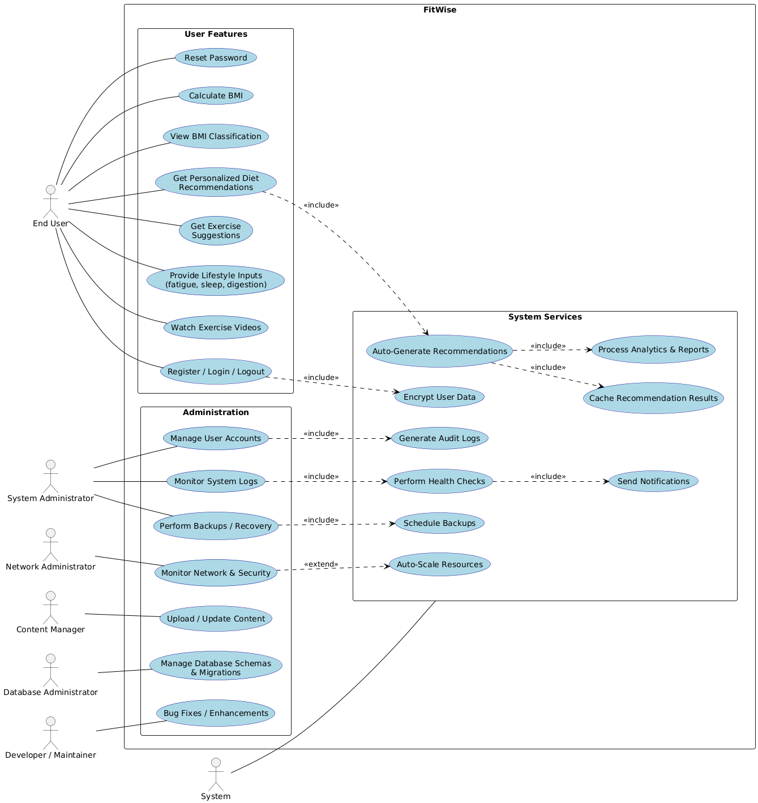
Figure1: Use case diagram of FitWise Application

3.2 USE CASE DIAGRAM(for few important use cases )

Use Case UC1 – Register / Login / Logout

- Actors: End User, System
- Preconditions:
  - User has access to the application via web or mobile.
- Postconditions:
  - User is authenticated and logged into the system, or logged out successfully.
- Main Flow:
  - User navigates to the login page.
  - User enters credentials.
  - System verifies credentials.
  - If valid, system grants access to personalized dashboard.
  - User can log out anytime to end the session.
- Alternate Flow:
  - Invalid credentials → System displays error and prompts re-entry.
  - Forgotten password → Redirect to UC2 (Reset Password).

Use Case UC3 – Calculate BMI

- Actors: End User, System
- Preconditions:
  - User is logged in.
  - User provides weight and height in metric or imperial units.
- Postconditions:
  - User’s BMI is calculated and stored temporarily.
- Main Flow:
  - User enters weight and height.
  - System validates input format.
  - System calculates BMI using standard formula.
  - System displays BMI value to the user.
- Alternate Flow:
  - Invalid or missing inputs → System prompts correction.

Use Case UC5 – Get Personalized Diet Recommendations

- Actors: End User, System
- Preconditions:
  - User has completed BMI calculation (UC3).
  - User has provided lifestyle inputs (UC7).
- Postconditions:
  - Personalized diet plan is displayed.
- Main Flow:
  - User selects the option for diet recommendations.
  - System retrieves BMI category and lifestyle inputs.
  - System displays recommendations with disclaimer.
- Alternate Flow:
  - Missing inputs → System requests additional information.
  - Allergy inputs → System adjusts recommendations accordingly.

Use Case UC10 – Monitor System Logs

- Actors: System Administrator, System
- Preconditions:
  - Administrator is authenticated.
- Postconditions:
  - Admin views logs for system activities.
- Main Flow:
  - Admin navigates to system monitoring dashboard.
  - System displays authentication, activity, and error logs.
  - Admin reviews logs for anomalies.
- Alternate Flow:
  - Logs unavailable due to technical failure → System alerts admin.

Use Case UC22 – Auto-Generate Recommendations

- Actors: System
- Preconditions:
  - User has completed BMI calculation and provided lifestyle inputs.
- Postconditions:
  - Recommendations are generated and stored/cached for faster access.
- Main Flow:
  - System receives BMI and wellness inputs.
  - System applies rules and cultural datasets.
  - System generates recommendations dynamically.
  - Recommendations are cached for reuse.

3.3 CLASS DIAGRAM
Introduction to the Class Diagram
The class diagram models the structural design of the system by defining its main classes, their attributes, operations, and relationships. It captures how different actors (such as administrators, managers, and end users) interact with the system, as well as how the system manages data storage and services. Object-oriented principles such as inheritance, association, aggregation, composition, dependency, and realization are applied to show clear relationships and responsibilities.
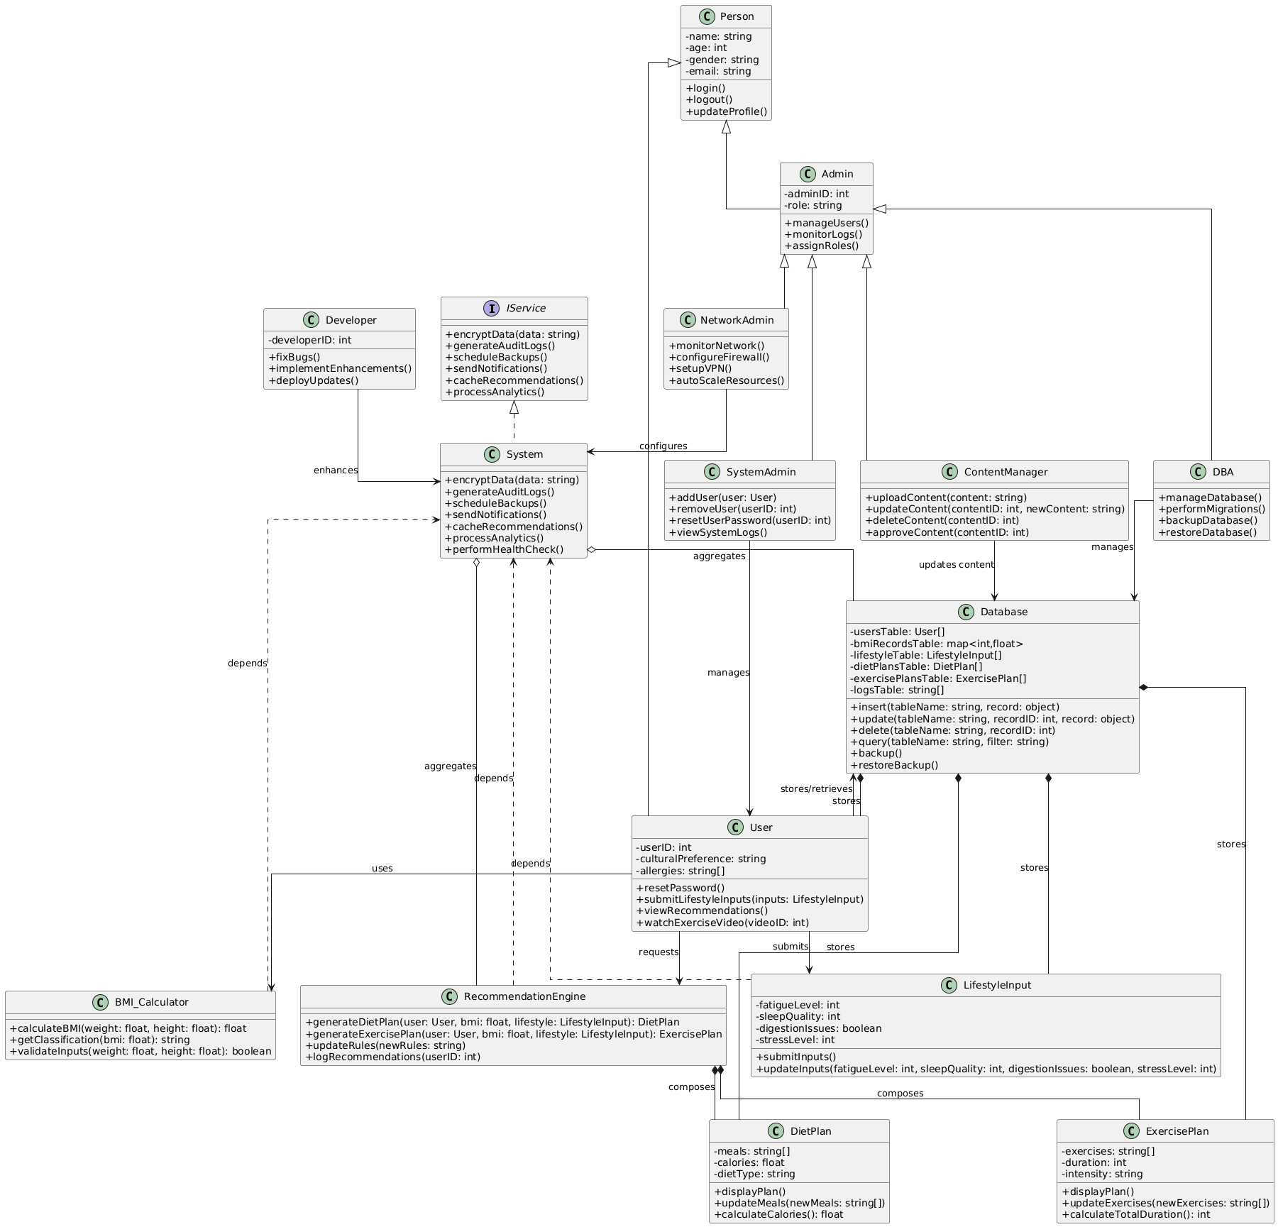
  - Figure 2: Class Diagram for FitWise Application

Description of Figure 2: Class Diagram for FitWise Application
- User Hierarchy
  - A general abstract class User is defined with common attributes such as userId, username, and email, along with basic operations like login(), logout(), and viewProfile().
  - Specialized roles such as NetworkAdmin, SystemAdmin, ContentManager, and DBA inherit from the User class, applying the principle of generalization (inheritance).
    - NetworkAdmin manages configurations, monitors performance, and handles security incidents.
    - SystemAdmin manages system accounts, applies patches, and backs up the system.
    - ContentManager adds, updates, and removes digital content from the platform.
    - DBA oversees database optimization, user management, and backup/restore operations.
- System Class and Services
  - The System class acts as the central entity, managing operations such as authentication, authorization, audit logging, and encryption.
  - It realizes the IService interface, applying the principle of realization, meaning it provides actual implementations for service operations like authenticateUser() and generateAuditLogs().
- Database Class
  - The Database class manages the storage and retrieval of application data. It includes operations such as executeQuery(), backupData(), and restoreData().
  - The System class maintains a composition relationship with the Database, signifying that the database is an integral part of the system. Without the system, the database loses its meaning in this context.
- Associations Between Actors and System
  - Each specialized user role (NetworkAdmin, SystemAdmin, ContentManager, DBA) maintains an association with the System class. This indicates their interaction with the system to perform administrative or content-related tasks.
  - The general User class also associates with the system for core operations such as authentication and content access.
- Object-Oriented Principles Applied
  - Generalization: Specialized users inherit from User.
  - Realization: The System class implements the IService interface.
  - Composition: The System contains the Database as an essential component.
  - Association: User roles interact with the system.
  - Dependency: Some operations depend on others (e.g., backup depends on authentication).

3.5. SEQUENCE DIAGRAM

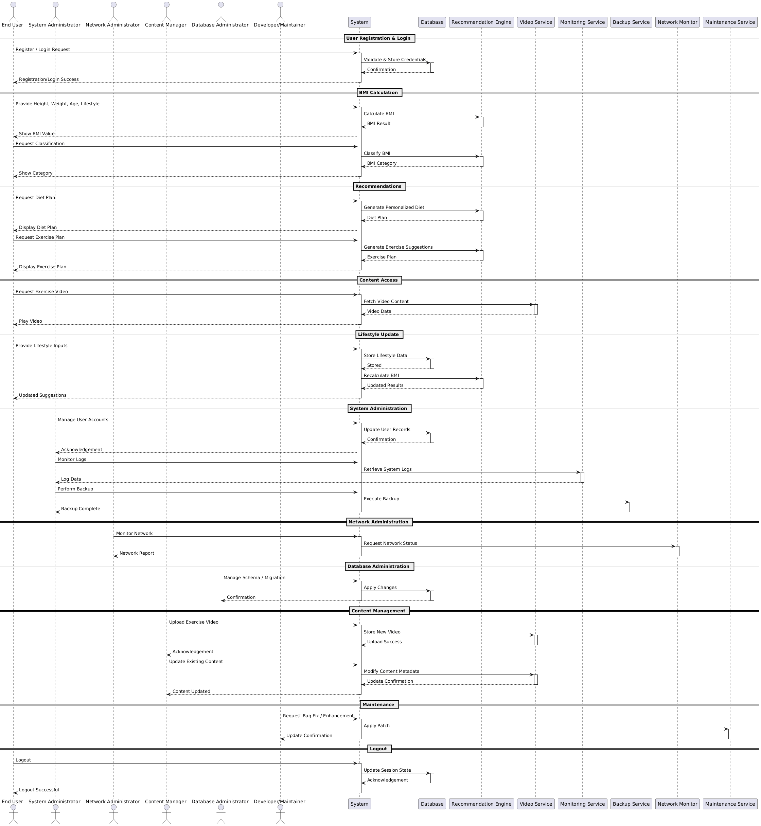

Sequence Diagram Description
The FitWise Sequence Diagram models the dynamic interactions between actors (users and administrators) and system components, showing the order of operations and lifelines throughout the system’s workflow.
🔹 User Interactions
- Registration & Login
  - The End User interacts with the System to register or log in.
  - The System communicates with the Database to validate and store credentials.
  - Successful authentication returns control to the user, allowing access to features.
- BMI Calculation & Classification
  - The End User provides health data (height, weight, lifestyle).
  - The System invokes the Recommendation Engine to calculate BMI and classify results.
  - Outcomes are sent back to the user in real time.
- Personalized Recommendations
  - Users can request diet or exercise plans.
  - The System calls the Recommendation Engine to generate personalized advice.
  - Final recommendations are displayed to the user.
- Content Access
  - Users can request exercise videos.
  - The System communicates with the Video Service to fetch and display content.
- Lifestyle Updates
  - Users provide additional health inputs (sleep, fatigue, digestion).
  - The System stores data in the Database and recalculates suggestions via the Recommendation Engine.
- Logout
  - The user logs out.
  - The System updates the session state in the Database and confirms logout.

🔹 Administrative Interactions
- System Administration (SysAdmin)
  - Manages user accounts through the Database.
  - Monitors system logs via the Monitoring Service.
  - Performs data backups using the Backup Service.
- Network Administration (NetAdmin)
  - Monitors network and security status via the Network Monitor.
  - Receives reports about performance and connectivity.
- Database Administration (DBA)
  - Executes schema updates and migrations through the Database.
  - Ensures structural integrity and availability of stored data.
- Content Management (Content Manager)
  - Uploads new videos or updates existing content via the Video Service.
  - The System mediates communication, ensuring content changes are acknowledged.
- System Maintenance (Developer/Maintainer)
  - Applies patches, bug fixes, and enhancements through the Maintenance Service.
  - Updates are confirmed back to the developer once successful.

3.6. STATE DIAGRAM
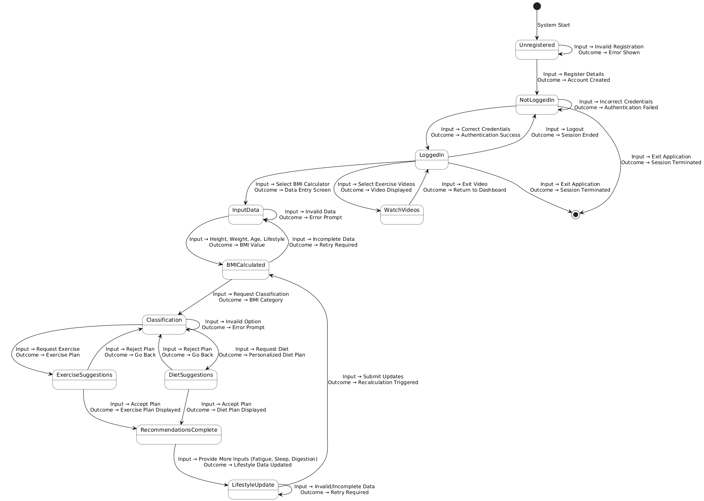

Description

The state diagram models the life cycle of a user interacting with the FitWise system, capturing all major states, transitions, inputs, and outcomes.
- Start State → Unregistered
  - When the system starts, users are initially unregistered.
  - Inputs: Registration details (successful → account created; invalid → error shown).
- NotLoggedIn State
  - Represents users who have an account but are not yet logged in.
  - Inputs:
    - Correct credentials → transition to LoggedIn.
    - Incorrect credentials → remain in NotLoggedIn with error feedback.
    - Exit application → terminate session (end state).
- LoggedIn State (Main Dashboard)
  - Central hub for users after successful login.
  - From here, the user can:
    - Access the BMI Calculator (→ InputData).
    - Watch Exercise Videos (→ WatchVideos).
    - Logout (→ NotLoggedIn).
    - Exit system (→ End state).
- BMI Calculation Flow
  - Users in InputData enter height, weight, age, and lifestyle inputs.
  - If valid, the system calculates BMI (→ BMICalculated).
  - If invalid, the user remains in InputData until corrected.
  - From BMICalculated, the user may:
    - Request BMI Classification (→ Classification).
    - Return for corrections if data is incomplete.
- Recommendations Flow
  - In Classification, users can request personalized diet or exercise suggestions.
  - Each suggestion (Diet or Exercise) can either be accepted (→ RecommendationsComplete) or rejected (→ return to Classification).
  - In RecommendationsComplete, users may also provide lifestyle updates (fatigue, sleep, digestion) to refine results, which loops back to recalculating BMI.
- Video Flow
  - From LoggedIn, selecting exercise videos transitions to WatchVideos.
  - Exiting video playback returns the user to LoggedIn.
- End States
  - Users can terminate their session either by logging out or explicitly exiting the application, leading to the final [ * ] state.

3.7. COMMUNICATION DIAGRAM
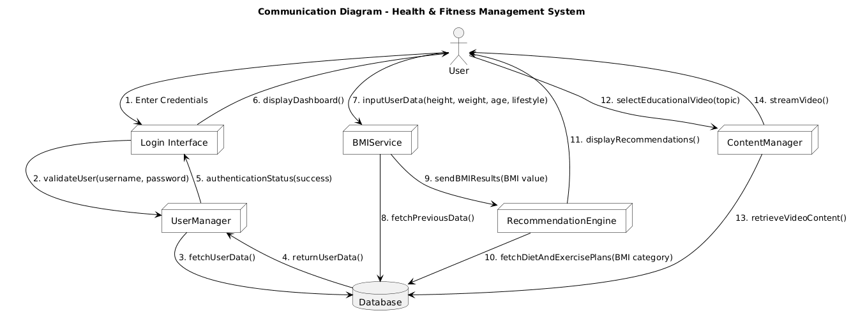
Communication (Collaboration) Diagram Description
The Communication Diagram illustrates the dynamic interactions between objects and actors within the Health & Fitness Management System. Unlike the sequence diagram that emphasizes the order of execution over time, this diagram highlights the structural relationships and message exchanges between components participating in the use cases.
In this system, various actors and internal objects collaborate to achieve fitness management functions such as authentication, BMI calculation, recommendation generation, and content delivery.
Key Components and Relationships
- User
  - Initiates all primary interactions in the system such as login, BMI calculation, and viewing fitness recommendations or videos.
  - Interacts directly with the Login Interface, BMIService, and ContentManager objects.
- Login Interface (LI)
  - Acts as the entry point for authentication.
  - Receives user credentials and communicates with the UserManager to validate login attempts.
  - Provides success or failure feedback to the user interface.
- UserManager (UM)
  - Handles user validation and profile management.
  - Fetches and verifies credentials by querying the Database.
  - Returns authentication results to the Login Interface.
- Database (DB)
  - Serves as the persistent data store for user information, BMI records, diet plans, exercise recommendations, and multimedia content.
  - Responds to data requests from UserManager, BMIService, RecommendationEngine, and ContentManager.
- BMIService (BMIS)
  - Manages BMI-related computations based on user input (height, weight, age, lifestyle).
  - Fetches previous BMI records from the database to ensure continuity of user data.
  - Sends results to the RecommendationEngine for further processing.
- RecommendationEngine (RE)
  - Processes BMI outcomes and maps them to appropriate diet and exercise plans.
  - Retrieves plans from the Database and sends recommendations back to the User interface.
- ContentManager (CM)
  - Handles multimedia content such as workout and nutrition videos.
  - Communicates with the Database to retrieve requested video resources.
  - Streams or displays educational fitness content to the user.

Communication Flow Summary
- Login Process:
The user sends login credentials to the Login Interface, which delegates validation to UserManager. The UserManager retrieves stored data from the Database and sends the result back for user authentication.
- BMI Calculation:
Once logged in, the user provides data to the BMIService. This component may retrieve previous data from the Database before forwarding results to the RecommendationEngine.
- Personalized Recommendations:
The RecommendationEngine interacts with the Database to fetch suitable diet and exercise plans, then delivers personalized recommendations to the user.
- Content Access:
The user requests specific health-related videos via the ContentManager, which queries the Database for the appropriate file and streams it to the user interface.

Interpretation
This communication diagram underscores collaboration through direct message exchanges among objects.
The numbered messages reflect the logical order of communication, but the layout reveals how system components are interconnected.
It provides a holistic understanding of how data flows between users, functional modules, and the database, ensuring clear traceability between the use case, class, and sequence diagrams.

CHAPTER 4

Functional Test Plan
4.1 Objective
The objective of this Functional Test Plan is to verify that each function of the FitWise Health & Fitness Management System operates in accordance with the defined functional requirements. The tests ensure that the system meets user expectations, performs accurately, and maintains data consistency and security across all modules.

4.2 Scope
This test plan covers all major functionalities of the system, including:
- User registration, authentication, and session management
- BMI calculation and classification
- Diet and exercise recommendation generation
- Lifestyle input handling and recalculation
- Administrative operations (system, network, database, and content management)
- Data persistence and content retrieval

4.3 Test Environment
Component | Description
Operating System | Windows 11 / Linux Ubuntu
Development Framework | Web-based application (HTML, CSS, JavaScript, Node.js / Flask backend)
Browser | Google Chrome / Mozilla Firefox / Edge
Tools | Postman (API Testing), Selenium (UI Automation), JMeter (Performance Testing)

3.4 Roles and Responsibilities
Role | Responsibilities
Test Manager | Oversees the testing process and resource allocation
QA Engineer | Designs and executes functional test cases
Developer | Fixes bugs identified during testing
Database Administrator | Verifies data integrity and backup functionality
Network Administrator | Tests network reliability and connectivity during user operations

3.5 Functional Test Cases
3.5.1 User Registration and Authentication
Test Case ID | FT-01
Objective | Validate user registration, login, and logout functionalities
Preconditions | Application is running; database connection is active
Test Steps | 1. Open registration form  2. Enter valid details  3. Submit form  4. Attempt login with credentials  5. Logout
Expected Result | User account created successfully, valid login grants access, logout redirects to home page
Outcome Criteria | Pass if successful session creation and termination occur without errors

3.5.2 BMI Calculation
Test Case ID | FT-03
Objective | Validate BMI computation accuracy
Steps | - Enter height, weight, and age  - Click “Calculate BMI”
Expected Result | Accurate BMI displayed with category (Underweight, Normal, Overweight, Obese)

3.5.3 Personalized Recommendations
Test Case ID | FT-04
Objective | Validate diet and exercise recommendation generation
Steps | - Complete BMI calculation  - Select “Get Recommendations”
Expected Result | Appropriate diet and exercise plans displayed based on BMI category

    - Content Management
Test Case ID | FT-06
Objective | Ensure correct upload and retrieval of exercise and diet content |
Actors | Content Manager
Steps | - Upload new video/ article  - Retrieve and view content as User
Expected Result | Content successfully uploaded and accessible to users

    - System Administration
Test Case ID | FT-07
Objective | Verify user account and log monitoring functionalities
Actors | System Administrator
Steps | - Access admin dashboard  - View user logs and sessions  - Manage user accounts
Expected Result | Logs and account actions display accurately

    - Network Monitoring
Test Case ID | FT-08
Objective | Verify network uptime and security event logging
Actors | Network Administrator
Steps | - Trigger simulated traffic  - 2. View live monitoring dashboard  - Check alerts
Expected Result | Real-time network statistics displayed; security alerts logged

3.5.9 Database Operations
Test Case ID | FT-09
Objective | Validate backup, restore, and migration functionalities |
Actors | Database Administrator
Steps | - Initiate backup  - Delete records intentionally  - Perform restore
Expected Result | Database successfully restored to previous state

3.5.10 Error Handling and Validation
Test Case ID | FT-10
Objective | Verify proper input validation and error prompts
Steps | - Enter invalid or incomplete inputs in forms  - Submit
Expected Result | System displays clear error messages and prevents incorrect submissions

3.6 Exit Criteria
- All critical and high-severity test cases pass successfully
- No open critical defects remain unresolved
- Functional requirements are verified against acceptance criteria

3.7 Deliverables
- Test case report with results (Pass/Fail)
- Bug tracking document
- Final test summary report

CHAPTER 5

System Design Specifications

Layered (Logical) Architecture
Description
The layered architecture separates concerns and improves maintainability, testability and scalability. Typical layers for FitWise:
- Presentation Layer (UI / Client)
  - Responsibilities: render UI, handle user interaction, client-side validation, call backend APIs.
  - Components: React SPA (or React + lightweight SSR), mobile-responsive pages (BMI calculator, recommendations, profile, history), static assets.
  - Mapping: UI components, Login Interface, Dashboard, Video player.
- API / Application Layer (Backend / Business Logic)
  - Responsibilities: authentication, session management, request validation, business rules enforcement, orchestration of services (BMI calc → recommendation engine), admin endpoints.
  - Components: REST/GraphQL API (Django/Flask + DRF or FastAPI), BMI Calculator, Recommendation Engine, UserManager, ContentManager, System services wrapper.
  - Mapping: BMI_Calculator, RecommendationEngine, User, Admin classes, System service interface.
- Service/Integration Layer
  - Responsibilities: integrations with 3rd-party services and internal subsystems: Video Service (CDN or Object Storage), Notification Service (email/SMS), Authentication Provider (OAuth2/JWT), Monitoring, Backup service.
  - Components: Video storage (S3 or equivalent), CDN, Email provider, Analytics, Monitoring (Prometheus/Grafana), Cache (Redis).
  - Mapping: Video Service, Monitoring Service, Backup Service, Network Monitor.
- Data Layer (Persistence)
  - Responsibilities: durable storage: relational DB for users and structured data; object store for large media; caches for hot reads; audit logs.
  - Components: Relational DB (Postgres), Object Storage (S3/MinIO), Cache (Redis), Logging store (ELK/EFK).
  - Mapping: Database class; tables for users, BMI records, diet/exercise plans, content metadata, logs.
- Infrastructure Layer
  - Responsibilities: runtime environment, container orchestration, load balancing, networking, security, backups.
  - Components: Docker, Kubernetes/ECS, Load Balancer (ALB/NGINX), VPC, IAM, Certificate manager.

LAYERED/ COMPONENT DIAGRAM

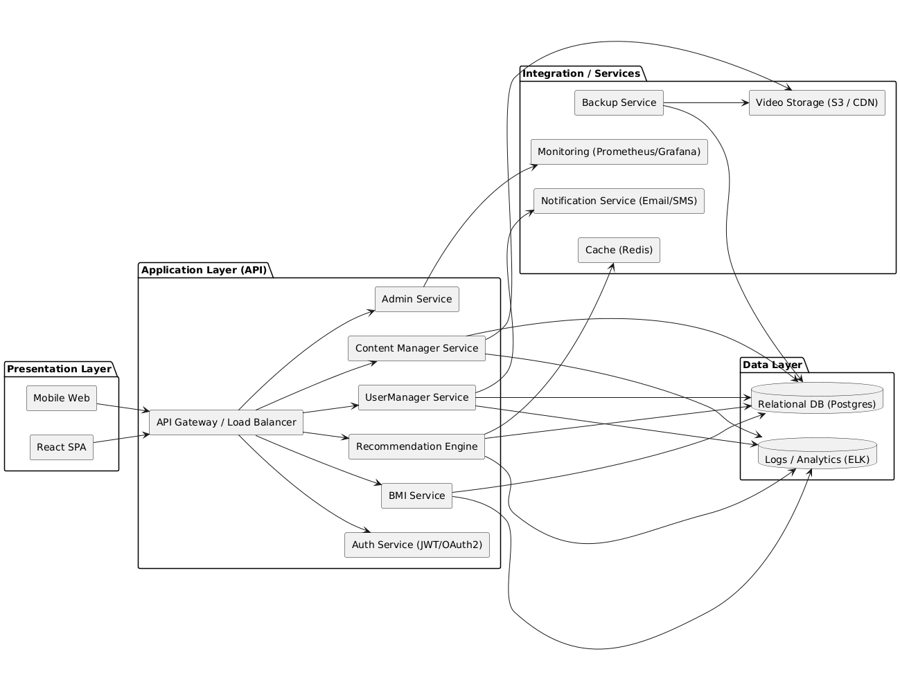

PHYSICAL/ DEPLOYMENT DIAGRAM
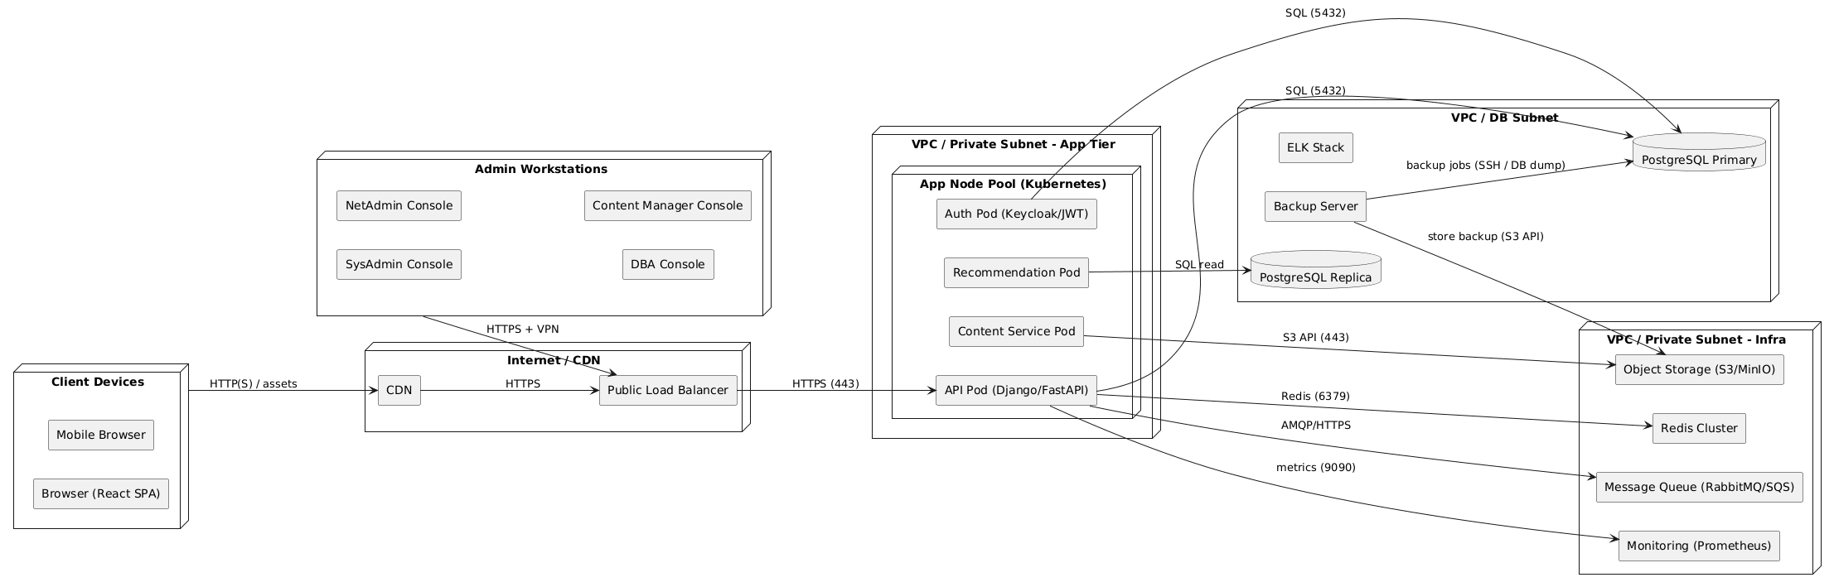

Explanation of the Deployment Diagram (short)

- Client Devices (browser, mobile) access content via CDN (static JS/CSS, video streaming) and go through a public load balancer to reach API endpoints.
- API Layer runs in a containerized cluster (Kubernetes or equivalent). Separate pods/services host the API, auth, recommendation engine and content handlers.
- Database tier uses a primary/replica PostgreSQL setup for high availability and read scaling. Backups go to an object store.
- Redis provides caching for recommendations and session/state.
- Object storage (S3) stores exercise videos and large content; CDN serves these to clients.
- Monitoring & Logging (Prometheus + ELK) collect metrics and application logs.
- Message Queue decouples long-running tasks (video processing, recommendation pre-computation) from request/response cycles.
- Admin consoles connect over secure VPN and MFA to manage the system.

Mapping classes / components → deployment
- User, Admin classes → stored & managed by UserManager service and Postgres. UI renders via React (client).
- BMI_Calculator, RecommendationEngine → deployed as microservices/pods (Recommendation Pod), can be scaled independently.
- DietPlan, ExercisePlan, LifestyleInput instances → persisted in Postgres; large media referenced in S3.
- System / IService operations → implemented by system-level services: Backup, Monitoring, Encryption utilities on infra nodes.

Non-functional / design considerations
Scalability
- Autoscale API pods based on CPU / request latency (HPA).
- Use read-replicas for Postgres to handle heavy read traffic (recommendation lookups).
- Cache recommendation results in Redis for repeated requests.
Availability & Reliability
- Multi-az deployment for DB primary/replica; automated failover (Patroni or managed service).
- Daily automated backups to S3, encrypted at rest.
- Health checks and readiness probes for pods.
Security
- TLS for all public endpoints (HTTPS).
- OAuth2/JWT for user authentication; 2FA for admin roles.
- Role-based access control (RBAC) for admin consoles.
- Secrets in a vault (Kubernetes secrets + KMS).
- Input validation and server-side sanitization to prevent XSS/SQL injection.
Performance
- Response time target: < 2s for BMI calc & <5s for generating recommendations (use caching and pre-compute where possible).
- CDN for serving videos; transcoding into multiple bitrates for adaptive streaming.
Maintainability
- CI/CD pipeline (GitHub Actions/GitLab CI) with automated tests, staging environment, and blue-green deploys.
- Microservice modularity to ease independent deployments and testing.

Database Tables (brief)
A short list of the main tables shall be included (can appear in System Design specs):
- users (id, name, email, password_hash, cultural_pref, allergies, created_at, updated_at)
- bmi_records (id, user_id, weight, height, bmi, category, created_at)
- lifestyle_inputs (id, user_id, fatigue_level, sleep_quality, digestion, stress_level, created_at)
- diet_plans (id, title, region_tag, meals_json, calories, allergen_tags, created_by, active_flag)
- exercise_plans (id, title, exercises_json, duration, intensity, video_ref, created_by)
- content_items (id, type, title, description, s3_key, status, created_by)
- audit_logs (id, user_id, action, resource, timestamp, metadata)
- admin_actions (id, admin_id, action, details, timestamp)

Deployment readiness checklist
- Ensure secrets stored in vault + KMS configured.
- TLS certs provisioned (ACME/Let’s Encrypt or managed CA).
- DB replicas configured and tested for failover.
- CDN + S3 bucket configured with proper CORS and signed URLs.
- Monitoring dashboards (Prometheus + Grafana) created for request latency, CPU, memory and DB replication lag.
- Alerting (PagerDuty/Email) set up on critical thresholds.
- Load test (JMeter) to confirm 500 - 1000 concurrent users requirement.
- Daily backup & restore test completed.

Database Tables
1. users
Field | Data Type | Description
id (PK) | INT | Unique user ID
name | VARCHAR(100) | Full name of the user
email | VARCHAR(100) | User email address
password_hash | VARCHAR(255) | Hashed password
cultural_pref | VARCHAR(50) | User’s cultural preference for diet/exercise
allergies | VARCHAR(255) | Comma-separated allergy list
created_at | DATETIME | Account creation timestamp
updated_at | DATETIME | Last update timestamp

2. bmi_records
Field | Data Type | Description
id (PK) | INT | Unique BMI record ID
user_id (FK) | INT | References users(id)
weight | FLOAT | User’s weight in kg
height | FLOAT | User’s height in meters
bmi | FLOAT | Calculated BMI value
category | VARCHAR(50) | Classification (Underweight, Normal, Overweight, etc.)
created_at | DATETIME | Timestamp of BMI record

3. lifestyle_inputs
Field | Data Type | Description
id (PK) | INT | Unique lifestyle record ID
user_id (FK) | INT | References users(id)
fatigue_level | INT | Scale 1–10
sleep_quality | INT | Scale 1–10
digestion | BOOLEAN | True if digestive issues present
stress_level | INT | Scale 1–10
created_at | DATETIME | Timestamp of input

4. diet_plans
Field | Data Type | Description
id (PK) | INT | Unique diet plan ID
title | VARCHAR(100) | Plan name
region_tag | VARCHAR(50) | Cultural or regional tag
meals_json | JSON | Structured list of meals
calories | FLOAT | Total calorie count
allergen_tags | VARCHAR(255) | Comma-separated allergens
created_by (FK) | INT | References admins(adminID)
active_flag | BOOLEAN | Active/inactive status

5. exercise_plans
Field | Data Type | Description
id (PK) | INT | Unique exercise plan ID
title | VARCHAR(100) | Plan name
exercises_json | JSON | List of exercises in structured format
duration | INT | Total duration in minutes
intensity | VARCHAR(50) | Level of intensity (Low, Medium, High)
video_ref | VARCHAR(255) | Reference to tutorial video
created_by (FK) | INT | References admins(adminID)

6. content_items
Field | Data Type | Description
id (PK) | INT | Unique content ID
type | VARCHAR(50) | Content type (article, video, infographic)
title | VARCHAR(100) | Content title
description | TEXT | Content description
s3_key | VARCHAR(255) | S3 storage key
status | VARCHAR(50) | Draft, Published, or Archived
created_by (FK) | INT | References admins(adminID)

7. audit_logs
Field | Data Type | Description
id (PK) | INT | Unique audit entry ID
user_id (FK) | INT | References users(id)
action | VARCHAR(255) | Action performed
resource | VARCHAR(100) | Resource affected
timestamp | DATETIME | When action occurred
metadata | TEXT | Additional JSON metadata

8. admin_actions
Field | Data Type | Description
id (PK) | INT | Unique admin action ID
admin_id (FK) | INT | References admins(adminID)
action | VARCHAR(255) | Description of admin operation
details | TEXT | Extra context for action
timestamp | DATETIME | When action occurred

9. system_logs
Field | Data Type | Description
logID (PK) | INT | Unique log entry ID
timestamp | DATETIME | Time of the event
userID (FK, nullable) | INT | References users(id) if user-triggered
action | VARCHAR(255) | Description of the event
logType | VARCHAR(20) | Log category (INFO, ERROR, SECURITY)

10. admins
Field | Data Type | Description
adminID (PK) | INT | Unique admin ID
name | VARCHAR(50) | Admin’s full name
role | VARCHAR(50) | Role (SystemAdmin, NetworkAdmin, etc.)
email | VARCHAR(100) | Contact email
privileges | TEXT | Description of permissions granted

Entity Relationship Diagram
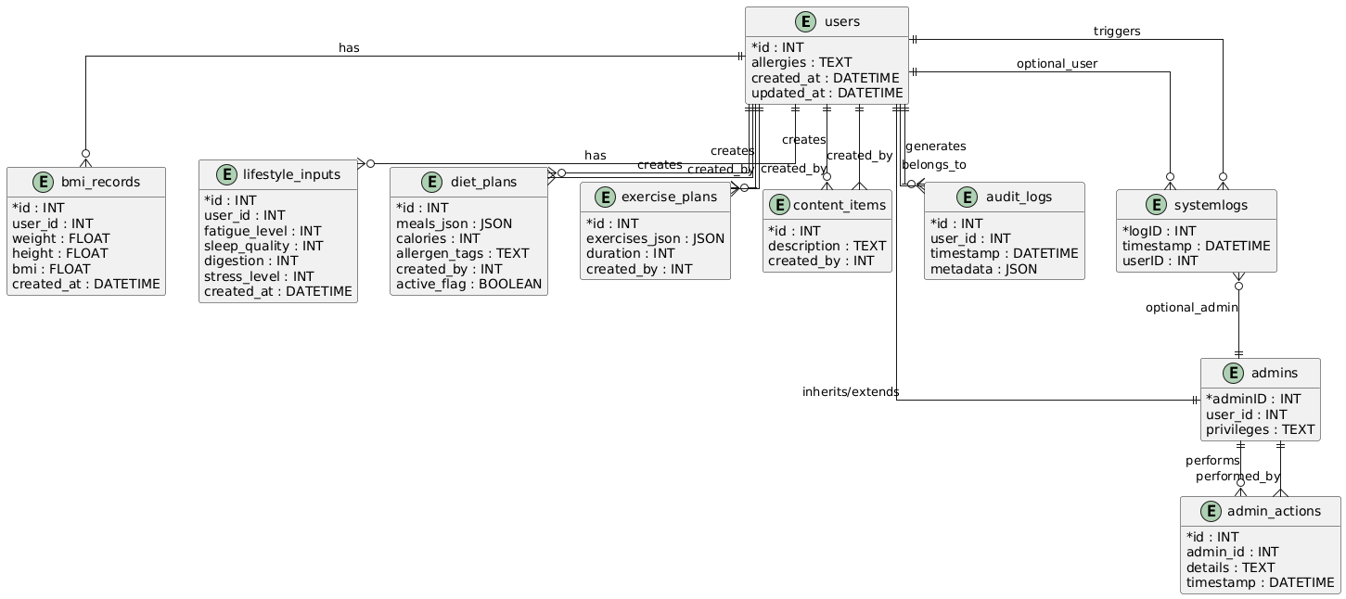

Window Navigation Diagram
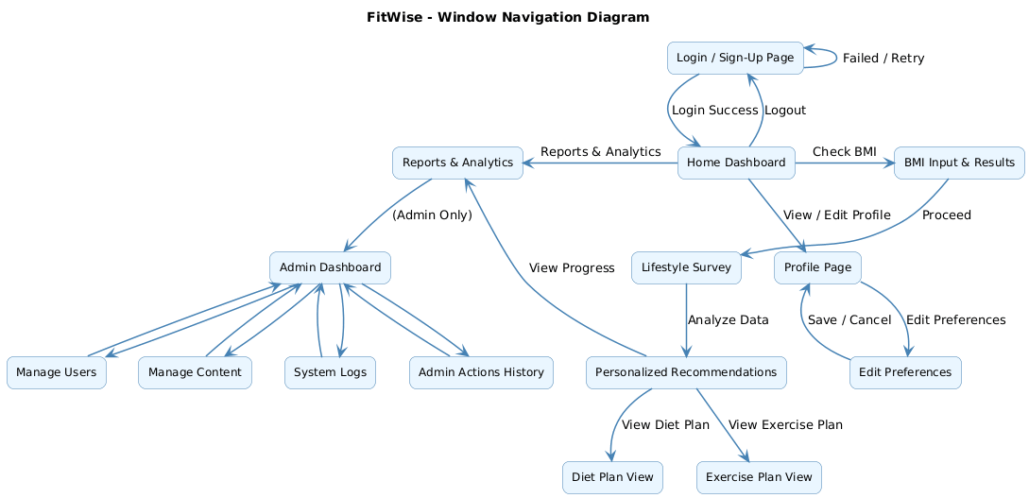

References
BMI Calculators :
1. Centers for Disease Control and Prevention. (n.d.). BMI Calculator. https://www.cdc.gov/bmi
2. Centers for Disease Control and Prevention. (n.d.). About Adult BMI. https://www.cdc.gov/healthyweight/assessing/bmi/adult_bmi/index.html
3. National Heart, Lung, and Blood Institute. (n.d.). Calculate your body mass index.
https://www.nhlbi.nih.gov/calculate-your-bmi
4.MyFitnessPal. (n.d.). MyFitnessPal: Calorie counter app. Under Armour, Inc. https://www.myfitnesspal.com
5. Google LLC. (2025). YouTube (Version 20.22.1) [Mobile app]. App Store.

Cultural and Regional Dietary Guidelines:
5. Food and Agriculture Organization of the United Nations. (2016). Promoting healthy diets through nutrition education and changes in the food environment: An international review of actions and their effectiveness. https://www.fao.org/3/i5640e/i5640e.pdf
6. Harvard T.H. Chan School of Public Health. (n.d.). Healthy eating plate & healthy eating pyramid. https://www.hsph.harvard.edu/nutritionsource/healthy-eating-plate/
7. Indian Council of Medical Research. (2024). Nutrient requirements for Indians. National Institute of Nutrition. https://www.nin.res.in/RDA_Full_Report_2024.html
8. National Health Service (UK). (n.d.). Eat well – How to eat a balanced diet. https://www.nhs.uk/live-well/eat-well/
9. U.S. Department of Health and Human Services, & U.S. Department of Agriculture. (2020). Dietary guidelines for Americans, 2020–2025. https://www.dietaryguidelines.gov/
10. World Health Organization. (2020). Healthy diet. https://www.who.int/news-room/fact-sheets/detail/healthy-diet

