**Coding Metrics**

In this particular metric calculation, we are using the Jhawk Metric Tool. JHawk collects metrics at four different levels. The lowest level is the method level, then up to the class level, then the package level then, finally, the system level. The method, class and package levels correlate with the Java artefacts with these names. The 'system' level represents a group of these artefacts that you wish to examine collectively e.g. all the code in an application. Since only our backend, a small part of our project, is coded in java, mainly using Spring Boot and MongoDB , JHawk collects all metrics related to the classes, modules and sub-classes used.

1. **Database Connectivity using MongoDB**

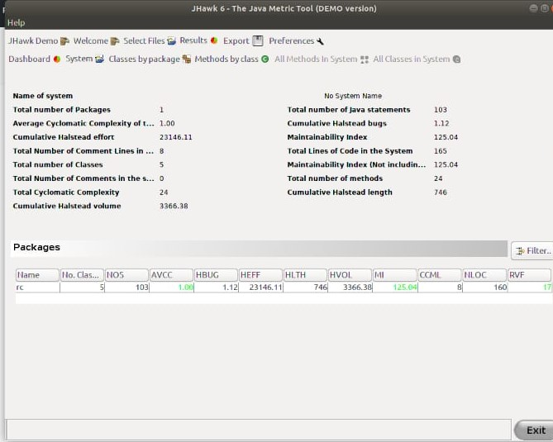

1. **User Portal**

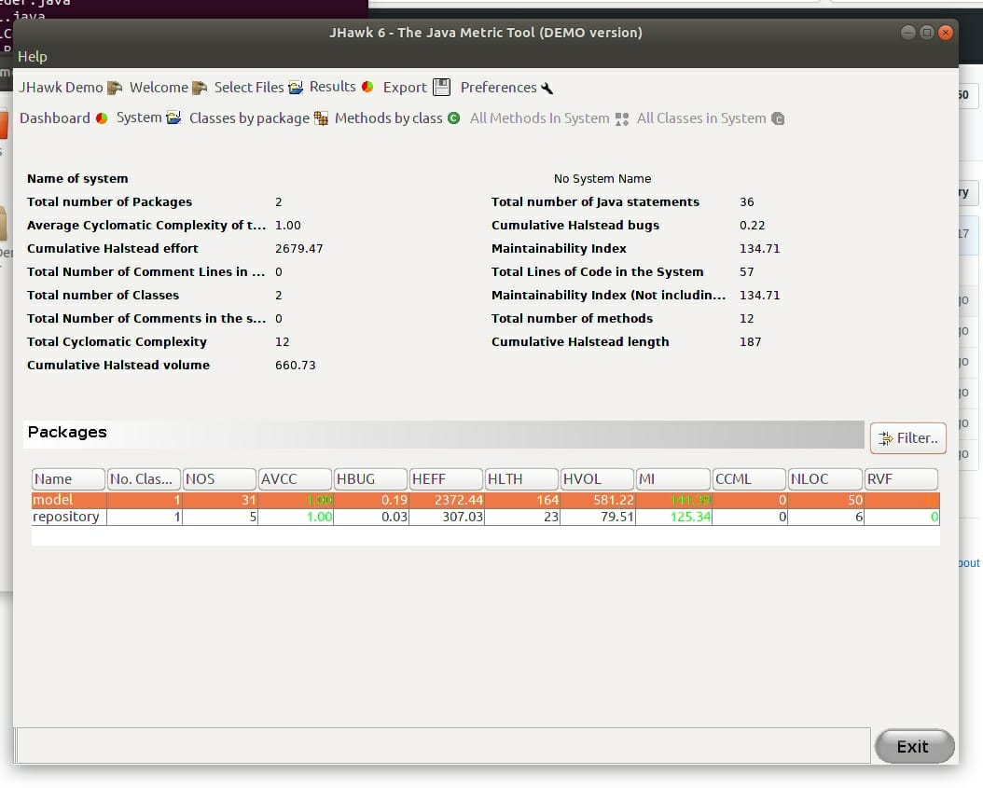

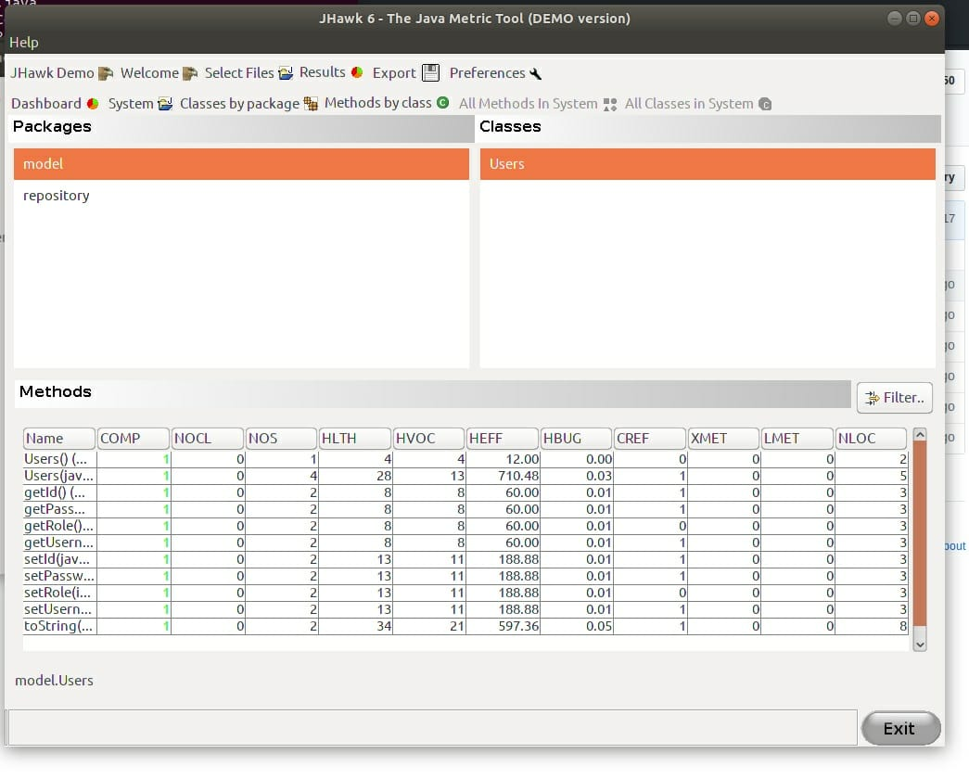

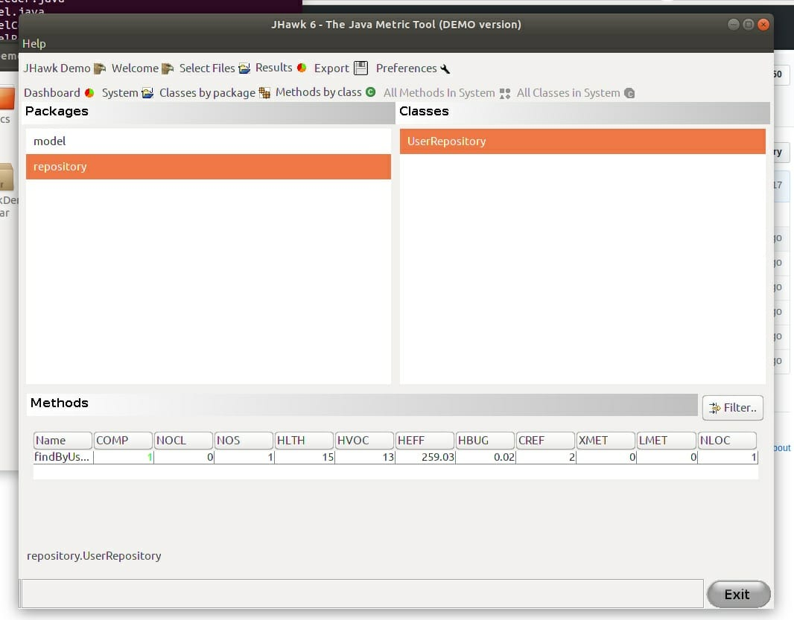

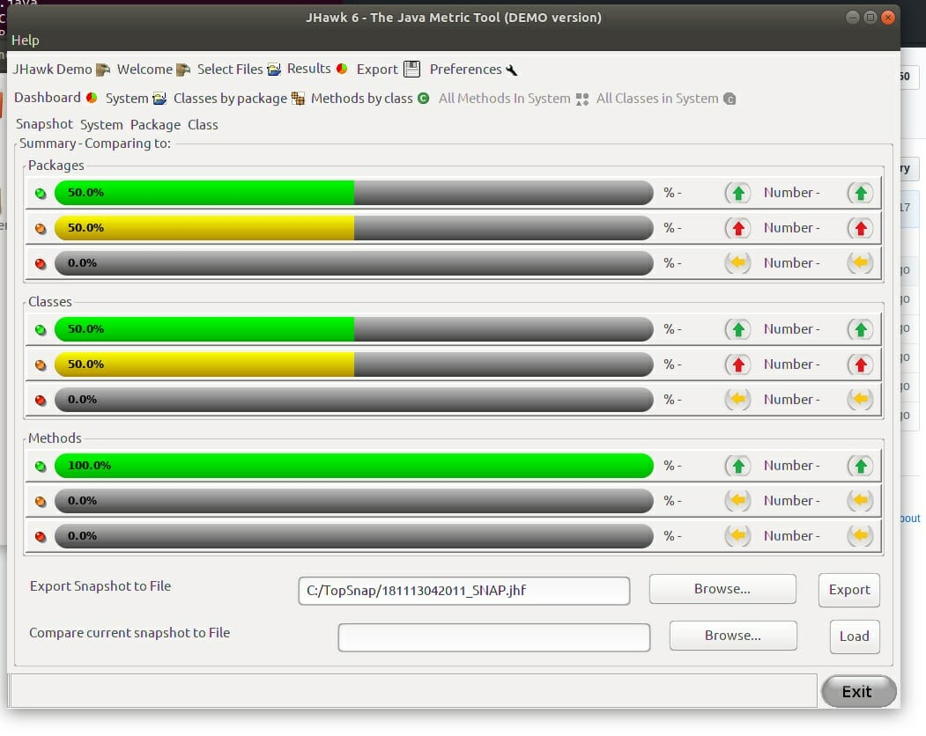

1. **Admin Portal**

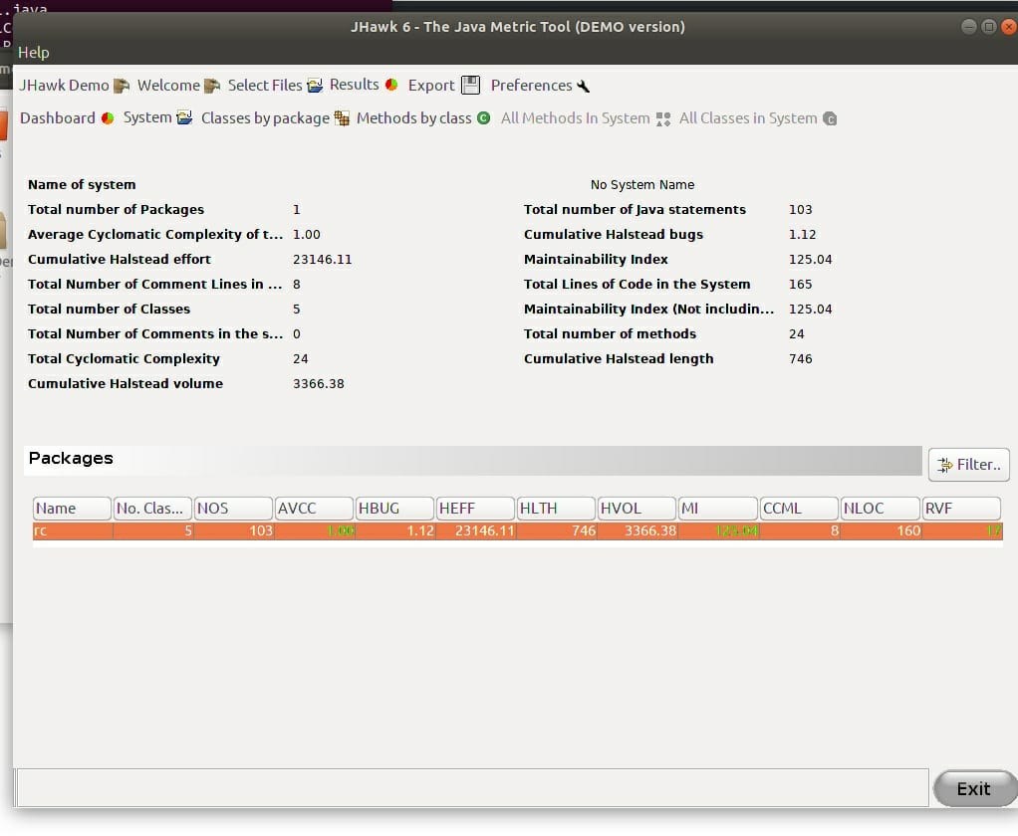

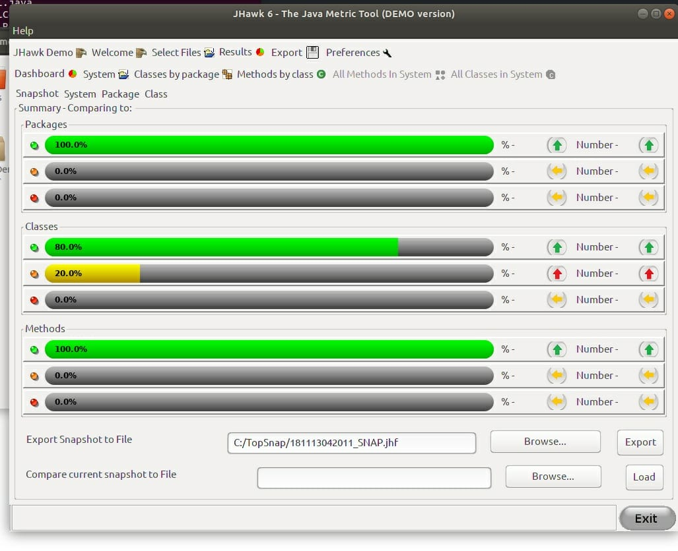

1. **Spring Boot**

