# Software Requirements Specification

# for

# Exam Preparation Portal

Version 1.0 approved

Prepared by

Arnav Ajay(014)

Ashwin Jawahar(017)

Gayathri Chandrasekar(039)

Neeraj Pandey

Hrithik Raj(047)

NIIT University

05/09/18

Table of Contents

Table of Contents ii

Revision History ii

1. Introduction 1

1.1 Purpose 1

1.2 Document Conventions 1

1.3 Intended Audience and Reading Suggestions 1

1.4 Product Scope 1

1.5 References 1

2. Overall Description 2

2.1 Product Perspective 2

2.2 Product Functions 2

2.3 User Classes and Characteristics 2

2.4 Operating Environment 2

2.5 Design and Implementation Constraints 2

2.6 User Documentation 2

2.7 Assumptions and Dependencies 3

3. External Interface Requirements 3

3.1 User Interfaces 3

3.2 Hardware Interfaces 3

3.3 Software Interfaces 3

3.4 Communications Interfaces 3

4. System Features 4

4.1 System Feature 1 4

4.2 System Feature 2 (and so on) 4

5. Other Nonfunctional Requirements 4

5.1 Performance Requirements 4

5.2 Safety Requirements 5

5.3 Security Requirements 5

5.4 Software Quality Attributes 5

5.5 Business Rules 5

6. Other Requirements 5

Appendix A: Glossary 5

Appendix B: Analysis Models 5

Appendix C: To Be Determined List 6

Revision History

|  |  |  |  |
| --- | --- | --- | --- |
| **Name** | **Date** | **Reason For Changes** | **Version** |
|  |  |  |  |
|  |  |  |  |

# Introduction

## Purpose

The purpose of this document is to build an online generic system that provides mock

examinations for students. As it is evaluated and generated by the server, it saves a lot of time of the students. The administrator has privileges to create, modify and delete the test papers and the questions, whereas users can register, login and give the test with his or her specific id, and can see the results as well.

## Document Conventions

This document was prepared using the IEEE recommended practice for Software Requirements

Specification*.*

This document uses the following conventions.

|  |  |
| --- | --- |
| DB | Database |
| SRS | Software Requirement Specification |

## Intended Audience and Reading Suggestions

This project is a prototype for the developers, project managers, marketing staff, users, testers, and documentation writers. It is open to students, teachers as well as exam moderators to use and provide feedback on the project. The developers are advised to focus on modules 2.3, 2.4 and 2.5 to understand the implementation and integration of various classes in the project. The students and staff are suggested to read the module 2.6 to understand how to use the system. Whereas, the project managers are suggested to begin reading from module 3 to understand the system requirements. The rest of this SRS contains Overall Description, External Interface Requirements, System Features, Non-Functional Requirements and Other Requirements. The general suggested

sequence for reading the document - begin with the overview sections and proceed through the sections that are most pertinent to each reader type.

## Product Scope

The goal of the online examination portal is to provide students with a free user-friendly mock examination that helps them prepare for their required examinations. The scope of this project is very broad as compared to manually taken examinations:

* This portal is not only limited to educational institutes but also to the corporate world
* There is no restriction as to the presence of an examiner during the period of the exam
* Less time consumption, thereby increasing the efficiency

## References

This web application has been prepared on the basis of discussion with Team members and also

taken information from following- <https://angular.io/> and the IEEE Website.

# Overall Description

## Product Perspective

This project is a more efficient and user-friendly replacement for the existing unpaid examination practice portals on the internet. Since, the websites that are free of cost usually lack in functionality, this project aims to provide better functionality at no cost for the numerous students who prepare for various examinations every year. It is accessible via the Internet, 24 hours a day, 7 days a week. This app will only allow the registered users to enter the test module. The various stages in the app are as follows:

* Login: This window offers the user two choices of logins- Candidate Login and Admin Login
* System Overview: It can only be accessed by an administrator. It allows the admin to add, modify and delete the test modules.
* Test: This window contains the exam that the candidate is supposed to attempt.
* Result: The result window displays the result of the exam that the candidate has just
* attempted.
* Rank: It displays the rank of the candidate among all the other users who have attempted the same mock examination.
* Review: This window provides feedback on the candidates’ weak spots in the attempted examination.

## Product Functions

The major functions that the product is required to perform are:

* Candidate
* Preparing for Examinations
* Tracking the performance of each student
* Realizing the weak subjects/topics of the student
* Competing with other candidates preparing for the same
* Administrator
* Add test module/questions
* Delete test module/questions
* Modify test module/questions

## User Classes and Characteristics

The main users of the system are the candidates and the admins/moderators. The candidates should be able to:

* Login to the website
* Take the examination
* View their score
* View their rank
* View their weak areas

The admins should be able to:

* Login to the website
* Set questions for the examination
* Help students with their problems

## Operating Environment

Operating environment for the airline management system is as listed below.

* Any internet browser such as, Google Chrome, Mozilla Firefox, Internet Explorer, etc.
* Operating System does not matter

## Design and Implementation Constraints

The candidate is allowed to give the exams any number of times, until specified otherwise by the

administrator while building the test. While giving the exam the candidate is given only a set

amount of time and the remaining time should be displayed, after which the exam should close

and display the result. The only condition under which the project will face issues if there is no internet connectivity in the system or the internet connectivity is very slow resulting in inefficient use of the online system.

## User Documentation

The basic functionality of the online examination portal will be stated in the website’s ‘Help’ section. The user manual will include product overview, complete configuration of the required software and hardware, technical details and contact information which will include email address.

## Assumptions and Dependencies

Proper working of this app is dependent on the internet connectivity of the users’ computer.

Assumptions and dependencies:

* It is assumed that the user has basic knowledge of the system (i.e. he/she is not a first time

user) as any action by the user is considered valid during an examination.

* It is assumed that the data entered by the user while registering is true.
* It is assumed that the candidate does not cheat during the exam as there are no supervisors around to monitor.

# External Interface Requirements

## User Interfaces

* Registration Screen:

Various fields available on this screen will be:

* Login Name
* Email Id
* Password
* Login Screen:

Various fields available on this screen will be:

* Login Name
* Password
* Entering Questions:

Various fields available on this screen will be:

* Questions
* Options-4
* Correct Answer
* Examination Details Screen:

Various fields available on this screen will be:

* Examination Name
* Number of Questions
* Passing Marks
* Time Limit
* Result Screen:

Various fields available on this screen will be:

* Number of Correct Questions
* Number of Incorrect Questions
* Total Marks
* Result
* Review Screen:

Various fields available on this screen will be:

* Ranking in the Examination
* Weak Topics

## Hardware Interfaces

* Screen resolution of at least 800X600 is required for proper and complete viewing of screens. Higher resolution will be accepted.
* Any internet browser.
* Any operating system.

## Software Interfaces

* Any Operating System
* MySql Server Database
* JavaScript
* HTML
* CSS
* Angular

## Communications Interfaces

* HTTP
* TCP/IP: Database Connectivity

# System Features

## Candidate Module

4.1.1 Description and Priority

The candidate module includes all the actions that a candidate can perform which includes:

* + - * Login to the website
      * Take the examination
      * View their score
      * View their rank
      * View their weak areas

4.1.2 Stimulus/Response Sequences

The response to the given functionalities will be:

* Login: The website will authenticate the username and password and redirect to user’s dashboard in case of correct authentication, else displays an error message.
* Take the examination: The user chooses the rights answers among the multiple choices and it is stored in a database.
* View score, rank and review: Displays the score, rank and weak subjects after finishing the examination.

4.1.3 Functional Requirements

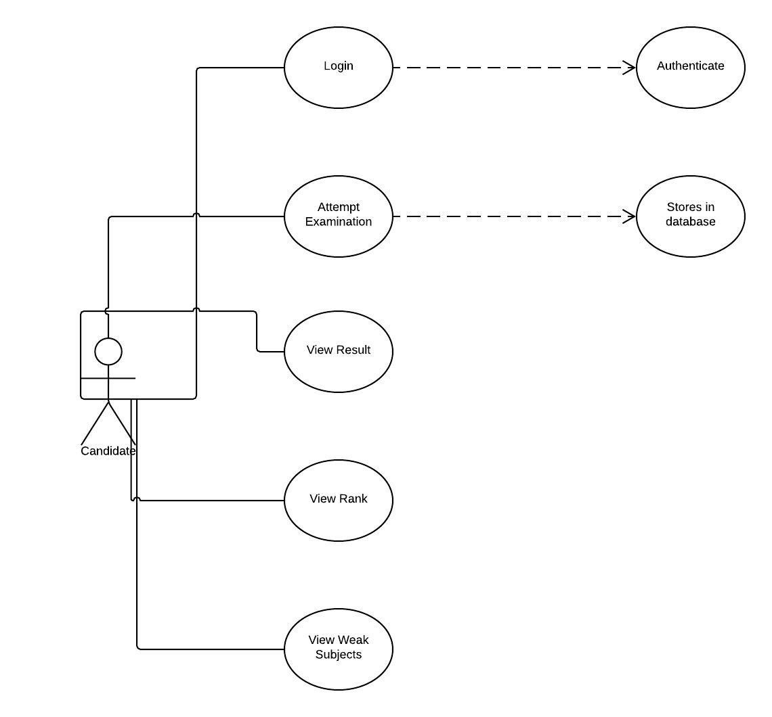

## Administrator Module

4.2.1 Description and Priority

The administrator module includes all the actions that an admin can perform:

* + - * Login to the website
      * Add exam module
      * Delete exam module
      * Modify exam module

4.2.2 Stimulus/Response Sequences

The response to the given functionalities will be:

* Login: The website will authenticate the username and password and redirect to user’s dashboard in case of correct authentication, else displays an error message.
* Modify Examination: The admin can modify, add or delete the questions or test modules.

4.2.3 Functional Requirements

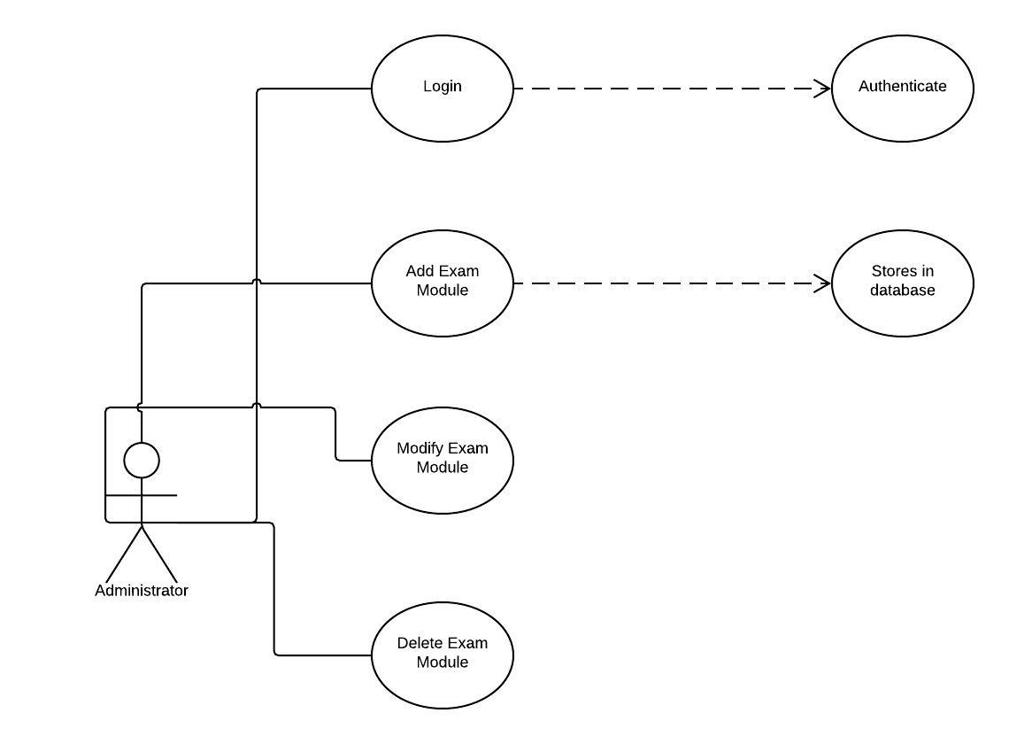

# Other Nonfunctional Requirements

## Performance Requirements

Some Performance requirements identified is listed below:

* The database shall be able to accommodate a minimum of 1,000 records of Users.
* The software shall support use of multiple users at a time.
* There are no other specific performance requirements that will affect development.

## Safety Requirements

The database might crash at any given time due to virus or operating system failure. It is advised to take a backup of the database.

## Security Requirements

Some of the factors that are identified to protect the software from accidental or malicious access, use or modification are given below:

* Keep specific log or history data sets
* Assign certain functions to different modules

## Software Quality Attributes

* AVAILABILITY: The mock exams should be available for all candidates, students as well as corporate employees.
* CORRECTNESS: The result and reviews displayed should be accurate.
* MAINTAINABILITY: The administrators should maintain the test modules and question banks.
* USABILITY: The exam portal should fulfil all the users’ needs and requirements.

## Business Rules

None

# Other Requirements

None.

Appendix A: Glossary

Appendix B: Analysis Models

Appendix C: To Be Determined List