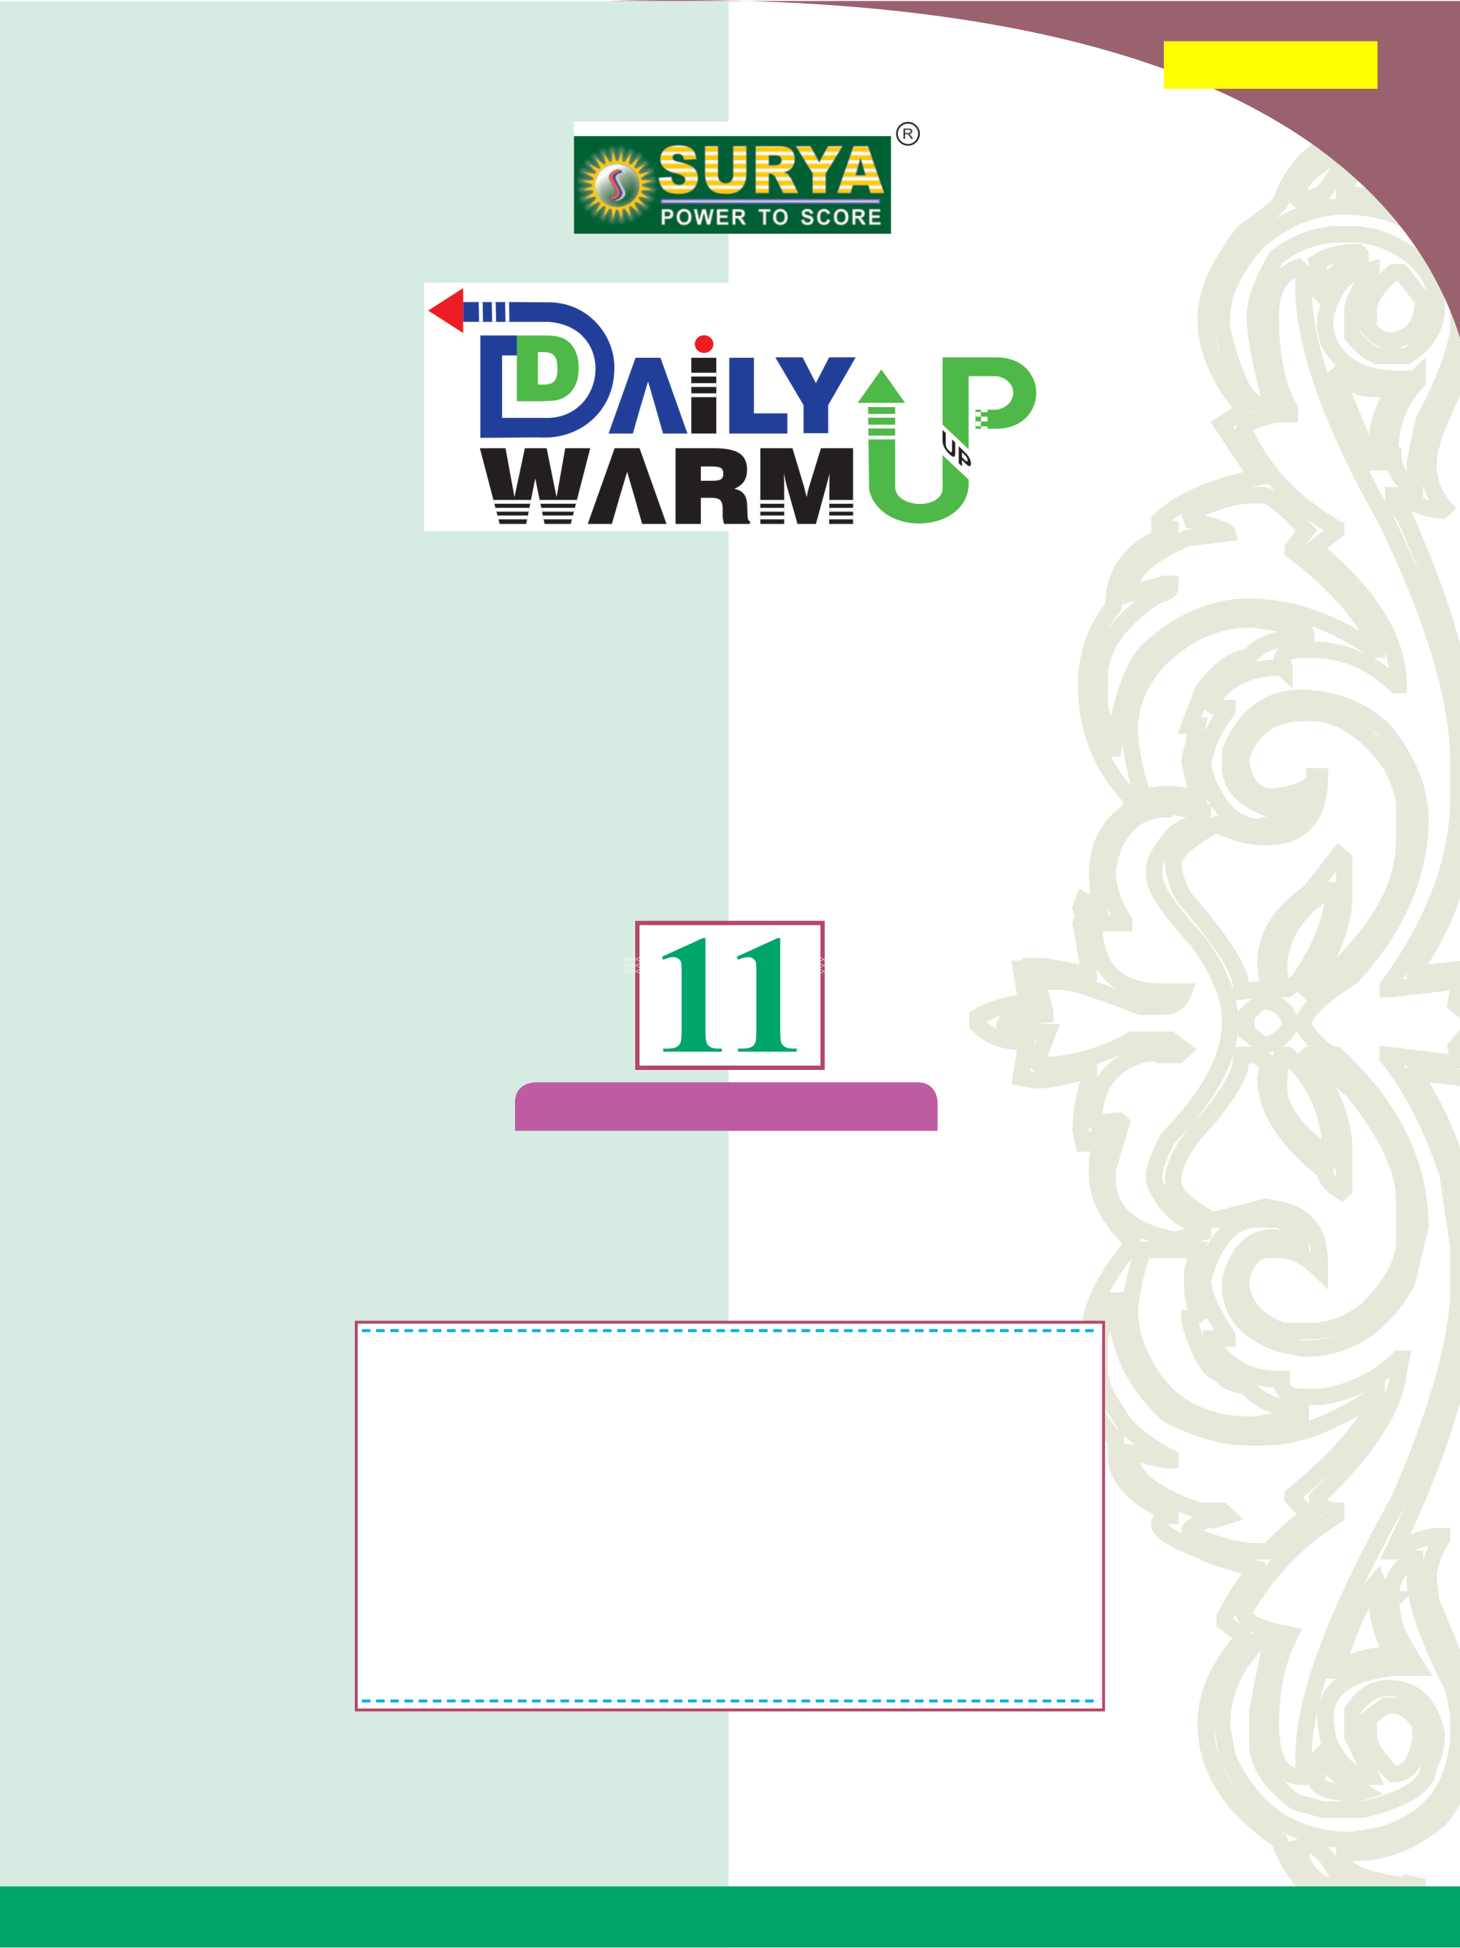

***[Tnkalvi.Net](https://www.tnkalvi.net/)***

,aw;gpay;

ifnaL

bjhFjp I & II ,ize;jJ

**Tnkalvi.Net**

®

SURYA PUBLICATIONS

(A unit of **Shyamala** Group)

No. 1, Sugar Mill Colony, Salai Kumaran illam,

Mobile : 94431-58484,   
 94421-58484,

Madurai Road, 94425-58484,

**Tirunelveli - 627 001.** 89032-58484.

**E-mail: suryaguides@yahoo.com**

**website : www.suryapublications.in**

tpiy:` **100/-**

(ii)



**Online Shopping**

PhonePe No. :94431-58484

|  |  |
| --- | --- |
| G.Pay No. | :94425-58484 |

Pay TM No. :94431-58484

**Tnkalvi.Net**

|  |
| --- |
|  |
|  |
| Account Name : **Surya PublicaTionS**  Account Number : **510909010051752**  Bank Name : **ciTy union banK**  IFSC Code : **ciub0000230**  Branch Name : **PalayamKoTTai** |
|  |
| Account Name : **Sri ganga PublicaTion**  Account Number : **928507483**  Bank Name : **inDian banK**  IFSC Code : **iDib000T034**  Branch Name : **Tirunelveli JuncTion** |

**Printed at: Sri Shyamala Printers, Tirunelveli.**

**Marketed by: SURYA Publications & GANGA Publications.**

|  |  |
| --- | --- |
|  | (iii) |

bghUslf;fk;

t. vz; ghlj; jiyg;g[ gf;f vz; khjk;

,ay; cyfj;jpd; jd;ika[k;

myF 1 mstPl;oaYk; 1 $^d;

$^d;?

myF 2 ,af;ftpay; 10

$^iy

$^iy?

myF 3 ,af;f tpjpfs; 22

Mf!;L

myF 4 ntiy/ Mw;wy; kw;Wk; jpwd; 36 Mf!;L

Jfs;fshyhd mikg;g[ kw;Wk;

**Tnkalvi.Net**

myF 8 btg;gKk; btg;g ,af;ftpaYk; 88 mf;?et

myF 9 tha[f;fspd; ,af;ftpaw; bfhs;if 113 etk;gu;

myF 10 miyt[fs; 124 et?or

myF 11 miyfs; 138 ork;gu;

muR tpdhj;jhs; ? khu;r; 2023 157



|  |  |  |  |
| --- | --- | --- | --- |
|  | SURYA  | → | **1** |
| myF ? 1 | ,ay; cyfj;jpd; jd;ika[k; mstPl;oaYk; |  |  |

**I.** rupahd tpiliaj; nju;e;bjLj;J vGJf.

|  |  |  |  |  |
| --- | --- | --- | --- | --- |
| 1. | mog;gil khwpypfspy; ,Ue;J **hc/G** vd;w xU rkd;ghL bgwg;gLfpwJ. ,e;j | | | |
| rkd;ghl;od; myF  a) kg2 b) m3 | | | c) s–1 | d) m |
| 2. | xU nfhsj;jpd; Muj;ij mstpLjypy; gpiH **2%** vdpy;/ mjd; fdmsitf; | | | |
| fzf;fpLjypd; gpiHahdJ | | | | |
| a) 8% | | b) 2% | c) 4% | d) 6% |
| 3. | miyt[Wk; Crypd; ePsk; kw;Wk; miyt[ neuk; bgw;Ws;s gpiHfs; Kiwna **1%** | | | |
| kw;Wk; **3%** vdpy; <u;g;g[ KLf;fk; mstpLjypy; Vw;gLk; gpiH | | | | |
| a) 4% | | b) 5% | c) 6% | d) 7% |
| 4. | bghUbshd;wpd; ePsk; **3.51 m** vd mstplg;gl;Ls;sJ. Jy;ypaj;jd;ik **0.01 m** | | | |
| vdpy;/ mstPl;od; tpGf;fhl;Lg; gpiH | | | | |
| a) 351% | | b) 1% | c) 0.28% | d) 0.035% |
| 5. fPH;f;fz;ltw;Ws; mjpf Kf;fpa vz;QUf;fisf; bfhz;lJ vJ>  7.  8. **Tnkalvi.Net** a) tpir kw;Wk; jpwd; b) jpUg;g[tpir kw;Wk; Mw;wy;  6. | | | | |
| c) jpUg;g[tpir kw;Wk; jpwd; | | | d) tpir kw;Wk; jpUg;g[tpir | |
| 9. | gpsh=;f; khwpypapd; **(Planck's constant)** gupkhz tha;ghL  a) [ML2T–1] b) [ML2T–3] c) [MLT–1] | | | d) [ML3T–3] |
| 10. **t** vd;w fzj;jpy; xU Jfspd; jpirntfk; **v = at + bt2** vdpy; **b**?,d; gupkhzk;  a) [L] b) [LT–1] c) [LT–2] d) [LT–3] | | | | |
| 11. <u;g;gpay; khwpyp **G** apd; gupkhz tha;ghL  a) [ML3T–2] b) [M–1L3T–2] c) [M–1L–3T–2] | | | | d) [ML–3T2] |
| 12. **CGS** Kiwapy; xU bghUspd; mlu;j;jp **4 g cm–3** MFk;. ePsk; **10 cm,** epiw **100 g**  bfhz;oUf;Fk; Xu; myF Kiwapy; mg;bghUspd; mlu;j;jp | | | | |
| a) 0.04 | | b) 0.4 | c) 40 | d) 400 |
| 13. tpirahdJ jpirntfj;jpd; ,Ukof;F neu;tpfpjg; bghUj;jKilaJ vdpy; tpfpj | | | | |
| khwpypapd; gupkhz tha;ghL a) [MLT0] b) [MLT–1] | | | c) [ML–2T] | d) [ML–1T0] |
| 14. **(**m**0**e**0)–½** gupkhzj;ijf; fPH;f;fz;ltw;Ws; vJ bgw;wpUf;Fk;> | | | | |
| a) ePsk; | | b) fhyk; | c) jpirntfk; | d) tpir |

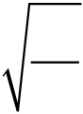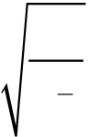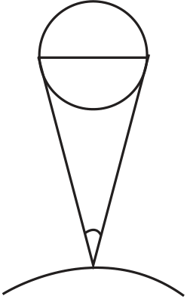

|  |  |
| --- | --- |
| **2** | **11**Mk; tFg;g[[,aw;gpay;](https://www.tnkalvi.net/) |

15. gpsh=; khwpyp **(h)** btw;wplj;jpd; xspapd; jpirntfk; **(c)** kw;Wk; epa{l;ldpd; <u;g;g[ khwpyp **(G)** Mfpa @d;W mog;gil khwpypfs; bfhz;L bgwg;gLk; fPH;f;fhQk; ve;j bjhlu;g[ ePsj;jpd; gupkhzj;ijg; bgw;wpUf;Fk;.

|  |  |  |  |  |  |  |  |  |  |  |
| --- | --- | --- | --- | --- | --- | --- | --- | --- | --- | --- |
| a) | *hG* | | b) | *hG* | | c) | *hc* | d) | *Gc* | |
|  | 3 | |  | 5 | |  |  |  | 3 | |
|  |
|  | *c* | 2 |  | *c* | 2 |  | *G* |  | *h* | 2 |

|  |  |  |  |  |  |  |  |  |  |  |  |  |  |  |
| --- | --- | --- | --- | --- | --- | --- | --- | --- | --- | --- | --- | --- | --- | --- |
| tpilfs; | | | | | | | | | | | | | | |
| 1.a | 2.d | 3.d | 4.c | 5.d | 6.c | 7.b | 8.b | 9.a | 10.d | 11.b | 12.c | 13.d | 14.c | 15.a |

**II.** FWtpdhf;fs;.

|  |  |
| --- | --- |
| 1. | ,aw;gpay; mst[fspd; tiffis tptup. |

**(i)** mog;gil mst[fs;:  
 ntW ve;j ,aw;gpay; mst[fshYk; Fwpg;gplg;gl ,ayhj mst[fs;.

v.fh: ePsk;/ epiw/ fhyk;/ kpd;ndhl;lk;/ btg;gepiy/ xspr;brwpt[ kw;Wk; bghUspd; mst[.

**(ii)** tHp mst[fs;:   
 mog;gil mst[fshy; Fwpg;gplf;Toa mst[fs; tHp mst[fs; vdg;gLk;.

|  |  |  |
| --- | --- | --- |
| v.fh: gug;g[/ fdmst[/ jpirntfk;/ ntfk;/ KLf;fk;/ tpir.  3. **Tnkalvi.Net** Kf;fpa vz;QUf;fis fzf;fpLtjd; tpjpfisj; jUf.  x  2. | | B |
| Ë RHpaw;w midj;J vz;fSk; Kf;fpa vz;QUf;fs;. v.fh:23674 ? Kf;fpa vz;QU 5 | C |

Ë ,U vz;fSf;F ,ilna cs;s RHpfs; Kf;fpa vz;QUf;fs;. v.fh:23004 ? Kf;fpa vz;QU 5

Ë jrk g[s;sp ,y;iy vdpy;/ RHpaw;w vz;Qf;F gpd;tUk; RHpfs; Kf;fpa vz;QUf;fs; my;y. v.fh:23400 ? Kf;fpa vz;QU 3

Ë jrk g[s;sp ,Ue;jhy;/ ,Wjpapy; tUk; RHpfs; Kf;fpa vz;QUf;fs; v.fh:2340.00 ? Kf;fpa vz;QU 6

Ë xd;iwtpl Fiwthd vz;zpy;/ RHpaw;w vz;Qf;F Kd;tUk; RHpfs; Kf;fpa vz;QUf;fs; my;y. v.fh:0.00020340 ? Kf;fpa vz;QU 6

Ë myFld; kw;Wk; jrk g[s;spa[ld; vGJk; mstPLfspy; cs;s vy;yh RHpfSk; Kf;fpa vz;QUf;fs;. v.fh:40700 m kw;Wk; 40700 ? Kf;fpa vz;QU 5

4. gupkhz gFg;gha;tpd; tuk;g[fs; ahit>   
 Ë vz;fs;/p, e nghd;w gupkhzkw;w khwpypfspd; kjpg;ig bgw ,ayhJ.

Ë btf;lu; msth my;yJ !;nfyu; msth vd jPu;khdpf;f ,ayhJ.



|  |  |  |  |  |  |
| --- | --- | --- | --- | --- | --- |
| Ë jpupnfhzkpjp/ | mLf;Ff;Fwp/ | klf;if | nghd;w | rhu;g[fs; | cs;sl=;fpa |

rkd;ghLfspd; bjhlu;gpidf; fz;lwpa ,ayhJ.

Ë @d;Wf;F nkw;gl;l ,aw;gpay; mst[fs; cs;sl=;fpa rkd;ghLfSf;F gad;gLj;j ,ayhJ.

Ë bfhLf;fg;gl;l rkd;ghL gupkhz Kiwg;go rupahdjh vd kl;Lnk bka;gpf;f Koa[k;. cz;ikahd rkd;ghl;ilf; fz;lwpa ,ayhJ.

5. El;gk; kw;Wk; Jy;ypaj;jd;ik tiuaW. xU vLj;Jf;fhl;Lld; tpsf;Ff.

**(i)** El;gk;:  
 ,uz;L my;yJ mjw;F nkw;gl;l mst[fs; xd;Wf;bfhd;W vt;tst[ beUf;fkhf cs;sJ vd;gij El;gk; Fwpf;fpwJ.

**(ii)** Jy;ypaj;jd;ik:  
 cz;ikahd kjpg;g[f;F vt;tst[ mUfpy; mstPL bra;njhk; vd;gij Jy;ypaj;jd;ik Fwpf;fpwJ.

v.fh. tpsf;fk;:   
Fspu;gjdg;bgl;o cs;ns btg;gepiy 9°C vdpy;/

|  |  |  |  |  |  |
| --- | --- | --- | --- | --- | --- |
| **III.** beLtpdhf;fs;. 1. **Tnkalvi.Net**   |  |  |  | | --- | --- | --- | | Kjy; btg;gepiykhdp | ,uz;lhk;  btg;gepiykhdp | @d;whk;  btg;gepiykhdp | |  | |  |   mstp gw;wp tptup.  **(ii)** ePz;l bjhiyt[fis msf;Fk; Kf;nfhz Kiw kw;Wk; nulhu; Kiw gw;wpf; Fwpg;gpLf. |

**(i)** jpUF mstp:   
 Ë 50 mm tiuapyhd bghUl;fspd; gupkhz=;fshf kpfj;Jy;ypakhf mstplg; gad;gLk; fUtp.

Ë jj;Jtk;: tl;l ,af;fj;ijg; gad;gLj;jp bgupjhf;fg;gl;l neu;f;nfhl;L ,af;fkhFk;.

Ë jpUF mstpapd; kPr;rpw;wst[ 0.01 mm.

btu;dpau; mstp:   
Ë Jisapd; MHk; my;yJ Jisapd; tpl;lk; nghd;w mstPLfis msf;fg; gad;gLk; gd;Kfj;jd;ik bfhz;l fUtp btu;dpau; mstp MFk;.

Ë btu;dpau; mstpapd; kPr;rpw;wst[ 0.1 mm.

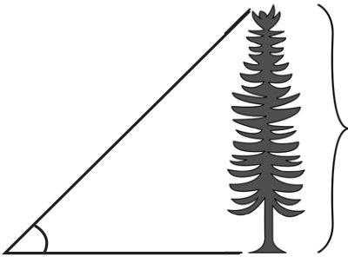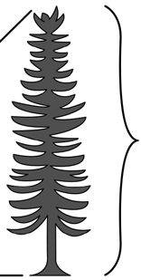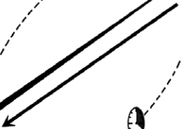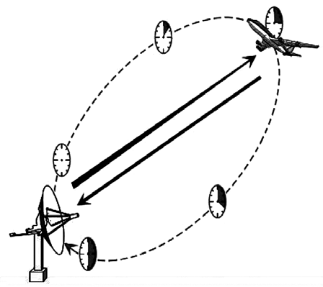

|  |  |  |  |  |  |  |
| --- | --- | --- | --- | --- | --- | --- |
| (**ii)**Kf;nfhz Kiw: | | | | | A | |
| cw;Wnehf;Fgtu; cs;s g[s;sp = C | | | | | | |
| nfhg[uk; my;yJ kuj;jpd; cauk; : AB = *h* | | | | | *h* | |
| kuj;jpd; bjhiyt[ | | : BC = *x* | | |
| kuj;jpd; Vw;wf;nfhzk; | | : ÐACB = q | C | q | *x* | B |
| DABC-apy;/ | tan q = *AB BC*=*h x* (my;yJ) *h* = *x* tanq | |
| bjhiyt[ *x* kjpg;g[ bjupe;jhy;/ nfhg[uk; my;yJ kuj;jpd; cauk; h kjpg;ig | | | | | | |

bgwyhk;.

nulhu; Jog;g[ Kiw:

Ë nulhu; (RADAR) ? Radio Detection And Ranging Ë g[tpg;gug;gpypUe;J nuonah gug;gp @yk; nuonah miyJog;g[fs; btspapy; gug;gg;gLfpwJ.

bjhiytpy; cs;s ,yf;fpy; gl;L vjpbuhspf;fg;gl;l Jog;g[fs; Vw;gp @yk; czug;gLfpwJ.

Ë mDg;gg;gl;l (gug;gp) kw;Wk; Vw;fg;gl;l (Vw;gp) nulhu; epfH;t[fSf;fhd fhy ,ilbtsp t vd;f. vdnt

vLj;Jf;bfhz;l neuk;;*v* = *2D*

2. **Tnkalvi.Net**  gpiHfspd; tiffs;:

**(i)** Kiwahd gpiH:   
 bjhlu;r;rpahf kPz;Lk; kPz;Lk; Vw;gLk; xnu khjpupahd gpiH. ,J 5 tifg;gLk;.

Ë fUtpg;gpiH: fUtp jahupf;fg;gLk;nghJ Vw;gLk; FiwghL.

Ë gupnrhjidapd; FiwghL: Ma;tfr; NHypy; nrhjid bra;a[k; fUtpfis mikf;Fk;nghJ Vw;gLtJ.

Ë jdpg;gl;l gpiHfs;: mstpLgtupd; bray;ghl;lhy; cUthtJ.

Ë g[wf;fhuzpfshy; Vw;gLk; gpiH: g[wr;NHypy; Vw;gLk; btg;gepiy kw;Wk; mGj;j khWghl;lhy; Vw;gLtJ.

Ë kPr;rpw;wst[ gpiH: mst[nfhy; xd;wpd; kpfr;rpwpa mstpdhy; Vw;gLtJ.

**(ii)** xG=;fw;w gpiH:

Ë mGj;jk;/ btg;gepiy nghd;wtw;why; Vw;gLk; bjhlu;gw;w khWghLfshYk; cw;Wnehf;Ftupd; ftdf;FiwthYk; rktha;g;g[ Kiwapy; Vw;gLk; gpiH. ,J `tha;g;g[ gpiH~ vdt[k; miHf;fg;gLk;.



Ë mstPLfspd; Tl;Lr; ruhrup kjpg;igf; fhz;gjd; @yk; ,g;gpiHapid Fiwf;fyhk;.

**(iii)** bkhj;jg; gpiH:   
 Ë cw;Wnehf;Fgtupd; ftdf;Fiwthy; Vw;gLk; gpiH.

Ë fUtpia Kiwahfg; bghUj;jhik.

Ë Kd;bdr;rupf;if eltof;iffis gpd;gw;whik.

Ë jtwhf cw;Wnehf;Fjy; kw;Wk; jtwhd kjpg;g[fis fzf;fPl;oy; gad;gLj;Jjy; Mfpatw;why; ,g;gpiH Vw;gLfpwJ.

Ë nrhjid bra;gtu; ftdkhf/ tpHpg;g[ld; ,Ue;jhy; ,g;gpiHapid Fiwf;fyhk;.

|  |  |
| --- | --- |
| 3. | gpiHfspd; bgUf;fk; gw;wp ePtpu; mwpe;jJ vd;d> Tl;ly; kw;Wk; fHpj;jypy; gpiHfspd; bgUf;fj;ij tptup. |

gpiHfspd; bgUf;fk;:   
,Wjp Kot[fspy; cs;s gpiHfs;/   
Ë jdpj;jdpahd mstPLfspy; cs;s gpiHfs;   
Ë ,Wjp Koitg; bgw bra;ag;gLk; fdpj braypfspd; ,ay;g[ Mfpatw;iwr; rhu;e;Js;sJ.

**~~Tnkal~~vi.Net**

|  |  |
| --- | --- |
| Z ±DZ = (A ±DA) + (B ±DB) |  |
|  |
| Z ±DZ = (A ±DA) – (B ±DB) |
| DZ = (DA + DB) | DZ = (DA + DB) |
| TLjypd; bgUk gpiHahdJ  jdpj;jdp mst[fspd; jdpg;gpiHfspd; TLjYf;Fr; rkk;. | ntWghl;od; bgUk gpiHahdJ  jdpj;jdp mst[fspd; jdpg;gpiHfspd; TLjYf;Fr; rkk; |

|  |  |
| --- | --- |
| 4. | fPH;f;fz;ltw;iwg; gw;wp Fwpg;bgGJf.  **(a)** myF **(b)** KGikg;gLj;Jjy; **(c)** gupkhzkw;w mst[fs; |

**(a)** myF:   
 Ë cyfstpy; Vw;Wf;bfhs;sg;gl;l/ jdpj;Jtkpf;f bjupt[ bra;ag;gl;l xU mstpd; goj;ju msnt `myF~ vd miHf;fg;gLfpwJ.

Ë mog;gil mst[fis mse;jwpa[k; myFfs; `mog;gil myFfs;~ vdg;gLk;.

Ë kw;w ,aw;gpay; mst[fis mstpLtjw;fhf mog;gil myFfspd; mLf;Ffspd; jFe;j bgUf;fy; my;yJ tFj;jy;fspd; @yk; bgwg;gLk; myFfs; `tHp myFfs;~ vdt[k; miHf;fg;gLfpd;wd.

**(b)** KGikg;gLj;Jjypd; tpjpfs;:

|  |  |  |  |  |  |  |  |  |  |  |  |  |  |  |  |  |  |  |  |  |  |  |  |  |  |  |  |  |  |  |
| --- | --- | --- | --- | --- | --- | --- | --- | --- | --- | --- | --- | --- | --- | --- | --- | --- | --- | --- | --- | --- | --- | --- | --- | --- | --- | --- | --- | --- | --- | --- |
| **T~~nkal~~vi.Net**   |  |  |  | | --- | --- | --- | | vz; | vLj;Jf;fhl;L | tpjpfs; | | 1. | 7.3**2** MdJ 7.3 Mf  KGikg;gLj;jg;gLfpwJ. | ePf;fg;gLk; ,yf;fk; 5 I tpl Fiwt[ vdpy;/ mjw;F Kd;g[ cs;s ,yf;fk; khwhJ. | | 2. | 7.3**6** MdJ 7.4 Mf  KGikg;gLj;jg;gLfpwJ. | ePf;fg;gLk; ,yf;fk; 5 I tpl mjpfk; vdpy;/ mjw;F Kd;g[ cs;s ,yf;fj;Jld; 1 I mjpfupf;f ntz;Lk;. | | 3. | 7.3**5**2 MdJ 7.4 Mf  KGikg;gLj;jg;gLfpwJ. | |  |  |  |  | | --- | --- | --- | --- | | ePf;fg;gLk; | vz; | 5f;Fr; | rkkhft[k;/ |   mjw;Fg; gpd; tUk; ,yf;fk; RHp my;yhj vz; vdpy;/ Kd;g[ cs;s ,yf;fj;Jld; 1 I mjpfupf;f ntz;Lk;. | | 4. | 7.3**5** my;yJ 7.3**5**0  MdJ 7.4 Mf  KGikg;gLj;jg;gLfpwJ. | ePf;fg;gLk; vz; 5f;Fr; rkkhft[k;/ mjw;Fg; gpd; tUk; ,yf;fk; ,y;iy vdpy;/ my;yJ RHp tUk; vdpy; mjw;F Kd;g[ cs;s ,yf;fk; xw;iwg;gil vdpy; 1 I mjpfupf;f ntz;Lk;. | | 5. | 7.4**5** my;yJ 7.4**5**0 | ePf;fg;gLk; vz; 5f;Fr; rkkhft[k;/ mjw;Fg;  vdpy; |  |  |  |  | | --- | --- | --- | | 1. | gupkhzk; mw;W/ Mdhy;  khWgl;l kjpg;g[fis kl;Lk; bfhz;l ,aw;gpay; mst[fs;. |  | | gupkhzj;ija[k;/ epiyahd kjpg;iga[k; bgw;Ws; ,aw;gpay; mst[fs;. | | 2. | v.fh: xg;glu;j;jp/ xsp tpyfy; vz;/ jpupg[. | v.fh: <u;g;gpay; khwpyp/ gpsh=;f; khwpyp. | | |
| 5. | gupkhzj;jpd; xUgoj;jhd bewpKiw vd;why; vd;d> vLj;Jf;fhl;L jUf. |

xU rkd;ghl;oy; cs;s xt;bthU cWg;g[fspd; gupkhz=;fSk; rkkhFk;. ,Jnt gupkhz=;fspd; xUgoj;jhd bewpKiwahFk;.

v.fh:*v*2 = *u*2 + 2*as* vd;w rkd;ghl;oy;/   
 [LT–1]2 = [LT–1]2 + [LT–2] [L] Þ [L2T–2] = [L2T–2] + [L2T–2]

TLjy; tpdhf;fs;

|  |  |
| --- | --- |
| 1. | xspahz;L tiuaW. |

Ë btw;wplj;jpy; xspahdJ xU Mz;oy; flf;Fk; bjhiyt[. Ë 1 xspahz;L = 9.467×1015 m





|  |  |  |
| --- | --- | --- |
| 2. | thdpay; myF tiuaW. | MAR-20 |

Ë g[tpapypUe;J Nupadpd; ruhrup bjhiyt[ xU thdpay; myF vdg;gLk;. Ë 1 thdpay; myF (A.U) = 1.496×1011 m

|  |  |  |  |
| --- | --- | --- | --- |
| 3. | xU ,aw;gpay; mst[ ***x* = x= a b2 c d** vdf; bfhLf;fg;gl;Ls;sJ. **a, b, c** kw;Wk; **d** ?I  mstpLjypy; Vw;gLk; tpGf;fhl;Lg; gpiHfs; Kiwna **4%, 2%, 3%** kw;Wk; **1%**  vdpy;/ ***x*** ?d; tpGf;fhl;Lg; gpiHiaf; fhz;f. **x= a b2**  *a b*  **c d**    *x*  ∆  *x*  1 1%  2  =  *x* × *a b*  *c d*  100  2 2  = (2×4%) + (3×2%) + (1×3%) +  =  2∆  *a a* ×100  +   ∆  *x*   1 1%  2  *x*  3 × *c d*  ∆ 100  *b*  ×    =  100 2    ∆  *a*  +  *a* ×    100  ∆    *x*  ∆  *c x*  *c*  1 1%  2  =  *x*  ××  *a b*  *c d*  100 100  2  +   2       =  3  +    ∆  *b*  2  *b*   ∆  ×  1  2 *a*  *a*   100  ∆×  *d*  *d* 100    ×  +  100     + ∆  *c*   *c*  3 ×  ∆ 100  *b*  *b* ×     100 +1  2  +  ∆    *d*  *d*  ∆  *c* ×  *c*   100  ×100    = 8% + 6% + 3% + 0.5% = 17.5% |  | + |

*x* -d; tpGf;fhl;Lg; gpiH = 17.5%

|  |
| --- |
| 4. nrhdhu; fUtp **(SONAR)** bghUj;jg;gl;l xU ePu;@H;fp fg;gypypUe;J mDg;gg;gl;l  5. **Tnkalvi.Net** xU tl;lj;jpd; Muk; **3.12 m** vdpy;/ mjd; gug;ig Kf;fpa vz;QUf;fspy; MAR-22 |

fzf;fpLf.

r = 3.12 m ; A = ?

A = p*r*2 = 3.14 × 3.12 × 3.12 = 30.57 *m*2   
A = 30.6 *m*2 (3 ,yf;fk; Kf;fpa vz;QUtpy;)

|  |  |  |
| --- | --- | --- |
| 6. | **E = mc2** vd;w rkd;ghl;il gupkhz Kiwapy; rupghu;f;f. | JUN-20 |

E = *mc*2   
 ML2T–2 = [M] [LT–1]2   
 ML2T–2 = ML2T–2   
,Ug[w=;fspYk; gupkhz=;fs; rkk;. vdnt rkd;ghL rup.

|  |  |  |
| --- | --- | --- |
| 7. | **v = u + at** rkd;ghl;il gupkhz Kiwapy; rupahdjh vdf; fhz;f. | SEP-21 |

*v* = *u* + *at*   
 LT–1 = LT–1 + [LT–2] [T]   
 LT–1 = LT–1 + LT–1   
,Ug[w=;fspYk; gupkhz=;fs; rkk;. vdnt rkd;ghL gupkhz Kiwg;go rup.

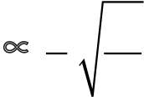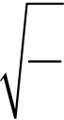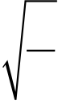

|  |  |
| --- | --- |
| 8. | ***s* = *ut* + 1 2*at*2** rkd;ghl;il gupkhz Kiwapy; rupahdjh vdf; fhz;f. *s* **=** *ut* **+** 1 2*at***2** |

[L] = [LT–1] [T] + [LT–2] [T2]   
 L = L + L   
,Ug[w=;fspYk; gupkhz=;fs; rkk;. vdnt rkd;ghL gupkhz Kiwg;go rup.

|  |  |
| --- | --- |
| 9. | **1**  **2*mv*2= *mgh***vd;w rkd;ghl;il gupkhz Kiwapy; rupahdjh vdf; fhz;f. 1 2*mv***2=** *mgh*  MAR-20, MAY-22  M [LT–1]2 = [M] [LT–2] [L] |

ML2T–2 = ML2T–2   
,Ug[w=;fspYk; gupkhz=;fs; rkk;. vdnt rkd;ghL gupkhz Kiwg;go rup.

|  |  |  |
| --- | --- | --- |
| 10. jdpCrypd; miyt[ neuj;jpw;fhd nfhitia gupkhz Kiwapy; bgWf. miyt[ neukhdJ **(i)** Cry; Fz;od; epiw **'m' (ii)** Crypd; ePsk; **'*l*'** kw;Wk; **(iii)** mt;tplj;jpy; g[tp<u;g;g[ KLf;fk; **'g'** Mfpatw;iwr; rhu;e;jJ. **(**khwpyp **k = 2**p**)**  MAR-23 | | |
| T ∝*malbgc* (my;yJ) T = *kmalbgc* | ----- (1) (k - khwpyp) | |
| gupkhz=;fisg; gpujpapl/  **Tnkalvi.Net**  *l*  T = *km*0*l*1/2*g*–1/2 (my;yJ) T = *k*  *g*  *l*  *k* = 2pvd;gjhy;/ T = 2p  *g*  **1**  ***F***  ***l***  ***m***  *l*  11. mjpu;tila[k; fk;gpapd; mjpu;btz; **(*v*)** MdJ/ **(1)** mspf;fg;gl;l tpir **(*F*) (2)** ePsk;  **(*l*)(3)** XuyF ePsj;jpw;fhd epiw **(*m*)** Mfpatw;iwg; bghUj;J vdf;bfhz;lhy;/  gupkhzg; Kiwg;go mjpu;btz; ***v*** ∝  ***l***  ***m***   1  2         1   **1**   *g*  1   ***F***  *v* ∝*l*a*F*b*m*c ----- (1) 2   *l F m*−1 ***l***−  2 ***m***  *v*?d; gupkhz tha;ghL [T]–1; *l*?d; gupkhz tha;ghL [L];  *F*?d; gupkhz tha;ghL [MLT–2]; *m*?d; gupkhz tha;ghL [ML–1]  rkd;ghL (1) ?,y; gupkhz tha;ghLfisg; gpujpapl/  [M0 L0 T–1) ∝ [Mb+c La+b–c T–2b]  ,Ug[wKk; M, L, T ?d; gofis xg;gpl/   [T–1] ∝ [L]a [M L T–2]b [M L–1]c   *l F m*  *lm*  *l*  *F* −1  1  2  *m*   =   1  *l*   2    1  *lm*  *l*  *F*  *m*   2  1      *m*  *F*  1  2  =  *lm*  1  2  *F*  1  *l*        1  2  1  2 1 *m*   *F*  =      1 −  *l*  2  1    *m*   *F*    1  2 | | |
| 1 | | *F* |
| *l* | *m* | |

|  |  |  |  |  |  |  |  |  |  |  |  |  |
| --- | --- | --- | --- | --- | --- | --- | --- | --- | --- | --- | --- | --- |
| *l* | *l* | *l* | *l* | *l*  *g*  **1**  ***F*** | | | | | | | | |
| *g* |
| *g* | *g* |
| *g* |
| **1**  **1 *F*** *l* ***F***  **1 1**  ***F F***  b + c = 0  c = –b ***l***  ***l m*** *g* ***m***  a + b + c = 0  a + b + b = 0 ***l l***  ***m m***  a, b, c kjpg;g[fis rkd;ghL (1) ?y; gpujpapl/ c = –  *v*∝  *lm*  1  2  *F* −         1  2  1  2  *l F m*  *lm*  1  *F*  *l F m*  1  2  - 1  1 é ù  ê ú ë û  1  2  2  ê ú ë û  1  1  1  *l*  ***m***  ***F***  1  =    1     1 -  *l m*  *F*   1  2  é  ê ë     a + 2  *m*  *F*  1  2  *=*  ù  ú û  *lm*  1  2  *F*  1  2  *lm*  1  2  *F*       1  1        1  2  1  2  a = –1 1  =  1  = 0  =  1 −  *l*   1  1 −  *l*    1  *m*  *F*  *m*  *F*    1  2    1  2    *v*∝  *l*   1  *l*  *lm*  *m F*  *F* 2  1  2 *m*  *F* =  1  *l*   é  ê ë *m*  *F*  1  *l*  ù  ú û  1  2  *l*  *m*   *F*  *m*  *F* | | | |
| –2b = –1 ***l*** | | ***m***      | | | | | | |
| b = | 1 |
| 2 |
| 1 | | | | − | 1 | | | |
| *l F m*−1 | | | | 2 | | | |
| 1 | | |  | 1 |  | *F* |  | 1 |
| *F* | | 2 | 2 |
| 1 | | | = | *l* |  | *m* |  |
| *lm* | | 2 |
| 1 | | *F* | | | | | | |
| *l* | | *m* | | | | | | |
| 12. tl;lg;ghijapy; ,a=;Fk; bghUs; xd;wpd; tpir bghUspd; epiw **(*m*)**/ jpirntfk; 1 *F*  (***v***) kw;Wk; Muk; **(*r*)** Mfpatw;iwr; rhu;e;jJ vdpy;/ tpirf;fhd rkd;ghl;il gupkhz *l*  *m*  Kiwapy; bgWf. **(**khwpyp **k = 1)**  MAR-19 | | | | | | | | | | | | |

*F*∝ *m*a *v*b *r*c   
F = k *m*a *v*b *r*c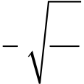

|  |
| --- |
| gupkhz=;fisg; gpujpapl/  **Tnkalvi.Net**  *F* = *mv* 2  *r* |

***

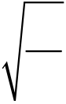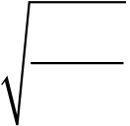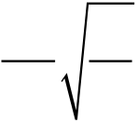

|  |  |
| --- | --- |
| myF ? 2 | ,af;ftpay; |

**I.** rupahd tpiliaj; nju;e;bjLj;J vGJf.

|  |  |  |  |  |  |  |  |  |  |  |  |
| --- | --- | --- | --- | --- | --- | --- | --- | --- | --- | --- | --- |
| 1. | gpd;tUk; ve;j fhu;Orpad; Ma mr;Rj;bjhFg;g[ ,aw;gpaypy; | | | | | | | | | | |
| gad;gLj;jg;gLtjpy;iy> | | | | | | | | | | | |
| a) | | | | | b) | | c) | | d) | | |
| 2. | gpd;tUtdtw;Ws; vJ XuyF btf;lu;> | | | | | | | | | | |
| a) | | +*j* | b) | | | *i* | c) *k* − | *j* | d) | *i* | +*j* |
| 2 | 2 |
| 2 |
| 3. | gpd;tUtdtw;Ws; ve;j ,aw;gpay; mst[ !;nfyuhy; Fwpg;gpl ,ayhJ> | | | | | | | | | | |
| a) epiw | | | | | | | b) ePsk; | | | | |
| c) ce;jk; d) KLf;fj;jpd; vz;kjpg;g[  5. **Tnkalvi.Net** 4.  vdpy;/ mj;Jfspd; ntfk; | | | | | | | | | | | |
| 6. | a) mjpfupf;Fk; b) Fiwa[k;    Jfbshd;wpd; jpirntfk; ν **= 2 + 2** | | | | | | c) khwhJ d) RHp    **- 9 *k***vdpy;/ **t = 0.5** tpdhoapy; mj;Jfspd; | | | | |
| KLf;fj;jpd; vz;kjpg;g[ ahJ> a) 1 m s–2 b) 2 m s–2 | | | | | | | c) RHp | | d) –1 m s–2 | | |
| 7. | bghUbshd;W fl;olj;jpd; cr;rpapypUe;J fPnH tpGfpwJ. mg;bghUs; **4** tpdhoapy; | | | | | | | | | | |
| jiuia mile;jhy; fl;olj;jpd; caubkd;d> (fhw;Wj; jiliag; g[wf;fzpf;f) | | | | | | | | | | | |
| a) 77.3 m | | | | b) 78.4 m | | | c) 80.5 m | | d) 79.2 m | | |
| 8. | **v** vd;w jpirntfj;Jld; ge;J xd;W br=;Fj;jhf nky;nehf;fp vwpag;gLfpwJ. mJ | | | | | | | | | | |
| **t** neuj;jpy; jiuia milfpwJ. gpd;tUk; ve;j **v – t** tiuglk; ,t;tpaf;fj;jpid | | | | | | | | | | | |
| rupahf tpsf;FfpwJ> | | | | | | | c) | | d) | | |
| a) | | | | | b) | |