Note : You can use Visual Studio code for frontend peojects. For that you need to install VSCode and make sure whether all plugins are installed successfully and install Angular extension pack in extensions.

Step -1 – In git codespace install angular extensions pack

Go to your project repo and go to the integrated terminal and install angular cli

And check whether angular cli is installed successfully or not

Open integrated terminal and use this command to create an angular project

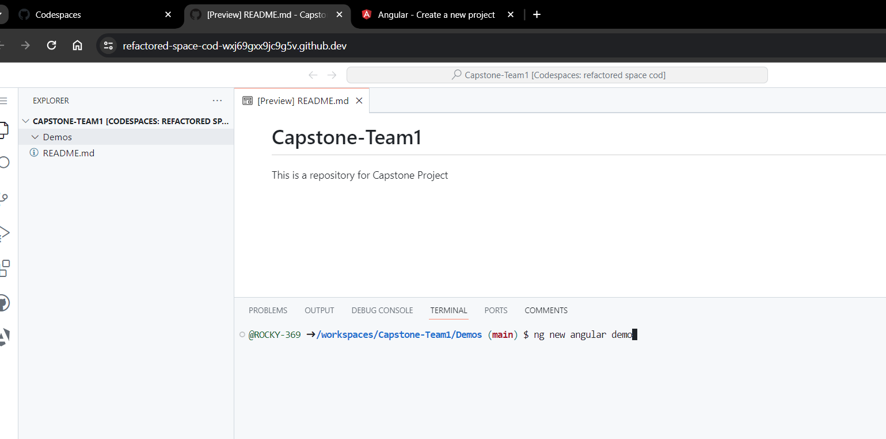

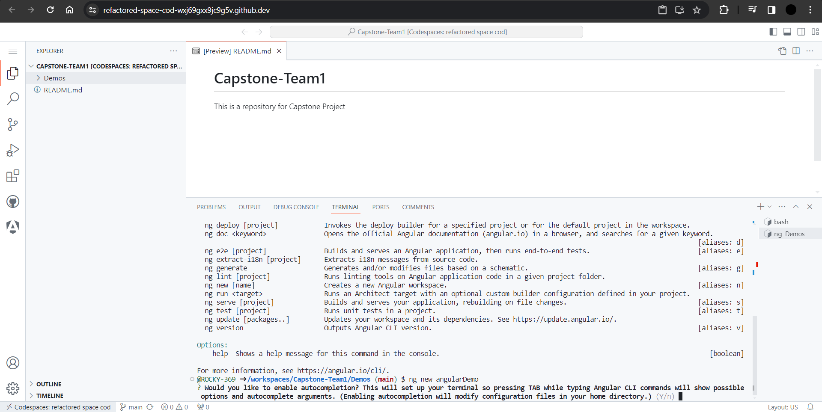

It will ask for this prompt give Y to enable autocompletion. By enabling it you can auto fill the cli commands without memorizing by pressing <Tab>.

And again it will ask for this prompt you can give yes or no whether to share your usage data.

And again it will ask for this prompt to choose the type of styling sheet we are using CSS

Here, Give yes because SSR refers to when a webpage is generated each time a user requests it. In other words, a page returned to the user at request time is a server-side rendered webpage. SSG is a method used to generate webpages at build time. The pages are then re-used each time a user requests them.

After successfully creating angular project you can see all the packages and index files that are generally needed for a web page.

Component.ts - The component class code, written in TypeScript.

Component.html - The component template, written in HTML.

Component.CSS - The component's private CSS styles.

By playing with html and css file you can understand quickly how it works.

