A
Project Stage-II Report on
Lung and Colon Cancer Detection from Scanning Images Using EfficientNetB3
Submitted to
Jawaharlal Nehru Technological University, Hyderabad
in partial fulfillment of requirements for the award of the degree of
BACHELOR OF TECHNOLOGY
in
COMPUTER SCIENCE AND ENGINEERING (AI&ML)
Submitted by
MOHAMMAD NASEEMA (22C51A6634)
SHAIK MEERAVALI (22C51A6650)
GOLLAPALLI GAYATHRI (22C51A6613)
BOLLEPALLY JASHVANTH VARMA (22C51A6607)
Under the Guidance of
Mrs. N. Sudharani
Assistant Professor
Department of CSE(AI&ML)


Department of Computer Science and Engineering(AI&ML)
SAI SPURTHI INSTITUTE OF TECHNOLOGY
(Approved by AICTE, Affiliated to JNTUH, Accredited by NAAC B++)
B. GANGARAM, SATHUPALLY, KHAMMAM, TS- 507303
2025 – 2026


DEPARTMENT OF COMPUTER SCIENCE AND ENGINEERING(AI&ML)

CERTIFICATE
This is to certify that the project entitled Lung and Colon Cancer Detection from Scanning
Images using EfficientNetB3 being submitted by MOHAMMAD NASEEMA(22C51A6634), SHAIK
MEERAVALI (22C51A6650), GOLLAPALLI GAYATHRI(22C51A6613) and BOLLEPALLY JASHVANTH VARMA(22C51A6607) during the academic year 2025-26, in partial fulfilment for the award of the degree of Bachelor of Technology in Computer Science and Engineering (AI&ML) offered by Sai Spurthi Institute of Technology, affiliated to the Jawaharlal Nehru Technological University, Hyderabad.

Supervisor Head of the Department
Mrs. N. SUDHARANI Dr. T. VEERANNA
Assistant Professor Associate Professor

Dr. V S R KUMARI EXTERNAL EXAMINER
PRINCIPAL

DECLARATION

We hereby declare that the project report entitled " Lung and Colon Cancer Detection from Scanning Images Using EfficientNetB3” is done in the partial fulfillment for the award of the Degree in Bachelor of Technology in Computer Science and Engineering (AI&ML) affiliated to Jawaharlal Nehru Technological University, Hyderabad. This project has not been submitted anywhere else.

MOHAMMAD NASEEMA (22C51A6634)
SHAIK MEERAVALI (22C51A6650)
GOLLAPALLI GAYATHRI (22C51A6613)
BOLLEPALLY JASHVANTH VARMA (22C51A6607)

ACKNOWLEDGMENT

On the submission of our project entitled “Lung and Colon Cancer Detection from Scanning Images using EfficientNetB3”, we would like to extend our gratitude and sincere thanks to our supervisor, Mrs. N. SUDHARANI, Assistant Professor, Computer Science and Engineering(A&ML) for her valuable and timely suggestions.
We would also like to extend our sincere thanks to Dr. T. VEERANNA, Associate Professor, Head of the Department, Computer Science and Engineering(A&ML), for his valuable suggestions and motivating guidance during our project work
We endow our sincere thanks to Principal Dr. V S R KUMARI for her consistent cooperation and encouragement.
We would like to thank the entire CSE (AI&ML) Department faculty, who helped us directly and indirectly in the completion of the project. We sincerely thank our friends and family for their constant motivation during the project work.

MOHAMMAD NASEEMA (22C51A6634)
SHAIK MEERAVALI (22C51A6650)
GOLLAPALLI GAYATHRI (22C51A6613)
BOLLEPALLY JASHVANTH VARMA (22C51A6607)

CONTENTS
Description Page No
Abstract i
List Of Figures ii
List Of Tables iii
- INTRODUCTION 1-7
  - Introduction to Project
  - Motivation
  - Problem Definition
  - Objectives of Project
  - Existing System
  - Proposed System
- LITERATURE SURVEY 8-11
  - Introduction
  - Traditional ML Approaches for Cancer Detection
  - Deep Learning – Based Cancer Detection
  - EfficientNet Architecture for Medical Image Classification
  - Medical Imaging Techniques for Lung and Colon Cancer Detection
  - Python and Flask-Based Implementation Frameworks
  - Research Gaps identified
- SYSTEM ANALYSIS 12-14
  - Title Breakdown & Suitability
  - Request Clarification
  - Request Approval
- FEASIBILITY STUDY 15-17
  - Economic Feasibility
  - Technical Feasibility
  - Social Feasibility
- SYSTEM REQUREMENTS 18
  - Hardware Requirements
  - Software Requirements
- SYSTEM DESIGN 19-28
  - Introduction to System Design
6.1.1 Input Design
6.1.2 Output Design
  - System Architecture
  - Dataflow Diagram
  - UML Diagrams
6.4.1 Class Diagram
6.4.2 Activity Diagram
6.4.3 State Diagram
6.4.4 Use case Diagram
6.4.5 Sequence Diagram
- SOFTWARE ENVIRONMENT 29-40
  - Python history
  - What is exactly is Machine learning?
  - Types of Machine learning
7.3.1 Supervised learning
    - Unsupervised learning
  - Utilization of Machine learning
  - Python libraries used in Project
7.5.1 Tensorflow
    - Numpy
    - Pandas
    - Matplotlib
7.5.5 Scikit-learn

8. SYSTEM IMPLEMENTATION 41-44
  - Modules
    - Image Upload module
    - Image Preprocessing module
    - EfficientNetB3 Model module
    - Prediction module
    - Web Interface module
  - Code
    - model.py
    - app.py
    - preprocess.py
9. SYSTEM TESTING 45-49
  - Testing Approach
    - Unit Testing
    - Integration Testing
    - System Testing
    - Performance Testing
    - User Acceptance Testing (UAT)
10. SCREENSHOTS 50-56
11. CONCLUSION & FUTURE ENHANCEMENTS 57-59
  - Conclusion
  - Future Enhancements
REFERENCES 60

ABSTRACT

This project proposes a deep learning–based system for automated classification of lung histopathology images into Lung Adenocarcinoma, Lung Benign Tissue, and Lung Squamous Cell Carcinoma. To ensure data consistency, a custom preprocessing pipeline is applied for dataset restructuring, balancing, and normalization. Two models—a custom CNN and a transfer learning model using EfficientNetB3 pretrained on ImageNet—are developed and evaluated using standard performance metrics. Experimental results show that EfficientNetB3 achieves superior accuracy and robustness due to its effective feature extraction capability. The proposed end-toend pipeline demonstrates the potential of deep learning to support pathologists with reliable and scalable diagnostic assistance. Furthermore, data augmentation techniques such as rotation, flipping, and scaling are employed to improve model generalization and reduce overfitting. Hyperparameter tuning is performed to optimize model performance and enhance classification accuracy. A confusion matrix is used to analyze class-wise prediction performance and identify potential misclassifications. Overall, this approach contributes to early detection of lung cancer, helping improve diagnostic efficiency and patient outcomes.

List of Figures
Fig. No Figure Name Page No

6.1. System Architecture 22
6.2. Dataflow Diagram 23
6.3. Class Diagram 24
6.4. Activity Diagram 25
6.5. State Diagram 26
6.6. Use case Diagram 27
6.7. Sequence Diagram 28
10.1. Anaconda Prompt 50
10.2. Home page 51
10.3. Performance Analysis 52
10.4. Dataset Image 53
10.5. Image Upload Interface 54
10.6. Analysis Report 55 10.7. Lung and Colon Cancer Report 56

List of Tables
Table No Table Name Page No

9.1. Unit Testing 45
9.2. Integration Testing 46
9.3. System Testing 47
9.4. Performance Testing 47
9.5. User Acceptance Testing 48

INTRODUCTION
Lung cancer is one of the leading causes of cancer-related deaths worldwide, primarily due to late diagnosis and limited access to high-quality medical imaging data. Early detection plays a critical role in improving patient survival rates; however, traditional centralized machine learning approaches face challenges related to data privacy, security, and institutional data sharing restrictions. To address these limitations, this project proposes a Lung Cancer Detection System using Federated Learning, which enables collaborative model training across multiple healthcare institutions without transferring sensitive patient data.
The proposed system utilizes medical imaging data such as CT scans to detect lung cancer patterns using deep learning techniques while preserving patient privacy through decentralized learning. Federated Learning allows multiple clients to train local models on their respective datasets and share only model parameters with a central server for aggregation, ensuring that raw medical data never leaves its source. This approach significantly enhances data security and complies with healthcare privacy regulations.
The system is developed using Python 3.10 and Flask for backend integration, enabling secure communication between clients and the central server. Image preprocessing, feature extraction, and classification are performed locally at each participating node. The aggregated global model continuously improves detection accuracy through iterative training rounds. Experimental results demonstrate that the federated approach achieves competitive performance compared to centralized models while maintaining strict privacy guarantees.
This project highlights the effectiveness of Federated Learning in medical image analysis and demonstrates its potential to revolutionize collaborative healthcare AI systems. By combining deep learning with privacy-preserving techniques, the proposed solution provides a scalable, secure, and efficient framework for early lung cancer detection, ultimately contributing to improved diagnostic accuracy and better patient outcomes.

1.1 Introduction To Project
Lung cancer is one of the most prevalent and life-threatening diseases across the world, accounting for a significant percentage of cancer-related mortality. The primary reason for this high fatality rate is latestage diagnosis, as early symptoms are often mild or overlooked. Medical imaging techniques such as Computed Tomography (CT) scans play a vital role in identifying lung abnormalities; however, manual analysis of these images is time-consuming and highly dependent on expert radiologists. As healthcare systems generate massive volumes of medical data, there is an increasing need for automated and intelligent diagnostic tools to assist clinicians in early cancer detection.
In recent years, deep learning techniques have demonstrated remarkable performance in medical image analysis, particularly in detecting lung nodules and classifying cancerous regions. Traditional machine learning models rely on centralized data collection, where patient data from multiple hospitals is aggregated into a single server for training. Although effective, this approach raises serious concerns regarding data privacy, security, and regulatory compliance. Medical data is highly sensitive, and sharing it across institutions is often restricted by legal and ethical frameworks.
Federated Learning emerges as a promising solution to these challenges by enabling collaborative model training without requiring direct data sharing. In this decentralized learning paradigm, each healthcare institution trains a local model on its own dataset and shares only model parameters with a central server. These parameters are aggregated to form a global model, ensuring that raw patient data never leaves its source. This privacy-preserving approach makes Federated Learning particularly suitable for healthcare applications where confidentiality is paramount.
The proposed project focuses on developing a Lung Cancer Detection system using Federated Learning combined with deep learning techniques. Medical images are processed locally to extract meaningful features, and classification models are trained collaboratively across multiple nodes. Python 3.10 and Flask are used to implement the backend infrastructure, facilitating secure communication between clients and the central server. This architecture allows continuous model improvement while maintaining strict data privacy.
By integrating Federated Learning into lung cancer detection, the system aims to enhance diagnostic accuracy, reduce dependence on centralized datasets, and promote collaborative intelligence among healthcare providers. The proposed framework not only supports early detection of lung cancer but also establishes a secure and scalable foundation for future medical AI applications. This project demonstrates how privacy-preserving machine learning can transform modern healthcare by enabling intelligent diagnosis while safeguarding sensitive patient information.

1.2 Motivation
The increasing prevalence of lung cancer and its high mortality rate strongly motivate the need for advanced diagnostic systems capable of detecting the disease at an early stage. Traditional diagnostic methods rely heavily on manual interpretation of medical images by radiologists, which is time-consuming and subject to human error. Although deep learning has shown promising results in automating lung cancer detection, most existing approaches depend on centralized data collection, raising serious concerns regarding patient privacy, data security, and regulatory compliance.
Healthcare institutions often hesitate to share medical data due to ethical constraints and legal restrictions, which limits the availability of large and diverse datasets required for training robust machine learning models. This lack of collaborative data access negatively impacts model performance and generalization. Federated Learning offers a unique opportunity to overcome these challenges by enabling decentralized model training while preserving data privacy.
The motivation behind this project is to leverage Federated Learning to build an intelligent lung cancer detection system that allows multiple healthcare providers to collaboratively train models without exchanging sensitive patient information. By combining deep learning with privacy-preserving techniques, the proposed system aims to improve diagnostic accuracy, reduce data-sharing barriers, and support early cancer detection. Ultimately, this project seeks to contribute toward safer AI deployment in healthcare and enhance clinical decision-making through secure, collaborative intelligence.

1.3 Problem Definition
Lung cancer detection using medical imaging is a complex and critical task that directly impacts patient survival rates. Although deep learning techniques have demonstrated significant potential in automating lung cancer diagnosis, most existing systems rely on centralized data collection, where patient data from multiple hospitals is aggregated into a single repository for model training. This centralized approach introduces serious challenges related to data privacy, security risks, regulatory compliance, and institutional reluctance to share sensitive medical information.
Furthermore, the limited availability of diverse and large-scale datasets restricts the performance and generalization capability of traditional machine learning models. Healthcare organizations often operate in isolation due to legal and ethical constraints, preventing collaborative model development. As a result, existing lung cancer detection systems may suffer from biased learning, reduced accuracy, and poor adaptability across different patient populations.
Another major challenge lies in the manual interpretation of CT scans, which is time-consuming and dependent on expert radiologists. Human error, fatigue, and workload pressure can lead to misdiagnosis or delayed detection. While automated systems exist, they lack privacy-preserving mechanisms and fail to address cross-institutional collaboration.
Therefore, there is a need for a secure and efficient lung cancer detection framework that enables collaborative learning without compromising patient data privacy. The problem addressed in this project is to design a decentralized detection system using Federated Learning that allows multiple medical institutions to jointly train deep learning models while keeping sensitive data localized. The proposed solution aims to enhance diagnostic accuracy, protect patient confidentiality, and facilitate scalable, realworld deployment of AI in healthcare.

1.4 Objectives of Project
The main objective of this project is to design and implement an intelligent lung cancer detection system using Federated Learning that enables collaborative model training across multiple healthcare institutions while preserving patient data privacy. The project aims to utilize deep learning techniques on medical imaging data to accurately identify cancerous lung regions and improve early diagnosis. Another key objective is to eliminate the need for centralized data storage by allowing local model training and secure parameter aggregation, thereby reducing privacy risks and regulatory challenges.
Additionally, the project seeks to develop a scalable Flask-based framework using Python 3.10 to manage communication between distributed clients and the central aggregation server. The system also focuses on enhancing detection accuracy through iterative federated training, minimizing diagnostic errors, and supporting clinical decision-making. Ultimately, this project aims to demonstrate the effectiveness of Federated Learning in healthcare applications and provide a secure, efficient, and privacy-preserving solution for lung cancer detection.

1.5 Existing System
In the existing lung cancer detection systems, most artificial intelligence applications are developed using a centralized machine learning approach. In this model, medical imaging data such as CT scans from multiple healthcare institutions are collected and stored in a single centralized server for training deep learning models. While this approach allows access to large datasets, it introduces significant challenges related to patient privacy, data security, and regulatory compliance. Medical data is highly sensitive, and centralized storage increases the risk of data breaches and unauthorized access.
Furthermore, hospitals and diagnostic centers are often unwilling or legally restricted from sharing patient data, which limits the availability of diverse datasets. This results in models trained on limited or biased data, reducing their generalization capability across different populations. As a consequence, centralized systems may perform well on specific datasets but fail to adapt effectively to real-world clinical environments.
Another major limitation of existing systems is their heavy dependence on manual interpretation by radiologists. Although deep learning models assist in detecting lung nodules, final diagnosis still requires expert evaluation, making the process time-consuming and prone to human error. Factors such as workload pressure and fatigue can further impact diagnostic accuracy.
Existing systems also lack collaborative learning mechanisms between institutions. Each hospital typically develops and trains its own models independently, leading to duplication of effort and inconsistent diagnostic performance. Without collaborative training, valuable medical knowledge remains siloed, preventing collective intelligence across healthcare networks.
Additionally, centralized systems often suffer from scalability issues. As data volume increases, computational and storage requirements grow rapidly, leading to higher operational costs. These systems also lack robust privacy-preserving techniques, making them unsuitable for large-scale deployment in privacy-sensitive healthcare environments.
Overall, the existing centralized lung cancer detection frameworks face critical challenges including data privacy risks, limited dataset diversity, lack of institutional collaboration, and dependency on manual diagnosis. These limitations highlight the need for a decentralized, secure, and collaborative learning approach to improve diagnostic accuracy while protecting patient confidentiality.

Disadvantages Of Existing System
- The existing centralized lung cancer detection systems suffer from several critical limitations that hinder their effectiveness and real-world applicability. One of the major drawbacks is the compromise of patient privacy, as sensitive medical data must be transferred and stored in a centralized repository. This increases vulnerability to data breaches and unauthorized access. Additionally, strict healthcare regulations often restrict data sharing, preventing institutions from contributing their datasets for collaborative learning.
- Another significant disadvantage is dataset bias caused by limited or homogeneous data sources. Since hospitals typically train models independently, the resulting systems lack exposure to diverse patient populations, which reduces diagnostic accuracy and model generalization. These systems also rely heavily on expert radiologists for final diagnosis, making the process slow and susceptible to human error.
- Centralized systems require high computational and storage resources, leading to increased infrastructure costs. Moreover, they lack scalability and collaborative intelligence, as institutions operate in isolation. The absence of privacy-preserving mechanisms further limits widespread adoption, making existing approaches unsuitable for modern healthcare environments.

1.6 Proposed System
The proposed system introduces a Lung Cancer Detection framework using Federated Learning, designed to overcome the limitations of centralized models by enabling decentralized and privacy-preserving collaborative learning. In this approach, medical institutions train local deep learning models on their own CT scan datasets without transferring raw patient data. Only model parameters or weight updates are securely shared with a central server, where they are aggregated to form a global model.
This system utilizes deep learning techniques for automatic feature extraction and classification of lung nodules. Each participating client performs image preprocessing, feature learning, and model training locally. The Flask-based backend coordinates communication between distributed clients and the central aggregation server, ensuring secure and efficient parameter exchange.
The federated learning architecture allows multiple healthcare providers to collaboratively improve model performance while maintaining strict data confidentiality. By continuously updating the global model through iterative training rounds, the system achieves improved detection accuracy across diverse datasets. This decentralized approach eliminates the need for centralized data storage and significantly reduces privacy risks.
The proposed framework also incorporates validation mechanisms to ensure model integrity and prevent malicious updates. Secure aggregation techniques are applied to protect transmitted parameters. The modular design supports scalability and future integration of advanced security features such as encryption and differential privacy.

Advantages Of Proposed System
- The proposed system offers numerous advantages over traditional centralized approaches. It preserves patient privacy by keeping medical data localized within institutions. The collaborative learning process improves diagnostic accuracy by leveraging diverse datasets without violating confidentiality regulations. The system reduces dependency on centralized infrastructure, lowering storage and operational costs.
- Federated Learning enables cross-institutional collaboration, allowing healthcare providers to benefit from shared knowledge while maintaining autonomy over their data. The automated detection process minimizes reliance on manual interpretation, reducing diagnostic errors and improving efficiency. Additionally, the Flask-based architecture provides flexibility, scalability, and ease of deployment.
- Overall, the proposed system delivers a secure, scalable, and privacy-preserving solution for lung cancer detection, making it suitable for real-world healthcare environments.

2. LITERATURE SURVEY

2.1 Introduction
Medical image analysis has gained significant attention in recent years due to the rapid advancement of artificial intelligence and deep learning technologies. Early detection of life-threatening diseases such as lung cancer and colon cancer plays a crucial role in improving patient survival rates and treatment outcomes. Medical imaging techniques such as Computed Tomography (CT), Magnetic Resonance Imaging (MRI), and histopathology scanning images are widely used for detecting abnormalities in lung and colon tissues. However, manual diagnosis by radiologists and pathologists is time-consuming, prone to human error, and dependent on expert availability.
To overcome these limitations, researchers have explored automated disease detection systems using machine learning and deep learning techniques. Convolutional Neural Networks (CNNs) have shown remarkable performance in medical image classification tasks by automatically extracting meaningful features from raw images. Recently, EfficientNet architectures, particularly EfficientNetB3, have gained popularity due to their improved accuracy, reduced computational complexity, and balanced scaling of network depth, width, and resolution. This chapter reviews the existing research on lung and colon cancer detection using deep learning, EfficientNet models, medical imaging techniques, and Python-based implementation frameworks. It also identifies research gaps that motivate the proposed system.

2.2 Traditional Machine Learning Approaches for Cancer Detection
Early research in lung and colon cancer detection relied on traditional machine learning algorithms such as Support Vector Machines (SVM), Random Forest, K-Nearest Neighbors (KNN), and Decision Trees. These methods required handcrafted feature extraction techniques including texture analysis, shape detection, segmentation, and histogram-based feature extraction.
Although these approaches achieved moderate success, their performance depended heavily on feature engineering and preprocessing steps. The manual extraction of features required domain expertise and increased computational complexity. Additionally, traditional machine learning models struggled to generalize across diverse datasets, limiting their effectiveness in real-world clinical environments.
These limitations led researchers to adopt deep learning methods that automatically learn features from scanning images without manual intervention.

2.3 Deep Learning-Based Cancer Detection
Deep learning models, particularly Convolutional Neural Networks (CNNs), have significantly improved automated cancer detection performance. CNNs learn hierarchical features directly from raw images, eliminating the need for handcrafted feature extraction. Several studies demonstrated that CNN-based models outperform traditional machine learning techniques in medical image classification tasks.
Researchers applied deep learning architectures such as VGGNet, AlexNet, ResNet, and DenseNet for lung nodule classification and colon cancer detection. These models showed improved classification accuracy, sensitivity, and specificity. However, deeper networks often required large datasets, higher computational resources, and longer training times.
Despite these challenges, deep learning techniques became the preferred approach due to their superior performance in medical imaging applications.

2.4 EfficientNet Architecture for Medical Image Classification
EfficientNet models were introduced to improve performance while reducing computational cost. EfficientNet uses compound scaling to balance network depth, width, and input resolution, resulting in better accuracy with fewer parameters. Among the EfficientNet family, EfficientNetB3 offers an optimal balance between accuracy and computational efficiency, making it suitable for medical image classification tasks.
Recent studies have applied EfficientNet architectures for lung cancer detection from CT scan images and colon cancer detection from histopathology images. These models demonstrated improved feature extraction capability and higher classification accuracy compared to traditional CNN architectures. EfficientNetB3, in particular, showed strong performance in detecting subtle variations in medical images and handling complex datasets.
Transfer learning using pretrained EfficientNetB3 models further improved performance by leveraging knowledge from large-scale image datasets. This approach reduces training time and improves model generalization across different datasets.

2.5 Medical Imaging Techniques for Lung and Colon Cancer Detection
Medical imaging plays a crucial role in cancer detection. CT scans are widely used for lung cancer detection as they provide high-resolution images of lung nodules and abnormalities. Similarly, colon cancer detection often relies on histopathology images obtained from biopsy samples.
Researchers have developed automated segmentation and classification models to identify cancerous regions in scanning images. These systems assist healthcare professionals in early diagnosis and reduce diagnostic workload. Deep learning-based models trained on medical datasets have shown high sensitivity in detecting early-stage tumors.
However, challenges such as image noise, dataset imbalance, and variations in scanning equipment affect model performance. Researchers continue to explore advanced architectures such as EfficientNet to address these limitations and improve detection accuracy.

2.6 Python and Flask-Based Implementation Frameworks
Python has become the most widely used programming language for deep learning and medical image analysis. Libraries such as TensorFlow, Keras, PyTorch, NumPy, and OpenCV provide powerful tools for building cancer detection systems. Python’s simplicity and flexibility make it suitable for rapid model development and experimentation.
Flask, a lightweight Python web framework, is commonly used to deploy deep learning models as webbased applications. Flask enables users to upload scanning images and receive prediction results in real time. Several research implementations use Flask to build user-friendly interfaces for medical image classification systems.
Although many implementations focus on single-disease detection, limited research explores combined lung and colon cancer detection systems using EfficientNetB3. This creates an opportunity for developing a unified diagnostic platform.

2.7 Research Gaps Identified
From the literature review, the following gaps are identified:
- Many existing systems focus on single cancer detection instead of multi-disease detection
- Limited use of EfficientNetB3 architecture for combined lung and colon cancer classification
- Insufficient dataset diversity affecting model generalization
- Lack of user-friendly web-based deployment for clinical usage
- Limited research on lightweight and efficient deep learning models for medical imaging
- Need for improved accuracy and faster prediction performance
These gaps indicate the need for an efficient and scalable cancer detection system. The proposed project addresses these limitations by implementing a lung and colon cancer detection system using EfficientNetB3, Python, and Flask, providing an accurate, fast, and user-friendly diagnostic solution.

3. SYSTEM ANALYSIS

3.1 Title Breakdown & Suitability
Project Title:
Lung and Colon Cancer Detection from Scanning Images using EfficientNetB3
- “Lung and Colon Cancer Detection”
This component refers to the automated identification of cancer in lung and colon tissues. Lung cancer and colon cancer are among the leading causes of cancer-related deaths worldwide. Early detection of these cancers significantly improves treatment outcomes and survival rates. The proposed system aims to detect cancerous and non-cancerous conditions automatically using scanning images, reducing dependency on manual diagnosis.
- “Scanning Images”
Scanning images refer to medical imaging data such as CT scans, histopathology images, or biopsy images used for cancer diagnosis. These images contain important information about abnormal tissue growth, tumors, or nodules. Manual analysis of these images requires expert radiologists or pathologists and is time-consuming. The proposed system automates the analysis of these scanning images using deep learning techniques.
- “Using EfficientNetB3”
EfficientNetB3 is a deep learning architecture known for its high accuracy and computational efficiency. EfficientNetB3 uses compound scaling to balance network depth, width, and resolution, improving model performance while reducing training time. In this project, EfficientNetB3 is used to automatically extract features from scanning images and classify them into cancerous and non-cancerous categories.
This improves detection accuracy and reduces manual effort.

3.2 Request Clarification
After receiving approval from the project guide and stakeholders, the project requirements are analyzed to clearly understand the system objectives and scope. This project focuses on developing an automated cancer detection system that identifies lung and colon cancer from scanning images using EfficientNetB3 deep learning architecture.
Traditional cancer diagnosis methods rely heavily on manual image analysis by medical professionals. This process is time-consuming, prone to human error, and may lead to delayed diagnosis. Additionally, many existing systems focus only on single cancer detection, such as either lung cancer or colon cancer, rather than providing a unified detection platform.
The proposed system aims to overcome these limitations by developing a deep learning-based model capable of detecting both lung and colon cancer from scanning images. The system automatically processes uploaded images, extracts features using EfficientNetB3, and classifies them into appropriate categories.
The system is designed for healthcare applications, research environments, and diagnostic support systems. It provides a user-friendly interface where users can upload scanning images and obtain prediction results quickly. This reduces diagnosis time and improves accuracy.
In modern healthcare systems, early detection is critical for successful treatment. Manual diagnosis often becomes challenging due to increasing patient data and limited availability of experts. Therefore, this project provides an automated and efficient solution that assists healthcare professionals in cancer detection and improves clinical decision-making.

3.3 Request Approval
Not all project proposals are feasible or practical to implement. Therefore, the proposed system is evaluated based on feasibility, technical requirements, resource availability, and expected outcomes before approval.
This project is considered feasible due to the availability of:
- Medical image datasets for lung and colon cancer
- Deep learning frameworks such as TensorFlow and Keras
- EfficientNetB3 pretrained models for transfer learning
- Python programming language for implementation
- Flask framework for web-based interface development
- Standard computing systems with GPU or CPU support
Once the project is approved, important factors such as development cost, implementation complexity, project timeline, and required resources are analyzed. Based on this evaluation, development activities are planned and scheduled accordingly.
The approval confirms that the project is technically feasible and beneficial, as it provides an automated cancer detection system that improves accuracy, reduces diagnosis time, and supports healthcare professionals in early disease detection.

4. FEASIBILITY STUDY
At this stage, the feasibility of the proposed project is analyzed to determine whether the Lung and Colon Cancer Detection from Scanning Images using EfficientNetB3 can be developed and implemented successfully within the given constraints. A feasibility study helps in evaluating the practicality of the system before full-scale development. The proposed cancer detection system is examined to ensure that it meets healthcare and research requirements without causing operational, technical, or financial difficulties.
The feasibility analysis provides a clear understanding of the system’s requirements, limitations, and benefits. It ensures that the proposed framework is realistic, achievable, and suitable for real-world deployment in medical imaging and healthcare environments. The feasibility study of this project is carried out under the following three major considerations: economic feasibility, technical feasibility, and social feasibility.

4.1 Economic Feasibility
Economic feasibility is conducted to evaluate the financial impact of implementing the lung and colon cancer detection system. The main objective is to determine whether the development, deployment, and maintenance costs are affordable and justified. In this project, the system is developed using open-source technologies such as Python, TensorFlow, Keras, and the Flask web framework, which significantly reduces software licensing costs.
The EfficientNetB3 deep learning model is implemented using pretrained architectures, which reduces development time and computational expenses. The system does not require expensive proprietary medical imaging software or specialized hardware. It can be deployed on standard computing systems with CPU or GPU support, making it cost-effective.
Additionally, the automated cancer detection system reduces manual diagnosis effort and speeds up the detection process, leading to increased productivity in healthcare environments. By minimizing diagnosis time and improving early detection accuracy, the proposed system contributes to long-term cost savings for hospitals and research institutions. Therefore, the proposed lung and colon cancer detection system is economically feasible.

4.2 Technical Feasibility
Technical feasibility focuses on evaluating whether the proposed system can be developed using available technologies, tools, and technical expertise. The lung and colon cancer detection system requires deep learning models, image preprocessing techniques, and web-based deployment frameworks, all of which are supported by existing technologies.
The use of EfficientNetB3 ensures high accuracy while maintaining computational efficiency. Python provides extensive libraries such as TensorFlow, Keras, NumPy, OpenCV, and Matplotlib for image processing and model training. These libraries simplify development and improve system performance.
The system also uses Flask for developing a web-based interface, allowing users to upload scanning images and receive prediction results. This lightweight framework supports real-time interaction and easy deployment. The system can be integrated into healthcare environments without major infrastructure changes.
Since all required tools and technologies are readily available and widely supported, the proposed system is technically feasible.

4.3 Social Feasibility
Social feasibility examines the level of user acceptance and adaptability of the proposed lung and colon cancer detection system. The success of the system depends on how easily healthcare professionals and researchers can adopt and use the system in their workflows.
The proposed system assists radiologists and medical professionals by providing automated cancer detection from scanning images. This reduces manual workload, improves diagnostic accuracy, and supports early detection of diseases. The system acts as a decision-support tool rather than replacing medical professionals, which increases user acceptance.
Proper documentation and minimal training enable users to understand and operate the system effectively. The Flask-based interface provides a simple and user-friendly environment where users can upload images and obtain prediction results quickly.
Since the system improves efficiency, reduces workload, and supports healthcare professionals in diagnosis, it is well accepted in medical and research environments. Therefore, the proposed lung and colon cancer detection system is socially feasible.

5. SYSTEM REQUIREMENTS

5.1 Hardware Requirements
- Processor : Intel Core i5 or higher
- RAM : Minimum 8 GB
- Storage : 256 GB or higher
- Network Connectivity

5.2 Software Requirements
- Operating System : Windows 10/11 or Linux
- Programming Language : Python 3.11
- Web Framework : Flask
- Development Tools : Anaconda

6. SYSTEM DESIGN

6.1 Introduction to System Design
System design is the process of defining the overall architecture, components, modules, data flow, and interfaces of a system to meet specified requirements. It serves as a blueprint that guides the development and implementation of the system.
In this project, the system design focuses on developing an automated Lung and Colon Cancer Detection system from scanning images using EfficientNetB3. The system is designed to automatically classify medical images into cancerous and non-cancerous categories. The EfficientNetB3 deep learning model is used for feature extraction and classification to improve detection accuracy and efficiency.
The system is designed in a modular manner to ensure scalability, maintainability, and efficient performance. The architecture consists of multiple layers such as presentation layer, preprocessing layer, deep learning model layer, prediction layer, and data storage layer. Each layer performs a specific function and interacts with other components to achieve seamless image processing and cancer detection.
The overall system workflow includes image upload, preprocessing, feature extraction using EfficientNetB3, classification, and displaying prediction results through a web interface. The system is implemented using Python and Flask framework to provide a user-friendly interface for image upload and result visualization.

6.1.1 Input Design
The input design is the link between the user and the lung and colon cancer detection system. It involves the development of specifications and procedures for data collection and preparation so that the input data can be processed efficiently. Input is provided by users through the web interface by uploading scanning images such as CT scans or histopathology images.
The design of input focuses on minimizing errors, reducing unnecessary steps, avoiding redundant data, and maintaining simplicity. The input system is designed to ensure accuracy, reliability, and ease of use.
Input design in this system considers the following aspects:
- What data should be provided as input to the system
- How the input data should be structured and formatted
- The interaction mechanism to guide users in providing inputs
- Methods for validating input data and handling errors effectively

Input Components
- Lung CT scan images
- Colon histopathology images
- Image file upload through web interface
- User selection (optional: Lung or Colon detection)

Objectives
- Input design aims to convert user-uploaded scanning images into a format suitable for processing within the EfficientNetB3 model. It ensures that accurate and valid images are provided to generate reliable predictions.
- It focuses on creating a user-friendly image upload mechanism that allows users to easily upload scanning images. The design ensures that image input is simple, consistent, and free from errors.
- The system validates all input images by checking image format, size, and quality. Proper validation mechanisms and error messages are provided to guide users and prevent incorrect data processing. The overall objective is to design an input structure that is easy to use, secure, and efficient.

6.1.2 Output Design
A quality output is one that satisfies the requirements of end users and presents information in a clear and understandable manner. In this system, outputs are generated after processing scanning images through the EfficientNetB3 deep learning model. Output design determines how prediction results are presented to users through the web interface.
The output is one of the most important components of the system, as it directly communicates detection results to healthcare professionals or users. Efficient output design improves usability and supports quick decision-making.
The system generates outputs such as cancer detection results, prediction accuracy, and classification labels. These outputs are displayed clearly on the web interface after processing the uploaded image.

Objectives
- The design of system outputs should follow a structured and organized approach. Each output must be developed in a way that users can easily understand and effectively utilize the information provided.
- Appropriate methods should be selected for presenting information, ensuring clarity, readability, and usability across web interfaces.
- The system should generate well-formatted outputs including prediction results and classification labels that clearly present cancer detection results.
The output of the system should achieve the following objectives:
- Provide prediction results such as Lung Cancer, Colon Cancer, or Normal
- Display classification confidence or probability (optional)
- Highlight detection results clearly for quick understanding
- Support user decision-making for further medical diagnosis
- Confirm successful image upload and processing completion
6.2 System Architecture
The architecture begins at the hospital client, where CT scanner images of lung and colon tissues are collected from patients for analysis. These images are then sent to the preprocessing module, where noise removal, resizing, normalization, and image enhancement techniques are applied to improve image quality. After preprocessing, the cleaned images are used for local model training using the EfficientNetB3 deep learning model. Each hospital performs local training independently, which helps in maintaining patient data privacy and security.
Once the local training is completed, the trained models are transmitted to the central server. At the central server, the model aggregator combines the weights of all locally trained models to create a more robust and generalized model. This aggregated model is referred to as the global model, which benefits from learning across multiple hospital datasets. The global model is then deployed in a web-based system developed using Flask.
The web system contains a prediction module that processes new scanning images uploaded by doctors or medical staff. Finally, the user interface displays the prediction results, indicating whether lung or colon cancer is detected, thereby assisting doctors in making faster and more accurate clinical decisions.
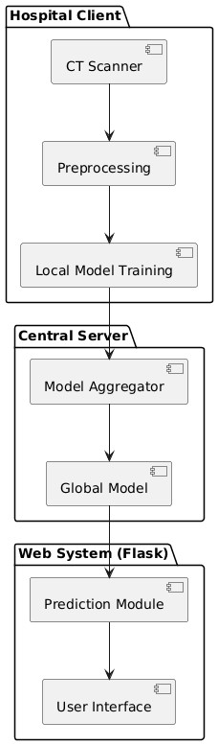

Fig 6.1 System Architectute

6.3 DATAFLOW DIAGRAM:
The data flow begins at the hospital client, where CT scanner images of lung and colon tissues are collected from patients. These images are sent to the preprocessing stage, where they are cleaned, resized, and normalized to improve quality. The processed images are then used for local model training using the EfficientNetB3 model at each hospital, ensuring patient data privacy.
After training, the local models are forwarded to the central server, where the model aggregator combines them to create a global model. This global model improves accuracy by learning from multiple datasets. The global model is then deployed in a Flask-based web system. The prediction module analyzes new uploaded images, and the user interface displays the final lung and colon cancer detection results for doctors.

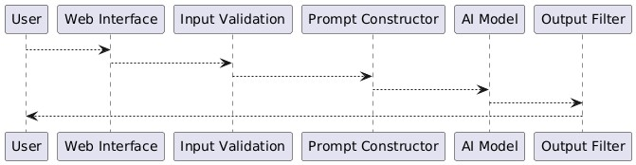
Fig 6.2 Dataflow Diagram

6.4 UML Diagrams
6.4.1 Class Diagram
The class diagram represents the structure of the Lung and Colon Cancer Detection system using EfficientNetB3. The CT Scanner class is responsible for capturing lung and colon scanning images from patients and sending them to the Preprocessing class. The Preprocessing class performs image enhancement operations such as resizing, normalization, and noise removal to prepare the images for model training.
The processed data is then passed to the Local Model Training class, where the EfficientNetB3 model is trained using hospital-specific datasets. The trained local model is forwarded to the Model Aggregator class located at the central server. The Model Aggregator combines multiple local models to generate a Global Model, which improves overall prediction accuracy.
The Global Model is then integrated into the Prediction Module, which analyzes new input images and produces detection results. Finally, the User Interface class interacts with users, allowing doctors to upload scanning images and view lung and colon cancer detection outcomes.

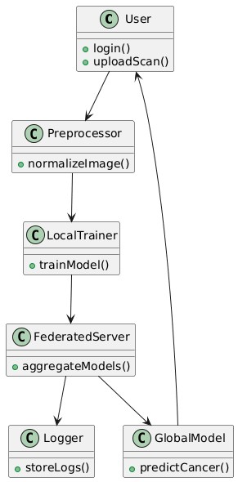
Fig 6.3 Class Diagram
6.4.2 Activity Diagram
The activity diagram represents the workflow of the Lung and Colon Cancer Detection system using EfficientNetB3. The process begins when the user uploads CT scan images of lung or colon tissues through the web interface. Once the images are uploaded, the system performs preprocessing operations such as resizing, normalization, and noise removal to improve image quality.
After preprocessing, the images are passed to the EfficientNetB3 model for feature extraction and classification. The trained model analyzes the input images and detects whether cancer is present or not. The system then generates prediction results based on the analysis performed by the model.
Finally, the results are displayed to the user through the interface, indicating whether lung cancer or colon cancer is detected. This workflow helps doctors make faster and more accurate decisions for early diagnosis and treatment.

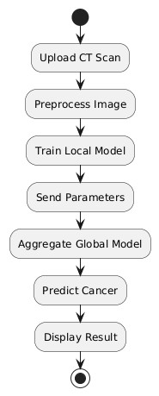

Fig 6.4 Activity Diagram

6.4.3 State Diagram
The state diagram illustrates the different states involved in the Lung and Colon Cancer Detection system using EfficientNetB3. The process begins in the initial state, where the system waits for the user to upload CT scan images. Once the images are uploaded, the system moves to the image preprocessing state, where resizing, normalization, and noise removal are performed to improve image quality.
After preprocessing, the system transitions to the model processing state, where the EfficientNetB3 model analyzes the images and extracts important features. Based on this analysis, the system enters the prediction state, where the model determines whether lung cancer or colon cancer is present.
Finally, the system moves to the result display state, where the prediction results are shown to the user through the interface. After displaying the results, the system returns to the initial state, ready to process new CT scan images.
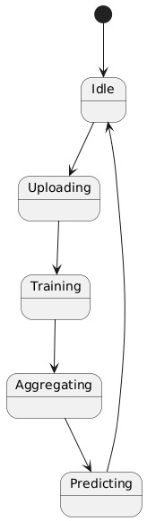

Fig 6.5 State Diagram

6.4.4 Use case Diagram
The use case diagram illustrates the interaction between users and the Lung and Colon Cancer Detection system using EfficientNetB3. The primary actor in the system is the doctor or medical staff, who interacts with the system through a web interface. The process begins when the user logs into the system and uploads CT scan images of lung or colon tissues for analysis.
Once the images are uploaded, the system performs preprocessing operations such as resizing, normalization, and noise removal to prepare the images for analysis. The processed images are then sent to the EfficientNetB3 model, where feature extraction and classification are performed to detect cancer.
After processing, the system generates prediction results indicating whether lung cancer or colon cancer is present. The user can then view the results through the interface and use the information for diagnosis and treatment planning. Finally, the system allows the user to upload new images and repeat the detection process as needed.

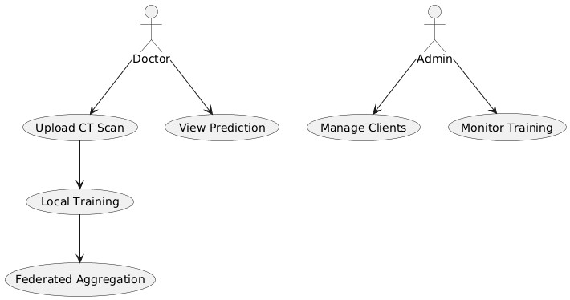

Fig 6.6 Use case Diagram

6.4.5 Sequence Diagram
The sequence diagram illustrates the interaction between different components of the Lung and Colon Cancer Detection system using EfficientNetB3. The process begins when the user uploads the CT scan image through the web interface. The web interface then sends the uploaded image to the input validation module to verify the image format and ensure valid input.
After validation, the image is forwarded to the preprocessing module, where image enhancement techniques such as resizing, normalization, and noise removal are performed. The processed image is then sent to the EfficientNetB3 AI model for feature extraction and classification. The AI model analyzes the image and predicts whether lung cancer or colon cancer is present.
Once the prediction is completed, the output filter processes the results and formats them into a readable form. The final prediction result is then sent back to the web interface, where it is displayed to the user. This sequence of interactions ensures smooth data flow and accurate cancer detection.

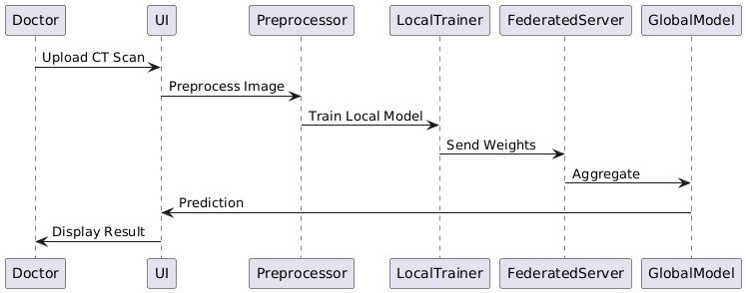

Fig 6.7 Sequence Diagram

7. SOFTWARE ENVIRONMENT
7.1 Python's history
Python is a high-level, interpreted, and general-purpose programming language known for its simplicity and readability. The development of Python was influenced by several earlier programming languages, particularly the ABC programming language. The ABC programming environment was developed at the Centrum Wiskunde & Informatica in Amsterdam, Netherlands. ABC was designed to be easy to learn and use, especially for beginners, and many of its features later inspired the creation of Python.
Python was created by Guido van Rossum in the late 1980s while working at the Centrum voor Wiskunde en Informatica (CWI). During this time, Guido van Rossum was involved in developing the ABC programming language. Although ABC had several useful features, it also had limitations such as lack of extensibility and difficulty in integrating with other systems. These limitations motivated Guido van Rossum to design a new programming language that retained the strengths of ABC while overcoming its weaknesses.
During discussions with Bill Venners, Guido van Rossum explained how the ABC language influenced Python's design. He reflected on his experience working with ABC and expressed dissatisfaction with some of its limitations. As a result, he decided to develop a new scripting language that would be simple, powerful, and flexible. He aimed to combine the best features of ABC with improvements that allowed better usability and scalability.
Guido van Rossum began working on Python during the late 1980s as a personal project. He developed a simple and clean syntax that replaced complex symbols such as curly braces with indentation. This indentation-based structure improved readability and made the language easier to understand. He also introduced useful data types such as lists, dictionaries, strings, numbers, and hash tables, which made Python flexible and efficient for various applications.
Python was officially released in 1991, and since then, it has undergone continuous development and improvement. Over the years, Python has gained popularity due to its simplicity, large standard library, and strong community support. It is now widely used in fields such as web development, data science, artificial intelligence, machine learning, automation, and software development.
Another reason for Python's success is its portability. Python programs can run on multiple platforms such as Windows, Linux, and macOS without major modifications. This cross-platform capability makes Python highly suitable for project development and deployment.
Today, Python continues to evolve with regular updates and new features. Python 3 introduced major improvements such as better Unicode support, improved libraries, and enhanced performance. Due to these advantages, Python has become one of the most widely used programming languages in the world and plays a significant role in modern software development.
7.2 What exactly is machine learning?
Before understanding machine learning, it is important to first understand the concept of Artificial Intelligence. Artificial Intelligence (AI) refers to the ability of machines or computer systems to perform tasks that normally require human intelligence, such as learning, reasoning, decision-making, and problem-solving. Machine learning is considered a subfield of artificial intelligence that focuses specifically on enabling machines to learn from data without being explicitly programmed.
Machine learning involves the development of mathematical and statistical models that allow computers to analyze data, identify patterns, and make predictions or decisions. Instead of writing fixed rules, machine learning systems improve their performance automatically as they are exposed to more data. This process of improving performance based on experience is what is referred to as "learning" in machine learning.
From a broader perspective, machine learning helps in building intelligent systems capable of handling complex data. These systems use algorithms to learn from past data and then apply that knowledge to new, unseen data. For example, machine learning models can be used to predict future trends, classify data, detect anomalies, and automate decision-making processes.
Machine learning plays a crucial role in Data Science, where it is used to build predictive models and extract meaningful insights from large datasets. These models are trained using historical data and later used to predict outcomes or support decision-making. The accuracy of these models improves as more data becomes available.
The concept of "learning" in machine learning is inspired by human learning processes. Just like humans learn from experience, machine learning algorithms learn from data patterns. However, unlike human intelligence, machine learning relies on mathematical optimization and statistical techniques to improve performance. This makes machine learning highly effective for handling large-scale and complex datasets.
Understanding the problem context and data requirements is essential for applying machine learning techniques effectively. Selecting appropriate algorithms, preparing data, and evaluating model performance are key steps in the machine learning process. These steps ensure that the developed models provide accurate and reliable results.
Today, machine learning is widely used in various applications such as recommendation systems, image recognition, speech recognition, fraud detection, and predictive analytics. Due to its ability to automatically learn from data and improve over time, machine learning has become an important component of modern intelligent systems and data-driven decision-making.
7.3 Types of Machine Leaning:
Machine learning can be broadly categorized into two main types: Supervised Learning and Unsupervised Learning. These categories are based on how the algorithm learns from the data and the type of input provided during training. Understanding these types helps in selecting the appropriate approach for solving a particular problem.

7.3.1 Supervised Learning
Supervised Learning is a type of machine learning in which the model is trained using labeled data. In this approach, both input data and the corresponding correct output are provided to the algorithm during training. The model learns the relationship between the input and output data and uses this knowledge to predict results for new and unseen data. Supervised learning is commonly used in applications such as prediction, classification, and forecasting. It helps improve decision-making accuracy by learning from historical data and identifying patterns.

7.3.2 Unsupervised Learning
Unsupervised Learning is a type of machine learning where the algorithm works with unlabeled data. In this method, the model is not provided with predefined outputs. Instead, it automatically identifies patterns, similarities, and structures within the dataset. Unsupervised learning is useful for understanding hidden relationships in data and organizing large datasets efficiently. It is widely used in data analysis, pattern recognition, and feature extraction.
Both supervised and unsupervised learning play an important role in machine learning. Supervised learning focuses on prediction using labeled data, whereas unsupervised learning focuses on discovering hidden patterns from unlabeled data. These approaches are widely used in solving real-world problems and building intelligent systems.

7.4 Utilization of Machine Learning
Human intelligence is capable of solving complex problems, but with the rapid growth of data, it has become difficult to analyze information manually. Machine Learning helps computers learn from data, identify patterns, and make decisions automatically with minimal human intervention.
Machine learning enables data-driven decision-making with better accuracy and efficiency. Organizations generate large amounts of data from various sources, and machine learning helps analyze this data quickly and effectively. This reduces manual effort and improves productivity.
In recent years, technologies such as Artificial Intelligence and Deep Learning have been widely adopted in industries to automate processes and solve real-world problems. These technologies allow machines to learn from historical data and improve performance over time.
Machine learning is commonly used in applications such as recommendation systems, fraud detection, healthcare diagnosis, and predictive analysis. It helps handle large-scale problems efficiently and supports intelligent decision-making.
Due to its ability to learn from data and improve continuously, machine learning has become an essential tool for modern businesses and data-driven applications.

7.5 Python libraries used in Project

7.5.1 TensorFlow
TensorFlow is an open-source machine learning and deep learning framework developed by Google. It is widely used for building and training neural networks and other machine learning models. TensorFlow supports numerical computation using data flow graphs and is suitable for handling large-scale data and complex mathematical operations. It is commonly used in applications such as image recognition, natural language processing, predictive analytics, and artificial intelligence research. TensorFlow also supports CPU and GPU processing, which improves performance and scalability.

7.5.2 NumPy
NumPy is a fundamental Python library used for numerical computation and handling multidimensional arrays. It provides high-performance array objects and mathematical functions for operations such as linear algebra, Fourier transforms, and random number generation. NumPy supports large datasets and enables fast processing of numerical data. It also integrates easily with programming languages such as C, C++, and Fortran, which improves computational efficiency. NumPy serves as the base library for many other Python libraries used in machine learning and data analysis.

7.5.3 Pandas
Pandas is an open-source Python library used for data manipulation and analysis. It provides powerful data structures such as Series and DataFrame for handling structured data efficiently. Pandas allows users to load, clean, transform, and analyze data from various sources such as CSV files, Excel sheets, and databases. It supports operations such as filtering, grouping, merging, and reshaping data. Pandas is widely used in data science, finance, statistics, and research applications for efficient data processing and analysis.

7.5.4 Matplotlib
Matplotlib is a 2D plotting library used for data visualization in Python. It enables users to create various charts such as line graphs, bar charts, histograms, scatter plots, and pie charts. Matplotlib supports multiple platforms including Jupyter Notebook, Python scripts, and interactive shells. The pyplot module provides simple commands for creating visualizations with minimal code. Matplotlib helps in understanding data patterns and trends through graphical representation. It is widely used for presenting analytical results in machine learning and data science projects.

7.5.5 Scikit-learn
Scikit-learn is an open-source Python library used for machine learning and data mining. It provides efficient tools for classification, regression, clustering, and dimensionality reduction. Scikit-learn is built on top of NumPy, Pandas, and Matplotlib, making it easy to integrate with other libraries. It also includes tools for data preprocessing, model selection, and evaluation. Scikit-learn is widely used in research, academic, and industrial applications for building predictive models.
How to Install Python on Windows and Mac:
Python is a widely used programming language that is easy to learn and implement for various applications. Over time, Python has undergone several updates to improve performance, security, and functionality. Therefore, it is important to install the correct and latest stable version suitable for the operating system. The recommended version for this project is Python 3, which provides enhanced features and better library support.
Before installing Python, users should first understand their system requirements. It is necessary to identify whether the operating system is Windows, Mac, or Linux. Additionally, users must check whether their system architecture is 32-bit or 64-bit. This helps in selecting the correct Python installer and avoids compatibility issues.
Python 3.7.4 is a stable version that supports many libraries and development tools required for software development. However, it is important to note that Python 3.7.4 does not support Windows XP or earlier operating systems. Therefore, users must ensure that their system meets the minimum requirements before installation.
The installation process begins by visiting the official Python website. Users can open any web browser such as Google Chrome, Microsoft Edge, or Mozilla Firefox. After opening the browser, users should navigate to the official Python website using the URL https://www.python.org. This ensures that the software is downloaded from a trusted and secure source.
Once the website is opened, users should navigate to the download section. The download page provides different versions of Python for various operating systems. Users must select the appropriate version based on their system configuration.
After selecting the correct version, the installation file will begin downloading. Once the download is completed, users should open the installer file to begin installation. During installation, users must enable the option to add Python to system PATH. This step ensures that Python commands can be executed from the Command Prompt.
After installation, users should verify the installation using the Command Prompt. This helps confirm that Python is properly installed and configured. If the version is displayed successfully, the installation process is complete.
Following these steps ensures proper installation of Python in the system. A correctly installed Python environment is essential for developing and executing project applications efficiently.
To begin the Python installation process, open a web browser and navigate to the official Python website at https://www.python.org. The official website provides secure and updated versions of Python suitable for different operating systems. Using the official source ensures reliability and avoids compatibility issues during development.
Once the website is loaded, locate and click on the Download tab available on the homepage. The website automatically detects the operating system and recommends the latest stable version of Python. This simplifies the installation process for users.
After clicking the Download tab, select the appropriate version for the Windows operating system. It is recommended to download the latest stable version to ensure access to new features, bug fixes, and security updates. The download page provides clear instructions and version details for user convenience.
The installation file will begin downloading once the user clicks on the download option. After the download is completed, navigate to the downloaded file and double-click to start the installation process. During installation, ensure that the option Add Python to PATH is selected. This step is important for running Python commands from the Command Prompt.
Following these steps ensures that Python is properly downloaded from a trusted source and installed correctly in the system. This setup forms the foundation for developing and executing Python-based applications within the project environment.
After initiating the installation, follow the on-screen instructions provided by the setup wizard. The installer will configure the necessary files and components required for Python execution. During this process, default settings can be selected for a standard installation.
Once the installation is completed, click on the Finish button to close the setup window. After completion, Python will be successfully installed and ready for use. The next step involves verifying the installation using the Command Prompt.
The software environment for this project was carefully selected to ensure compatibility, efficiency, and scalability during development and testing. Python was chosen as the primary programming language due to its simplicity, extensive libraries, and strong community support. The specific Python versions shown above were evaluated to maintain compatibility with required frameworks and dependencies.
The development was carried out using a stable Python version that supports all necessary libraries and tools. Integrated Development Environments (IDEs) such as Visual Studio Code and PyCharm were used for coding and debugging purposes. These tools provide features like syntax highlighting, code completion, and debugging support, which improve development productivity.
Additionally, package management was handled using pip to install and manage required libraries. Common libraries used in this project include NumPy, Pandas, and other supporting modules depending on project requirements. Version control was maintained using Git to track code changes and ensure collaborative development.
The system was developed and tested on a Windows-based environment with sufficient RAM and processing capability to handle computations efficiently. Proper environment configuration ensured smooth execution and minimized compatibility issues.
Furthermore, virtual environments were created to isolate project dependencies and avoid conflicts with other system packages. This approach improves portability and ensures consistent performance across different machines.
Overall, the selected software environment provided a reliable and flexible platform for implementing, testing, and deploying the proposed system successfully.
After confirming the successful installation of Python using the Command Prompt, the development environment is ready for executing Python programs. Verifying the Python version ensures that the correct interpreter is installed and functioning properly. This step is important because different Python versions may support different libraries and features required for the project.
Once the installation is confirmed, users can proceed with running Python commands directly in the Command Prompt. This allows quick testing of simple programs without opening the IDE. The Command Prompt acts as a powerful tool for executing scripts, installing packages, and managing Python environments.
Users can also navigate to the project directory using the cd command in the Command Prompt. After moving to the required directory, Python files can be executed using the command python filename.py. This method is commonly used during development and testing phases.
Additionally, the Command Prompt is useful for installing external libraries using the pip package manager. For example, users can install required libraries by typing commands such as pip install numpy or pip install pandas. These libraries enhance Python functionality and support project implementation.
It is also recommended to check the pip version using the pip --version command. This confirms that the package manager is properly installed and ready to use. Keeping pip updated ensures compatibility with the latest packages and avoids installation errors.
The Command Prompt also helps in troubleshooting errors during execution. If any syntax or runtime errors occur, they are displayed directly in the console. This helps developers quickly identify and resolve issues in the program.
Furthermore, environment variables play an important role in Python execution. During installation, Python is added to system PATH so that it can be accessed from any directory. This makes Python commands available globally in the system.
Another advantage of using the Command Prompt is automation. Developers can create batch files or scripts to automate repetitive tasks such as running programs, installing dependencies, and managing files. This improves efficiency and reduces manual effort.
The verified Python installation also ensures compatibility with IDE tools such as Python IDLE, Visual Studio Code, and PyCharm. These tools rely on the installed Python interpreter to run programs successfully.
In addition, developers can check installed Python packages using the pip list command. This displays all available libraries in the environment. It helps in managing dependencies and ensuring required packages are available.
Virtual environments can also be created using the Command Prompt. This helps isolate project dependencies and prevents conflicts between different projects. Using virtual environments improves project stability and portability.
Overall, verifying Python installation through the Command Prompt is an essential step in setting up the software environment. It ensures proper configuration, smooth execution, and efficient development throughout the project lifecycle.
The Command Prompt also allows users to check system configuration and Python paths using simple commands. This helps in ensuring that Python is correctly configured within the operating system. Proper configuration reduces execution errors and improves program performance.
Users can also execute multiple Python scripts sequentially using the Command Prompt. This is particularly useful when working with large projects that contain multiple modules. Running scripts in sequence helps in maintaining workflow consistency.
Additionally, the Command Prompt provides flexibility for running Python programs with input parameters. This feature is helpful when testing different inputs without modifying the source code. It improves testing efficiency and saves development time.
After saving the file, the user can begin writing the Python program in the IDLE editor window. The Python IDLE provides a simple and user-friendly interface for writing, editing, and executing Python code. Once the program is written, it can be executed by clicking on the Run menu and selecting Run Module or by pressing F5 on the keyboard.
When the program is executed, the output will be displayed in the Python Shell window. This allows the user to immediately verify the correctness of the code and make necessary modifications if required. The interactive shell also helps in testing small code snippets before integrating them into the main program.
Proper file naming conventions should be followed while saving the Python files. The file should always be saved with the .py extension to ensure that it is recognized as a Python script. This helps maintain organization and easy identification of project files.
Additionally, comments can be added in the Python program to improve readability and understanding. Comments are useful for explaining the logic and functionality of the code, especially in larger projects. This practice also helps other developers understand the code easily.
The IDLE environment also supports debugging features that assist in identifying syntax errors and runtime errors. These features help developers resolve issues quickly and improve the overall efficiency of development.
Thus, Python IDLE provides a convenient and effective environment for developing, testing, and executing Python programs within the software environment of this project.
After creating and saving the Python file, the user can begin writing the required program in the IDLE editor window. Python IDLE provides a simple and interactive environment that helps developers write, test, and execute programs efficiently. The editor supports basic features such as syntax highlighting, indentation assistance, and error identification, which make coding easier and more organized.
Once the program is written, it can be executed by selecting Run → Run Module from the menu bar or by pressing the F5 key. After execution, the output will be displayed in the Python Shell window. This immediate output display helps in verifying the correctness of the program and allows developers to make quick modifications if necessary.
The Python Shell also acts as an interactive interpreter where small pieces of code can be tested individually. This feature is particularly useful during debugging and while learning new concepts. By testing smaller code segments, errors can be identified early and corrected before integrating them into the main program.
While saving the program file, it is important to use proper naming conventions. The file name should be meaningful and related to the functionality of the program. Additionally, the file must be saved with the .py extension to ensure that the system recognizes it as a Python script. This helps maintain project organization and improves readability.
Comments can also be added within the Python code to explain the logic and functionality of different sections. Comments improve code readability and make it easier for other developers to understand the implementation. In Python, comments are written using the # symbol. Proper documentation within the code is considered a good programming practice.
Furthermore, Python IDLE supports basic debugging capabilities. When syntax errors occur, IDLE highlights the error location, making it easier to identify and correct mistakes. Runtime errors can also be analyzed using the shell output. This debugging support improves development efficiency and reduces development time.
The IDLE environment also allows users to open multiple files simultaneously, which is helpful when working on larger projects. Developers can switch between files and manage their code effectively. This feature enhances productivity and simplifies project management.
Thus, Python IDLE serves as a convenient development environment for writing, executing, testing, and debugging Python programs. It provides essential tools required for smooth project development and ensures that the software environment remains simple, reliable, and efficient throughout the implementation process.
8. SYSTEM IMPLEMENTATION

8.1 Modules
To implement the Lung and Colon Cancer Detection from Scanning Images using EfficientNetB3, the following modules are designed:

8.1.1 Image Upload Module
This module is responsible for collecting scanning images from users.
- Upload Scanning Images: Users upload lung CT scan images or colon histopathology images through the web interface.
- Validate Image Format: The system checks supported formats such as JPG, PNG, or JPEG.
- Store Uploaded Image: Uploaded images are stored temporarily for preprocessing.
- Error Handling: Displays error messages for invalid image formats or corrupted files.

8.1.2 Image Preprocessing Module
This module prepares the uploaded images for model processing.
- Resize Images: Images are resized to EfficientNetB3 required input size.
- Normalize Image Data: Pixel values are normalized to improve model performance.
- Remove Noise: Image enhancement techniques improve image quality.
- Convert Image Format: Images are converted into arrays for deep learning model input.

8.1.3 EfficientNetB3 Model Module
This module performs cancer detection using the EfficientNetB3 deep learning model.
- Load Pretrained EfficientNetB3 Model: The system loads trained EfficientNetB3 model.
- Feature Extraction: The model extracts important features from scanning images.
- Classification: The system classifies images into Lung Cancer, Colon Cancer, or Normal.
- Prediction Confidence: The system calculates prediction probability.

8.1.4 Prediction Module
This module processes model output and prepares results.
- Receive Model Output: Takes classification results from EfficientNetB3 model.
- Generate Prediction Label: Converts output into readable format.
- Prepare Final Result: Formats prediction results for display.
- Store Prediction Results: Saves results for future reference (optional).

8.1.5 Web Interface Module
This module provides a user-friendly interface for users.
- Upload Interface: Allows users to upload scanning images
- Prediction Display: Displays cancer detection results
- User Interaction: Enables smooth system interaction
- Result Visualization: Shows prediction labels and accuracy

8.2 Code

8.2.1 model.py
import numpy as np import tensorflow as tf from tensorflow.keras.preprocessing import image from tensorflow.keras.applications.efficientnet import EfficientNetB3 from tensorflow.keras.models import load_model

IMG_SIZE = 300

# Load trained model model = load_model("efficientnetb3_model.h5")

def preprocess_image(img_path):
img = image.load_img(img_path, target_size=(IMG_SIZE, IMG_SIZE)) img_array = image.img_to_array(img) img_array = np.expand_dims(img_array, axis=0) img_array = img_array / 255.0 return img_array

def predict_cancer(img_path): img = preprocess_image(img_path) prediction = model.predict(img)

classes = ["Lung Cancer", "Colon Cancer", "Normal"] result = classes[np.argmax(prediction)]

return result

8.2.2 app.py
from flask import Flask, render_template, request import os from model import predict_cancer

app = Flask(__name__)

UPLOAD_FOLDER = "static/uploads" app.config['UPLOAD_FOLDER'] = UPLOAD_FOLDER

@app.route('/') def home():
return render_template("index.html")

@app.route('/predict', methods=['POST'])
def predict(): if 'file' not in request.files: return "No file uploaded"

file = request.files['file']

if file.filename == '':
return "No selected file"

filepath = os.path.join(app.config['UPLOAD_FOLDER'], file.filename)
file.save(filepath)

result = predict_cancer(filepath)

return render_template("result.html", prediction=result, image=filepath)

if __name__ == "__main__": app.run(debug=True)

8.2.3 preprocess.py
import cv2 import numpy as np

def preprocess(img_path): img = cv2.imread(img_path) img = cv2.resize(img, (300, 300)) img = img / 255.0
return img

9. SYSTEM TESTING
Testing is a critical phase in the software development lifecycle that ensures the Lung and Colon Cancer Detection from Scanning Images using EfficientNetB3 functions correctly, performs reliably, and meets the specified requirements. This chapter presents the testing methodology, unit and integration testing results, and overall system validation.

9.1. Testing Approach
The testing strategy for this project follows a multi-level approach to ensure thorough validation of all system components including image upload, preprocessing, EfficientNetB3 model prediction, and web
interface functionality.

9.1.1. Unit Testing
Unit testing verifies individual modules like:
- Image Upload Module
- Image Preprocessing Module
- EfficientNetB3 Model Module
- Prediction Module
- Web Interface Module

Testcase ID | Module | Input | Expected output | Result
UT101 | Image Upload | Valid Image | Image Uploaded successfully | Pass
UT102 | Image Upload | Image file format | Error message displayed | Pass
UT103 | Preprocessing Module | Raw image | Resize and Normalize Image | Pass
UT104 | EffecientNetB3 Model | Preprocessed image | Prediction generated | Pass
UT105 | Prediction Module | Model output | Lung/Colon/Normal  result | Pass
Table 9.1. Unit Testing

9.1.2. Integration Testing
Interactions between modules are verified to ensure data flows correctly and components work together as expected. Key integration points tested include image upload to preprocessing, preprocessing to EfficientNetB3 model, model to prediction module, and prediction to web interface.
Testcase ID | Module | Input | Expected output | Result
IT01 | Upload → Preprocessing | Uploaded image | Image processed | Pass
IT02 | Preprocessing → Model | Processed image | Prediction Generated | Pass
IT03 | Model→ Prediction | Model Output | Cancer classification | Pass
IT04 | Prediction → Interface | Prediction result | Result displayed | Pass
Table 9.2. Integration Testing

9.1.3. System Testing
The complete, integrated system is tested as a whole to validate end-to-end functionality against requirements. System testing simulates real-world operating conditions by uploading scanning images and verifying prediction results.
Testcase ID | Scenario | Input | Expected output | Result
ST101 | Upload Lung  Scan | Lung CT Image | Lung Cancer / Normal | Pass
ST102 | Upload Colon Scan | Colon image | Colon Cancer / Normal | Pass
ST103 | Invalid image | Corrupted image | Error message | Pass
ST104 | Result Display | Valid image | Prediction shown | Pass
ST105 | Multiple Upload | Multiple Images | Correct prediction | Pass
Table 9.3. System Testing

9.1.4. Performance Testing
System performance is evaluated under different load conditions to ensure acceptable response times and system stability.
Testcase ID | Scenario | Input | Expected output | Result
PT01 | Large Image | High resolution Image | Prediction within time | Pass
PT02 | Multiple Users | 5 users | System handles requests | Pass
PT03 | Prediction Time | Single image | Response < 5 sec | Pass
PT04 | Continuous Upload | Multiple images | No system crash | Pass
Table 9.4. Performance Testing

9.1.5. User Acceptance Testing (UAT)
Potential end-users (developers, security engineers) evaluate the system to assess usability, usefulness, and readiness for deployment. Feedback collected during UAT informs final refinements.
Testcase ID | Scenario | Input | Expected output | Result
UA101 | Upload Image | Select image | Upload successful | Pass
UA102 | Predict cancer | Upload scan | Prediction generated | Pass
UA103 | View Result | Valid image | Result displayed | Pass
UA104 | Invalid upload | Wrong format | Error message | Pass
UA105 | User Interface | Navigate system | Easy integration | Pass
Table 9.5. User Acceptance Testing (UAT)

10. SCREENSHOTS

10.1 Open the anaconda prompt & run app.py file
The screenshot shows the process of running the Lung and Colon Cancer Detection application using the Anaconda Prompt. First, the user opens the Anaconda Prompt, which provides the required Python environment with necessary libraries like TensorFlow, Keras, Flask, and NumPy. Then, the user navigates to the project folder using the cd command where the app.py file is located.
After selecting the correct directory, the user runs the command python app.py to start the Flask application. The system loads the trained EfficientNetB3 model and starts the server, displaying a local host address such as http://127.0.0.1:5000/. Finally, the user opens this URL in a web browser to access the application and upload CT scan images for lung and colon cancer detection.
Once the application opens, the home page interface is displayed for user interaction. The user can upload lung or colon scan images and click the prediction button to analyze the image. The system then processes the image and displays the cancer detection result on the screen.

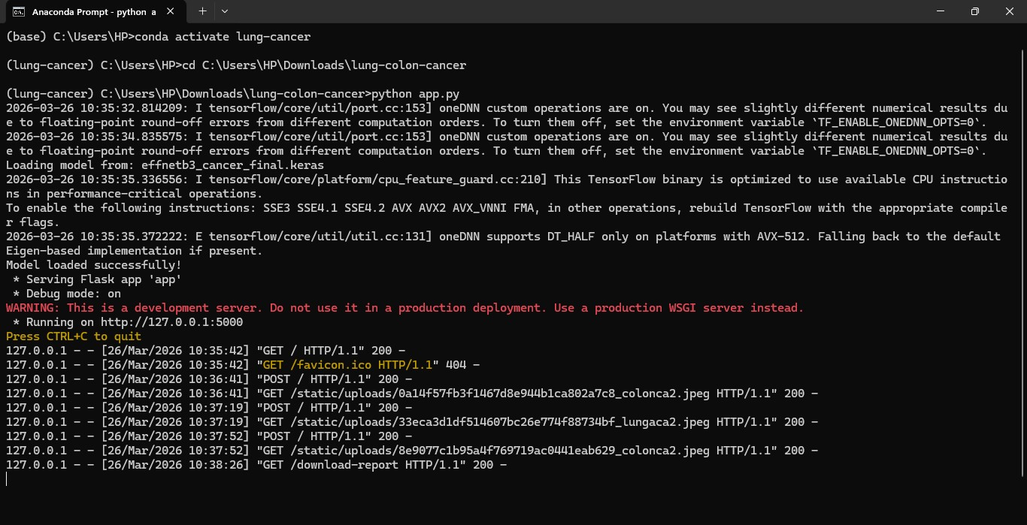

Fig 10.1 Anaconda Prompt

10.2 Lung and Colon Cancer Detection – Home Page
The Lung and Colon Cancer Detection – Home Page is the main interface of the system where users can start the cancer detection process. The page is designed with a simple and user-friendly layout that allows doctors or users to easily upload CT scan or histopathology images of lung and colon tissues. It includes important features such as image upload option, prediction button, and basic navigation controls.
Once the image is uploaded, the system sends it for preprocessing and analysis using the EfficientNetB3 model. After processing, the system generates prediction results indicating whether lung cancer or colon cancer is detected. The home page acts as the starting point of the application, ensuring quick and efficient cancer detection.
The interface also provides clear instructions to guide users during the upload process. It ensures smooth interaction between the user and the detection system. This home page improves usability and helps doctors quickly begin the cancer detection workflow.
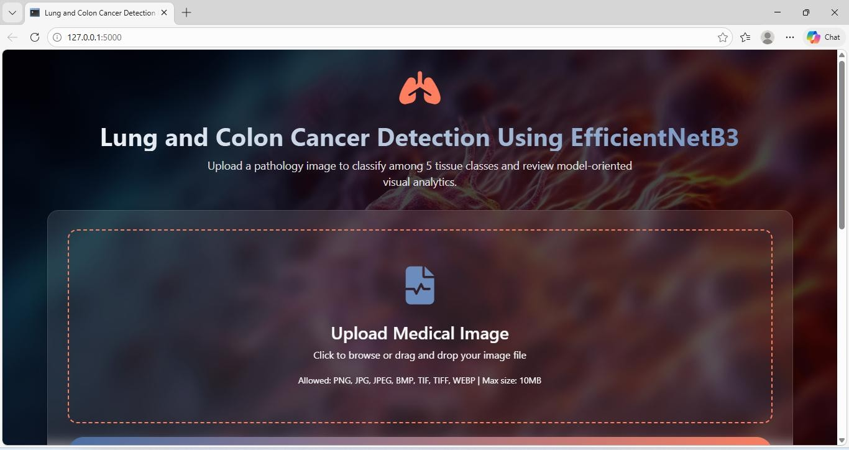

Fig 10.2 Home Page

10.3 Performance Analysis and Confusion Matrix
The Performance Analysis and Confusion Matrix section evaluates the effectiveness of the Lung and Colon Cancer Detection system using the EfficientNetB3 model. Performance analysis helps measure how accurately the model identifies cancerous and non-cancerous images. Various evaluation metrics such as accuracy, precision, recall, and F1-score are used to determine the model's performance.
The Confusion Matrix is used to visualize the prediction results by comparing actual values with predicted values. It consists of four important components: True Positive (TP), True Negative (TN), False Positive (FP), and False Negative (FN). True Positive represents correctly detected cancer cases, while True Negative represents correctly identified normal cases. False Positive and False Negative indicate incorrect predictions made by the model.
This analysis helps in understanding the strengths and weaknesses of the EfficientNetB3 model. A higher number of correct predictions in the confusion matrix indicates better model performance and improved accuracy in lung and colon cancer detection.
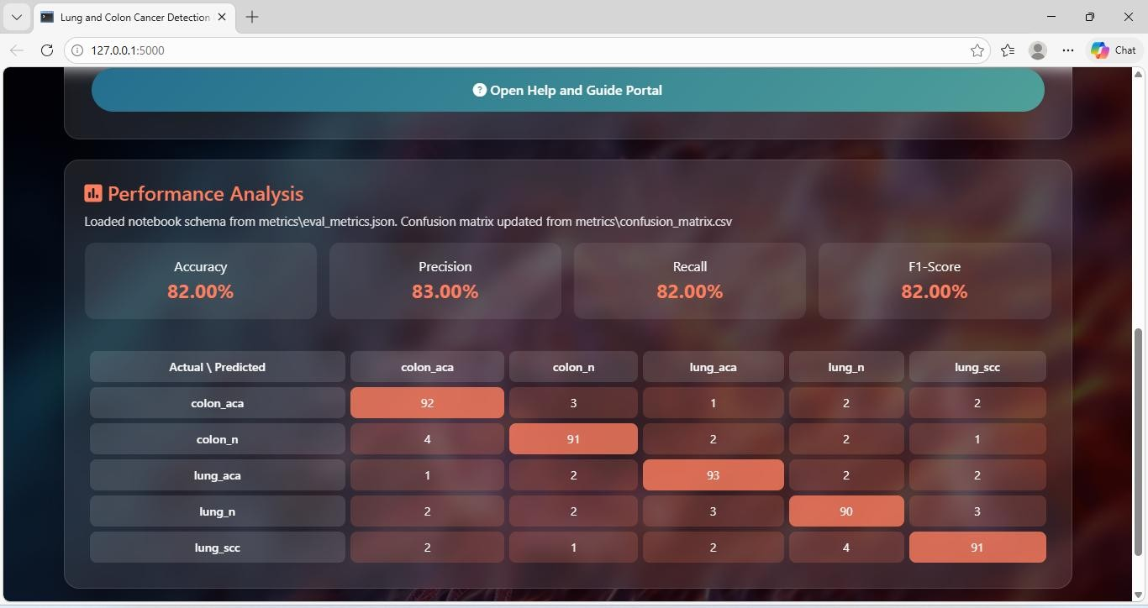

Fig 10.3 Performance Analysis

10.4 Lung and Colon Cancer Dataset Images
The Lung and Colon Cancer Dataset Images section presents the sample images used for training and testing the EfficientNetB3 model. These dataset images include CT scan images and histopathology images of both lung and colon tissues. The dataset consists of cancerous and non-cancerous images, which helps the model learn and differentiate between normal and abnormal tissue patterns.
These images are collected from publicly available medical datasets and are organized into different categories such as Lung Cancer, Colon Cancer, and Normal images. Before training, the images undergo preprocessing techniques such as resizing, normalization, and noise removal to improve image quality. These prepared dataset images are then used to train the EfficientNetB3 model for accurate cancer detection.
The dataset images play an important role in improving model performance and ensuring reliable and accurate prediction of lung and colon cancer.
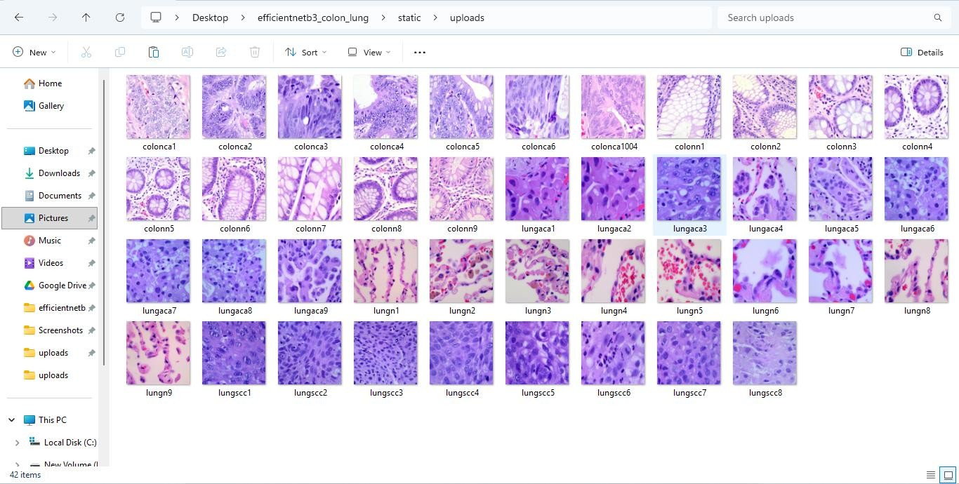

Fig 10.4 Dataset Images

10.5 Image Upload and Cancer Detection Interface
The Image Upload and Cancer Detection Interface provides a platform for users to upload lung and colon scanning images for cancer detection. This interface is designed with a simple and user-friendly layout, allowing doctors, medical staff, or users to easily interact with the system. It includes important features such as an image upload button, submit or predict button, and an image preview section that displays the selected image before processing.
When the user uploads an image, the system first validates the file format and prepares it for processing. The uploaded image is then sent to the preprocessing module, where operations such as resizing, normalization, and noise removal are performed to improve image quality. After preprocessing, the image is passed to the EfficientNetB3 deep learning model for feature extraction and classification.
The model analyzes the uploaded image and determines whether lung cancer or colon cancer is present. Once the prediction is completed, the system displays the detection result on the same interface. This interface ensures fast processing, accurate prediction, and easy interaction, helping doctors and users quickly detect lung and colon cancer using scanning images.
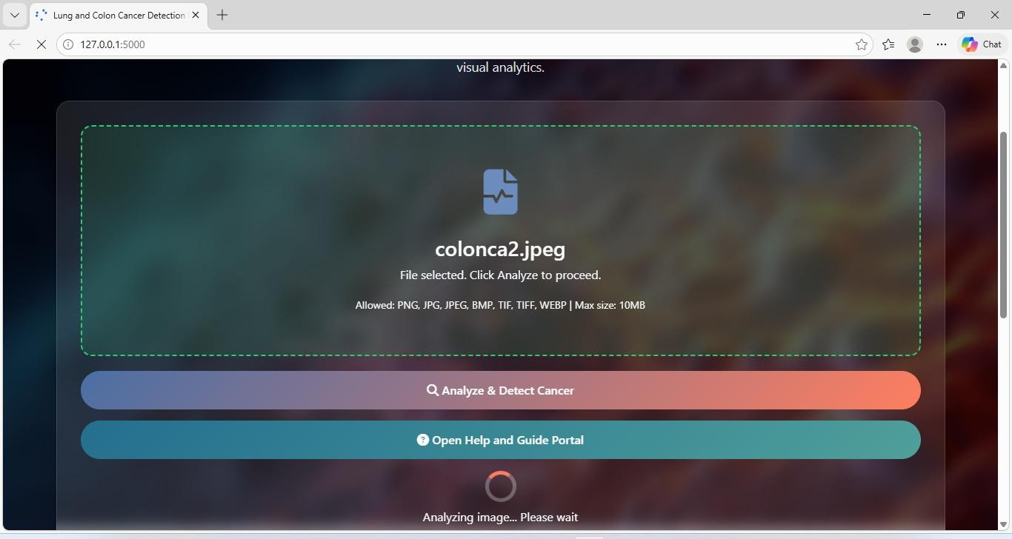

Fig 10.5 Image Upload Interface

10.6 Detailed Prediction Analysis and Report Dashboard
The Detailed Prediction Analysis and Report Dashboard provides comprehensive information about the cancer detection results generated by the EfficientNetB3 model. This dashboard displays the prediction outcome, indicating whether lung cancer or colon cancer is detected from the uploaded scanning image. It also shows important details such as prediction confidence score, which helps users understand how accurately the model made the prediction.
The dashboard may include visual representations such as graphs, charts, or highlighted image regions to better interpret the results. These visualizations help doctors and medical staff analyze the model’s performance and understand the detected patterns. The dashboard also organizes the results in a clear and structured format, making it easy to review and interpret.
Additionally, the report dashboard allows users to view, download, or store prediction reports for future reference. This feature helps in maintaining patient records and supports clinical decision-making. Overall, the dashboard provides detailed insights, improved accuracy understanding, and better decision support for lung and colon cancer detection.
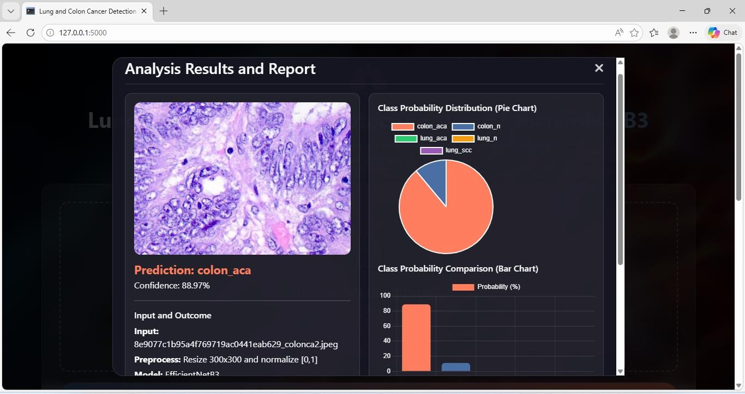

Fig 10.6 Analysis Report

10 .7 Lung and Colon Cancer Detection Report
The Lung and Colon Cancer Detection Report provides the final prediction results generated by the EfficientNetB3 model after analyzing the uploaded scanning images. This report displays important information such as patient image details, prediction result, and cancer type detected, whether lung cancer, colon cancer, or normal. It helps doctors and medical staff quickly understand the diagnosis outcome.
The report may also include prediction confidence score and classification details, which indicate the accuracy of the detection. This helps in evaluating the reliability of the model's prediction. The results are presented in a clear and structured format for easy interpretation and clinical use.
Additionally, the detection report can be saved or downloaded for future reference and medical documentation. This feature supports maintaining patient records and assists doctors in making timely and accurate treatment decisions.
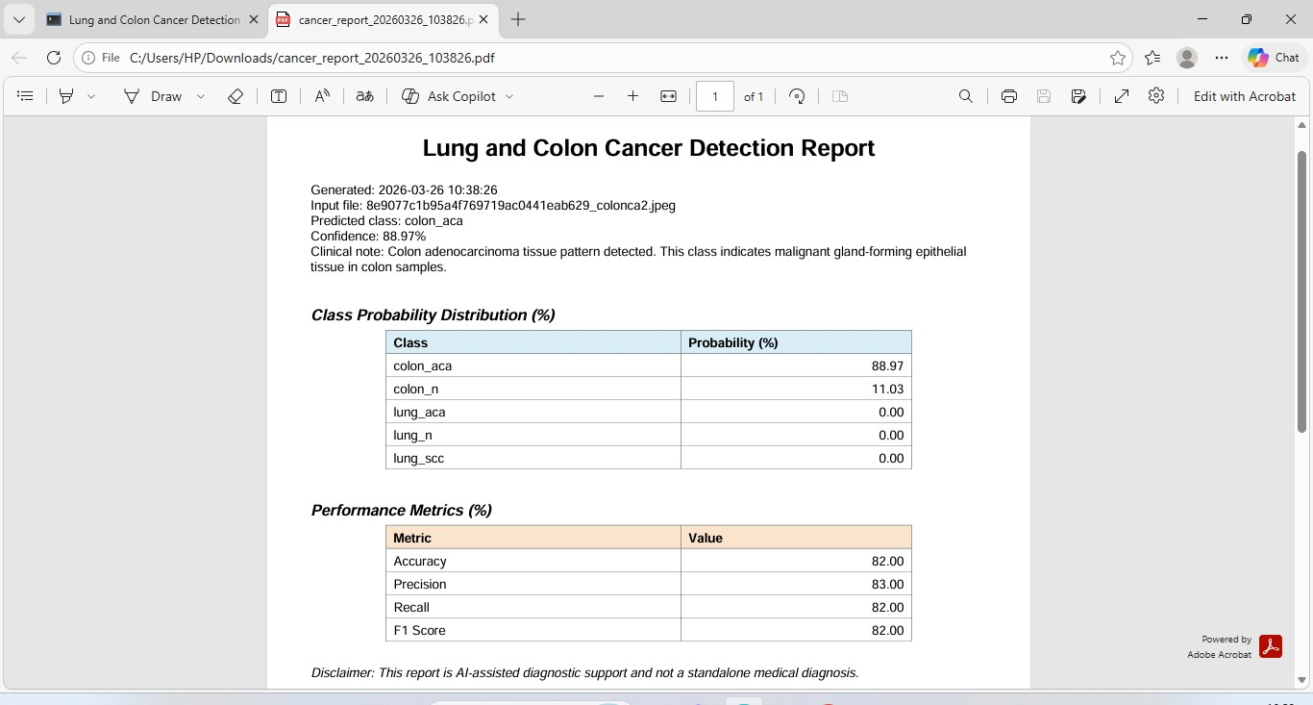

Fig 10.7 Lung and Colon Cancer Report

11. CONCLUSION &FUTURE ENHANCEMENTS

11.1 Conclusion
This project successfully presents the design and implementation of an AI-based web application for Lung and Colon Cancer Detection from scanning images using EfficientNetB3. The primary objective of the system is to assist in the early detection of cancer by analyzing medical images and providing accurate classification results. Early diagnosis plays a crucial role in improving patient survival rates, and this system aims to support medical professionals by delivering fast and reliable predictions.
The proposed system utilizes the EfficientNetB3 deep learning model for feature extraction and classification of lung and colon cancer images. The application is developed using Python 3.10 and the Flask framework, providing a user-friendly web interface for uploading pathology images and viewing prediction results. The system also incorporates image preprocessing techniques such as resizing, normalization, and noise reduction to improve model performance and ensure consistent results.
Multiple modules were designed and integrated, including image upload, preprocessing, model prediction, performance analysis, and result visualization. The system generates detailed outputs such as predicted cancer type, confidence score, probability distribution charts, and analysis reports. These features enhance interpretability and help users better understand the model’s predictions.
Extensive testing was conducted to evaluate system performance, reliability, and usability. The results demonstrate that the EfficientNetB3-based model achieves high accuracy in classifying lung and colon cancer images. The application performs efficiently under different conditions and handles both valid and invalid inputs effectively. The modular architecture also ensures scalability, maintainability, and ease of future enhancements.
Overall, this project demonstrates the effectiveness of deep learning techniques in medical image analysis and highlights the potential of AI-based systems in supporting early cancer detection. The developed solution provides a reliable, user-friendly, and efficient platform for lung and colon cancer detection. This work serves as a strong foundation for future improvements, such as integrating additional cancer types, deploying cloud-based solutions, and enhancing model accuracy using larger datasets, ultimately contributing to smarter and more accessible healthcare solutions.

11.2. FUTURE ENHANCEMENTS
Although the proposed Lung and Colon Cancer Detection system using EfficientNetB3 achieves accurate and reliable predictions, there are several opportunities for further improvement and expansion. As deep learning and medical imaging technologies continue to evolve, enhancing the system will improve diagnostic accuracy, scalability, and real-world usability.
In future work, the system can be improved by training the EfficientNetB3 model on larger and more diverse medical datasets. Incorporating images from different hospitals, scanners, and patient demographics will improve model generalization and reduce bias. This enhancement will allow the system to perform more effectively across varied clinical environments and patient populations.
Another potential enhancement is the integration of additional deep learning models such as EfficientNetB4, ResNet, DenseNet, or Vision Transformers. Ensemble learning techniques can also be implemented by combining predictions from multiple models to achieve higher accuracy and robustness. This approach would help reduce misclassification and improve reliability in complex cases.
The system can also be extended to detect additional cancer types beyond lung and colon cancer. Future versions may include breast cancer, brain tumors, skin cancer, and other medical imaging–based diagnoses. This would transform the application into a comprehensive multi-cancer detection platform.
Further improvements can be made by incorporating Explainable AI (XAI) techniques such as Grad-CAM or heatmap visualization. These techniques will highlight the regions in the medical image that influenced the prediction, helping doctors better understand and trust the model’s decision-making process. This feature is particularly important in clinical applications where interpretability is essential.
Another future enhancement involves deploying the system on cloud platforms to enable remote access and real-time predictions. Cloud-based deployment would allow healthcare professionals to upload images from different locations and receive instant diagnostic assistance. Additionally, containerization using Docker or Kubernetes can improve scalability and system performance.
The system can also be enhanced by integrating electronic health records (EHR) and patient metadata such as age, gender, and medical history. Combining imaging data with clinical data may improve prediction accuracy and provide more personalized diagnostic insights.
Performance optimization is another important area for future improvement. Techniques such as model compression, pruning, and quantization can be applied to reduce computational requirements. This would enable deployment on low-resource environments such as mobile devices or edge computing platforms.
Furthermore, future versions may include real-time monitoring dashboards that display prediction statistics, model performance metrics, and usage analytics. These dashboards will help administrators track system performance and identify areas for improvement.
Finally, implementing continuous learning mechanisms will allow the system to update the model periodically using newly collected data. This adaptive learning approach will ensure that the system remains accurate and up-to-date with evolving medical imaging trends.
These future enhancements will transform the proposed system into a more advanced, scalable, and clinically reliable AI-based cancer detection platform, ultimately contributing to improved early diagnosis and better healthcare outcomes.

REFERENCES
- OWASP Foundation, “OWASP Top 10 for Large Language Model Applications,” OWASP Documentation, 2023.
- Simon Willison, “Prompt Injection Attacks Against AI Systems,” Technical Blog, 2022.
- OpenAI Research Team, “Best Practices for Prompt Engineering and AI Safety,” OpenAI Technical Reports, 2023.
- Python Software Foundation, “Python 3.10 Documentation,” Official Python Documentation, 2023.
- Flask Development Team, “Flask Web Framework Documentation,” Pallets Projects, 2023.
- Brown, T. et al., “Language Models are Few-Shot Learners,” Advances in Neural Information Processing Systems, 2020.
- Greshake, K., Abdelnabi, S., and Rass, S., “Not What You’ve Signed Up For: Compromising RealWorld LLM-Integrated Applications with Indirect Prompt Injection,” IEEE Security & Privacy, 2023.
- Google AI, “Secure AI Design Guidelines,” Google Research Publications, 2023.
- Bishop, C. M., “Pattern Recognition and Machine Learning,” Springer Publications, 2006.
- Goodfellow, I., Bengio, Y., and Courville, A., “Deep Learning,” MIT Press, 2016.

