**FUTURE SALES PREDICTION - PHASE 5**

**INTRODUCTION :**

The primary goal of future sales prediction is to provide insights into expected sales volumes over a defined period, allowing organizations to make informed decisions about inventory management, resource allocation, marketing strategies, and financial planning.

**STEPS IN PREDICTING FUTURE SALES :**

* **Data Collection**:Collect historical sales data, including date-time records, product attributes, sales quantities, pricing details, and any notable influences like marketing campaigns or special occasions.
* **Data Preparation**:Refine and preprocess the dataset by addressing missing data points and handling outliers.Standardize the timestamp format and introduce supplementary features like day-of-week or month.
* **Time Series Exploration**:Examine the dataset to identify recurring patterns, seasonal fluctuations, overarching trends, and cyclic behaviors.Dissect the time series into its constituent elements such as trend, seasonality, and residual variations.
* **Data Partitioning**:Divide the dataset into two subsets: one for training the model and another for evaluating its performance.
* **Model Selection**:Choose an appropriate forecasting model tailored to the unique characteristics of the sales data, whether it's ARIMA, Prophet, or a machine learning algorithm such as XGBoost.
* **Model Training**:Educate the chosen model using the training dataset, ensuring it learns from historical patterns.
* **Model Assessment**:Evaluate the model's effectiveness by assessing its predictions against the reserved testing dataset, relying on metrics like Mean Absolute Error (MAE) or Root Mean Squared Error (RMSE). Hyperparameter Optimization:Fine-tune the model's parameters to maximize its prediction accuracy.
* **Sales Forecasting**:Employ the trained model to generate forecasts for future sales figures, enabling proactive decision-making.
* **Model Deployment**: Implement the model in a production environment where it can provide ongoing sales forecasts.
* **Continuous Oversight and Maintenance:** Continuously monitor the model's performance and update it regularly as new data becomes available, ensuring its relevance and accuracy over time.

**TECHNIQUES FOR FUTURE SALES PREDICTION:**

* ARIMA (AutoRegressive Integrated Moving Average):
* Exponential Smoothing (ETS):
* Prophet:
* Long Short-Term Memory (LSTM) Networks:
* Convolutional Neural Networks (CNNs):
* Gated Recurrent Units (GRUs):
* Seasonal Decomposition of Time Series (STL)
* State Space Models:
* Bayesian Structural Time Series (BSTS):
* Hybrid Models:
* Ensemble Methods:
* Transfer Learning:
* Anomaly Detection:
* Feature Engineering:
* Hyperparameter Optimization:

**CODE :**

**LOAD DATA**

import pandas as pd

df = pd.read_csv('/kaggle/input/future-sales-prediction/Sales.csv')

df.head()

**output:**

*TV Radio Newspaper Sales*

*0 230.1 37.8 69.2 22.1*

*1 44.5 39.3 45.1 10.4*

*2 17.2 45.9 69.3 12.0*

*3 151.5 41.3 58.5 16.5*

*4 180.8 10.8 58.4 17.9*

df.shape

**output:**

(200, 4)

df.info()

**output:**

<class 'pandas.core.frame.DataFrame'>

RangeIndex: 200 entries, 0 to 199

Data columns (total 4 columns):

# Column Non-Null Count Dtype

--- ------ -------------- -----

0 TV 200 non-null float64

1 Radio 200 non-null float64

2 Newspaper 200 non-null float64

3 Sales 200 non-null float64

dtypes: float64(4)

memory usage: 6.4 KB

df.describe() . T

**output:**

count mean std min 25% 50% 75% max

TV 200.0 147.0425 85.854236 0.7 74.375 149.75 218.825 296.4

Radio 200.0 23.2640 14.846809 0.0 9.975 22.90 36.525 49.6

Newspaper 200.0 30.5540 21.778621 0.3 12.750 25.75 45.100 114.0

Sales 200.0 15.1305 5.283892 1.6 11.000 16.00 19.050 27.0

**Exploratory Data Analysis (EDA)**

import plotly.express as px

figure = px.scatter(df, x='Sales', y='TV', size='TV', trendline='ols', title='Relationship Between Sales and TV Advertising')

figure.update_traces(marker=dict(line=dict(width=2, color='DarkSlateGrey')), selector=dict(mode='markers'))

figure.update_layout(

xaxis_title='Sales',

yaxis_title='TV Advertising',

legend_title='TV Ad Size',

plot_bgcolor='white'

)

figure.show()

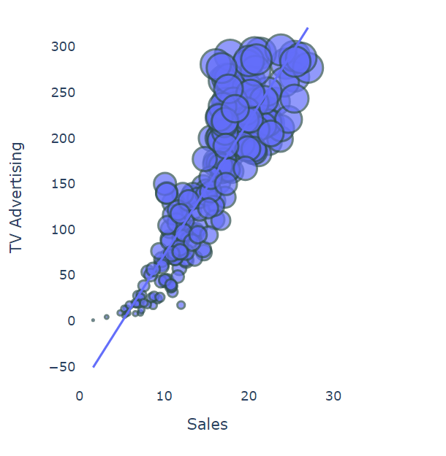

figure = px.scatter(df, x='Sales', y='Newspaper', size='Newspaper', trendline='ols', title='Relationship Between Sales and Newspaper Advertising')

figure.update_traces(marker=dict(line=dict(width=2, color='DarkSlateGrey')), selector=dict(mode='markers'))

figure.update_layout(

xaxis_title='Sales',

yaxis_title='Newspaper Advertising',

legend_title='Newspaper Ad Size',

plot_bgcolor='white'

)

figure.show()

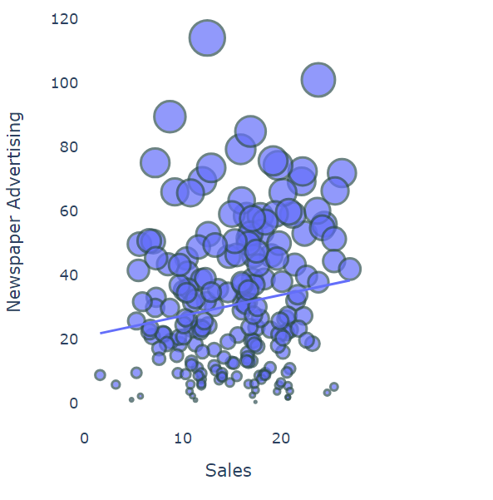

figure = px.scatter(df, x='Sales', y='Radio', size='Radio', trendline='ols', title='Relationship Between Sales and Radio Advertising')

figure.update_traces(marker=dict(line=dict(width=2, color='DarkSlateGrey')), selector=dict(mode='markers'))

figure.update_layout(

xaxis_title='Sales',

yaxis_title='Radio Advertising',

legend_title='Radio Ad Size',

plot_bgcolor='white'

)

figure.show()

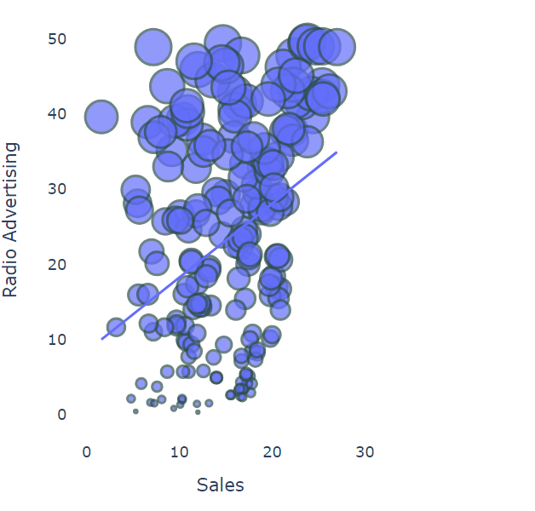

# Calculate the correlation

correlation = df.corr()

sales_correlation = correlation["Sales"].sort_values(ascending=False)

# Format and style the correlation values

styled_sales_correlation = sales_correlation.apply(lambda x: f'{x:.2f}')

styled_sales_correlation = styled_sales_correlation.reset_index()

styled_sales_correlation.columns = ["Feature", "Correlation with Sales"]

styled_sales_correlation.style.background_gradient(cmap='coolwarm', axis=0)

**output:**

Feature Correlation with Sales

0 Sales 1.00

1 TV 0.90

2 Radio 0.35

3 Newspaper 0.16

# Data Preprocessing

import seaborn as sns

import matplotlib.pyplot as plt

# Create the box plot

plt.figure(figsize=(8, 6))

sns.boxplot(x='TV', data=df, palette='Blues')

plt.title('Box Plot of TV Advertising')

plt.xlabel('TV Advertising Spending')

plt.grid(axis='x', linestyle='--', alpha=0.6)

# Show the plot

plt.show()

import seaborn as sns

import matplotlib.pyplot as plt

# Create the box plot

plt.figure(figsize=(8, 6))

sns.boxplot(x='TV', data=df, palette='Blues')

plt.title('Box Plot of TV Advertising')

plt.xlabel('TV Advertising Spending')

plt.grid(axis='x', linestyle='--', alpha=0.6)

# Show the plot

plt.show()

# Create the box plot

plt.figure(figsize=(8, 6))

sns.boxplot(x='Newspaper', data=df, palette='YlGnBu')

plt.title('Box Plot of Newspaper Advertising')

plt.xlabel('Newspaper Advertising Spending')

plt.grid(axis='x', linestyle='--', alpha=0.6)

​

# Show the plot

plt.show()

import numpy as np

# Ambang batas atas (threshold) untuk Winsorizing

upper_threshold = 2 * np.std(df['Newspaper']) + np.mean(df['Newspaper'])

# Menerapkan Winsorizing pada kolom 'Newspaper'

df['Newspaper'] = np.where(df['Newspaper'] > upper_threshold, upper_threshold, df['Newspaper'])

# Create the box plot

plt.figure(figsize=(8, 6))

sns.boxplot(x='Newspaper', data=df, palette='YlGnBu')

plt.title('Box Plot of Newspaper Advertising')

plt.xlabel('Newspaper Advertising Spending')

plt.grid(axis='x', linestyle='--', alpha=0.6)

# Show the plot

plt.show()

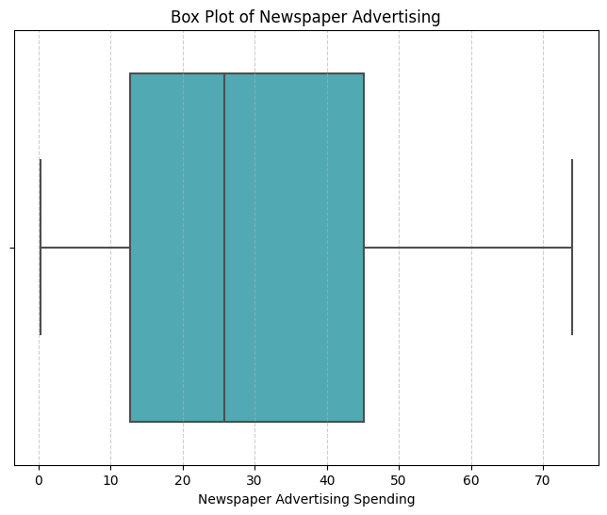

from sklearn.preprocessing import MinMaxScaler

# Create a MinMaxScaler object

scaler = MinMaxScaler()

# Columns to be normalized (e.g., TV, Radio, Newspaper)

columns_to_normalize = ['TV', 'Radio', 'Newspaper']

# Apply Min-Max normalization to the selected columns

df[columns_to_normalize] = scaler.fit_transform(df[columns_to_normalize])

df.head()

**output:**

TV Radio Newspaper Sales

0 0.775786 0.762097 0.934843 22.1

1 0.148123 0.792339 0.607851 10.4

2 0.055800 0.925403 0.936200 12.0

3 0.509976 0.832661 0.789664 16.5

4 0.609063 0.217742 0.788307 17.9

# Modelling and Evaluation

X = df[['TV', 'Radio', 'Newspaper']]

y = df['Sales']

from sklearn.model_selection import cross_val_score

# Performing 5-fold cross-validation (can be adjusted to the desired number of folds)

num_folds = 5

# Function to perform cross-validation and calculate metrics in percentage

def perform_cross_validation(model, X, y, num_folds):

mse_scores = -cross_val_score(model, X, y, cv=num_folds, scoring='neg_mean_squared_error')

rmse_scores = np.sqrt(mse_scores)

mae_scores = -cross_val_score(model, X, y, cv=num_folds, scoring='neg_mean_absolute_error')

r2_scores = cross_val_score(model, X, y, cv=num_folds, scoring='r2')

return mse_scores, rmse_scores, mae_scores, r2_scores

from sklearn.linear_model import LinearRegression, Ridge, Lasso

# Linear Regression

linear_model = LinearRegression()

linear_mse, linear_rmse, linear_mae, linear_r2 = perform_cross_validation(linear_model, X, y, num_folds)

print("Linear Regression:")

print(f"Average MSE: {np.mean(linear_mse) / np.mean(y) * 100:.2f}%")

print(f"Average RMSE: {np.mean(linear_rmse) / np.mean(y) * 100:.2f}%")

print(f"Average MAE: {np.mean(linear_mae) / np.mean(y) * 100:.2f}%")

print(f"Average R-squared: {np.mean(linear_r2) * 100:.2f}%")

print("\n")

**output:**

Linear Regression:

Average MSE: 18.90%

Average RMSE: 11.01%

Average MAE: 8.38%

Average R-squared: 89.53%

# Ridge Regression

ridge_model = Ridge(alpha=1.0) # You can adjust alpha as needed

ridge_mse, ridge_rmse, ridge_mae, ridge_r2 = perform_cross_validation(ridge_model, X, y, num_folds)

print("Ridge Regression:")

print(f"Average MSE: {np.mean(ridge_mse) / np.mean(y) * 100:.2f}%")

print(f"Average RMSE: {np.mean(ridge_rmse) / np.mean(y) * 100:.2f}%")

print(f"Average MAE: {np.mean(ridge_mae) / np.mean(y) * 100:.2f}%")

print(f"Average R-squared: {np.mean(ridge_r2) * 100:.2f}%")

print("\n")

**output:**

Ridge Regression:

Average MSE: 19.67%

Average RMSE: 11.20%

Average MAE: 8.54%

Average R-squared: 89.19%

# Lasso Regression

lasso_model = Lasso(alpha=1.0) # You can adjust alpha as needed

lasso_mse, lasso_rmse, lasso_mae, lasso_r2 = perform_cross_validation(lasso_model, X, y, num_folds)

print("Lasso Regression:")

print(f"Average MSE: {np.mean(lasso_mse) / np.mean(y) * 100:.2f}%")

print(f"Average RMSE: {np.mean(lasso_rmse) / np.mean(y) * 100:.2f}%")

print(f"Average MAE: {np.mean(lasso_mae) / np.mean(y) * 100:.2f}%")

print(f"Average R-squared: {np.mean(lasso_r2) * 100:.2f}%")

print("\n")

**output:**

Lasso Regression:

Average MSE: 115.55%

Average RMSE: 27.51%

Average MAE: 22.39%

Average R-squared: 35.98%

from sklearn.tree import DecisionTreeRegressor

# Decision Trees

tree_model = DecisionTreeRegressor(max_depth=None, random_state=0) # You can adjust parameters as needed

tree_mse, tree_rmse, tree_mae, tree_r2 = perform_cross_validation(tree_model, X, y, num_folds)

print("Decision Trees:")

print(f"Average MSE: {np.mean(tree_mse) / np.mean(y) * 100:.2f}%")

print(f"Average RMSE: {np.mean(tree_rmse) / np.mean(y) * 100:.2f}%")

print(f"Average MAE: {np.mean(tree_mae) / np.mean(y) * 100:.2f}%")

print(f"Average R-squared: {np.mean(tree_r2) * 100:.2f}%")

print("\n")

**output:**

Decision Trees:

Average MSE: 16.73%

Average RMSE: 10.40%

Average MAE: 7.56%

Average R-squared: 90.65%

from sklearn.ensemble import RandomForestRegressor

# Random Forest

forest_model = RandomForestRegressor(n_estimators=100, random_state=0) # You can adjust parameters as needed

forest_mse, forest_rmse, forest_mae, forest_r2 = perform_cross_validation(forest_model, X, y, num_folds)

print("Random Forest:")

print(f"Average MSE: {np.mean(forest_mse) / np.mean(y) * 100:.2f}%")

print(f"Average RMSE: {np.mean(forest_rmse) / np.mean(y) * 100:.2f}%")

print(f"Average MAE: {np.mean(forest_mae) / np.mean(y) * 100:.2f}%")

print(f"Average R-squared: {np.mean(forest_r2) * 100:.2f}%")

**output:**

Random Forest:

Average MSE: 10.32%

Average RMSE: 8.09%

Average MAE: 5.99%

Average R-squared: 94.27%

# Classic assumption test

import statsmodels.api as sm

import statsmodels.stats.api as sms

# Adding a constant to the independent variables (intercept)

X = sm.add_constant(X)

# Fit the regression model

model = sm.OLS(y, X).fit()

# Residuals (model residuals)

residuals = model.resid

#Assumption 1: Linearity

# You can check linearity using residual vs. fitted values plot

import matplotlib.pyplot as plt

plt.scatter(model.fittedvalues, residuals)

plt.xlabel("Fitted Values")

plt.ylabel("Residuals")

plt.title("Linearity Check")

plt.show()

**output:**

# Assumption 2: Homoskedasticity

# You can check homoskedasticity using Breusch-Pagan test

_, p_homo, _, _ = sms.het_breuschpagan(residuals, X)

print(f"Homoskedasticity (Breusch-Pagan): p-value = {p_homo:.4f}")

**output**:

Homoskedasticity (Breusch-Pagan): p-value = 0.2634

# Assumption 3: Independence (Serial Correlation)

# You can check for serial correlation using Durbin-Watson test

from statsmodels.stats.stattools import durbin_watson

dw_stat = durbin_watson(residuals)

print(f"Serial Correlation (Durbin-Watson): DW Statistic = {dw_stat:.2f}")

**OUTPUT:**

Serial Correlation (Durbin-Watson): DW Statistic = 2.25

# Assumption 4: Normality

# You can check normality using a normal probability plot (Q-Q plot)

import scipy.stats as stats

fig, ax = plt.subplots(figsize=(6, 4))

_, (__, ___, r) = stats.probplot(residuals, plot=ax, fit=True)

ax.get_lines()[0].set_markerfacecolor('C0')

ax.get_lines()[0].set_markersize(5.0)

ax.get_lines()[1].set_linewidth(3.0)

plt.title("Normal Probability Plot")

plt.show()

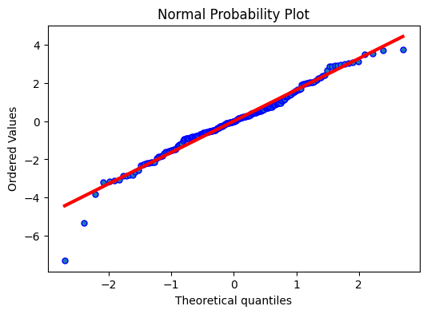

# Assumption 5: Multicollinearity

# You can check multicollinearity using the Variance Inflation Factor (VIF)

from statsmodels.stats.outliers_influence import variance_inflation_factor

vif = pd.DataFrame()

vif["Features"] = X.columns

vif["VIF"] = [variance_inflation_factor(X.values, i) for i in range(X.shape[1])]

print("Multicollinearity (VIF):")

print(vif)

**OUTPUT:**

Multicollinearity (VIF):

Features VIF

0 const 6.898975

1 TV 1.005037

2 Radio 1.150018

3 Newspaper 1.150920

# Assumption 6: Outliers

student_resid = model.get_influence().resid_studentized_internal

cooks_d = model.get_influence().cooks_distance[0]

outliers = pd.DataFrame({'Studentized Residuals': student_resid, "Cook's Distance": cooks_d})

outliers.index = X.index

print("Outliers:")

print(outliers[outliers['Studentized Residuals'].abs() > 2])

**OUTPUT:**

Outliers:

Studentized Residuals Cook's Distance

10 2.272004 0.021004

33 -2.322006 0.037363

97 2.148943 0.007995

130 -4.468814 0.195094

150 -3.233182 0.056641

154 2.120557 0.013399

196 2.261963 0.021244

**CONCLUSION :**

These results provide in-depth insights into the quality of our prediction model and its relevance in the context of future sales forecasting.