Basavarajeswari group of institutions

BALLARI INSTITUTE OF TECHNOLOGY & MANAGEMENT

NACC Accredited Institution*


(Recognized by Govt. of Karnataka, approved by AICTE, New Delhi & Affiliated to Visvesvaraya Technological University, Belagavi)
"JnanaGangotri" Campus, No.873/2, Ballari-Hospet Road, Allipur, Ballar1-583 104 (Karnataka) (India)
Ph: 08392 – 237100 / 237190, Fax: 08392 – 237197

DEPARTMENT OF CSE(DATA SCIENCE)

Project Report On
“Comprehensive Healthcare Analytics: Patient, Doctor & Hospital Performance Insights”

A report submitted in partial fulfillment of the requirements for the

DATA VISUALIZATION WITH POWER BI

Submitted By

J GAYATHRI USN: 3BR23CD029

Under the Guidance of Mr.Sundeep Sindhanoor
Asst. Professor
Dept of CSE (DATA SCIENCE),
BITM, Ballari



Visvesvaraya Technological University

Belagavi, Karnataka 2025-2026
BASAVARAJESWARI GROUP OF INSTITUTIONS

BALLARI INSTITUTE OF TECHNOLOGY & MANAGEMENT
NACC Accredited Institution*
(Recognized by Govt. of Karnataka, approved by AICTE, New Delhi & Affiliated to Visvesvaraya Technological University, Belagavi)
"JnanaGangotri" Campus, No.873/2, Ballari-Hospet Road, Allipur, Ballari-583 104 (Karnataka) (India)
Ph: 08392 – 237100 / 237190, Fax: 08392 – 237197




DEPARTMENT OF CSE (DATA SCIENCE)
CERTIFICATE
This is to certify that the OPEN-ENDED PROJECT of DATA VISUALIZATION WITH POWER BI “Comprehensive Healthcare Analytics: Patient, Doctor & Hospital Performance Insights” has been successfully presented by J GAYATHRI bearing USN 3BR23CD029 student of semester B.E for the partial fulfillment of the requirements for the award of Bachelor Degree in CSE(DS) of the BALLARI INSTITUTE OF TECHNOLOGY& MANAGEMENT, BALLARI during the academic year 2025-2026.

Signature of guide Signature of HOD

Mr. Sundeep Sindhanoor Dr. Aradhana D

The satisfactions that accompany the successful completion of our project on “Comprehensive Healthcare Analytics: Patient, Doctor & Hospital Performance Insights” would be incomplete without the mention of people who made it possible, whose noble gesture, affection, guidance, encouragement and support crowned my efforts with success. It is our privilege to express our gratitude and respect to all those who inspired us in the completion of our project. We are extremely grateful to our Guides Mr.Sundeep Sindhanoor for their noble gesture, support co-ordination and valuable suggestions given in completing the mini-project. We also thank Dr. Aradhana D, H.O.D. Department of CSE(DS), for his co-ordination and valuable suggestions given in completing the mini-project. We also thank the Principal, Management and non-teaching staff for their co-ordination and valuable suggestions given to us in completing the project.

NAME | USN
J GAYATHRI | 3BR23CD029

Table of Contents
Ch No | Chapter Name | Page
1 | Introduction  - About the project  - Language used | 1-2
2 | Scope of the project  - Problem statement  - Objectives | 3
3 | System requirements  - Functional Requirements  - Non-Functional Requirements  - Hardware Requirements  - Software Requirements | 4-5
4 | Methodology  - Data Collection  - Data Preparation(Power Query)  - Data Visualization  - Filters and Interactivity  - Dashboard Design  - outcome | 6-8
5 | Implementation  - Dataset Description  - Data Loading  - Data Transformation(Power Query)  - Data Modelling  - DAX Measures(Key Calculations)  - Dashboard Visualization  - Filters / Slicers  - Dashboard Layout  - Integration  - Final output | 9-13
6 | Result | 14-15
 | Conclusion  References | 15  16

ABSTRACT

The “Comprehensive Healthcare Analytics: Patient, Doctor & Hospital Performance Insights” project is designed to provide a comprehensive, interactive, and user-friendly visualization of hospital and patient management data using Power BI. It transforms raw healthcare data into meaningful insights through dynamic and visually engaging dashboards, enabling users to understand patterns in patient demographics, treatment outcomes, doctor performance, and financial operations. The dashboard allows dynamic filtering by parameters such as patient demographics, disease type, city, doctor specialization, and time period, making it easier to analyze healthcare trends and compare performance across different segments. It includes key performance indicators such as total number of patients, total revenue generated, number of appointments, and average treatment cost, providing a quick overview of hospital operations. Additionally, the system supports detailed analysis through various visualizations such as disease-wise treatment costs, doctor-wise patient handling, appointment trends, and payment method distribution. Advanced analytics features like decomposition trees and key influencer visuals help in identifying factors affecting treatment costs and revenue generation, enabling deeper insight into operational efficiency and patient care quality. By supporting data-driven decision-making, the dashboard assists hospital administrators, healthcare professionals, and analysts in improving resource allocation, optimizing treatment strategies, and enhancing overall patient satisfaction. Overall, the project converts complex healthcare data into an accessible and insightful format, making it a valuable tool for effective healthcare management and strategic planning.

CHAPTER 1
INTRODUCTION
1.1 About the Project
The healthcare sector plays a vital role in ensuring the well-being of individuals and the efficient functioning of society. With the increasing volume of patient data and the growing complexity of hospital operations, there is a strong need for effective data analysis tools that can transform raw healthcare information into meaningful insights. Accurate tracking of patient records, doctor performance, appointment trends, and operational efficiency is essential for improving service quality and overall healthcare management.
The “Comprehensive Healthcare Analytics: Patients, Doctors & Operational Insights” is an interactive Power BI project developed to address this need by providing a unified and structured view of healthcare data. The project integrates multiple datasets, including patient information, doctor details, appointments, and healthcare service records, to create a centralized analytical system.By leveraging this integrated dataset, the dashboard explores key aspects of healthcare operations such as patient demographics, consultation patterns, doctor workload, appointment trends, and service utilization across different healthcare centers.
Through the use of dynamic visualizations, interactive filters, and key performance indicators (KPIs), the dashboard enables users to analyze healthcare performance from multiple perspectives. Users can explore data based on factors such as location, department, doctor specialization, and time period, making it easier to evaluate operational efficiency and patient care quality.Ultimately, this dashboard aims to bridge the gap between raw healthcare data and informed decision-making. It serves as a valuable tool for healthcare administrators and analysts to optimize resource allocation, improve service delivery, and enhance overall patient satisfaction, contributing to efficient and data-driven healthcare management.

1.2 Language Used

The core technologies and tools used in this project are:

● Power BI: The primary tool used for data modeling, visualization, and dashboard development. It enables the creation of interactive, user-friendly dashboards for monitoring healthcare operations, patient analytics, and doctor performance across multiple dimensions.
● DAX (Data Analysis Expressions): Used within Power BI to develop calculated measures and Key Performance Indicators (KPIs) such as total patients, consultation counts, doctor workload, and operational efficiency metrics. It supports dynamic, real-time analytical computations.
● M (Power Query Formula Language): Utilized for ETL (Extract, Transform, Load) processes, including data cleaning, transformation, validation, and integration of multiple healthcare datasets into a structured format suitable for analysis.
● Excel/CSV (Data Sources): Used as the primary data storage format for healthcare datasets, including patient records, doctor details, appointment logs, and operational data, which are imported into Power BI for further processing.

CHAPTER 2

SCOPE OF THE PROJECT

Problem Statement

With the rapid expansion of the healthcare sector, large volumes of operational and clinical data are generated across Primary Health Centers (PHCs), telemedicine systems, and hospital units. This data includes patient registrations, consultations, doctor activities, and appointment records. However, such data is often distributed across multiple systems and stored in unstructured formats, making it difficult for healthcare administrators to extract meaningful insights.The absence of a centralized analytics platform leads to several challenges, including limited visibility into doctor performance, inefficient patient flow management, difficulty in tracking consultation outcomes, and delays in operational reporting. Additionally, monitoring key performance indicators (KPIs) such as consultation efficiency, conversion rates, and workload distribution becomes complex without proper analytical tools.

To address these challenges, this project develops a comprehensive healthcare analytics dashboard using Power BI, which transforms raw healthcare data into structured, interactive, and user-friendly visualizations. By integrating datasets related to patients, doctors, appointments, and PHC operations, the system enables real-time monitoring of healthcare performance, improves operational transparency, and supports data-driven decision-making.

Objectives
The main objectives of the project are as follows:
● To develop an interactive dashboard for monitoring healthcare operations, including patient registrations, consultations, and doctor performance.
● To track key performance indicators (KPIs) such as total patients, total consultations, doctor workload, and conversion rates.
● To enable dynamic data exploration using filters based on parameters such as location (PHC, district), gender, age group, and time period.
● To analyze patient flow, consultation trends, and service utilization across different healthcare centers.
● To evaluate doctor performance based on consultation count, efficiency, and workload distribution.
● To support comparative analysis across regions, PHCs, and departments for better operational planning.

CHAPTER 3

SYSTEM REQUIREMENTS

3.1 Functional Requirements

- Import healthcare datasets (patients, doctors, appointments, PHC operations) from Excel/CSV sources and perform data cleaning, transformation, and structuring using Power Query (M language).
- Provide dynamic filtering and slicing options based on parameters such as location (division, district, PHC), patient demographics (age, gender), and time period.
- Compute and display key performance indicators using DAX, including total patients, consultations, doctor workload, and conversion rates.
- Develop interactive visualizations such as bar charts, line charts, donut charts, tables, and KPI cards with cross-filtering capabilities.
- Enable analysis of patient flow, consultation efficiency, doctor performance, and operational metrics through structured dashboard views.
- Design multiple dashboard pages (Overview, PHC Analytics, Doctor Analytics) to present insights in a clear and organized manner.

3.2 Non-Functional Requirements
- Performance: The dashboard should load efficiently and respond quickly to user interactions to ensure a seamless analytical experience.
- Usability: The interface should be intuitive, visually structured, and easy to navigate, with clear labels and readable visuals.
- Scalability: The data model should support future expansion, allowing additional PHCs, time-based data, and operational metrics to be incorporated.
- Maintainability: Data transformations and DAX measures should be well-structured and documented for easy maintenance and updates.
- Security: Access to the dashboard should be restricted to authorized users to ensure data privacy and compliance.
- Reliability: The system should provide consistent and accurate results without errors o

3.3 Hardware Requirements

Operating System: Windows 10, Windows 11, or later versions

Processor (CPU): 1.4 GHz 64-bit processor or higher

Memory (RAM): Minimum 4 GB (8 GB recommended)

Storage: 2–5 GB available disk space for Power BI and datasets

Display: Minimum resolution 1366 × 768 (higher resolution recommended for better visualization)

3.4 Software Requirements

- Development Tool: Microsoft Power BI Desktop for data modeling and dashboard development
- Data Sources: Excel/CSV files containing patient, doctor, appointment, and operational data
- Data Processing: Power Query (M Language) for ETL operations
- Data Analysis: DAX for KPI calculations and dynamic measures
- Deployment & Hosting: Power BI Service for publishing and sharing dashboards
- End-User Access: Web browsers (Chrome, Edge, Safari) or Power BI Mobile App for report access

CHAPTER 4

METHODOLOGY

The methodology of this project focuses on transforming raw healthcare data into meaningful insights through a structured data analytics workflow. The process includes data collection, data preparation using ETL techniques, data modeling, and interactive visualization using Power BI. This approach ensures efficient monitoring of patient flow, doctor performance, and overall healthcare operations.
4.1 Dataset Overview
The project utilizes healthcare datasets in Excel/CSV format containing operational and clinical information related to patients, doctors, appointments, and healthcare services.
● Patient Data: Includes Patient_ID, Age, Gender, City, and other demographic details used to analyze patient distribution and healthcare usage patterns.
● Doctor Data: Contains Doctor_ID, Specialization, Experience, and related details to evaluate doctor performance and workload distribution.
● Appointment Data: Includes Appointment_ID, Date, Patient_ID, Doctor_ID, and Status to track patient visits, consultation flow, and appointment efficiency.
● Operational Data (PHC/Consultation): Captures consultation counts, registration data, and service utilization metrics across healthcare centers.
● Usage: All datasets are imported into Power BI and integrated to form a unified analytical data model for reporting and visualization.

4.2 Data Preparation (Power Query – ETL Process)
Power Query is used to perform ETL (Extract, Transform, Load) operations to ensure data quality, consistency, and usability.
● Data Cleaning: Handled missing values, corrected inconsistencies, and removed invalid records.
● Duplicate Removal: Eliminated duplicate entries to maintain data integrity.
● Standardization: Renamed columns and formatted data into consistent and user-friendly structures.
● Data Type Conversion: Converted fields such as dates, numerical values, and categorical attributes into appropriate formats.
● Data Integration: Merged datasets using common keys such as Patient_ID and Doctor_ID to create relationships.
● Data Modeling: Organized data into a structured format (star schema) to support efficient querying and faster dashboard performance.

4.3 Data Visualization
The processed data is visualized using Power BI to provide interactive and actionable insights into healthcare performance.
Visuals Used:
● KPI Cards → Display key metrics such as total patients, total consultations, doctor count, and performance indicators.
● Bar Charts → Compare values such as consultations by gender, doctor-wise performance, and age group distribution.
● Line Charts → Show trends over time, including patient registrations and consultation patterns.
● Donut/Pie Charts → Represent distribution such as specialization usage and gender proportion.
● Tree Map → Visualizes region-wise or zone-wise consultation distribution.
● Table/Matrix → Provides detailed records for doctor performance and PHC-level analysis.

4.4 Filters and Interactivity
To enhance usability and enable dynamic data exploration, slicers are implemented in the dashboard:
● Location Filters (Division, District, PHC) → Enable region-wise analysis
● Demographic Filters (Gender, Age Group) → Support patient-based analysis
● Time Filter (Date/Year) → Allows trend analysis over time
● Doctor/Specialization Filter → Helps evaluate performance across departments

4.5 Dashboard Design

The final dashboard is designed with a structured and intuitive layout to provide clear insights into healthcare operations and performance across multiple dimensions.

Top Section (KPI Cards):Displays key performance indicators such as total patients registered, total consultations, total appointments, doctor count, and conversion rates. These KPIs provide a quick overview of system performance.

Left Panel (Filters/Slicers):Includes interactive filters such as Division, District, PHC, Gender, Age Group, Doctor/Specialization, and Time. These slicers enable users to dynamically refine and explore the data.

Central Area (Trend Analysis):Contains primary visualizations such as line charts and bar charts to analyze patient registration trends, consultation patterns, and doctor performance over time.

Right & Bottom Sections (Distribution & Comparison):Include donut charts, bar charts, and treemaps to visualize demographic distribution (gender, age group), specialization usage, and region-wise healthcare activity. Tables/matrix visuals are also used for detailed, record-level insights.

Multi-Page Structure:The dashboard is organized into multiple pages such as Overview Dashboard ,PHC Analytics and Doctor Analytics

This structured design ensures easy navigation, logical data flow, and effective interpretation of healthcare insights.

4.6 Outcome
● Interactive Dashboard: Developed a Power BI dashboard to monitor patient flow, consultations, and doctor performance.
● Healthcare Insights: Provides analysis of patient demographics, trends, and operational efficiency across healthcare centers.
● Decision Support: Enables data-driven decision-making to improve resource allocation and overall healthcare services.

CHAPTER 5

IMPLEMENTATION

The implementation phase focuses on transforming healthcare datasets into actionable insights using Power BI. The process includes data loading, ETL operations using Power Query, creation of DAX measures, and development of an interactive dashboard to analyze patient flow, doctor performance, and healthcare operations.

5.1 Dataset Description

The dataset used in this project consists of healthcare-related information collected from multiple sources. The key fields include:
● Patient_ID – Unique identifier for each patient
● Doctor_ID – Unique identifier for each doctor
● Appointment_ID – Identifier for appointments
● Age, Gender, City – Patient demographic details
● Specialization – Doctor’s department
● Date – Appointment/consultation date
● Status – Appointment status (Completed, Pending, Cancelled)

These datasets are imported into Power BI using Excel/CSV format.

5.2 Data Loading
- The dataset is loaded into Power BI using the “Get Data” option.
- Data is previewed and verified before processing.

5.3 Data Transformation (Power Query)
Using Power Query Editor, the data is cleaned and prepared:
● Removed missing and duplicate values to ensure data accuracy
● Renamed columns for better readability
● Converted data types (date, numeric, categorical fields)
● Standardized values for consistency (gender, specialization, location)
● Merged datasets using common keys (Patient_ID, Doctor_ID)
5.4 Data Modeling
● A structured data model is created by establishing relationships between multiple tables such as Patients, Doctors, and Appointments.
● Relationships are defined using common keys like Patient_ID and Doctor_ID to link the datasets.
● This model enables efficient data filtering, cross-analysis, and better performance across all dashboard visuals.

5.5 DAX Measures (Key Calculations)

The following DAX measures are created to generate key insights:
● Total Patients = COUNT(Patient_ID)
● Total Appointments = COUNT(Appointment_ID)
● Total Doctors = DISTINCTCOUNT(Doctor_ID)
● Conversion Rate = (Consultations / Registrations) * 100

These measures are used in KPI cards and other visualizations to provide real-time insights.

5.6 Dashboard Visualizations
The dashboard uses the following visuals to represent data effectively:
● KPI Cards →Display key metrics such as total patients, consultations, and doctors
● Bar Charts →Show gender distribution, age group analysis, and doctor performance
● Line Charts →Represent trends in patient registrations and consultations over time
● Donut Charts →Show distribution of specialization and demographics
● Treemap →Visualizes region-wise or PHC-wise data distribution
● Table/Matrix → Displays detailed doctor-level and PHC-level information
5.7 Filters / Slicers
To enhance interactivity, the following slicers are implemented:
● Location (Division, District, PHC)
● Gender and Age Group
● Doctor / Specialization
● Date (for time-based analysis)
These filters allow users to dynamically explore and analyze the data.

5.8 Dashboard Layout
The dashboard is organized in a structured format:
● Top Section → KPI cards showing key metrics
● Left Panel → Filters for location, demographics, and time
● Center Area → Trend visualizations (line and bar charts)
● Right & Bottom Sections → Distribution charts and detailed tables
This layout ensures clear navigation and easy interpretation of insights.

5.9 Integration
● Data is imported from Excel/CSV sources into Power BI
● All visuals are connected through a unified data model
● Filters dynamically update all charts and visuals in real-time

5.10 Final Output
The final output is an interactive Power BI dashboard that:
● Monitors patient flow and consultation trends
● Analyzes doctor performance and workload
● Provides insights into healthcare operations across different locations
● Supports data-driven decision-making

CHAPTER 6

RESULT

The developed Healthcare Analytics Dashboard successfully provides an interactive and visually rich analysis of healthcare operations, patient trends, and doctor performance. The dashboard transforms raw healthcare data into meaningful insights using various visualizations such as KPI cards, bar charts, line charts, donut charts, and tables.
The trend visualizations clearly highlight patterns in patient registrations and consultations over time, enabling users to understand changes in healthcare demand. Bar charts and demographic visuals provide insights into gender distribution, age groups, and specialization usage, helping identify key patient segments and service requirements.
KPI cards effectively present critical metrics such as total patients, total consultations, doctor count, and conversion rates, allowing quick assessment of overall system performance. The dashboard also supports detailed analysis through tables and treemaps, which display doctor performance and region-wise healthcare activity.
Interactive filters such as location (Division, District, PHC), gender, age group, doctor specialization, and date allow users to customize the analysis based on specific needs. This enhances usability and enables deeper exploration of healthcare data across multiple dimensions.
The use of DAX measures and structured data modeling ensures accurate and real-time insights into healthcare operations. The integration of multiple visualizations allows users to analyze both trends and distributions efficiently.
Overall, the project successfully achieves its objective of providing a simple, interactive, and data-driven platform for healthcare analytics. It helps users monitor performance, identify patterns, and make informed decisions to improve healthcare services and operational efficiency.

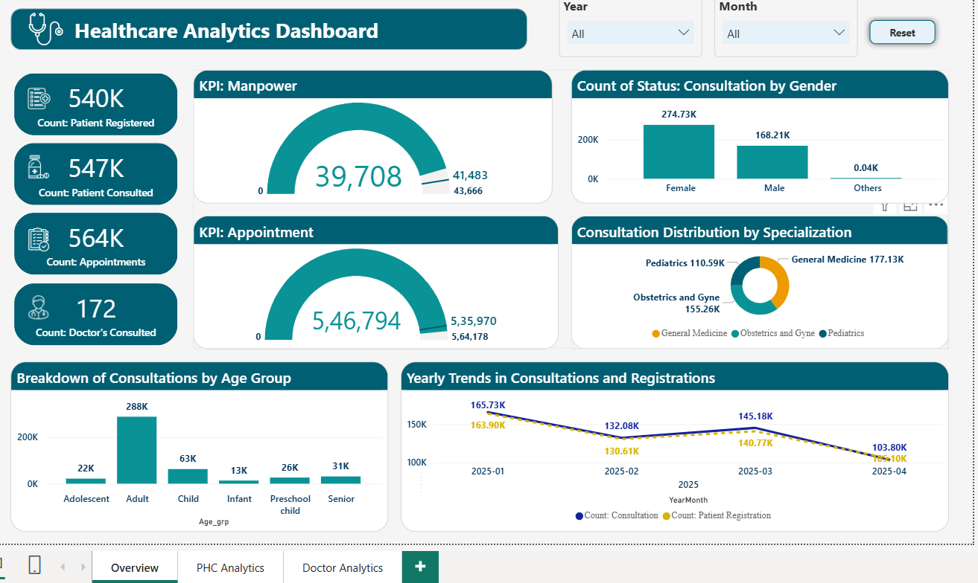
Fig 1 : Healthcare Analytics Dashboard – Overview Page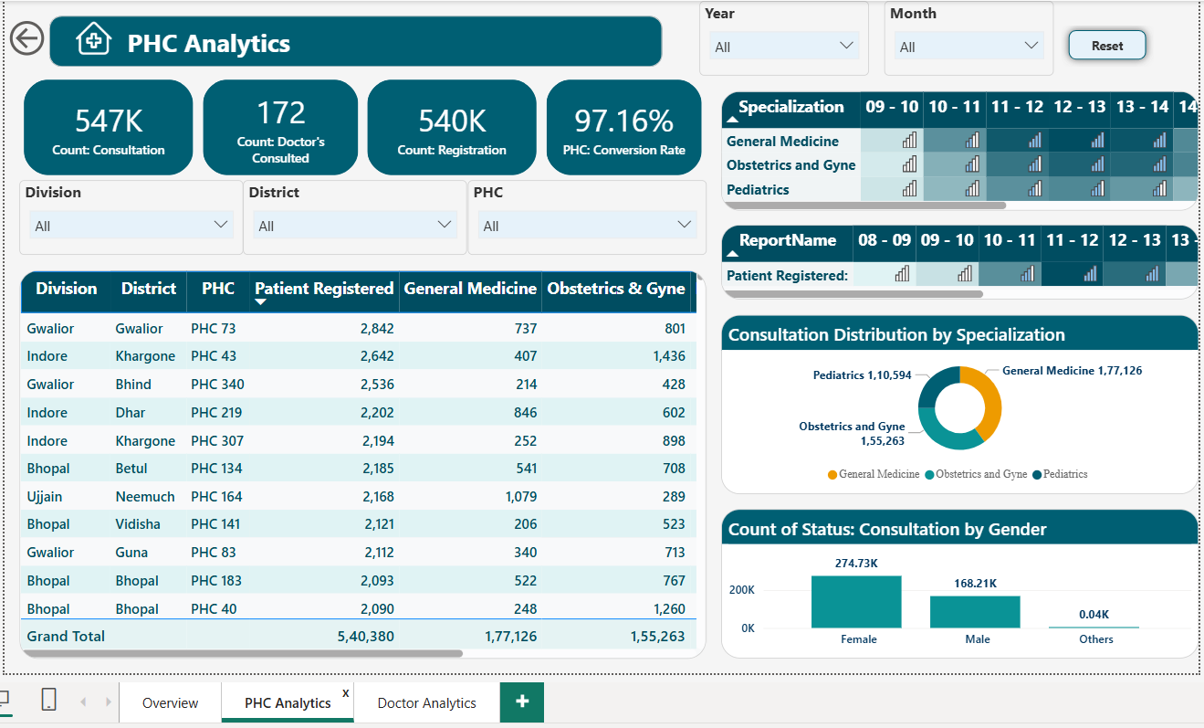
Fig 2 : PHC Analytics Dashboard
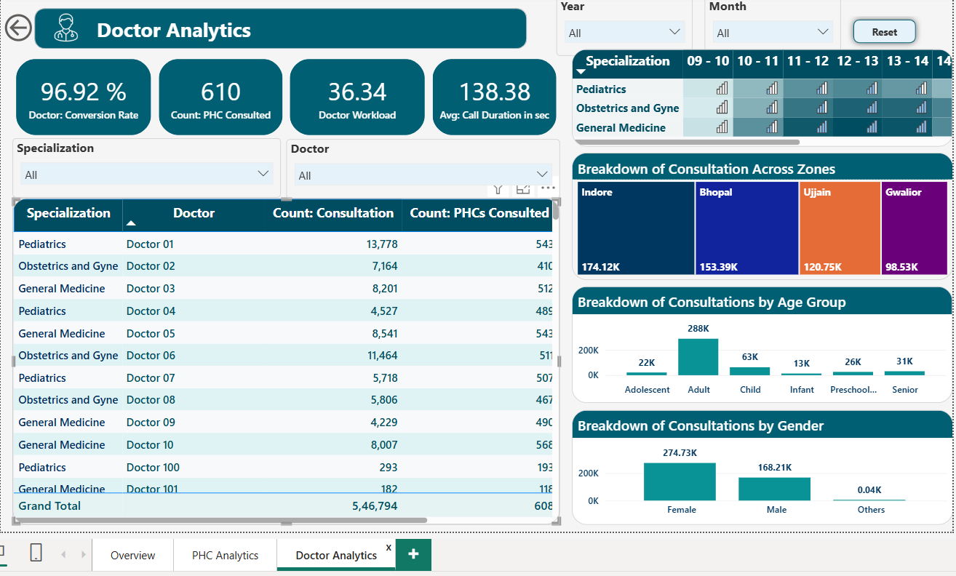

Fig 3 : Doctor Analytics Dashboard

CONCLUSION
The developed Healthcare Analytics Dashboard provides an interactive and efficient platform for analyzing healthcare operations. It transforms raw healthcare data into meaningful insights using visualizations such as KPI cards, bar charts, line charts, and donut charts. The dashboard helps in understanding patient trends, consultation patterns, and doctor performance. It highlights key metrics like total patients, consultations, and workload distribution. The use of interactive filters enables dynamic data exploration across different locations, demographics, and time periods. It allows users to analyze healthcare demand and service utilization effectively. The integration of DAX measures ensures accurate calculation of key performance indicators. The structured data model supports efficient filtering and smooth performance. Overall, the system enhances decision-making by providing clear and actionable insights. It contributes to improving healthcare efficiency and service quality.

REFERENCES

[1] Microsoft, “Power BI Documentation,” Microsoft Learn, 2024. [Online]. Available: https://learn.microsoft.com/en-us/power-bi/
[2] M. Russo and A. Ferrari, The Definitive Guide to DAX, 2nd ed., Microsoft Press, 2019.
[3] A. Ferrari, Power BI Data Modeling with Microsoft Business Intelligence, 2nd ed., Microsoft Press, 2023.
[4] World Health Organization (WHO), “Global Health Observatory Data Repository,” 2024. [Online]. Available: https://www.who.int/data
[5] Ministry of Health and Family Welfare (India), “Health Data Resources,” 2024. [Online]. Available: https://www.mohfw.gov.in/
[6] S. Few, Information Dashboard Design: Displaying Data for At-a-Glance Monitoring, Analytics Press, 2013.
[7] E. Tufte, The Visual Display of Quantitative Information, 2nd ed., Graphics Press, 2001.

