Project Documentation

Cook Book

1. **Introduction**

**Project Title :**

* Cook Book
* **Team ID** : CB001
* **Team Leader**: A. Gayathri / [gayathrikeerthana163@gmail.com](mailto:gayathrikeerthana163@gmail.com)
* **Team Members:**
* B.S Akshaya Dharani/ [akshayadharani0@gmail.com](mailto:akshayadharani0@gmail.com)
* M. Uma Maheswari / [mm2588205@gmail.com](mailto:mm2588205@gmail.com)
* M. Vency Veronica / [vency254@gmail.com](mailto:vency254@gmail.com)

1. **Project Overview**

* **Purpose:**

The Cook Book project is designed to provide and easy-to-use platform where users can explore, add, and share recipes. It helps beginners learn cooking step by step and allows experienced cooks to showcase their creations.

* **Features**:
* Add, edit, and delete recipes.
* Search recipes by name, ingredients, or category.
* Categorization (vegetarian, non-vegetarian, desserts, drinks, etc.)
* User-friendly interface with images and step-by-step instructions.
* Option to mark favorite recipes.

1. **Architecture:**

* **Frontend:** React.js
* **Backend:** Node.js
* **Database:** MongoDB

1. **Setup Instructions:**

* **Prerequisites:**

1. Browser (Chrome/Edge)
2. Code Editor (Visual Studio Code)
3. Node.js

* **Installation Steps:**

1. Download the project folder
2. Open is VS code
3. Run using npm start

**5. Folder Structure**

* Cookbook/

|-- index. html

|-- style. css

|-- script. js

|-- /images

|-- /recipes

1. **Running the Application**

* Run via Live Server in VS Code
* **Frontend**
* cd code
* npm install
* **Backend**
* npm start

1. **API Documentation**

* **User:**
* /api/recipes/add
* /api/recipes/:id

1. **User Interface**

* Home page (list of recipes)
* Recipe Details Page
* Add Recipe Form
* Favorites Section

1. **Testing**

* Manual testing on different browsers
* Verified recipe search and display

1. **Screenshot or Demo**

https://drive.google.com/file/d/1G3gHs6hfdsFHEYt1CEDUaNH_45AhYtlR/view?usp=sharing

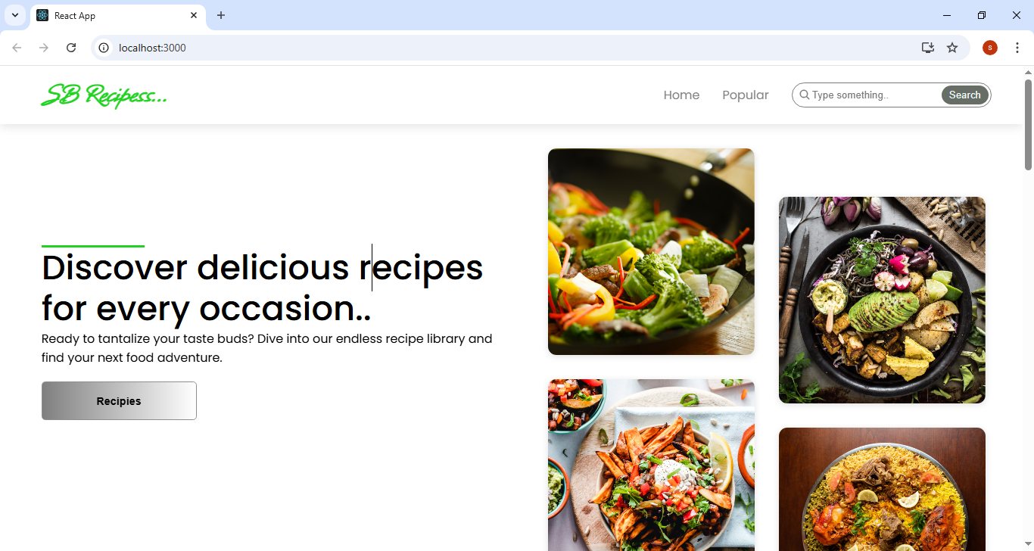

1. **Known Issues**

* Search may not work properly if spelling mistakes are made
* Limited recipes currently available

1. **Future Enhancements**

* Add video tutorials for each recipe
* Mobile app version
* AI- based recipe recommendations