Experiment No: 1
Comparative Study of Low-Code Development Versus Traditional Application Development Approaches

1. Aim
To conduct a detailed comparative study between the Low-Code Application Development approach and the Traditional (hand-coded) Application Development approach, examining their respective development stages, underlying philosophies, advantages, limitations, cost and time implications, and overall suitability for different categories of software projects.

2. Introduction to Traditional Approach
Traditional application development refers to the practice of building software by writing source code manually, statement by statement, using general-purpose programming languages such as Java, Python, C#, C++, or JavaScript, combined with frameworks, libraries, and tools selected deliberately by the development team based on project requirements. It follows a well-defined Software Development Life Cycle (SDLC) that typically progresses through requirement gathering, system analysis, architectural and detailed design, coding, unit and integration testing, deployment, and long-term maintenance.
Each phase of this life cycle demands specialized personnel, including business analysts to capture requirements, software architects to design scalable systems, developers to implement functionality, and quality assurance engineers to validate correctness. Because every layer of the application, from the database schema to the user interface, is constructed explicitly by the team, this approach affords complete control over performance tuning, security hardening, and integration with third-party or legacy systems.
2.1 Advantages of the Traditional Approach
- Complete flexibility to design custom architectures tailored to unique business needs.
- Fine-grained control over performance, security, and resource optimization.
- No dependency on a third-party platform vendor for core application logic.
- Suitable for building highly complex, mission-critical, or large-scale enterprise systems.
2.2 Limitations of the Traditional Approach
- Longer development cycles, often spanning several months to years for large systems.
- Requires a large team of experienced and often expensive technical specialists.
- Higher risk of project delays due to manual coding errors and complex debugging.
- Ongoing maintenance can be costly as codebases grow larger and more intricate.

3. Introduction to Low-Code Development
Low-code development is a modern, visual approach to software creation that enables both professional developers and non-technical business users, often referred to as citizen developers, to build functional applications using drag-and-drop interface builders, pre-configured templates, and visual workflow designers, thereby minimizing the volume of hand-written code required. Prominent low-code platforms such as OutSystems, Mendix, Microsoft Power Apps, and Zoho Creator supply libraries of reusable components, automatically generated backend services, built-in database connectivity, and streamlined one-click deployment pipelines.
By abstracting away much of the underlying technical complexity, low-code platforms significantly accelerate development speed, reduce dependence on large specialized engineering teams, and allow organizations to prototype, test, and iterate on new ideas far more quickly than conventional methods permit. This makes the approach particularly attractive for internal business tools, departmental workflow automation, and Minimum Viable Products (MVPs) intended for rapid market validation.
3.1 Advantages of Low-Code Development
- Significantly faster development and deployment timelines.
- Reduced dependency on large, highly specialized engineering teams.
- Lower overall development cost for small to medium complexity applications.
- Empowers business users to participate directly in application creation.
3.2 Limitations of Low-Code Development
- Restricted customization when requirements fall outside platform capabilities.
- Potential vendor lock-in, making migration to another platform difficult.
- May face scalability constraints for very large or highly complex systems.
- Integration options are limited to the connectors the platform provides.

4. Diagram: Stages in Traditional Approach
The diagram below illustrates the sequential stages followed in a typical traditional, hand-coded software development life cycle, beginning with requirement gathering and concluding with ongoing maintenance.
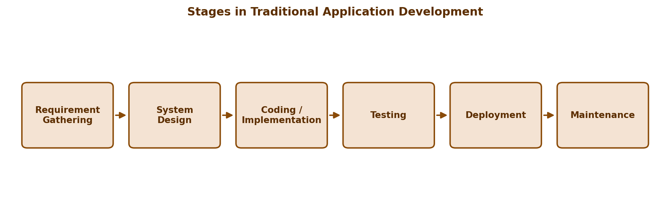

5. Diagram: Steps in Low-Code Approach
The diagram below illustrates the streamlined steps followed in a typical low-code development workflow, from initial requirement analysis to rapid, one-click deployment.
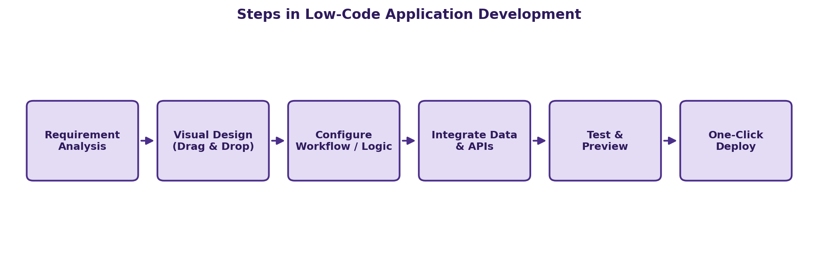

6. Comparative Analysis
The table below presents a detailed side-by-side comparison of the traditional and low-code development approaches across several key parameters relevant to project planning and technology selection.
Parameter | Traditional Development | Low-Code Development
Development speed | Slower; every feature is hand-coded from scratch | Much faster; drag-and-drop components and reusable modules
Skill requirement | Requires experienced programmers and architects | Usable by citizen developers with minimal training
Cost | Higher, due to larger teams and longer timelines | Lower, due to smaller teams and shorter cycles
Customization | Very high; full control over logic and architecture | Limited by platform capabilities and templates
Scalability | Highly scalable when architected properly | Depends on the platform's underlying scalability limits
Maintenance | Manual, code-level debugging and version control | Simplified via visual editors and automatic platform updates
Integration flexibility | Can integrate with virtually any external system | Depends on available pre-built connectors and plugins
Learning curve | Steep; needs strong programming background | Gentle; visual tools reduce technical barriers
Time to market | Longer, often months to years for large systems | Shorter, often days to weeks for typical business apps
Best suited for | Complex, large-scale, performance-critical applications | Internal tools, MVPs, workflow automation, and prototypes
Vendor dependency | None; technology-agnostic and portable | High; tied to the low-code platform vendor's ecosystem
Security control | Fully controlled by the development team | Shared responsibility with the platform vendor
Long-term flexibility | Easier to re-architect or migrate over time | Harder to migrate away from the chosen platform

7. Result
The comparative study of traditional and low-code application development approaches was successfully carried out. It was observed that the traditional approach offers superior flexibility, deep customization, and long-term scalability, making it the preferred choice for complex, large-scale, and mission-critical enterprise applications where full control over architecture and integration is essential.
In contrast, the low-code approach offers markedly faster development cycles, lower initial cost, and a gentler learning curve, making it well suited for rapid prototyping, internal business tools, workflow automation, and Minimum Viable Products where speed to market outweighs the need for deep customization.
Ultimately, the choice between the two approaches should be guided by project complexity, available technical skill sets, budgetary constraints, timeline pressures, and long-term scalability requirements. Many organizations today adopt a hybrid strategy, using low-code platforms for simpler internal applications while reserving traditional development for core, high-complexity business systems.

