RENTALHUB
Equipment Rental Platform
Team: PentaVerse
Domain: Real Estate / Equipment Rental
Technology: MERN Stack
Team Members :
1.Gayathri M
2.Miruthala M K
3.Kiruthiga I G
4.Preethi S
5.Sibika K S

Table of Contents

1. Project Overview
2. Problem Statement
3. Objectives
4. Proposed Solution
5. Key Features
6. User Roles and Modules
7. Technology Stack
8. System Architecture
9. Project Structure
10. Database Design
11. MongoDB Collections
12. API Design and Endpoints
13. Authentication and Security
14. Core Application Workflows
15. Frontend Screens
16. Testing and Validation
17. Optimization and Performance
18. Error Handling
19. Installation and Setup
20. Environment Variables
21. GitHub Repository and Submission
22. Screenshots
23. Future Enhancements
24. Conclusion

1. Project Overview
RentalHub is a web-based equipment rental platform developed as a full-stack MERN application. The platform connects customers who need equipment with equipment owners or rental providers who list their resources for rental. Customers can browse equipment, view details, select rental dates and create bookings. Owners can manage equipment information and rental-related activities. The system uses React.js for the frontend, Node.js and Express.js for REST APIs, and MongoDB with Mongoose for persistent data storage.
The current MVP focuses on establishing a complete frontend-backend-database flow, including user registration, login, equipment creation, equipment retrieval, equipment details, and the initial booking workflow.

2. Problem Statement
Finding suitable equipment for short-term use can be difficult when information about available resources, rental pricing, owners and booking dates is scattered across different sources. RentalHub addresses this problem by providing a centralized platform where equipment can be listed, discovered and requested for specific rental periods.

3. Objectives
- Build a functional MERN-based equipment rental platform.
- Provide registration and login functionality for users.
- Store users, equipment and bookings in MongoDB.
- Allow customers to browse available equipment and view details.
- Provide a booking workflow based on start and end dates.
- Provide REST APIs for frontend-backend integration.
- Use Mongoose schemas and relationships between users, equipment and bookings.
- Apply secure configuration through environment variables.
- Provide a responsive and user-friendly interface.
- Deliver a working MVP with an end-to-end application workflow.

4. Proposed Solution
RentalHub provides a centralized web application with separate customer and owner-oriented capabilities. A user can register and log in, browse equipment, open an equipment details page and start a booking. Equipment records are stored in MongoDB and exposed through Express REST APIs. React consumes these APIs using Fetch API.
Application flow:
- React frontend → REST API request
- Express.js route → Controller
- Controller → Mongoose model
- Mongoose → MongoDB
- MongoDB response → Express API → React UI

5. Key Features
Feature | Description | Status in MVP
User Registration | Create a RentalHub user account. | Implemented
User Login | Authenticate using registered email and password. | Implemented
Equipment Creation | Create an equipment listing through the API. | Implemented
Equipment Listing | Fetch equipment records from MongoDB and display them in React. | Implemented
Equipment Details | View information about a selected equipment item. | Implemented / MVP
Booking Form | Select rental start and end dates. | Implemented / Integration in progress
Booking API | Create booking records using REST API. | Backend implemented; frontend integration in progress
Owner Management | Associate equipment with an owner. | MVP data model implemented
Admin Dashboard | Administrative management and reporting. | Future enhancement
Reviews & Ratings | Customer feedback after rental. | Future enhancement
Notifications | Booking and status notifications. | Future enhancement

6. User Roles and Modules
Role | Responsibilities / Modules
Customer | Register, login, browse equipment, view equipment details, select rental dates, create bookings, view booking history, and later submit reviews.
Equipment Owner | Register/login, create equipment listings, manage pricing and availability, view booking requests, and later update rental/return status.
Administrator | Manage users, equipment, categories, bookings, platform activities, reports and notifications. Planned for future enhancement.

7. Technology Stack
Layer | Technology | Purpose
Frontend | React.js | Build the interactive user interface.
Frontend Routing | React Router | Navigate between Home, Equipment, Details, Login, Register and Booking screens.
Frontend API | Fetch API | Connect React components to REST APIs.
Backend | Node.js | JavaScript runtime for server-side application logic.
API Framework | Express.js | Build RESTful API routes and middleware.
Database | MongoDB | Persistent storage for application data.
ODM | Mongoose | Schemas, validation, relationships and database queries.
Authentication | JWT + bcryptjs | Planned/required secure authentication implementation.
Security / Config | CORS + dotenv | Cross-origin API access and environment configuration.
Development | Vite | Frontend development server and build tooling.
API Testing | Thunder Client / equivalent | Test REST endpoints during development.

8. System Architecture
RentalHub follows a three-layer MERN architecture. The React frontend provides the user interface. The Express/Node.js backend exposes REST endpoints and performs application logic. MongoDB stores users, equipment and booking information through Mongoose models.
Layer | Components
Presentation | React components, React Router, CSS, forms and navigation
Application / API | Node.js, Express.js, routes, controllers, middleware
Data | MongoDB Atlas, Mongoose models and collections
Integration | Fetch API, JSON request/response, CORS

System Architecture Diagram
architecture diagram showing React → Express → Mongoose → MongoDB.
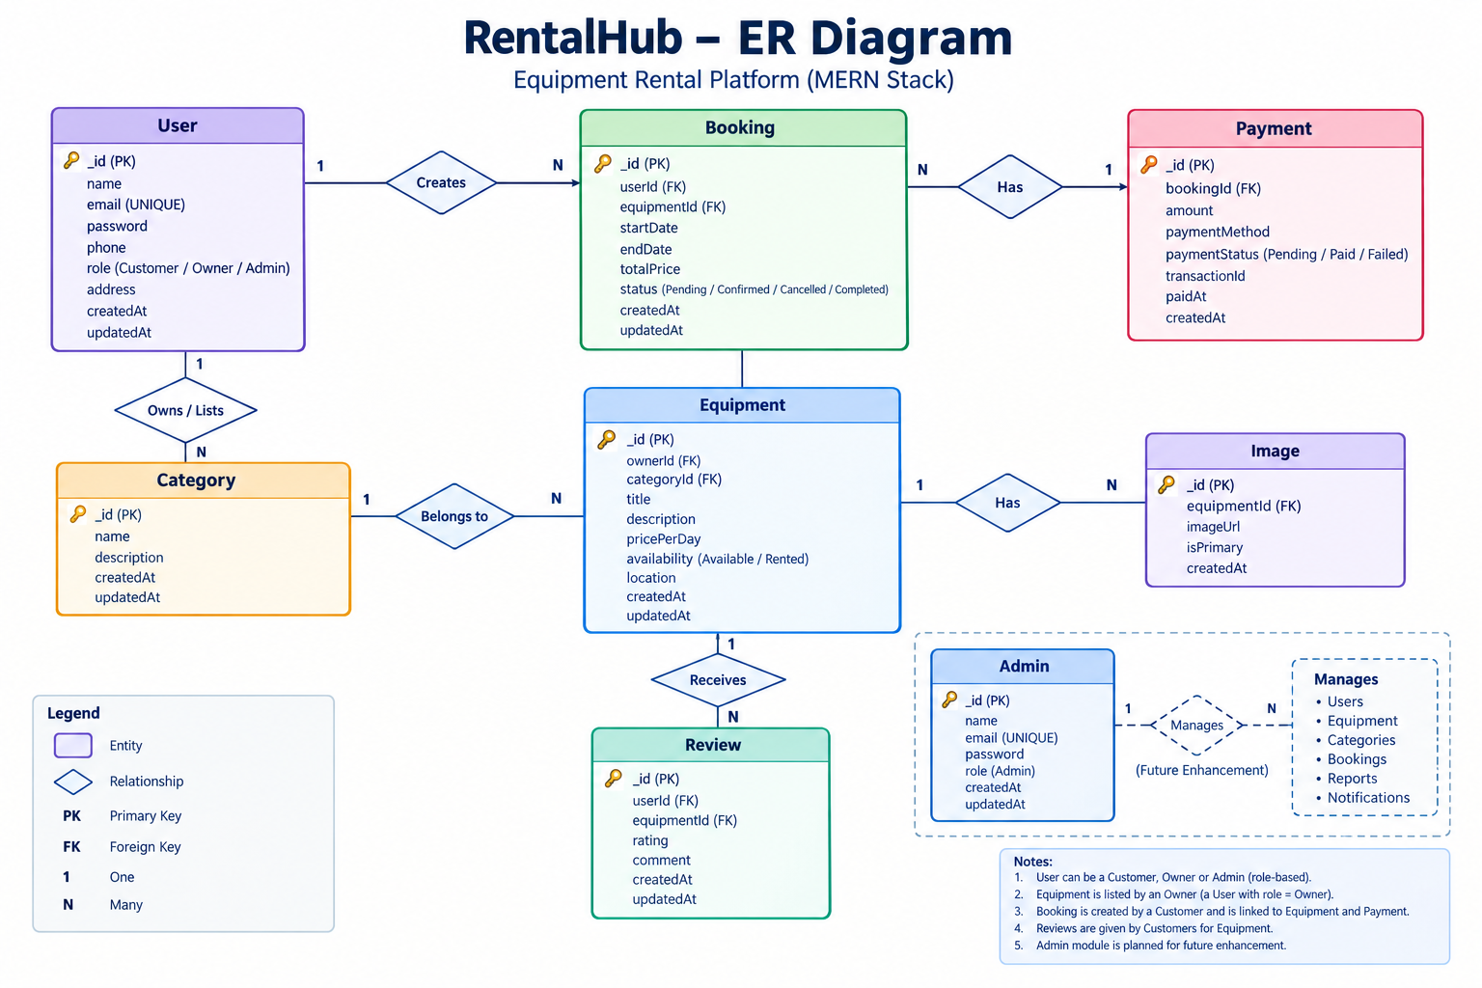

9. Project Structure
Current project structure:
rental hub/
├── backend/
│ ├── config/
│ │ └── db.js
│ ├── controllers/
│ │ ├── authController.js
│ │ ├── bookingController.js
│ │ └── EquipmentController.js
│ ├── models/
│ │ ├── User.js
│ │ ├── Equipment.js
│ │ └── Booking.js
│ ├── routes/
│ │ ├── authRoutes.js
│ │ ├── equipmentRoutes.js
│ │ └── bookingRoutes.js
│ ├── .env
│ ├── server.js
│ └── package.json
│
└── frontend/
├── src/
│ ├── App.jsx
│ ├── App.css
│ └── ...
├── package.json
└── vite.config.js

10. Database Design
MongoDB is used as the primary database. Mongoose models define the application data structures and references between related documents.
Entity | Important Fields | Relationships
User | name, email, password, phone, address | Referenced by Equipment.owner and Booking.customer/owner
Equipment | name, description, category, owner, pricePerDay, location, image | owner references User
Booking | customer, equipment, owner, startDate, endDate, totalAmount | customer/owner reference User; equipment references Equipment

11. MongoDB Collections

11.1 Users Collection
Stores customer and equipment-owner account information. Passwords should be stored only as secure hashes when authentication is fully implemented.

11.2 Equipment Collection
Stores rental equipment details including name, description, category, owner reference, daily price, location and optional image.

11.3 Bookings Collection
Stores rental transactions by connecting customer, equipment and owner with the selected rental dates and total amount.
Planned additional collections: Categories, Reviews, Notifications, and administrative/reporting data.

12. API Design and Endpoints
Method | Endpoint | Purpose | Status
GET | / | Check whether RentalHub backend is running. | Implemented
POST | /api/auth/register | Register a new user. | Implemented
POST | /api/auth/login | Login a registered user. | Implemented
POST | /api/equipment | Create an equipment listing. | Implemented
GET | /api/equipment | Fetch all equipment. | Implemented
GET | /api/equipment/:id | Fetch equipment by ID. | Implemented
POST | /api/bookings | Create a booking. | Implemented
GET | /api/bookings | Fetch all bookings. | Implemented

API testing is performed during development using Thunder Client. The frontend communicates with the backend using Fetch API and JSON request/response payloads.

13. Authentication and Security
- User registration and login endpoints are implemented.
- Password hashing with bcryptjs is part of the required authentication design.
- JWT-based authentication is required for secure session handling and protected operations.
- CORS is enabled for frontend-backend communication during development.
- dotenv is used for environment variables such as the MongoDB connection string.
- Sensitive credentials must not be committed to GitHub.
- Protected routes and role-based authorization should be applied to owner/admin operations.
- Input validation and authorization checks should be added/strengthened across protected APIs.

14. Core Application Workflows

14.1 Registration and Login
User opens Register → enters details → React sends POST /api/auth/register → Express controller processes the request → user is stored in MongoDB → success response is shown.
For login, the frontend sends credentials to POST /api/auth/login and stores the returned authentication token when successful.

14.2 Equipment Listing
Owner/equipment manager creates an equipment record → equipment is stored in MongoDB → React requests GET /api/equipment → available equipment is rendered as cards.

14.3 Equipment Details
Customer selects View Details → React Router navigates to /equipment/:id → frontend can request the corresponding equipment record from GET /api/equipment/:id → details are displayed.

14.4 Booking
Customer selects Book Now → booking form opens → customer selects start and end dates → frontend sends booking information to POST /api/bookings → booking is stored in MongoDB.
The MVP booking workflow should be extended with authenticated customer/owner IDs, equipment ID, date validation, availability checking and calculated rental amount.

15. Frontend Screens
Screen | Purpose
Home | Introduce RentalHub and provide a Browse Equipment entry point.
Equipment | Display equipment fetched from the backend.
Equipment Details | Show selected equipment information and provide Book Now.
Booking | Collect rental start and end dates and confirm booking.
Login | Authenticate existing users.
Register | Create a new account.
Register Page Screenshot
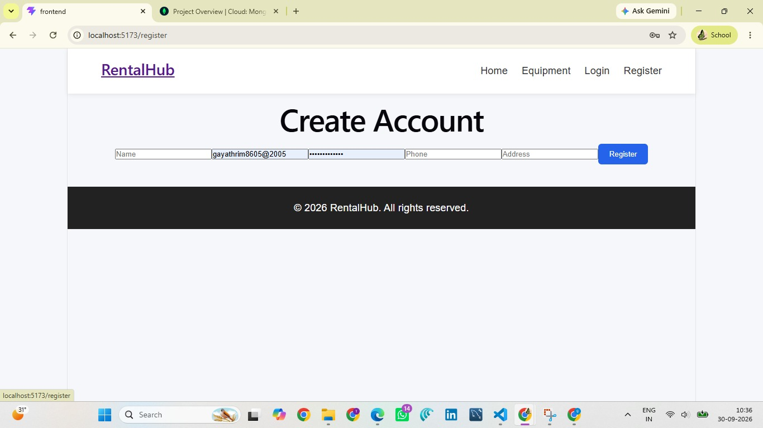
Equipment Listing Screenshot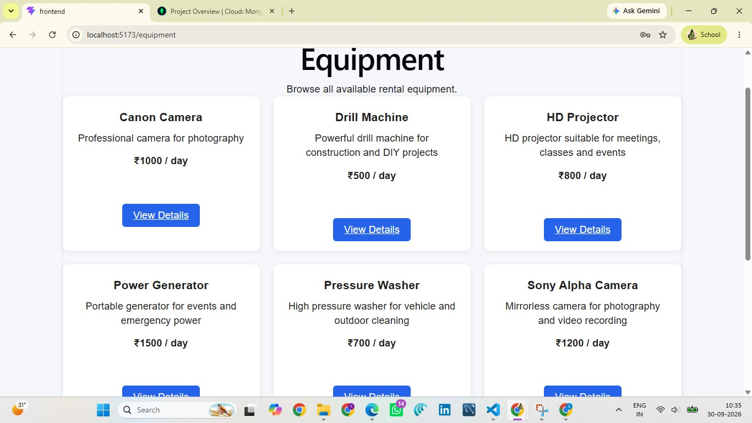
Booking Page Screenshot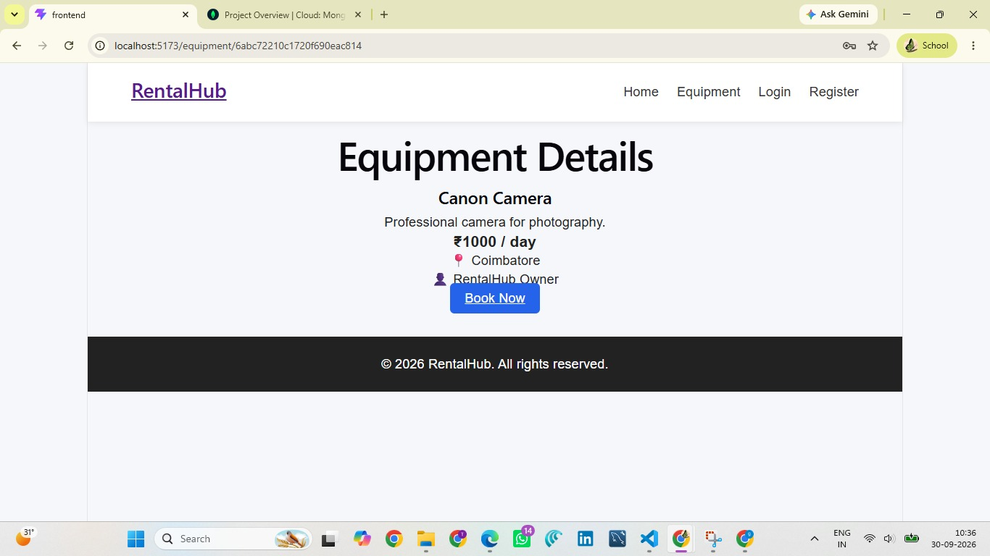
Login Screenshot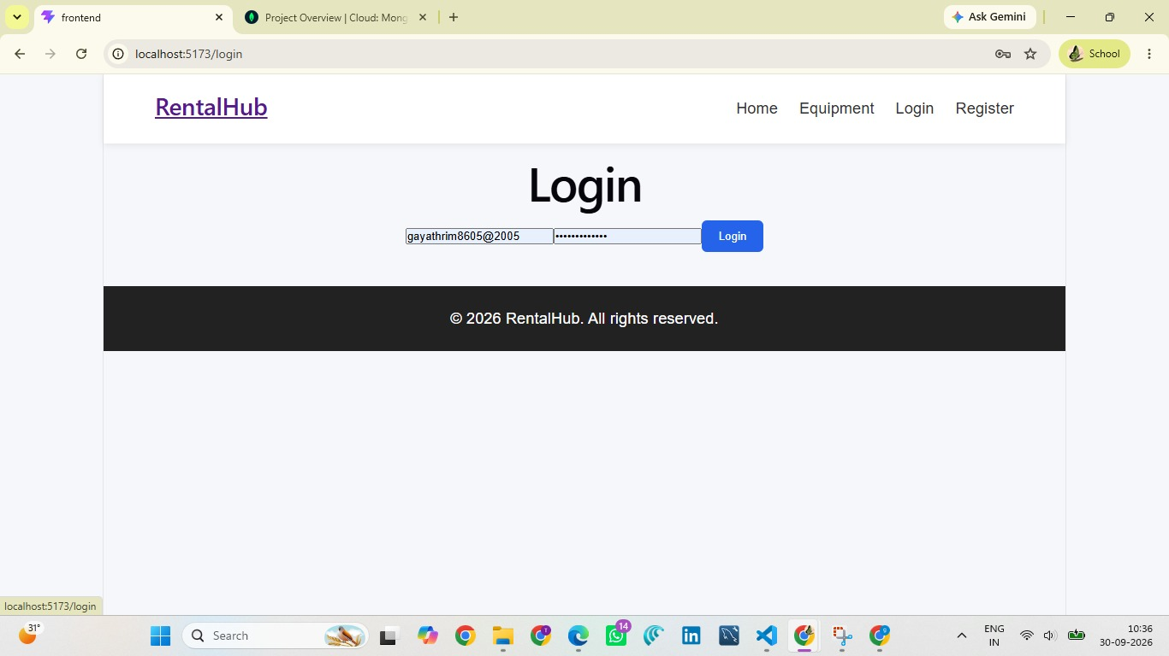

Home page Screenshot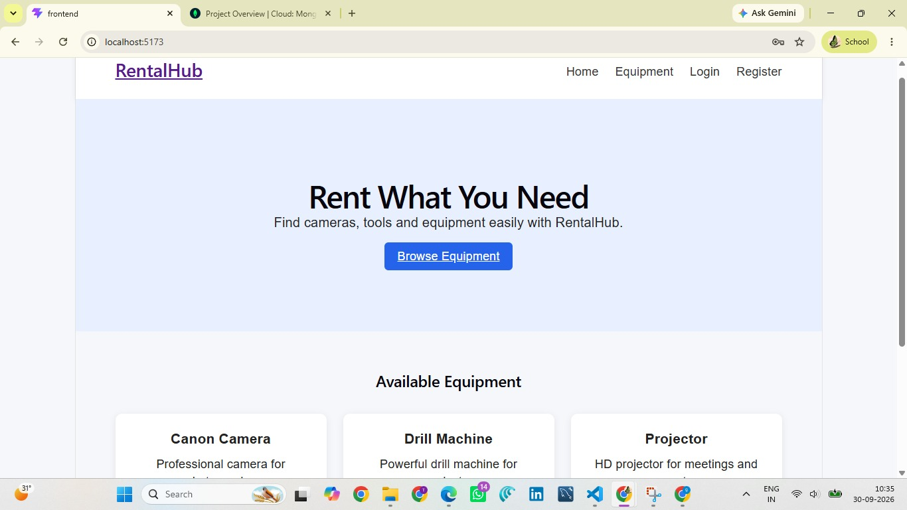

16. Testing and Validation
Test Area | Test Case | Expected Result | Current Validation
Backend | Open GET / | Backend status response is returned. | Verified
Database | Start backend with valid MongoDB environment variable. | MongoDB connection succeeds. | Verified
Authentication | Register a new user. | User is created successfully. | Verified
Equipment API | POST equipment with valid owner ID. | Equipment is created. | Verified
Equipment API | GET /api/equipment. | Equipment list is returned. | Verified
Frontend | Open /equipment. | Equipment from MongoDB appears. | Verified
Routing | Click View Details. | Equipment details route opens. | MVP implemented
Booking UI | Click Book Now. | Booking form opens. | Verified
Booking API | Submit valid booking payload. | Booking is stored in MongoDB. | Backend implemented; frontend integration being completed
Validation | Submit invalid/missing required fields. | Meaningful validation error is shown. | To be strengthened

Testing should be repeated after every major integration change and before final submission.

17. Optimization and Performance
- Use database indexes for frequently searched fields such as category, location and owner where appropriate.
- Use pagination when equipment and booking records become large.
- Use efficient Mongoose queries and populate only required fields.
- Add search and filtering for equipment name, category, price and location.
- Use reusable React components for equipment cards and forms.
- Use lazy loading for larger frontend modules where appropriate.
- Optimize images and avoid storing unnecessarily large image files directly in MongoDB.

18. Error Handling
The backend uses try/catch blocks and returns HTTP status codes with JSON messages for common failures. The frontend handles failed fetch requests and displays user-friendly alerts/messages. Future improvements should include centralized error handling, validation middleware and more descriptive frontend error states.

19. Installation and Setup

19.1 Backend Setup
- Open the backend folder in VS Code.
- Install dependencies using npm install.
- Create a .env file containing the MongoDB connection string.
- Start the backend using node server.js.
- Verify the server at http://localhost:5000/.

19.2 Frontend Setup
- Open a second terminal in the frontend folder.
- Install dependencies using npm install.
- Start the Vite development server using npm run dev.
- Open the displayed local URL, normally http://localhost:5173/.

20. Environment Variables
Example backend .env configuration (do not commit real secrets to GitHub):
MONGO_URL=<MongoDB Atlas connection string>
# Additional future variables:
JWT_SECRET=<strong-secret>
PORT=5000
The actual password, JWT secret and other credentials must remain private and must not be included in screenshots or public repositories.

21. GitHub Repository and Submission
The final RentalHub source code should be maintained in a GitHub repository for mentor evaluation. The repository should contain the frontend and backend source code, README documentation and a safe example environment file (for example, .env.example) without real credentials.
GitHub Repository URL: https://github.com/gayathrim8605/RentalHub
Live Demo URL: https://drive.google.com/file/d/1EWUXE4kgjTSaaU098YSB3gEVChH10NZw/view
Team Lead: Gayathri M
Team: PentaVerse
Team Members: Gayathri M, Krithiga I G, Preethi S, Miruthala M K, SIBIKA K S

22. Screenshots
Insert final application screenshots in this section. Recommended screenshots include the home page, equipment listing, equipment details, registration, login, booking form, successful booking response, Thunder Client API tests, and MongoDB collections.
Backend Running + MongoDB Connected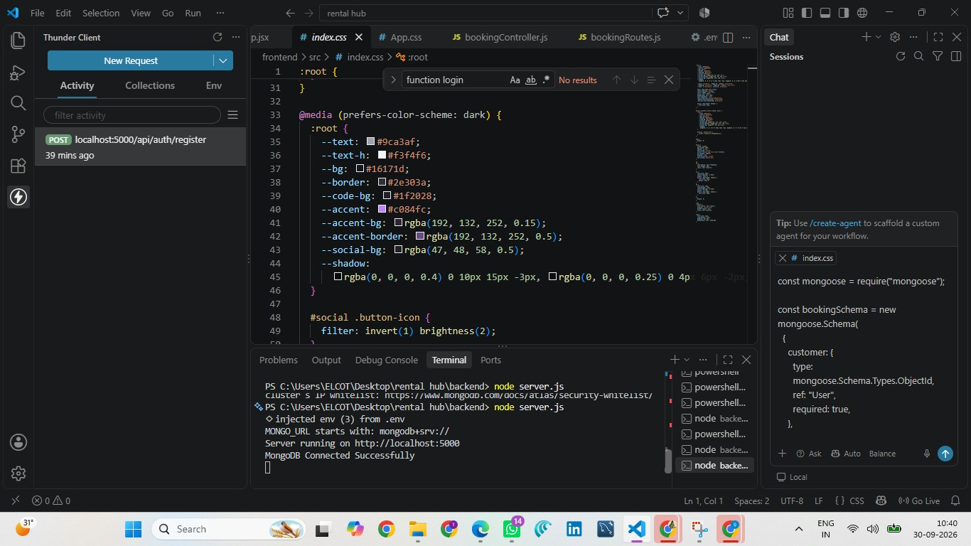

Thunder equipment API
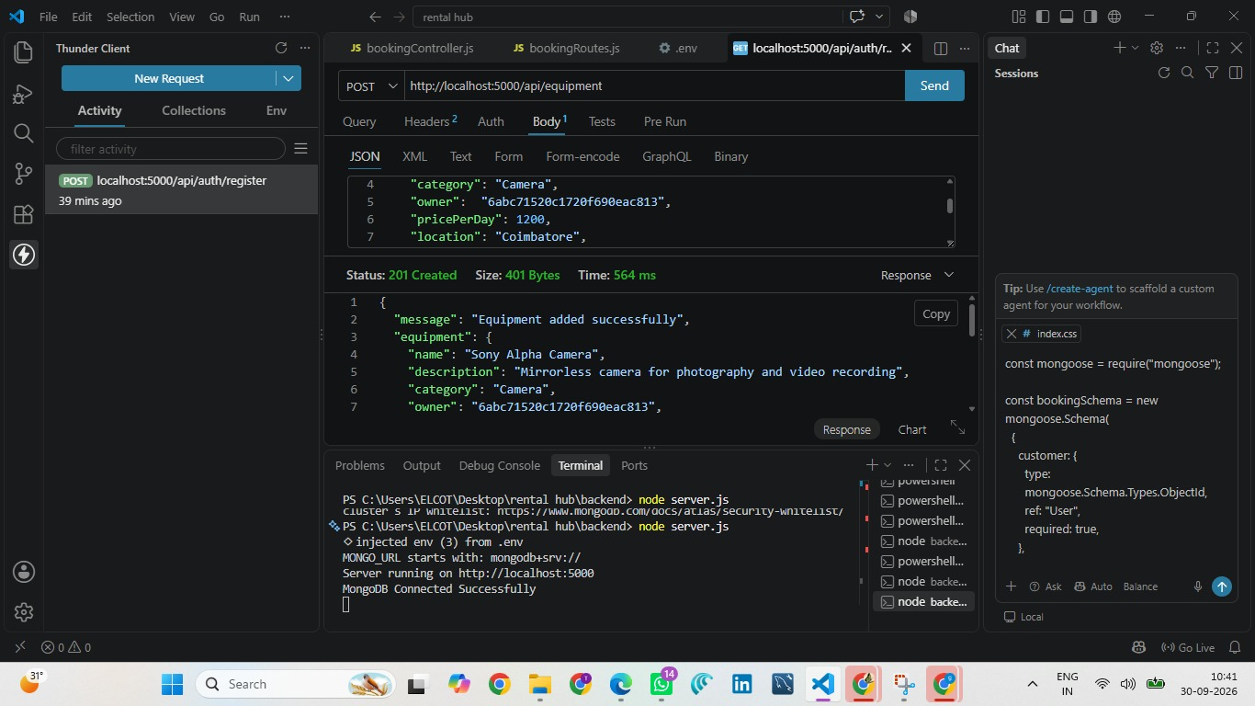
Booking Successful
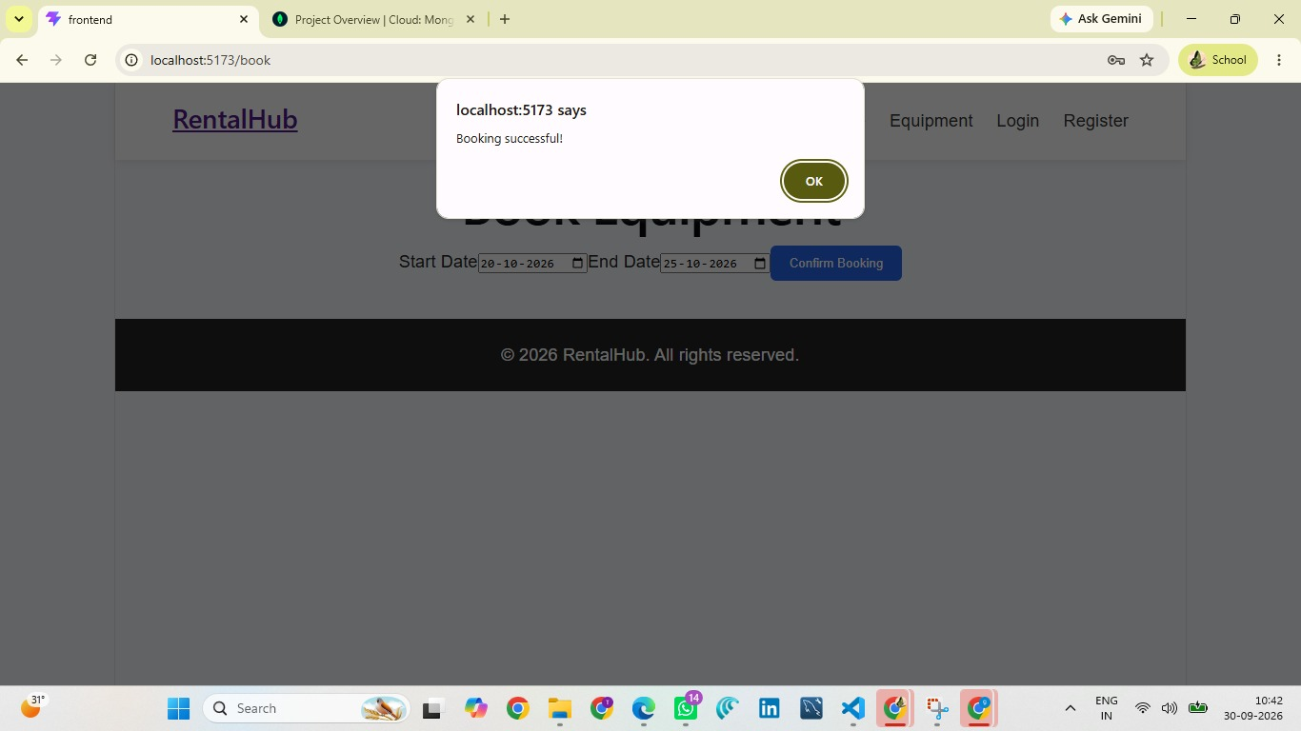

23. Future Enhancements
- JWT-protected customer and owner dashboards.
- Role-based access control for customers, owners and administrators.
- Complete CRUD operations for equipment: update and delete.
- Equipment availability calendar and date conflict prevention.
- Automatic rental amount calculation based on number of days.
- Booking status tracking: pending, approved, active, returned and cancelled.
- Search, filtering and sorting by category, location and price.
- Reviews and ratings after completed rentals.
- Notifications for booking confirmation, approval and return reminders.
- Admin dashboard with user, equipment and booking management.
- Image upload and cloud-based image storage.
- Pagination and database indexing.
- Reports and analytics for rental activity.
- Production deployment of frontend, backend and database.

24. Conclusion
RentalHub demonstrates the design and implementation of a MERN-based equipment rental platform. The project establishes the essential React frontend, Express/Node.js REST API layer and MongoDB data layer. The current MVP supports user registration and login, equipment creation and retrieval, frontend equipment display, equipment details navigation and the initial booking flow. The architecture is extensible for authentication, authorization, availability management, booking status, reviews, notifications and administrative features. The project is designed to prioritize a working end-to-end workflow while providing a clear path for future enhancements.

Appendix A — Sample API Payloads
Equipment creation request:
{
"name": "Canon Camera",
"description": "Professional camera for photography",
"category": "Camera",
"owner": "<OWNER_ID>",
"pricePerDay": 1000,
"location": "Coimbatore",
"image": ""
}
Booking creation request:
{
"customer": "<CUSTOMER_ID>",
"equipment": "<EQUIPMENT_ID>",
"owner": "<OWNER_ID>",
"startDate": "<START_DATE>",
"endDate": "<END_DATE>",
"totalAmount": 1000
}

Appendix B — Submission Checklist
- Frontend runs successfully with npm run dev.
- Backend runs successfully with node server.js.
- MongoDB connection works.
- Registration tested.
- Login tested.
- Equipment creation tested.
- Equipment listing tested.
- Equipment details tested.
- Booking form tested.
- Booking API tested.
- Required screenshots inserted.
- GitHub repository URL added.
- Demo URL added, if available.
- README and setup instructions completed.
- Real secrets removed from repository.
- Final end-to-end workflow tested.

