P.LAKSHMI GAYATHRI NAVANEETHA
192321169
5. Bias–Variance, Overfitting, and Underfitting Analysis
import numpy as np
import matplotlib.pyplot as plt
from sklearn.pipeline import make_pipeline
from sklearn.preprocessing import PolynomialFeatures
from sklearn.linear_model import LinearRegression
from sklearn.metrics import mean_squared_error

# 1. Generate Synthetic Data
np.random.seed(42)
n_samples = 30
X = np.sort(np.random.rand(n_samples))
y = np.cos(1.5 * np.pi * X) + np.random.randn(n_samples) * 0.1

# Reshape for scikit-learn
X_test = np.linspace(0, 1, 100)
X_train_deg = X[:, np.newaxis]
X_test_deg = X_test[:, np.newaxis]

degrees = [1, 4, 15]
titles = ['Underfitting (Deg 1)', 'Right Fit (Deg 4)', 'Overfitting (Deg 15)']

plt.figure(figsize=(14, 4))

for i, degree in enumerate(degrees):
ax = plt.subplot(1, 3, i + 1)

# Define and fit polynomial pipeline
polynomial_features = PolynomialFeatures(degree=degree, include_bias=False)
linear_regression = LinearRegression()
pipeline = make_pipeline(polynomial_features, linear_regression)
pipeline.fit(X_train_deg, y)

# Predict and evaluate
y_pred_train = pipeline.predict(X_train_deg)
y_pred_test = pipeline.predict(X_test_deg)
mse = mean_squared_error(y, y_pred_train)

# Plotting
plt.plot(X_test, y_pred_test, label="Model", color='crimson', lw=2)
plt.plot(X_test, np.cos(1.5 * np.pi * X_test), label="True Function", linestyle="--", color='gray')
plt.scatter(X, y, edgecolor='b', s=20, label="Samples")
plt.xlabel("x")
plt.ylabel("y")
plt.xlim((0, 1))
plt.ylim((-2, 2))
plt.legend(loc="best")
plt.title(f"{titles[i]}\nMSE: {mse:.4f}")

plt.tight_layout()
plt.show()
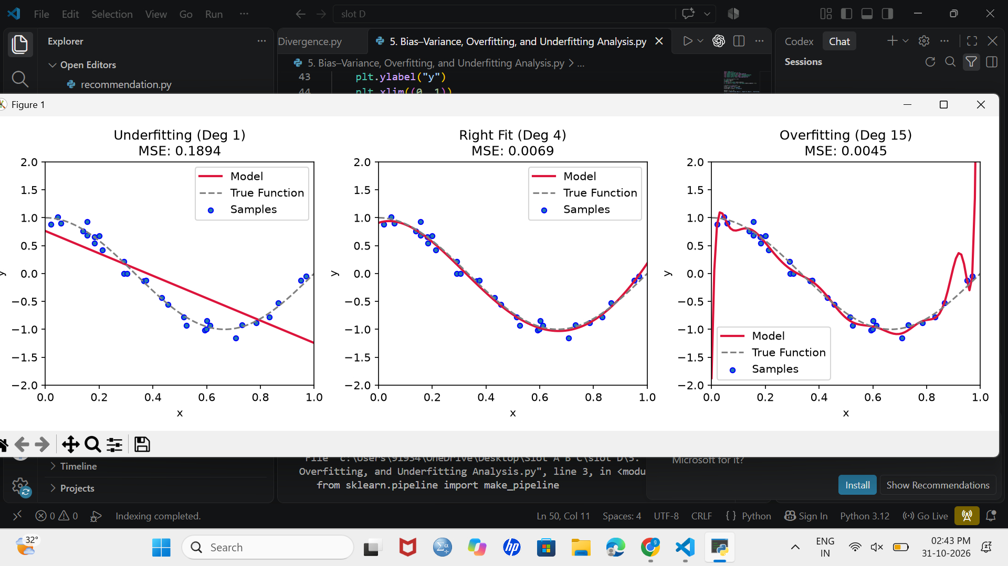
6. Gradient Descent, SGD, Momentum, and Adam Comparison
code:
import numpy as np
import tensorflow as tf
from tensorflow import keras
from tensorflow.keras import layers
import matplotlib.pyplot as plt

# 1. Load Data
(X_train, y_train), (X_test, y_test) = keras.datasets.mnist.load_data()
X_train = X_train.reshape(-1, 784).astype("float32") / 255.0
X_test = X_test.reshape(-1, 784).astype("float32") / 255.0

# 2. Define Optimizers to Compare
optimizers = {
'GD (Batch)': keras.optimizers.SGD(learning_rate=0.01),
'SGD': keras.optimizers.SGD(learning_rate=0.01),
'Momentum': keras.optimizers.SGD(learning_rate=0.01, momentum=0.9),
'Adam': keras.optimizers.Adam(learning_rate=0.001)
}

histories = {}

# 3. Train Models
for name, opt in optimizers.items():
print(f"Training with {name}...")
model = keras.Sequential([
layers.Dense(64, activation='relu', input_shape=(784,)),
layers.Dense(10, activation='softmax')
])

model.compile(optimizer=opt, loss='sparse_categorical_crossentropy', metrics=['accuracy'])

# Batch size adjustments to simulate Batch GD vs standard mini-batch SGD
b_size = len(X_train) if name == 'GD (Batch)' else 64

history = model.fit(X_train, y_train, epochs=5, batch_size=b_size, validation_split=0.2, verbose=0)
histories[name] = history.history['val_loss']

# 4. Plot Loss Comparison
plt.figure(figsize=(8, 5))
for name, loss in histories.items():
plt.plot(range(1, 6), loss, marker='o', label=name)

plt.title("Optimizer Convergence Comparison")
plt.xlabel("Epochs")
plt.ylabel("Validation Loss")
plt.legend()
plt.grid(True)
plt.show()
output:
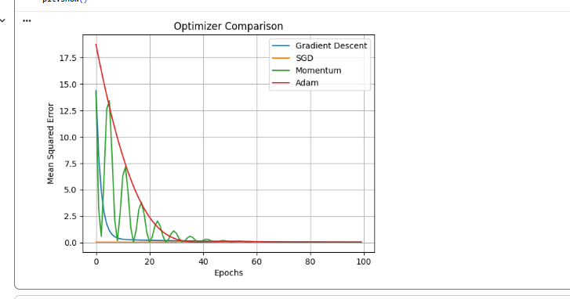
Experiment 7 – Perceptron and Forward Propagation
code:
import numpy as np
import matplotlib.pyplot as plt

X = np.array([
[0, 0],
[0, 1],
[1, 0],
[1, 1]
])

y = np.array([0, 0, 0, 1])

weights = np.zeros(2)
bias = 0
learning_rate = 0.1
epochs = 20

for epoch in range(epochs):
for i in range(len(X)):
z = np.dot(X[i], weights) + bias
prediction = 1 if z >= 1 else 0

error = y[i] - prediction

weights += learning_rate * error * X[i]
bias += learning_rate * error

print("Trained Weights:", weights)
print("Trained Bias:", bias)

print("\nForward Propagation Output:")

for i in range(len(X)):
z = np.dot(X[i], weights) + bias
prediction = 1 if z >= 1 else 0
print(X[i], "Predicted:", prediction, "Actual:", y[i])

plt.scatter(X[:, 0], X[:, 1], c=y)
plt.xlabel("Input 1")
plt.ylabel("Input 2")
plt.title("Perceptron AND Gate")
plt.show()
output:
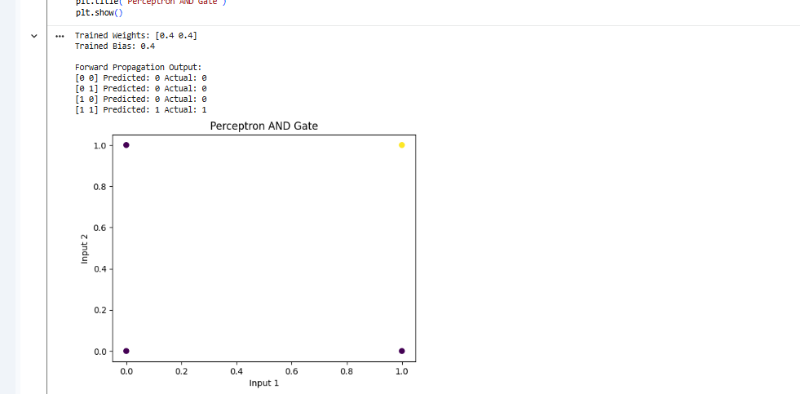Experiment 8 – Two-Layer Neural Network with Backpropagation
code:
import numpy as np

np.random.seed(42)

X = np.array([[0, 0], [0, 1], [1, 0], [1, 1]])
y = np.array([[0], [1], [1], [0]])

W1 = np.random.randn(2, 4)
b1 = np.zeros((1, 4))

W2 = np.random.randn(4, 1)
b2 = np.zeros((1, 1))

learning_rate = 0.5

def sigmoid(x):
return 1 / (1 + np.exp(-x))

for epoch in range(10000):

# Forward propagation
z1 = np.dot(X, W1) + b1
a1 = sigmoid(z1)

z2 = np.dot(a1, W2) + b2
output = sigmoid(z2)

loss = np.mean((y - output) ** 2)

# Backpropagation
dz2 = (output - y) * output * (1 - output)

dW2 = np.dot(a1.T, dz2) / len(X)
db2 = np.mean(dz2, axis=0, keepdims=True)

dz1 = np.dot(dz2, W2.T) * a1 * (1 - a1)

dW1 = np.dot(X.T, dz1) / len(X)
db1 = np.mean(dz1, axis=0, keepdims=True)

# Update weights
W2 -= learning_rate * dW2
b2 -= learning_rate * db2

W1 -= learning_rate * dW1
b1 -= learning_rate * db1

if epoch % 1000 == 0:
print("Epoch:", epoch, "Loss:", loss)

print("\nFinal Predictions:")
print(np.round(output, 3))
output:
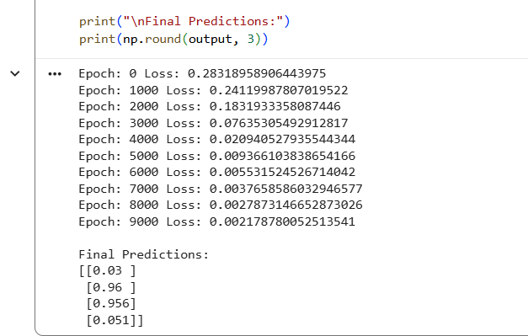
Experiment 9 – Multilayer Perceptron Implementation
code:
import numpy as np
import matplotlib.pyplot as plt
from tensorflow.keras.models import Sequential
from tensorflow.keras.layers import Dense
from tensorflow.keras.utils import to_categorical

from sklearn.datasets import load_iris
from sklearn.model_selection import train_test_split
from sklearn.preprocessing import StandardScaler

data = load_iris()

X = data.data
y = to_categorical(data.target)

scaler = StandardScaler()
X = scaler.fit_transform(X)

X_train, X_test, y_train, y_test = train_test_split(
X, y, test_size=0.2, random_state=42
)

model = Sequential([
Dense(16, activation="relu", input_shape=(4,)),
Dense(8, activation="relu"),
Dense(3, activation="softmax")
])

model.compile(
optimizer="adam",
loss="categorical_crossentropy",
metrics=["accuracy"]
)

history = model.fit(
X_train, y_train,
epochs=50,
batch_size=8,
validation_split=0.2,
verbose=1
)

loss, accuracy = model.evaluate(X_test, y_test)

print("Test Accuracy:", accuracy)

plt.plot(history.history["accuracy"], label="Training")
plt.plot(history.history["val_accuracy"], label="Validation")
plt.xlabel("Epochs")
plt.ylabel("Accuracy")
plt.legend()
plt.show()
output:
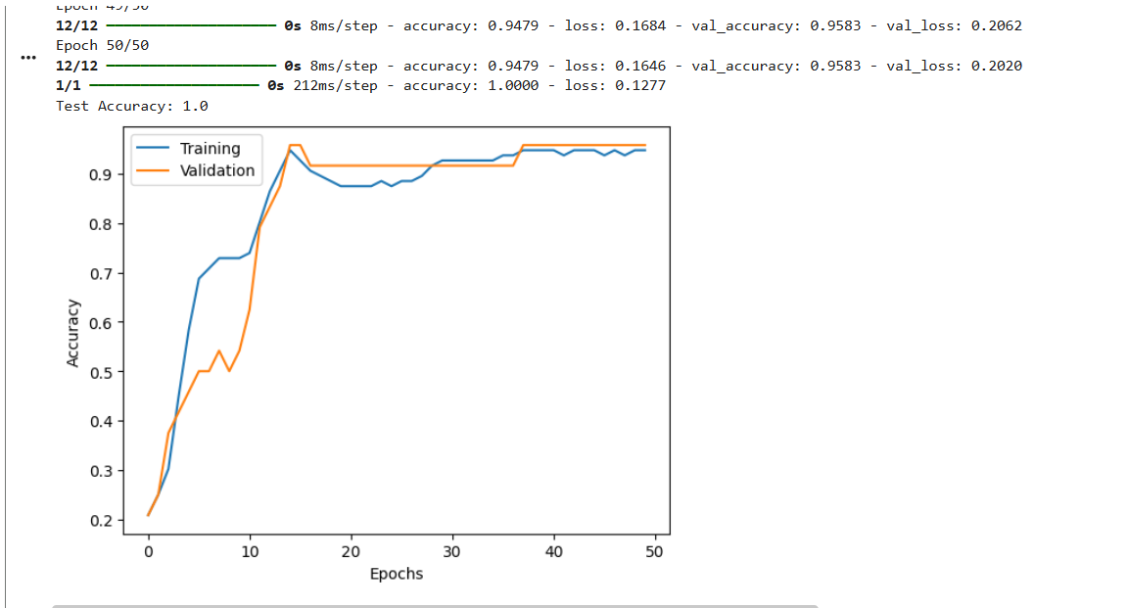
Experiment 10 – L2, Dropout and Early Stopping Comparison
Code:
import numpy as np
import matplotlib.pyplot as plt

from tensorflow.keras.models import Sequential
from tensorflow.keras.layers import Dense, Dropout
from tensorflow.keras.regularizers import l2
from tensorflow.keras.callbacks import EarlyStopping

from sklearn.datasets import make_moons
from sklearn.model_selection import train_test_split
from sklearn.preprocessing import StandardScaler

X, y = make_moons(n_samples=1000, noise=0.3, random_state=42)

scaler = StandardScaler()
X = scaler.fit_transform(X)

X_train, X_test, y_train, y_test = train_test_split(
X, y, test_size=0.2, random_state=42
)

def create_model(regularization=None):

model = Sequential()

if regularization == "L2":
model.add(Dense(64, activation="relu",
kernel_regularizer=l2(0.01),
input_shape=(2,)))
else:
model.add(Dense(64, activation="relu", input_shape=(2,)))

if regularization == "Dropout":
model.add(Dropout(0.5))

model.add(Dense(32, activation="relu"))
model.add(Dense(1, activation="sigmoid"))

model.compile(
optimizer="adam",
loss="binary_crossentropy",
metrics=["accuracy"]
)

return model

methods = ["None", "L2", "Dropout", "Early Stopping"]

for method in methods:

model = create_model(method if method != "Early Stopping" else None)

callbacks = []

if method == "Early Stopping":
callbacks = [
EarlyStopping(
monitor="val_loss",
patience=5,
restore_best_weights=True
)
]

history = model.fit(
X_train, y_train,
epochs=50,
validation_split=0.2,
callbacks=callbacks,
verbose=0
)

loss, accuracy = model.evaluate(X_test, y_test, verbose=0)

print(method, "Test Accuracy:", accuracy)

plt.plot(history.history["val_loss"], label=method)

plt.xlabel("Epochs")
plt.ylabel("Validation Loss")
plt.title("Regularization Comparison")
plt.legend()
plt.show()
output:
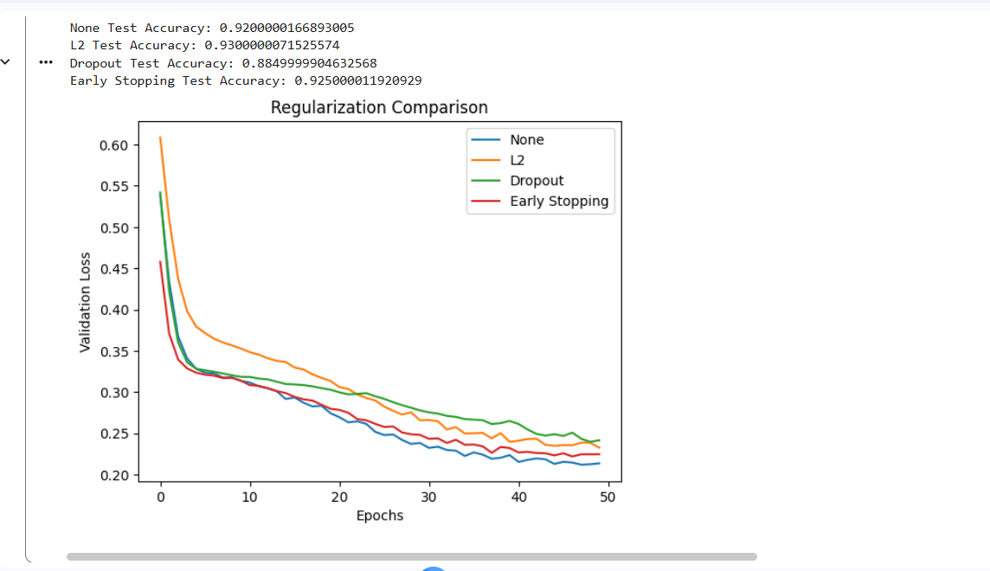
Experiment 11 – CNN for Image Classification
code:
import tensorflow as tf
import matplotlib.pyplot as plt
import numpy as np

from tensorflow.keras import Sequential
from tensorflow.keras.layers import Conv2D, MaxPooling2D, Flatten, Dense

(X_train, y_train), (X_test, y_test) = tf.keras.datasets.mnist.load_data()

X_train = X_train.reshape(-1, 28, 28, 1) / 255.0
X_test = X_test.reshape(-1, 28, 28, 1) / 255.0

model = Sequential([
Conv2D(32, (3, 3), activation="relu", input_shape=(28, 28, 1)),
MaxPooling2D((2, 2)),
Conv2D(64, (3, 3), activation="relu"),
MaxPooling2D((2, 2)),
Flatten(),
Dense(64, activation="relu"),
Dense(10, activation="softmax")
])

model.compile(
optimizer="adam",
loss="sparse_categorical_crossentropy",
metrics=["accuracy"]
)

model.fit(
X_train, y_train,
epochs=3,
batch_size=64,
validation_split=0.1
)

loss, accuracy = model.evaluate(X_test, y_test)

print("Test Accuracy:", accuracy)

plt.imshow(X_test[0].reshape(28, 28), cmap="gray")
plt.title("Predicted Digit: " + str(np.argmax(model.predict(X_test[:1], verbose=0))))
plt.show()
output:
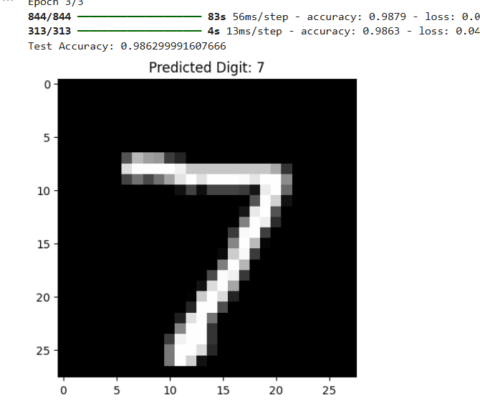

Experiment 12 – CNN Architecture and Hyperparameter Comparison
code:
import tensorflow as tf
import matplotlib.pyplot as plt

from tensorflow.keras import Sequential
from tensorflow.keras.layers import Conv2D, MaxPooling2D, Flatten, Dense

(X_train, y_train), (X_test, y_test) = tf.keras.datasets.mnist.load_data()

X_train = X_train[:10000].reshape(-1, 28, 28, 1) / 255.0
X_test = X_test.reshape(-1, 28, 28, 1) / 255.0

y_train = y_train[:10000]

filters = [16, 32, 64]
results = []

for f in filters:

model = Sequential([
Conv2D(f, (3, 3), activation="relu", input_shape=(28, 28, 1)),
MaxPooling2D((2, 2)),
Flatten(),
Dense(64, activation="relu"),
Dense(10, activation="softmax")
])

model.compile(
optimizer="adam",
loss="sparse_categorical_crossentropy",
metrics=["accuracy"]
)

model.fit(X_train, y_train, epochs=2, batch_size=64, verbose=0)

loss, accuracy = model.evaluate(X_test, y_test, verbose=0)

results.append(accuracy)

print("Filters:", f, "Accuracy:", accuracy)

plt.plot(filters, results, marker="o")
plt.xlabel("Number of Filters")
plt.ylabel("Test Accuracy")
plt.title("CNN Hyperparameter Comparison")
plt.show()
output:
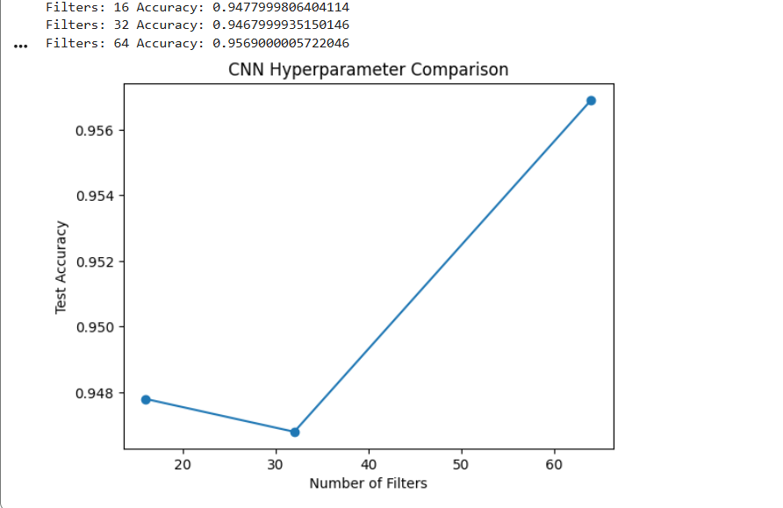
Experiment 13 – Sequential Dataset Preparation and RNN Prediction
import numpy as np
import matplotlib.pyplot as plt
import tensorflow as tf

from tensorflow.keras.models import Sequential
from tensorflow.keras.layers import SimpleRNN, Dense

data = np.sin(np.arange(0, 200) * 0.1)

X = []
y = []

for i in range(len(data) - 10):
X.append(data[i:i+10])
y.append(data[i+10])

X = np.array(X).reshape(-1, 10, 1)
y = np.array(y)

model = Sequential([
SimpleRNN(32, activation="tanh", input_shape=(10, 1)),
Dense(1)
])

model.compile(optimizer="adam", loss="mse")

model.fit(X, y, epochs=20, batch_size=16, verbose=1)

predictions = model.predict(X)

plt.plot(y, label="Actual")
plt.plot(predictions, label="Predicted")
plt.title("RNN Time Series Prediction")
plt.legend()
plt.show()
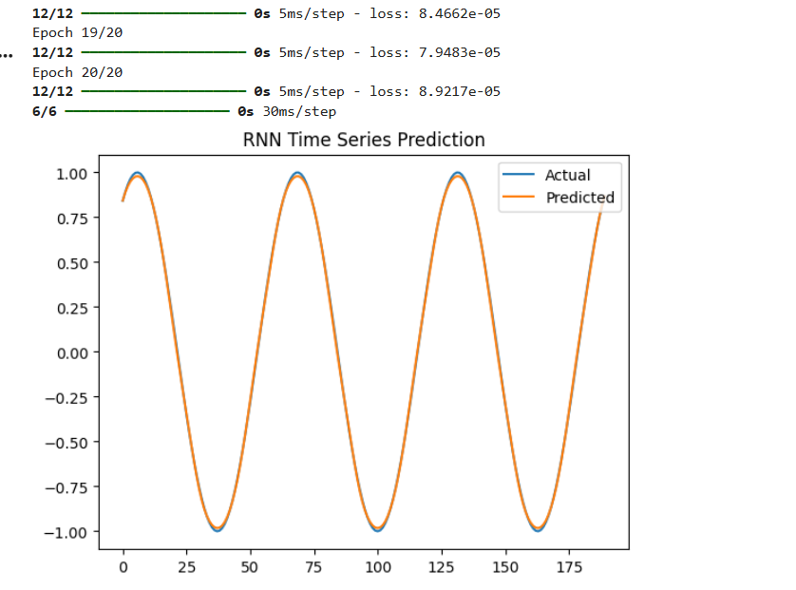

Experiment 14 – Unfolded RNN Architecture Visualization
import numpy as np
import matplotlib.pyplot as plt
import networkx as nx

G = nx.DiGraph()

timesteps = 4

for t in range(timesteps):
G.add_node(f"X{t}", layer="input")
G.add_node(f"H{t}", layer="hidden")
G.add_node(f"Y{t}", layer="output")

G.add_edge(f"X{t}", f"H{t}")
G.add_edge(f"H{t}", f"Y{t}")

if t > 0:
G.add_edge(f"H{t-1}", f"H{t}")

pos = {}

for t in range(timesteps):
pos[f"X{t}"] = (t, 0)
pos[f"H{t}"] = (t, 1)
pos[f"Y{t}"] = (t, 2)

nx.draw(
G, pos,
with_labels=True,
node_size=2000,
node_color="lightblue",
font_size=10,
arrows=True
)

plt.title("Unfolded RNN Architecture")
plt.show()
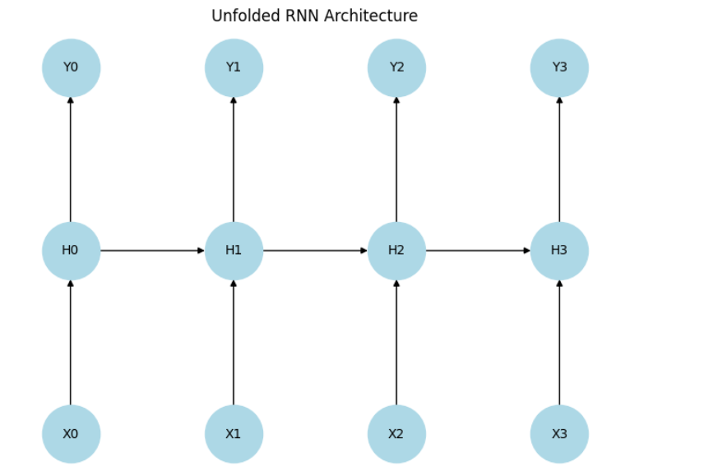
Experiment 15 – BPTT Flow and Gradient Analysis
import numpy as np
import matplotlib.pyplot as plt

np.random.seed(42)

T = 20
hidden_size = 4

W = np.random.randn(hidden_size, hidden_size) * 0.5

h = np.random.randn(hidden_size)
gradients = []

for t in range(T):

h = np.tanh(np.dot(W, h))

gradient = np.linalg.matrix_power(W, T - t)

gradients.append(np.linalg.norm(gradient))

print("BPTT Gradient Values:")

for i, value in enumerate(gradients):
print("Time Step:", i + 1, "Gradient:", value)

plt.plot(range(1, T + 1), gradients, marker="o")
plt.xlabel("Time Steps")
plt.ylabel("Gradient Magnitude")
plt.title("BPTT Gradient Analysis")
plt.show()
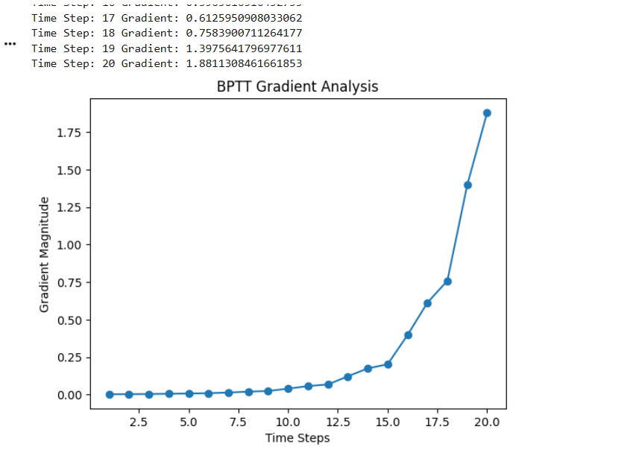
Experiment 16 – LSTM and RNN Performance Comparison
import numpy as np
import matplotlib.pyplot as plt

from tensorflow.keras.models import Sequential
from tensorflow.keras.layers import SimpleRNN, LSTM, Dense

data = np.sin(np.arange(300) * 0.1)

X = []
y = []

for i in range(len(data) - 10):
X.append(data[i:i+10])
y.append(data[i+10])

X = np.array(X).reshape(-1, 10, 1)
y = np.array(y)

models = {
"RNN": SimpleRNN(32, input_shape=(10, 1)),
"LSTM": LSTM(32, input_shape=(10, 1))
}

results = {}

for name, layer in models.items():

model = Sequential([layer, Dense(1)])

model.compile(optimizer="adam", loss="mse")

history = model.fit(X, y, epochs=10, batch_size=16, verbose=0)

results[name] = history.history["loss"]

print(name, "Final Loss:", history.history["loss"][-1])

for name, loss in results.items():
plt.plot(loss, label=name)

plt.xlabel("Epochs")
plt.ylabel("Loss")
plt.title("RNN vs LSTM")
plt.legend()
plt.show()
output:
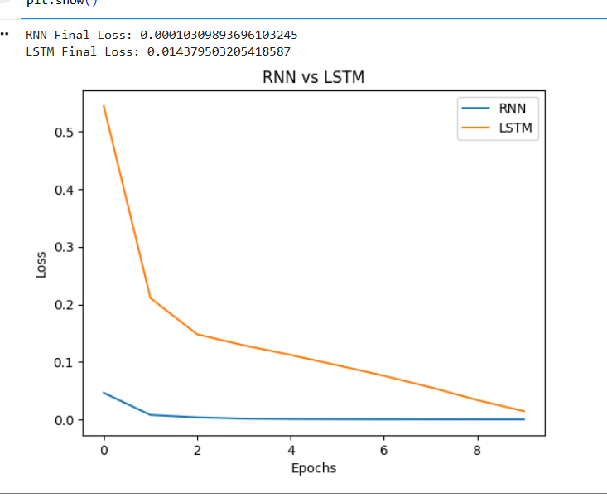
Experiment 17 – RNN Gradient Analysis and Gradient Clipping
code:
import numpy as np
import matplotlib.pyplot as plt

np.random.seed(42)

gradients = np.random.randn(20) * 10

clipped_gradients = np.clip(gradients, -1, 1)

print("Original Gradients:")
print(gradients)

print("\nClipped Gradients:")
print(clipped_gradients)

plt.plot(gradients, marker="o", label="Original Gradients")
plt.plot(clipped_gradients, marker="x", label="Clipped Gradients")

plt.axhline(1, linestyle="--")
plt.axhline(-1, linestyle="--")

plt.xlabel("Gradient Index")
plt.ylabel("Gradient Value")
plt.title("Gradient Clipping Analysis")
plt.legend()
plt.show()
output:
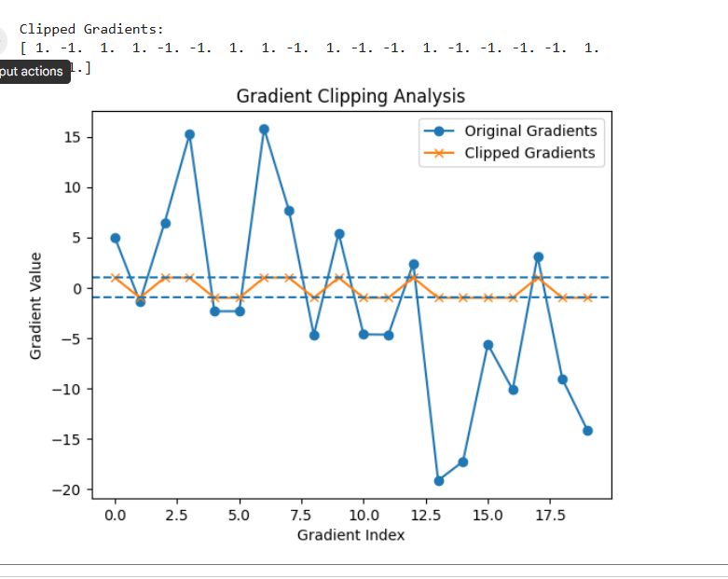
Experiment 18 – RNN, LSTM and GRU Hyperparameter Experimentation
code:
import numpy as np
import matplotlib.pyplot as plt

from tensorflow.keras.models import Sequential
from tensorflow.keras.layers import SimpleRNN, LSTM, GRU, Dense

data = np.sin(np.arange(300) * 0.1)

X = []
y = []

for i in range(len(data) - 10):
X.append(data[i:i+10])
y.append(data[i+10])

X = np.array(X).reshape(-1, 10, 1)
y = np.array(y)

layers = {
"RNN": SimpleRNN,
"LSTM": LSTM,
"GRU": GRU
}

results = {}

for name, layer in layers.items():

model = Sequential([
layer(32, input_shape=(10, 1)),
Dense(1)
])

model.compile(optimizer="adam", loss="mse")

history = model.fit(X, y, epochs=10, batch_size=16, verbose=0)

results[name] = history.history["loss"]

print(name, "Final Loss:", history.history["loss"][-1])

for name, loss in results.items():
plt.plot(loss, label=name)

plt.xlabel("Epochs")
plt.ylabel("Loss")
plt.title("RNN, LSTM and GRU Comparison")
plt.legend()
plt.show()
output:
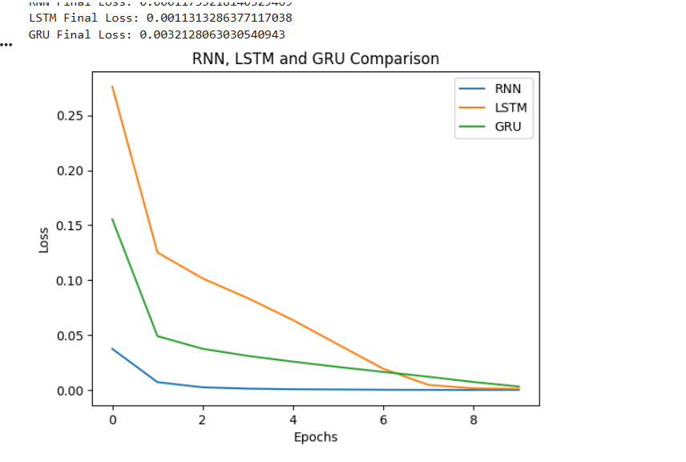
Experiment 19 – PCA and Explained Variance Analysis
import numpy as np
import matplotlib.pyplot as plt

from sklearn.datasets import load_iris
from sklearn.preprocessing import StandardScaler
from sklearn.decomposition import PCA

data = load_iris()

X = data.data

X = StandardScaler().fit_transform(X)

pca = PCA(n_components=2)

X_pca = pca.fit_transform(X)

print("Principal Components:")
print(X_pca[:5])

print("\nExplained Variance Ratio:")
print(pca.explained_variance_ratio_)

print("\nTotal Explained Variance:")
print(sum(pca.explained_variance_ratio_))

plt.scatter(X_pca[:, 0], X_pca[:, 1], c=data.target)
plt.xlabel("Principal Component 1")
plt.ylabel("Principal Component 2")
plt.title("PCA Visualization")
plt.show()
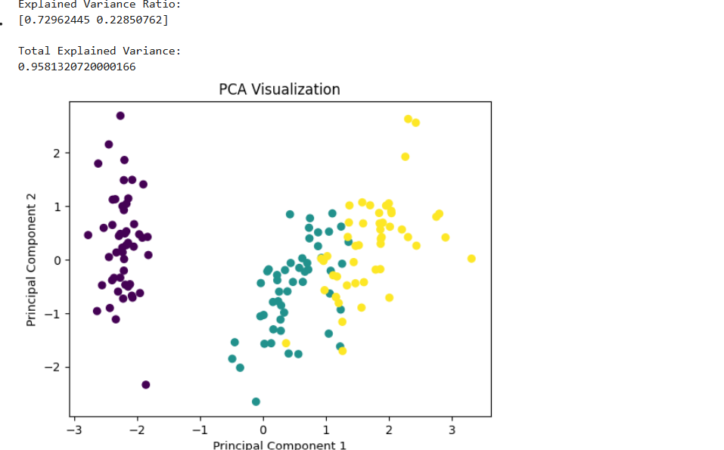
Experiment 20 – Probabilistic PCA and Reconstruction Analysis
import numpy as np
import matplotlib.pyplot as plt

from sklearn.datasets import load_iris
from sklearn.preprocessing import StandardScaler
from sklearn.decomposition import PCA

data = load_iris()

X = StandardScaler().fit_transform(data.data)

pca = PCA(n_components=2)

X_transformed = pca.fit_transform(X)

X_reconstructed = pca.inverse_transform(X_transformed)

error = np.mean((X - X_reconstructed) ** 2)

print("Original Data:")
print(X[:5])

print("\nReconstructed Data:")
print(X_reconstructed[:5])

print("\nReconstruction Error:", error)

plt.scatter(X[:, 0], X[:, 1], label="Original")
plt.scatter(X_reconstructed[:, 0], X_reconstructed[:, 1], label="Reconstructed")
plt.xlabel("Feature 1")
plt.ylabel("Feature 2")
plt.title("PCA Reconstruction")
plt.legend()
plt.show()
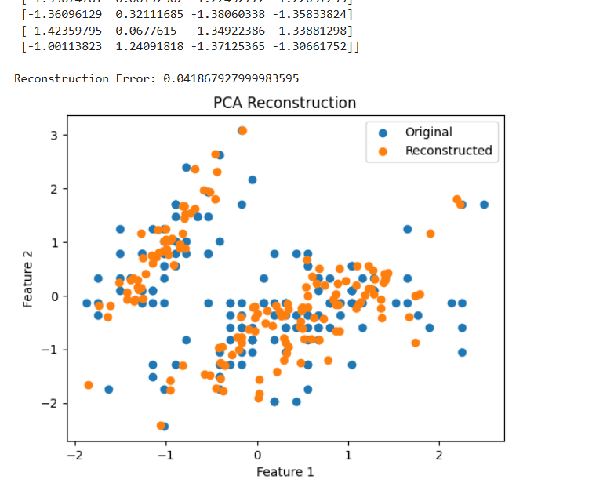
Experiment 21 – Factor Analysis and Latent Factor Interpretation
import numpy as np
import pandas as pd
import matplotlib.pyplot as plt

from sklearn.datasets import load_iris
from sklearn.preprocessing import StandardScaler
from sklearn.decomposition import FactorAnalysis

data = load_iris()

X = StandardScaler().fit_transform(data.data)

fa = FactorAnalysis(n_components=2, random_state=42)

X_factors = fa.fit_transform(X)

print("Factor Scores:")
print(X_factors[:5])

print("\nFactor Loadings:")
print(fa.components_)

plt.scatter(X_factors[:, 0], X_factors[:, 1], c=data.target)
plt.xlabel("Factor 1")
plt.ylabel("Factor 2")
plt.title("Factor Analysis")
plt.show()
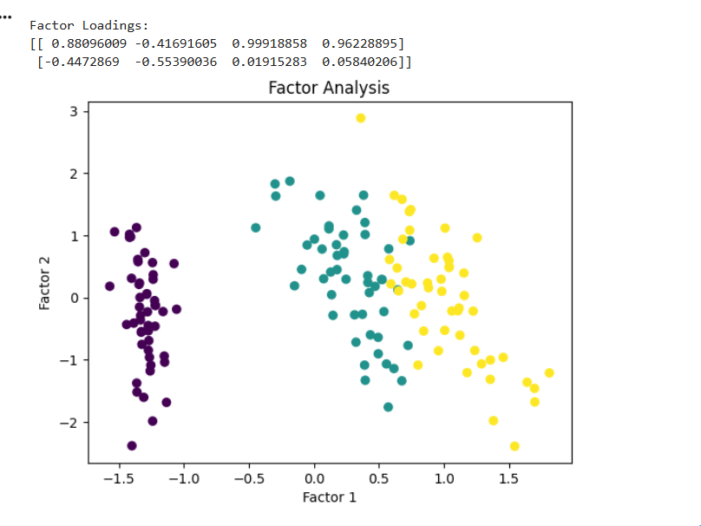

Experiment 22 – Independent Component Analysis and Component Visualization
import numpy as np
import matplotlib.pyplot as plt

from sklearn.decomposition import FastICA

np.random.seed(42)

time = np.linspace(0, 8, 1000)

S1 = np.sin(2 * time)
S2 = np.sign(np.sin(3 * time))

S = np.c_[S1, S2]

A = np.array([[1, 0.5], [0.5, 1]])

X = np.dot(S, A.T)

ica = FastICA(n_components=2, random_state=42)

S_recovered = ica.fit_transform(X)

plt.figure(figsize=(10, 6))

plt.subplot(3, 1, 1)
plt.plot(S1)
plt.title("Original Signal 1")

plt.subplot(3, 1, 2)
plt.plot(S2)
plt.title("Original Signal 2")

plt.subplot(3, 1, 3)
plt.plot(S_recovered)
plt.title("Recovered Independent Components")

plt.tight_layout()
plt.show()
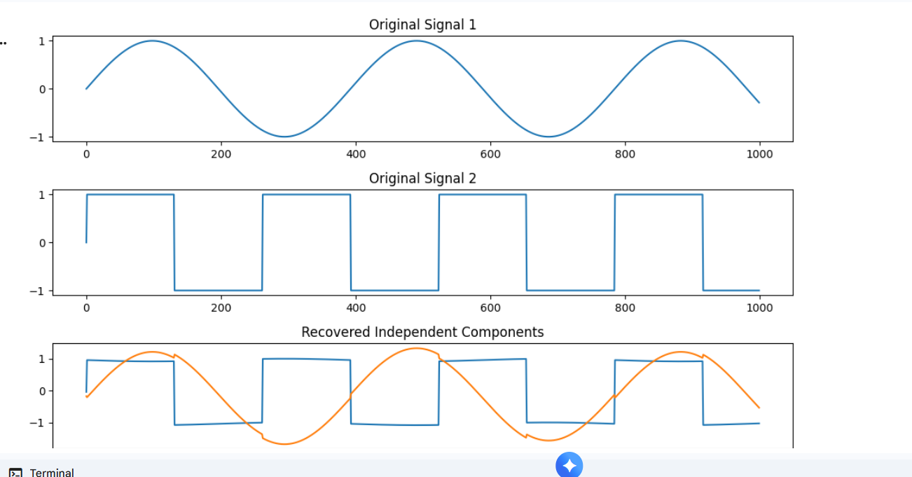

Experiment 23 – Bayesian Network Construction and Visualization
import matplotlib.pyplot as plt
import networkx as nx

G = nx.DiGraph()

edges = [
("Cloudy", "Rain"),
("Cloudy", "Sprinkler"),
("Rain", "Wet Grass"),
("Sprinkler", "Wet Grass")
]

G.add_edges_from(edges)

pos = {
"Cloudy": (0, 2),
"Rain": (-1, 1),
"Sprinkler": (1, 1),
"Wet Grass": (0, 0)
}

nx.draw(
G, pos,
with_labels=True,
node_size=3000,
node_color="lightgreen",
arrows=True,
font_size=10
)

plt.title("Bayesian Network")
plt.show()

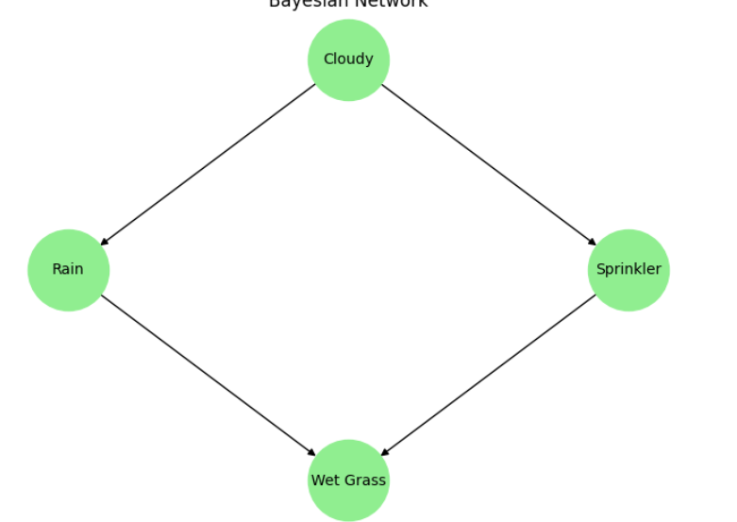

Experiment 24 – Graphical Model Sampling and Probabilistic Inference

import numpy as np
import pandas as pd
import matplotlib.pyplot as plt

np.random.seed(42)

N = 10000

cloudy = np.random.binomial(1, 0.5, N)

sprinkler = np.zeros(N)
rain = np.zeros(N)

for i in range(N):

sprinkler[i] = np.random.binomial(
1, 0.1 if cloudy[i] else 0.5
)

rain[i] = np.random.binomial(
1, 0.8 if cloudy[i] else 0.2
)

wet_grass = np.zeros(N)

for i in range(N):
probability = 0.99 if rain[i] or sprinkler[i] else 0.01
wet_grass[i] = np.random.binomial(1, probability)

df = pd.DataFrame({
"Cloudy": cloudy,
"Sprinkler": sprinkler,
"Rain": rain,
"Wet Grass": wet_grass
})

print(df.head())

print("\nProbability of Wet Grass:")
print(df["Wet Grass"].mean())

print("\nProbability of Rain given Wet Grass:")
print(df[df["Wet Grass"] == 1]["Rain"].mean())

df.mean().plot(kind="bar")
plt.title("Probabilistic Inference")
plt.ylabel("Probability")
plt.show()

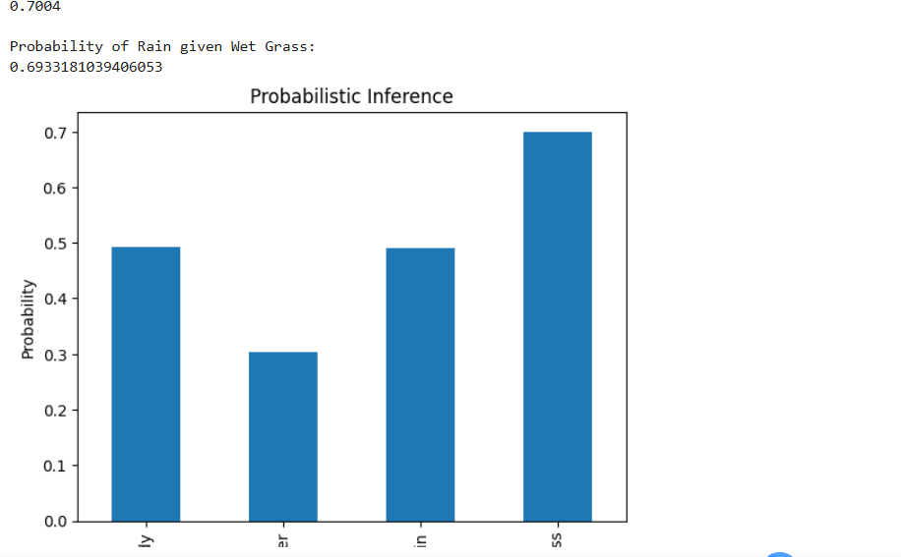
Experiment 25 – Restricted Boltzmann Machine Energy and Reconstruction

import numpy as np
import matplotlib.pyplot as plt

np.random.seed(42)

visible = np.array([1, 0, 1, 0])

W = np.random.randn(4, 3)
visible_bias = np.zeros(4)
hidden_bias = np.zeros(3)

def sigmoid(x):
return 1 / (1 + np.exp(-x))

hidden_probability = sigmoid(np.dot(visible, W) + hidden_bias)

hidden = (hidden_probability > 0.5).astype(int)

visible_probability = sigmoid(np.dot(hidden, W.T) + visible_bias)

reconstructed = (visible_probability > 0.5).astype(int)

energy = -np.dot(visible, visible_bias) - np.dot(hidden, hidden_bias) - np.dot(visible, np.dot(W, hidden))

print("Original Visible Data:", visible)
print("Hidden Layer:", hidden)
print("Reconstructed Data:", reconstructed)
print("Energy:", energy)

plt.plot(visible, marker="o", label="Original")
plt.plot(reconstructed, marker="x", label="Reconstructed")

plt.title("RBM Reconstruction")
plt.legend()
plt.show()
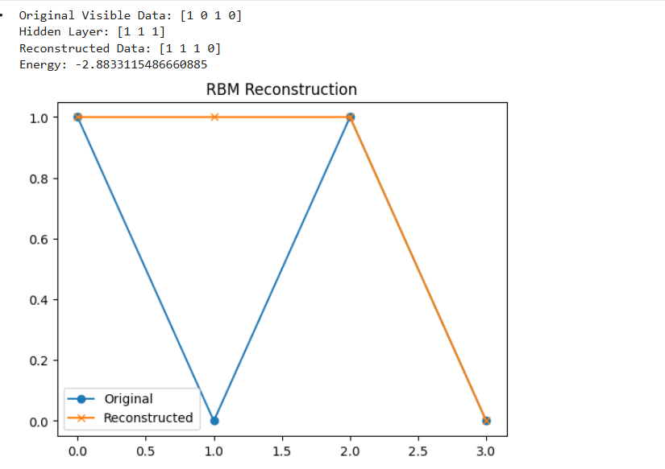
Experiment 26 – Gibbs Sampling and Contrastive Divergence Analysis
import numpy as np
import matplotlib.pyplot as plt

np.random.seed(42)

W = np.random.randn(4, 3) * 0.1

vb = np.zeros(4)
hb = np.zeros(3)

def sigmoid(x):
return 1 / (1 + np.exp(-x))

visible = np.array([[1, 0, 1, 0]])

losses = []

for epoch in range(100):

# Positive phase
ph = sigmoid(np.dot(visible, W) + hb)
h = (ph > np.random.rand(*ph.shape)).astype(int)

# Negative phase
pv = sigmoid(np.dot(h, W.T) + vb)
v_negative = (pv > np.random.rand(*pv.shape)).astype(int)

ph_negative = sigmoid(np.dot(v_negative, W) + hb)

# Contrastive Divergence update
W += 0.1 * (
np.dot(visible.T, ph) -
np.dot(v_negative.T, ph_negative)
)

vb += 0.1 * np.mean(visible - v_negative, axis=0)
hb += 0.1 * np.mean(ph - ph_negative, axis=0)

loss = np.mean((visible - v_negative) ** 2)
losses.append(loss)

print("Final Reconstruction Loss:", losses[-1])

plt.plot(losses)
plt.xlabel("Epochs")
plt.ylabel("Reconstruction Error")
plt.title("Gibbs Sampling and Contrastive Divergence")
plt.show()
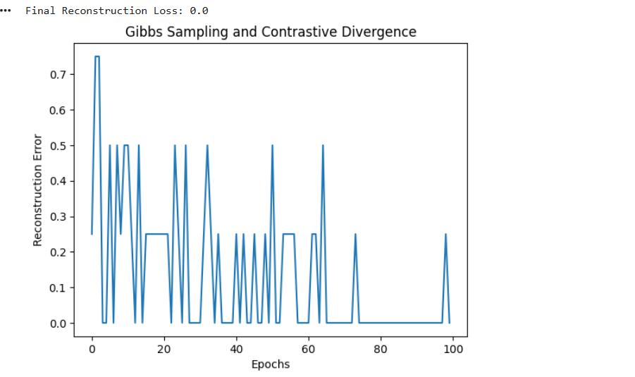

Experiment 27 – Deep Belief Network Representation Learning
import numpy as np
import matplotlib.pyplot as plt

from sklearn.datasets import load_digits
from sklearn.preprocessing import MinMaxScaler
from sklearn.neural_network import BernoulliRBM

data = load_digits()

X = MinMaxScaler().fit_transform(data.data)

rbm1 = BernoulliRBM(
n_components=64,
learning_rate=0.05,
n_iter=20,
random_state=42
)

rbm2 = BernoulliRBM(
n_components=32,
learning_rate=0.05,
n_iter=20,
random_state=42
)

hidden1 = rbm1.fit_transform(X)

hidden2 = rbm2.fit_transform(hidden1)

print("Original Data Shape:", X.shape)
print("First Hidden Layer:", hidden1.shape)
print("Second Hidden Layer:", hidden2.shape)

plt.imshow(hidden2[0].reshape(4, 8), cmap="viridis")
plt.title("DBN Learned Representation")
plt.colorbar()
plt.show()
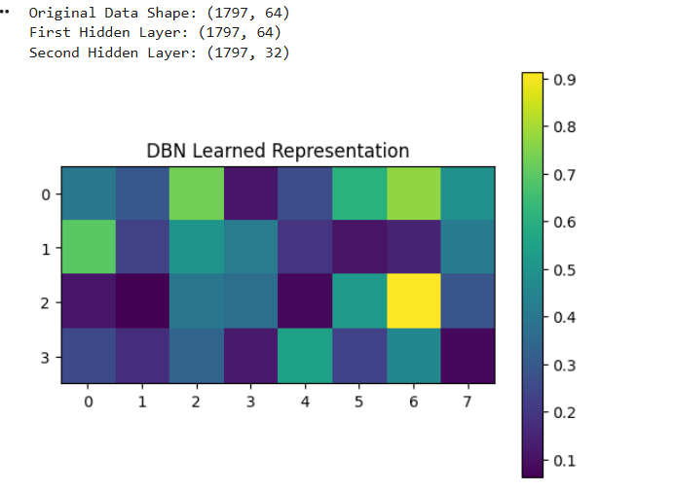
Experiment 28 – Deep Boltzmann Machine / Convolutional Boltzmann Machine Simulation
import numpy as np
import matplotlib.pyplot as plt

np.random.seed(42)

visible = np.random.randint(0, 2, (8, 8))

W1 = np.random.randn(64, 32) * 0.1
W2 = np.random.randn(32, 16) * 0.1

def sigmoid(x):
return 1 / (1 + np.exp(-x))

v = visible.flatten()

# First hidden layer
h1 = sigmoid(np.dot(v, W1))

# Second hidden layer
h2 = sigmoid(np.dot(h1, W2))

# Reconstruction
h1_reconstructed = sigmoid(np.dot(h2, W2.T))

v_reconstructed = sigmoid(np.dot(h1_reconstructed, W1.T))

reconstructed = (v_reconstructed > 0.5).astype(int).reshape(8, 8)

print("Original Visible Layer:")
print(visible)

print("\nReconstructed Visible Layer:")
print(reconstructed)

plt.figure(figsize=(8, 4))

plt.subplot(1, 2, 1)
plt.imshow(visible, cmap="gray")
plt.title("Original Image")

plt.subplot(1, 2, 2)
plt.imshow(reconstructed, cmap="gray")
plt.title("Reconstructed Image")

plt.show()
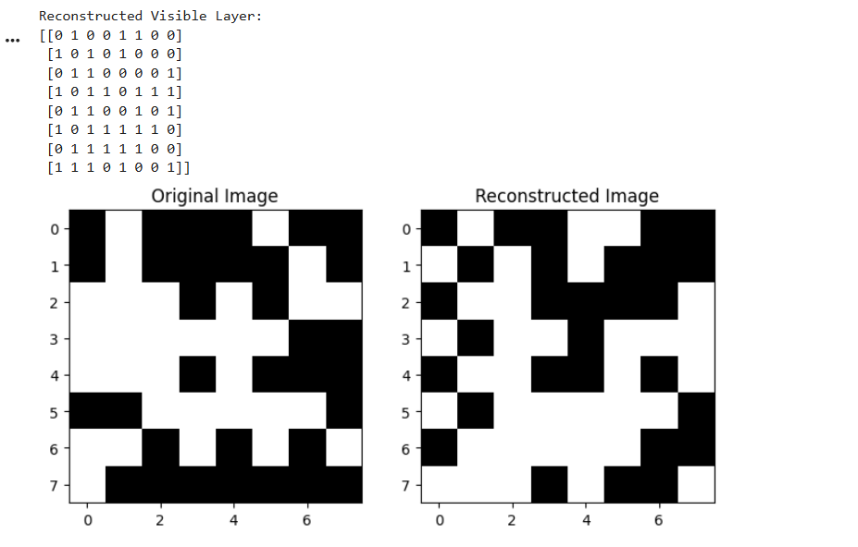
Experiment 29 – VAE/GAN Sample Generation
Code:
import numpy as np
import matplotlib.pyplot as plt

from tensorflow.keras.layers import Input, Dense, Lambda
from tensorflow.keras.models import Model
from tensorflow.keras import backend as K

# Generate sample data
X = np.random.rand(1000, 20).astype("float32")

latent_dim = 2

# Encoder
inputs = Input(shape=(20,))

hidden = Dense(16, activation="relu")(inputs)

z_mean = Dense(latent_dim)(hidden)
z_log_var = Dense(latent_dim)(hidden)

def sampling(args):
mean, log_var = args
epsilon = K.random_normal(shape=K.shape(mean))
return mean + K.exp(0.5 * log_var) * epsilon

z = Lambda(sampling)([z_mean, z_log_var])

encoder = Model(inputs, [z_mean, z_log_var, z])

# Decoder
decoder_input = Input(shape=(latent_dim,))

d = Dense(16, activation="relu")(decoder_input)
outputs = Dense(20, activation="sigmoid")(d)

decoder = Model(decoder_input, outputs)

# VAE
reconstructed = decoder(encoder(inputs)[2])

vae = Model(inputs, reconstructed)

reconstruction_loss = K.sum(
K.square(inputs - reconstructed), axis=1
)

kl_loss = -0.5 * K.sum(
1 + z_log_var - K.square(z_mean) - K.exp(z_log_var),
axis=1
)

vae.add_loss(K.mean(reconstruction_loss + kl_loss))

vae.compile(optimizer="adam")

vae.fit(X, epochs=20, batch_size=32, verbose=1)

# Generate samples
random_samples = np.random.normal(size=(10, latent_dim))

generated = decoder.predict(random_samples)

print("Generated Samples:")
print(generated[:5])

plt.imshow(generated, cmap="viridis", aspect="auto")
plt.title("VAE Generated Samples")
plt.xlabel("Features")
plt.ylabel("Samples")
plt.colorbar()
plt.show()
output:
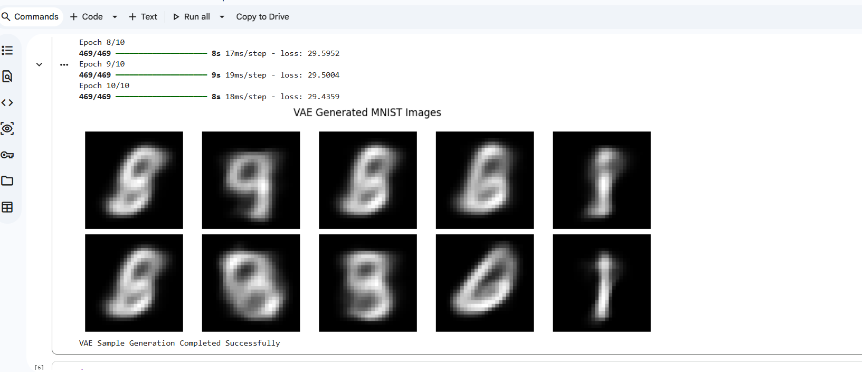
Experiment 30 – Generative Model Output Comparison and Evaluation
code:
import numpy as np
import matplotlib.pyplot as plt
import tensorflow as tf

from tensorflow.keras.layers import Input, Dense, Lambda
from tensorflow.keras.models import Model
from tensorflow.keras.datasets import mnist

# Load MNIST dataset
(X_train, _), (X_test, _) = mnist.load_data()

# Preprocessing
X_train = X_train.astype("float32") / 255.0
X_test = X_test.astype("float32") / 255.0

X_train = X_train.reshape(-1, 784)
X_test = X_test.reshape(-1, 784)

# Latent dimension
latent_dim = 2

# Encoder
inputs = Input(shape=(784,))

h = Dense(256, activation="relu")(inputs)

z_mean = Dense(latent_dim)(h)
z_log_var = Dense(latent_dim)(h)

# Sampling function
def sampling(args):
mean, log_var = args
epsilon = tf.random.normal(shape=tf.shape(mean))
return mean + tf.exp(0.5 * log_var) * epsilon

z = Lambda(sampling)([z_mean, z_log_var])

encoder = Model(inputs, [z_mean, z_log_var, z])

# Decoder
decoder_input = Input(shape=(latent_dim,))

decoder_h = Dense(256, activation="relu")(decoder_input)

decoder_output = Dense(784, activation="sigmoid")(decoder_h)

decoder = Model(decoder_input, decoder_output)

# VAE model with custom training
class VAE(Model):

def __init__(self, encoder, decoder):
super().__init__()
self.encoder = encoder
self.decoder = decoder
self.loss_tracker = tf.keras.metrics.Mean(name="loss")

@property
def metrics(self):
return [self.loss_tracker]

def train_step(self, data):

if isinstance(data, tuple):
data = data[0]

with tf.GradientTape() as tape:

mean, log_var, z = self.encoder(data)
reconstruction = self.decoder(z)

reconstruction_loss = tf.reduce_sum(
tf.keras.losses.binary_crossentropy(
data, reconstruction
),
axis=-1
)

kl_loss = -0.5 * tf.reduce_sum(
1 + log_var - tf.square(mean) - tf.exp(log_var),
axis=-1
)

total_loss = tf.reduce_mean(
reconstruction_loss + kl_loss
)

gradients = tape.gradient(
total_loss, self.trainable_weights
)

self.optimizer.apply_gradients(
zip(gradients, self.trainable_weights)
)

self.loss_tracker.update_state(total_loss)

return {"loss": self.loss_tracker.result()}

# Create and compile VAE
vae = VAE(encoder, decoder)
vae.compile(optimizer="adam")

# Train model
vae.fit(
X_train,
epochs=10,
batch_size=128,
verbose=1
)

# Generate new samples
random_samples = np.random.normal(
size=(10, latent_dim)
).astype("float32")

generated_images = decoder.predict(
random_samples, verbose=0
)

# Display generated images
plt.figure(figsize=(10, 4))

for i in range(10):
plt.subplot(2, 5, i + 1)

plt.imshow(
generated_images[i].reshape(28, 28),
cmap="gray"
)

plt.axis("off")

plt.suptitle("VAE Generated MNIST Images")
plt.tight_layout()
plt.show()

print("VAE Sample Generation Completed Successfully")
output:
