Heart Disease Risk Prediction
End-to-End MLOps: model development, CI/CD, containerisation, deployment and monitoring
Course | Machine Learning Operations (MLOps) AIMLCZG523, Assignment 01
Name | Gayathri Palani
Roll no / email | 2025AE05661 / 2025ae05661@wilp.bits-pilani.ac.in
Code repository | https://github.com/gayathripalani/heart-disease-mlops-assignment
API (local test) | Swagger at http://localhost:8001/docs; on Kubernetes at http://localhost:8080 (port-forward). See sections 7 to 10.
Date | 20 October 2026

1. Setup and installation
The project needs Python 3.12. One script creates a virtual environment, installs the pinned requirements, downloads the data, runs the EDA, lint and unit tests, and trains the models. Nothing is installed by hand.
git clone https://github.com/gayathripalani/heart-disease-mlops-assignment.git
cd heart-disease-mlops
bash scripts/run_all.sh # Windows: powershell -File scripts/run_all.ps1

source .venv/bin/activate && export PYTHONPATH=src
python -m mlflow ui --backend-store-uri sqlite:///mlflow.db # http://127.0.0.1:5000
python -m uvicorn api.app:create_app --factory --port 8000 # http://localhost:8000/docs

The MLflow UI is started with python -m mlflow so that the version installed in the virtual environment (3.17.1) is used. A different global MLflow cannot read the tracking database.

2. Data acquisition and EDA
The data is the UCI Heart Disease dataset (Cleveland subset). scripts/download_data.py downloads the archive, and writes the cleaned file data/processed/heart_clean.csv. The cleaned file is also committed to the repository. The dataset has 303 patients, 13 features and a binary target (num > 0 means heart disease).

Cleaning
- Missing values appear only in ca (4 rows) and thal (2 rows). They are imputed inside the model pipeline: median for numeric columns and most frequent value for categorical columns.
- Categorical features (sex, cp, fbs, restecg, exang, slope, ca, thal) are one-hot encoded, and unknown categories are ignored at prediction time.
- The target is binarised: 0 for no disease and 1 for disease.

Visualisations
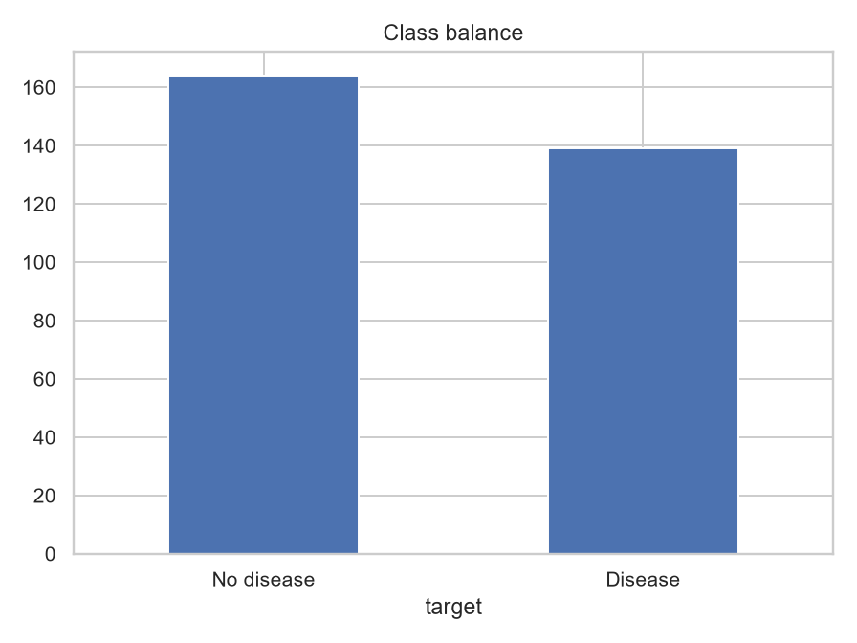
Figure 1: Class balance. 54.1% of patients have no disease and 45.9% have disease, so the classes are close to balanced.
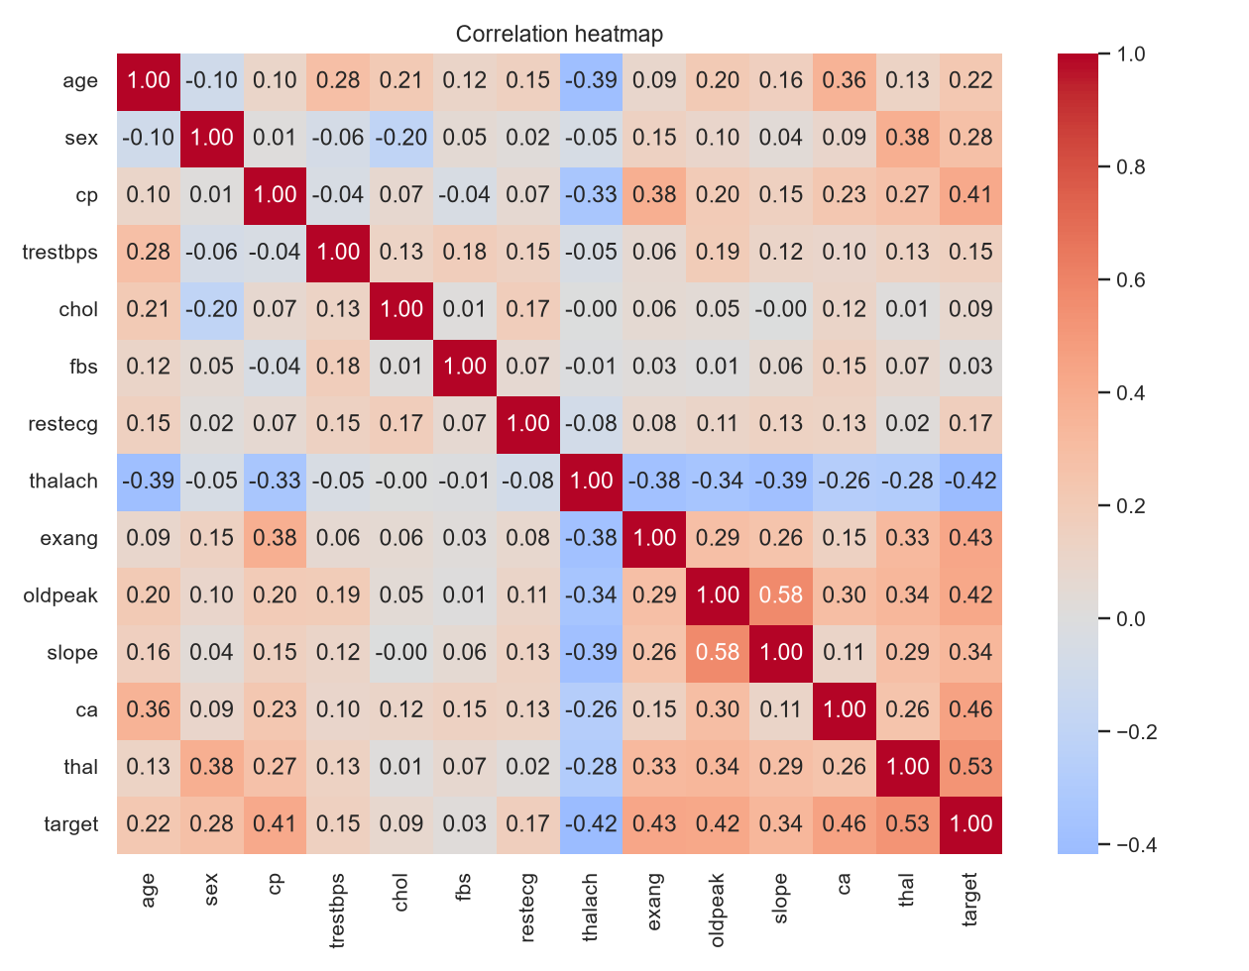
Figure 2: Correlation heatmap of the features and the target.
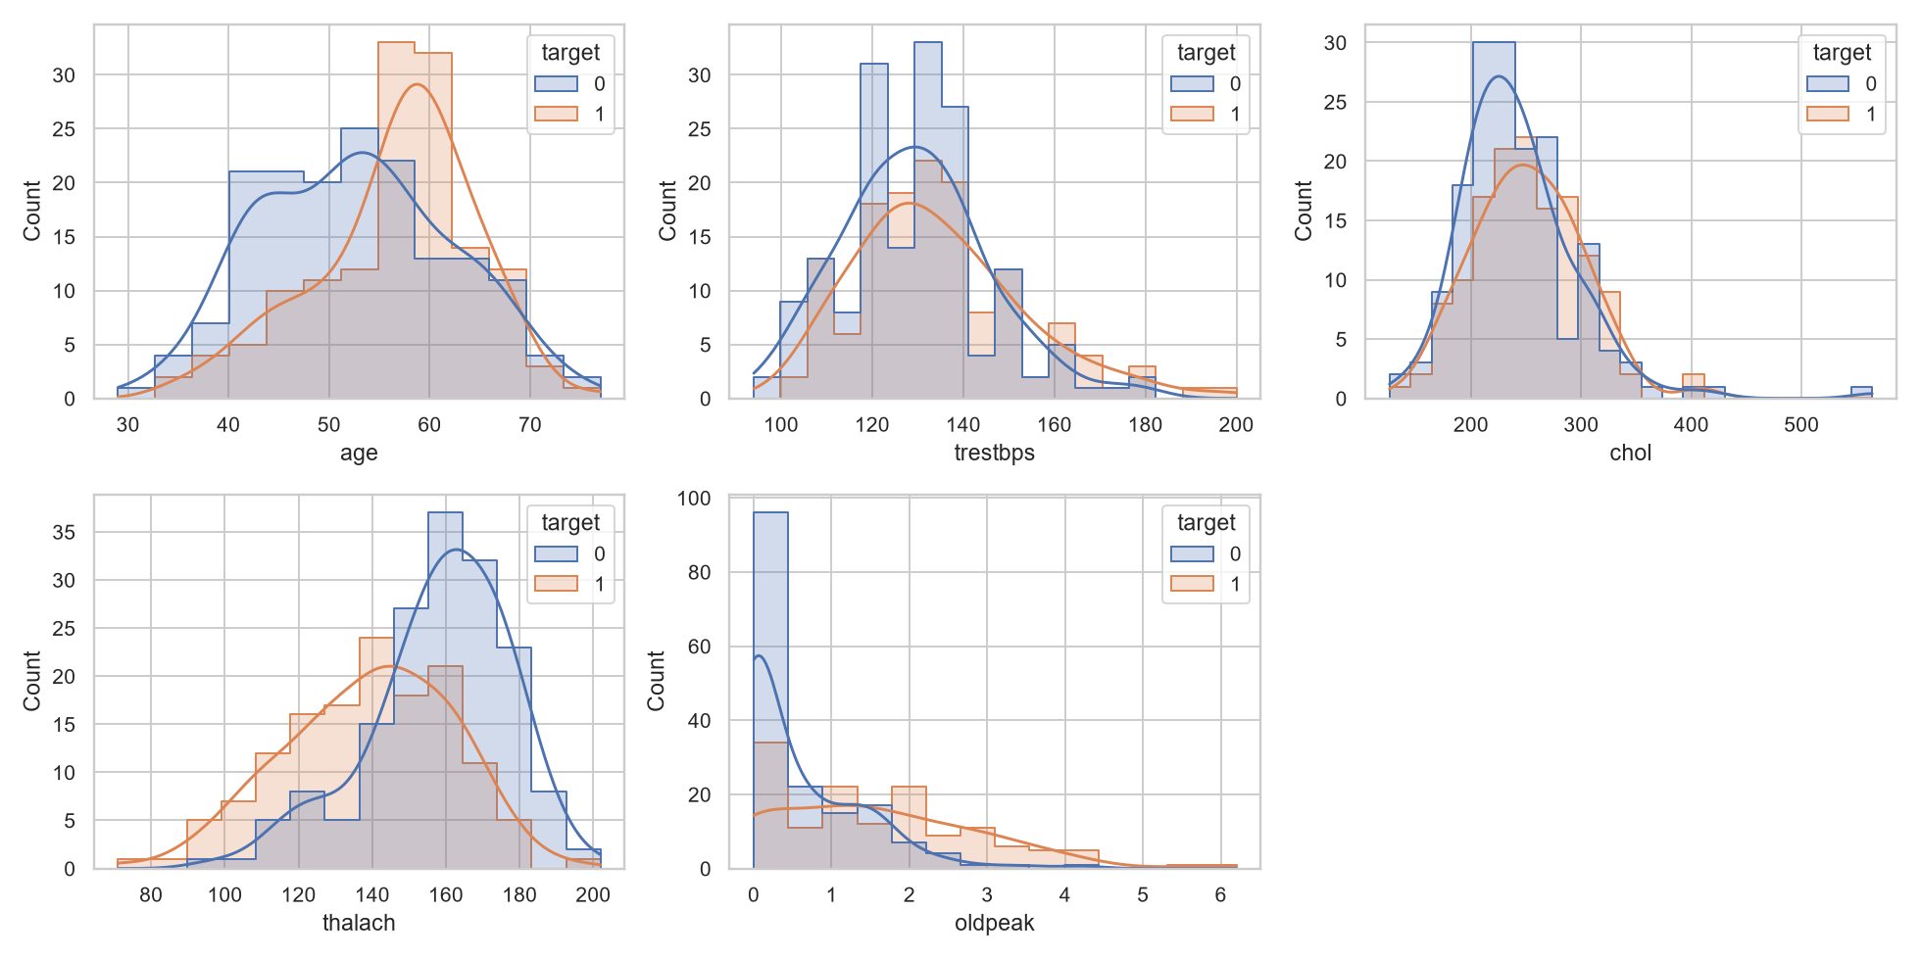
Figure 3: Histograms of the numeric features.
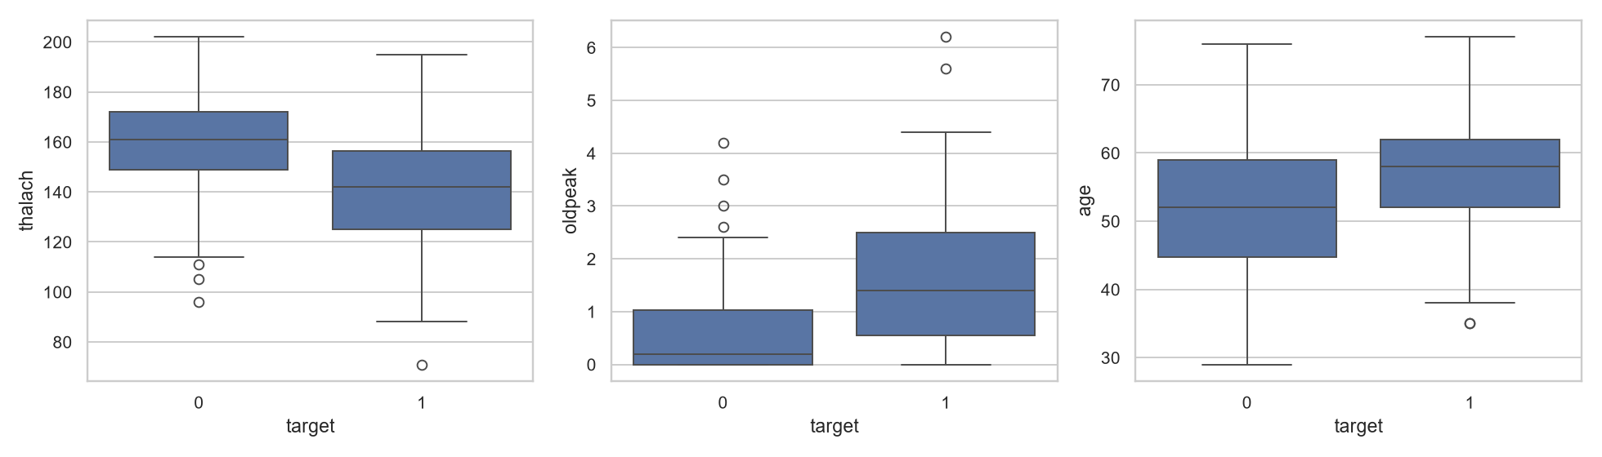
Figure 4: Boxplots of the numeric features, split by target.

Observations
- The features most correlated with the target are thal (0.53), ca (0.46), exang (0.43), oldpeak (0.42), thalach (-0.42) and cp (0.41).
- Patients with disease have a lower maximum heart rate (mean 139 against 158 bpm) and a higher ST depression, oldpeak (mean 1.6 against 0.6). They are also slightly older (56.6 against 52.6 years).
- Cholesterol (251 against 243 mg/dl) and resting blood pressure (135 against 129 mm Hg) differ only a little between the groups, so they are weak separators on their own.
- Because the classes are nearly balanced, accuracy is meaningful, but recall is still tracked because a missed case is the costlier error in screening.

3. Feature engineering and model development
Everything runs in one scikit-learn Pipeline, so the same transformations apply at training time and at prediction time.
- Numeric features: median imputation, then standard scaling.
- Categorical features: most-frequent imputation, then one-hot encoding.
- Engineered features: hr_reserve = (220 - age) - thalach, which is the gap between the age-predicted and the achieved maximum heart rate, and chol_age_ratio = chol / age.
Three classifiers were tuned with GridSearchCV (5-fold stratified, scored on ROC-AUC) and then re-scored with 5-fold cross-validation. Metrics are the mean over the folds.
Model | Best parameters | Accuracy | Precision | Recall | ROC-AUC
Logistic Regression | C = 0.1 | 0.868 | 0.896 | 0.805 | 0.919
Random Forest | n_estimators = 100, max_depth = 5 | 0.848 | 0.873 | 0.784 | 0.918
Gradient Boosting | n_estimators = 100, learning_rate = 0.05 | 0.805 | 0.819 | 0.748 | 0.888
Table 1: Cross-validated results (values taken from the MLflow runs in Figure 5).

Model selection
Logistic Regression was selected. It has the best accuracy, precision, recall and ROC-AUC of the three, it is the simplest model, and it gives usable probabilities, which the API returns as the confidence. On a dataset of only 303 rows a simple, regularised model is also the safer choice against overfitting. Its fold-to-fold spread is small (ROC-AUC standard deviation 0.019, accuracy 0.045). The tuning folds and the scoring folds share data, so the scores are slightly optimistic.

4. Experiment tracking with MLflow
Each model is one MLflow run in the experiment heart-disease. A run logs the parameters (model, cv and the tuned hyperparameters), the mean and standard deviation of every metric, an out-of-fold ROC curve, a confusion matrix, and the fitted pipeline. The backend is SQLite (mlflow.db).
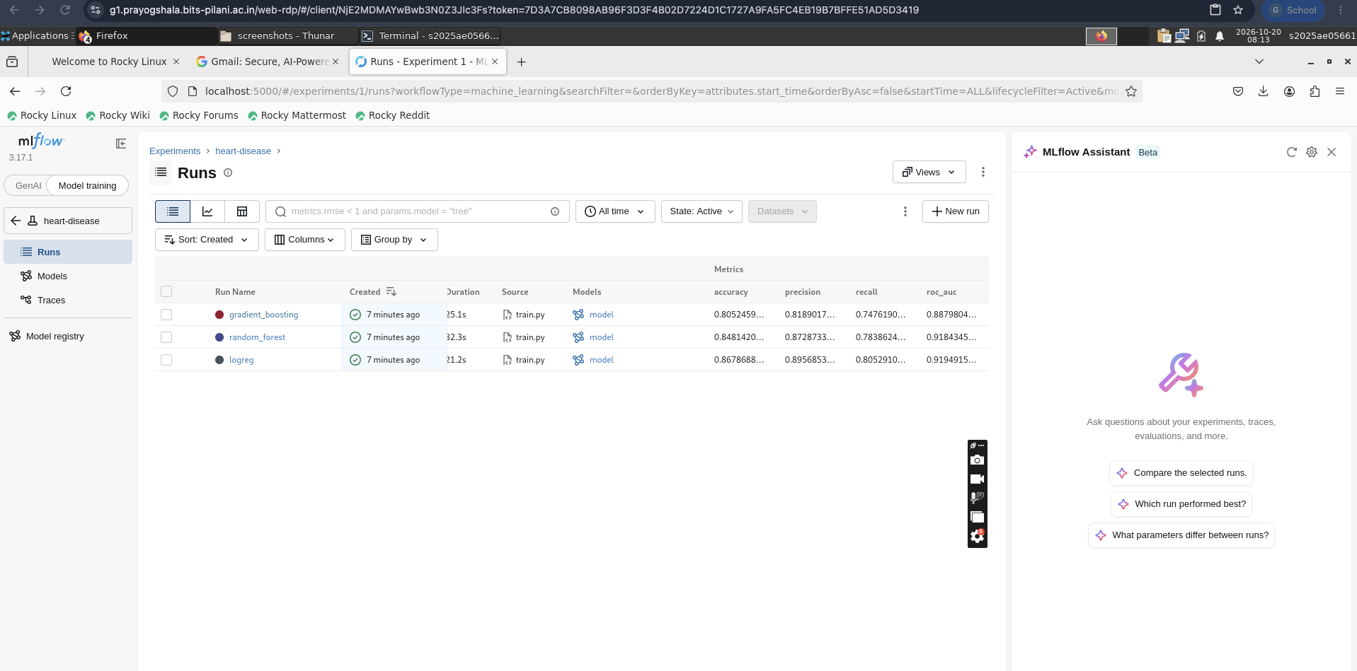
Figure 5: The three runs with accuracy, precision, recall and ROC-AUC.
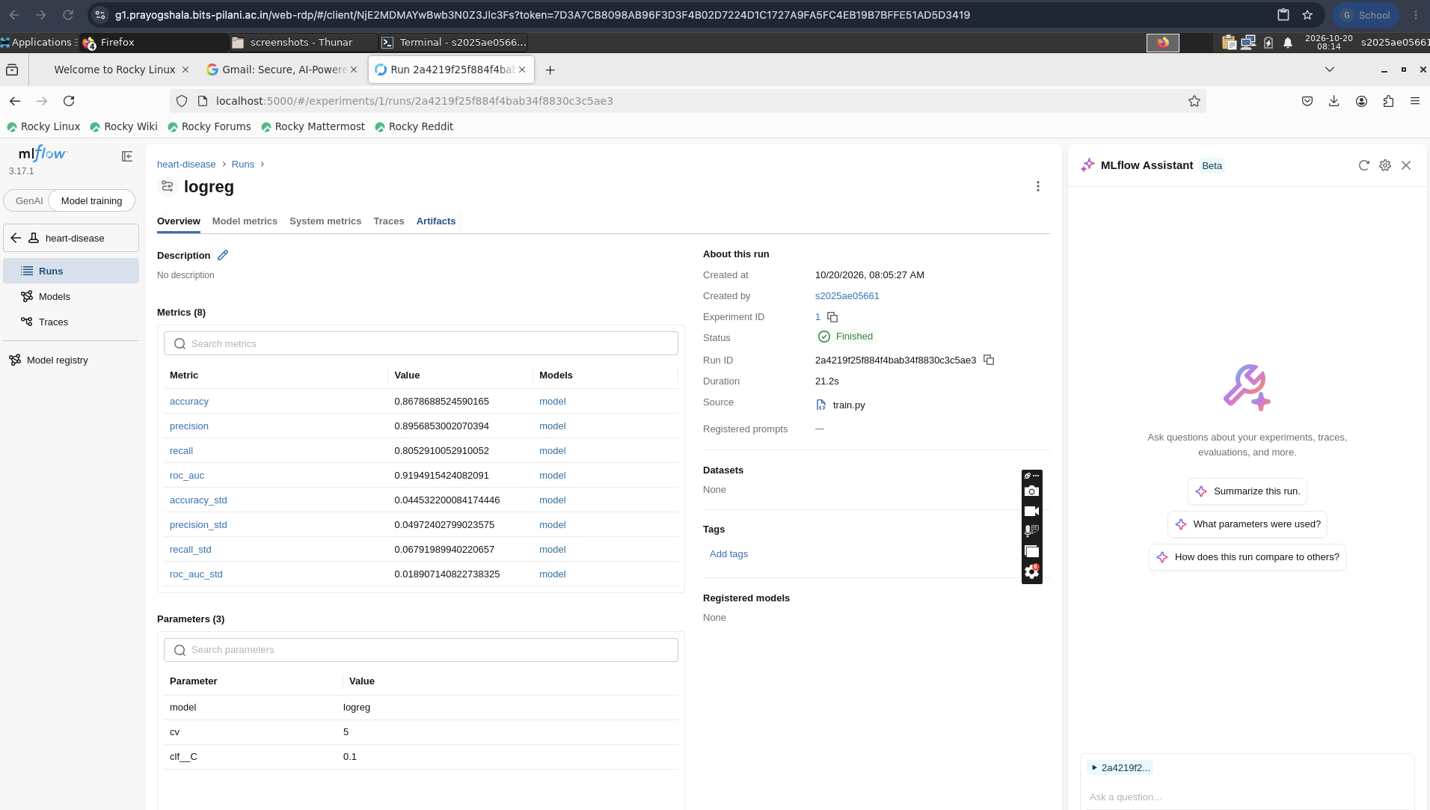
Figure 6: The logreg run: 8 metrics (mean and standard deviation) and its parameters (model, cv = 5, clf__C = 0.1).
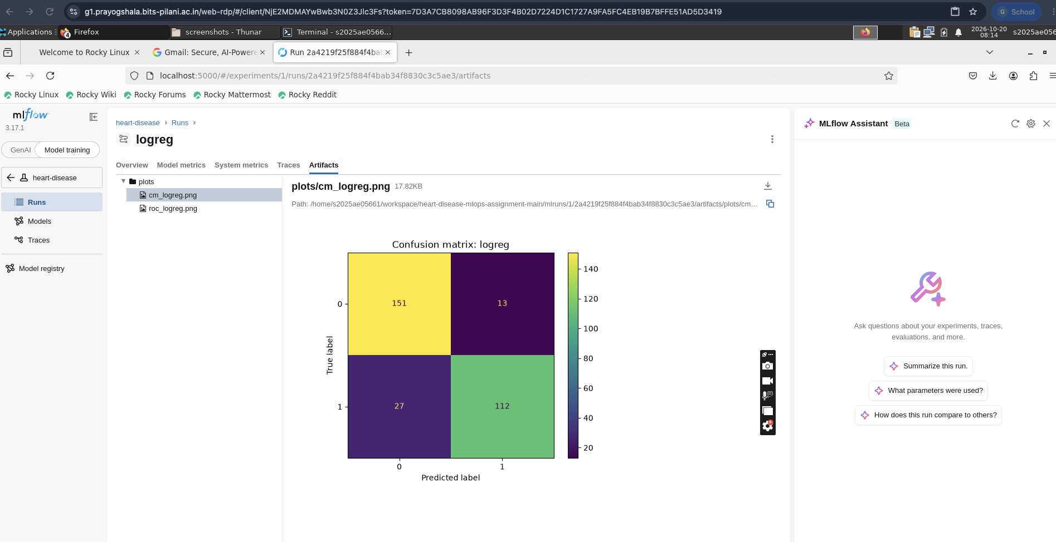
Figure 7: Confusion matrix artifact of the logreg run: 151 true negatives, 13 false positives, 27 false negatives, 112 true positives.
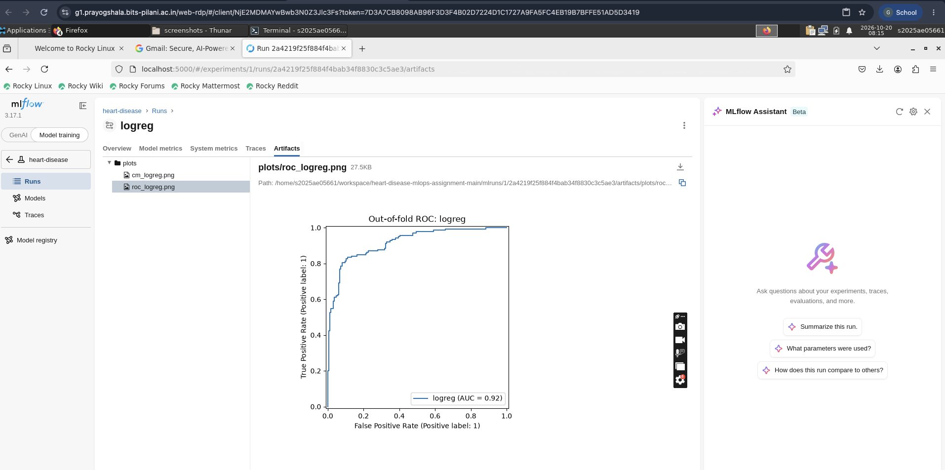
Figure 8: Out-of-fold ROC curve of the logreg run (AUC = 0.92).
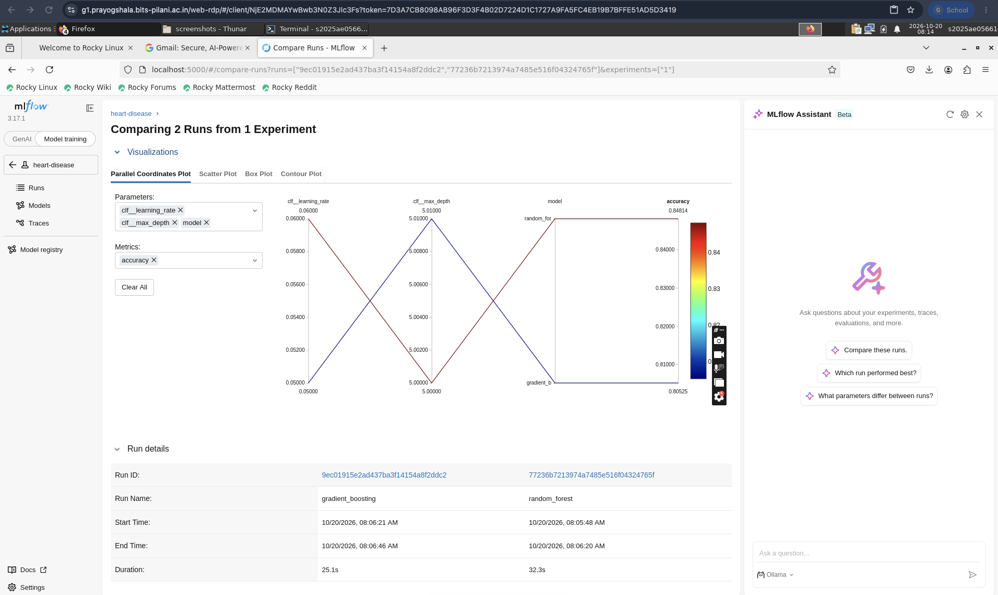
Figure 9: Comparison view of two runs (gradient boosting and random forest) with their parameters and accuracy.
Reading the confusion matrix: of the 139 patients with disease, 27 were missed (recall 0.81 on pooled predictions). Recall is the metric to watch in a screening setting.

5. Model packaging and reproducibility
- The final model is the complete Pipeline (feature engineering, preprocessing and classifier) saved with joblib as models/model.joblib. The API therefore accepts raw patient fields only.
- requirements.txt pins every dependency, for example mlflow==3.17.1, fastapi==0.143.1 and uvicorn==0.54.0. requirements-dev.txt adds pytest, pytest-cov, httpx and ruff. requirements-serve.txt is the smaller set used inside the Docker image.
- Random seeds are fixed. scripts/run_all.sh rebuilds everything from a clean checkout.
- The notebooks (01_eda, 02_training, 03_inference) mirror the scripts for exploration.

6. CI/CD pipeline and automated tests
Sixteen pytest tests cover data processing, the feature pipeline, training, prediction and the API (valid request, range checks and error responses). They are run by the GitHub Actions workflow .github/workflows/ci.yml on every push and pull request:
- Lint: ruff check src tests scripts.
- Unit tests: pytest with coverage, producing junit.xml and coverage.xml.
- Training: python -m heart.train.
- Artifacts: the test reports, and the model together with the MLflow tracking data, are uploaded for each run.
- Docker job: builds the image, starts the container, and smoke-tests /health and /predict.
Any lint or test failure fails the run and the log shows the failing step.
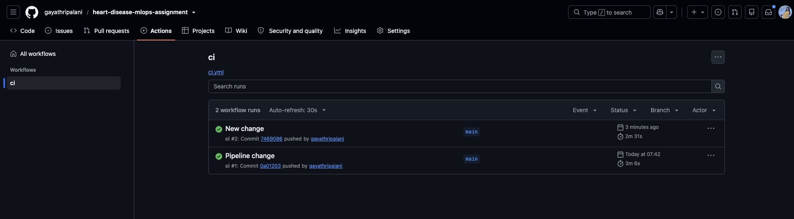
Figure 10: GitHub Actions workflow "ci" in the repository heart-disease-mlops-assignment. Both runs on main (#1 "Pipeline change" and #2 "New change") completed successfully, in about 3 minutes each.

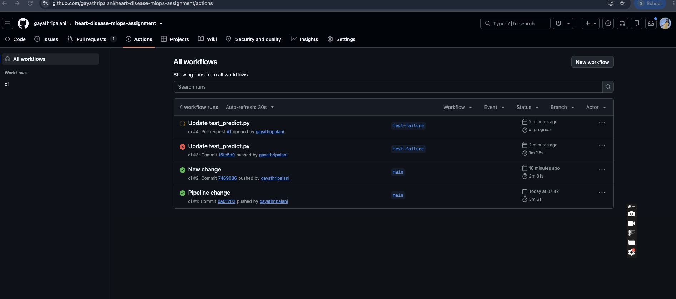
Figure 11: The pipeline fails on an error. Run #3 on the branch test-failure (commit 15fc5d0, test_predict.py changed on purpose) ends with a red cross after 1 minute 28 seconds, while the runs #1 and #2 on main are green. The same change opened as pull request #1 starts run #4.

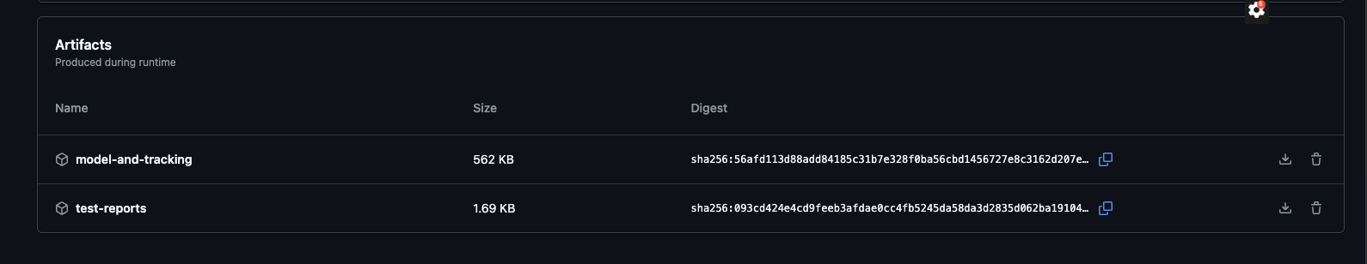
Figure 12: Artifacts produced by a workflow run: model-and-tracking (562 KB, the trained model and the MLflow tracking data) and test-reports (1.69 KB, junit.xml and coverage.xml).

7. Model containerisation
The API is a FastAPI application (src/api/app.py). POST /predict accepts the patient fields as JSON and returns the prediction and the confidence. Inputs are range-checked, and invalid input returns HTTP 422. GET /health and GET /metrics are also exposed. The Dockerfile uses python:3.12-slim, runs as a non-root user, installs only the serving requirements, and defines a health check.
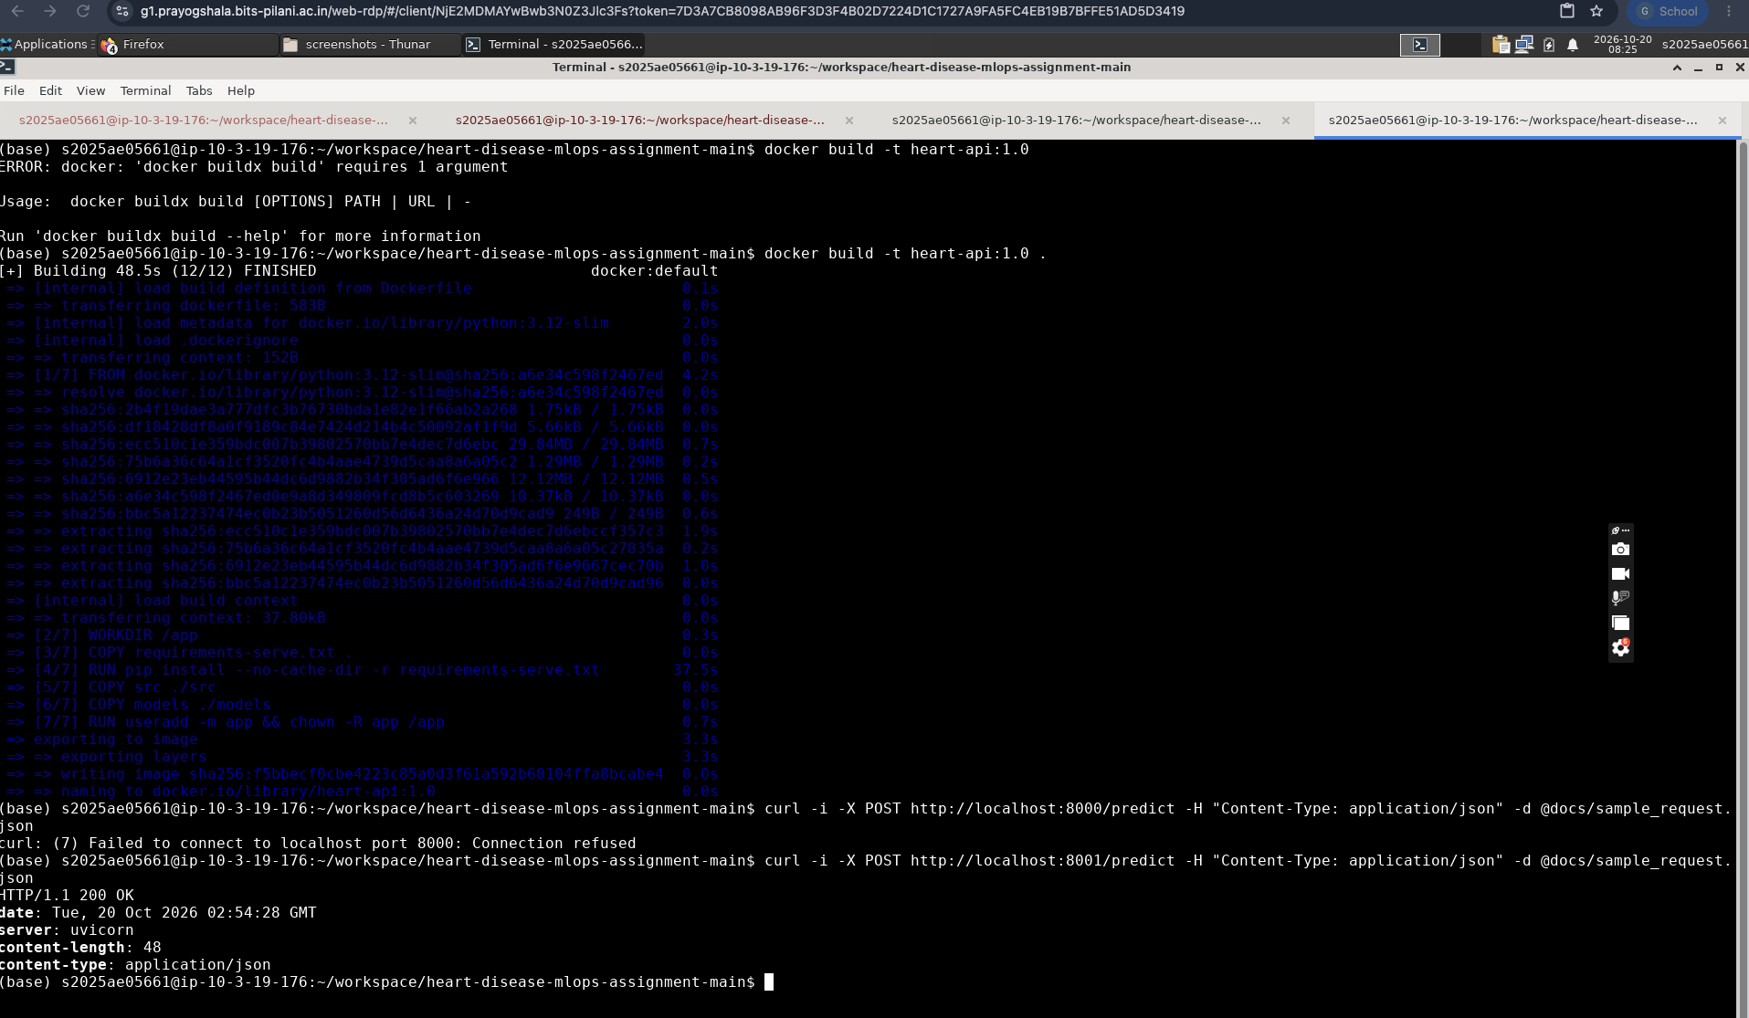
Figure 13: docker build of heart-api:1.0 (12 of 12 steps finished) and a POST /predict request answered with HTTP 200 OK by the uvicorn server.

8. API verification
The interactive Swagger page was used to send a request for a 55-year-old male patient. The server answered 200 with a prediction and a confidence.
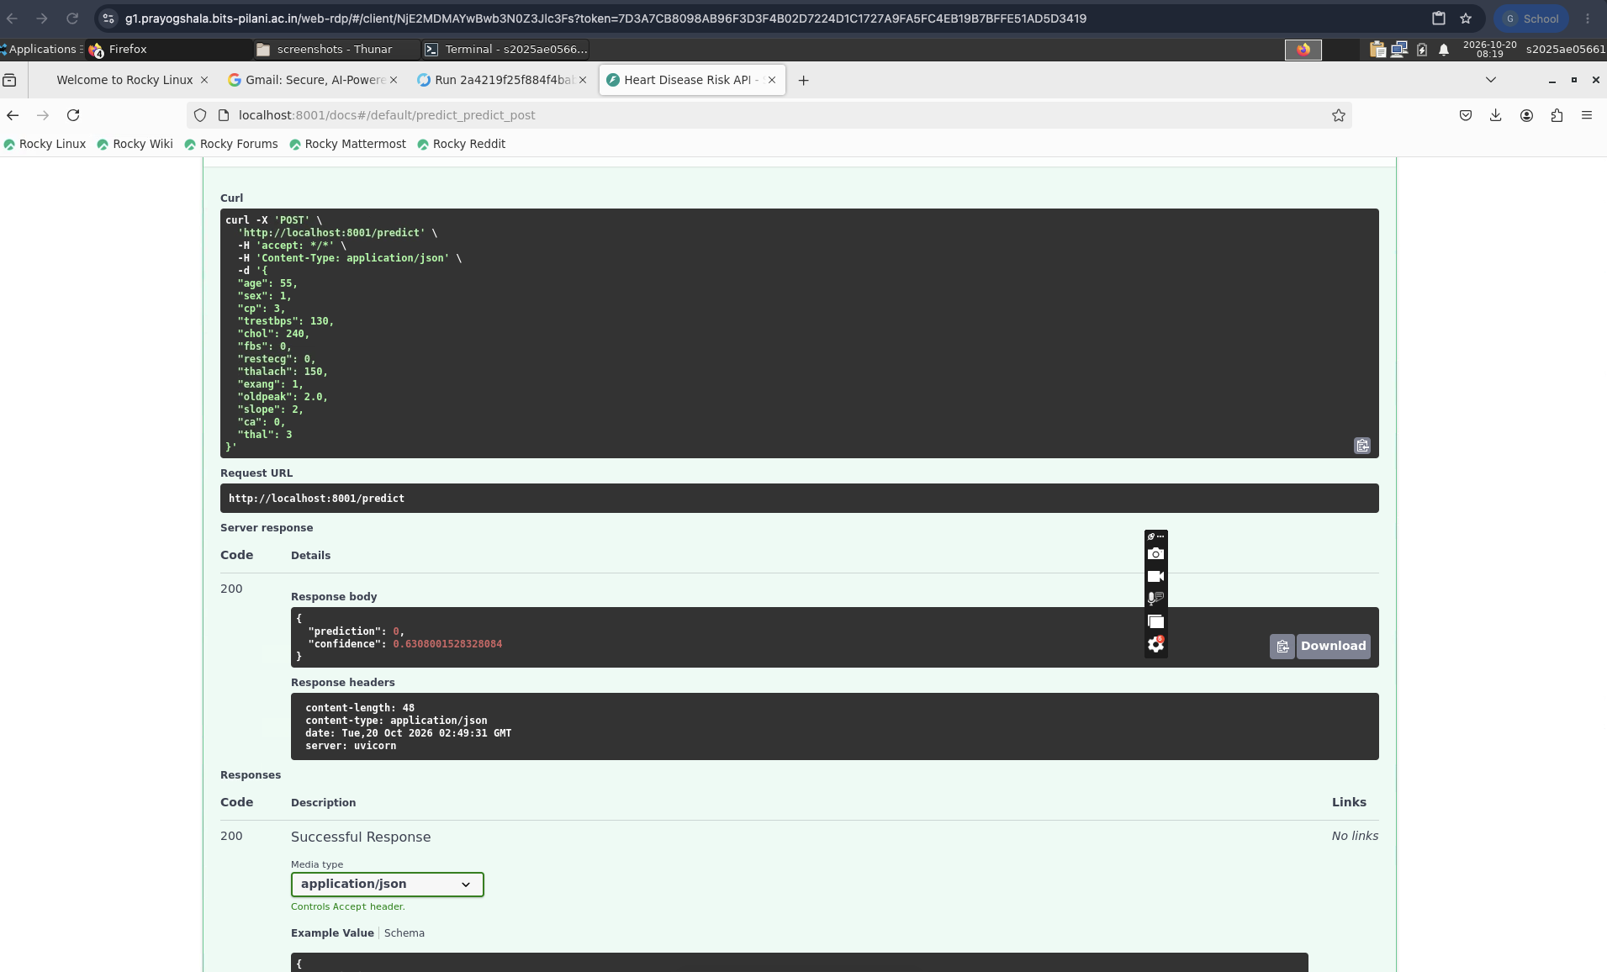
Figure 14: POST /predict through Swagger: prediction 0 (no disease) with confidence 0.631.
Out-of-range input, for example age 500, or a thal value other than 3, 6 or 7, is rejected with HTTP 422 and a message naming the field.

9. Production deployment on Kubernetes
k8s/deployment.yaml runs one replica of heart-api:1.0 with readiness and liveness probes on /health and CPU and memory requests and limits. One replica keeps a single metrics series for Prometheus. k8s/service.yaml exposes it as a LoadBalancer on port 80, targeting container port 8000. scripts/deploy_lab.sh builds the image, creates a local kind cluster, applies the manifests and tests the endpoint.
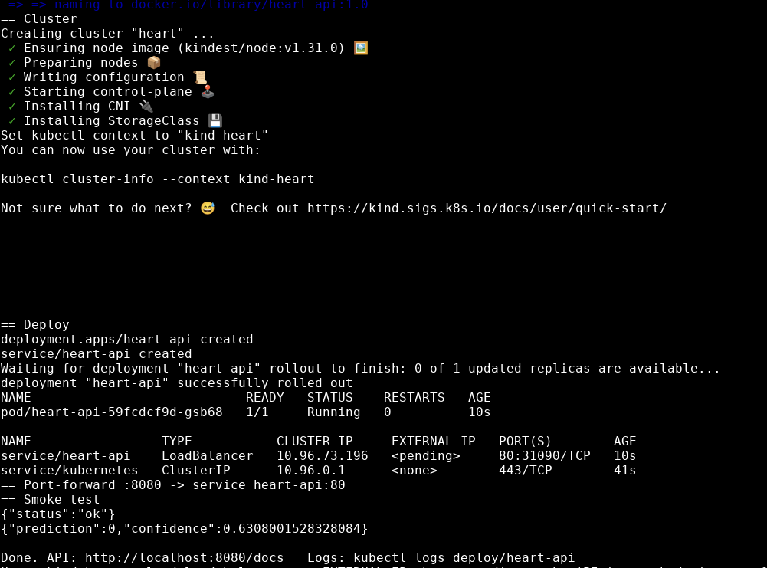
Figure 15: The deploy script creates the kind cluster "heart", applies the manifests and waits for the rollout. pod/heart-api is 1/1 Running, and service/heart-api is a LoadBalancer on port 80:31090. The smoke test through the port-forward returns {"status":"ok"} and a prediction (0, confidence 0.6308).
The EXTERNAL-IP of the LoadBalancer stays <pending>, because a local kind cluster has no cloud load balancer. The service is therefore reached through kubectl port-forward on localhost:8080, which is what the smoke test and Prometheus use.

10. Monitoring and logging
The API writes one JSON log line per request (kubectl logs deploy/heart-api). It exposes Prometheus metrics at /metrics: predict_requests_total, predict_latency_seconds and predict_positive_total. Prometheus scrapes them, and a provisioned Grafana dashboard, Heart API (monitoring/grafana/dashboards/heart-api.json), shows the request rate, the latency and the share of positive predictions. scripts/send_traffic.py sends sample requests so the panels have data.
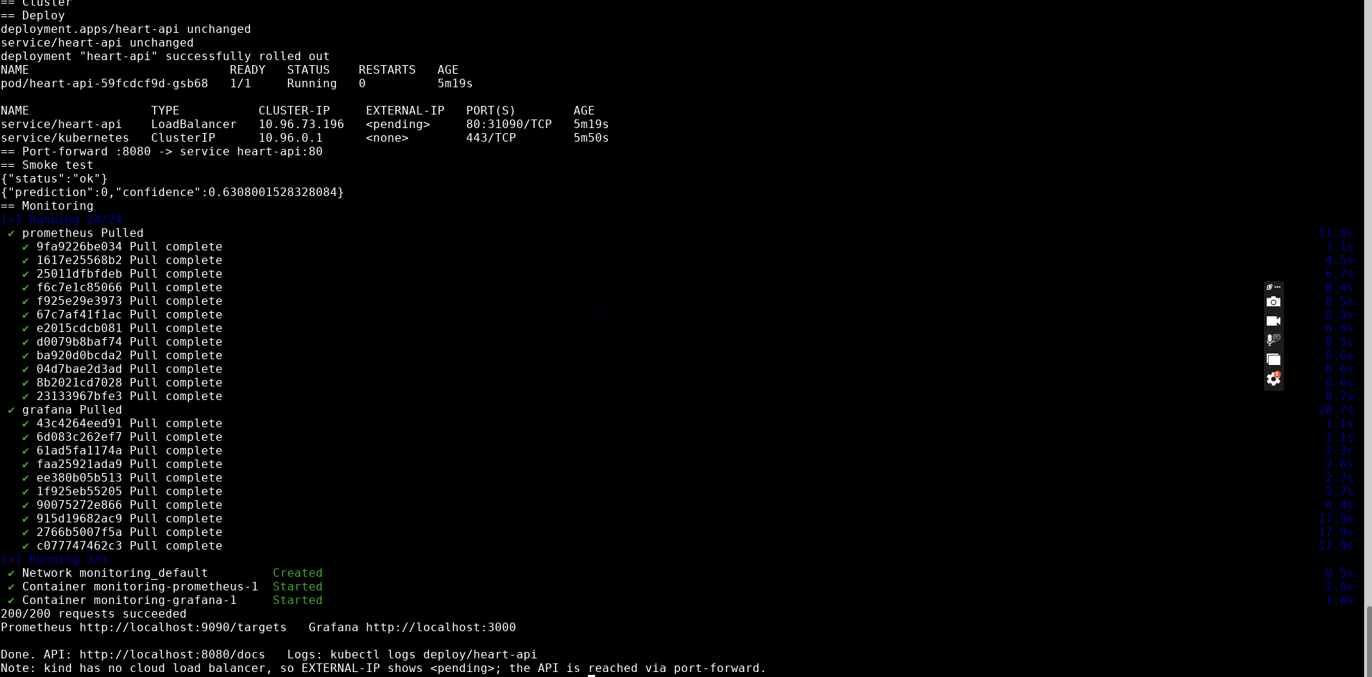
Figure 16: The deploy script with the monitoring option: the pod and service are unchanged, Prometheus and Grafana containers start, and 200 of 200 sample requests succeed.
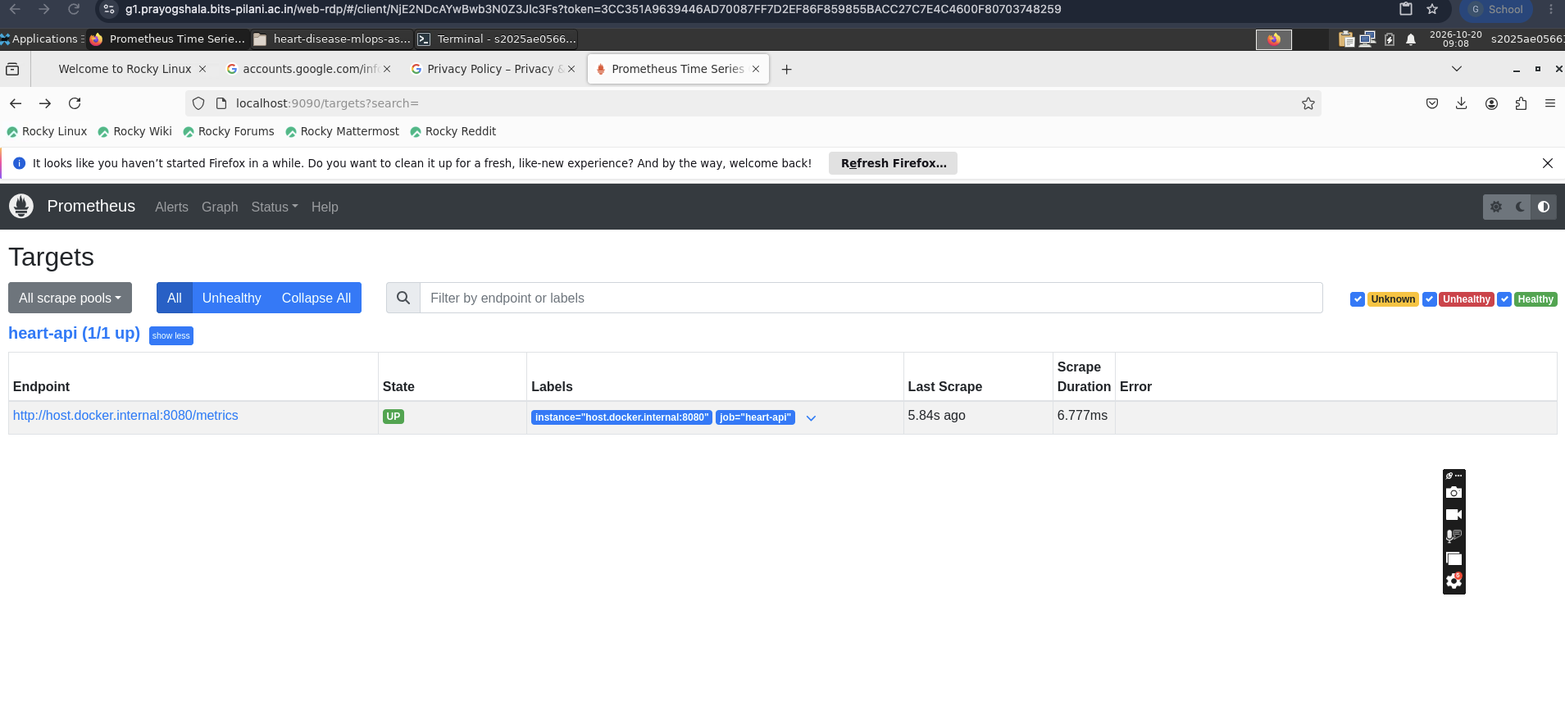
Figure 17: Prometheus targets page. The heart-api job is 1/1 up, scraping host.docker.internal:8080/metrics every 5 seconds.
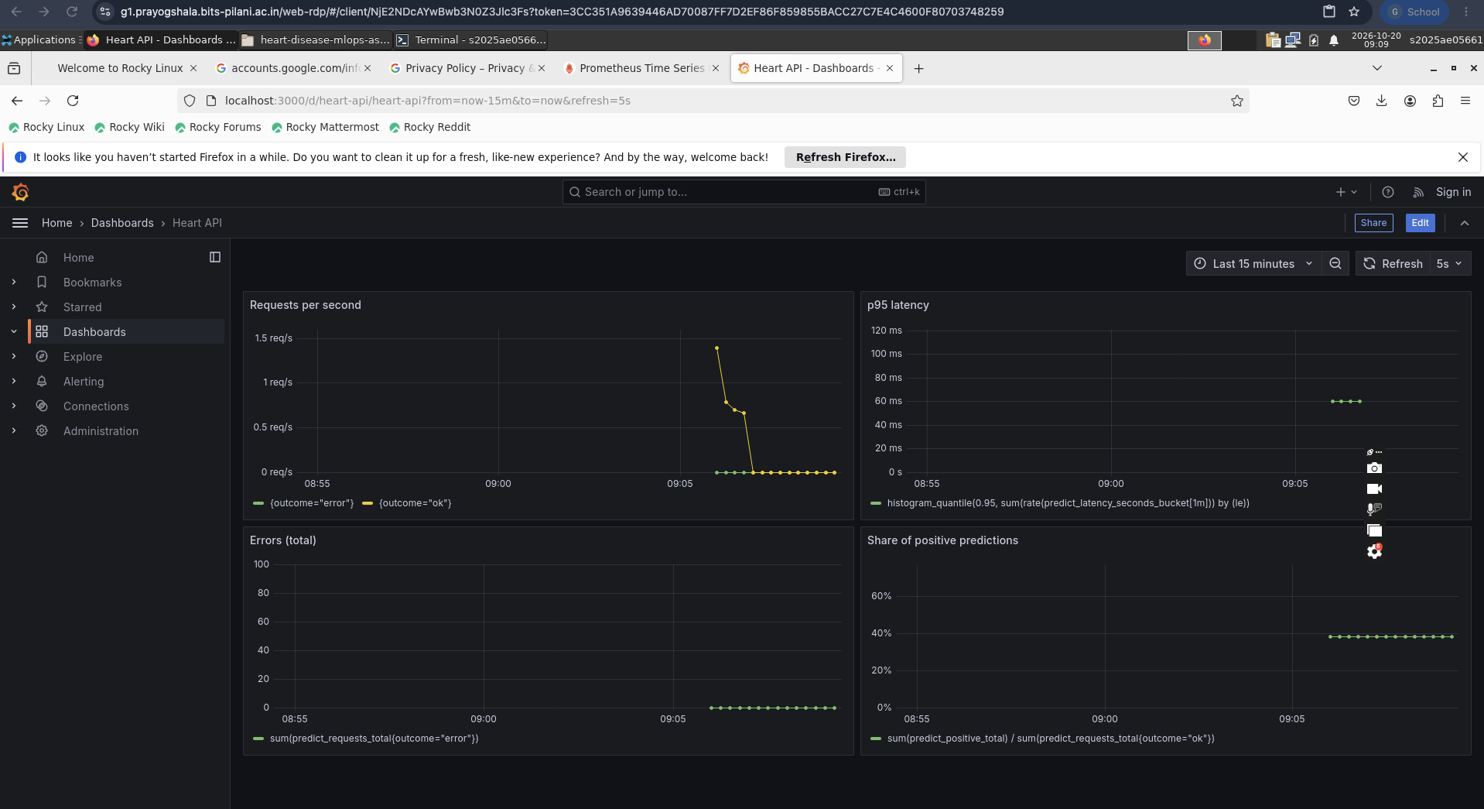
Figure 18: Grafana dashboard Heart API after the traffic run. Panels: requests per second by outcome, p95 latency (about 60 ms), total errors (zero) and the share of positive predictions (about 40%).
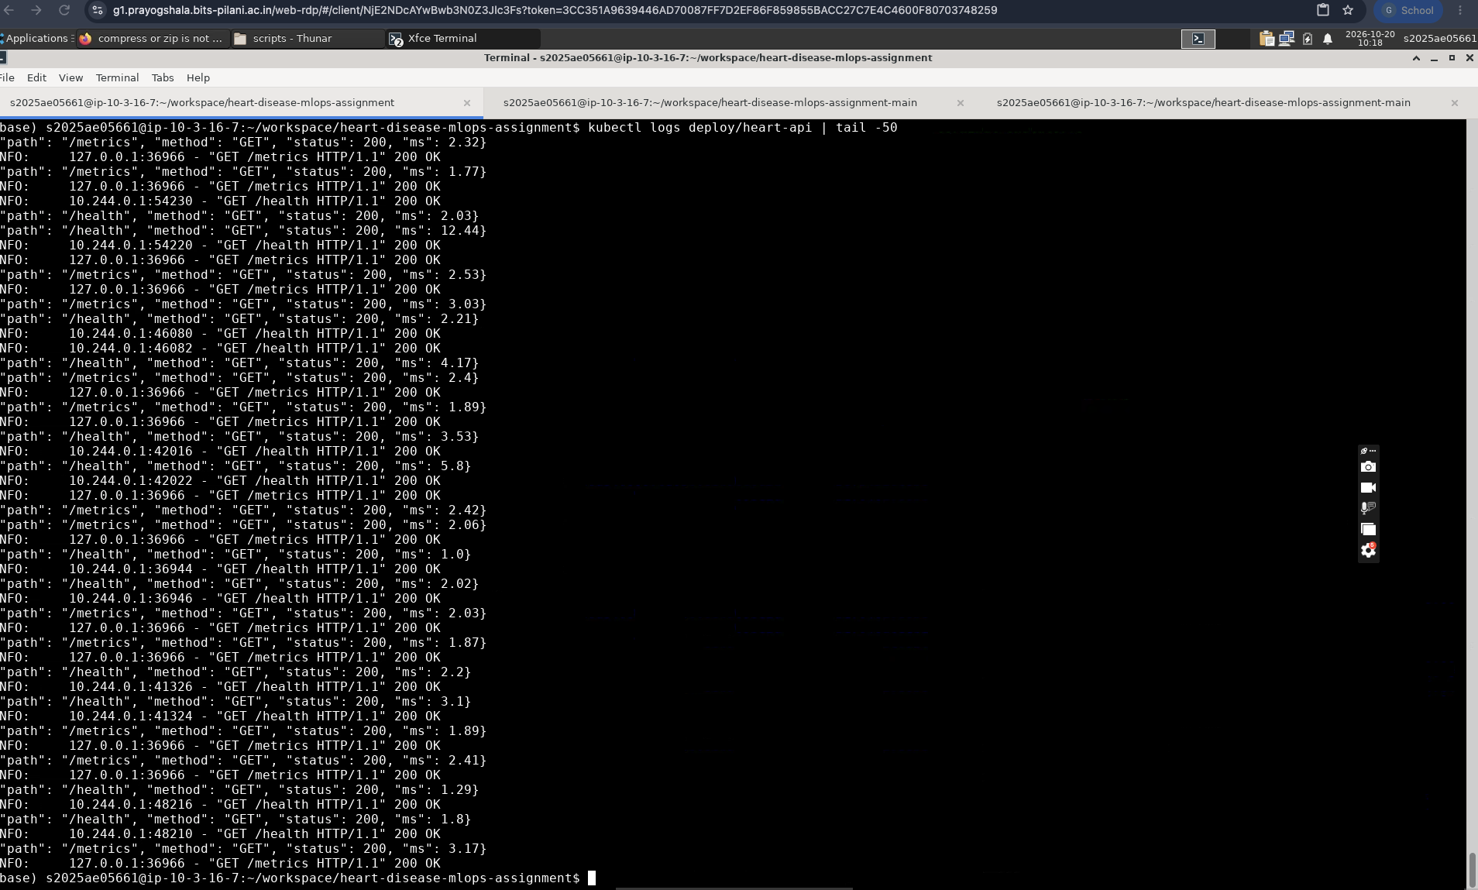
Figure 19: Output of kubectl logs deploy/heart-api. Each request produces a JSON log line with the path, the method, the status code and the latency in milliseconds, next to the uvicorn access line. The lines shown are the Kubernetes health probes (/health) and the Prometheus scrapes (/metrics), all with status 200 and a latency of a few milliseconds.

11. Architecture
UCI dataset (zip) | → | scripts/download_data.py | → | data/processed/heart_clean.csv | → | heart.train: CV + GridSearch
 |  |  |  |  |  | MLflow (sqlite + artifacts)
models/model.joblib | → | Docker image heart-api:1.0 | → | Kubernetes Deployment + LoadBalancer Service | ← | Client: POST /predict
 |  | Grafana dashboard | ← | Prometheus (scrapes /metrics) | ← | API /metrics + JSON logs
GitHub Actions: lint → test → train → docker build and smoke test (runs on every push)
Figure 20: Data and model flow, serving, monitoring and the CI pipeline.

12. Limitations
- The dataset is small (303 patients) and comes from a single site. There is no external validation, so the results may not carry over to other populations.
- The cross-validated scores are slightly optimistic, because the folds used to tune the hyperparameters are also used to score the models.
- The model is an educational exercise and is not a clinical tool.
- The local cluster has no cloud load balancer, so the service is reached through a port-forward in the lab.

