     



# COURSE NAME : DIGITAL MARKETING

**GROUP NUMBER : 7**

# PROJECT TITLE : GOOGLE ANALYTICS

**PROJECT SURMITTED TO : ANNA UNIVERSITY-NAAN MUDHALVAN YEAR : II**

# DEPARTMENT : B.E Computer Science Engineering &

**B.E Civil Engineering**

# SEMESTER : 4

**GROUP MEMBERS : GAYATHRI P (513121104005)**

# VINITHA G (513121104047)

**NALINI V (513121104024)**

# ALMAS S (513121103004)

**SIVA RANJANI A (513121103039)**

# GUIDED BY : T.Suja

**SPOC NAME : Pradeep**

# Table of Contents:

|  |  |  |
| --- | --- | --- |
| **S.NO** | **Contents** | **Page No** |
| **1.** | **Introduction** | **3** |
| **2.** | **Methodology** | **3** |
| **3.** | **Results and Analysis** | **22** |
| **4.** | **Interpretation and Recommendation** | **22** |
| **5.** | **Conclusion** | **23** |
| **6.** | **References** | **23** |

**Introduction:**

The purpose of this project report is to provide an analysis of website traffic using Google Analytics on the Google Analytics demo account for GA4 - Google Merch Shop. The Google Analytics demo account is a valuable resource that provides users with a real- world example of how Google Analytics can be used to track and measure website traffic and user behavior.

The Google Merch Shop is an e-commerce website that sells a range of Google-branded merchandise, including t-shirts, hats, and other accessories. The website is designed to showcase Google's brand and provide a seamless online shopping experience for users.

To analyze website traffic for the Google Merch Shop, we used Google Analytics, a web analytics service offered by Google that helps website owners and marketers to track and analyze their website traffic and user behavior. Using Google Analytics, we collected and analyzed data on key metrics such as page views, sessions, bounce rate, and time on site, to gain insights into user behavior and engagement.

The findings of this project report can help businesses and organizations to better understand the value of website traffic analysis and the benefits of using Google Analytics to track and measure website performance. By analyzing website traffic, businesses can make data-driven decisions to improve website content, design, and functionality, and ultimately increase engagement, conversions, and revenue.

# Methodology:

To analyze website traffic for the Google Analytics demo account for GA4 - Google Merch Shop, we used Google Analytics, a web analytics service offered by Google that helps website owners and marketers to track and analyze their website traffic and user behavior. The following steps were taken to collect and analyze website traffic data:

# Accessing the Google Analytics demo account:

We accessed the Google Analytics demo account for GA4 - Google Merchant Shop by logging in to the Google Analytics account using the provided credentials.

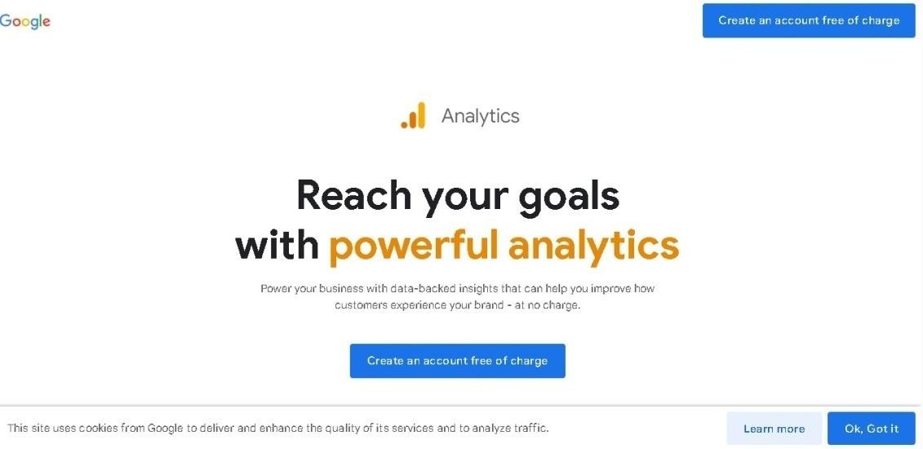

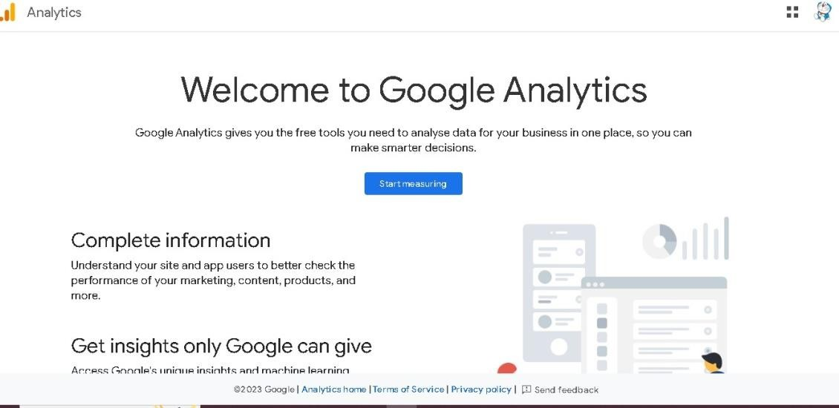

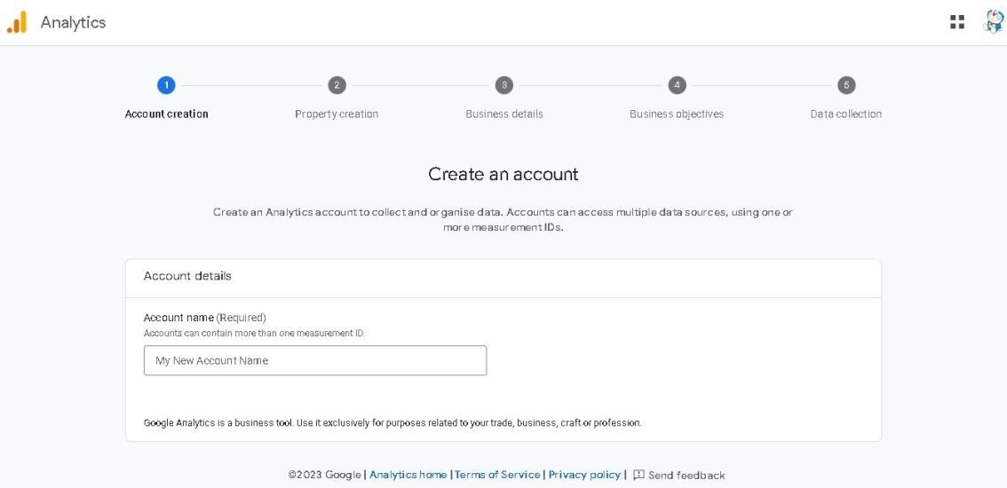

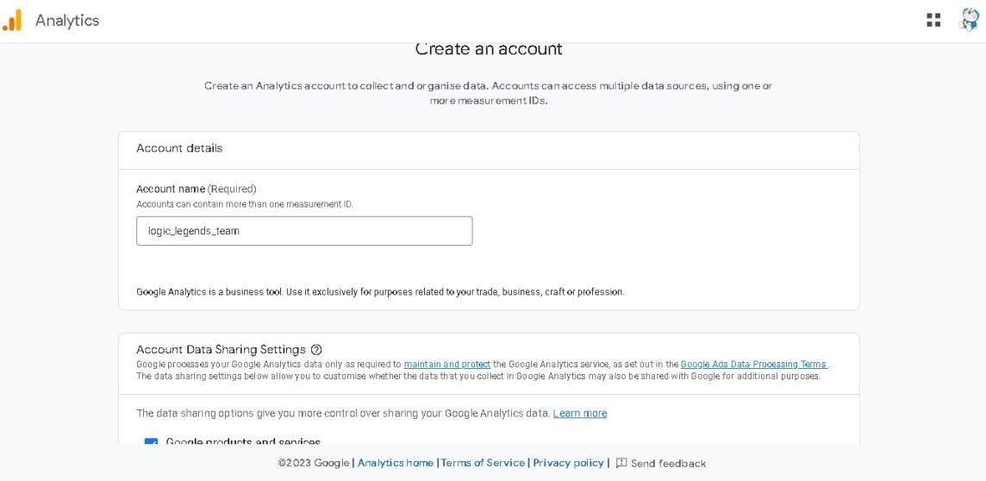

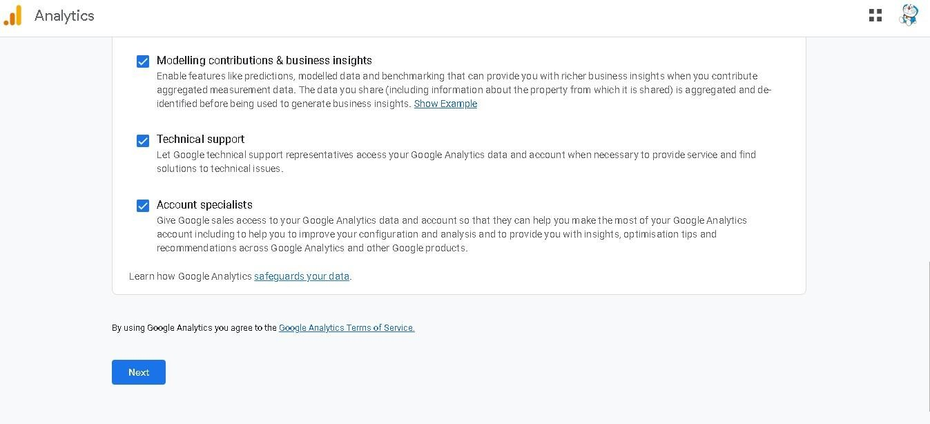

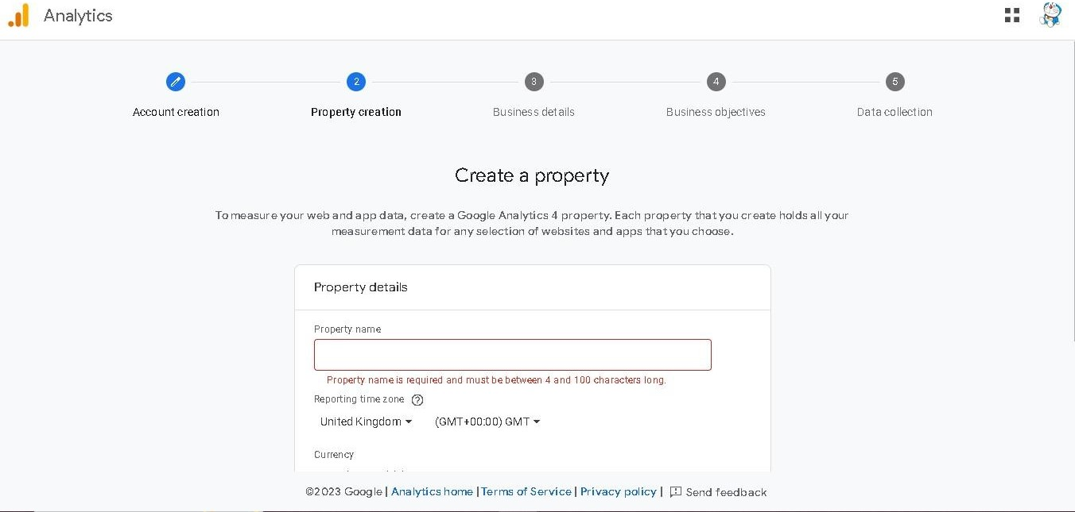

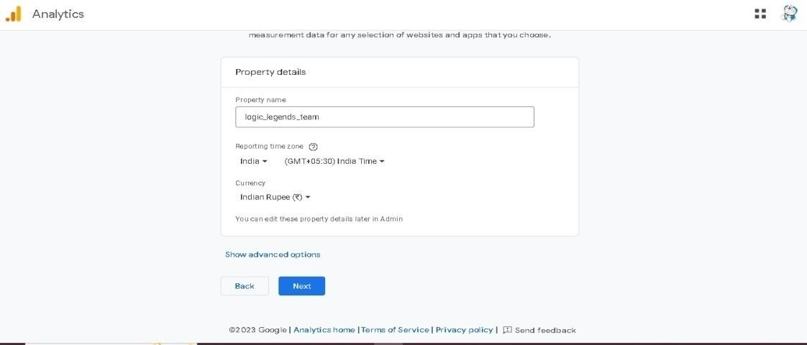

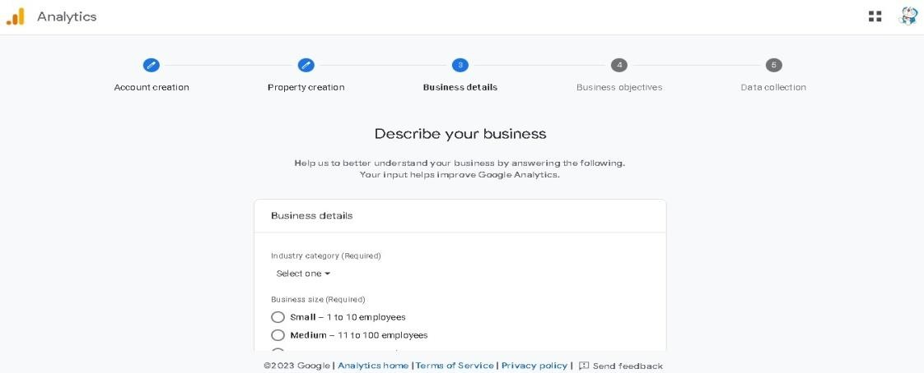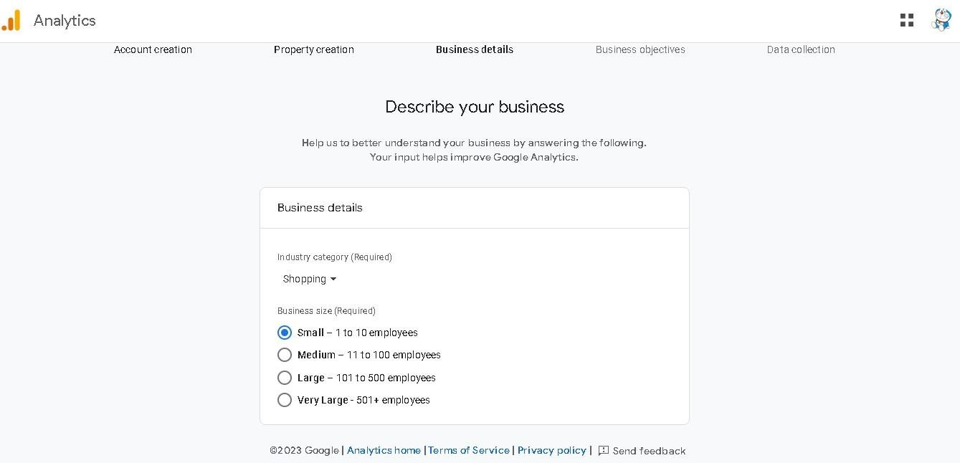

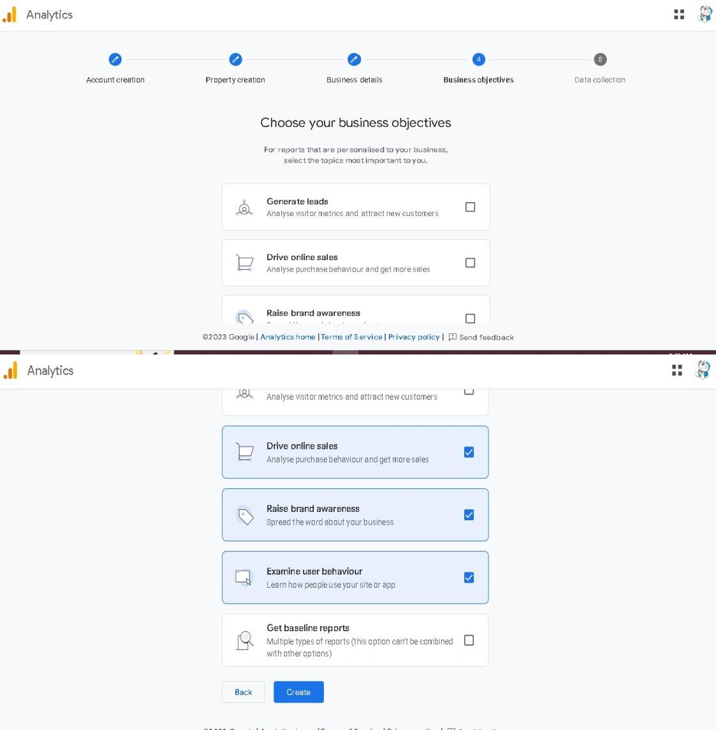

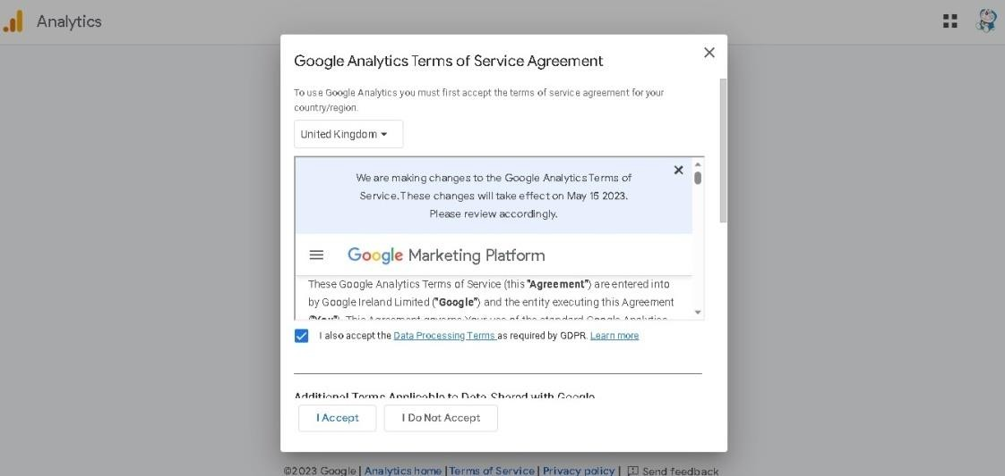

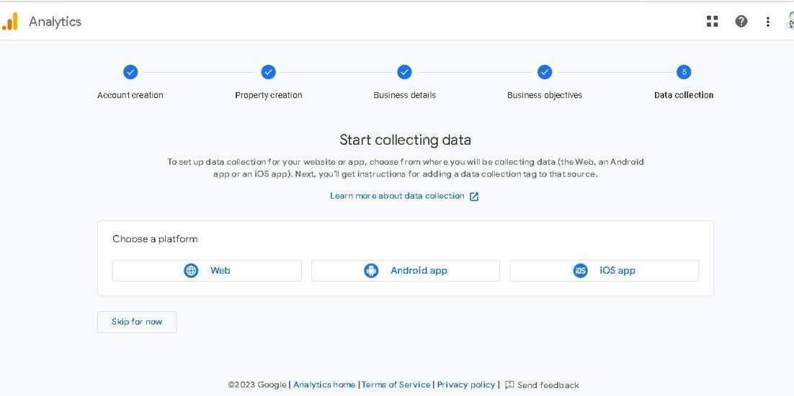

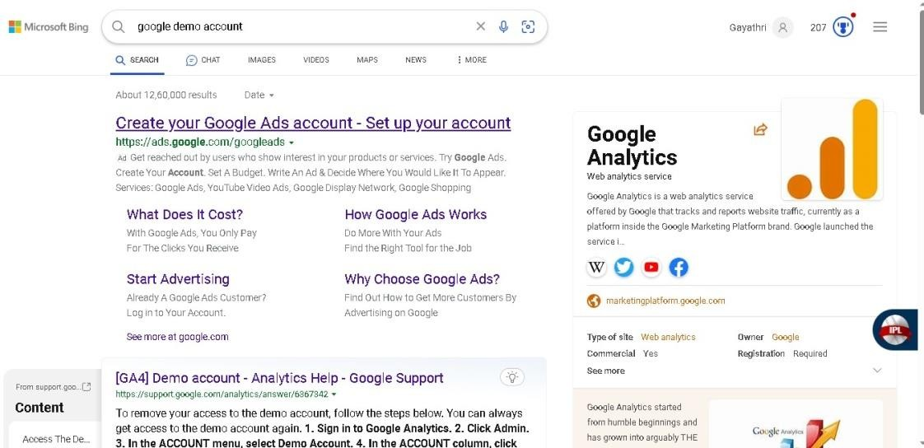

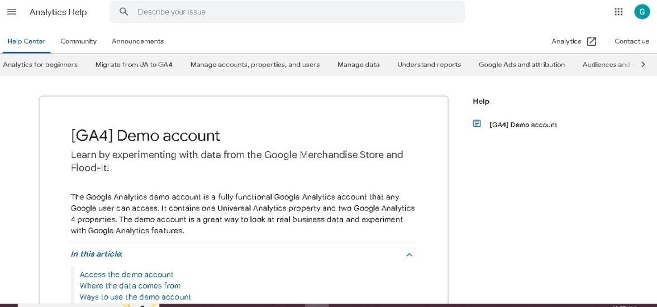

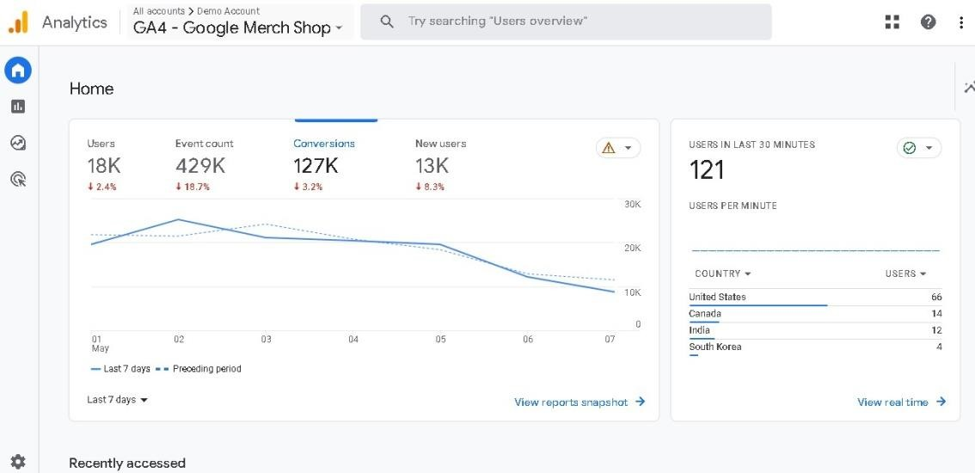

# Setting up the Google Analytics account:

We ensured that the Google Analytics account was properly set up with the GA4 tracking code installed on the website.

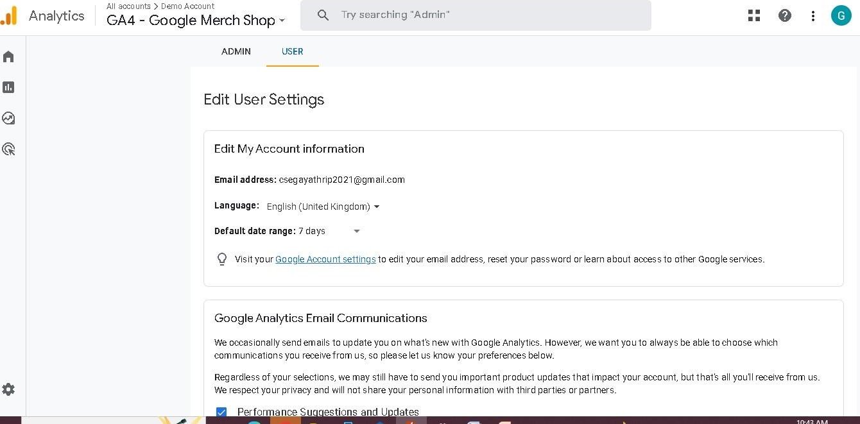

# Setting up the Google Analytics reports:

We configured the Google Analytics reports to track and measure key metrics such as page views, sessions, bounce rate, and time on site.

# Page views:

In Google Analytics, a page view is a metric that measures the number of times a page on your website has been viewed by a user. Each time a user visits a page on your website, it is counted as a page view.

Google Analytics tracks page views by using a small piece of tracking code on your website that sends data to Google Analytics servers every time a page is loaded. This data includes information about the page viewed, the user who viewed it, and the source of the traffic that led to the page view.

Page views can be useful for understanding which pages on your website are the most popular, how users are engaging with your content, and where you may need to make improvements to your website. By tracking page views in Google Analytics, you can gain insights into user behavior and engagement, and optimize your website for better performance and user experience.

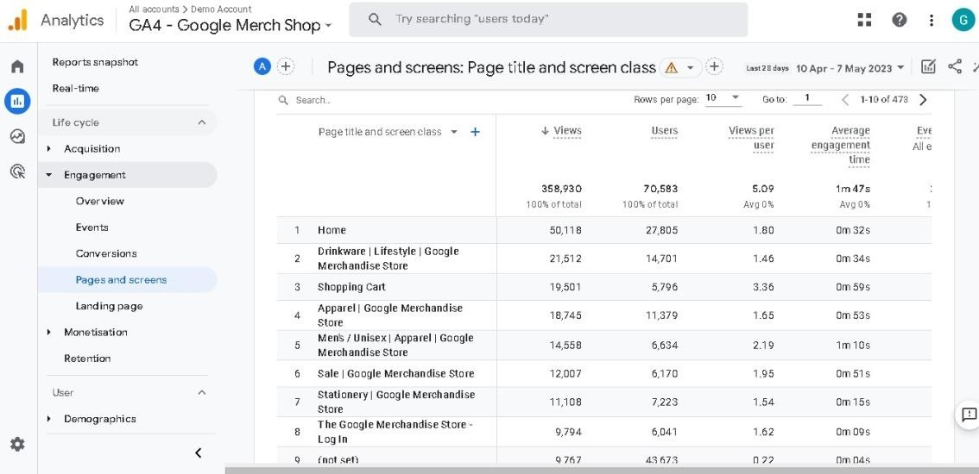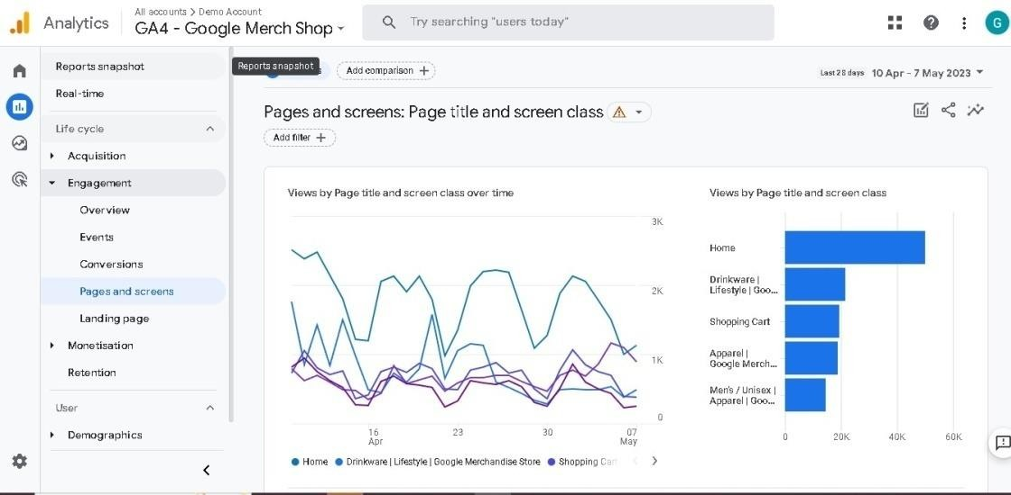

# Sessions:

In Google Analytics, a session is a group of interactions that a user takes on your website within a given time period. A session starts when a user arrives on your website and ends when they leave or after 30 minutes of inactivity.

During a session, a user can interact with multiple pages on your website, trigger multiple events, and perform various actions such as filling out a form or making a purchase.

Google Analytics tracks each interaction during the session and aggregates this data to provide insights into user behavior and engagement.

Some examples of interactions that can be included in a session are pageviews, events, e- commerce transactions, and social interactions. By analyzing the data on sessions, you can gain insights into how users are interacting with your website, what content is most engaging, and where you may need to make improvements to your website or marketing strategies.

It's important to note that a single user can have multiple sessions on your website, and that sessions are not the same as unique users. A user may visit your website multiple times, and each visit will count as a separate session.

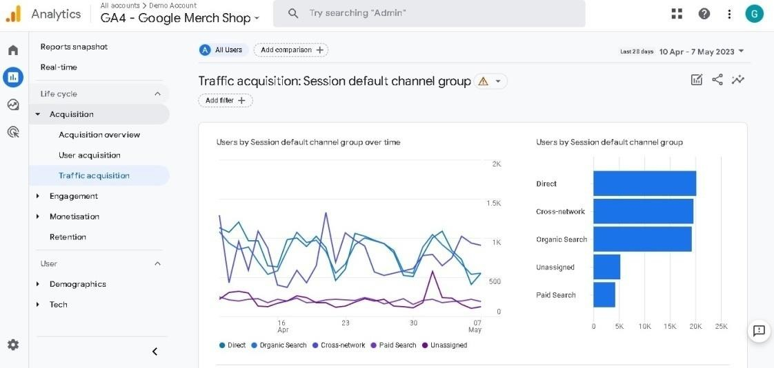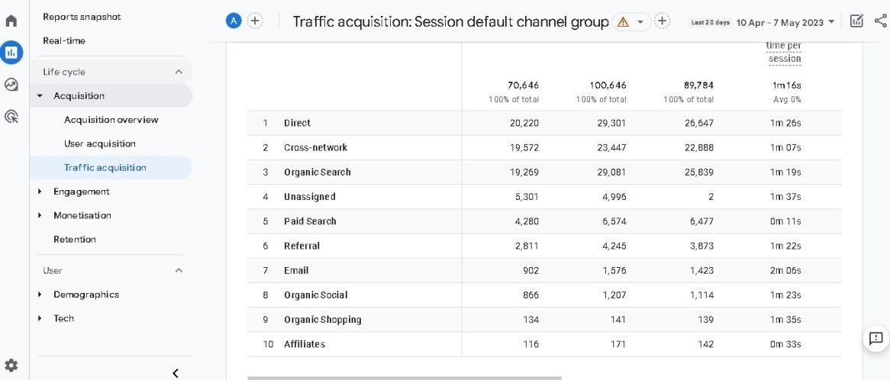

# Bounce Rate:

In Google Analytics, bounce rate is a metric that measures the percentage of sessions in which the user only visited one page on your website and then left without interacting with the website any further.

In other words, when a user lands on a page of your website and then immediately leaves without clicking on any other pages or interacting with your website in any other way, it is counted as a "bounce". The bounce rate is calculated as the number of single-page sessions divided by the total number of sessions.

A high bounce rate can be an indication that users are not finding what they are looking for on your website or that your website is not providing a good user experience.

However, it's important to note that a high bounce rate is not always a bad thing, as there may be certain pages on your website that are designed to be viewed as standalone pages, such as a contact page or a landing page for a specific campaign.

By monitoring the bounce rate in Google Analytics, you can gain insights into how users are interacting with your website and identify areas for improvement in terms of user experience, content, and page design. You can also use this information to optimize your website for better engagement and conversions.

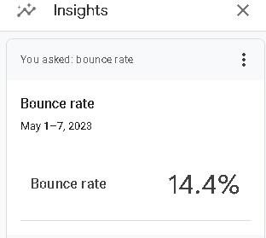

# Time:

In Google Analytics, "Time" refers to the amount of time that users spend on your website, and it is measured in a few different ways.

One metric that measures time is "Average Session Duration", which is the average length of time that users spend on your website per session. This metric is calculated by dividing the total duration of all sessions by the number of sessions.

Another metric that measures time is "Time on Page", which is the amount of time that users spend on a specific page before navigating away or closing the page. This metric is calculated by subtracting the time that the user arrived on the page from the time that the user navigated away or closed the page.

Both of these metrics can provide insights into user engagement and the effectiveness of your website content. For example, a high average session duration may indicate that users are finding your website engaging and valuable, while a low time on page may indicate that users are not finding a specific page or piece of content interesting or useful.

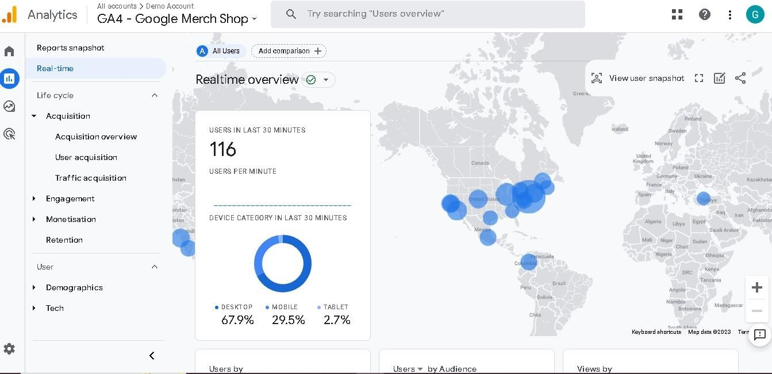

# Collecting website traffic data:

We collected website traffic data for the Google Merch Shop.

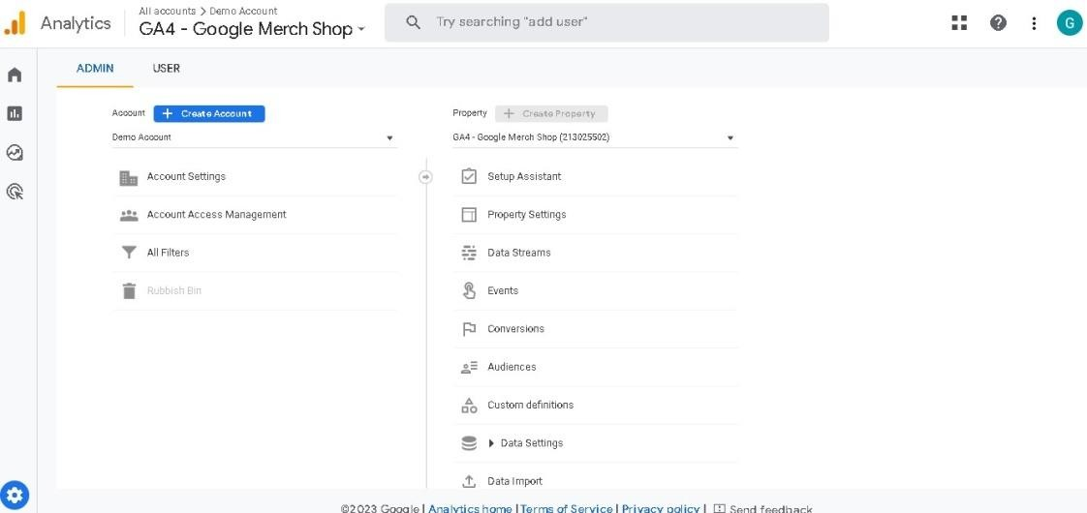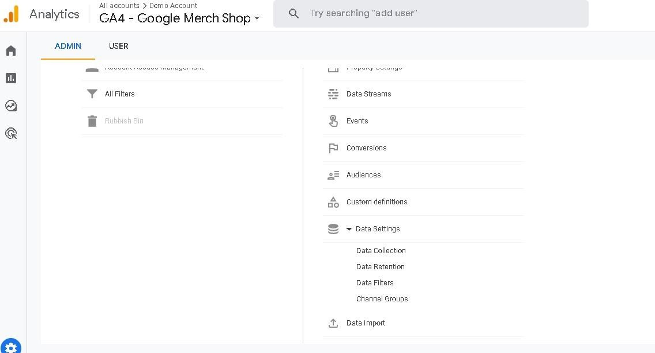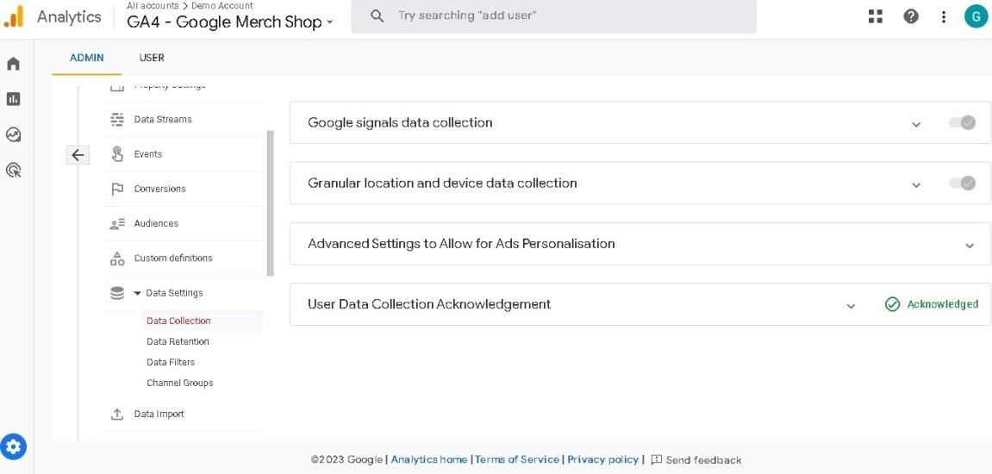

# Analyzing website traffic data:

We analyzed the collected data using Google Analytics reports and tools, such as the Behavior Flow report, to gain insights into user behavior and engagement.

# Finding 1: NEST or Branded Merch

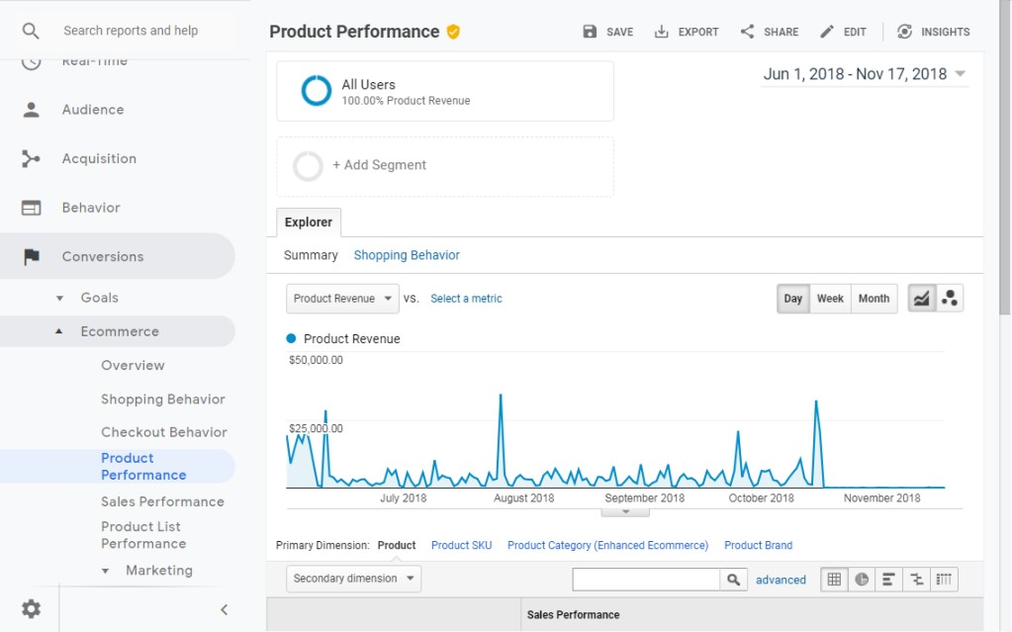

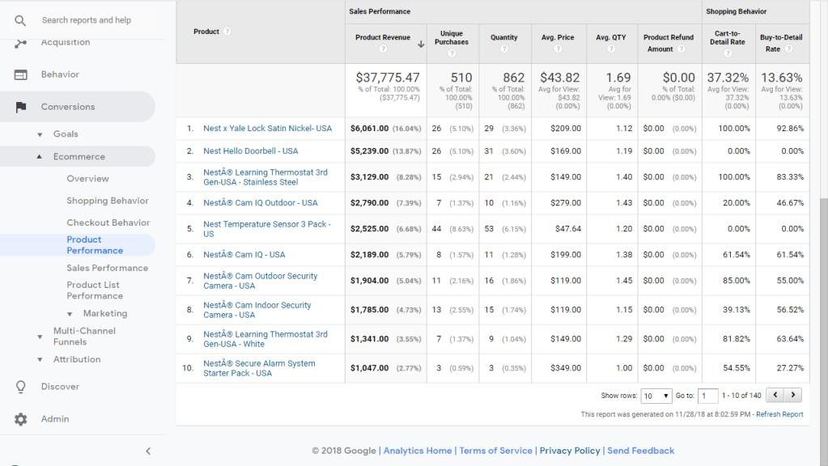

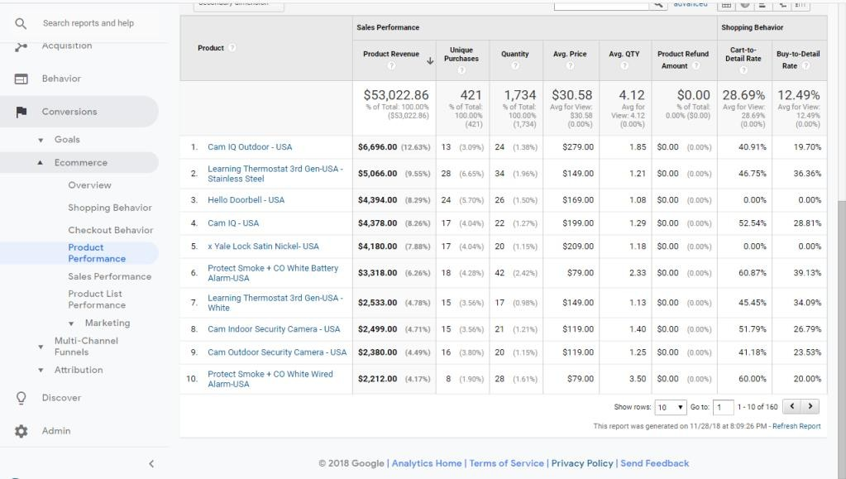

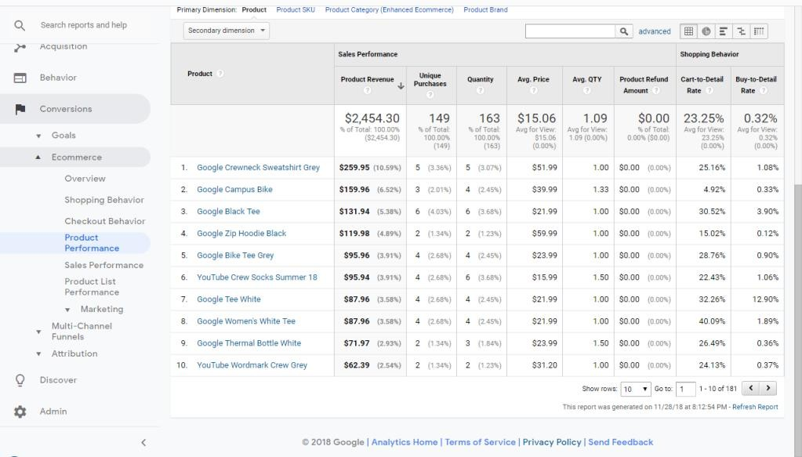

we investigated the other spikes to find occasionally someone will spend thousands of dollars on several dozen identical grey YouTube t-shirts. A couple other spikes were due to sales of backpacks and roller bags

# Finding 2: Daily User/Transaction Pattern

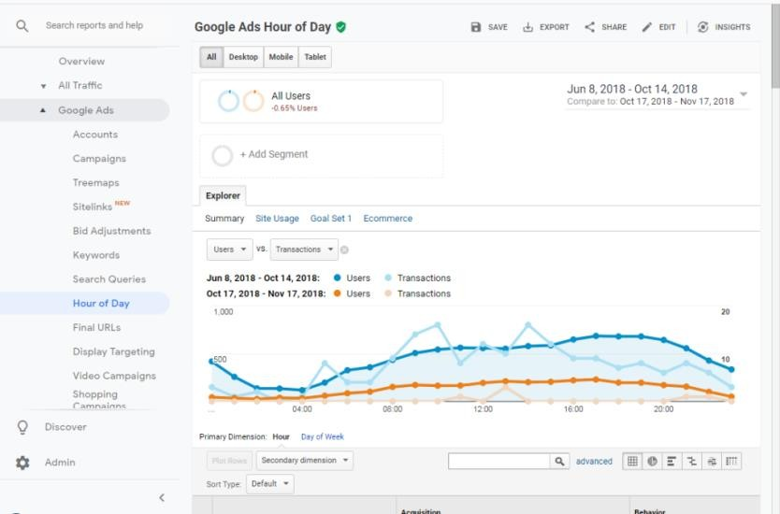



That line was a smooth curve that grew throughout the day, peaked in the afternoon, and fell at night. We expected a neat correlation with transactions. Instead, transactions appeared clustered at certain times of the day. We found strong activity in the early morning, the hour after noon, and a small surge in sales just before midnight.

# Finding 3: Big Spenders vs. Slow Shoppers

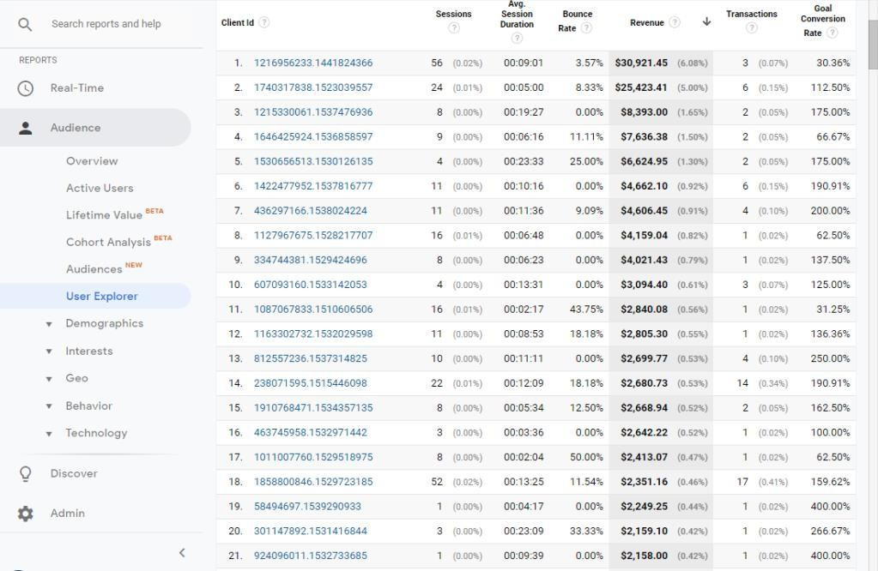

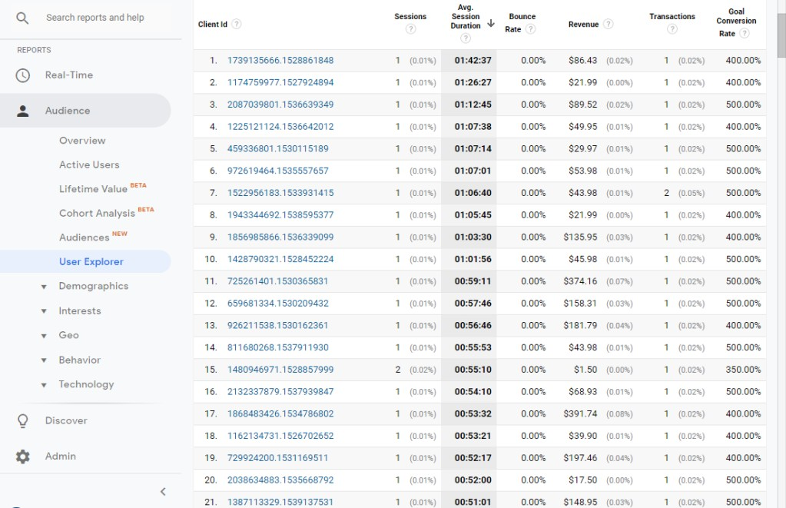

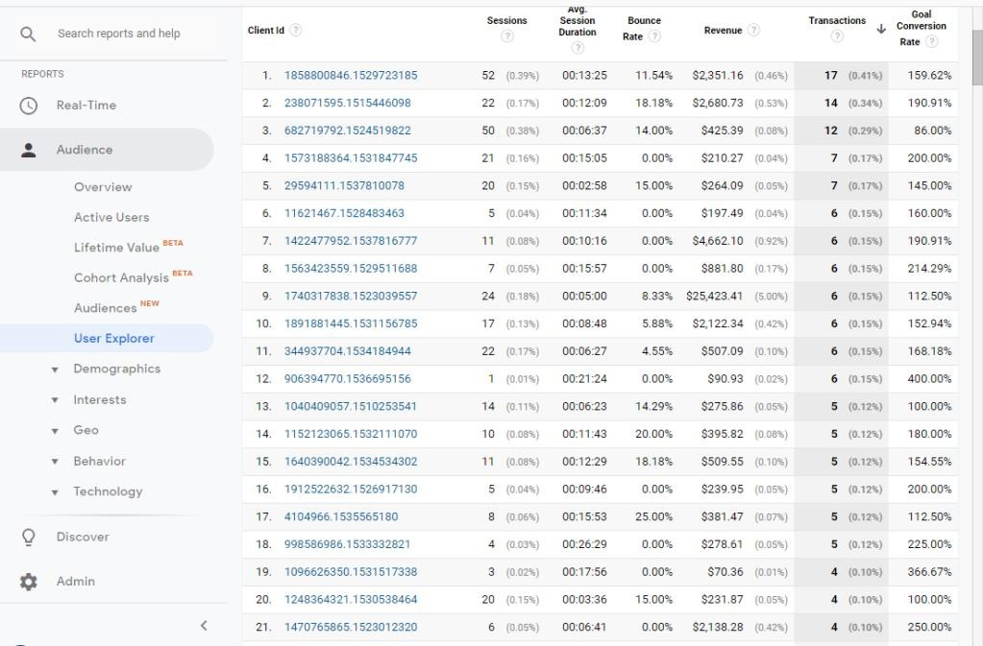

**Finding 4: Countries Need Speed**

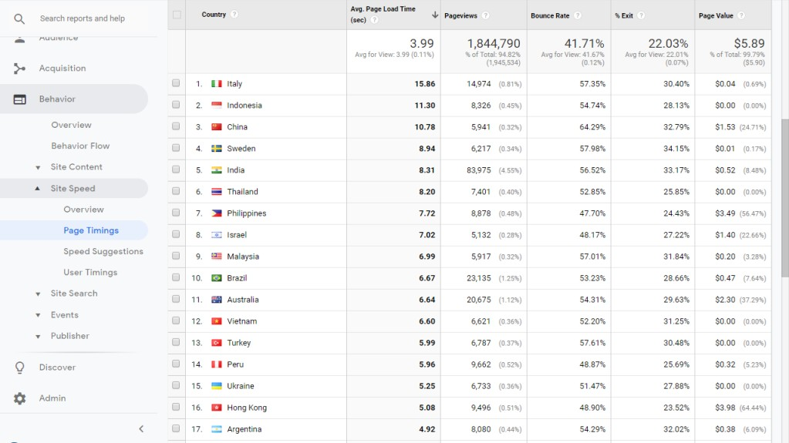

|  |  |  |
| --- | --- | --- |
| COUNTRY | BROWSER | % SESSIONS WITH THAT BROWSER |
| Italy | Chrome | 75% |
| Indonesia | Chrome | 75% |
| China | Chrome | 85% |
| Sweden | Chrome | 74% |
| India | Chrome | 84% |
| Thailand | Chrome | 75% |
| Philippines | Chrome | 84% |
| Israel | Chrome | 88% |
| Malaysia | Chrome | 78% |
| Brazil | Chrome | 86% |

# Finding 5: Social Media and Display Campaigns

.

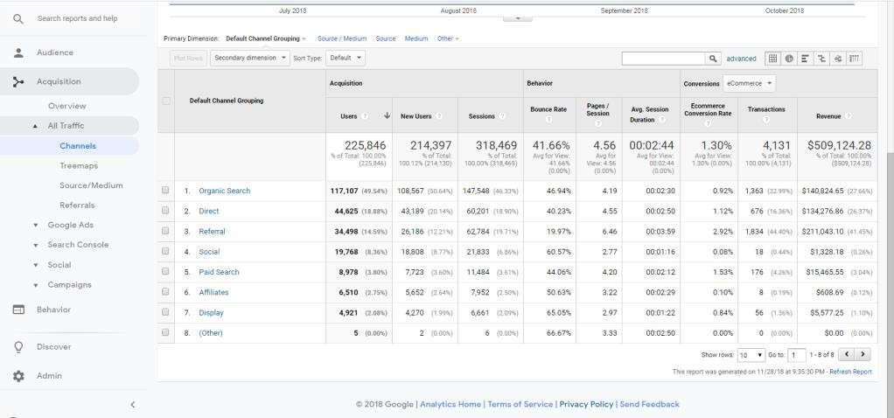

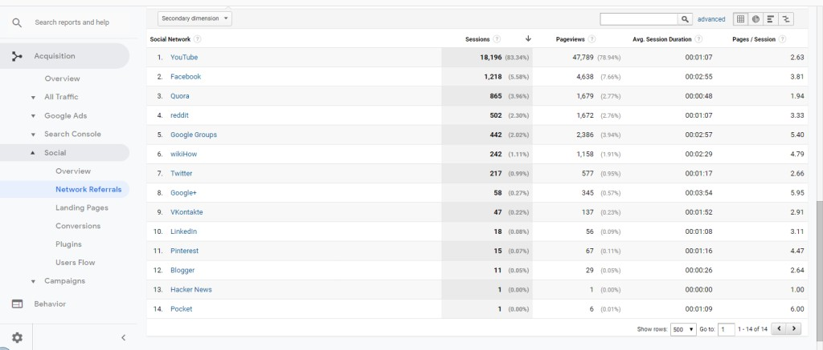

# Finding 6: Strong Ad Period

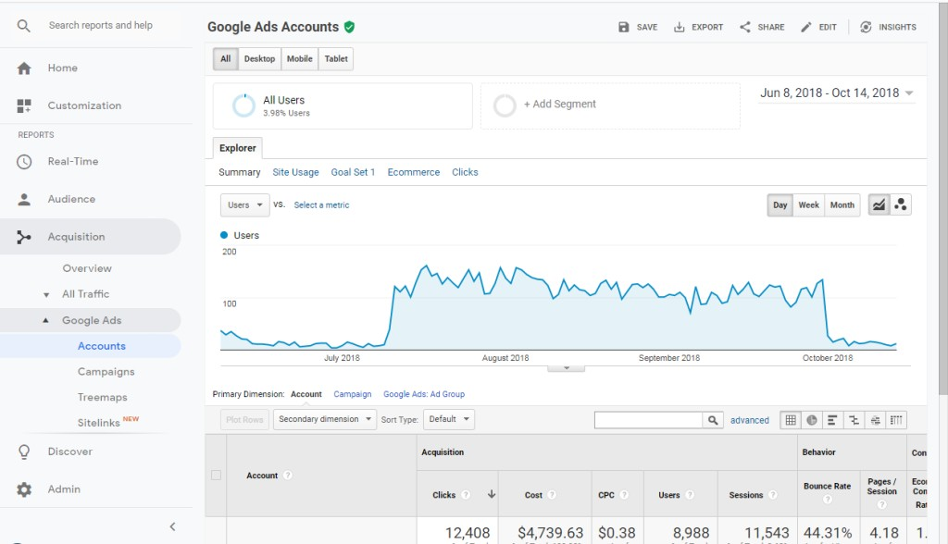

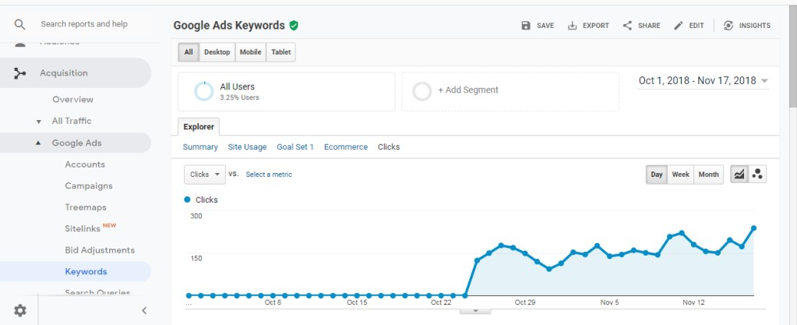

1. **Interpreting the results:**

We interpreted the results of the website traffic analysis, identified areas for improvement, and provided recommendations for optimizing website content, design, and functionality.

By following this methodology, we were able to collect and analyze website traffic data for the Google Analytics demo account for GA4 - Google Merch Shop, and provide valuable insights into user behavior and engagement. This methodology can be applied to other websites and businesses to track and measure website performance and improve user experience.

# Results and Analysis:

* 1. The trend and average calculations may be skewed by bulk buyers. While revenue is decreasing, the impact of large purchases can overshadow daily activity, making it look like sales are down if no bulk purchases occur. Bulk buyers have different motivations than individual shoppers who buy a single gift.
  2. Transactions are clustered in certain hours due to various factors. The store has many impulse buy items, and shoppers may arrive with a specific product category in mind but become convinced by the store's branding and quality as the best offer. Shoppers also come to the site determined to buy something branded as Google, YouTube, etc.
  3. YouTube dominates social media referrals since the store sells YouTube merchandise and it is a Google property. Other networks such as wikiHow and Quora, not known as visual mediums, are also surprisingly present, suggesting that users who use the search engine to learn valuable information may be more willing to show their gratitude with branded merchandise.

# Interpretation and Recommendations:

1. Consider reintroducing NEST branded merchandise to the store in order to re-attract previous NEST buyers who may be checking back periodically for new products.
2. Take steps to better understand Bulk Buyers, such as sponsoring their events or offering bundled packages. These buyers likely have different motivations than individual shoppers, so understanding their needs and preferences could lead to increased sales.
3. Given that users are willing to spend significant time on the site, it is important to ensure that page loading times are optimized for all countries, even those with strong ties to Google brands. Display ads can be effective in overcoming language or technological barriers that may be slowing down the site.

# Conclusion:

The analysis of the GA4-Google Merchandise Store traffic data revealed several key insights and recommendations. The presence of bulk buyers skewed the automatically calculated trends and averages, which should be taken into account when interpreting the data. The clustering of transactions in certain hours was likely due to impulse purchases and the store's branding and quality offering. To optimize the website, it is recommended to re- acquire NEST buyers by reintroducing NEST branded merchandise, seek to understand bulk buyers through sponsoring events or offering bundled packages, optimize page loading times for all countries, and utilize display ads to overcome language or technological barriers.

These recommendations aim to increase sales and improve the overall user experience of the website.

# References:

Analytics | Pages and screens: Page title and screen class (google.com) [[GA4] Demo account - Analytics Help (google.com)](https://support.google.com/analytics/answer/6367342?hl=en&zippy=%2Cin-this-article)

[What Is Google Analytics & Why Do You Need It? (semrush.com)](https://www.semrush.com/blog/beginners-definitive-guide-to-google-analytics/?kw=core_bu_341&cmp=ROW_SRCH_DSA_Blog_Core_BU_BING&label=dsa_pagefeed&Network=o&Device=c&utm_content&kwid=dat-2332957515843535%3Aloc-90&cmpid=412653544&agpid=1298523565796483&BU=Core&extid&adpos&msclkid=a13d1a184319120d3ca07e417e6ea3ea&utm_source=bing&utm_medium=cpc&utm_campaign=ROW_SRCH_DSA_Blog_Core_BU_BING&utm_term=core_bu_341) [Analytics Academy (google.com)](https://analytics.google.com/analytics/academy/)

[Step by Step Google Analytics Tutorial for Beginners (2023) (firstsiteguide.com)](https://firstsiteguide.com/google-analytics-for-wordpress/)