ASSIGNMENT – 6
43. RESEARCH PAPER TRACKING AND RECOMMENDATION TOOL
OBJECT I PICKED – RESEARCH PAPER

- State chart diagram
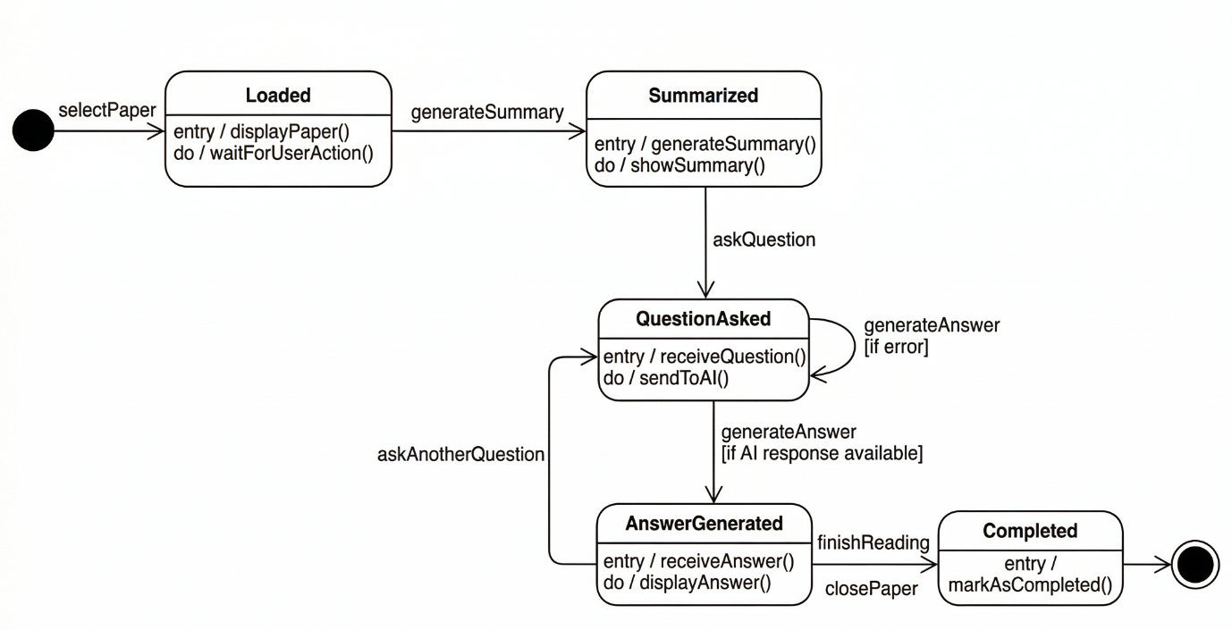
- Activity diagram
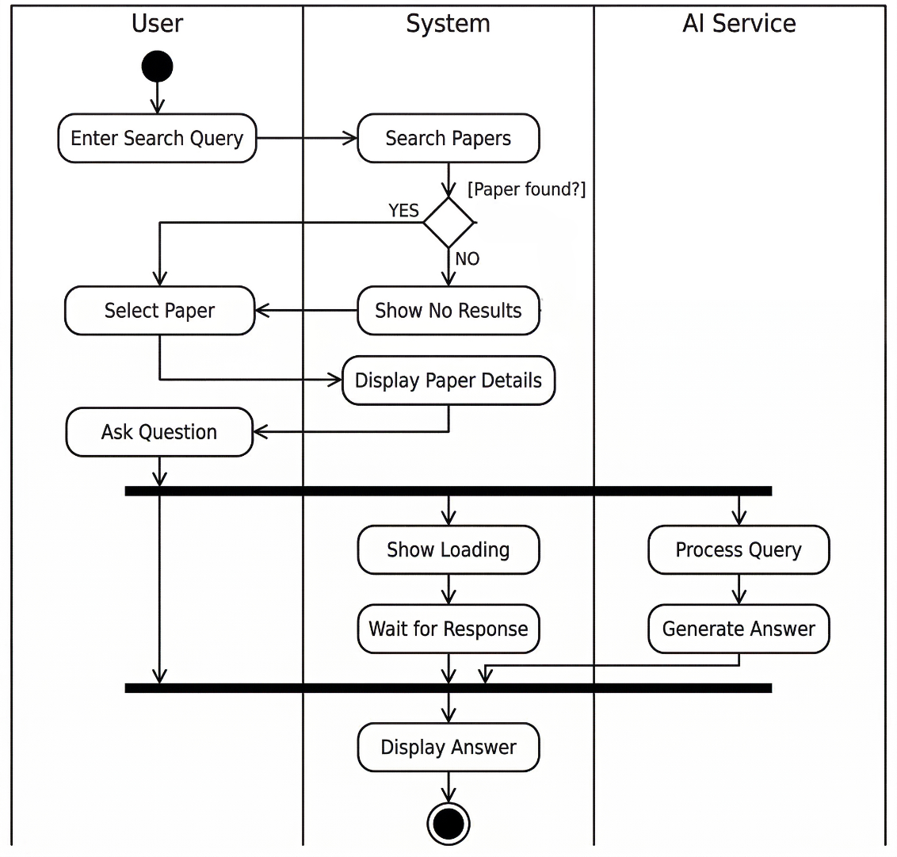

- Component diagram
