CLASS AND SEQUENCE DIAGRAMS
43. RESEARCH PAPER TRACKING AND RECOMMENDATION TOOL

1. Class diagram
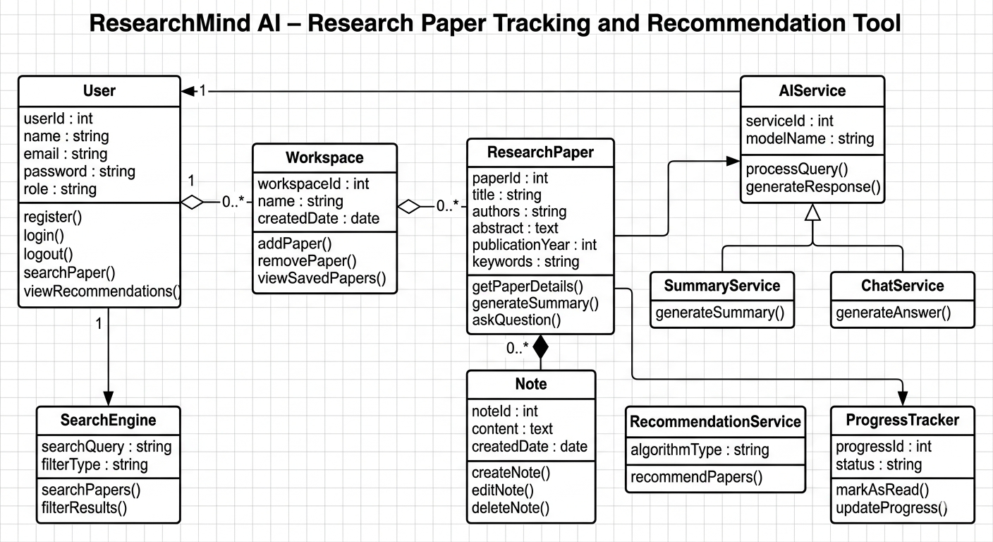

2. Sequence diagram
