PROJECT DOCUMENTATION

[ Project Title ]
Student Name(s) | [ Gayathri Srivalli Kajuluri - 2520080010 ]
Section / Branch | [ B.Tech AI&DS ]
Academic Year | [ e.g., Semester l 2025–26 ]
Course | FEDF
Course Code | 25CS1201E
Faculty Guide | - Shiva Krishna Assistant Professor ]
Date of Submission | [ 19/06/26 ]

Table of Contents
(Update in MS Word: Right-click → Update Field → Update entire table)

Table of Contents 2
Abstract 4
Chapter 1: Introduction 5
1.1 Problem Statement 5
Large airports often create navigation challenges for passengers due to their complex layouts and multiple facilities. Travelers frequently struggle to locate gates, lounges, restaurants, parking areas, and other services within limited time. Existing solutions may not provide an intuitive and interactive navigation experience. Therefore, a React.js-based Single Page Application is developed to offer real-time guidance, route visualization, and accessibility support for airport passengers. 5
1.2 Objectives 5
1.3 Scope 5
Chapter 2: Requirements 6
2.1 Functional & Non-Functional Requirements 6
2.2 Use Case Summary 6
Chapter 3: System Design 8
3.1 System Architecture 8
3.2 Component Hierarchy 8
3.3 Route Map 8
3.4 UI Wireframes 8
Chapter 4: Implementation 10
4.1 Technology Stack 10
4.2 Key Modules 10
4.2.1 Routing Module 10
4.2.2 Form Engineering 10
4.2.3 Accessibility 10
4.2.4 Performance Optimizations 10
4.3 Challenges and Solutions 11
Chapter 5: Testing 12
5.1 Test Cases 12
Chapter 6: Results and Discussion 13
6.1 Screenshots 13
6.2 Discussion 13
Chapter 7: Conclusion and Future Work 14
7.1 Conclusion 14
The Airport Way Finding App UI was successfully developed using React.js and modern frontend technologies. All project objectives, including navigation support, route guidance, accessibility features, and responsive design, were achieved. The application provides a user-friendly solution for airport navigation and enhances passenger convenience. 14
7.2 Lessons Learned 14
7.3 Future Enhancements 14
Appendix 15
A. GitHub Repository 15
B. Installation 15
C. Individual Contribution (Group Projects) 15

Abstract
The Airport Way Finding App UI is a smart and interactive web application developed using React.js to help passengers navigate efficiently inside large airport environments. The system provides an interactive airport map that enables users to locate gates, lounges, restaurants, parking areas, restrooms, and other important facilities. Features such as point-of-interest search, route highlighting, floor selection, gate information, QR code scanning, favorites management, accessibility support, and live queue status updates improve the overall travel experience.
The project addresses the common problem of passenger confusion and navigation difficulties within airports. By offering clear directions, real-time location assistance, and a user-friendly interface, the application helps travelers save time and reach destinations quickly. React.js was used to build reusable components, client-side routing, state management, and responsive user interfaces. The final outcome is a scalable and accessible Single Page Application that enhances airport navigation and improves passenger convenience.

Chapter 1: Introduction

1.1 Problem Statement

Large airports often create navigation challenges for passengers due to their complex layouts and multiple facilities. Travelers frequently struggle to locate gates, lounges, restaurants, parking areas, and other services within limited time. Existing solutions may not provide an intuitive and interactive navigation experience. Therefore, a React.js-based Single Page Application is developed to offer real-time guidance, route visualization, and accessibility support for airport passengers.

1.2 Objectives
- To design and implement a responsive Single Page Application (SPA) using React.js.
- To implement client-side routing using React Router v6.
- To build accessible and user-friendly interfaces.
- To apply performance optimization techniques.
- To provide interactive airport navigation and route guidance.
- To improve passenger convenience through real-time airport information and accessibility features.

1.3 Scope
The project focuses on the front-end development of an airport navigation system using React.js. It includes airport maps, route guidance, gate information, accessibility options, search functionality, and queue status displays. Mock APIs and sample datasets are used where real airport data is unavailable. The project does not include actual airport tracking hardware or real-time GPS integration.

Chapter 2: Requirements

2.1 Functional & Non-Functional Requirements
The table below lists the key requirements of the system:

ID | Type | Requirement | Priority | Category
R-01 | Functional | Users can navigate between pages without a full page reload (SPA routing). | High | Routing
R-02 | Functional | Dynamic content displayed based on URL parameters (e.g., /product/:id). | High | Routing
R-03 | Functional | Certain pages restricted to authenticated users (protected routes). | High | Routing
R-04 | Functional | All form fields validated with real-time feedback and clear error messages. | High | Forms
R-05 | Functional | Application is keyboard-navigable and screen-reader accessible (WCAG 2.1 AA). | Medium | Accessibility
R-06 | Functional | Heavy components loaded on demand to reduce initial bundle size (lazy loading). | Medium | Performance
R-07 | Functional | [ Your project-specific requirement ] | [ ] | [ ]
R-08 | Non-Functional | Initial page load must complete within 3 seconds on a standard 4G connection. | High | Performance
R-09 | Non-Functional | UI must be responsive across desktop (1280px+), tablet (768px), and mobile (375px). | High | Usability
R-10 | Non-Functional | All text must meet WCAG 2.1 AA contrast ratio (minimum 4.5:1 for normal text). | Medium | Accessibility

2.2 Use Case Summary
Use Case 1: Search Location
Actor: Passenger
Precondition: User accesses application
Main Flow:
- User enters location name.
- System searches airport database.
- Matching locations are displayed.
Outcome: User finds desired location.

Use Case 2: Route Navigation
Actor: Passenger
Precondition: Source and destination selected
Main Flow:
- User selects destination.
- System calculates route.
- Route is highlighted on map.
Outcome: User receives navigation guidance.

Use Case 3: View Gate Information
Actor: Passenger
Precondition: Flight information available
Main Flow:
- User searches flight.
- System retrieves gate details.
- Gate information displayed.
Outcome: Passenger reaches correct gate.

Chapter 3: System Design

3.1 System Architecture
User → React UI → React Components → State Management → API/Mock Data → Airport Information Database
[ Insert System Architecture Diagram here ]
Figure 3.1: System Architecture Diagram

3.2 Component Hierarchy

Component | Responsibility
App.jsx | Root component — holds <Routes> and global state/context
Navbar.jsx | Navigation bar — <Link> components for SPA navigation
ProtectedRoute.jsx | Guards private routes — redirects to /login if unauthenticated
ErrorBoundary.jsx | Catches runtime JS errors — shows fallback UI
[ PageName ].jsx | [ Describe what this page does ]
[ PageName ].jsx | [ Describe what this page does ]
[ ComponentName ].jsx | [ Reusable UI component — describe its purpose ]

3.3 Route Map

Path | Component | Access
/ | HomePage | Public
/login | LoginPage | Public
/dashboard | Dashboard | Protected (auth required)
/dashboard/profile | Profile (nested) | Protected
/[ route ]/:id | [ Component ] (dynamic) | [ Public / Protected ]
* | NotFoundPage | Public — 404 fallback

3.4 UI Wireframes
Insert screenshots/wireframes for:
- Home Page
- Airport Map Page
- Route Navigation Page
- Gate Information Page
- Accessibility Settings Page

[ Insert Wireframe — Home Page ]
Figure 3.2: Wireframe — Home Page
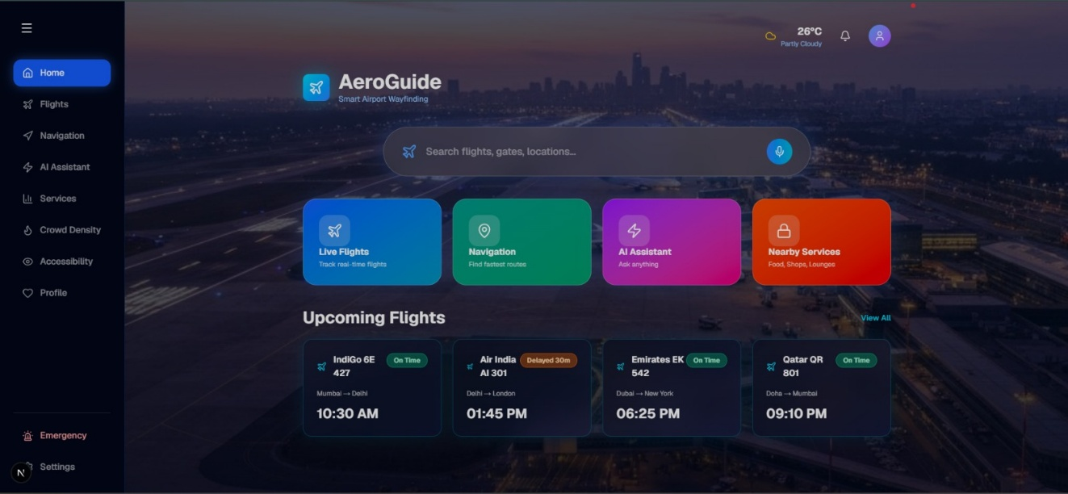

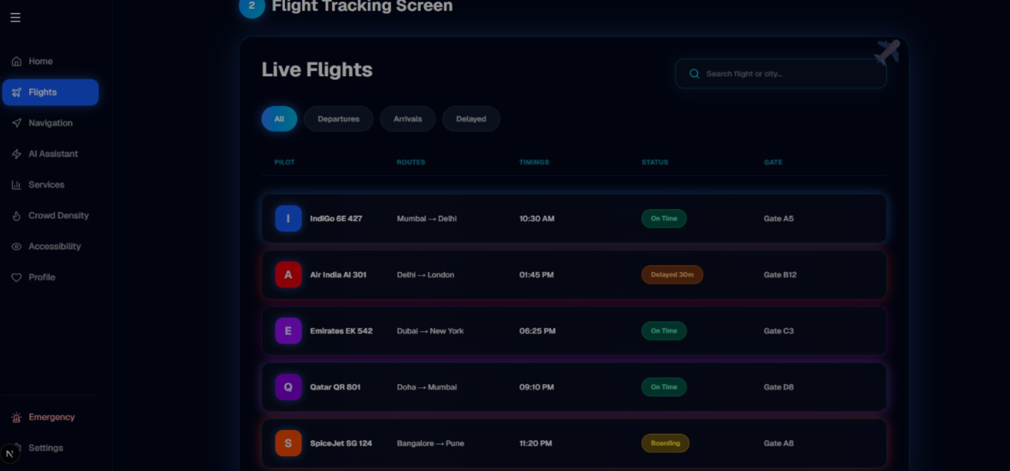
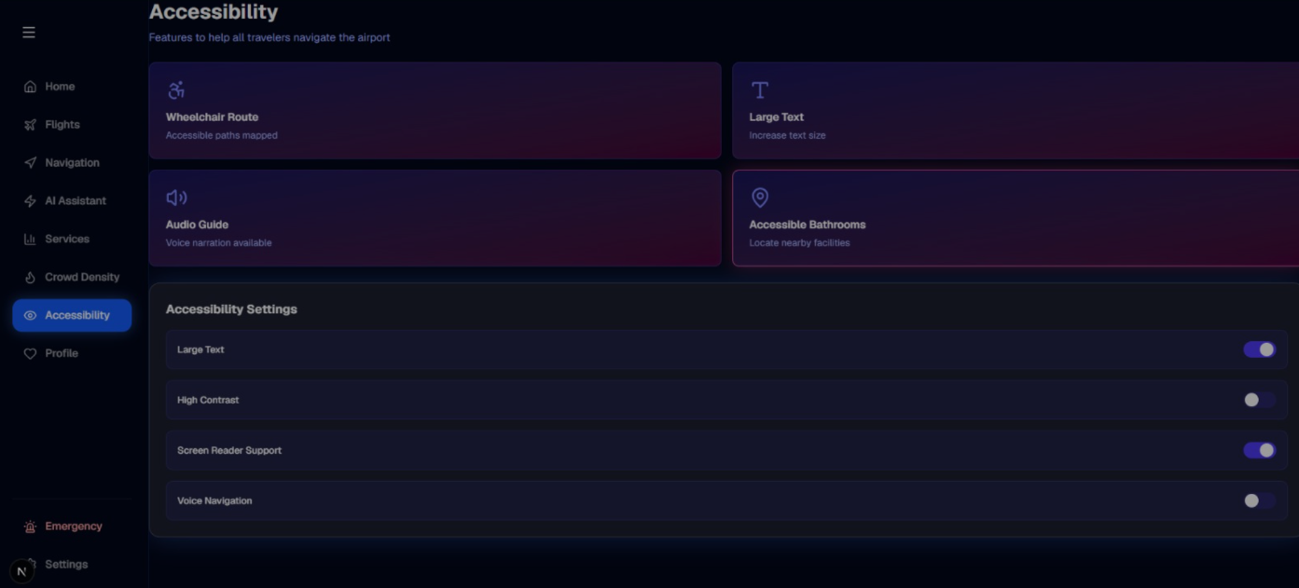
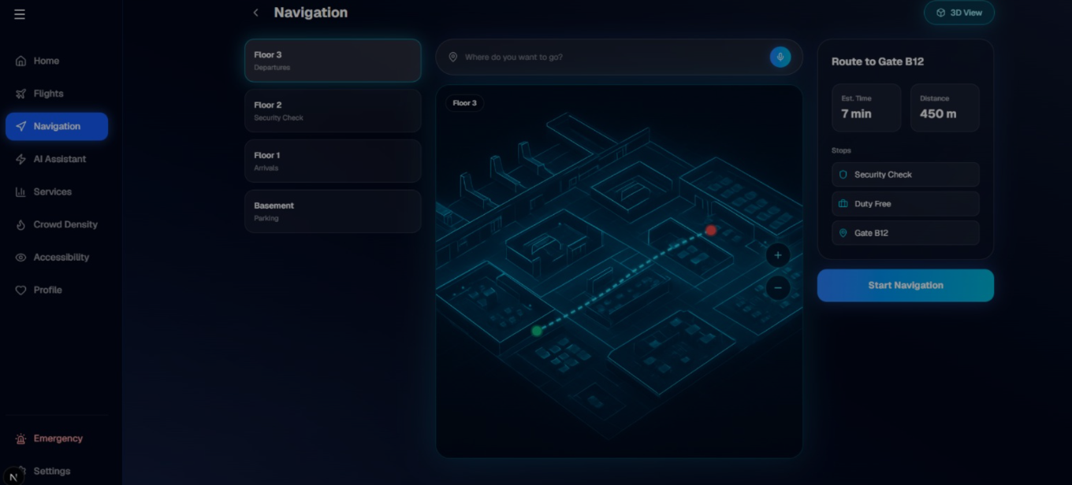
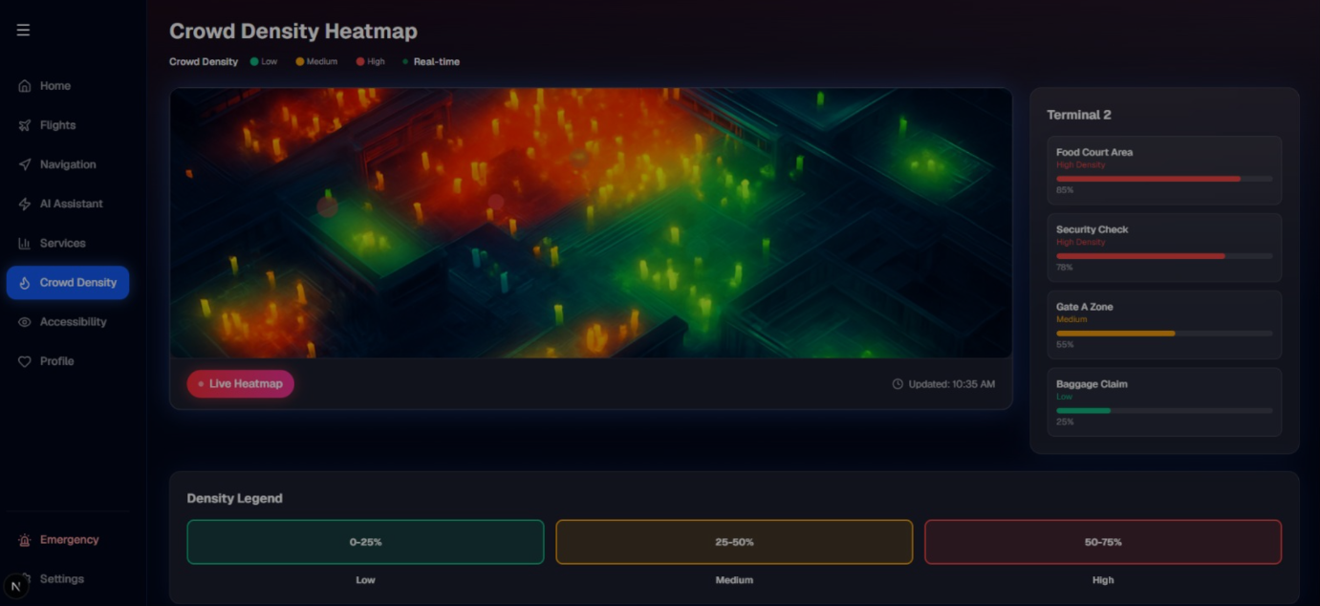

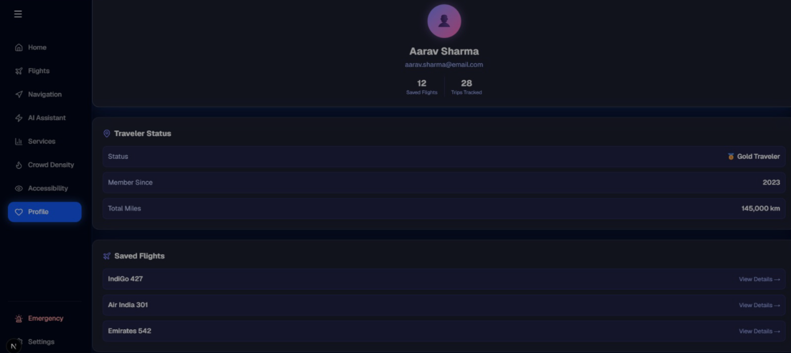

Chapter 4: Implementation

4.1 Technology Stack

Category | Technology | Purpose
UI Library | React.js 18 | Component-based SPA development
Routing | React Router v6 | Client-side navigation and protected routes
Build Tool | Vite | Fast development server and bundling
Styling | [ CSS Modules / Tailwind / Styled Components ] | [ Component-level or utility-first styling ]
State Management | [ useState / Context API / Redux ] | [ Global / local state management ]
API / Data | [ Fetch API / Axios / Mock Data ] | [ HTTP requests or mock server ]
Version Control | Git & GitHub | Source code management

4.2 Key Modules

4.2.1 Routing Module
SPA routing was implemented using React Router v6. The App.jsx file defines all routes using <Routes> and <Route> components. Nested routes are used for the dashboard, and a ProtectedRoute wrapper guards authenticated pages.
[ Paste a key code snippet (10–20 lines) from your App.jsx showing route definitions. Add inline comments explaining each line. ]

4.2.2 Form Engineering
All forms use the controlled form pattern — React state is the single source of truth for every input. A custom useFormValidation hook implements a per-field validation pipeline. Errors are displayed below each field using role='alert' for screen reader accessibility.
[ Paste a key code snippet from your form component or validation hook. ]

4.2.3 Accessibility
The following accessibility measures were implemented:
- ARIA roles and labels added to all interactive elements
- All buttons and links reachable via Tab key
- Modal dialogs implement focus trapping and restore focus on close
- Color contrast verified using Chrome DevTools Accessibility panel (min 4.5:1)
- [ Add any additional measure specific to your project ]

4.2.4 Performance Optimizations
The following performance techniques were applied:
- React.memo — applied to [ ComponentName ] to prevent unnecessary re-renders
- useMemo — used in [ ComponentName ] to cache [ computation ]
- useCallback — used in [ ComponentName ] to memoize [ function name ]
- React.lazy + Suspense — [ ComponentName ] is lazy-loaded for code splitting
- [ Any other optimization applied ]

4.3 Challenges and Solutions

Challenge | Solution Adopted
Managing form state across multiple fields without repetition | Created a generic useFormValidation hook with a validate() function per field
Preventing child re-renders when parent unrelated state changes | Used React.memo paired with useCallback for passed functions
[ Describe a challenge you faced ] | [ Describe how you solved it ]
[ Describe a challenge you faced ] | [ Describe how you solved it ]

Chapter 5: Testing

5.1 Test Cases

TC ID | Module | Test Description | Expected Result | Status
TC-01 | Routing | Navigate to /about — verify About page renders | About component shown; URL = /about | Pass ✅
TC-02 | Routing | Access /dashboard without login | Redirected to /login | Pass ✅
TC-03 | Forms | Submit form with empty required field | Error message displayed below field | Pass ✅
TC-04 | Forms | Submit form with invalid email format | 'Enter a valid email' error shown | Pass ✅
TC-05 | Accessibility | Navigate all interactive elements via Tab key | All elements reachable; focus ring visible | Pass ✅
TC-06 | Performance | Navigate to a lazy-loaded route for the first time | Suspense fallback shown; component loads | Pass ✅
TC-07 | [ Module ] | [ Describe your test case ] | [ Expected result ] | [ Pass/Fail ]
TC-08 | [ Module ] | [ Describe your test case ] | [ Expected result ] | [ Pass/Fail ]

Chapter 6: Results and Discussion

6.1 Screenshots
[ Insert screenshots of your working application. Add a figure number and caption for each. Minimum: Home page, form with validation errors, and the protected page. ]

[ Insert Screenshot — Home Page ]
Figure 6.1: Home Page — Desktop View

[ Insert Screenshot — Form with Validation Errors ]
Figure 6.2: Registration Form — Validation Error Surfaces

6.2 Discussion
The Airport Way Finding App UI successfully provides an intuitive and efficient navigation experience for airport passengers. The React.js component-based architecture enabled modular development and code reusability. Features such as route highlighting, facility search, gate information, and accessibility support improved usability.
Performance optimization techniques including lazy loading, memoization, and efficient state management resulted in faster page rendering and smoother user interactions. Although the system currently uses mock airport data, it provides a strong foundation for future integration with real-time airport information systems.

Chapter 7: Conclusion and Future Work

7.1 Conclusion

The Airport Way Finding App UI was successfully developed using React.js and modern frontend technologies. All project objectives, including navigation support, route guidance, accessibility features, and responsive design, were achieved. The application provides a user-friendly solution for airport navigation and enhances passenger convenience.

7.2 Lessons Learned
- Learned component-based architecture in React.
- Learned React Router implementation.
- Learned state management techniques.
- Learned responsive UI design.
- Learned performance optimization methods.

7.3 Future Enhancements
- Real-time airport data integration.
- Live flight tracking.
- Indoor GPS navigation.
- Multi-language support.
- AI-powered route recommendations.
- Push notifications for gate changes.
- Integration with airport management systems.

Appendix

A. GitHub Repository
Project Repository URL:
https://github.com/gayathrisrivalli0612/FEDF-UIE.git

B. Installation
- Clone: git clone https://github.com/[ username ]/[ repo ].git
- Navigate: cd [ repo-name ]
- Install dependencies: npm install
- Start dev server: npm run dev
- Open in browser: http://localhost:5173

C. Individual Contribution (Group Projects)

Student Name | Roll Number | Modules / Contributions
[ Name 1 ] | [ Roll No ] | [ e.g., Routing, Protected Routes, Navbar ]
[ Name 2 ] | [ Roll No ] | [ e.g., Form Engineering, Validation Hook ]
[ Name 3 ] | [ Roll No ] | [ e.g., Accessibility, Performance Tuning ]
[ Name 4 ] | [ Roll No ] | [ e.g., Testing, Documentation ]

