MODULE 1

Analysis of Alan Turing’s Contribution to Artificial Intelligence

1. Introduction
Alan Turing is universally acknowledged as one of the principal architects of theoretical computer science and artificial intelligence. His intellectual contributions transcended mathematics and extended into logic, philosophy of mind, cryptography, and early computational engineering. Turing did not merely propose isolated ideas; he constructed a rigorous formal framework that defined what computation is, what machines can theoretically achieve, and where their limitations lie.
Artificial Intelligence (AI), as a discipline concerned with replicating or simulating intelligent behavior through computational systems, is fundamentally rooted in Turing’s formalization of algorithmic processes. By establishing a mathematical theory of computation, defining undecidability, and reframing the philosophical question of machine intelligence into an operational test, Turing laid the epistemic and structural foundation upon which contemporary AI systems — including deep learning models — continue to operate.
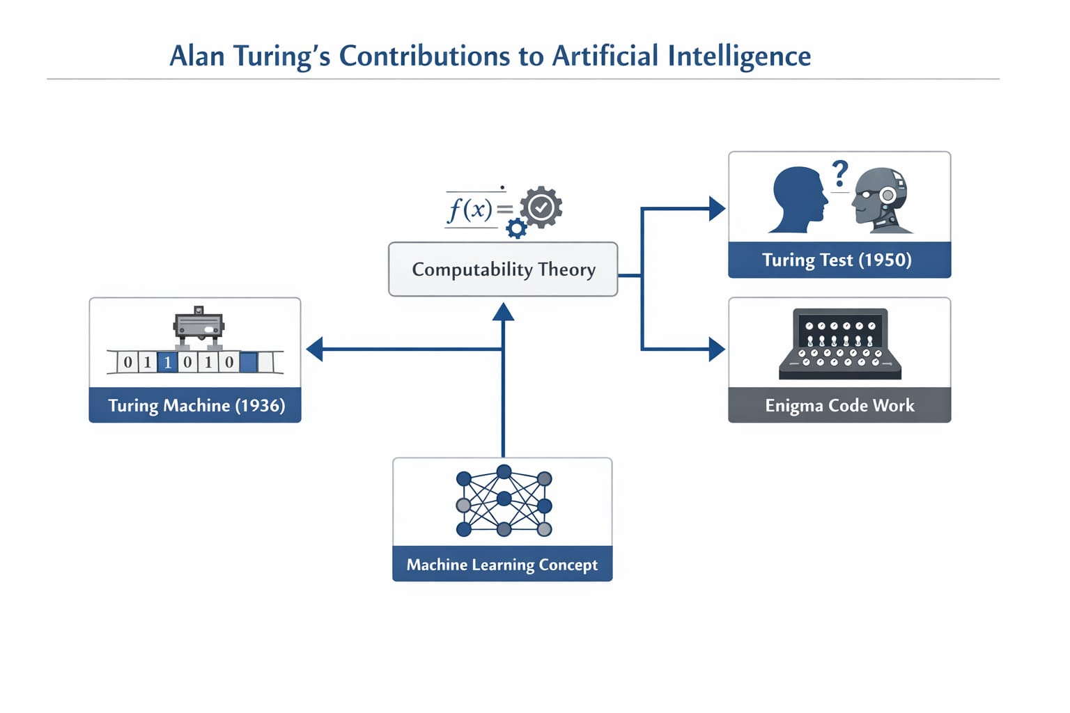
2. Theoretical Foundation of Computation (1936)The Universal Turing Machine
In 1936, Turing published his seminal paper “On Computable Numbers, with an Application to the Entscheidungsproblem.” In this work, he introduced the abstract computational device now known as the Turing Machine.
A Turing Machine is defined by:
An infinite tape serving as unbounded memory
A read/write head that scans symbols
A finite set of internal states
A transition function mapping state-symbol pairs to actions
This construct was not intended as a physical machine but as a formal abstraction capable of capturing the notion of mechanical procedure or algorithm.
The most revolutionary extension of this idea was the Universal Turing Machine (UTM) — a single machine capable of simulating any other Turing Machine. This concept introduced the theoretical blueprint for modern programmable computers, where hardware remains fixed while software determines behavior.
Technical Significance
Provided a precise definition of effective computation
Formalized algorithmic procedures mathematically
Established the universality principle in computation
Contributed to the Church–Turing Thesis (that any effectively calculable function is computable by a Turing Machine)
Contribution to AI
Artificial Intelligence depends intrinsically on symbolic and algorithmic manipulation. Without a formal definition of computation, the very concept of machine intelligence would lack rigor. Turing’s model:
Enabled formal reasoning about machine-based cognition
Established the theoretical foundation for automata theory and formal languages
Influenced computational complexity, which shapes AI feasibility analysis
Defined the computational substrate underlying symbolic AI systems
Thus, AI exists within the computational universe Turing mathematically defined.
3. Computability and Decidability Theory
Turing demonstrated that certain problems are fundamentally undecidable. The most notable example is the Halting Problem, which proves that no general algorithm can determine for every possible program-input pair whether the program will halt or run indefinitely.
AI Relevance
This discovery has deep implications for artificial intelligence:
Establishes intrinsic limits of automated reasoning
Demonstrates that complete algorithmic omniscience is impossible
Influences formal verification and AI safety research
Frames constraints on Artificial General Intelligence (AGI)
Understanding machine intelligence requires understanding not only capabilities but also inherent limitations. Turing’s undecidability results serve as boundary conditions for AI research, particularly in discussions about autonomy and self-modifying systems.
4. The Turing Test (1950)
In 1950, Turing published “Computing Machinery and Intelligence” in the journal Mind. Instead of attempting to define “thinking,” he proposed an operational and behavior-based criterion for intelligence — now known as the Turing Test, or the Imitation Game.
Structure of the Test
A human interrogator communicates via text interface
One participant is human
One participant is a machine
If the interrogator cannot reliably distinguish between them, the machine is considered intelligent
Technical Importance
Shifted AI from metaphysical speculation to empirical evaluation
Emphasized linguistic competence as a proxy for cognition
Stimulated research in Natural Language Processing (NLP)
Provided the first benchmark for machine intelligence
The Turing Test reframed intelligence as observable behavior rather than internal consciousness. This behavioral operationalization profoundly influenced chatbot development, conversational AI, and human-computer interaction paradigms.
However, it also sparked philosophical debate regarding whether imitation constitutes genuine cognition.
5. Early Concepts of Machine Learning
Turing anticipated the limitations of directly programming adult-level intelligence. He proposed instead the construction of a “child machine” capable of learning through experience.
Key conceptual innovations included:
Adaptive modification of internal states
Learning through reinforcement mechanisms (reward and punishment)
Experience-driven behavioral refinement
These ideas foreshadowed:
Reinforcement Learning
Neural Networks
Evolutionary Computation
Adaptive Algorithms
This shift from static symbolic systems to adaptive, learning-based systems marked a conceptual transformation in AI. Turing’s proposal anticipated modern machine learning architectures decades before computational resources made them feasible.
6. Contributions to Cryptanalysis and Applied Computation
During World War II at Bletchley Park, Turing played a pivotal role in breaking the German Enigma cipher. He designed the Bombe machine to automate cryptanalytic reasoning.
AI Relevance
Demonstrated mechanization of logical inference
Applied probabilistic reasoning to large-scale computation
Showed feasibility of automated pattern detection
Though primarily cryptographic, this work exemplified machine-based problem solving in complex domains — an early manifestation of applied computational intelligence.
7. Turing’s Vision of Artificial Intelligence
Turing engaged directly with objections to machine intelligence, including:
Theological objection
Consciousness argument
Lady Lovelace objection (machines cannot originate ideas)
He argued that creativity and intelligence need not require metaphysical consciousness. By anticipating these critiques, Turing effectively established the philosophical groundwork for AI ethics, cognitive modeling, and machine creativity research.
His predictions included:
Machines surpassing human intelligence in narrow domains
Learning-based adaptive systems
Creative computational processes
These forecasts align closely with modern developments in generative AI and domain-specific superhuman systems.
8. Technical Impact on Modern AI
Turing’s intellectual legacy permeates multiple AI subfields:
Automata Theory
Computational Complexity
Formal Language Theory
Symbolic AI
Cognitive Modeling
Artificial Neural Networks
AI Evaluation Metrics
Even deep learning systems — though statistical rather than symbolic — operate within the universal computational paradigm he established. Every modern AI architecture is ultimately executable on a universal computational machine.
9. Critical Analysis of His Contributions
Strengths
Provided formal mathematical grounding for computation
Introduced measurable criteria for machine intelligence
Established theoretical limits of algorithmic reasoning
Anticipated adaptive and learning-based AI
Limitations
Turing Test evaluates behavioral imitation rather than intrinsic cognition
Does not address subjective consciousness or qualia
Focused primarily on symbolic computational frameworks
Did not foresee large-scale statistical data-driven AI
Despite these limitations, his conceptual architecture remains foundational and indispensable.
10. Long-Term Influence on Artificial General Intelligence (AGI)
Turing’s work remains central to discussions on:
Artificial General Intelligence
Machine consciousness
Algorithmic autonomy
AI alignment and safety
Computational theories of mind
The Church–Turing Thesis continues to inform debates about whether human cognition itself is computationally reducible. His framework underlies contemporary inquiries into whether intelligence is substrate-independent.
11. Comparative Analysis: Alan Turing vs. John McCarthy in AI
11.1 Background Overview
Alan Turing
Formalized computation
Proposed the Turing Machine
Introduced behavioral intelligence testing
Focused on conceptual foundations
John McCarthy
Coined the term “Artificial Intelligence” (1956)
Organized the Dartmouth Conference
Developed the LISP programming language
Advanced symbolic reasoning systems
11.2 Comparison of Contributions
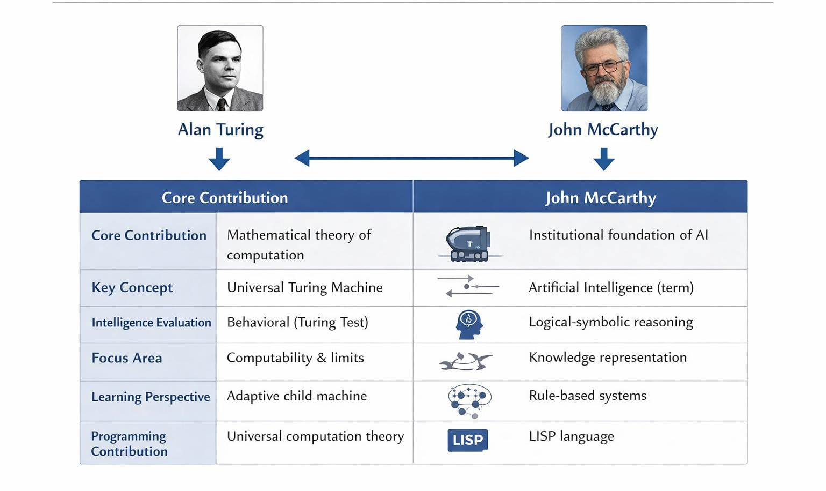
Aspect
Alan Turing
John McCarthy
Core Contribution
Mathematical theory of computation
Institutional foundation of AI
Key Concept
Universal Turing Machine
Artificial Intelligence (term)
Intelligence Evaluation
Behavioral (Turing Test)
Logical-symbolic reasoning
Focus Area
Computability & limits
Knowledge representation
Learning Perspective
Adaptive child machine
Rule-based systems
Programming Contribution
Universal computation theory
LISP language
Nature of Work
Foundational & philosophical
Structural & engineering-oriented
11.3 Philosophical vs. Engineering Approach
Turing approached AI through philosophical inquiry and mathematical abstraction. He asked whether machines can think and reformulated the problem behaviorally.
McCarthy approached AI as an engineering discipline, emphasizing formal logic, symbolic reasoning, and institutional research structures.
Turing defined the computational possibility space; McCarthy constructed research methodologies within it.
11.4 Impact on Modern AI
Influence of Turing:
Computational models
AI evaluation paradigms
Theoretical AI safety discussions
Learning-based AI foundations
Influence of McCarthy:
Expert systems
Symbolic reasoning
AI programming environments
Institutional AI research
11.5 Symbolic AI vs. Learning-Based AI
Turing anticipated adaptive intelligence mechanisms.
McCarthy emphasized symbolic logic systems.
Modern AI integrates both paradigms:
Deep Learning (closer to Turing’s adaptive vision)
Knowledge Graphs and Logical Systems (closer to McCarthy’s symbolic AI)
11.6 Long-Term Influence Comparison
Dimension
Turing
McCarthy
Theoretical Depth
Extremely foundational
Strong but field-specific
Practical Tools
Indirect
Direct (LISP)
AI Philosophy
Defined intelligence
Defined AI discipline
Influence on ML
Conceptual precursor
Limited
Influence on Symbolic AI
Indirect
Direct pioneer
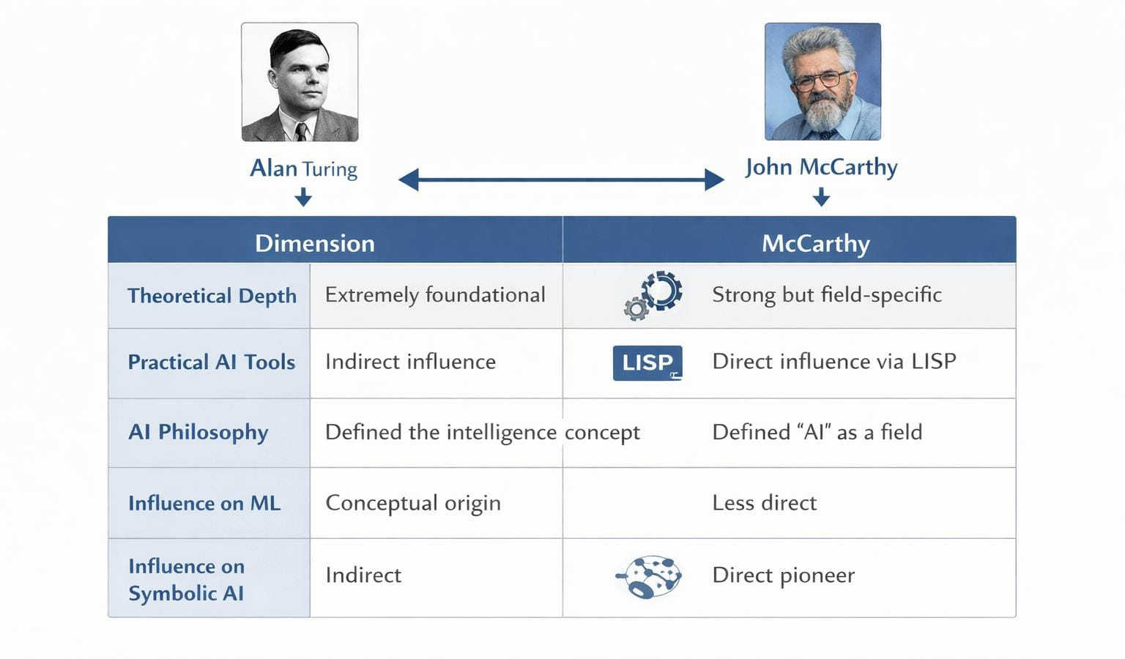
11.7 Critical Evaluation
Turing established the computational ontology within which AI operates. Without his theory of universal computation, programmable intelligence would lack formal legitimacy.
McCarthy operationalized AI as a scientific discipline by institutionalizing research, formalizing symbolic reasoning, and developing programming infrastructure.
Thus:
Turing → Architect of computational foundations
McCarthy → Architect of disciplinary AI structure
Their contributions are complementary and collectively indispensable.
12. Conclusion
Alan Turing’s contributions represent the intellectual genesis of Artificial Intelligence. By mathematically defining computation, establishing algorithmic limits, proposing behavioral evaluation criteria, and anticipating adaptive learning systems, he constructed the conceptual superstructure upon which AI is built.
His theoretical insights remain embedded in every computational system. Modern AI — whether symbolic reasoning engines or large-scale neural networks — operates within the universal computational paradigm he conceptualized.
For this reason, Alan Turing is not merely a contributor to AI; he is its foundational architect, whose ideas continue to delimit and enable the future trajectory of machine intelligence.

