MODULE 2
Data Ethics Case Study
The Cambridge Analytica – Facebook Data Misuse Scandal (2018)
1. Introduction
In the modern digital ecosystem, data plays a crucial role in shaping services, business decisions, and social interactions. Organizations increasingly rely on personal data to design targeted systems, personalized advertisements, and predictive models. While such data-driven innovation offers many benefits, it also introduces serious ethical challenges when data is collected or used irresponsibly.
Data ethics focuses on the moral responsibilities associated with data handling, including fairness, transparency, privacy, and accountability. When these principles are ignored, the misuse of data can lead to large-scale societal harm.
One of the most widely cited examples of unethical data practices is the 2018 scandal involving Cambridge Analytica and Facebook. This case revealed how personal data was exploited for political purposes and exposed serious weaknesses in data governance frameworks.
2. Background of the Incident
The Cambridge Analytica scandal came to public attention in early 2018 through investigative journalism and regulatory inquiries. Cambridge Analytica was a political consulting firm that specialized in data-driven election campaigning. It claimed to use psychological and behavioral data to influence voter behavior.
The controversy arose when it was discovered that the firm had obtained personal data of approximately 87 million Facebook users without their explicit consent. This data was originally collected for academic research but was later repurposed for political profiling and targeted advertising.
The incident raised global concern because the data was allegedly used to influence major democratic processes, including the 2016 United States Presidential Election and the United Kingdom’s Brexit referendum. The scale of the data misuse and its political implications made this case a landmark event in discussions about data ethics and digital responsibility.
3. How the Data Misuse Occurred
The misuse of data occurred through a multi-step process involving technical loopholes, weak governance, and lack of oversight.
Step 1: App Installation
A third-party researcher developed a Facebook personality quiz application called “This Is Your Digital Life.” Users voluntarily installed the app and consented to share their personal data for research purposes.
Step 2: Excessive Data Collection
At the time, Facebook’s API policies allowed applications not only to collect data from users who installed the app but also from their friends. As a result, personal information of millions of users who never interacted with the app was collected without their knowledge.
Step 3: Unauthorized Data Sharing
The collected data was transferred to Cambridge Analytica, violating Facebook’s platform policies, which prohibited sharing data with external commercial entities.
Step 4: Psychological Profiling
Cambridge Analytica used the data to build psychographic profiles, categorizing individuals based on personality traits, political views, and emotional tendencies.
Step 5: Targeted Political Messaging
These profiles were then used to deliver highly targeted political advertisements designed to influence voter opinions and behavior.
4. Diagram: Data Flow and Governance Failure
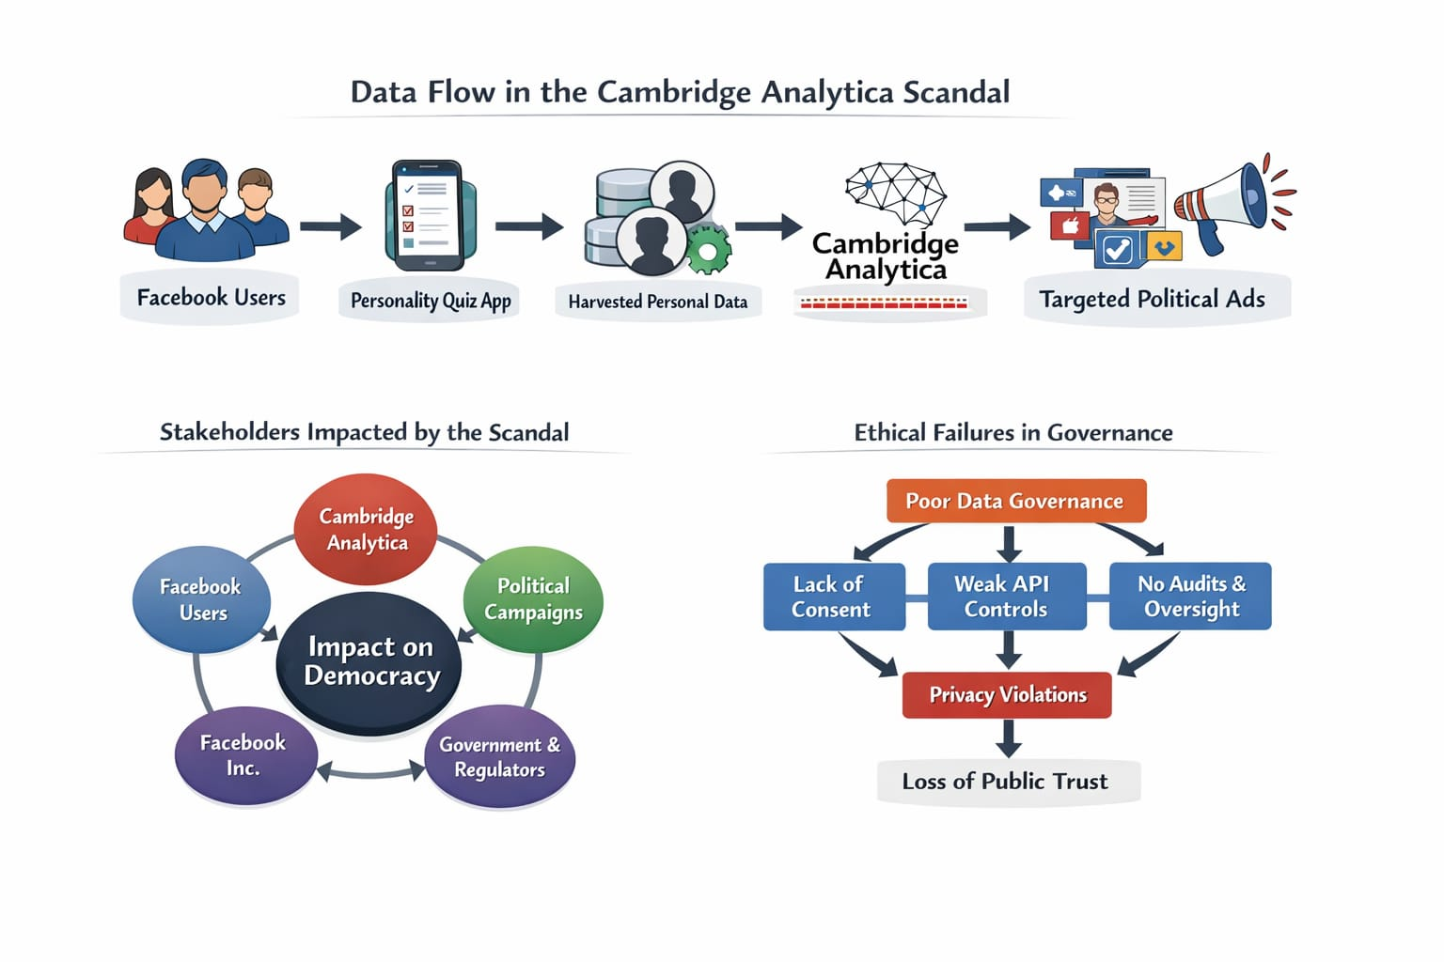
The diagram visually explains:
How data flowed from Facebook users to political campaigns
The role of third-party applications
Stakeholders affected by the misuse
Governance and ethical failures that led to privacy violations
This visual representation improves clarity and helps readers quickly understand the sequence of events and ethical breakdowns.
5. Ethical Issues Identified
5.1 Lack of Informed Consent
A fundamental ethical violation in this case was the absence of informed consent. While users agreed to share their data for a personality quiz, they were not clearly informed that their data would be used for political profiling. More importantly, friends of users did not provide any consent at all.
This violates the ethical principle that individuals should have control over how their personal data is collected and used.
5.2 Violation of Privacy Principles
Several core privacy principles were breached:
Transparency: Users were unaware of the true purpose of data usage
Purpose Limitation: Data collected for research was used for political campaigning
Data Minimization: Excessive data was collected beyond necessity
User Autonomy: Individuals had no control over political use of their data
These violations significantly eroded user trust in digital platforms.
5.3 Manipulation Through Micro-Targeting
The use of psychographic profiling enabled political campaigns to tailor messages to specific psychological traits. This raised ethical concerns because voters could be manipulated through emotionally charged or misleading information.
Such practices challenge the fairness of democratic processes, as voters may be influenced without being aware of the manipulation.
5.4 Weak Corporate Governance
The scandal also highlighted failures in corporate governance. Facebook did not adequately monitor third-party developers or enforce compliance with its data usage policies. Despite being aware of potential misuse, timely action was not taken to protect user data.
This shows that ethical responsibility extends beyond technology to organizational decision-making and accountability.
6. Legal and Regulatory Consequences
Following global investigations:
Facebook was fined $5 billion by the U.S. Federal Trade Commission (FTC).
Cambridge Analytica ceased operations in 2018.
Facebook introduced stricter API controls and data access limitations.
Governments worldwide strengthened enforcement of data protection laws.
The incident accelerated awareness and enforcement of regulations such as the General Data Protection Regulation (GDPR).
7. How Better Governance Could Have Prevented the Incident
Effective governance mechanisms could have significantly reduced or prevented the misuse.
Strong Access Controls
Limiting third-party access to only essential user data would have prevented mass data harvesting.
Explicit Consent Mechanisms
Separate and clear consent for political use of data should have been mandatory.
Regular Audits and Monitoring
Continuous audits of third-party applications could have detected misuse early.
Data Minimization
Collecting only necessary data reduces the risk of misuse.
Ethical Oversight
Independent ethics committees could evaluate high-risk data projects before deployment.
8. Stakeholders Affected
The scandal affected multiple stakeholders:
Users whose privacy was violated
Political voters exposed to manipulation
Governments responsible for regulation
Social media companies facing trust loss
Democratic institutions impacted by unethical campaigning.
Conclusion
The Cambridge Analytica scandal stands as a defining example of unethical data use in the digital era. It demonstrated how weak governance, lack of transparency, and disregard for ethical principles can result in widespread privacy violations and societal harm.
This case emphasizes the need for robust data governance frameworks, ethical accountability, and regulatory oversight. Organizations handling personal data must ensure that innovation does not come at the cost of individual rights and democratic values.

