MODULE 3
Build a Complete ML Process Flow
1. Introduction to Machine Learning Process
1.1 What is Machine Learning?

Machine Learning is a subset of Artificial Intelligence (AI) that allows systems to learn from data and make predictions or decisions without explicit programming. ML systems identify patterns in data and use them to automate tasks that normally require human intelligence.

1.2 Importance of a Structured ML Process

A structured ML process ensures that projects are systematic, reproducible, and reliable. By following a step-by-step workflow, teams can reduce errors, improve accuracy, and make models ready for real-world deployment.

2. Problem Definition
2.1 Understanding the Problem

Defining the problem is the first critical step. Teams must clearly outline the objective, type of expected output, and scope of the project.

Key Questions:

What is the problem we are solving?

What type of output do we need (category, numeric value, grouping)?

What metric will define success?

2.2 Importance of Problem Definition

A well-defined problem guides:

Data collection strategy

Algorithm selection

Evaluation criteria
Without this, the project may fail or produce irrelevant predictions.

3. Data Collection
3.1 Identifying Data Sources

Data can be collected from:

Company databases

Surveys and questionnaires

IoT or sensors

Web APIs

Public datasets like Kaggle or UCI ML Repository

3.2 Ensuring Data Quality

High-quality data is essential for training effective ML models. It should be:

Accurate and clean

Representative of the problem

Sufficient in size for learning

3.3 Structuring Data

Collected data must be organized in a structured format for processing, with clearly labeled columns for each feature and target variable.

4. Feature Extraction
4.1 Identifying Relevant Features

Features are the attributes used by the model to make predictions. Choosing relevant features improves model performance.

Example: For a music recommendation system:

Time of listening

User mood

Language preference

4.2 Transforming Raw Data

Raw data often needs to be transformed into numerical or model-friendly formats:

Categorical features are encoded

Text or timestamp data may be converted into numbers

4.3 Creating New Features

Feature engineering can create new insights, e.g., combining Time and Mood to form “Energy Level” which can better predict music preference.

5. Data Preprocessing
5.1 Data Cleaning

Remove duplicates, handle missing values, and correct inconsistent data entries.

5.2 Data Transformation

Convert categories into numbers, normalize numeric values, and standardize features.

5.3 Feature Scaling

Scaling ensures that all features contribute equally to the model and prevents algorithms from being biased toward certain features.

6. Splitting Data
6.1 Training and Testing Sets

Divide the dataset into:

Training set: Used to train the model

Testing set: Used to evaluate model performance on unseen data

6.2 Importance of Data Split

This ensures that the model generalizes well to new data and does not memorize the training data (overfitting).

7. Algorithm Selection
7.1 Choosing Based on Problem Type

The type of problem determines which algorithm is suitable:

Classification → Decision Tree, KNN, Logistic Regression

Regression → Linear Regression, Random Forest

Clustering → K-Means, Hierarchical

7.2 Considerations in Selection

Dataset size

Feature types (categorical, numerical)

Model interpretability

Computational efficiency

8. Model Training
8.1 Learning Patterns

The training process adjusts the algorithm’s parameters to learn relationships between features and the target variable.

8.2 Handling Overfitting and Underfitting

Overfitting: Model memorizes training data but fails on new data

Underfitting: Model fails to capture the underlying patterns

Techniques like cross-validation or regularization can address these issues.

9. Model Testing
9.1 Using the Testing Set

The testing set contains unseen data to evaluate how well the model predicts outcomes.

9.2 Analyzing Predictions

Compare predicted outputs with actual results to identify accuracy and errors. This step ensures that the model is robust and reliable.

10. Model Evaluation
10.1 Metrics for Evaluation

Classification: Accuracy, Precision, Recall, F1 Score

Regression: Mean Squared Error, Root Mean Squared Error, R² Score

10.2 Decision Point

If the model meets performance criteria, it proceeds to deployment. If not, further tuning or feature adjustments are required.

11. Parameter Tuning and Iteration
11.1 Hyperparameter Adjustment

Hyperparameters like tree depth, learning rate, or number of neighbors can be tuned to improve model performance.

11.2 Iterative Improvement

Training, testing, and tuning are repeated until the model achieves the desired accuracy. This iterative approach is essential for robust machine learning systems.

12. Deployment and Monitoring
12.1 Deployment

Once the model is ready, it is deployed in real-world systems such as web apps, mobile apps, or cloud platforms.

12.2 Continuous Monitoring

After deployment, the model must be monitored for:
- Data drift (changes in input data patterns)
- Performance degradation
- Need for retraining
- This ensures the model remains accurate and reliable over time.

Flowchart Diagram
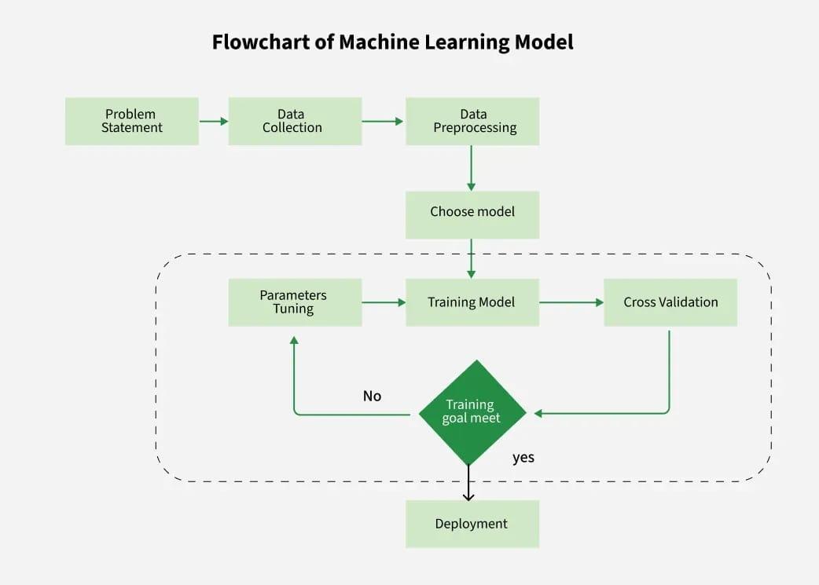

Flowchart Notes:

- Rectangles represent processes.
- Diamonds or decision points indicate evaluation checks.
- Arrows show flow and iterations.
- The loop emphasizes iterative improvement

13. Conclusion

- The group task demonstrates a complete Machine Learning project workflow, covering every critical step from data collection to deployment. By following this structured approach:
- Problem Definition ensures the team understands the objective and scope.
- Data Collection and Feature Extraction provide the foundation for accurate predictions.
- Algorithm Selection allows choosing the most suitable learning method for the problem type.
- Training and Testing teach the model to learn patterns and evaluate its ability to generalize.
- Evaluation and Parameter Tuning ensure the model reaches optimal performance.
- Deployment and Monitoring make the model functional in real-world scenarios and maintain long-term reliability.

Key insights from this task:

- Machine Learning is iterative; continuous evaluation and tuning improve model performance.
- High-quality data and meaningful features are critical for accurate predictions.
- Structured workflows like this mirror industry-standard practices, ensuring ML projects are systematic, reproducible, and effective.
- Monitoring post-deployment is essential to maintain model relevance as real-world data changes.

In summary, this task not only demonstrates the theoretical ML lifecycle, but also emphasizes practical considerations for implementing ML solutions in real-world applications. Following such a structured process ensures robust, reliable, and scalable machine learning systems that can adapt to new data and continue providing accurate predictions.

