INDIVIDUAL TASK 1
Comparison Between Human, Animal and Machine Intelligence
Introduction
Intelligence is the ability to learn, understand, think, and solve problems. Different living beings and systems show intelligence in different ways. Humans use intelligence to develop society, animals use it mostly for survival, and machines use programmed intelligence to perform tasks quickly.
In today’s world, understanding these three types of intelligence helps us see how technology and nature are different but also connected.
This document compares:
- Human Intelligence
- Animal Intelligence
- Machine Intelligence
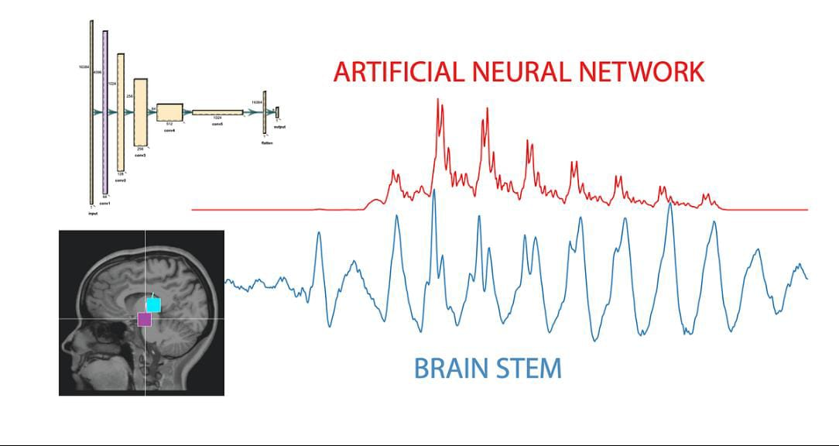
Types of Intelligence
- Human Intelligence

- Human intelligence is the most advanced form of intelligence known. Humans have the ability to think deeply, analyze situations, and make decisions based on logic and emotions.
- Humans can learn throughout their lives. Education, experience, observation, and communication all help humans grow intellectually.
- Another important feature of human intelligence is creativity. Humans create art, music, literature, science, and technology. Humans also have moral values and understand the difference between right and wrong.
Humans can imagine the future, plan long-term goals, and solve complex problems. However, humans can also make mistakes, forget things, and get emotionally affected.

- Animal Intelligence

- Animal intelligence is mainly related to survival. Animals use intelligence to find food, escape danger, and live in their environment.
- Many animals can learn from experience. For example, dogs can understand commands, monkeys can use objects as tools, and birds can build nests.
- Some animals also show memory and problem-solving ability. Dolphins, elephants, and crows are known to be very intelligent.
However, animals do not have the same level of reasoning, creativity, or moral understanding as humans. Their actions are mostly influenced by instinct and environmental needs.

- Machine Intelligence
- Machine intelligence is also called Artificial Intelligence. It is created by humans using computer programs and data.
- Machines do not have a biological brain. Instead, they use processors and algorithms to analyze information.
- Machine intelligence is very fast and accurate. Computers can process large amounts of data within seconds. Machines are used in banking, healthcare, education, transportation, and many other fields.
However, machines do not have emotions, self-awareness, or true understanding. They work only according to the instructions or data provided by humans.

Detailed Comparison Table

Aspect | Human Intelligence | Animal Intelligence | Machine Intelligence
Origin | Natural, developed through human evolution | Natural, developed through species evolution | Artificial, created by humans
Brain/System | Complex human brain | Simpler brain compared to humans | Computer processors and algorithms
Learning | Education, experience, observation | Experience and training | Data and machine learning
Creativity | Very high | Limited | Pattern-based output
Emotions | Present | Basic emotions | No emotions
Decision Making | Logical and emotional | Instinct-based | Programmed logic
Speed | Moderate | Moderate | Very fast
AdaptabilIty | Very high | Medium | Limited to programming
Moral Sense | Present | Not present | Not present

Real World Examples
Human Intelligence:
Examples include:
- Scientists developing new medicines
- Engineers building bridges
- Students learning new subjects
These activities require thinking, understanding, and creativity.
Animal Intelligence
Examples include:
- Birds building nests
- Dolphins communicating with sounds
- Dogs recognizing their owners
- Elephants remembering locations
These actions show learning and memory.
Machine Intelligence
Examples include:
- Voice assistants
- Self-driving systems
- Recommendation systems
- Chatbots
Machines analyze data and provide results quickly.

Illustration of Intelligence Levels
Humans → Thinking + Emotions + Creativity
Animals → Instinct + Learning
Machines → Data + Algorithms

Advantages of Each Type

Human Intelligence
- Creative thinking
- Emotional understanding
- Moral judgement
- Innovation
Animal Intelligence
- Strong survival skills
- Natural adaptation
- Quick reactions in environment
Machine Intelligence
- High speed
- Accuracy
- Large data processing
- Continuous work without fatigue

Limitations

Humans
- Can forget
- Can be emotional
- Physical limitations
Animals
- Limited reasoning
- Cannot develop technology
- Mostly instinct-driven
Machines
- No emotions
- No true understanding
- Dependent on humans

Conclusion
Human, animal, and machine intelligence are different in many ways. Human intelligence is the most flexible and creative. Animal intelligence is specialized for survival and adaptation. Machine intelligence is powerful in speed and data processing but lacks emotions and true understanding.
All three types of intelligence play important roles in the world. Humans create machines, animals maintain natural ecosystems, and machines help humans solve complex problems efficiently.

