HematoVision: Advanced Blood Cell Classification Using Transfer Learning
Abstract:
HematoVision is an advanced system developed for the automatic classification of blood cells using deep learning techniques. Blood cell classification is important for diagnosing many diseases, but manual analysis of blood smear images is time-consuming and prone to errors. This project uses transfer learning with pre-trained convolutional neural network models to improve classification accuracy. Models such as MobileNetV2 and Xception are used to extract important features from blood cell images. Image preprocessing and data augmentation techniques are applied to improve the model’s performance. The trained model classifies different types of blood cells effectively. Performance is evaluated using metrics like accuracy, precision, and recall. The results show that transfer learning helps achieve better accuracy with less training time. This system can assist medical professionals in faster and more reliable diagnosis of blood-related diseases.
Transfer Learning
Transfer learning is a technique that uses knowledge gained from a pre-trained model on one task to boost performance on a different but related task. It takes advantage of the learned features and representations from the pre-trained model, which can be applied to a new task. This approach helps overcome data limitations, speeds up training, and improves the performance of models on new tasks by leveraging the knowledge encoded in the pre-trained model.
Benefits of Transfer Learning
Transfer learning offers several benefits:
- Improved Performance: By leveraging pre-trained models that have been trained on large-scale datasets, transfer learning can help achieve higher performance on new tasks with limited available data.
- Faster Training: Transfer learning reduces the training time and computational resources required to build models from scratch, as the pre-trained model has already learned generic features that can be used as a starting point.
- Generalization: Transfer learning allows models to generalize better to new tasks by learning abstract and generic representations from a diverse range of data. This helps in capturing higher-level features that can be relevant across different tasks.
- Data Efficiency: With transfer learning, models can achieve good performance even with smaller datasets, as they can leverage the knowledge learned from large-scale datasets.
Overall, transfer learning is a powerful technique that enables the transfer of knowledge and representations learned from one task to another, leading to improved performance, faster training, and better generalization capabilities.
Project Overview
The project consists of the following key steps:
- Data Acquisition :
You can download the data from kaggle.
- Data Preprocessing
The image data is loaded and preprocessed using the ImageDataGenerator class from TensorFlow. Data is split into training and validation sets.
- Build Pretrained Model:
The MobileNetV2 model is loaded with pre-trained weights and frozen to retain its learned features. Additional layers are added to the model for classification purposes.
- Training the Model:
The model is trained using the training images and validated using the validation images. Training is performed for a specified number of epochs, and early stopping is applied to prevent overfitting.
- Evaluating Results:
The trained model is evaluated on the test data. Metrics such as loss, accuracy, and a classification report are computed. Additionally, a confusion matrix is plotted to analyze the model's performance.
Implementation:
To reproduce this project, follow these steps:
- Dataset: Prepare a dataset of blood cell images, divided into training and testing directories. The train_dir and test_dir variables in the code should be updated with the respective directory paths.
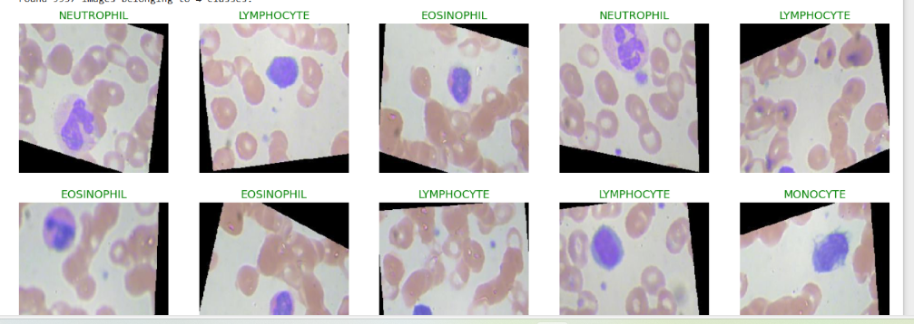
- Environment Setup: Set up a Python environment with TensorFlow and the necessary dependencies. Use pip or conda to install the required packages.
- Code Execution: Execute the code cells in the provided Jupyter Notebook model in sequential order.
- Analyze Results: Review the training and validation loss/accuracy plots to assess the model's performance. Evaluate the model on the test data and examine the confusion matrix and classification report.
Results
The project yields the following conclusions based on the validation set:
- The model achieves a high accuracy of 94.5% on the validation images.
- There are two possible explanations for the subpar performance on the test set:
  - The test data may contain mislabeled samples.
  - The test set might have been generated differently from the original training set, leading to inconsistencies in image quality or class representation.
The confusion matrix provides additional insights, suggesting that the neutrophil class in the test set could contain mixed samples from other classes.
Output Screenshots:
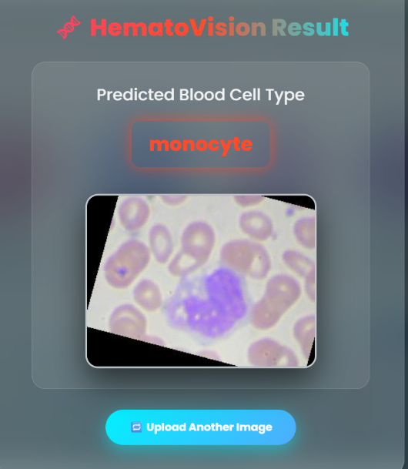
Predicted blood cell type
Model Accuracy
The model achieves a high accuracy of 94.5% on the validation images.
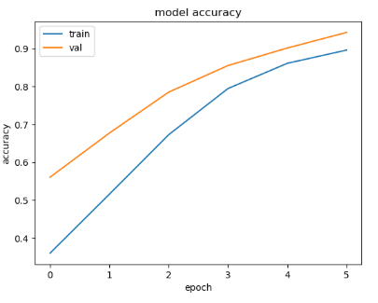
Model Accuracy
Conclusion
This project demonstrates the application of transfer learning using the MobileNetV2 architecture for blood cell type classification. Despite achieving high accuracy on the validation set, further investigation is required to understand the discrepancies in performance on the test set. The project can be extended and optimized by implementing various strategies to improve the model's accuracy and generalization capability.
Further Improvements
To enhance the project, consider the following steps:
- Data Augmentation: Apply data augmentation techniques to increase the diversity of the training data and improve the model's generalization.
- Hyperparameter Tuning: Explore different hyperparameter configurations, such as learning rate, batch size, and number of epochs, to optimize the model's performance.
- Model Selection: Experiment with other pre-trained models, such as Xception or ResNet, to compare their performance with MobileNetV2.
- Ensemble Methods: Combine multiple models or use ensemble techniques to enhance classification accuracy and robustness.
- Fine-tuning: Gradually unfreeze and fine-tune the pre-trained layers of the model to adapt to the specific blood cell classification task.

