A Minor Project Proposal Report on
Automatic Smart Street Light

Submitted in partial Fulfillment on the Requirement for the Degree of Bachelor in Information Technology
Under Pokhara University

Submitted by:
Prashant Baral (CRN: 161428)
Manisha Shah (CRN: 161423)

Under the supervision of
Roshan Chitrakar

Date:
2075/04/20

Department of Information Technology


NEPAL COLLEGE OF
INFORMATION TECHNOLOGY
Balkumari, Lalitpur, Nepal

Table of Contents
Abstract 2
Introduction 3
- Background 3
- Problem Statement 4
- Project Objective 5

Scope And Importance Of The Project 6
Literature Review 7
Methodology 8
- Block Diagram 8
- Component Required 8
2.1 Arduino UNO 8
2.1.1 Summary 9
2.2 IR Sensor 10
2.3 LED 10
2.3.1 Structure of LED 10
Task and Time Schedule 11
BIBLOGRAPHICAL REFERENCES 12

List of Figures
- Block Diagram Of Automatic Street Light Control System 8
- Arduino UNO Board 9
- IR Sensor 10
- Working Principal of IR Sensor 10

List of Tables
- Task Schedule 11
- Time Schedule 11

ABSTRACT
This paper aims at designing and executing the advanced development in embedded systems for energy saving from the street lights. Nowadays, human beings have become too busy, and are unable to find time even to switch the lights wherever not necessary. The present system is like, the street lights will be switched on in the evening before the sun sets and they are switched off the next day morning after there is sufficient light on the roads. This paper gives the best solution for electrical power wastage. Also the manual operation of the lighting system is completely eliminated. In this paper we used a photoelectric sensor which is IR (Infrared) sensor that detect the movement of the on the street. An Arduino UNO is used as brain to control the street light system. We use the word “Smart” because the system not only automatically ONs at night and OFFs at daylight but also gets dim at night when no object around and only gets ON when object is detected. Finally, the system has been successfully designed and implemented as prototype system. This project is all about to control the power consumptions at the streets and eliminating manpower.

Keywords - Street lights, LEDs, IR module, Arduino UNO, Energy Saving and Circuit Design.

INTRODUCTION
- Background
Automatic systems are being preferred over manual system. The research work shows automatic control of streetlights as a result of which power is saved to some extent. By using “Automatic Smart Street Light” energy consumption is also reduced because now-a-days the manually operated street light are not switched OFF properly even the sunlight comes or in the day time and also not switched ON earlier before sunset. So our main theme of making this project is to save and conserve the energy.
Automatic Smart Street Light Systems are smarter versions of the mechanical or electronic timers previously used for street light ON-OFF operation. They come with energy conservation options like automatic on-off at day/night, and dimming. It automatically switches ON lights when the sunlight goes below the visible region of our eyes. It automatically switches OFF lights under illumination by sunlight.

Meanwhile, street light system can be classified according to the type of lamps used such as incandescent light, mercury vapor light, metal halide light, high pressure sodium light, low pressure sodium light, fluorescent light, compact fluorescent light, induction light and LED light. Different type of light technology can be used in lighting design with their luminous efficiency, lamp service life and their considerations. From which, the LED is considered a promising solution to modern street lighting system due to its behavior and advantages. Thus in this project, the LEDs are used as street light system.

The circuit mainly consist of IR sensor which is followed by processing unit/microcontroller, Arduino, which takes input in .ino format for sensing element and gives its output to the LEDS. In this concept, the street light gets ON according to the movement of the vehicle or pedestrians on the street. If there is no vehicle or pedestrians on the street the intensity of light becomes dim, which makes it more advantageous on conserving energy. The IR modules will be activated only on the night time. If any object (vehicles or pedestrians) crosses the sensing zone of IR sensor, a particular light will automatically get ON. In the day time when there is sunlight or natural light the lights is fully OFF. All these coding are done in the Arduino. By using this as a basic principle, the intelligent system can be designed for the perfect usage of streetlights in any place.

Problem Statement
In the present context of Nepal, a lot of electrical energy is wasted because of busyness of people or their lack of activeness. Most people do not ON and OFF the manual control street lights in time. They may forget to switch on the light in the morning. Which leads to more consumption of energy when there is a better daylight. When we talk about Automatic Street Light Control, it not only ON and OFF the lights at day-night time but also it OFFs the light whenever there is no object on street.
Technology is running ahead of time. In context of Nepal, Technology is game changer so it should grow exponentially. Now-a-days road constructions are rapidly going on, which needs to consider on street light system too. If Manual Street Light System is implemented there is still energy wastage. While we deal with energy wastage there is still a problem that manual street light give raise to road accidents in comparison to the automatic one. People may forget to switch on the light at night which leads to no proper light in darkness. Animals like dogs, cats and cows get on the street at night, and darkness makes them in danger.
Considering all of these problems we came with the idea of the Automatic Street Light Control Systems.

Project Objective
The main objective of this project is to eliminate manual street control and bring all new automatic street light control. As the traffic decreases slowly during late-night hours, the intensity gets reduced progressively till morning to save energy and thus, the street lights switch on at the dusk and then switch off at the dawn, automatically. The process repeats every day.
LED lights are the future of lighting because of their low energy consumption and long life. LED lights are fast replacing conventional lights because intensity control is possible by the pulse width modulation. This proposed system uses an Arduino board. Strings of LED are interfaced to the Arduino board. A programmed Arduino board is engaged to provide different intensities at different times of the night.
The main objectives for this project are as follows:
- To avoid unnecessary waste of light.
- Provide efficient, automatic and smart lighting system.
- Longer life expectancy.
- Energy saving.
- Safety.

SCOPE AND IMPORTANCE OF THE PROJECT
We Nepalese are now more familiar with Advance Technologies such internet, sensors, automatic machines, etc. Life has been easier and convenient with these technologies. Automation, Power consumption and Cost Effectiveness are the important considerations in the present field of electronics and electrical related technologies. Industry of street lighting systems are growing rapidly and going to complex with rapid growth of industry and cities. To control and maintain complex street lighting system more economically, various street light control systems are developed. This proposed system utilizes LED Lamps instead of generally used street lamps such as High Pressure Sodium Lamps, etc. The LED technology is preferred as it offers several advantages over other traditional technologies like energy saving due to high current luminous efficiency, low maintenance cost, high color rendering index, rapid start up speed, long working life etc.

LITERATURE REVIEW
Lighting can account for 10-38% of the total energy bill in typical cities worldwide. Street lighting is a particularly critical concern for public authorities in developing countries because of its strategic importance for economic and social stability. Inefficient lighting wastes significant financial resources each year, and poor lighting creates unsafe conditions. Energy efficient technologies and design can cut street lighting costs dramatically (often by 25-60%). The main consideration in the present field technologies are Automation, Power consumption and cost effectiveness. Automation is intended to reduce man power with the help of intelligent systems. Power saving is the main consideration forever as the sources of the power are getting diminished due to various reasons. The busy lifestyle of humans has led to untimely switching of street lights. As a result lot of power is being wasted. The advanced development in embedded system has set a platform for designing energy efficient systems. Electrical Power wastage can be reduced by using two light dependent resistors as light sensing devices or light sensors to indicate day or night time. A photoelectric sensor has been used to detect the movement of humans and vehicles on the streets.
However in this era advancement in embedded systems, Automatic Street Light controlling can be achieved using Microcontrollers and IR sensors. Again IR modules are used to detect if object has passed a certain part of road. This system is basically street light intensity control, sensing control as well as switching control. A lot more amount of power is conserved as the power is conserved as the power utilization depends on the light in the streets.

METHODOLOGY
This paper proposes an effective scheme for controlling the wastage of electricity due to streetlights. It reduces the manual effort by automating the streetlight on the basis of light intensity. The electricity wastage can be reduced by glowing the light on the basis of movement detection. Here three parts have been included under this topic for completed this study. Design architecture is the main block function for the proposed design. While, the hardware specification will detail out the components involved in this design from the sensor components until the controller selection. Software development based on the proposed design will be detail out in software part where the flow of the system operation will be detailed out elaborated.
- Block Diagram

LED
Light
Arduino
UNO
IR S
ensor
Power Supply

FIGURE 1: Block Diagram Of Automatic Street Light Control System

- Components Required

  - Arduino UNO :

The Arduino UNO is ATmega328 datasheet based microcontroller that has 6 analog inputs, 8 digital outputs and 6 PWM outputs. It has a reset button and 16 MHz ceramic resonator with a USB connection facility along with a power jack.
"Uno" implies one in Italian and is named to stamp the forthcoming arrival of Arduino 1.0. The Uno and version 1.0 will be the reference renditions of Arduino, making headway. The Uno is the most recent in a progression of USB Arduino sheets, and the reference model for the Arduino stage.

2.1.1 Summary:
Microcontroller | ATmega328
Operating Voltage | 5V
Input Voltage (recommended) | 7-12V
Input Voltage (limits) | 6-20V
Digital I/O Pins | 14 (of which 6 provide PWM output)
Analog Input Pins | 6
DC Current per I/O Pin | 40 mA
DC Current for 3.3V Pin | 50 mA
Flash Memory | 32 KB (ATmega328) of which 0.5 KB used by boot loader
SRAM | 2 KB (ATmega328)
EEPROM | 1 KB (ATmega328)
Clock Speed | 16 MHz
Length | 68.6 mm
Width | 53.4 mm
Weight | 25 g

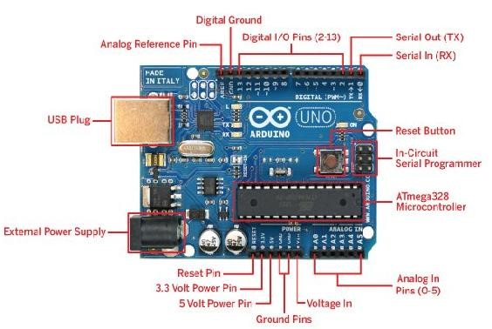

FIGURE 2: Arduino UNO Board

  - IR Sensor
Figure 3.1 and 3.2 shown as the IR sensor and working principle of sensor. An infrared sensor is an electronic device that emits in order to sense some aspects of the surroundings. An IR sensor can measure the heat of an object as well as detects the motion. These types of sensors measures only infrared radiation, rather than emitting it that is called as a passive IR sensor. Usually in the infrared spectrum, all the objects radiate some form of thermal radiations. These types of radiations are invisible to our eyes that can be detected by an infrared sensor. The emitter is simply an IR LED and the detector is simply an IR photodiode which is sensitive to IR light of the same wavelength as that emitted by the IR LED. When IR light falls on the photodiode. The resistances and these output voltages, change in proportion to the magnitude of the IR light received.
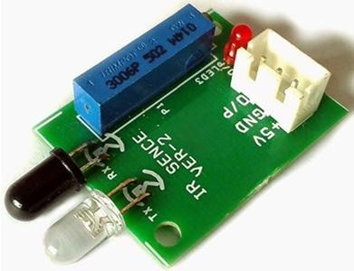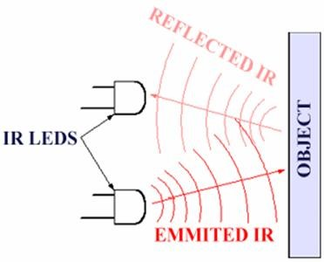
FIGURE 3.1 IR Sensor | FIGURE 3.2 Working Principal of IR Sensor

  - LED
A light-emitting diode (LED) is a p-n junction diode, which emits light when activated. When we apply voltage across its leads, electrons are able to recombine with holes within the LED, releasing energy in the form of photons which gives the light. Hence, it is a two-lead semiconductor light source. Light emitting diodes represents our lighting system and the amount of light emitted by it is directly related to the amount of light in the environment that is when outside light is less than the light given by LEDS is more and vice-versa.

Structure of LED
LEDs produce more light per watt than incandescent bulbs; this is useful in battery powered or energy-saving devices. LEDs can emit light of an intended color without the use of color filters that traditional lighting methods require. This is more efficient and can lower initial costs. The solid package of the LED can be designed to focus its light. Incandescent and fluorescent sources often require an external reflector to collect light and direct it in a usable manner. When used in applications where dimming is required, LEDs do not change their color tint as the current passing through them is lowered, unlike incandescent lamps, which turn yellow. LEDs are ideal for use in applications that are subject to frequent on-off cycling, unlike fluorescent lamps that burn out more quickly when cycled frequently, or High Intensity Discharge (HID) lamps that require a long time before restarting.

TASK AND TIME SCHEDULE

- Task Schedule

Task | Person
Analysis | Manisha, Prashant
Circuit Design | Prashant
Coding | Prashant, Manisha
Implementation | Manisha, Prashant
Testing and Debugging | Prashant, Manisha
Model Design | Manisha
Documentation | Manisha, Prashant

Time Schedule

Week(s)  Activity | 1st Week | 2nd Week | 3rd Week | 4th Week | 5th Week
Analysis | 
Circuit Design |  | 
Coding |  | 
Implementation |  |  | 
Testing and Debugging |  |  |  | 
Model Design |  |  |  |  | 
Documentation |  |  |  |  | 

BIBLOGRAPHICAL REFERENCES
- http://www.electronics-tutorials.ws
- https://www.arduino.cc/en/Tutorial/HomePage
- https://www.instructables.com/id/Smart-Street-Light-Using-Ir-Sensor-With-Arduino/
- https://www.codeproject.com/Articles/1109511/IR-obstacle-sensor-with-Arduino

