**S3 (Simple Storage Service)**

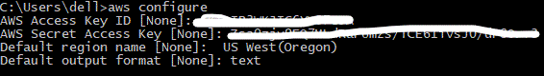Credentials to connect to your aws account:

**(Use your Access Key ID and Secret Key to establish the connection)

* Choose the region and output format according to your requirement

1. To create a bucket using in s3 using CLI:

aws s3api create-bucket --bucket trial-bucket-gayu --region us-east-1

1. 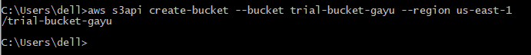To check the created bucket:

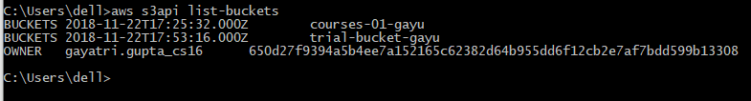aws s3api list-buckets