**Exercise 1: Implementing the Singleton Pattern**

**Logger.java**

public class Logger

{

private static Logger instance;

private Logger()

{

System.out.println("Logger initialized.");

}

public static Logger getInstance()

{

if (instance == null)

{

instance = new Logger();

}

return instance;

}

public void log(String message)

{

System.out.println("Log: " + message);

}

}

**Main.java (Test Class)**

public class Main

{

public static void main(String[] args)

{

Logger logger1 = Logger.getInstance();

Logger logger2 = Logger.getInstance();

logger1.log("First message.");

logger2.log("Second message.");

if (logger1 == logger2)

{

System.out.println("Both logger1 and logger2 refer to the same instance.");

}

else

{

System.out.println("Different instances were created. Singleton failed.");

}

}

}

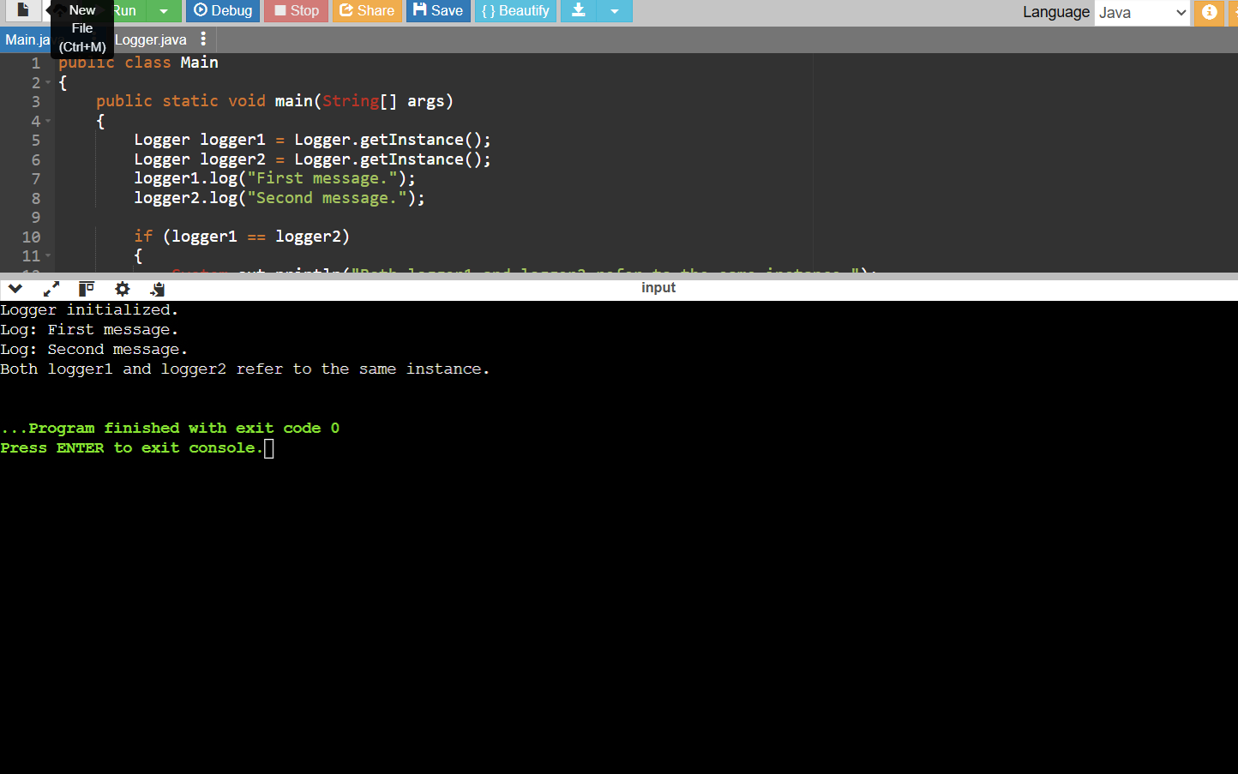

**Exercise 2: Implementing the Factory Method Pattern**

**Document.java**

public interface Document

{

void open();

}

**WordDocument.java**

public class WordDocument implements Document

{

@Override

public void open()

{

System.out.println("Opening Word document...");

}

}

**PdfDocument.java**

public class PdfDocument implements Document

{

@Override

public void open()

{

System.out.println("Opening PDF document...");

}

}

**ExcelDocument.java**

public class ExcelDocument implements Document

{

@Override

public void open()

{

System.out.println("Opening Excel document...");

}

}

**DocumentFactory.java**

public abstract class DocumentFactory

{

public abstract Document createDocument();

}

**WordDocumentFactory.java**

public class WordDocumentFactory extends DocumentFactory

{

@Override

public Document createDocument()

{

return new WordDocument();

}

}

**PdfDocumentFactory.java**

public class PdfDocumentFactory extends DocumentFactory

{

@Override

public Document createDocument()

{

return new PdfDocument();

}

}

**ExcelDocumentFactory.java**

public class ExcelDocumentFactory extends DocumentFactory

{

@Override

public Document createDocument()

{

return new ExcelDocument();

}

}

**Main.java (Test Class)**

public class Main

{

public static void main(String[] args)

{

DocumentFactory wordFactory = new WordDocumentFactory();

Document wordDoc = wordFactory.createDocument();

wordDoc.open();

DocumentFactory pdfFactory = new PdfDocumentFactory();

Document pdfDoc = pdfFactory.createDocument();

pdfDoc.open();

DocumentFactory excelFactory = new ExcelDocumentFactory();

Document excelDoc = excelFactory.createDocument();

excelDoc.open();

}

}

