**Hello World RESTful Web Service**

**HelloController.java**

package com.cognizant.spring_learn.controller;

import org.slf4j.Logger;

import org.slf4j.LoggerFactory;

import org.springframework.web.bind.annotation.GetMapping;

import org.springframework.web.bind.annotation.RestController;

@RestController

public class HelloController {

private static final Logger *LOGGER* = LoggerFactory.*getLogger*(HelloController.class);

@GetMapping("/hello")

public String sayHello() {

*LOGGER*.info("START sayHello()");

String message = "Hello World!!";

*LOGGER*.info("END sayHello()");

return message;

}

}

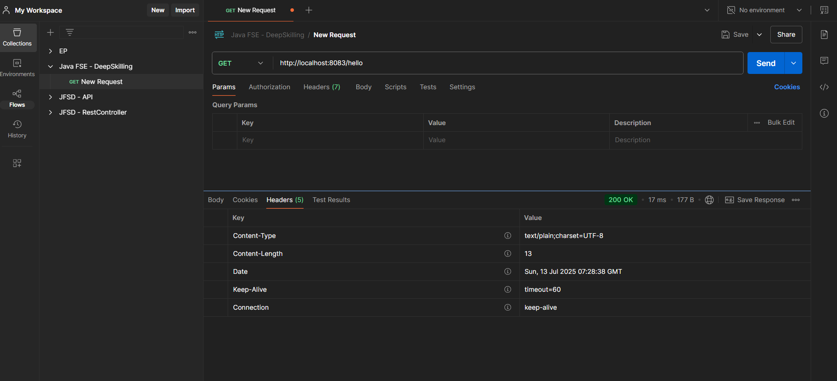

**REST - Country Web Service**

**CountryController.java**

package com.cognizant.spring_learn.controller;

import com.cognizant.spring_learn.Country;

import org.slf4j.Logger;

import org.slf4j.LoggerFactory;

import org.springframework.context.ApplicationContext;

import org.springframework.context.support.ClassPathXmlApplicationContext;

import org.springframework.web.bind.annotation.RequestMapping;

import org.springframework.web.bind.annotation.RestController;

@RestController

public class CountryController {

private static final Logger *LOGGER* = LoggerFactory.*getLogger*(CountryController.class);

@RequestMapping("/country")

public Country getCountryIndia() {

*LOGGER*.info("START getCountryIndia()");

ApplicationContext context = new ClassPathXmlApplicationContext("country.xml");

Country country = context.getBean("country", Country.class);

*LOGGER*.info("END getCountryIndia()");

return country;

}

}

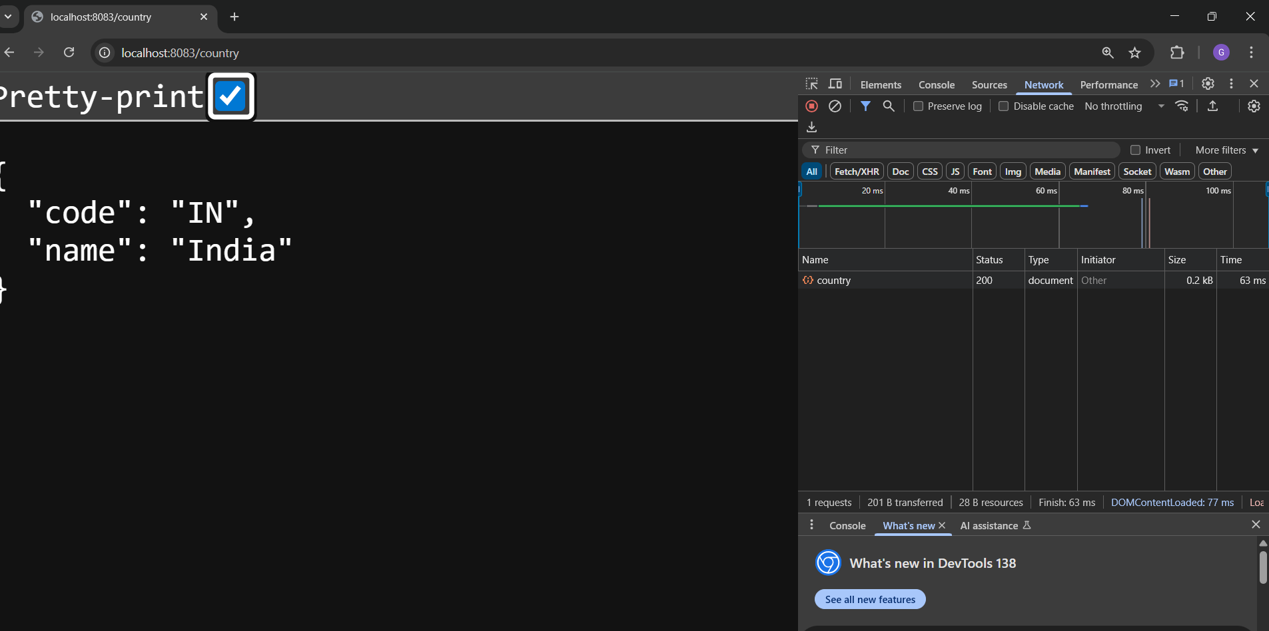

**REST - Get country based on country code**

**CountryController.java**

package com.cognizant.spring_learn.controller;

import com.cognizant.spring_learn.Country;

import com.cognizant.spring_learn.service.CountryService;

import org.springframework.beans.factory.annotation.Autowired;

import org.springframework.web.bind.annotation.*;

@RestController

public class CountryController {

@Autowired

private CountryService countryService;

@GetMapping("/country/{code}")

public Country getCountry(@PathVariable String code) {

return countryService.getCountry(code);

}

}

**CountryService.java**

package com.cognizant.spring_learn.service;

import com.cognizant.spring_learn.Country;

import org.springframework.context.ApplicationContext;

import org.springframework.context.support.ClassPathXmlApplicationContext;

import org.springframework.stereotype.Service;

@Service

public class CountryService {

public Country getCountry(String code) {

ApplicationContext context = new ClassPathXmlApplicationContext("country.xml");

Country country = context.getBean("country", Country.class);

if (country.getCode().equalsIgnoreCase(code)) {

return country;

} else {

return null;

}

}

}

