**1. Git-HOL**

**2. Git-HOL**

**3. Git-HOL**

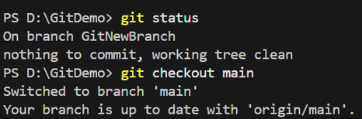

**4. Git-HOL**

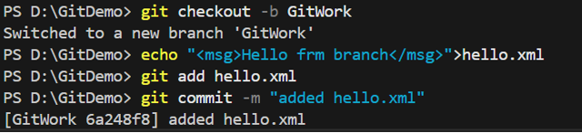

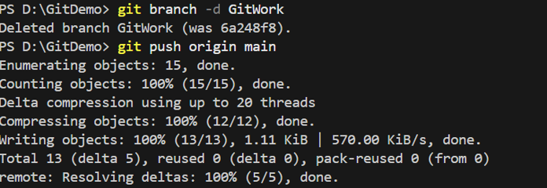

**5. Git-HOL**

