AN
INTERNSHIP REPORT ON

“ShopEase: An Online Shopping Portal
(Web Development Internship)”

SUBMITTED BY
Gayatri Wani
[31064]

UNDER THE SUPERVISION OF
Prof. Dr. Mrs. S. A. Itkar

DEPARTMET OF COMPUTER ENGINEERING


PROGRESSIVE EDUCATION SOCIETY’S
MODERN COLLEGE OF ENGINEERING
PUNE – 411005.

SAVITRIBAI PHULE PUNE UNIVERSITY
[2025-26]

Progressive Education Society’s
Modern College of Engineering,
Shivaji Nagar, Pune- 411005.
Certificate
This is to certify that the project report entitled
“ShopEase – An Online Shopping Portal”
Submitted by
Gayatri Prafulla Wani
Seat No: - 31064
Academic Year: 2025-26

This bonafide work is carried out by the student under the supervision of Prof. Dr. Mrs. S. A. Itkar and the internship report is approved for the partial fulfillment of the requirements for the degree of Bachelor of Engineering (Computer Engineering) of Savitribai Phule Pune University, Pune.

Prof. Dr. Mrs. S. A. Itkar
Internal Supervisor External Supervisor Head of Department (Computer Engineering) (Computer Engineering) (Computer Engineering)


Internship Completion Certificate



Internship Place Details


Scalrithm IT Solutions

Scalrithm IT Solutions is an MSME-registered organization engaged in providing innovative and industry-oriented software solutions and IT services. The organization emphasizes practical learning through hands-on training in areas such as web development, application design, and modern software engineering practices. With a structured approach to real-time project development and professional mentorship, Scalrithm IT Solutions creates a conducive learning environment that helps interns bridge the gap between theoretical knowledge and industry requirements. The organization contributes significantly to the development of technically skilled and industry-ready professionals through its outcome-based and skill-focused training model.

Table of Contents
Internship Completion Certificate i
Internship Place Details ii
ABSTRACT iv
List of Figures v
List of Tables vi
List Of Abbreviations vii
1. Introduction 1
1.1 Evolution of Online Shopping Systems 2
1.2 Importance of User-Centric E-Commerce Platforms 3
1.3 Data Accuracy and Transaction Reliability 3
1.4 Practical Relevance of Project 3
2.Problem Statement 4
2.1 Preamble 5
2.2 Problem Statement 5
3.Objectives 6
3.1 Functional Objectives 7
3.2 Non-Functional Objectives 7
3.3 Technical Objectives 7
4.Motivation 9
4.1 Growing Importance of Online Shopping 10
4.2 Addressing Consumer Challenges 11
4.3 Personal and Professional Motivation 11
4.4 Personal Learning and Growth 11
4.5 Collaborative Approach 11
5.Scope & Rational of Study 13
5.1 Scope 14
5.2 Rationale of the Study 14
6.1 Requirement Analysis and System Planning 17
6.1.1 Identification of system requirements 17
6.1.2 Technology Stack Selection 17
6.2 Data Collection and Preparation 18
6.2.1 Product Data Collection 18
6.2.2 User and Transactional Data Handling 18
6.2.3 Database Design and Structuring 18
6.3 Inter-Entity Relationships and Data Flow 19
6.3.1 User – Order Association 19
6.3.2 Order - Item Decomposition 19
6.4 Database Normalization and Integrity Assurance 19
6.4.1 First Normal Form(1NF) 19
6.4.2 Second Normal Form(2NF) 19
6.4.3 Third Normal Form(3NF) 19
6.5 ShopEase: System Architecture: 20
6.6 Use Case Analysis 24
6.7 Development, Validation, and Maintenance 24
6.7.1 Frontend Development (React Vite) 24
6.7.2 Backend Development (Spring Boot) 24
6.7.3 Data Analysis Module (Python – Streamlit) 24
6.7.4 Deployment and Maintenance 25
6.7.5 Source Control and Collaboration 25
7.Result 26
8.Analysis 33
8.1 Requirement Analysis and Data Understanding 34
8.2 Initial System State (Early Development Phase) 34
8.3 Challenges Identified During Development 34
8.4 System Reliability and Data Handling 34
8.5 Current System (Final Implementation – ShopEase) 34
8.6 Practical Implementation and Impact 35
9.Inferences & Conclusion 36
9.1 Inferences 37
9.2 Conclusion 37
10.Feedback 38
11.Attendance Record 42
12.Acknowledgement 44
13. List Of References 46

ABSTRACT
ShopEase is an online shopping portal developed to simplify and enhance the digital purchasing experience for users while providing efficient management capabilities for administrators. The project aims to address common challenges in online retail platforms, such as ease of navigation, effective product discovery, and reliable order management. ShopEase enables users to browse products, manage shopping carts, place orders, and track purchases through a user-friendly interface, ensuring a smooth and convenient shopping experience.
From an administrative perspective, the system supports effective product catalogue management, order monitoring, and user management, helping maintain operational efficiency. The application emphasizes data accuracy, secure handling of user information, and consistency in order processing. By focusing on usability, reliability, and real-world applicability, ShopEase offers a practical solution for modern e-commerce needs. This project demonstrates the application of full-stack development concepts to create a scalable and dependable online shopping platform suitable for real-world deployment.
Keywords— Online Shopping Portal, E-Commerce Application, Order Management, User Experience, Digital Commerce, Web-Based System

List of Figures

- Figure 1: Growth Rate of Online Shopping in India
- Figure 2: Online Shoppers in India compared to World
- Figure 3: Technology Stack
- Figure 4: MySQL Database shopease_db
- Figure 5: Entity – Relationship Architecture
- Figure 6: Architecture Diagram
- Figure 7: Use-Case diagrams for Customers and Admin
- Figure 8: Welcome Screen
- Figure 9: Admin Dashboard
- Figure 10: User Management by Admin
- Figure 11: Product Categories
- Figure 12: Cart Layout
- Figure 13: Checkout Process
- Figure 14: Order Placed Conformation
- Figure 15: ShopEase Analytics Interface
- Figure 16: Revenue by Category
- Figure 17: Payment Method Analysis
- Figure 18: Market Basket Analysis
- Figure 19: Age Range of Users
- Figure 20: Responses about easy navigation through UI
- Figure 21: Responses about the Designing, Layout of Website
- Figure 22: Responses regarding Cart Functionality and Checkout Process

List of Tables

- Table 1: Difference between React (Vite) and React (Native)
- Table 2: Weekly Work Progress

List Of Abbreviations
- API – Application Programming Interface
- CSS – Cascading Style Sheets
- CRUD – Create, Read, Update, Delete
- DB – Database
- DBMS – Database Management System
- ER – Entity Relationship
- HTTP – Hypertext Transfer Protocol
- JPA – Java Persistence API
- JS – JavaScript
- JSON – JavaScript Object Notation
- JSX – JavaScript XML
- JWT – JSON Web Token
- KPI – Key Performance Indicator
- NPM – Node Package Manager
- RDBMS – Relational Database Management System
- SDK – Software Development Kit
- SQL – Structured Query Language
- UI – User Interface
- URI – Uniform Resource Identifier
- URL – Uniform Resource Locator
- UX – User Experience
- VS Code – Visual Studio Code

Introduction

The rapid advancement of digital technologies and widespread internet accessibility have significantly transformed the way people interact with products and services. One of the most prominent outcomes of this transformation is the growth of electronic commerce (e-commerce), which has reshaped traditional shopping models by offering convenience, accessibility, and efficiency. Online shopping platforms allow users to browse, compare, and purchase products from the comfort of their homes, eliminating geographical and time-related constraints.
In today’s fast-paced lifestyle, consumers increasingly prefer digital solutions that simplify daily activities. Online shopping portals play a crucial role in fulfilling this demand by providing centralized platforms where users can explore a wide range of products, make informed purchasing decisions, and manage orders efficiently. At the same time, such systems assist businesses in reaching a broader audience, managing inventory digitally, and streamlining sales operations.
ShopEase – An Online Shopping Portal has been developed with the objective of delivering a user-centric and reliable e-commerce solution that addresses common challenges faced by both customers and administrators in online retail environments. The project focuses on creating a seamless shopping experience by emphasizing usability, organized product management, and efficient order handling.

Evolution of Online Shopping Systems
The concept of online shopping has evolved considerably over the past few decades. Early e-commerce systems were limited in functionality and primarily focused on displaying products with basic purchasing options. However, modern online shopping portals have become comprehensive systems that integrate product browsing, user account management, order tracking, and customer support into a unified platform.
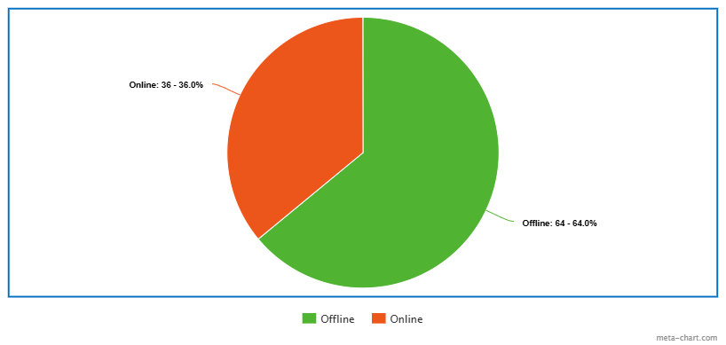
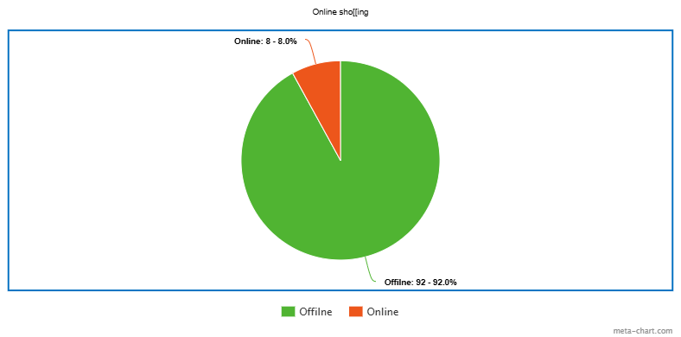
With the increasing penetration of smartphones and high-speed internet, users now expect online shopping platforms to be intuitive, responsive, and trustworthy. Features such as categorized product listings, secure user accounts, shopping carts, and order history have become essential components of any successful e-commerce application. Additionally, consumers expect transparency in pricing, availability, and order status, making system reliability a critical factor. ShopEase is designed in alignment with these evolving expectations, aiming to replicate real-world shopping convenience while offering the added benefits of digital automation and accessibility.
Figure 1: Growth Rate of Online Shopping in India

Importance of User-Centric E-Commerce Platforms
User experience plays a vital role in determining the success of an online shopping portal. A poorly designed interface, complex navigation, or inconsistent system behavior can discourage users and negatively impact trust. Therefore, modern e-commerce platforms must prioritize simplicity, clarity, and ease of interaction.
ShopEase emphasizes a user-centric approach by allowing customers to:
- Easily browse and search for products
- View detailed product information
- Add items to a shopping cart
- Place and track orders seamlessly
By focusing on intuitive navigation and structured information presentation, the platform ensures that users with varying levels of technical familiarity can comfortably interact with the system. The goal is to reduce cognitive effort and make online shopping a smooth and engaging experience.

1.3 Data Accuracy and Transaction Reliability
Data integrity and reliability are fundamental aspects of any online shopping system. From product details to order confirmations, every interaction within the platform depends on accurate data handling. Errors in product availability or order processing can lead to user dissatisfaction and loss of credibility.
ShopEase is developed with a strong emphasis on maintaining consistency in data storage and transaction flow. The system ensures that user actions—such as adding items to a cart or placing an order—are reflected accurately throughout the platform. This focus on reliability enhances user trust and promotes repeated usage of the system.

Practical Relevance of Project
The project reflects scenarios commonly encountered in modern e-commerce systems, such as:
- Processing user orders efficiently
- Ensuring a consistent user experience
By simulating real-world operations, ShopEase serves as a valuable learning platform and a foundation for further enhancements and real-time deployment.

2.Problem Statement

2.1 Preamble
The growing adoption of online shopping has increased the need for digital platforms that offer convenience, reliability, and ease of use. Despite the availability of numerous e-commerce solutions, many systems still face challenges related to complex navigation, unclear product information, and inefficient order handling. These issues can affect user trust and reduce the overall effectiveness of online shopping platforms. To overcome these limitations, there is a need for a well-structured online shopping portal that supports smooth user interaction as well as efficient administrative management. ShopEase is developed to address these requirements by providing a dependable and user-friendly digital shopping environment.

2.2 Problem Statement
To design and develop a secure, scalable and user-centric online shopping portal that ensures efficient product discovery, seamless cart management and reliable order processing.

3.Objectives

3.1 Functional Objectives
- To provide role-based user experience
  - Offer distinct functionalities for customers and administrators based on their respective roles.
  - Enable customers to browse products, manage carts, and place orders, while allowing administrators to manage products, users, and orders.
- To enable efficient product browsing and discovery
  - Support basic search and filtering options to help users quickly find desired products.
  - Allow users to view products categorized by type and relevance.
- To ensure smooth order and cart management
  - Facilitate a clear and structured order placement and order tracking process.
  - Enable users to add, update, or remove items from the shopping cart easily.
- To provide a user-friendly interface and navigation
  - Deliver a simple, intuitive, and responsive interface for users with varying levels of technical familiarity.
  - Ensure easy navigation across all sections of the application for a seamless shopping experience.

3.2 Non-Functional Objectives
- To develop analytical thinking and solution-oriented practices
  - Promote active participation in identifying challenges and proposing suitable solutions during development.
  - Facilitate discussions that help evaluate alternative approaches and improve decision-making quality.
- To support coordinated development and teamwork
  - Organize development activities by distributing responsibilities across different aspects of the project such as design, logic implementation, and system integration.
  - Encourage continuous communication and collaborative planning to ensure smooth progress throughout the project lifecycle.
- To enhance overall user interaction and ease of use
  - Ensure that navigation and interactions are straightforward to improve usability and user satisfaction.
  - Design the application interface to be clear, consistent, and easy to understand for users with varying technical skills.
- To ensure long-term system quality and ease of maintenance
  - Follow structured development and documentation practices to simplify future modifications.
  - Design the system in a flexible manner that supports updates and feature expansion without major rework.

3.3 Technical Objectives
- To design a structured frontend–backend interaction model
  - Implement backend services using Spring Boot and Java to handle business logic and server-side operations.
  - Build the frontend using React (Vite) to provide a fast, responsive, and interactive user interface.
- To implement secure user authentication and role-based access
  - Develop authentication mechanisms to manage customer and administrator access securely.
  - Enforce role-based authorization to restrict system functionalities according to user privileges.
- To establish seamless frontend and backend integration
  - Enable smooth data communication between the React-based frontend and Spring Boot backend using RESTful APIs.
  - Ensure reliable data exchange for user actions such as product browsing, cart updates, and order processing.
- To design and manage a structured relational database system
  - Use MySQL to store and manage data related to users, products, orders, and transactions.
  - Ensure data consistency and integrity through well-defined database relationships.
- To ensure system reliability and performance
  - Conduct thorough performance evaluations across various devices and network conditions.
  - Resolve platform-specific issues proactively to ensure a smooth and crash-free user experience.
- To apply version control and collaborative development practices
  - Use Git and GitHub to manage source code, track changes, and support team collaboration.
  - Maintain a structured commit history to improve code traceability and maintenance.

4.Motivation

4.1 Growing Importance of Online Shopping
- Over the past decade, online shopping has shifted from being a convenience to becoming a mainstream method of retail worldwide. As of 2025, there are approximately 2.77 billion online shoppers around the world, accounting for about one-third of the global population engaged in e-commerce purchases, and this number continues to grow each year.
- In India, the trend toward online shopping has also accelerated rapidly with increasing internet access, affordable data, and widespread smartphone usage. India is already among the fastest-growing e-commerce markets globally, with hundreds of millions of consumers purchasing goods digitally. While traditional offline retail remains significant, the ongoing shift to online channels reflects changing consumer preferences in both urban and increasingly in rural areas, where digital commerce continues to penetrate.
- These trends indicate that online shopping is not merely a technological novelty but a transformative force in modern commerce, reshaping how consumers discover, select, and purchase products every day. It highlights why there is a pressing need for improved, user-friendly online shopping portals like ShopEase.
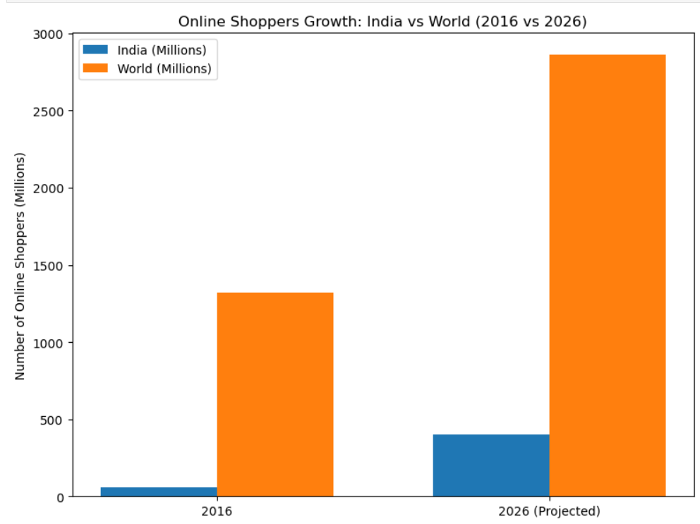

Figure 2: Online Shoppers in India compared to World

4.2 Addressing Consumer Challenges
Although online shopping has grown significantly, consumers still encounter multiple practical challenges while interacting with e-commerce platforms. One major concern is information overload. With thousands of products available across various categories, users often struggle to quickly identify items that match their preferences. Inefficient search mechanisms and inadequate filtering options can make product discovery time-consuming and frustrating.
Furthermore, security and trust remain fundamental concerns in digital commerce. Users expect secure authentication systems, protected transaction processes, and reliable order tracking mechanisms. Ensuring data privacy and maintaining transaction transparency are crucial factors in building long-term customer confidence.
ShopEase has been conceptualized to address these challenges by implementing structured product categorization, dynamic filtering capabilities, clear product presentation, and a secure login and checkout workflow. By prioritizing usability, system performance, and transactional security, the platform aims to provide a reliable and user-centric online shopping experience.

4.3 Personal and Professional Motivation
- On a personal level, the motivation for building ShopEase stems from a strong interest in solving real-world problems through technology. The project presented an opportunity to apply and deepen skills in full-stack development—spanning frontend user interface design, backend logic, secure database integration, and real-world system deployment.
- This experiential learning has enabled the application of modern development practices, reinforced understanding of user behaviour in digital commerce, and improved proficiency in both design thinking and software implementation. The project has served as a valuable bridge between academic learning and professional software development practice.

4.4 Personal Learning and Growth
- The project aligned with personal interests in:
  - Web Development.
  - Solving real-world problems using tech.
- Key skills applied and enhanced:
  - React Vite for cross-platform development.
  - Spring-boot for backend services and data management.
  - User Experience (UX) design for building an intuitive interface.

4.5 Collaborative Approach
- The development of ShopEase was strongly supported by a collaborative working approach. Regular discussions and shared planning helped in aligning ideas, resolving challenges, and improving design decisions throughout the project lifecycle. Collaboration enabled effective coordination between different aspects of the project, including interface design, logic implementation, and system integration.
- This collaborative approach encouraged knowledge sharing, constructive feedback, and collective problem-solving, which contributed to improving the overall quality and consistency of the application. Working as a team not only enhanced the project outcome but also strengthened communication and professional skills, making the development process more structured and efficient.

5.Scope & Rational of Study

5.1 Scope
User Categories and Access Levels
- ShopEase is developed as a web-based online shopping portal that connects customers and administrators within a single digital platform.
- Two main user categories are supported: end users (customers) and system administrators.
- Customers are provided with features such as product browsing, cart handling, and order placement, while administrators are granted access to manage products, monitor orders, and oversee system activity.
Core Features Covered
- The project focuses on implementing fundamental e-commerce functionalities including product listing, category-based navigation, search functionality, shopping cart operations, and order management.
- The system emphasizes simplicity and clarity rather than incorporating advanced commercial features, ensuring ease of use for first-time and non-technical users.
- Technology Usage and System Design
- The frontend interface is developed using React (Vite) to deliver a responsive and interactive user experience.
- Server-side processing and business logic are handled using Spring Boot with Java, ensuring structured and reliable backend operations.
- MySQL is used as the database management system to store and organize application data securely.
- The architecture is designed to be modular, allowing future improvements without major redesign.
Deployment Conditions and Constraints
- ShopEase is intended to run as a browser-based application and requires an active internet connection.
- The current implementation does not include offline access, online payment processing, or third-party service integration.
- The project is developed primarily as an academic and functional prototype rather than a commercial-grade platform.
Out-of-Scope Features and Future Direction
- Features such as payment gateway integration, personalized recommendations, user reviews, and logistics tracking are excluded from the current scope.
- These components may be incorporated in future versions to enhance functionality and real-world applicability.

5.2 Rationale of the Study
Digital Shift in Consumer Purchasing Behaviour
The rapid digitalization of retail has significantly changed how consumers explore and purchase products. With increasing internet penetration and smartphone usage, users now expect faster access to products, transparent pricing, and convenient purchasing mechanisms. This shift has created a demand for structured online platforms that can support seamless digital transactions while maintaining simplicity and clarity.

Operational Challenges and User Experience Issues
From a practical perspective, issues such as unclear product categorization, inefficient cart handling, and lack of transparency in order status negatively impact user confidence. Similarly, administrators face challenges in maintaining accurate product data and managing orders efficiently. Addressing these operational inefficiencies is essential to improving overall system reliability and user trust.
Purpose and Impact of the Project
ShopEase is developed to address these identified challenges by focusing on organized data flow, simplified user interaction, and clear separation of user roles. The project demonstrates how a well-structured online shopping portal can improve both customer experience and administrative efficiency, making digital commerce more approachable and reliable.
Academic and Practical Significance
From an academic standpoint, the project provides hands-on exposure to full-stack application development and system design principles. Practically, it serves as a functional model that reflects real-world e-commerce workflows and can be extended to support additional features in future implementations.
Future Prospects
Looking ahead, the project holds significant potential for further expansion. With the integration of advanced features such as secure payment processing, enhanced inventory management, and analytics-driven insights, ShopEase can evolve beyond an academic implementation into a scalable digital commerce solution. By addressing real-world shopping challenges and adapting to future market needs, the platform has the capacity to contribute meaningfully to the growing e-commerce ecosystem.

6.Methodological Details

6.1 Requirement Analysis and System Planning

6.1.1 Identification of system requirements
The development of ShopEase began with a detailed analysis of functional and non-functional requirements essential for an online shopping portal. The system was designed to support core e-commerce operations while maintaining simplicity and reliability.
- Key Functional requirements include:
  - User registration and authentication.
  - Product listing, categorization and search functionality.
  - Shopping cart management and order placement.
- Non-Functional requirements include:
  - Responsive and user-friendly interface
  - Secure handling of user and transaction data
  - Reliable system performance under multiple user requests
  - Maintainability and scalability for future enhancements.

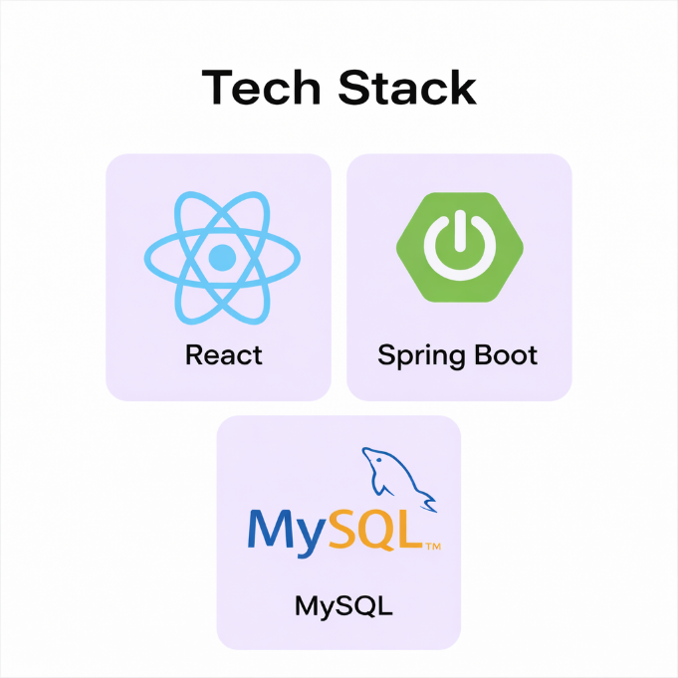
6.1.2 Technology Stack Selection
Figure 3: Technology Stack
- Frontend: React (Vite) for building fast, responsive and interactive user interface.
- Backend: Spring Boot with Java to implement business logic RESTful APIs and request handling.
- Database: MySQL for structured storage of users, products and orders.
- API Communication: Axios for frontend – backend data exchange.
- Language: Frontend – HTML, CSS, JavaScript, Backend – Java, Data Analysis -Python.
- Additional Technologies Used: Streamlit, Plotly for dynamic and interactive charts, Scikit-learn.
- Version Control: Git and GitHub for code collaboration and versioning.

6.2 Data Collection and Preparation

Product Data Collection
Product-related data in the ShopEase application includes:
- Product names
- Categories
- Prices
- Description
- Product Images
- The product data was manually curated during the initial development phase to closely simulate a real- world e-commerce environment.
- Product images were sourced from Unsplash(unsplash.com), a publicly available platform offering high-quality, royalty-free images which are free to use without legal restrictions.
- Using license-free images ensure compliance with copyright regulations while enhancing visual appeal of the ShopEase application.

User and Transactional Data Handling
Unlike static product data, user profiles, shopping carts, and order records are generated dynamically during application usage. Validation rules were applied at both frontend and backend layers to prevent invalid inputs, duplicate records, and inconsistent transaction states. This approach ensures accuracy and reliability across all transactional workflows.

Database Design and Structuring
Based on system requirements, the following core entities were identified:
- Users – authentication and profile details
- Products – product metadata including price and image reference
- Orders – order-level information
- Order_Items – product-wise breakdown of each order
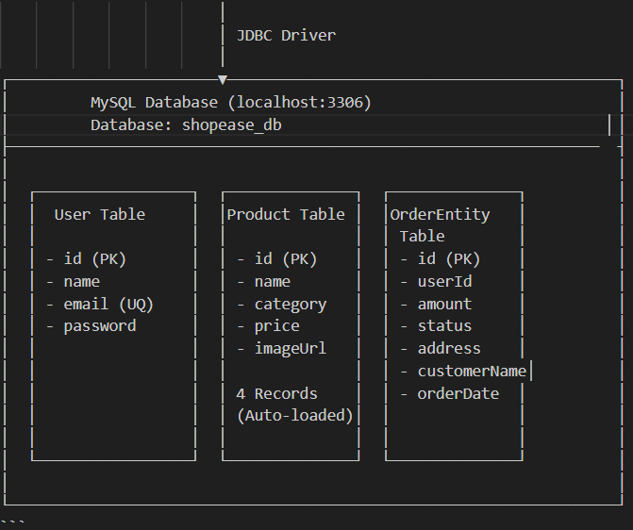
Each entity is mapped to a dedicated table to maintain clarity and separation responsibilities.
Figure 4: MySQL Database shopease_db

Inter-Entity Relationships and Data Flow

User – Order Association
A one-to-many relationship exists between users and orders, where a single user can place multiple orders over time. This association allows maintaining a clean separation between user identity and transaction records.

Order - Item Decomposition
Orders are decomposed into individual order items to accurately record:
- Product Quantity
- Purchase price at the time or order
This structure enables precise billing, auditing and order reconstruction without duplicating product data.

6.4 Database Normalization and Integrity Assurance

First Normal Form(1NF)
- All attributes contain atomic values
- No repeating groups or multi-valued fields exist

Second Normal Form(2NF)
- Non-key attributes depend entirely on the primary key
- Order – level and item – level data are stored separately

Third Normal Form(3NF)
- Transitive dependencies are eliminated
- User and Product details are stored only once and referenced where needed
The final schema conforms to Third Normal Form(3NF), ensuring reduced redundancy, improved consistency and simplified maintenance.

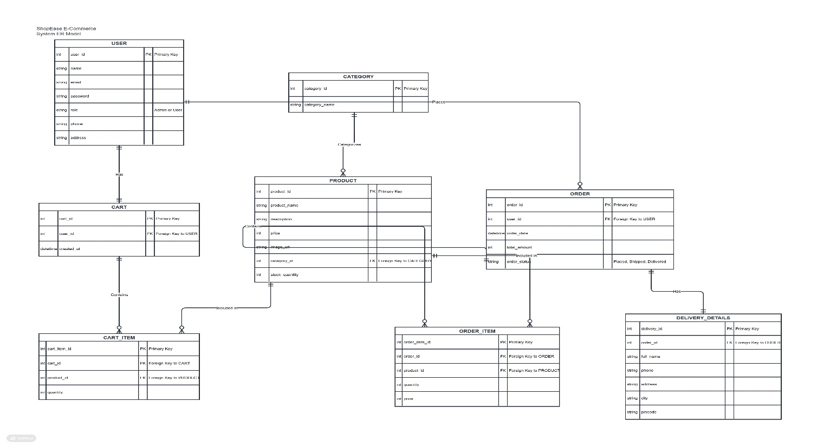
Figure 5: Entity - Relationship Architecture

6.5 ShopEase: System Architecture:
Architecture Overview:
ShopEase is designed as a web-based, full-stack online shopping platform that enables users to browse products, manage carts, and place orders through a seamless and responsive interface. The system follows a layered and modular architecture, integrating a modern frontend with a robust backend and a relational database to ensure scalability, performance, and maintainability.
The architecture leverages React (Vite) for the client-side presentation layer, Spring Boot for backend business logic and API management, and MySQL for persistent data storage. This separation of concerns ensures efficient data flow, secure transactions, and a smooth user experience across the application.
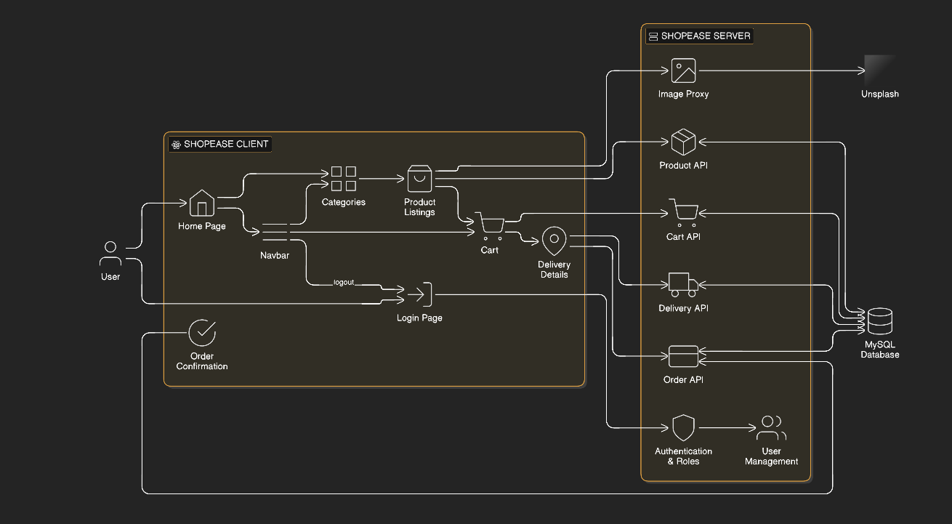
Figure 6: Architecture diagram
System Components:
A. User Layer
- User interacts with ShopEase with web browser
- User: Two types of users interact with the application:
- New User – Can browse and view product details.
- Registered User – Can log-in, Manage carts and place orders.
B. Client Interface (Frontend)
- The frontend act as a primary interaction point between users and the system.
- Displaying product listings with images, prices, and descriptions.
- Handling cart operations (add, remove, update quantity).
- Managing user authentication workflows.
- Rendering order summaries and confirmations.
React (Vite):
The frontend of the ShopEase application is developed using React with Vite, a modern build tool designed for fast and efficient web development. React enables the creation of a dynamic and component-based user interface, allowing the application to be modular, reusable, and easy to maintain. Each feature, such as product listings, cart management, and navigation, is implemented as independent components, improving code organization and scalability.
API integration is handled using HTTP requests to connect the React frontend with the Spring Boot backend for fetching product data, managing cart operations, and processing orders. State management is used to handle dynamic data such as selected products, cart items, and user sessions. Vite is utilized as the build tool to provide fast development, instant updates, and optimized performance during both development and deployment.
React (Vite) | React (Native)
Faster development with Vite’s instant reload and build speed. | Slower setup and build compared to Vite.
Simpler integration with backend APIs (Spring Boot). | More complex integration for full-stack web applications.
Supports SEO and direct URL access | No SEO support.
Enables responsive UI for multiple screen sizes. | Limited responsiveness towards various screen sizes.
Simpler deployment and updates on web servers. | Requires app store deployment and updates.
Table 1: Difference between React (Vite) and React (Native)
C. Backend Application Layer
The backend serves as the core processing unit of the ShopEase system.
Responsibilities include:
- Handling RESTful API requests from the frontend
- Validating user inputs and business rules
- Managing user authentication and authorization
- Processing cart and order transactions
A layered backend structure is followed:
- Controller Layer – Handles incoming requests
In the ShopEase project, the Controller layer is implemented using Spring Web to handle incoming HTTP requests from the React frontend. REST APIs are created using annotations such as @RestController and @RequestMapping to manage functionalities like fetching products, handling cart actions, and processing orders. The controller acts as an entry point, receiving client requests, forwarding them to the service layer, and returning responses in JSON format.

- Service Layer – Implements business logic
The Service layer is developed using Spring Boot and Java to implement the core business logic of the application. It processes operations such as product management, cart updates, and order handling. Service classes annotated with @Service act as an intermediate layer between the controller and repository, ensuring that all application logic, validations, and workflows are executed before interacting with the database.

- Repository Layer – Manages database operations
In ShopEase, the Repository layer is implemented using Spring Data JPA with Hibernate to manage database operations. Interfaces extending JpaRepository are used to perform CRUD operations on entities such as products, users, and orders without writing complex SQL queries. Hibernate handles the mapping between Java objects and MySQL tables, ensuring efficient data storage, retrieval, and consistency across the application.

D. Data Persistence layer
All application data is stored in a relational MySQL database. MySQL is used in ShopEase as the database management system due to its strong support for structured and relational data. The application involves entities like users, products, carts, and orders that require well-defined relationships, which are efficiently handled using MySQL. It ensures data integrity and reliability through ACID properties, which is essential for operations such as order processing and cart management. MySQL integrates seamlessly with Spring Boot using Spring Data JPA and Hibernate, simplifying database interactions and reducing the need for complex SQL queries. Compared to NoSQL databases, it is more suitable for this project as it maintains consistency and structured data flow. Its performance, scalability, and widespread support make it a reliable choice for building a robust e-commerce system.
Key characteristics:
- Normalized tables for users, products, orders, and order items.
- Primary and foreign key constraints to maintain referential integrity.
- Optimized queries for fast retrieval and transaction safety.
- Ensures Consistency, Accuracy and long – term Scalability.
E. Analytics Module (Python Integration):
- Developed a separate analytics module using Python and Streamlit.
- Connected to ShopEase MySQL database using mysql-connector.
- Retrived data such as:
- Orders
- Products
- Users
- Computed KPIs like:
- Total Revenue
- Total Orders
- Average Order Value
- Active Users
- Implemented data visualization using Plotly charts.
- Integrated insights to support business decision-making.
Advanced Analytics Features:
- Implemented market basket analysis to identify frequently bought products.
- Performed price and demand analysis.
- Provided geographical analysis (city/state-based sales).

Use Case Analysis
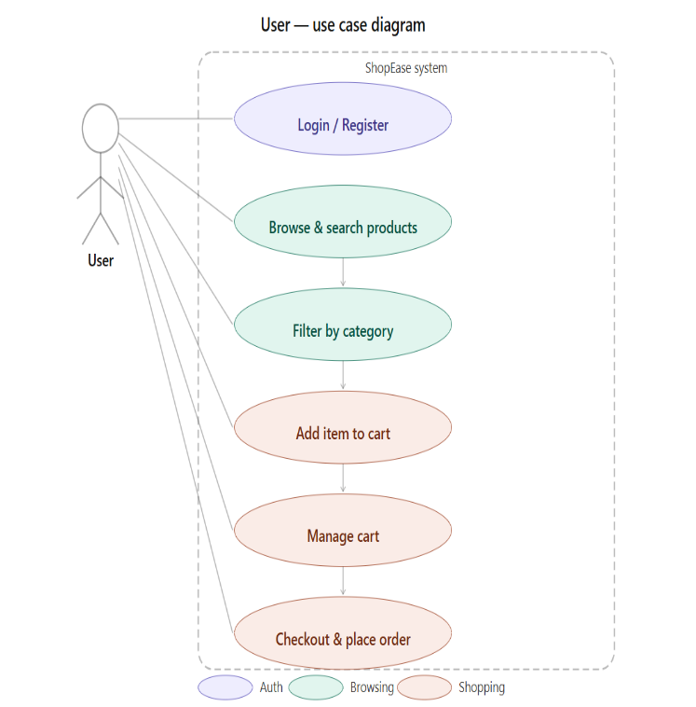
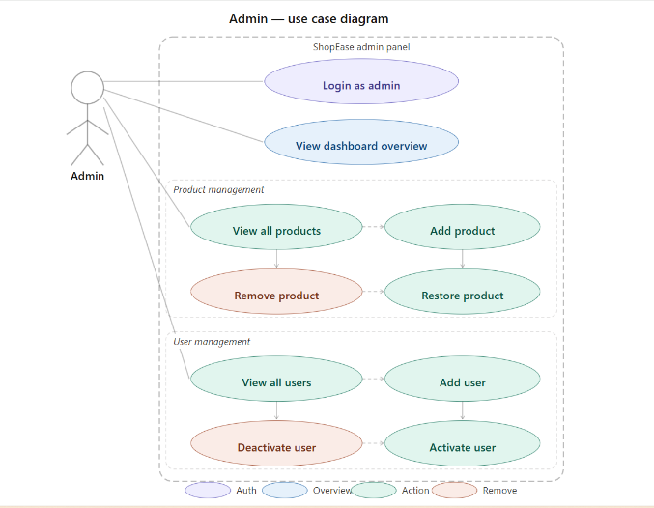
The ShopEase system supports multiple user interactions that represent real-world e-commerce workflows.
Figure 7: Use-Case diagrams for Customers and Admin

6.7 Development, Validation, and Maintenance

6.7.1 Frontend Development (React Vite)
- Project initialized using Vite for faster build and development cycles.
- Component-based architecture adopted for reusability.
- Responsive UI designed for multiple screen sizes.
- State management implemented for cart and session handling.

6.7.2 Backend Development (Spring Boot)
- REST APIs developed following standard conventions.
- Business logic isolated in service classes.
- Exception handling implemented for system stability.
- Integration with MySQL using JPA/Hibernate.

6.7.3 Data Analysis Module (Python – Streamlit)
- Connected to MySQL database to fetch real-time data (orders, users, products).
- Processed data using Pandas for cleaning and aggregation.
- Built interactive dashboard using Streamlit.
- Visualized insights using Plotly charts.
- Implemented market basket analysis for product association.
- Generated key business insights like revenue trends and user behavior.

6.7.4 Deployment and Maintenance
- Backend deployed as a standalone service.
- Frontend built and served efficiently.
- Application logs monitored for errors.
- System designed for future enhancements such as payment gateways and admin dashboards.

6.7.5 Source Control and Collaboration
- Hosted the codebase on GitHub, following industry-standard Git workflows.
- Maintained structured branching: main, dev, and feature/* branches.
- Used Pull Requests (PRs) and code reviews to ensure quality and enable collaborative development.
- Tagged builds/releases to track milestones, identify issues, and support rollback when needed.

7.Result

This section presents key screenshots from the ShopEase application on an Computer. These images illustrate how the developed solution meets the specified functional, non-functional, and technical objectives.

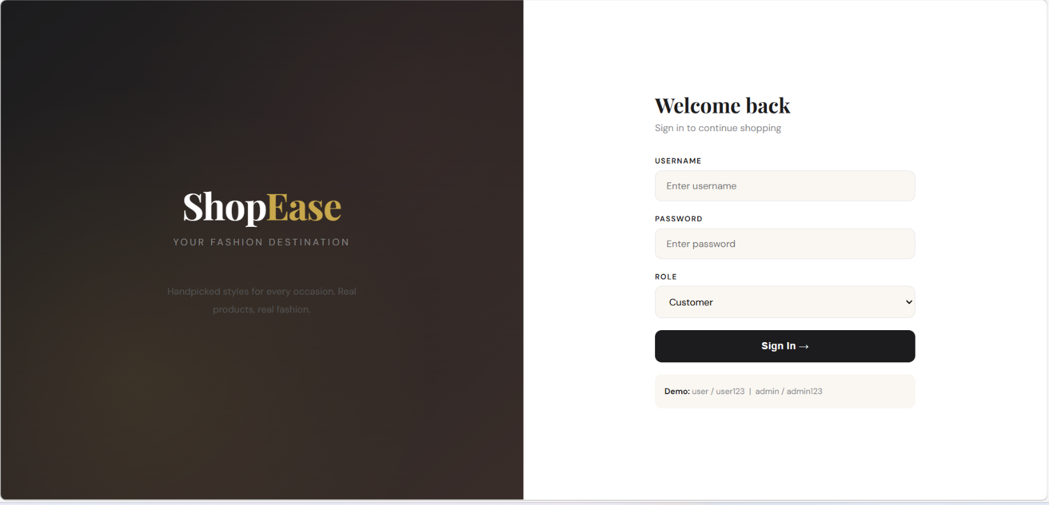
Figure 8: Welcome Screen

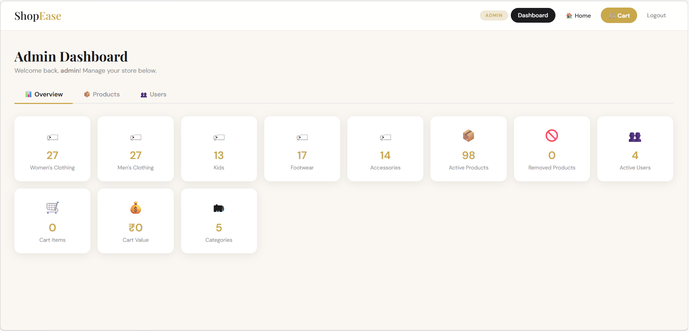
Figure 9: Admin Dashboard

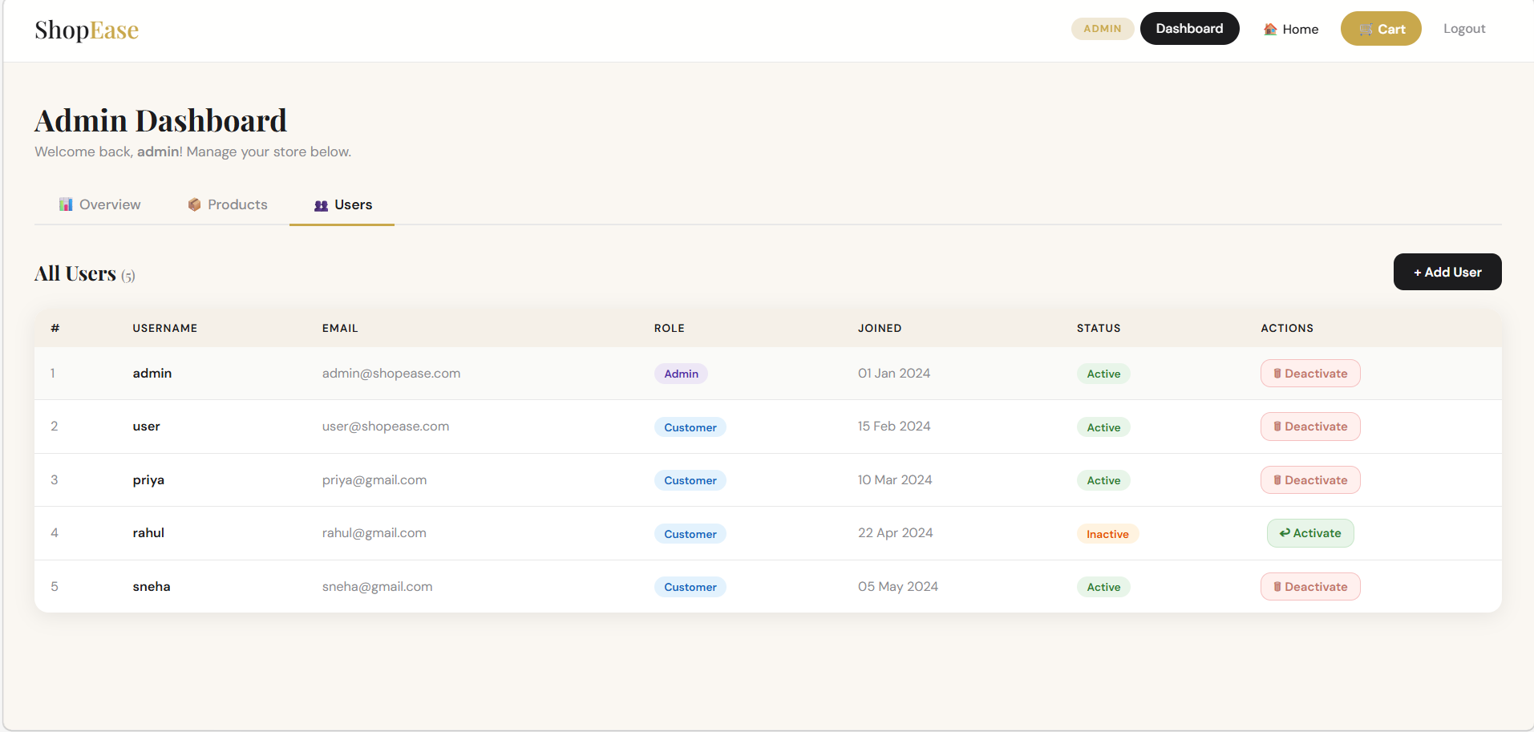
Figure 10: User Management by Admin
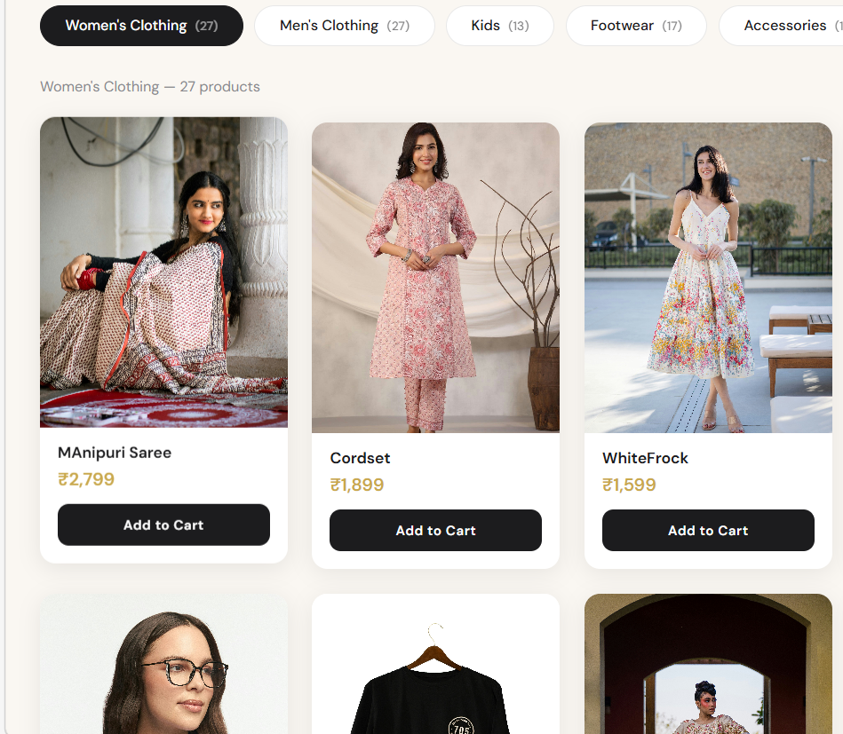
Figure 11: Product Categories

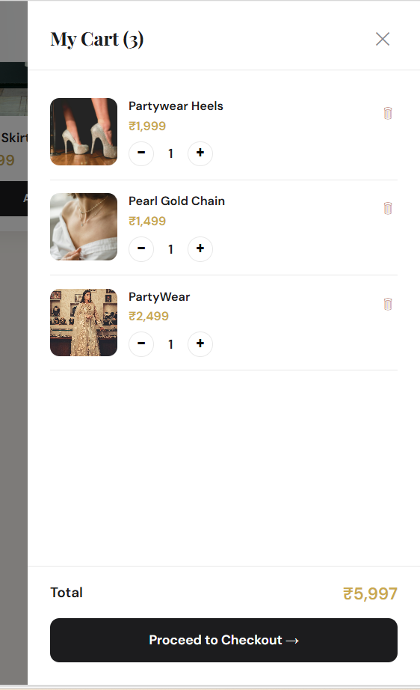
\Figure 12: Cart Layout
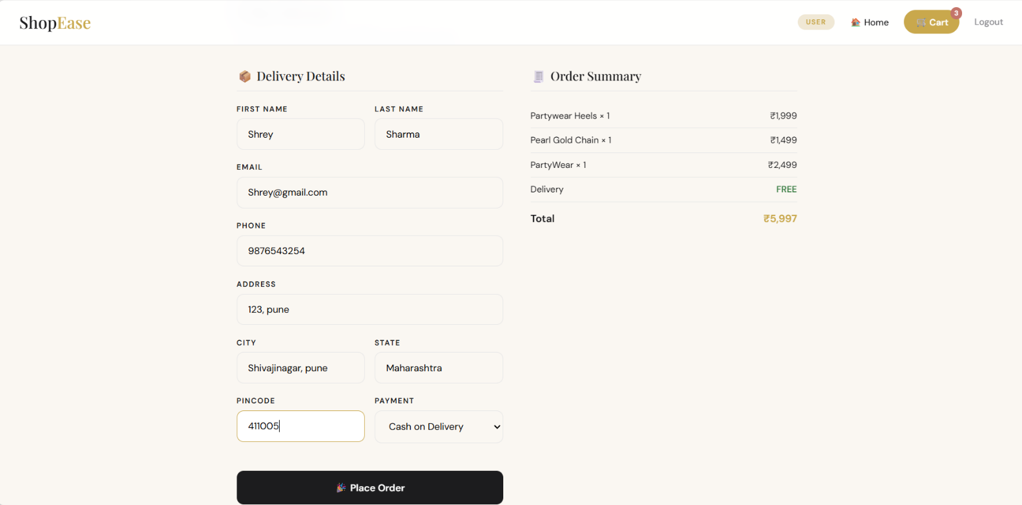
Figure 13: Checkout Process
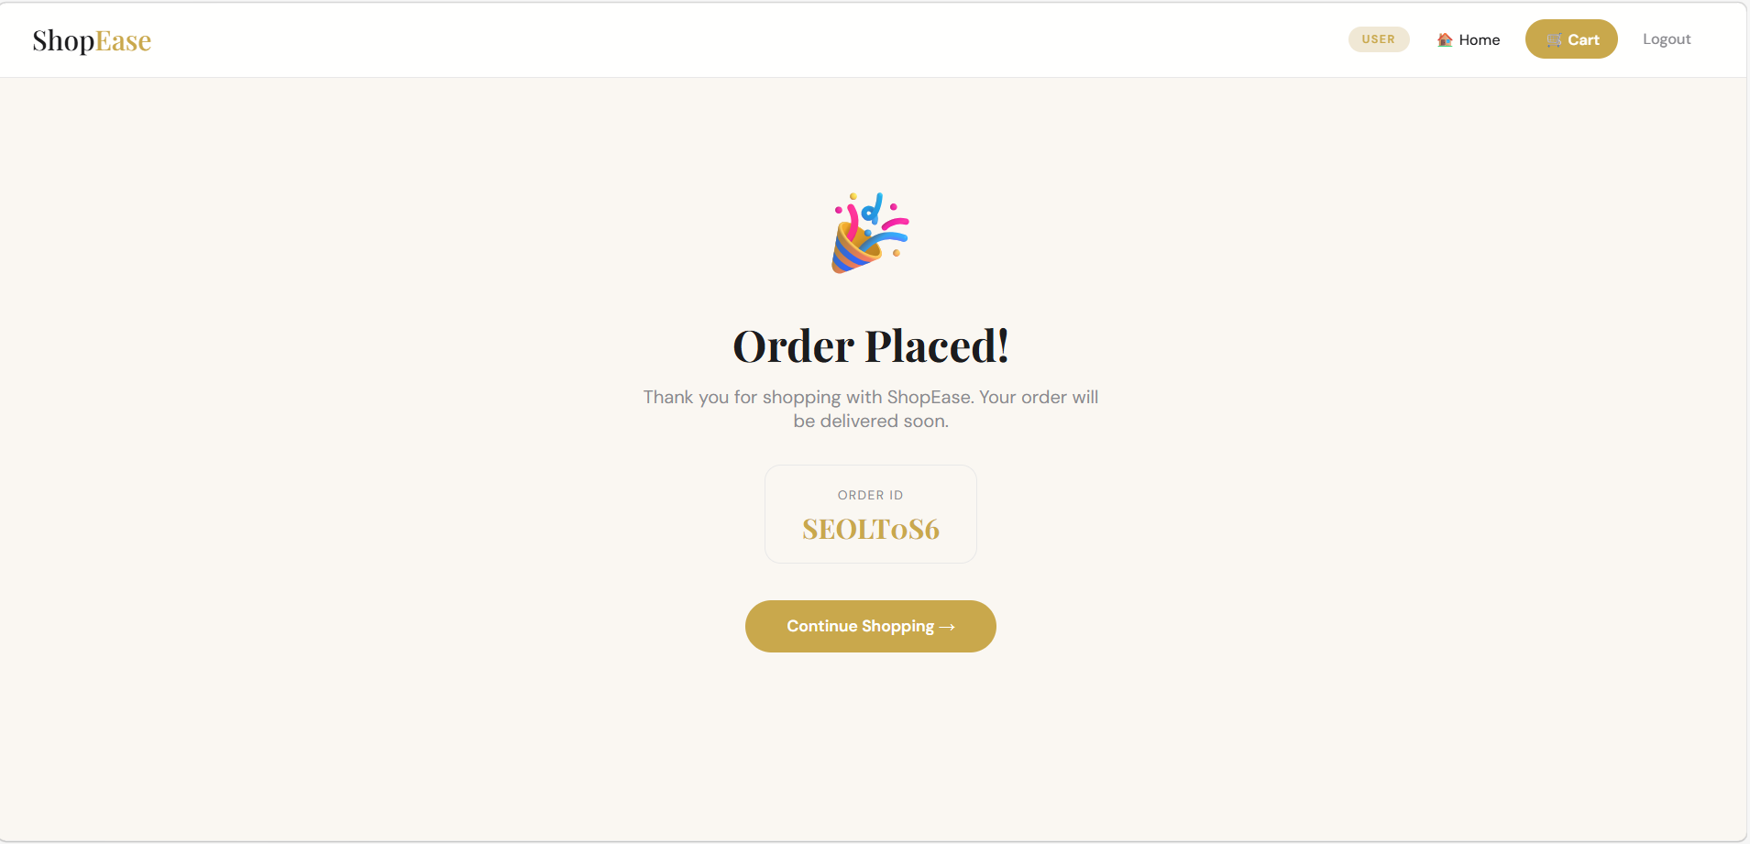
Figure 14: Order Placed Conformation

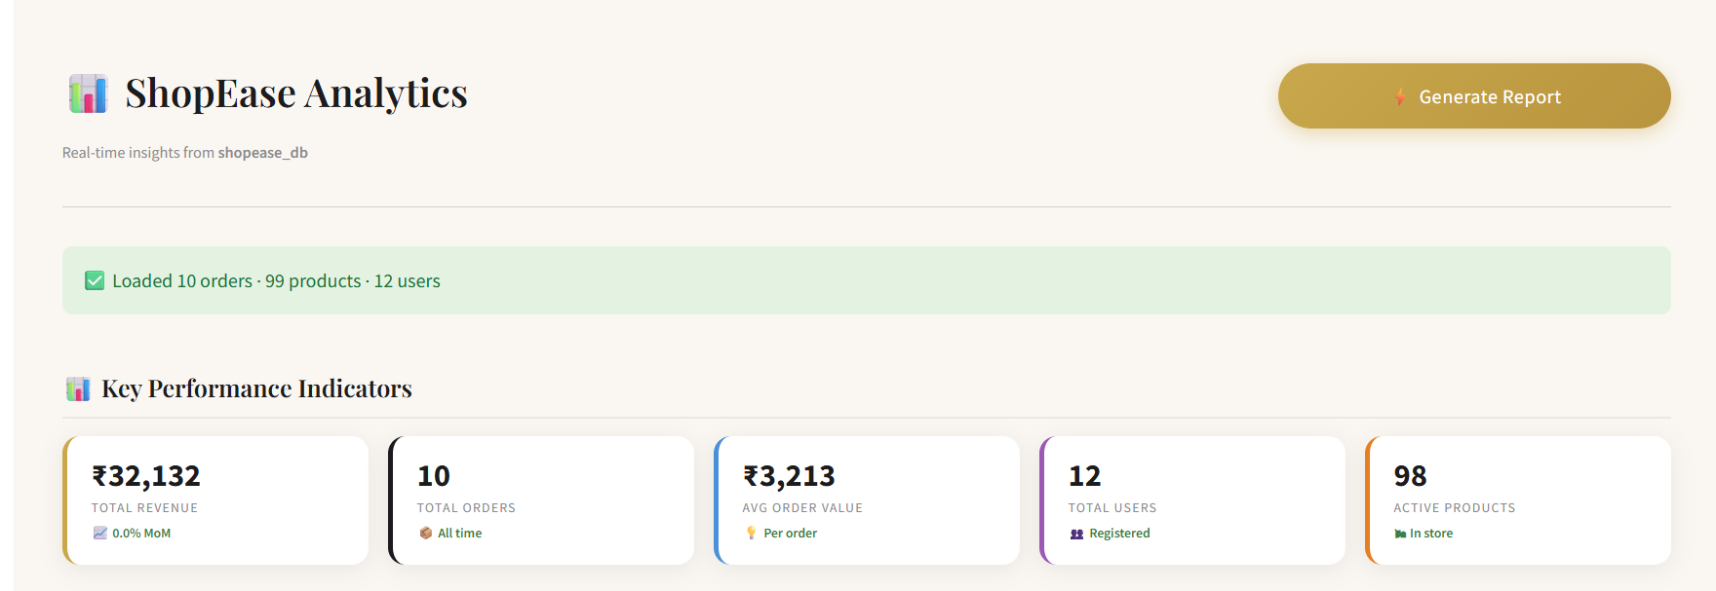
Figure 15: ShopEase Analytics Interface

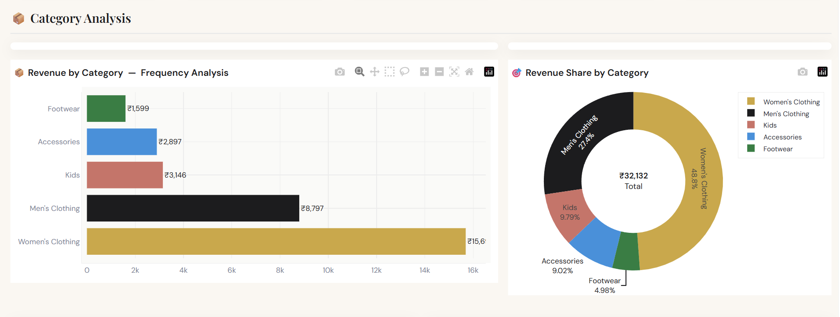

Figure 16: Revenue by Category

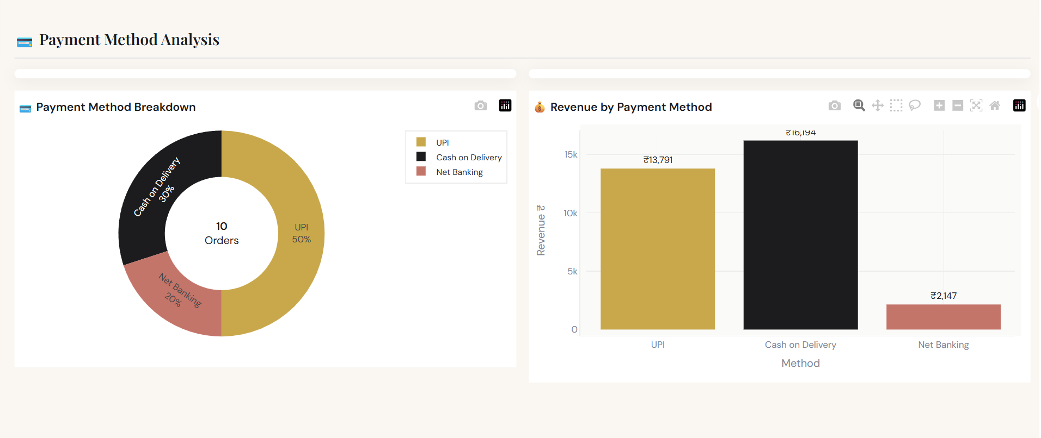
Figure 17: Payment Method Analysis

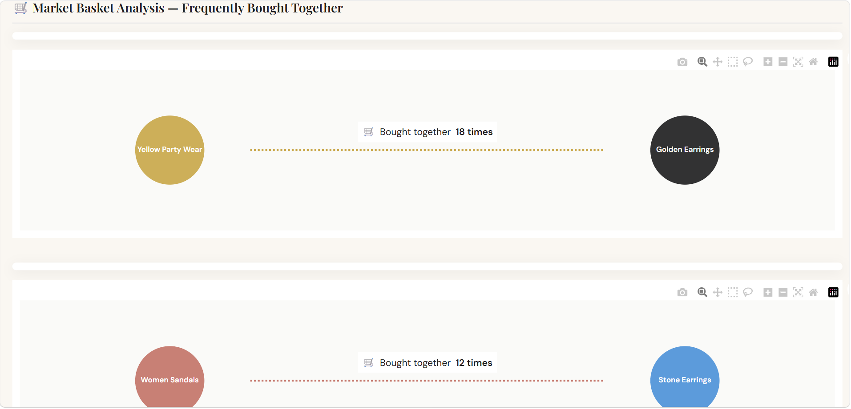
Figure 18: Market Basket Analysis

8.Analysis

8.1 Requirement Analysis and Data Understanding
The development of ShopEase is based on an in-depth understanding of current e-commerce trends and user expectations. With the rapid growth of online shopping, users increasingly demand platforms that are fast, intuitive, and reliable. Analysis of existing systems revealed that while many platforms offer extensive features, they often suffer from complex navigation, information overload, and inefficient user flows.
This study highlighted the need for a simplified and structured shopping system that focuses on core functionalities such as product discovery, cart management, and order processing. The goal was to design a system that minimizes user effort while maximizing efficiency and usability, especially for users with varying levels of technical familiarity. Additionally, the need for data-driven decision-making was identified, where analysing user behaviour, sales trends, and product performance becomes essential for improving business outcomes. This led to the inclusion of an analytics module to transform raw transaction data into meaningful insights.

8.2 Initial System State (Early Development Phase)
At the beginning of the ShopEase project, the system was developed as a basic prototype with limited functionality. The frontend consisted of static pages with minimal interactivity, and there was no proper integration with the backend. Product display was simple and lacked categorization, making navigation difficult for users.
The cart functionality was either absent or partially implemented, which restricted users from performing complete shopping operations. Additionally, there was no structured login system, and user roles such as admin and customer were not clearly defined. The backend logic was not fully organized, and database connectivity was either incomplete or inefficient, resulting in limited data handling capabilities.

8.3 Challenges Identified During Development
- During the early stages, several challenges were observed:
- Difficulty in connecting frontend with backend APIs
- Lack of proper state management in the user interface
- Insufficient handling of product and user data
- Absence of dynamic UI updates

8.4 System Reliability and Data Handling
Ensuring data accuracy and reliability is a critical aspect of the ShopEase system. The application maintains consistency in product data, cart updates, and order processing through structured backend logic and efficient database management. The use of a relational database ensures proper handling of relationships between users, products, and orders, while transactional operations are managed carefully to avoid inconsistencies.
To further enhance system capability, a Python-based analytics module has been integrated with the ShopEase database. This module processes transactional data to generate key insights such as revenue trends, user activity, and product performance. By combining reliable data handling with analytical processing, the system not only ensures accuracy but also supports informed decision-making.

8.5 Current System (Final Implementation – ShopEase)
In its final form, ShopEase has evolved into a fully functional and structured e-commerce web application. The frontend is built using React (Vite), providing a dynamic and responsive user interface with features such as category-based filtering, real-time cart updates, and intuitive navigation. A complete authentication system has been implemented, allowing users to log in with defined roles. The cart functionality is fully operational, enabling users to add, remove, and manage products efficiently, while the checkout process allows users to enter delivery details and successfully place orders.
On the backend, Spring Boot is used to implement a layered architecture consisting of Controller, Service, and Repository layers, ensuring proper handling of client requests, business logic, and database operations. MySQL is used as the database to maintain structured and consistent data storage. In addition to these core functionalities, the system is enhanced with an integrated analytics module that provides real-time insights and supports data-driven decision-making.

8.6 Practical Implementation and Impact
ShopEase successfully demonstrates the implementation of a real-world e-commerce system with essential functionalities. It provides users with a seamless platform to browse products, manage carts, and place orders efficiently. From a development perspective, the project has enabled the application of full-stack technologies, integration of frontend and backend systems, and handling of real-time data operations.
The inclusion of the analytics dashboard further extends the system from a transactional platform to an intelligent e-commerce solution. It enables monitoring of business performance, analysis of customer behavior, and identification of growth opportunities. Overall, the system bridges the gap between theoretical concepts and practical implementation, offering a strong foundation for future enhancements such as payment integration, recommendation systems, and advanced analytics.

9.Inferences & Conclusion

9.1 Inferences
1. Effective Implementation of Core E-Commerce Functionality
The development of ShopEase demonstrates that a structured web-based platform can efficiently handle essential e-commerce operations such as product browsing, cart management, and order processing. The system successfully simplifies the online shopping experience by focusing on usability and streamlined workflows.
2. Data Integrity and Reliable System Performance
By utilizing a relational database (MySQL) integrated with Spring Data JPA and Hibernate, the system ensures consistent data handling and transactional accuracy. Operations such as cart updates and order placement are managed reliably, minimizing errors and maintaining system stability.
3. User-Centric Design
The application is designed with a strong focus on usability, offering intuitive navigation, categorized product listings, and responsive design. This ensures that users with varying technical expertise can interact with the system efficiently, enhancing overall user satisfaction.
4. Effective Full-Stack Integration
Seamless communication between the React (Vite) frontend and Spring Boot backend through REST APIs enables real-time data exchange and smooth user interactions. This integration ensures that user actions are instantly reflected across the system.
5. Adoption of Modern Technology Stack
Leveraging React (Vite) for frontend development and Spring Boot for backend services results in a high-performance and maintainable system. The chosen technologies ensure faster development, efficient resource handling, and long-term scalability aligned with modern web application standards.

9.2 Conclusion
In conclusion, ShopEase demonstrates the development of a modern, user-centric online shopping portal that effectively supports product browsing, cart management, and order processing. By integrating a responsive frontend with a robust backend and a reliable database, the system ensures smooth functionality and a consistent user experience.
The project highlights the importance of structured architecture, data integrity, and seamless frontend–backend communication. It also serves as a strong foundation for future enhancements such as payment integration and advanced features, with the potential to evolve into a scalable, real-world e-commerce solution.

10.Feedback

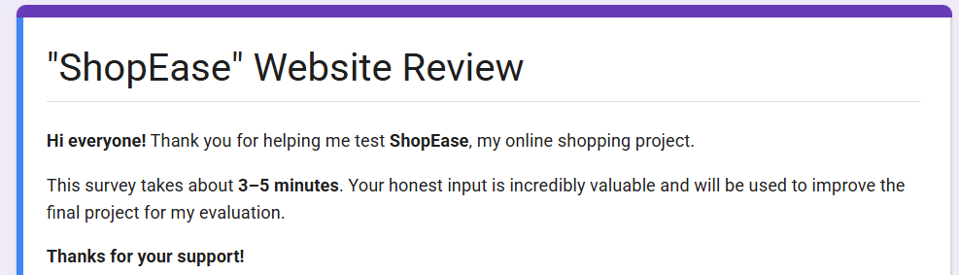
To evaluate the project, I conducted a Google Form survey. The feedback focused on Users experience throughout the project, specifically on collaboration, communication, and decision-making.
The responses were collected from a diverse age group ranging from 17 to 65 years, ensuring broad representation of users with varying levels of experience and digital familiarity. This wide age distribution provides valuable insights into user behavior and preferences across different generations, enhancing the reliability and inclusiveness of the analysis.
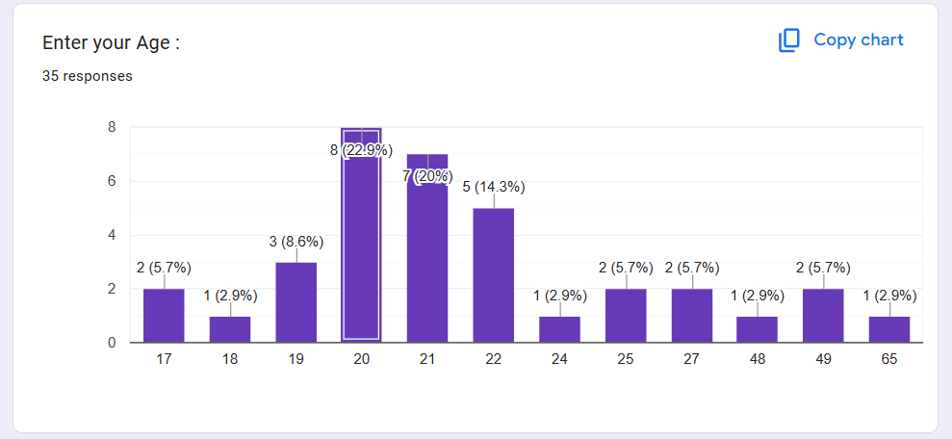
Figure 19: Age Range of Users
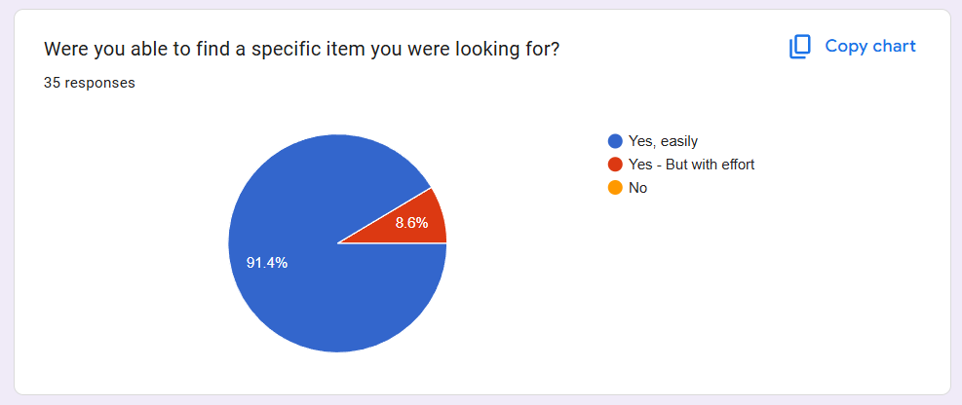
The questions included:
Figure 20: Responses about easy navigation through UI

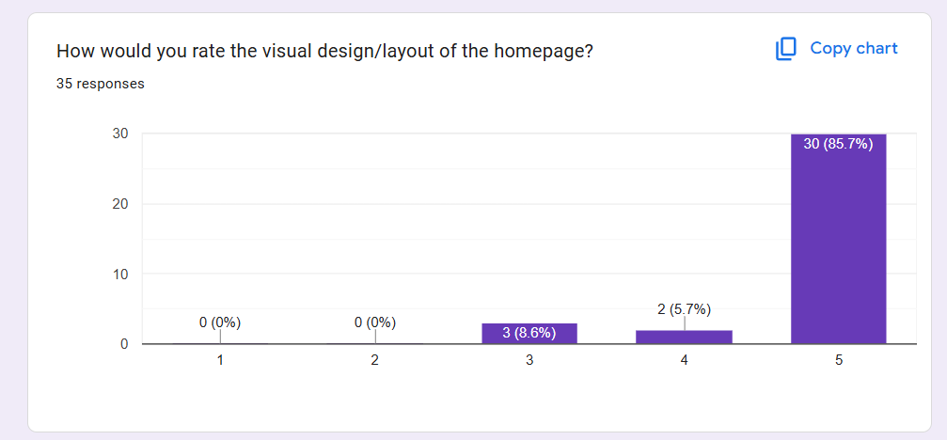

Figure 21: Responses about the Designing, Layout of Website
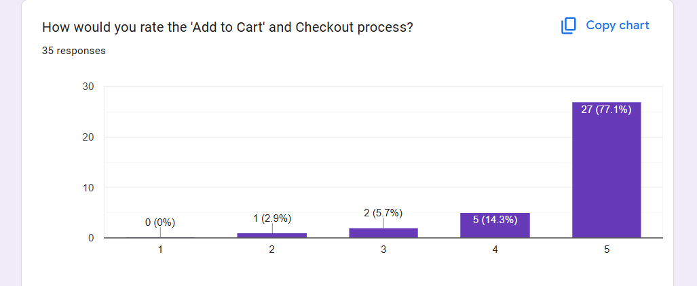
Figure 22: Responses regarding Cart Functionality and Checkout Process

11.Attendance Record

Date | Task Completed
31/12/2025 | Introduction to the organization and peers.
05/01/2026 | Understood about project requirements and individual role in it.
13/01/2026 | Created required databases and schemas.
22/01/2026 | Built APIs using Spring Boot for handling core functionalities.
30/01/2026 | Set up frontend application using React (Vite)
09/02/2026 | Implemented User Authentication flow and Session Handling.
16/02/2026 | Fixed Bugs related to API responses, database queries and UI Rendering.
18/02/2026 | Integrated frontend, backend and database into a fully functional web application.
23/02/2026 | Performed final debugging, optimization and code cleanup.
27/02/2026 | Conducted a feedback survey.
Table 2: Weekly Work Progress
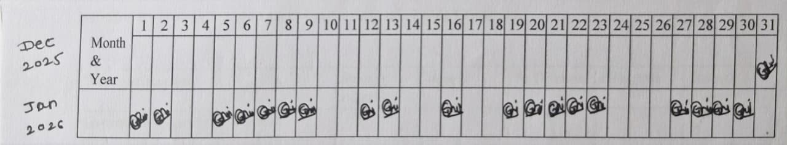
Figure 18: Attendance Record

12.Acknowledgement

ACKNOWLEDGEMENT
I would like to take this opportunity to express my heartfelt appreciation to everyone who supported and guided me during my internship at Scalrithm IT Solutions. This experience has significantly contributed to enhancing my technical skills and provided valuable exposure to real-world software development.
I am especially grateful to my mentors and team members at Scalrithm IT Solutions for their continuous support, valuable suggestions, and encouragement throughout the internship. Their insights and guidance helped me gain a deeper understanding of development practices and improved my overall approach to problem-solving.
I am profoundly grateful to my Internship Guide at Progressive Education Society's Modern College of Engineering, Prof. Dr. Mrs. S. A. Itkar, Head of the Computer Department, whose expert guidance and unwavering support significantly contributed to my learning journey.
I would also like to express my appreciation to the faculty of Progressive Education Society's Modern College of Engineering for their constant motivation and academic support, which enabled me to effectively connect theoretical knowledge with practical implementation.
Overall, this internship has been an enriching journey that allowed me to apply my knowledge in a practical environment, and I am truly thankful for the guidance and opportunities provided.
Gayatri Prafulla Wani
[31064]

13. List Of References

- Patil, A., Sharma, R., & Kulkarni, S. (2025). Design and Development of a Scalable E-Commerce Web Application using React and Spring Boot. International Journal of Innovative Research in Computer Science and Technology (IJIRCST), 13(2), 45–52. https://ijircst.org/papers/2025/ecommerce-react-springboot
- Gupta, V., Mehta, P., & Jain, A. (2024). Full Stack Web Development using Spring Boot and React: A Modern Approach to E-Commerce Systems. International Journal of Advanced Research in Computer Engineering & Technology (IJARCET), 13(1), 112–118. https://ijarcet.org/wp-content/uploads/IJARCET-VOL-13-ISSUE-1-112-118.pdf
- Kumar, S., & Verma, R. (2025). Implementation of RESTful Web Services in E-Commerce Applications using Spring Boot. Journal of Emerging Technologies and Innovative Research (JETIR), 12(6), 234–240. https://www.jetir.org/papers/JETIR2506234.pdf
- Singh, P., & Kaur, H. (2024). A Study on Scalable Web Application Development using ReactJS and Modern Frontend Tools. International Journal of Scientific Research in Computer Science, 9(4), 78–85. https://ijsrcs.com/papers/2024/reactjs-scalable-applications.pdf
- Reddy, K., & Nair, S. (2025). Database Design and Optimization Techniques for E-Commerce Platforms using MySQL. International Journal of Database Management Systems (IJDMS), 15(1), 33–41. https://airccse.org/journal/ijdms/papers/15125ijdms03.pdf
- Khan, M., & Ali, S. (2024). Secure Authentication and Authorization in Web Applications using JWT and Spring Security. International Journal of Cyber Security and Digital Forensics, 10(3), 55–63. https://ijcsdf.org/papers/2024/jwt-spring-security.pdf
- Sharma, N., & Patel, D. (2025). Microservices Architecture for Scalable E-Commerce Applications using Spring Boot and Docker. International Journal of Cloud Computing and Services Science (IJ-CLOSER), 14(1), 21–30. https://ijcloser.iaescore.com/index.php/IJ-CLOSER/article/view/21456
- Hariharan, S., & Sumalatha, V. (2025). A Modern E-Commerce Solution Using Spring Boot & Secure APIs. International Journal of Science, Engineering and Technology, 13(3). https://www.ijset.in/modern-e-commerce-solution-using-spring-boot-secure-apis/ IJSET
- Girhe, G. L., Gondane, A., & Gudadhe, P. (2024). Advancement of E-Commerce Development using React and Spring Boot. International Journal of Progressive Research in Engineering Management and Science (IJPREMS), 4(9), 971–973. https://www.doi.org/10.58257/IJPREMS36113

