**Topics: Descriptive Statistics and Probability**

1. Look at the data given below. Plot the data, find the outliers and find out $μ, σ, σ^{2}$

|  |  |
| --- | --- |
| **Name of company** | **Measure X** |
| Allied Signal | 24.23% |
| Bankers Trust | 25.53% |
| General Mills | 25.41% |
| ITT Industries | 24.14% |
| J.P.Morgan & Co. | 29.62% |
| Lehman Brothers | 28.25% |
| Marriott | 25.81% |
| MCI | 24.39% |
| Merrill Lynch | 40.26% |
| Microsoft | 32.95% |
| Morgan Stanley | 91.36% |
| Sun Microsystems | 25.99% |
| Travelers | 39.42% |
| US Airways | 26.71% |
| Warner-Lambert | 35.00% |

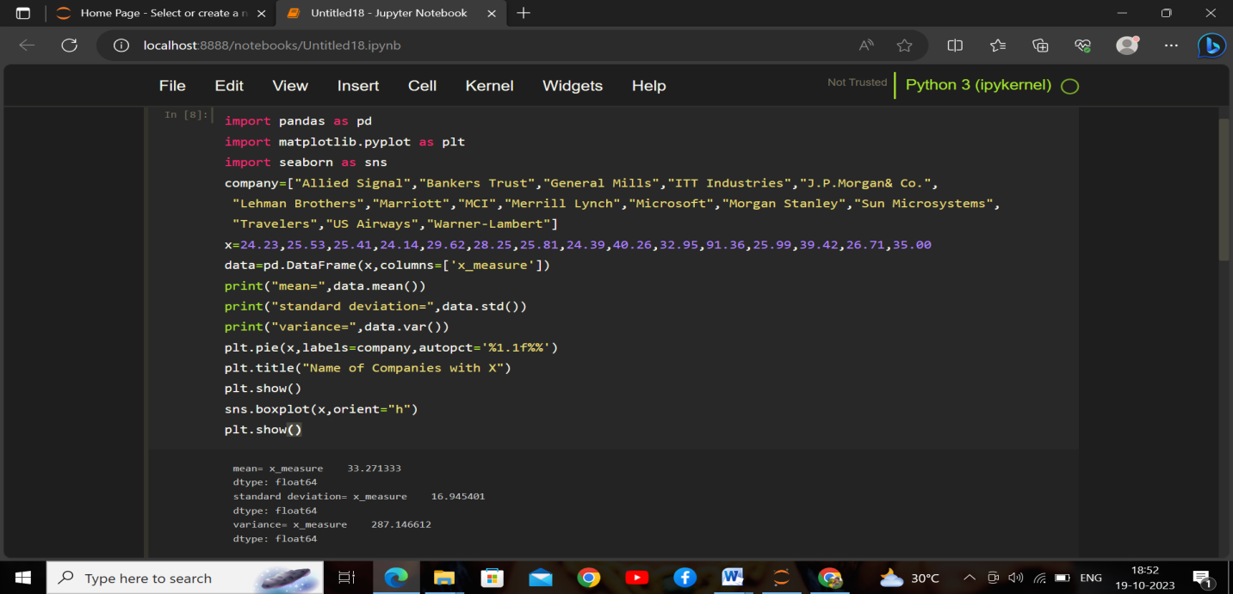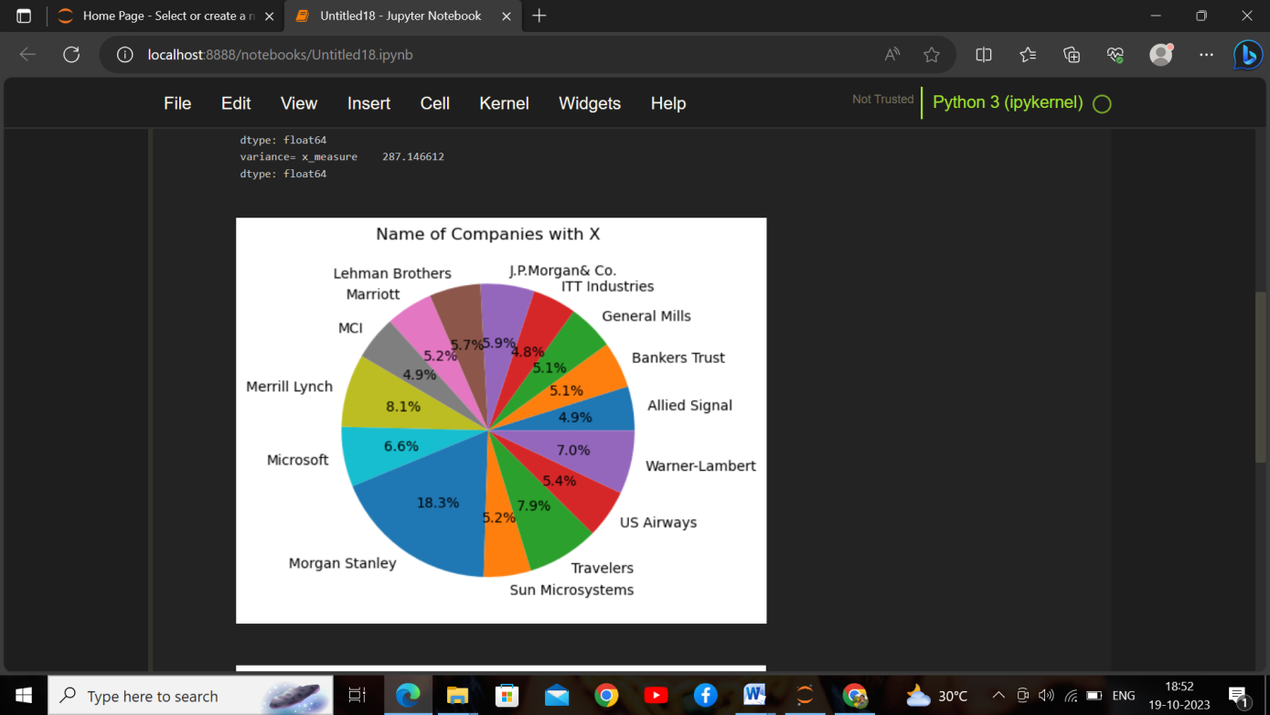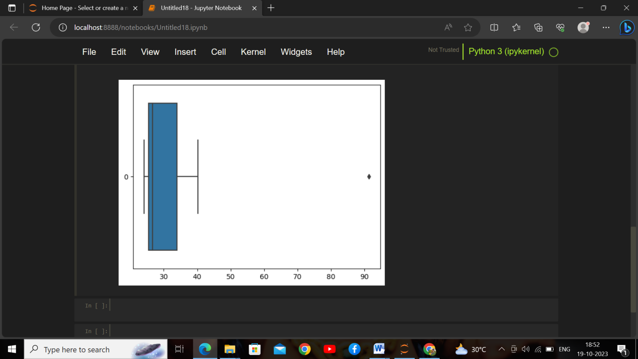

**2.Answer the following three questions based on the box-plot above.**



1. **What is inter-quartile range of this dataset? (please approximate the numbers) In one line, explain what this value implies.**

->first quartile(Q1)=5

Second Quartile(Q2)=7

Third Quartile(Q3)=12

Inter Quartile Range=Q3-Q1

=12-5

=7

1. **What can we say about the skewness of this dataset?**

->The median is mostly shifted at left side.Therefore the boxplot is poisitively skewed(i.e

Right skewed)

1. **If it was found that the data point with the value 25 is actually 2.5, how would the new box-plot be affected?**

-> If it was found that the data point with the value 25 is actually 2.5 then there is no outlier is present.It will also reduce the skewness and the data will be normally distributed.

3]



**Answer the following three questions based on the histogram above.**

1. **Where would the mode of this dataset lie?**

* The mode is approximetly lie between point 4 to 8.

1. **Comment on the skewness of the dataset**.

* The data is right skewed or positively skewed.

1. **Suppose that the above histogram and the box-plot in question 2 are plotted for the same dataset. Explain how these graphs complement each other in providing information about any dataset.**

* Both the box plot and histogram are right or positively skewed,both plot contain outlier. The boxplot gives the clear information about the median where the histogram give the clear information about the mode.

**4.]AT&T was running commercials in 1990 aimed at luring back customers who had switched to one of the other long-distance phone service providers. One such commercial shows a businessman trying to reach Phoenix and mistakenly getting Fiji, where a half-naked native on a beach responds incomprehensibly in Polynesian. When asked about this advertisement, AT&T admitted that the portrayed incident did not actually take place but added that this was an enactment of something that “could happen.” Suppose that one in 200 long-distance telephone calls is misdirected. What is the probability that at least one in five attempted telephone calls reaches the wrong number? (Assume independence of attempts.)**

🡪 If 1 call is mismatch from the 200 calls

Probability of call mismatch(p) =1/200

Probability of call not mismatch(q) =(200-1)/200

= 199/200

n=5

let x=1

P(x) = at least one in five attempted telephone calls reaches the wrong number.

P(x)= (nCx) (p^x) (q^n-x)

P(1)=(5C1)(1/200)(199^5-1)

P(1)=0.0245037

**5] Returns on a certain business venture, to the nearest $1,000, are known to follow the following probability distribution**

|  |  |  |  |
| --- | --- | --- | --- |
| x | P(x) | E(x) |  |
| -2,000 | 0.1 | -200 | 400000 |
| -1,000 | 0.1 | -100 | 100000 |
| 0 | 0.2 | 0 | 0 |
| 1000 | 0.2 | 200 | 200000 |
| 2000 | 0.3 | 600 | 1200000 |
| 3000 | 0.1 | 300 | 900000 |
| 800 | 2800000 |

1. W**hat is the most likely monetary outcome of the business venture?**

* The most likely monetary outcome of the business venture is at 0.3 which is maximum compared to others.

1. Is the venture likely to be successful? Explain

* To determine whether the venture is successful, we have to calculate the expected value .The expected value is calculated by multiplying each possible outcome by its probability and then summing up these values.

Expected value=sum((X)*P(X)

=(-200-100+0+200+600+300)

=800

on the basis of average, the venture is likely to be successful. In this case, the expected return is 800, which means, on average, the business venture is expected to generate a profit. Therefore, based on the expected return, the venture is likely to be successful.

1. What is the long-term average earning of business ventures of this kind? Explain

* Expected value=sum((X)*P(X)

=(-200-100+0+200+600+300)

=800

The average earing of business in long term is more than $800.

1. What is the good measure of the risk involved in a venture of this kind? Compute this measure

* To calculate the risk involved in venture we use standard deviation in probability distribution .

σ=∑i​(P(xi​)⋅(xi​−E)2)​

=1/2(360000+324000+128000+32000+432000+490000)|

=1/2(1344000)

σ≈ 1159.22

The standard deviation i.e the measure of risk is approximetly 1159.22.which indicate that the large standard deviation, the large risk associated with the venture.