BIKE SHARING DEMAND ANALYTICS
AND PREDICTION SYSTEM

Data Analytics with AI
IBM SkillsBuild Internship Project

Name: Gayatri Somasekhar
Branch: Computer Science and Engineering
Year: 2nd Year
College: VIT Chennai

- INTRODUCTION

Bike-sharing systems provide an environmentally friendly and convenient mode of transportation for short-distance travel. However, the demand for rental bikes changes depending on factors such as time of day, season, weather conditions, working days, and temperature.
Understanding these demand patterns is important for efficient bike availability and redistribution. If the demand can be estimated accurately, bike-sharing operators can prepare for high-demand periods and reduce shortages or inefficient allocation of bikes.
This project analyzes historical bike-sharing data using Python and data analytics techniques. Exploratory data analysis and visualization are used to identify important demand patterns. A Random Forest Regression model is also developed to predict the total number of hourly bike rentals.
The project follows a data-to-decision approach by converting raw data into information, insights, risks, opportunities, and recommended actions.

- PROBLEM STATEMENT

Bike-sharing operators need to understand how rental demand changes throughout the day and under different environmental and calendar conditions.
Without effective demand analysis, operators may face situations where there are not enough bikes during high-demand periods or excess bikes during periods of low demand.
The objective of this project is to analyze historical bike-sharing data, identify the major factors associated with rental demand, predict hourly bike demand using machine learning, and provide actionable recommendations for operational planning.

- OBJECTIVES

The main objectives of this project are:
- To analyze historical bike rental demand.
- To identify peak bike rental hours.
- To analyze demand across different months and seasons.
- To study the relationship between weather conditions and bike demand.
- To compare bike demand on working and non-working days.
- To identify important factors affecting bike rental demand.
- To build a machine learning model for predicting hourly bike demand.
- To evaluate the performance of the prediction model.
- To identify operational risks and opportunities.
- To generate actionable recommendations based on the analysis.

- DATASET DESCRIPTION

The project uses the Bike Sharing Dataset obtained from Kaggle.
Dataset Source: Kaggle
Dataset: Bike Sharing Dataset
Dataset Link: https://www.kaggle.com/datasets/lakshmi25npathi/bike-sharing-dataset
The project uses the hour.csv file because it contains hourly bike rental information.
The dataset contains information related to:
- Season
- Year
- Month
- Hour
- Holiday
- Weekday
- Working day
- Weather situation
- Temperature
- Feeling temperature
- Humidity
- Windspeed
- Casual users
- Registered users
- Total bike rentals
The target variable used in this project is cnt, which represents the total number of bike rentals.
The variables casual and registered were not used as prediction features because they are components of the total rental count. Excluding them prevents data leakage and makes the prediction task more meaningful.

- TECHNOLOGIES USED

The following technologies and Python libraries were used:
- Python
- Pandas
- NumPy
- Matplotlib
- Seaborn
- Scikit-learn
- Visual Studio Code
Pandas was used for data loading and manipulation.
NumPy was used for numerical calculations.
Matplotlib and Seaborn were used for data visualization.
Scikit-learn was used to build and evaluate the machine learning model.

- METHODOLOGY

The project follows the following workflow:
Data Collection → Data Cleaning → Exploratory Data Analysis → Visualization → Feature Selection → Machine Learning → Model Evaluation → Insights → Recommendations
Step 1: Data Collection
The Bike Sharing Dataset was downloaded from Kaggle.
Step 2: Data Loading
The hour.csv dataset was loaded into Python using Pandas.
Step 3: Data Quality Checking
The dataset was checked for:
- Missing values
- Duplicate records
- Data types
- Dataset dimensions
Step 4: Data Cleaning
Duplicate records were removed where necessary.
The relevant variables were selected for analysis and prediction.
Step 5: Exploratory Data Analysis
The dataset was analyzed to understand:
- Hourly demand
- Monthly demand
- Seasonal demand
- Weather-related demand
- Temperature-related demand
- Humidity-related demand
- Working-day demand
Step 6: Data Visualization
Multiple graphs were created to identify trends and relationships within the data.
Step 7: Machine Learning
A Random Forest Regression model was trained to predict hourly bike rental demand.
Step 8: Model Evaluation
The model was evaluated using:
- Mean Absolute Error
- Root Mean Squared Error
- R² Score
Step 9: Insight Generation
The results were converted into meaningful insights, risks, opportunities, and recommended actions.

- KEY PERFORMANCE INDICATORS

The following KPIs were calculated from the dataset.
KPI | Result
Total Bike Rentals | 3,292,679
Average Hourly Demand | 189.46
Peak Demand Hour | 17:00 (5 PM)
Average Demand at Peak Hour | 461.45
Average Working-Day Demand | 193.21
Average Non-Working-Day Demand | 181.41

The analysis shows that the dataset contains 17,379 hourly observations and a total of 3,292,679 recorded bike rentals. The average hourly demand is 189.46 rentals. The highest average demand occurs at 17:00 (5 PM), with an average demand of 461.45 rentals. Average demand on working days is 193.21 rentals, compared with 181.41 rentals on non-working days.
These KPIs provide a high-level overview of the bike-sharing system and help identify important demand patterns.
The peak demand hour is particularly useful because it indicates when operators may need to ensure sufficient bike availability.

- EXPLORATORY DATA ANALYSIS

8.1 Hourly Bike Rental Demand
The hourly demand analysis examines how the average number of bike rentals changes throughout the day.
The analysis helps identify periods of high and low demand. This information can be used to improve bike availability and redistribution planning.
Insert image: hourly_demand.png
Figure 1: Average Bike Rental Demand by Hour

8.2 Monthly Bike Rental Demand
Monthly demand was analyzed to identify changes in bike rental activity throughout the year.
Different months can show different rental patterns because of seasonal and environmental conditions.
Insert image: monthly_demand.png
Figure 2: Average Bike Rental Demand by Month

8.3 Seasonal Bike Rental Demand
The dataset contains information about different seasons. Average bike rental demand was calculated for each season.
This analysis helps identify whether seasonal conditions are associated with changes in bike rental activity.
Insert image: season_demand.png
Figure 3: Average Bike Rental Demand by Season

8.4 Weather-Based Demand Analysis
Weather conditions can affect people's willingness to use shared bicycles.
The average bike rental demand was calculated for different weather situations to understand how demand changes under different conditions.
Insert image: weather_demand.png
Figure 4: Average Bike Rental Demand by Weather Condition

8.5 Temperature and Bike Demand
Temperature was analyzed against total bike rental demand.
The scatter plot helps visualize whether changes in temperature are associated with changes in the number of bike rentals.
Insert image: temperature_vs_demand.png
Figure 5: Temperature vs Bike Rental Demand

8.6 Humidity and Bike Demand
Humidity was also analyzed because uncomfortable environmental conditions may affect bicycle usage.
The relationship between humidity and rental demand is shown below.
Insert image: humidity_vs_demand.png
Figure 6: Humidity vs Bike Rental Demand

8.7 Working-Day Analysis
Bike rental demand was compared between working days and non-working days.
This comparison helps identify differences in travel and rental patterns associated with working-day status.
Insert image: workingday_demand.png
Figure 7: Working Day vs Non-Working Day Demand

- CORRELATION ANALYSIS

A correlation heatmap was created to examine relationships between numerical variables in the dataset.
Correlation analysis helps identify variables that have stronger relationships with bike rental demand. However, correlation should not be interpreted as proof of causation.
Insert image: correlation_heatmap.png
Figure 8: Correlation Heatmap
The heatmap provides an overall view of how variables such as hour, temperature, humidity, weather, and other factors are associated with total rental demand.

- MACHINE LEARNING MODEL

10.1 Model Selection
A Random Forest Regressor was selected for predicting hourly bike rental demand.
Random Forest is an ensemble machine learning method that combines multiple decision trees to produce a prediction. It can model nonlinear relationships between different input variables and the target variable.

10.2 Target Variable
The target variable is:
cnt — Total Number of Bike Rentals

10.3 Input Features
The model uses the following variables:
- Season
- Year
- Month
- Hour
- Holiday
- Weekday
- Working day
- Weather situation
- Temperature
- Feeling temperature
- Humidity
- Windspeed
The casual and registered variables were excluded because they directly contribute to the total rental count and would introduce data leakage into the prediction model.

10.4 Training and Testing
The dataset was divided into two parts:
- 80% training data
- 20% testing data
The training data was used to train the Random Forest model, while the testing data was used to evaluate its performance on previously unseen records.

- MODEL EVALUATION

Three evaluation metrics were used.
Mean Absolute Error (MAE)
MAE measures the average absolute difference between the actual and predicted rental counts.
Root Mean Squared Error (RMSE)
RMSE measures the prediction error while giving greater importance to larger errors.
R² Score
R² indicates how much of the variation in the target variable is explained by the model.

Model Results
Evaluation Metric | Result
Mean Absolute Error (MAE) | 24.72
Root Mean Squared Error (RMSE) | 41.80
R² Score | 0.9448

The Random Forest Regression model achieved an R² score of 0.9448 on the test dataset. The Mean Absolute Error was 24.72, meaning that the model's predictions differed from the actual rental demand by approximately 24.72 rentals on average in absolute terms. The Root Mean Squared Error was 41.80.
The evaluation results provide an indication of how effectively the Random Forest model predicts hourly bike rental demand on the testing data.

- FEATURE IMPORTANCE

Feature importance was calculated from the Random Forest model.
This analysis helps identify which available variables contributed most to the model's predictions.
Insert image: feature_importance.png
Figure 9: Factors Influencing Bike Rental Demand
The feature-importance analysis can be used to understand which aspects of time, weather, and environmental conditions are particularly useful for predicting demand.
The exact ordering of important features is based on the trained model and is shown in the generated visualization.

- FINDINGS

Feature | Importance
Hour (hr) | 61.18%
Temperature (temp) | 11.89%
Year (yr) | 8.09%
Working Day | 5.84%
Humidity | 2.65%
Feeling Temperature | 2.17%
Season | 2.15%
Weather | 1.81%
Month | 1.65%
Weekday | 1.26%
Windspeed | 1.04%
Holiday | 0.26%

Feature importance analysis shows that the hour of the day is the strongest predictor used by the Random Forest model, with an importance value of approximately 61.18%. Temperature is the second most important feature at approximately 11.89%, followed by year at 8.09% and working-day status at 5.84%. This indicates that temporal patterns, particularly the hour of the day, play a major role in predicting bike rental demand.

- KEY INSIGHTS

The analysis produced several important findings about bike-sharing demand.
Insight 1: Evening demand reaches a major peak
The highest average hourly demand occurs at 17:00 (5 PM), with an average of 461.45 bike rentals.
This indicates that the evening period represents an important high-demand period and should receive additional attention when planning bike availability.
Insight 2: Hour of the day is the strongest predictive factor
The Random Forest model identifies hr as the most important feature, with a feature importance of approximately 61.18%.
This indicates that time-of-day patterns provide substantial information for predicting bike rental demand.
Insight 3: Temperature is an important demand-related variable
Temperature has a feature importance of approximately 11.89%, making it the second most important feature in the model.
This suggests that environmental conditions related to temperature provide useful information when estimating rental demand.
Insight 4: Demand is slightly higher on working days
Average working-day demand is 193.21 rentals, compared with 181.41 rentals on non-working days.
This represents a difference of approximately 11.80 rentals per hour, showing that working-day status provides useful information for demand planning.
Insight 5: The model captures demand patterns effectively
The Random Forest model achieved an R² score of 0.9448, indicating that the model explains a substantial proportion of the variation in the test-set rental demand.
The model achieved an MAE of 24.72 and an RMSE of 41.80.
Insight 6: Demand forecasting can support operational planning
The combination of hourly demand patterns, environmental variables, and calendar information can be used to support decisions about bike availability and redistribution.

- RISKS

The analysis identifies several potential operational risks.
14.1 Weather-related demand changes
Unfavorable weather conditions can result in lower rental demand and make demand forecasting more difficult.
14.2 Peak-hour shortages
If demand increases sharply during particular hours, insufficient bike availability may result in customer dissatisfaction.
14.3 Forecasting errors
Incorrect demand predictions may result in inefficient bike redistribution.
14.4 Changing demand patterns
Historical patterns may change over time due to changes in user behavior, weather, transportation preferences, or other external factors.

- OPPORTUNITIES

The analysis also provides several opportunities.
15.1 Improved bike redistribution
Predicted demand can be used to determine where and when bikes should be made available.
15.2 Peak-demand planning
High-demand periods can be identified in advance so that operators can prepare sufficient bike availability.
15.3 Weather-aware planning
Weather information can be incorporated into operational planning to account for potential demand changes.
15.4 Data-driven decision making
Historical rental data can support operational decisions instead of relying entirely on manual estimation.

- RECOMMENDED ACTIONS

Based on the analysis, the following actions are recommended:
- Increase bike availability during predicted high-demand periods.
- Use historical hourly demand patterns when planning bike redistribution.
- Incorporate weather information into daily demand planning.
- Monitor peak-hour demand to reduce the possibility of bike shortages.
- Use predictive analytics to support operational resource allocation.
- Continuously monitor new rental data and update the prediction model as demand patterns change.
Finding | Risk / Opportunity | Recommended Action
Peak demand occurs at 5 PM | Risk of bike shortages during peak periods | Increase bike availability before peak evening demand
Hour is the strongest model feature | Opportunity for time-based forecasting | Use hourly forecasts for redistribution planning
Temperature is an important feature | Weather/environmental changes can affect demand | Include weather conditions in operational planning
Working-day demand is higher | Different user patterns across working days | Adjust availability according to working-day patterns
Model achieves R² = 0.9448 | Opportunity for predictive planning | Use the model as a decision-support tool for demand estimation

These findings demonstrate how the project moves beyond visualization by converting analytical results into operational decisions. The results can support demand forecasting, bike redistribution, and preparation for high-demand periods.

- BUSINESS INTELLIGENCE FRAMEWORK

The project follows the framework:
DATA → INFORMATION → INSIGHT → DECISION → ACTION
Data
Historical hourly bike rental and environmental data.
Information
Analysis of rental demand across hours, months, seasons, weather conditions, and working days.
Insight
Identification of peak demand periods and important factors associated with rental demand.
Decision
Determine when and where additional bikes may be required.
Action
Improve bike redistribution, availability planning, and operational forecasting.
This framework converts raw historical data into actionable recommendations rather than presenting visualizations alone.

- PROJECT OUTPUTS

The project generates the following outputs:
- Hourly demand visualization
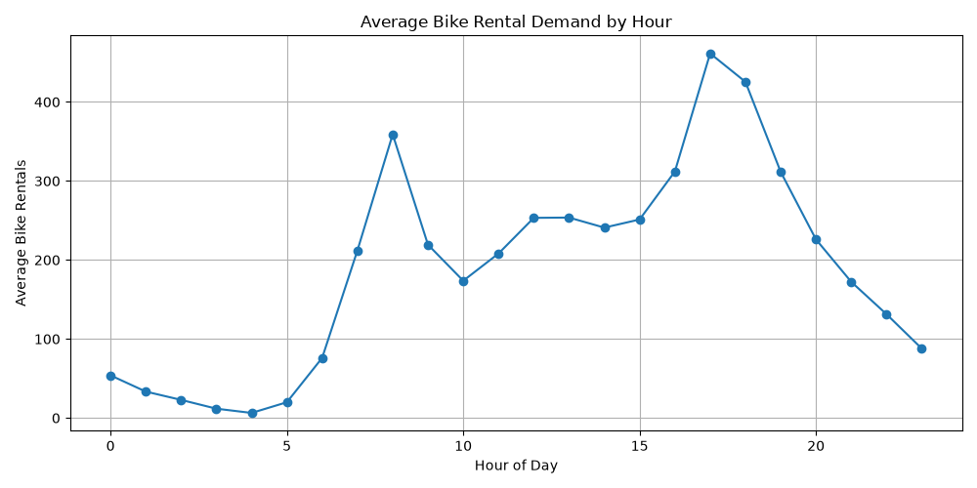

- Monthly demand visualization
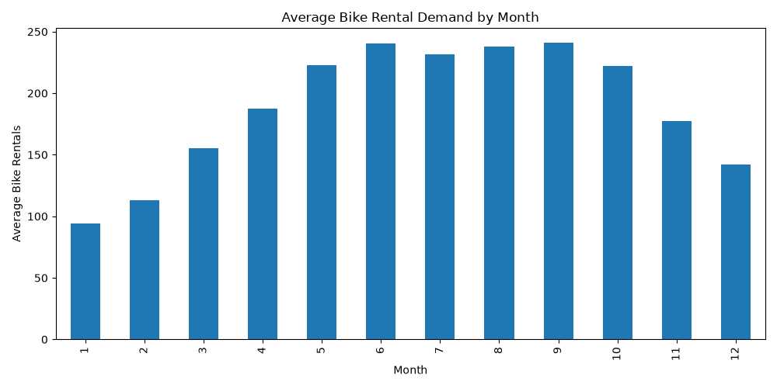

- Seasonal demand visualization
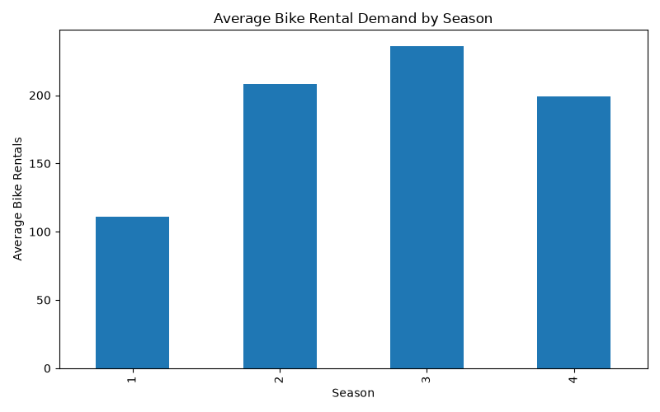

- Weather demand visualization
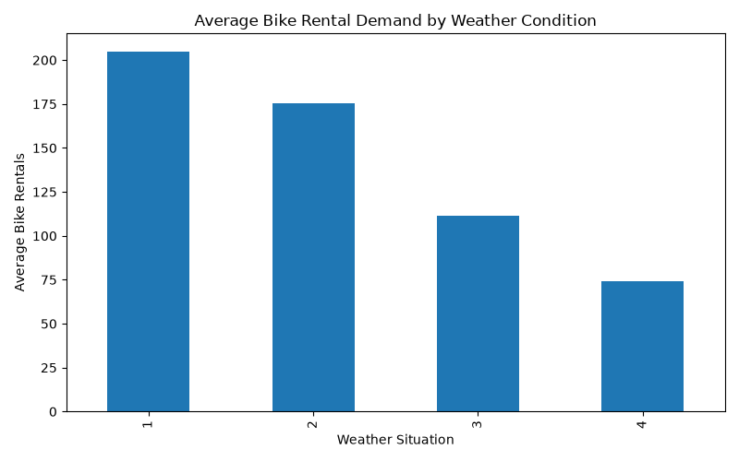

- Temperature versus demand visualization
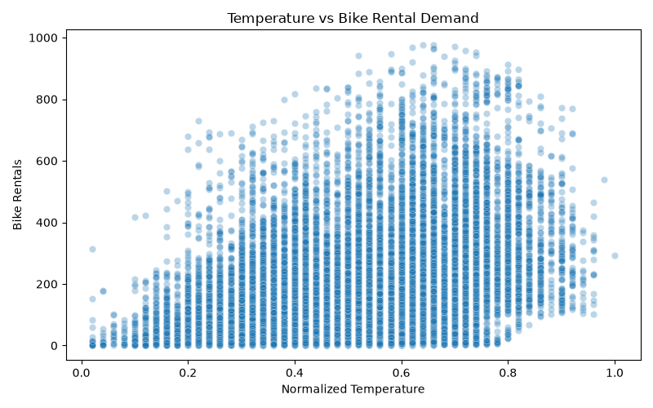

- Humidity versus demand visualization
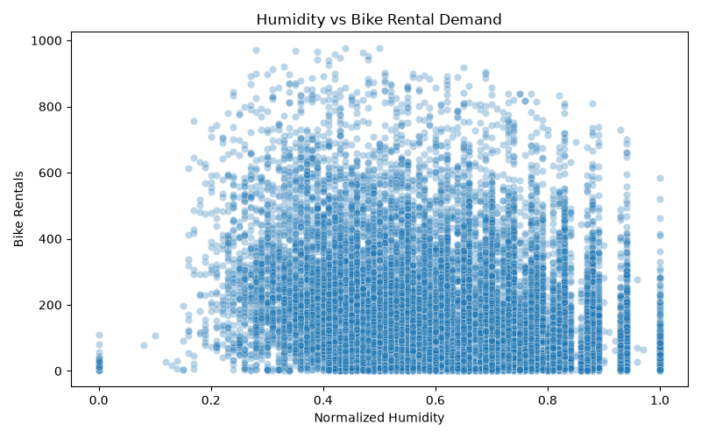

- Working-day demand visualization
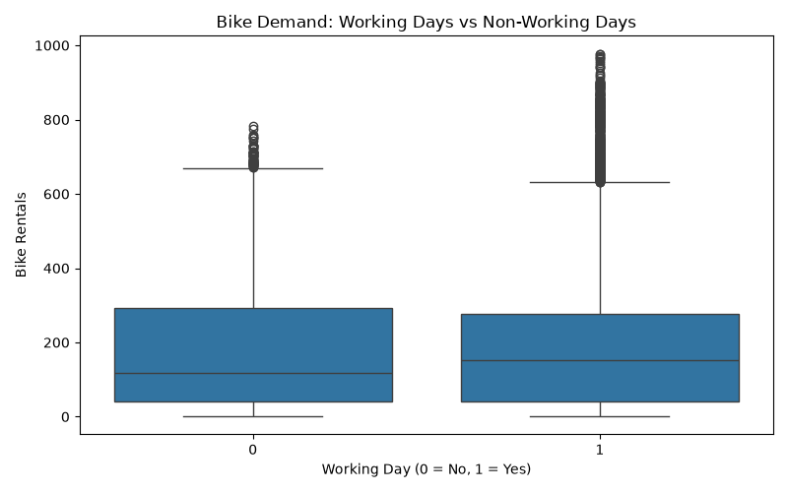

- Correlation heatmap
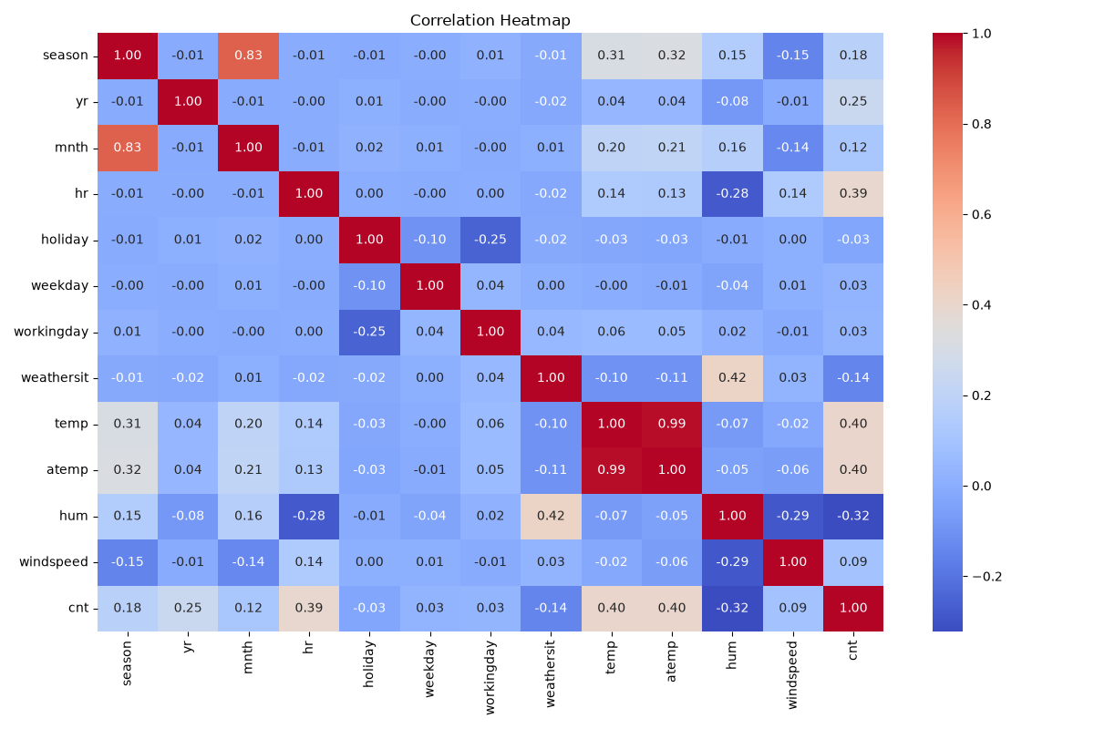

- Feature importance visualization
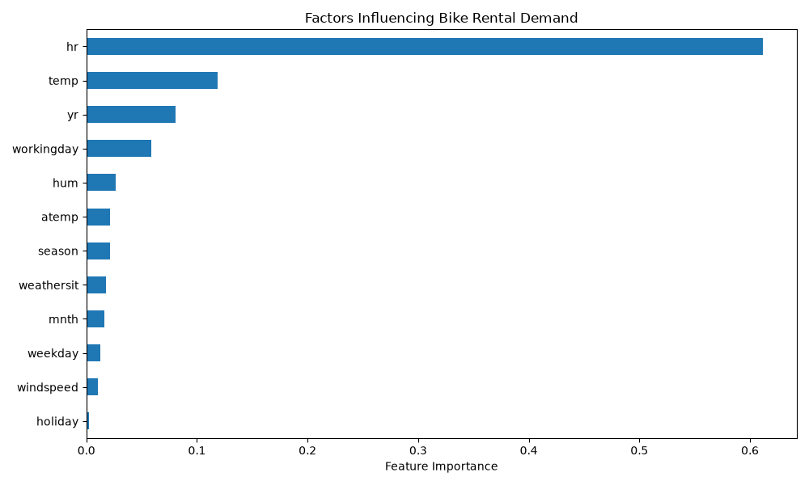

- Machine learning evaluation metrics
- Sample demand predictions
- Actionable recommendations

- CONCLUSION

The Bike Sharing Demand Analytics and Prediction System demonstrates how data analytics and machine learning can be used to transform historical bike-sharing data into actionable operational insights.
The analysis was performed on 17,379 hourly observations, containing a total of 3,292,679 recorded bike rentals. The average hourly demand was 189.46 rentals, while the highest average hourly demand occurred at 17:00 (5 PM) with 461.45 rentals.
The exploratory analysis showed that bike rental demand varies according to time, season, weather conditions, temperature, humidity, and working-day status. The machine learning analysis identified hour of the day as the most important feature used by the Random Forest model, followed by temperature, year, and working-day status.
The Random Forest Regression model achieved an R² score of 0.9448, with a Mean Absolute Error of 24.72 and a Root Mean Squared Error of 41.80 on the test data.
The project therefore demonstrates a complete data analytics workflow from raw data to information, insights, risks, opportunities, decisions, and recommended actions. The resulting analysis can support bike availability planning, peak-demand preparation, and data-driven bike redistribution.

20. REFERENCES
- Kaggle. Bike Sharing Dataset.
https://www.kaggle.com/datasets/lakshmi25npathi/bike-sharing-dataset
- Python Documentation.
https://www.python.org/
- Pandas Documentation.
https://pandas.pydata.org/
- Scikit-learn Documentation.
https://scikit-learn.org/
- Matplotlib Documentation.
https://matplotlib.org/
- Seaborn Documentation.
https://seaborn.pydata.org/

