12. Write the Python Program for Tic-Tac-Toe Game
Name:P.Gayathri
Reg.No:192424324

Aim
To implement a Tic-Tac-Toe game in Python where two players take turns placing X and O on a 3×3 board until one player wins or the game ends in a draw.

Algorithm:
Step 1:Create a 3×3 game board.
Step 2:Display the empty board.
Step 3:Player X enters the row and column.
Step 4:Check whether the selected position is empty.
Step 5:If valid, place X on the board.
Step 6:Check whether Player X has won.
Step 7:If not, Player O enters the row and column.
Step 8:Place O and check for a winner.
Step 9:Repeat until a player wins or all 9 positions are filled.
Step 10:Display the winner or draw message.

PROGRAM:
board = [[" " for i in range(3)] for j in range(3)]
def display():
print("\nBoard:")
for row in board:
print(row[0], "|", row[1], "|", row[2])
print("-" * 9)
def check_win(player):
for i in range(3):
if board[i][0] == board[i][1] == board[i][2] == player:
return True
for i in range(3):
if board[0][i] == board[1][i] == board[2][i] == player:
return True
if board[0][0] == board[1][1] == board[2][2] == player:
return True
if board[0][2] == board[1][1] == board[2][0] == player:
return True
return False
display()
for turn in range(9):
if turn % 2 == 0:
player = "X"
else:
player = "O"

print("\nPlayer", player)
row = int(input("Enter Row (0-2): "))
col = int(input("Enter Column (0-2): "))
if board[row][col] == " ":
board[row][col] = player
else:
print("Position already occupied!")
continue

display()
if check_win(player):
print("\nPlayer", player, "Wins!")
break
else:
print("\nGame Draw!")
OUTPUT:
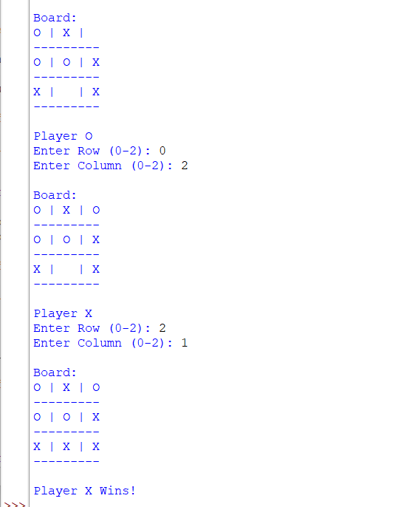

RESULT:
Thus, the Tic-Tac-Toe game was implemented successfully in Python, allowing two players to play alternately until one player wins or the game ends in a draw.

