SIMATS ENGINEERING
ASSESSMENT TOOL 3

COURSE NAME: Artificial Intelligence COURSE CODE: CSA17
NAME: Gayathri.P
Reg no:192424324

COURSE OUTCOME COVERED

CO5: Design AI-based systems using PySpark, RDD operations, and intelligent agent architectures, using scalable systems and integrate components in distributed AI applications. (BTL 5)

Assessment Tool Weightage: 10%

Duration : 1 Hour
QUESTIONS: 5 Total Marks:50

Annexure A

Technical Presentation

Code of Conduct:

I Gayathri(192424324) (Name / Reg No) certify that this submission is my original work and that I have adhered
to the guidelines specified for this assessment.
I understand that any violation of academic integrity rules will result in disciplinary action.

Signature of the student:
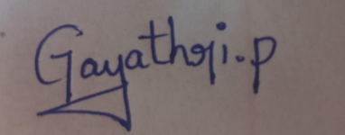

Annexure A
Technical Presentation

4. Data Flow & Processing Pipeline
Explain through a presentation the data flow, processing pipeline, and communication mechanisms in a reverse-engineered distributed system.
