Name:P.Gayathri
Reg.No:192424324

11. Write the Python Program for Map Coloring to Implement CSP
Aim:
To implement the Map Coloring Problem using Constraint Satisfaction Problem (CSP) and assign colors to regions such that no two adjacent regions have the same color.

Algorithm:
Step 1:Define the map regions and their neighboring regions.
Step 2:Define available colors.
Step 3:Assign a color to a region.
Step 4:Check whether the assigned color conflicts with neighboring regions.
Step 5:If no conflict exists, move to the next region.
Step 6:If conflict occurs, try another color (Backtracking).
Step 7:Repeat until all regions are colored.
Step 8:Display the final color assignment.

PROGRAM:
# Map Coloring using CSP
regions = ['A', 'B', 'C', 'D']
neighbors = {
'A': ['B', 'C'],
'B': ['A', 'C', 'D'],
'C': ['A', 'B', 'D'],
'D': ['B', 'C']
}
colors = ['Red', 'Green', 'Blue']
solution = {}
def is_safe(region, color):
for neighbor in neighbors[region]:
if neighbor in solution and solution[neighbor] == color:
return False
return True
def map_coloring(index):
if index == len(regions):
return True
region = regions[index]
for color in colors:
print("Trying", color, "for Region", region)
if is_safe(region, color):
solution[region] = color
print("Assigned", color, "to", region)

if map_coloring(index + 1):
return True
print("Backtracking from", region)
del solution[region]
return False
if map_coloring(0):
print("\nFinal Color Assignment:")
for region in solution:
print(region, "->", solution[region])
else:
print("No solution found")

OUTPUT:

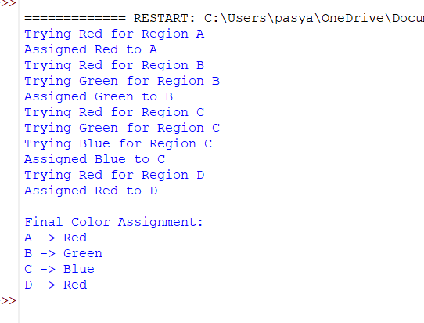

RESULT:
Thus, the Map Coloring Problem using Constraint Satisfaction Problem (CSP) was implemented successfully, and colors were assigned to all regions without violating adjacency constraints.

