SIMATS ENGINEERING
ASSESSMENT TOOL 1

COURSE NAME: Artificial Intelligence COURSE CODE: CSA17

COURSE OUTCOME COVERED

CO2: Experiment search and game-solving techniques such as Greedy Search, A*, CSP, Minimax, and Alpha-Beta pruning with heuristic functions for solving complex AI problems efficiently. (BL3)

Assessment Tool Weightage: 40%

Duration: 1 Hour
QUESTIONS: 3 Total Marks:30

Annexure A

Application Based Questions

Code of Conduct:

I Gayathri.P(192424324) certify that this submission is my original work and that I have adhered to the guidelines specified for this assessment.
I understand that any violation of academic integrity rules will result in disciplinary action.
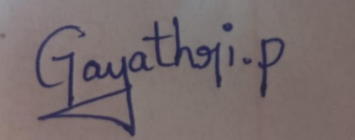
Signature of the student:

Annexure A

Application Based Questions

1. Intelligent Route Planning using A* and Greedy Search.
A smart delivery system is designed to transport medical supplies between cities. The system uses informed search strategies to determine optimal routes.
The road network is given below:
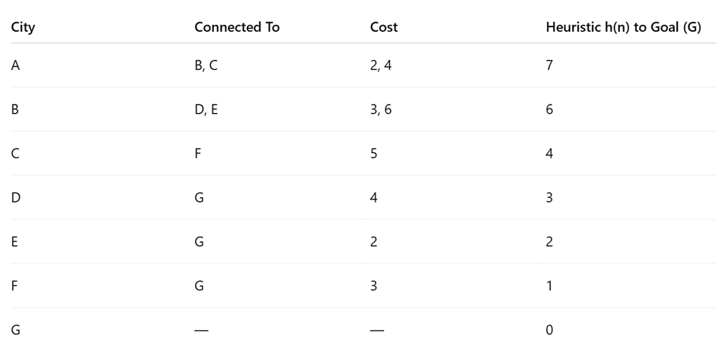
Tasks:
- Construct the search tree from A to G.
- Apply Greedy Best-First Search and show node expansion order.
- Apply A* algorithm using 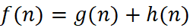.
- Justify which algorithm is better for real-time emergency delivery systems.
ANSWER:
- Construct the Search Tree from A to G
A
/ \
B C
/ \ \
D E F
| | |
G G G
Possible Paths
- A → B → D → G
- A → B → E → G
- A → C → F → G

ii. Apply Greedy Best-First Search
Principle
Greedy Best-First Search expands the node with the smallest heuristic value h(n). It ignores the path cost.
Step 1
Current Node = A
Children
Node | h(n)
B | 6
C | 4
Choose C because 4 < 6
Expansion Order
A → C
Step 2
Current Node = C
Child
Node | h(n)
F | 1
Choose F
Expansion Order
A → C → F
Step 3
Current Node = F
Child
Node | h(n)
G | 0
Goal reached.
Expansion Order
A → C → F → G
Greedy Search Result
Final Path
A → C → F → G
Total Cost
A → C = 4
C → F = 5
F → G = 3
Total Cost = 4 + 5 + 3 = 12

iii. Apply A Algorithm*
Formula
f(n)=g(n)+h(n)f(n)=g(n)+h(n)f(n)=g(n)+h(n)
where
- g(n) = Cost from Start
- h(n) = Heuristic
- f(n) = Evaluation Function
Step 1
Start Node
Node | g | h | f
A | 0 | 7 | 7
Expand A
Step 2
Children of A
Node B
g(B)=2
h(B)=6
f(B)=2+6=8

Node C
g(C)=4
h(C)=4
f(C)=4+4=8
Open List
Node | f
B | 8
C | 8
Choose B (tie broken by left-most node).
Step 3
Expand B
Node D
g(D)=2+3=5
h(D)=3
f(D)=8
Node E
g(E)=2+6=8
h(E)=2
f(E)=10
Open List
Node | f
C | 8
D | 8
E | 10
Choose D
Step 4
Expand D
Node G
g(G)=5+4=9
h(G)=0
f(G)=9
Open List
Node | f
C | 8
G | 9
E | 10
Expand C because f=8.
Step 5
Expand C
Child
Node F
g(F)=4+5=9
h(F)=1
f(F)=10
Open List
Node | f
G | 9
E | 10
F | 10
Choose G
Goal Reached.
A* Result
Optimal Path
A → B → D → G
Total Cost
2 + 3 + 4 = 9

A* Calculation Table
Node | g(n) | h(n) | f(n)=g+h
A | 0 | 7 | 7
B | 2 | 6 | 8
C | 4 | 4 | 8
D | 5 | 3 | 8
E | 8 | 2 | 10
F | 9 | 1 | 10
G | 9 | 0 | 9

iv. Which Algorithm is Better for Real-Time Emergency Delivery?
Greedy Best-First Search
Advantages
- Faster execution.
- Uses only heuristic values.
- Suitable when a quick solution is needed.
Disadvantages
- Does not guarantee the shortest route.
- May produce a higher travel cost.
A* Search
Advantages
- Uses both actual distance and estimated distance.
- Guarantees the optimal path when the heuristic is admissible.
- Reduces unnecessary exploration while maintaining accuracy.
- Provides the minimum transportation cost.
Disadvantages
- Requires slightly more computation than Greedy Search.

Comparison
Feature | Greedy Search | A* Search
Uses Heuristic | Yes | Yes
Uses Path Cost | No | Yes
Optimal Solution | No | Yes
Execution Speed | Fast | Moderate
Route Accuracy | Medium | High
Best for Emergency Delivery | No | Yes

Conclusion
Although Greedy Best-First Search quickly reaches the destination by selecting nodes with the smallest heuristic value, it ignores the actual travel cost and may produce a non-optimal route. In this example, Greedy Search finds the path A → C → F → G with a total cost of 12. In contrast, the A* algorithm considers both the accumulated path cost and the heuristic estimate, resulting in the optimal path A → B → D → G with a lower total cost of 9. Therefore, A* is the preferred algorithm for real-time emergency medical delivery systems because it provides the shortest and most cost-effective route while maintaining efficient search performance.

2. Constraint Satisfaction Problem – University Timetable Scheduling
A university must schedule final exams for 5 subjects: AI, ML, DBMS, OS, CN across 3 days (Day 1, Day 2, Day 3) with the conditions, AI and ML cannot be scheduled on the same day, DBMS must be scheduled before OS, CN cannot be on Day 1, At most 2 exams per day, A student is enrolled in AI, DBMS, and CN → these cannot overlap
Tasks:
- Formulate this problem as a Constraint Satisfaction Problem (CSP) by defining, Variables, Domains and Constraints
- Draw the constraint graph.
- Solve using Backtracking Search.
- Apply Forward Checking or Arc Consistency and explain how it reduces the search space.
- Provide one valid timetable solution.

ANSWER:
i. Formulation of CSP
Variables
- AI
- ML
- DBMS
- OS
- CN
Domains
Each subject can be scheduled on:
- Day 1
- Day 2
- Day 3
Constraints
- AI ≠ ML
- DBMS must be before OS.
- CN ≠ Day 1.
- Maximum 2 exams per day.
- AI, DBMS, and CN cannot be on the same day.

ii. Constraint Graph
AI -------- ML
|
|
DBMS ------ OS
|
|
CN
- AI connected to ML and DBMS.
- DBMS connected to OS and CN.

iii. Backtracking Search
Step 1: AI = Day 1 ✔️
Step 2: ML = Day 2 ✔️
Step 3: DBMS = Day 1 ✔️
Step 4: OS = Day 2 ✔️ (after DBMS)
Step 5: CN = Day 3 ✔️
All constraints are satisfied.

iv. Forward Checking
After assigning:
- AI = Day 1 → Remove Day 1 from ML.
- DBMS = Day 1 → OS can only be Day 2 or Day 3.
- CN cannot be Day 1, so choose Day 2 or Day 3.
Forward Checking removes invalid choices early, reducing the search space and avoiding unnecessary backtracking.

v. Valid Timetable
Day | Subjects
Day 1 | AI, DBMS
Day 2 | ML, OS
Day 3 | CN
Final Answer: The timetable satisfies all the given constraints with a maximum of two exams scheduled per day.

3. Game Playing – Minimax and Alpha-Beta Pruning
An AI agent is designed to play a turn-based strategy game. The game tree is given below:
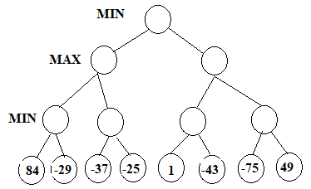
Tasks:
- Apply the Minimax algorithm and compute values for all internal nodes.
- Identify the optimal move for MAX.
- Apply Alpha-Beta Pruning to Show α and β values at each step and Clearly indicate which nodes are pruned
- Compare nodes evaluated in Minimax vs Alpha-Beta
- Explain the importance of evaluation functions in complex games like chess.

GANSWER:
i. Apply the Minimax Algorithm
Step 1: Evaluate MIN Nodes
- MIN(-84, -29) = -84
- MIN(-37, -25) = -37
- MIN(1, -43) = -43
- MIN(-75, 49) = -75
Step 2: Evaluate MAX Nodes
- MAX(-84, -37) = -37
- MAX(-43, -75) = -43
Step 3: Evaluate Root (MIN)
- MIN(-37, -43) = -43
Final Minimax Tree
Leaf Values:
(-84,-29) → -84
(-37,-25) → -37
(1,-43) → -43
(-75,49) → -75

MAX Nodes:
MAX(-84,-37) = -37
MAX(-43,-75) = -43

Root (MIN):
MIN(-37,-43) = -43

ii. Optimal Move for MAX
- Left MAX node = -37
- Right MAX node = -43
Since MAX selects the larger value,
Optimal Move = Left Subtree
Utility Value = -37

iii. Alpha-Beta Pruning
Initial values:
- α = -∞
- β = +∞
Left Subtree
- MIN(-84, -29) = -84
- α = max(-∞, -84) = -84
Next MIN node:
- MIN(-37, -25) = -37
- α = max(-84, -37) = -37
Right Subtree
β = -37 (received from root)
First MIN node:
- MIN(1, -43) = -43
Since
-43 ≤ β(-37)
The remaining subtree (-75, 49) is pruned.
Pruned Nodes
-75
49

iv. Comparison
Minimax | Alpha-Beta
Evaluates all 8 leaf nodes | Evaluates only 6 leaf nodes
No pruning | Prunes unnecessary nodes
Slower | Faster
More computations | Fewer computations

v. Importance of Evaluation Functions
- Evaluation functions estimate the quality of a game position.
- They help AI choose the best move without searching the entire game tree.
- In games like chess, they consider factors such as material, mobility, and king safety.
- Alpha-Beta pruning combined with good evaluation functions enables faster and stronger decision-making.

Conclusion: Alpha-Beta Pruning is more efficient than Minimax because it reduces the number of nodes evaluated while producing the same optimal decision.

RUBRICS FOR CALCULATION

Criteria | Weightage | Level 4 – Exemplary | Level 3 – Proficient | Level 2 – Developing | Level 1 – Beginning
Understanding of Problem Context | 20 | Clearly understands the problem and accurately identifies all requirements | Good understanding with minor gaps | Basic understanding; some requirements unclear | Poor understanding or misinterpretation of the problem
Application of Concepts | 30 | Accurately applies appropriate concepts to solve complex problems | Applies relevant concepts correctly with minor errors | Applies basic concepts with limited accuracy | Fails to apply appropriate concepts
Problem-Solving Approach | 20 | Logical, well-structured, and efficient approach | Mostly logical approach with minor gaps | Basic approach with some inconsistencies | Illogical or unclear approach
Accuracy of Solution | 20 | Completely correct solution with proper justification | Mostly correct with minor errors | Partially correct solution | Incorrect or incomplete solution
Clarity | 10 | Clear, well-organized, and properly explained solution | Understandable with minor clarity issues | Limited clarity and explanation | Poorly presented and difficult to understand

